Project Title

Given Name Surname   
Faculty of Applied Science & Technology  
Sheridan College *Oakville, Canada*  
your-email@sheridancollege.ca

***Abstract*—This is a short description of your project by writing about the need you felt in the market and the solution you provided in less than 250 words.**

***Keywords—HCI, keyword2, keyword3, keyword4 (****5 keywords are enough****)***

# Introduction (*Heading 1*)

Introducing the project by providing the history of the problem you have seen in the market and then decided to provide a new solution. Please cite other applications that are similar to your own.

Please Mention the current solutions in the market and then provide some reasons why your new solution probably makes a better experience. Anytime you are going to mention some application in the market, or a previous research on it, please make sure you provide a citation. The citation guide is provided in the REFERENCES section.

# Prototype Design

## Requirement Analysis (NeedFinding)

Based on your special project, provide your methodology for gathering requirements to implement the project, and provide the questions you asked from end users to gather the information. Please also provide feedback given by the end users. (**Needfinding in Assignment 2**)

## Competitive Analysis

In **Assignment 2**, you also learned the Procedure of Competitive Analysis, and created a matrix. Please put it here with some details.

## First Initial Prototype Alternatives

In assignment 1, you created a prototype. Please share the link of your first prototype that anyone can access and review. Please upload the sources on your GitHub account and cite them. (use a citation method for citing a URL explained in REFERENCES section). You should also upload your prototype sources to **GitHub**. If you are interested, please provide a video link, explaining the application. Upload it on YouTube and provide the link there.

In **Assignment 2 and 3**, you designed your second version of prototype. You used it for User Testing. Please put some screenshots, and also upload the source to your GitHub and share the links.

In this section, by providing some screenshots show some of the HCI concepts you considered in designing the final prototype. For example, if you designed something based on “Recognition Vs Recall”, cite the article about it (you can cite a book or research article) to support your claim, and then provide the screenshot as the evidence. In the following section, some guidelines regarding how to provide the figures are provided.

# Prototype evaluation

Please explain the list, the audience and test plans you created for testing the prototype on UserTesting.com or by yourself in **Assignment 3**.

# Usability Analysis

In **Assignment 3**, it was asked to use some usability metrics to analyze the video responses. Please summarize the user responses from the video feedback you received and explain what improvements are necessary.

Please provide the metrics and analysis you did in a table similar to the example TABLE 1 (you can change the number of columns, rows, etc).

## Figures and Tables Guidelines

#### Positioning Figures and Tables: Place figures and tables at the top and bottom of columns. Avoid placing them in the middle of columns. Large figures and tables may span across both columns. Figure captions should be below the figures; table heads should appear above the tables. Insert figures and tables after they are cited in the text. Use the abbreviation “Fig. 1”, even at the beginning of a sentence.

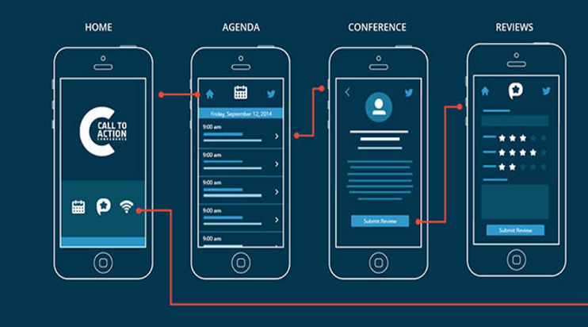

1. Example of a figure caption. (*figure caption*)
2. Table Type Styles

|  |  |  |  |
| --- | --- | --- | --- |
| **Table Head** | **Table Column Head** | | |
| ***Table column subhead*** | ***Subhead*** | ***Subhead*** |
| copy | More table copya |  |  |

1. Sample of a Table footnote. (*Table footnote*)

# Revised Prototype

Using the usability analysis after evaluating your prototype on UserTesing.com, you need to have a plan to revise the prototype. Please conclude what should be revised in the future version of your prototype and **if you have time,** **please create the revised prototype and share the sources on GitHub (optional).**

Provide before and after screenshots of your revised prototype here. An example is given in Fig. 2.

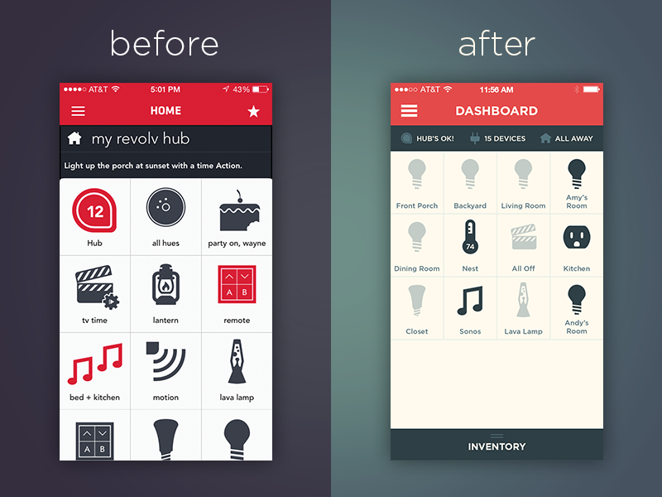

1. Example of a revised prototype

# Future works & Conclusions

Please provide some ideas about improving the prototype in the future. Write a brief conclusion at the end.

##### References

The template will number citations consecutively within brackets [1]. The sentence punctuation follows the bracket [2]. Refer simply to the reference number, as in [3]—do not use “Ref. [3]” or “reference [3]” except at the beginning of a sentence: “Reference [3] was the first ...”

Number footnotes separately in superscripts. Place the actual footnote at the bottom of the column in which it was cited. Do not put footnotes in the abstract or reference list. Use letters for table footnotes.

Unless there are six authors or more, give all authors’ names; do not use “et al.”. Papers that have not been published, even if they have been submitted for publication, should be cited as “unpublished” [4]. Papers that have been accepted for publication should be cited as “in press” [5]. Capitalize only the first word in a paper title, except for proper nouns and element symbols.

For papers published in translation journals, please give the English citation first, followed by the original foreign-language citation [6].

If you want to cite a website follow the instructions in this [URL](http://www.easybib.com/reference/guide/apa/website) [8].

The following lines show you some of the sample citations. In [8], you can see how a website is cited.

1. G. Eason, B. Noble, and I. N. Sneddon, “On certain integrals of Lipschitz-Hankel type involving products of Bessel functions,” Phil. Trans. Roy. Soc. London, vol. A247, pp. 529–551, April 1955. *(references)*
2. J. Clerk Maxwell, A Treatise on Electricity and Magnetism, 3rd ed., vol. 2. Oxford: Clarendon, 1892, pp.68–73.
3. I. S. Jacobs and C. P. Bean, “Fine particles, thin films and exchange anisotropy,” in Magnetism, vol. III, G. T. Rado and H. Suhl, Eds. New York: Academic, 1963, pp. 271–350.
4. K. Elissa, “Title of paper if known,” unpublished.
5. R. Nicole, “Title of paper with only first word capitalized,” J. Name Stand. Abbrev., in press.
6. Y. Yorozu, M. Hirano, K. Oka, and Y. Tagawa, “Electron spectroscopy studies on magneto-optical media and plastic substrate interface,” IEEE Transl. J. Magn. Japan, vol. 2, pp. 740–741, August 1987 [Digests 9th Annual Conf. Magnetics Japan, p. 301, 1982].
7. M. Young, The Technical Writer’s Handbook. Mill Valley, CA: University Science, 1989.
8. Staff, EasyBib. “The Free Automatic Bibliography Composer.” EasyBib, Chegg, 1 Jan. 2018,

##### Appendix

If you feel you like to add more screenshots from your work, add them in APPENDIX section.

We suggest that you use a text box to insert a graphic (which is ideally a 300 dpi TIFF or EPS file, with all fonts embedded) because, in an MSW document, this method is somewhat more stable than directly inserting a picture.

To have non-visible rules on your frame, use the MSWord “Format” pull-down menu, select Text Box > Colors and Lines to choose No Fill and No Line.