# Original Allotment Letter No.. 1110 in the name of Shri Naresh Kumar S/o Shri Deep Chand Yadav issued by RHB, Bikaner on dated 12.06.1984.

1. Original No Dues Cert1fi at

# No. 1328 in the am of

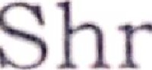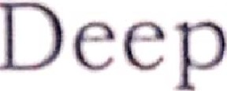Naresh Kuma · / .

1

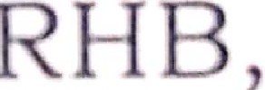Chand Yada · l 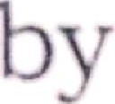

# Bikaner

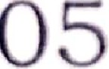25.02.20

## Original

1. fi '

## (One Ti I

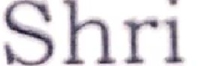the nam 0

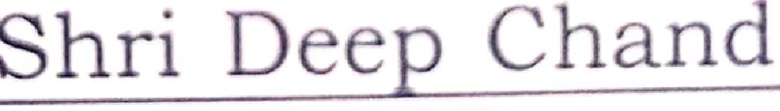 K11mar_S / o

Yadav issued Bikaner on 25.02.2005.

by RHB, dated

* 1. Original Perpetual Lease Deed in favour Shri Naresh Kumar S/ o Shri Deep Chand Yadav document registered on dated 07.03.2005 at Sub Registrar Office, Bikaner at Book No. 1, Vol. No. 890, Page No. 159, S. No. 2005001403, Add. Book No.

1, Vol. No. 1513, Page No. 74 to 87 document executed by RHB, Bikaner.

* 1. Original Conveyance Deed in favour Shri Naresh Kumar 8/o Shri Deep Chand Yadav document registered on d, ted 07.03.2005 at Sub Rcgi tr,tr Office, BikanC'r at Book r . I, Vol. No. 890, Pa J • 11o. I GO ..

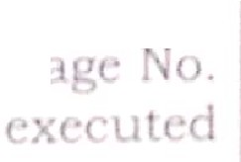No. 200.50 1 0 , , l. I ml

o. 1, Vol. 10. I I 3,I ,

88 lo 9 lr,cum **n**

by RHB, B1k:J1 ·r.

* 1. 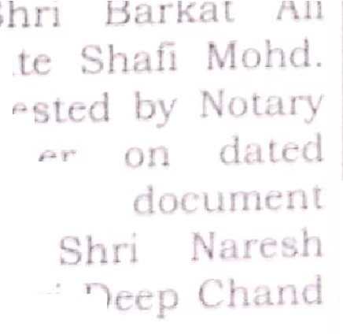0. n.gma.1 **p**( ,,_. favou of Khan *SJc1* L docum ·111, t <"

Public, Bih 1 **·r**

07.03.2005

C *re* utc-d lJr

Kumar *Jo* I 1 I

Yad·:1.v.

**e_, ll**

* 1. 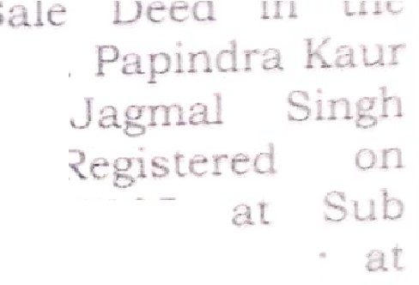Original

r vour of 'n 1. Papi.

**W** *Jo* hri

do um nt

dated 21.12.2005

R gistr r Offi · 81kane. Book o. 1, Voluml'. . o. 929, Page o. 101, ro.

-005009145, Add. Book o.

1, Volume No. 166 , P ge No.

1 to 14 documenr execUtL a by Shri Barkat Ali Khan *SJo* Lat.e .._'hafi Mohd. a. POA

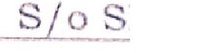hold r of hri Naresh .Kumar 1

hri De -Chand Yadav.



8. Original Sale Deed in favour of Smt. Rubina Bano W/o Shri Sakir Khan document registered on dated 05.02.2008 at Sub Registrar Office, Bikaner at Book No. 1 Vol. No. 890, Page No. 160, S. No. 2005001404, Add. Book

'

No. 1, Vol. No. 1513, Page No.

88 to 98 document executed by Smt. Papindra Kaur W/ o Shri Jagmal Singh.

Original Sale Agreement in favour of Smt. Alveera Khan W/ o Shri Shoyab Pardesi document attested by Notary Public, Bikaner on dated 30.08.2019 document executed by Smt. Rubina Bano W/ o Shri Sakir Khan.

0. Original Sale Deed in favour of Smt. Alveera Khan W/ o Shri Shoyab Pardesi document registered on dated 15.10.2019 at Sub Registrar Offie, Bikaner at Book No. 1, Vol. No. 1761, Page No. 172,

S. No. 201903058105770,

Add. Book No. 1, Vol. No. 4991, Page No. 198 to 210 document executed by Smt. Rubina Bano W/ o Shri Sakir

Khan.