**190905513 C SECTION 4thSEMESTER MOHAMMAD TOFIK**

**LAB 7 :**

**Solved Exercise :**

Write a program to simulate 4 -digit BCD up counter on the multiplexed seven segment display.

#include <LPC17xx.h>

#include <stdio.h>

unsigned int seg_select[4] = {0 << 23, 1 << 23, 2 << 23, 3 << 23};

unsigned int dig1 = 0x00, dig2 = 0x00, dig3 = 0x00, dig4 = 0x00;

unsigned int seg_count = 0x00, temp1 = 0x00;

unsigned char array_dec[10] = {0x3F, 0x06, 0x5B, 0x4F, 0x66, 0x6D, 0x7D, 0x07, 0x7F, 0x6F};

unsigned long int i = 0;

void delay(void);

void display(void);

int main(void)

{

LPC_PINCON->PINSEL0 &= 0xFF0000FF; //P0.4 to P0.11 GPIO data lines

LPC_PINCON->PINSEL3 &= 0xFFC03FFF; //P1.23 to P1.26 GPIO enable lines

LPC_GPIO0->FIODIR |= 0x00000FF0; //P0.4 to P0.11 output

LPC_GPIO1->FIODIR |= 0x07800000; //P1.23 to P1.26 output

while (1)

{

delay();

display();

seg_count += 1;

if (seg_count == 0x04)

{

seg_count = 0x00;

dig1 += 1;

if (dig1 == 0x0A)

{

dig1 = 0;

dig2 += 1;

if (dig2 == 0x0A)

{

dig2 = 0;

dig3 += 1;

if (dig3 == 0x0A)

{

dig3 = 0;

dig4 += 1;

if (dig4 == 0x0A)

{

dig4 = 0;

} //end of dig4

} //end of dig3

} //end of dig2

} //end of dig1

} //end of seg_count

} //end of while(1)

} //end of main

void display(void) //To Display on 7-segments

{

LPC_GPIO1->FIOPIN = seg_select[seg_count];

if (seg_count == 0x00) // For Segment U8

{

temp1 = dig1;

}

else if (seg_count == 0x01) // For Segment U9

{

temp1 = dig2;

}

else if (seg_count == 0x02) // For Segment U10

{

temp1 = dig3;

}

else if (seg_count == 0x03) // For Segment U11

{

temp1 = dig4;

}

LPC_GPIO0->FIOPIN = array_dec[temp1] << 4; // Taking Data Lines for 7-Seg

for (i = 0; i < 500; i++)

;

}

void delay(void)

{

unsigned int i;

for (i = 0; i < 60000; i++)

;

}

**Output:**

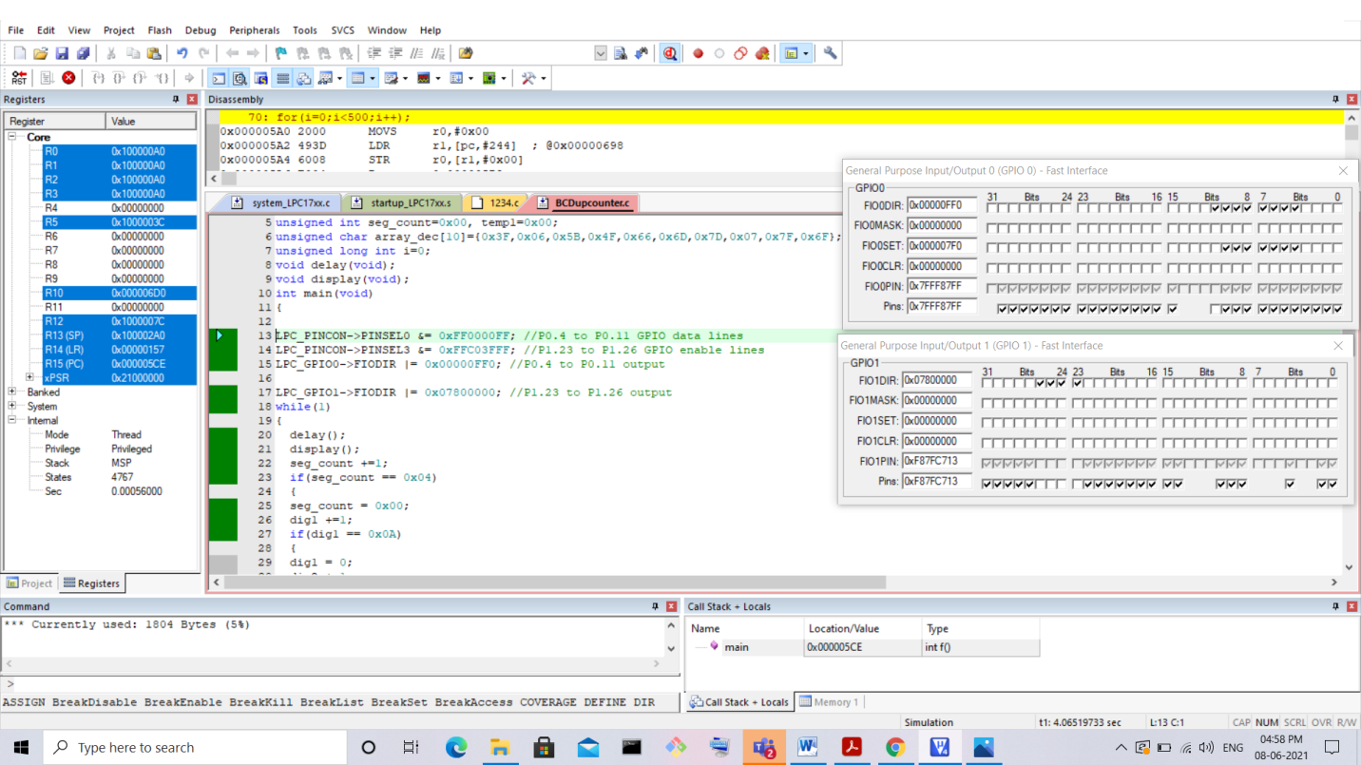

**Lab Exercises :**

1. Write a C program to display the number “1234” serially in the seven segment display.Program :

#include <LPC17xx.h>

unsigned seven_seg[10] = {0x3F, 0x06, 0x5B, 0x4F, 0x66, 0x6D, 0x7D, 0x07, 0x7F, 0x6F};

unsigned int dig_count = -1, i, j;

unsigned int dig_value[4] = {1, 2, 3, 4};

unsigned int dig_select[] = {0 << 23, 1 << 23, 2 << 23, 3 << 23};

void display()

{

LPC_GPIO1->FIOPIN = dig_select[dig_count];

LPC_GPIO0->FIOPIN = seven_seg[dig_value[dig_count]] << 4;

}

void delay()

{

for (i = 0; i < 60000; i++)

;

}

int main()

{

LPC_GPIO0->FIODIR = 0xFF << 4;

LPC_GPIO1->FIODIR = 0xF << 23;

while (1)

{

delay();

dig_count = (dig_count + 1) % 4;

display();

}

}

**Output:**

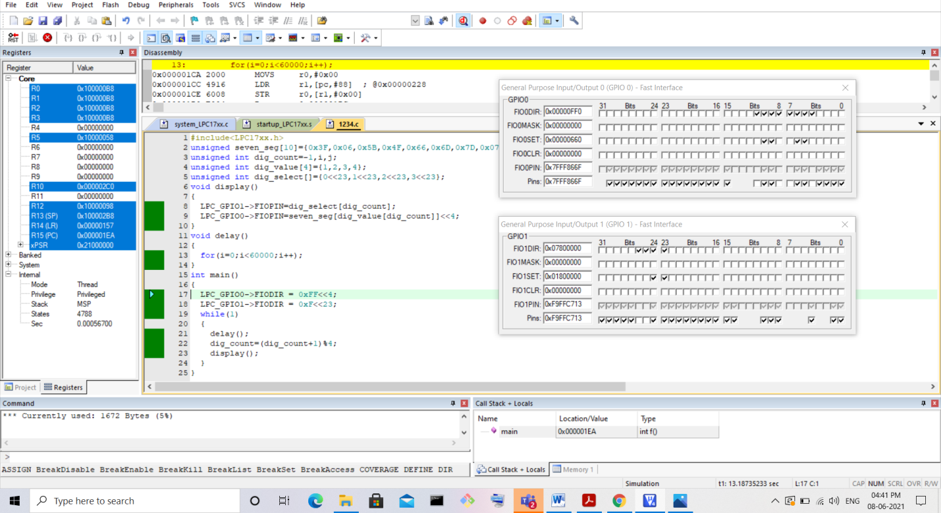

**2. Write a C program to simulate a 4 - digit BCD down counter.**

**Program :**

#include <LPC17XX.h>

void

delay(void);

int main()

{

unsigned int i;

unsigned int c_flag = 0;

unsigned int digit_value[4] = {9, 9, 9, 9};

unsigned long seven_seg[10] = {0x3F, 0x06, 0x5B, 0x4F, 0x66, 0x6D, 0x7D, 0x07, 0x7F, 0x6F};

LPC_PINCON->PINSEL0 = 0X00FF000FF;

LPC_PINCON->PINSEL3 = 0XFFC03FFF;

LPC_GPIO0->FIODIR = 0XFF << 4;

LPC_GPIO1->FIODIR = 0XF << 23;

while (1)

{

delay();

for (i = 0; i < 4; i++)

{

LPC_GPIO1->FIOPIN = i << 23;

LPC_GPIO0->FIOPIN = seven_seg[digit_value[i]] << 4;

}

c_flag = 0;

for (i = 0; i < 4; i++)

{

if (i == 0)

{

if (digit_value[i] < c_flag + 1)

{

digit_value[i] = digit_value[i] - 1 - c_flag + 10;

c_flag = 1;

}

else

{

digit_value[i] = digit_value[i] - 1 - c_flag;

c_flag = 0;

}

}

else

{

if (digit_value[i] < c_flag)

{

digit_value[i] = digit_value[i] - c_flag + 10;

c_flag = 1;

}

else

{

digit_value[i] = digit_value[i] - c_flag;

c_flag = 0;

}

}

}

}

return 2;

}

void delay(void)

{

unsigned int i;

for (i = 0; i < 1000; i++)

;

}

**Output:**

