**Week1 lab1**

**PROGRAM_1**

module lab1(a,b,c,f1,f2);

input a,b,c;

output f1;

output f2;

assign f1=(a&~c)|(b&c)|(~b&~c);

assign f2=(a|~b|c)&(a|b|~c)&(~a|b|~c);

endmodule

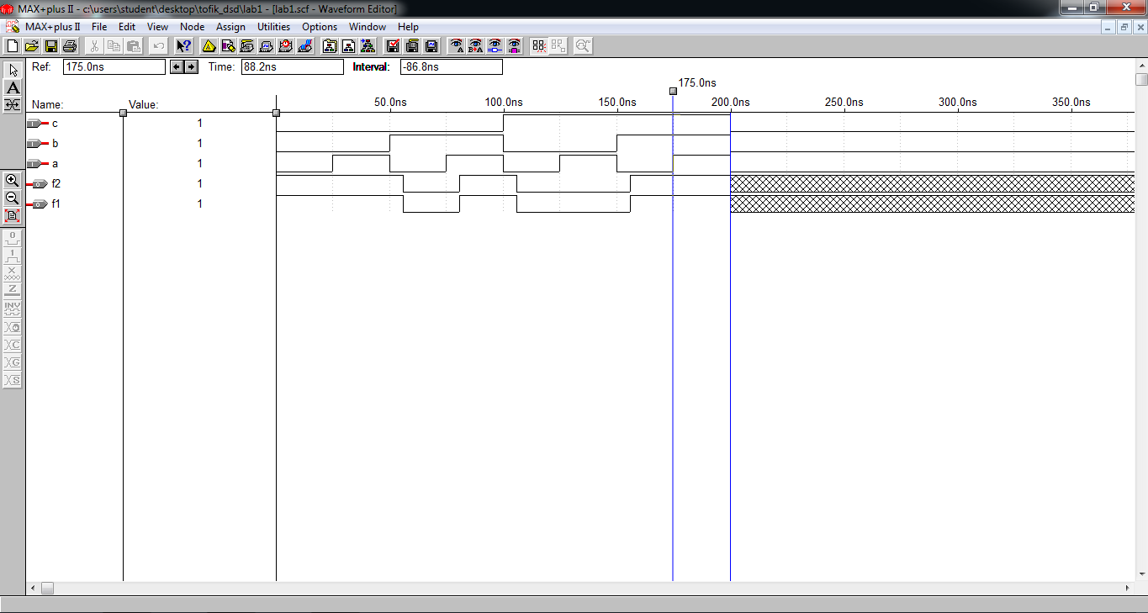

**Lab1 program2_1 :**

**module lab1_2(a, b, c, d, f1);**

**input a, b, c, d;**

**output f1;**

**assign f1 = (~b & d) | (~b & c) | (a & ~c & ~d)|(~a&~b);**

**endmodule**

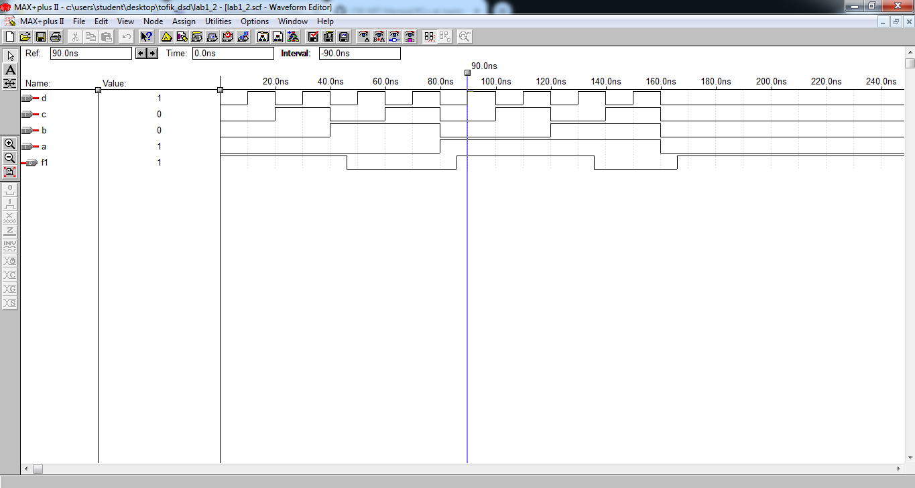

**LAB1 PROGRAM_2_2**

**module lab1_2_2(a, b, c, d, f);**

**input a, b, c, d;**

**output f;**

**assign f = (~b| ~c|~d) &(~a|b|c) &(~a|b| d)&(a|b|~d);**

**endmodule**

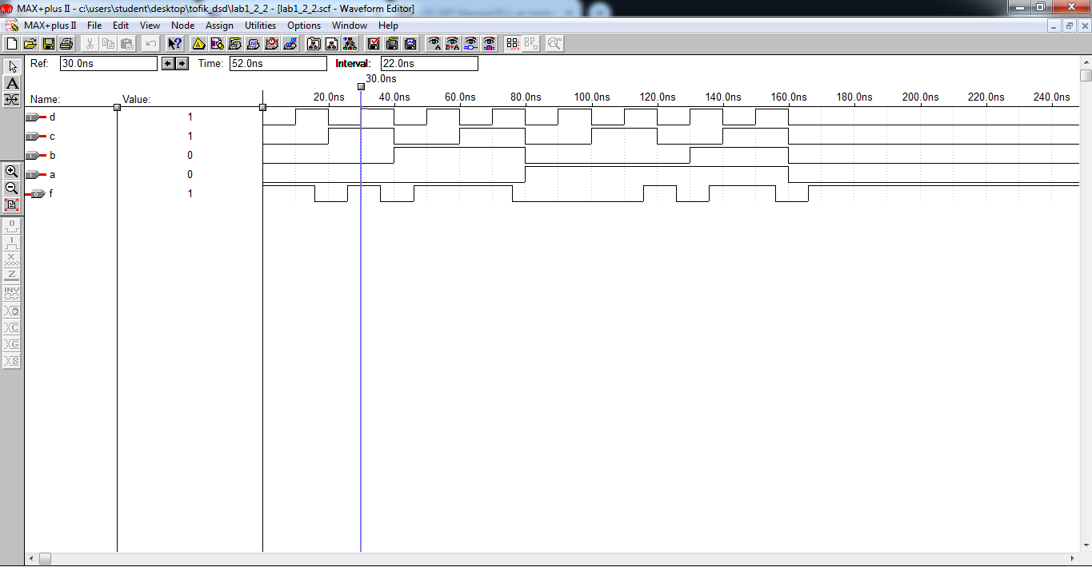

**PROGRAM_3 :**

module exercise3(a,b,c,d,f);  
input a,b,c,d;  
output f;  
assign f = ~(~(~(a&a)&b)&(~(~(c&c)&d)));  
endmodule

