**190905514**  **MOHAMMAD TOFIK**

**WEEK 6 LAB 6 :**

**1.**

Write behavioral Verilog code for a negative edge triggered T FF with asynchronous active low reset.

module tff(T,Clock,Reset,Q);

input T,Clock, Reset;

output Q;

reg Q;

always @ (negedge Clock or negedge Reset)

if(!Reset)

Q <= 0;

else

if(T)

Q <= ~Q;

else

Q <= Q;

endmodule

**OUTPUT :**

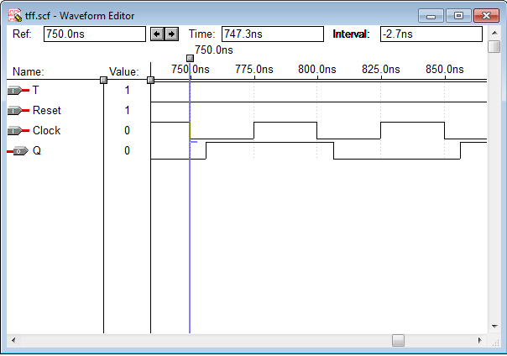

**2.**Write behavioral Verilog code for a positive edge-triggered JK FF with synchronous

active high reset .

module jkff(J,K,Clock,Q);

input J, K, Clock;

output Q;

reg Q;

always @ (posedge Clock)

begin

case({J, K})

0: Q <= Q;

1: Q <= 0;

2: Q <= 1;

3: Q <= ~Q;

endcase

end

endmodule

**OUTPUT :**

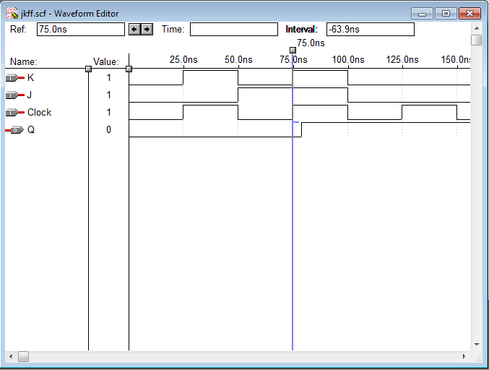

**3**. Design and simulate the following counters

a) 4-bit ring counter.

b) 5 bit Johnson counter.

**3(a).**

module ringcounter(q,clock,clear);

input clock,clear;

output [3:0]q;

reg [3:0]q;

always @(posedge clock)

if(clear==1)

q<=4'b1000;

else

begin

q[3]<=q[0];

q[2]<=q[3];

q[1]<=q[2];

q[0]<=q[1];

end

endmodule

**OUTPUT :**

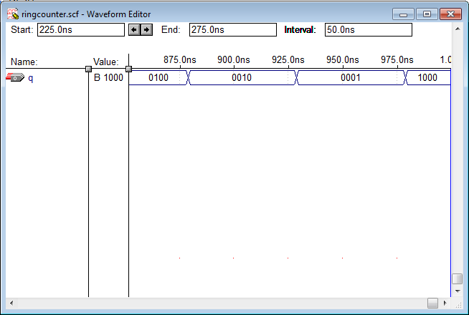

**3(b).**

odule jonsoncounter(clock,Q);

input clock;

output [4:0]Q;

reg [4:0]Q;

always@(posedge clock)

begin

case(Q)

5'b00000: Q<=5'b10000;

5'b10000: Q<=5'b11000;

5'b11000: Q<=5'b11100;

5'b11100: Q<=5'b11110;

5'b11110: Q<=5'b11111;

5'b11111: Q<=5'b01111;

5'b01111: Q<=5'b00111;

5'b00111: Q<=5'b00011;

5'b00011: Q<=5'b00001;

5'b00001: Q<=5'b00000;

endcase

end

endmodule

**OUTPUT :**

