**190905514** **MOHAMMAD TOFIK**

**WEE 8 LAB 8 :**

**1.** Write and simulate the Verilog code to swap the contents of two registers using

multiplexers.

**module swapmux(X,Y,Xout,Yout);  
input X,Y;  
output Xout,Yout;  
wire M;**

**mux2to1 mux1(Y,{~X,X},M);  
mux2to1 mux2(M,{~Y,Y},Yout);  
mux2to1 mux3(Yout,{~M,M},Xout);**

**endmodule**

**module mux2to1(S,W,f);  
input S;  
input [0:1]W;  
output f;  
assign f = S?W[1]:W[0];  
endmodule**

**OUTPUT :**

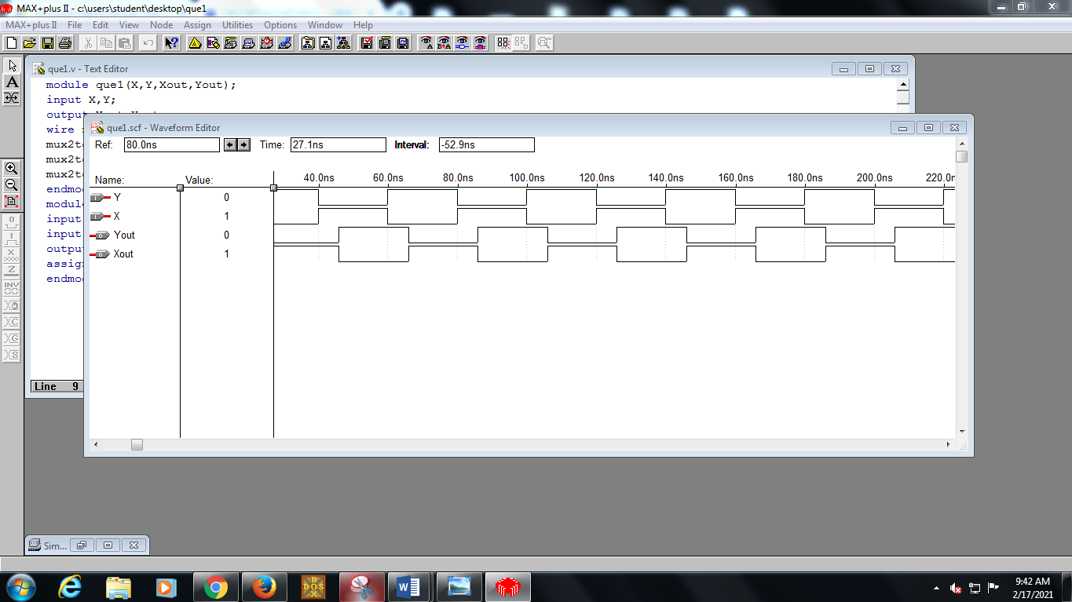

**2.** Simulate a simple processor that can perform the following functions:

**module processor(Data, Reset, w, Clock, F, Rx, Ry,R0, R1, R2, R3, Count, I, BusWires);**

**input [3:0] Data;**

**input Reset, w, Clock;**

**input [1:0] F, Rx, Ry;**

**output [1:0] Count, I;**

**output [3:0] BusWires, R0, R1, R2, R3;**

**reg [3:0] BusWires;**

**reg [3:0] Sum;**

**reg [0:3] Rin, Rout;**

**reg Extern, Ain, Gin, Gout, AddSub;**

**//wire [1:0] Count, I;**

**wire [0:3] Xreg, Y;**

**wire [3:0] A, G;**

**wire [1:6] Func, FuncReg, Sel;**

**upcount1 counter (Reset, Clock, Count);**

**assign Func = {F, Rx, Ry};**

**wire FRin = w & ~Count[1] & ~Count[0];**

**regn3 functionreg (Func, FRin, Clock, FuncReg);**

**//defparam functionreg.n = 6;**

**assign I = FuncReg[1:2];**

**dec2to4 decX (FuncReg[3:4], 1'b1, Xreg);**

**dec2to4 decY (FuncReg[5:6], 1'b1, Y);**

**always @(Count or I or Xreg or Y)**

**begin**

**Extern = 1'b0; Ain = 1'b0; Gin = 1'b0;**

**Gout = 1'b0; AddSub = 1'b0; Rin = 4'b0; Rout = 4'b0;**

**case (Count)**

**2'b00: ; //no signals asserted in time step T0**

**2'b01: //define signals in time step T1**

**case (I)**

**2'b00: begin //Load**

**Extern = 1'b1; Rin = Xreg;**

**end**

**2'b01: begin //Move**

**Rout = Y; Rin = Xreg;**

**end**

**default: begin //Add, Sub**

**Rout = Xreg; Ain = 1'b1;**

**end**

**endcase**

**2'b10: //define signals in time step T2**

**case(I)**

**2'b10: begin //Add**

**Rout = Y; Gin = 1'b1;**

**end**

**2'b11: begin //Sub**

**Rout = Y; AddSub = 1'b1; Gin = 1'b1;**

**end**

**default: ; //Add, Sub**

**endcase**

**2'b11:**

**case (I)**

**2'b10, 2'b11:**

**begin**

**Gout = 1'b1; Rin = Xreg;**

**end**

**default: ; //Add, Sub**

**endcase**

**endcase**

**end**

**regn2 reg_0 (BusWires, Rin[0], Clock, R0);**

**regn2 reg_1 (BusWires, Rin[1], Clock, R1);**

**regn2 reg_2 (BusWires, Rin[2], Clock, R2);**

**regn2 reg_3 (BusWires, Rin[3], Clock, R3);**

**regn2 reg_A (BusWires, Ain, Clock, A);**

**// alu**

**always @(AddSub or A or BusWires)**

**begin**

**if (!AddSub)**

**Sum = A + BusWires;**

**else**

**Sum = A - BusWires;**

**end**

**regn2 reg_G (Sum, Gin, Clock, G);**

**assign Sel = {Rout, Gout, Extern};**

**always @(Sel or R0 or R1 or R2 or R3 or G or Data)**

**begin**

**if (Sel == 6'b100000)**

**BusWires = R0;**

**else if (Sel == 6'b010000)**

**BusWires = R1;**

**else if (Sel == 6'b001000)**

**BusWires = R2;**

**else if (Sel == 6'b000100)**

**BusWires = R3;**

**else if (Sel == 6'b000010)**

**BusWires = G;**

**else BusWires = Data;**

**end**

**endmodule**

**module upcount1(Clear, Clock, Q);**

**input Clear, Clock;**

**output [1:0] Q;**

**reg [1:0] Q;**

**always @(posedge Clock)**

**if (Clear)**

**Q <= 0;**

**else**

**Q <= Q + 1;**

**endmodule**

**module regn2(R, L, Clock, Q);**

**parameter n = 4;**

**input [n-1:0] R;**

**input L, Clock;**

**output[n-1:0] Q;**

**reg [n-1:0] Q;**

**always @(posedge Clock)**

**if (L)**

**Q <= R;**

**endmodule**

**module dec2to4 (W, En, Y);**

**input [1:0]W;**

**input En;**

**output [0:3] Y;**

**reg [0:3] Y;**

**always @(W or En)**

**case ({En,W})**

**3'b100: Y = 4'b1000;**

**3'b101: Y = 4'b0100;**

**3'b110: Y = 4'b0010;**

**3'b111: Y = 4'b0001;**

**default: Y = 4'b0000;**

**endcase**

**endmodule**

**module regn3(R, L, Clock, Q);**

**parameter n = 6;**

**input [n-1:0] R;**

**input L, Clock;**

**output[n-1:0] Q;**

**reg [n-1:0] Q;**

**always @(posedge Clock)**

**if (L)**

**Q <= R;**

**Endmodule**

**OUTPUT :**

