**190905514 MOHAMMAD TOFIK**

**WEEK 7**

**Lab Exercises:**

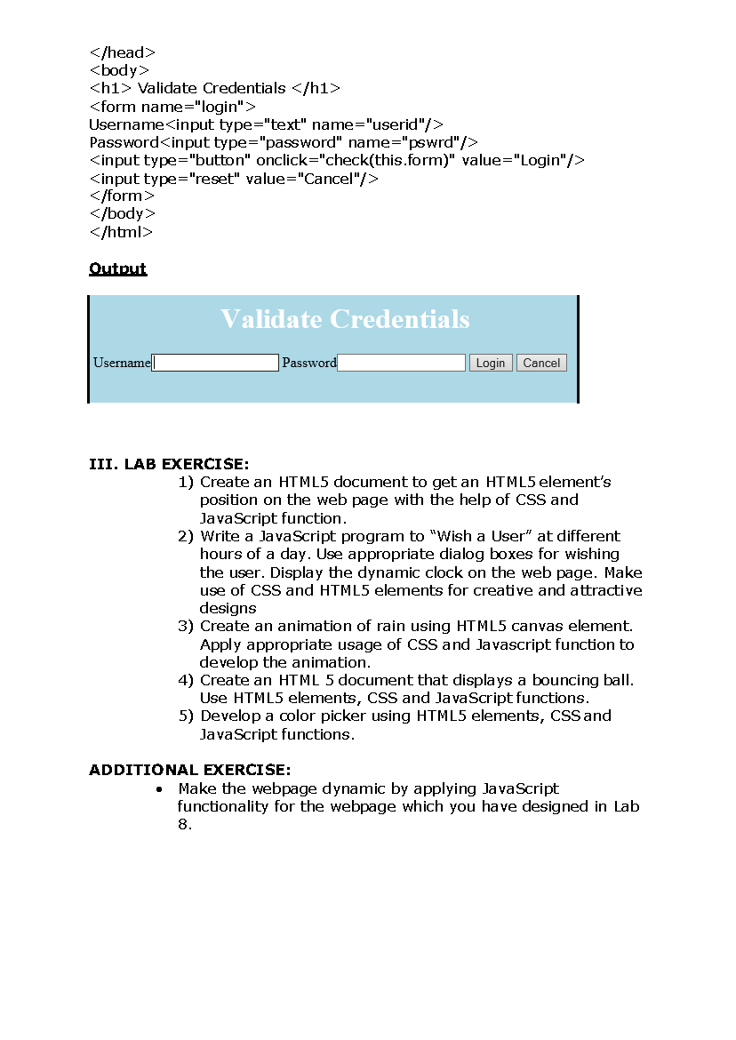

**Code:**

<!DOCTYPE html>

<html>

<head>

<title>

lab7_1

</title>

<script type="text/javascript">

function getPositionXY(element){ var

rect =

element.getBoundingClientRect();

document.getElementById('button').innerHTML ='X: ' + rect.x + ', ' + 'Y: ' + rect.y

}

</script>

</head>

<body>

<b>Getting Position of an element</b>

<br><br>

<button id='button1' onclick="getPositionXY(this)">

Button 1

</button>

<button id = 'button1' onclick = "getPositionXY(this)">

Button 2

</button>

<br><br>

<center>

<button id = 'button1' onclick = "getPositionXY(this)">

Button 3

</button>

</center>

<p id='button'></p>

</body>

</html>

**Output:**

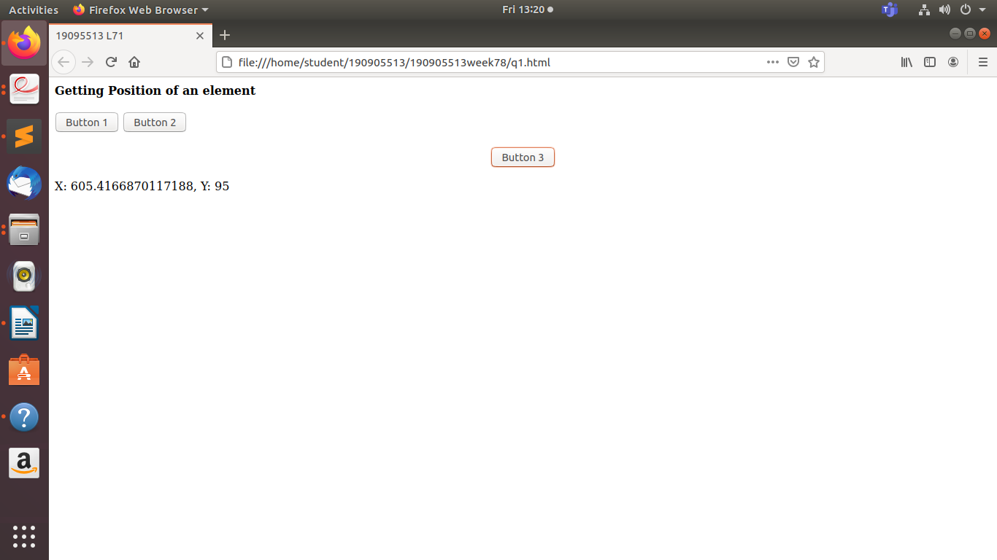

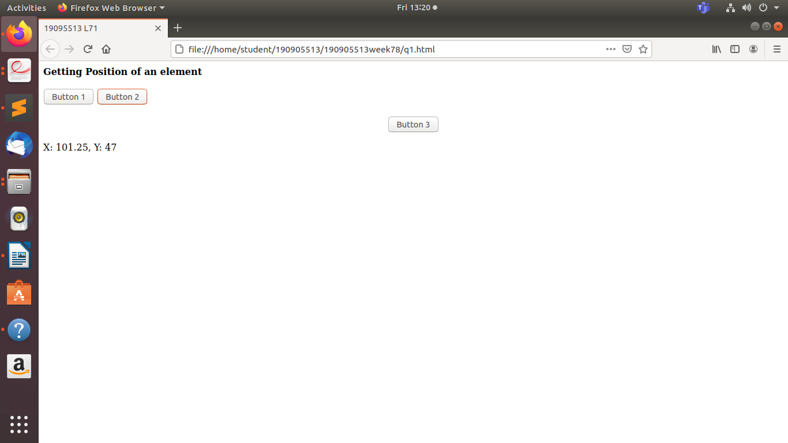

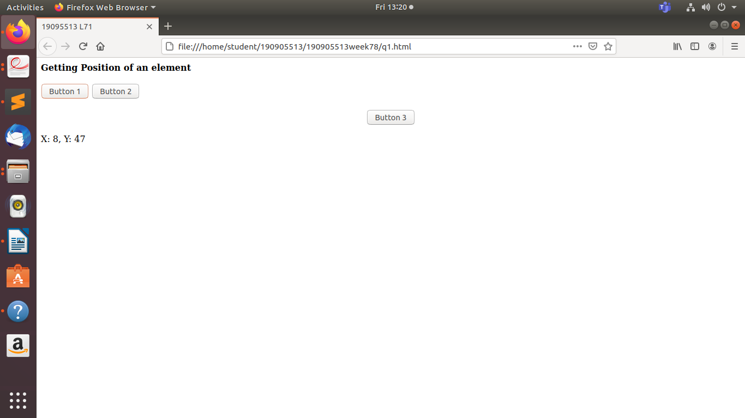



**Code:**

<!DOCTYPE html>

<html>

<head>

<title>Greeting</title>

<script

type="text/javascript">

function greet()

{

document.write("<center><font size=7 style='color: blue;'>");

var

myDate = new Date();

var hr = new Date().getHours();

if (hr >= 0 &&

hr < 12) {

document.write("Good Morning!");

}

else if (hr >= 12 && hr <= 17) {

document.write("Good Afternoon!");

} else {

document.write("Good Evening!");

}

document.write("</font></center>");

document.write('Time is '+myDate.getHours()+':'+myDate.getMinutes()

+':'+myDate.getSeconds());

}

</script>

</head><body>

<button onclick="greet()">Press Here</button>

</body>

</html>

**Output:**

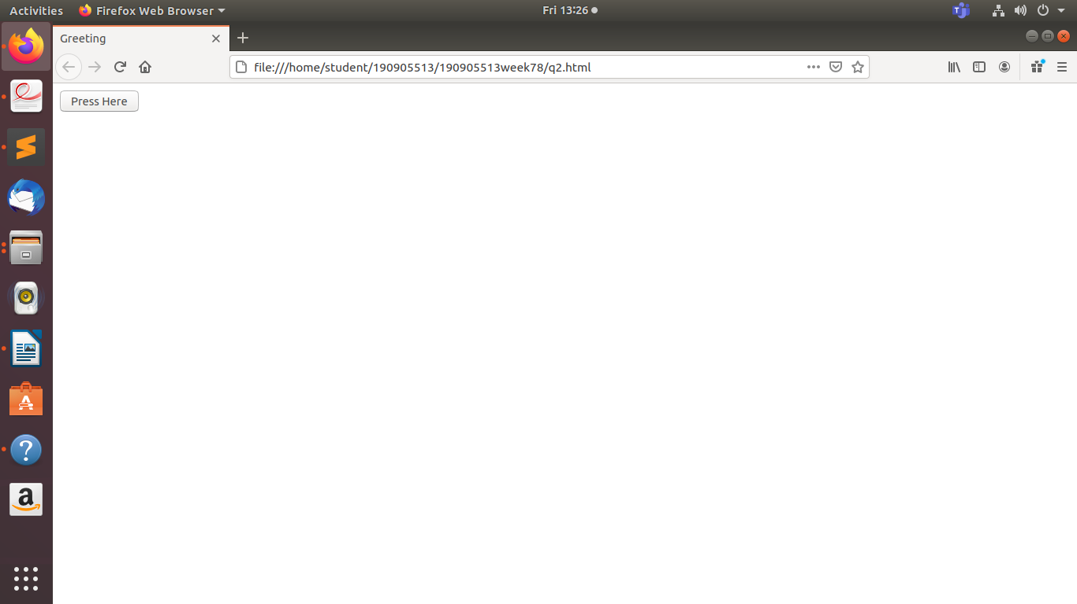

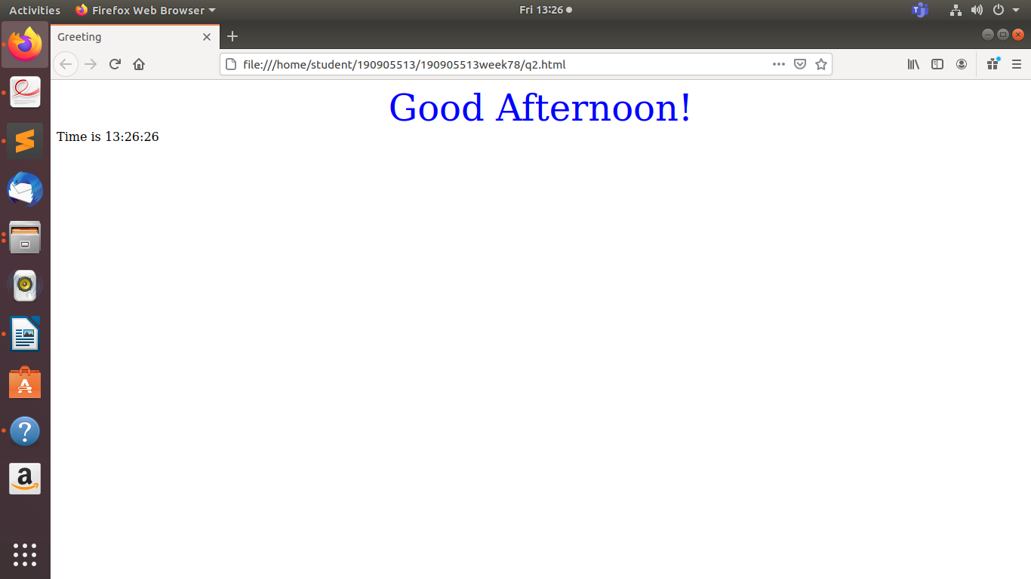



**Code:**

<!DOCTYPE html>

<html>

<head>

<title>

Dan 7_3

</title>

</head>

<body onload="rain()">

<script

type="text/javascript"> var

n = 1;

function rain()

{

this.rain_len = 5;

this.rain_ang= Math.PI/3;

var ctx =myCanvas.getContext('2d');

var x = Math.random() * 1800;

var y = Math.random() * 600;

ctx.strokeStyle = "blue";

ctx.beginPath();

ctx.moveTo(x,y);

ctx.lineTo(x-Math.cos(this.rain_ang)*this.rain_len,y-Math.sin(this.rain_ang)*this.rain_len); ctx.stroke(); n = n + 1;

if (n == 100)

{

ctx.clearRect(0, 0, 1800,600);

n = 1;

}

var t = setTimeout(rain, 15);

}

</script>

<canvas id="myCanvas" width="1200" height="600">

</canvas>

</body>

</html>

**Output:**

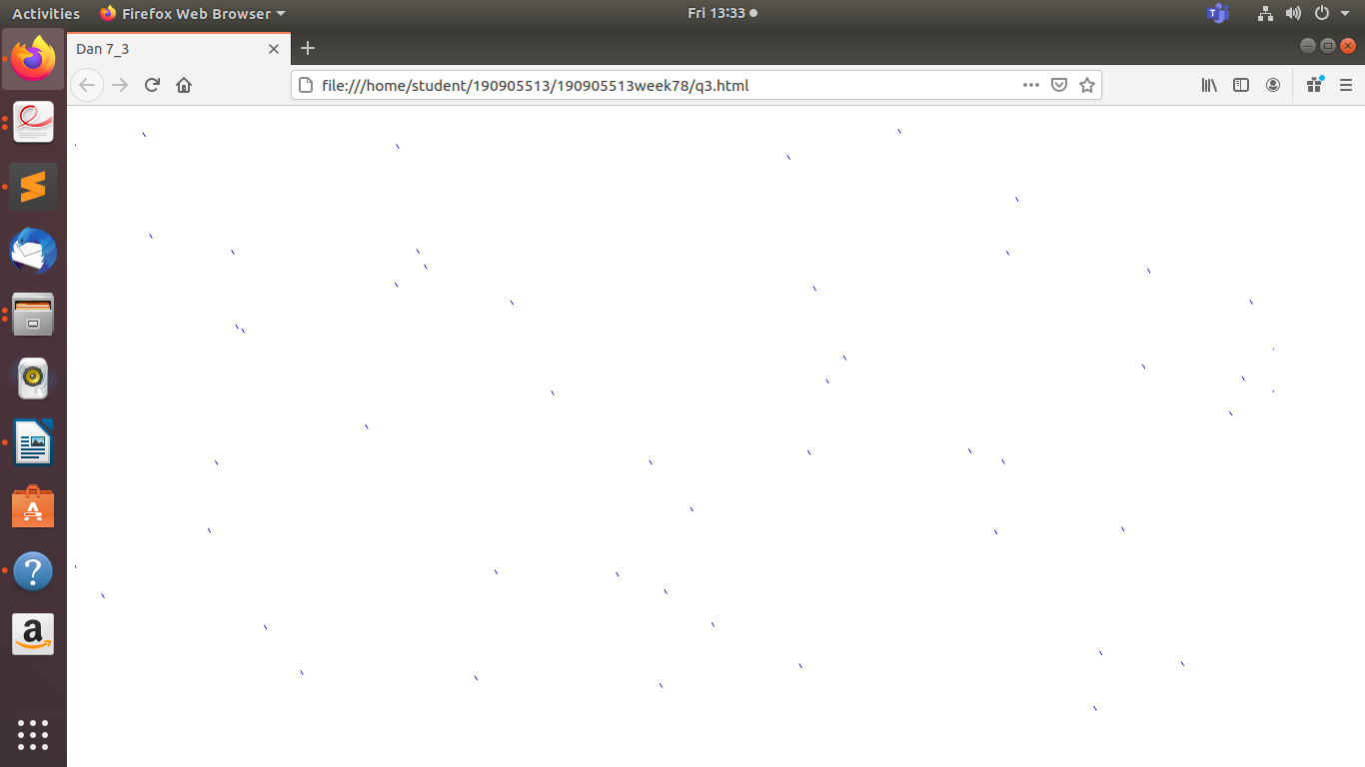



**Code:**

<!DOCTYPE HTML>

<html>

<head>

<title>

Dan 74</title>

</head>

<body>

<center>

<style>

h1

{

color:blue;

}

canvas

{

background-

color:#061928;

width:

800px;

height: 400px;

}

</style>

<h1>Bouncing Ball</h1>

<canvas>

</canvas>

<script>

var canvas = document.querySelector("canvas");

canvas.width= window.innerWidth;

canvas.height = window.innerHeight;

var l = canvas.getContext('2d');

var x = Math.floor(Math.random() *innerWidth);

var y = Math.floor(Math.random() * innerHeight);

var vx = Math.floor(Math.random() * 2);

var vy = Math.floor(Math.random() * 4);

var radius = 20;

move();

function move()

{

requestAnimationFrame(move);

l.clearRect(0, 0, innerWidth, innerHeight);

l.beginPath();

l.strokeStyle = "white";

l.arc(x, y, radius, 0, Math.PI * 2, false);

l.stroke();

if (y+ radius > innerHeight)

vy = 0 - vy;

if (y - radius < 0)

vy =0 - vy;

if (radius + x >innerWidth)

vx = 0 - vx;

if (x - radius < 0)

vx = 0 - vx;vx;

+ vy;

x = x +

y = y

}

</script>

</center>

</body>

</html>

**Output:**



**Code:**

<!DOCTYPE html>

<html>

<head>

<title>

Dan 75

</title>

</head>

<body>

<h1>

Pick Color:</h1>

<script>

function

func()

{

alert("color selected");

return false;

}

</script>

<form onsubmit="func()">

<input type="color" name="color" value="#ff0000">

<input type="submit">

</form>

</body>

</html>

**Output:**

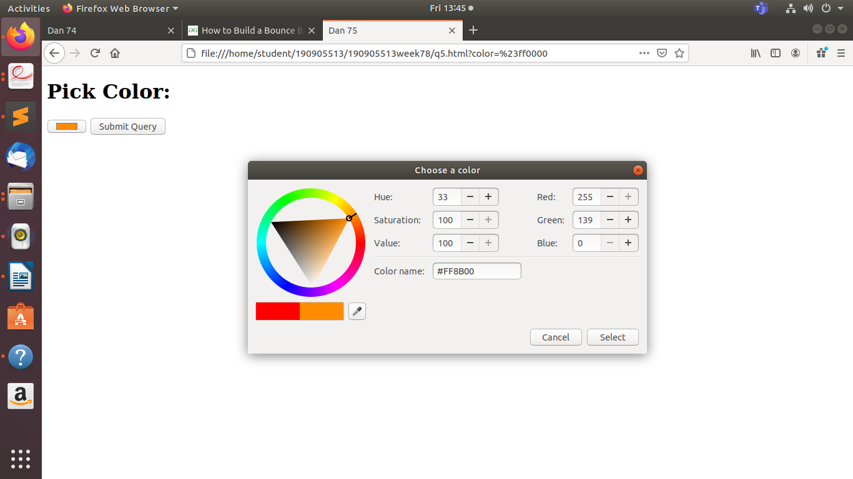

**190905513 MOHAMMAD DANISH EQBAL**

**WEEK 8**

**Lab Exercises:**

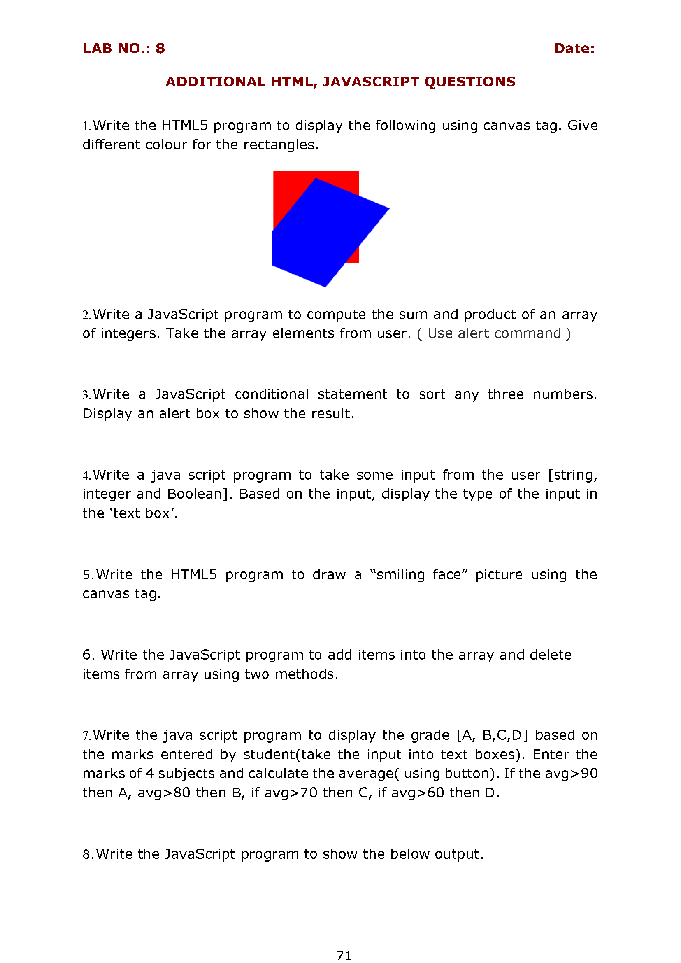

**Code:**

<!DOCTYPE html>

<html>

<head>

<title>Dan 81</title>

</head>

<body>

<canvas id="myCanvas" width="200" height="300" style="">

<script type="text/javascript"> var r1 =

document.getElementById("myCanvas");

var rect1 = r1.getContext("2d");

rect1.fillStyle = "magenta";

rect1.fillRect(20, 20, 125, 200);

var r2 = document.getElementById("myCanvas");

var rect2 = r2.getContext("2d");

rect2.fillStyle = "black";

rect1.rotate(40 * Math.PI / 180);

rect2.fillRect(100, -20, 125, 200);

</script>

</body>

</html>

**Output:**

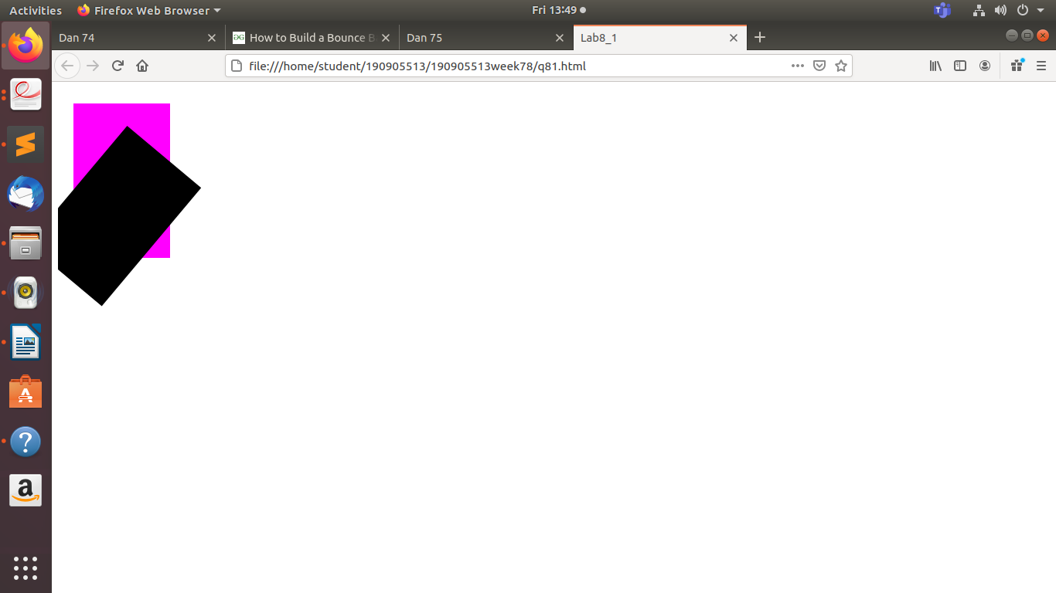



**Code:**

<!DOCTYPE html>

<html>

<body><div id="sum"></div>

<script> var sum =0;

var num = prompt("Enter Number of Elements ");

var arr = Array();

var n; var

product = 1;

for(var i = 0; i < num; i = i + 1)

{

n = prompt("Enter The Number");

sum += parseInt(n);

product *= n;

}

document.getElementById("sum").innerHTML = "sum is " + sum + " product is " + product;

alert("Sum = " + sum + " Product = " + product);

</script>

</body>

</html>

**Output:**

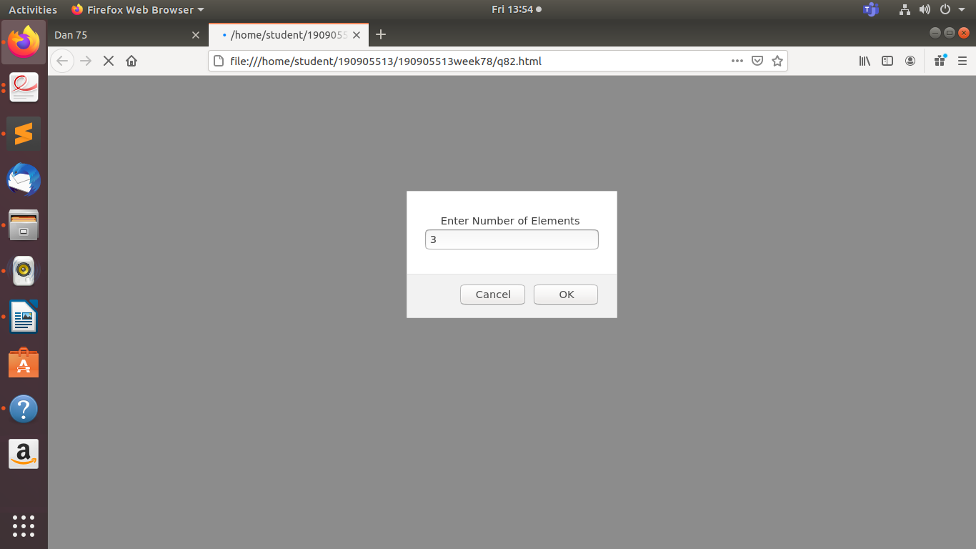

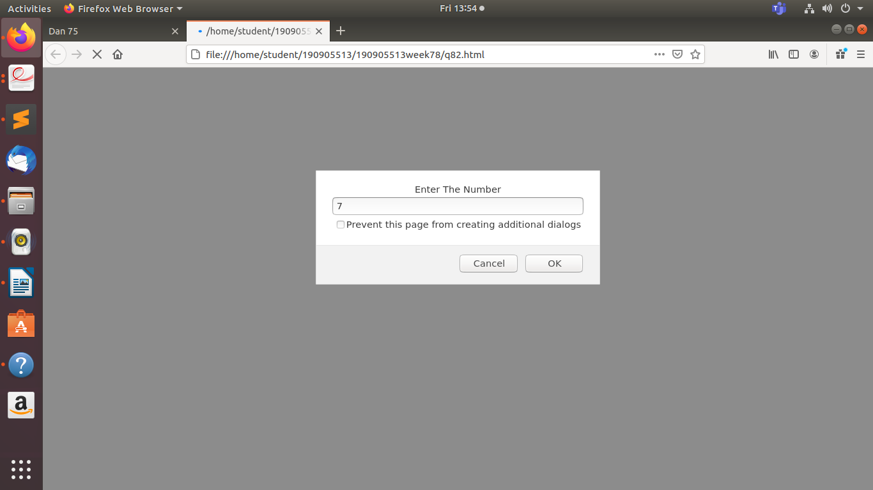

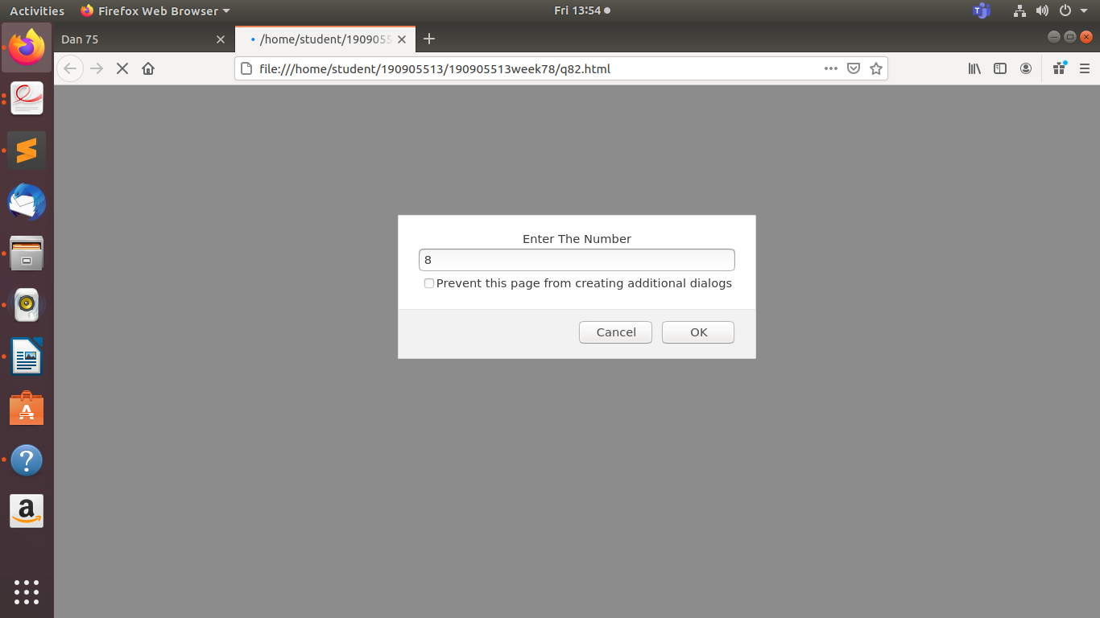

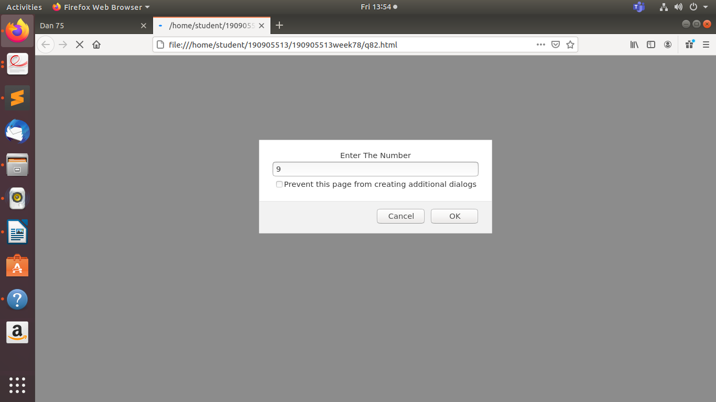

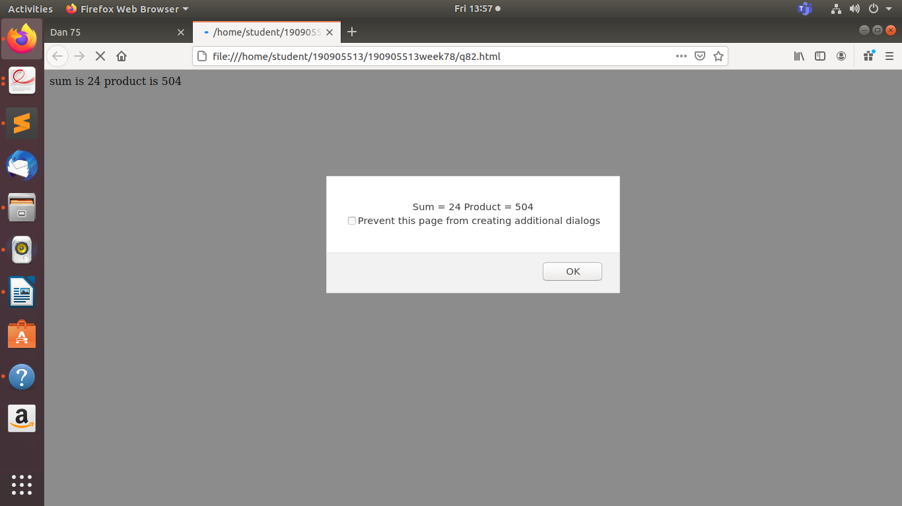



**Code:**

<!DOCTYPE html>

<html>

<head>

<title>Dan 83</title>

</head>

<body>

<script type="text/javascript">

var a =parseInt(prompt("Enter First Number"));

var b= parseInt(prompt("Enter Second Number"));

varc = parseInt(prompt("Enter Third Number"));

if(a > b) {

if(a > c) {

max = a; }

else {

max = c;

} } else

if( b > a) {

if(b > c) {

max = b;

}

else {

max = c;

}

}alert("Greatest Number = " + max);

if(a > b && c > b)

{

min= b;

}

else if(b > a && c > a)

{

min= a;

}

else{min = c;}

alert("Smallest Number = " + min);

</script>

</body>

</html>

**Output:**



**Code:**

<!DOCTYPE html>

<html>

<head>

<title>Dan 84</title>

</head>

<body>

<script type="text/javascript">

function check()

{var input = document.getElementById("inp").value;

var output = document.getElementById("out")

if (input.match(/(true)|(false)/g))

output.setAttribute("value" ,"boolean");

else if (input.match(/[A-z]/g))

output.setAttribute("value" ,"string");

else

output.setAttribute("value" , "integer");

}

</script>

<input type="text" name="in" id="inp" placeholder="Enter value to know its data type"> <br>

<input type="text" name="out" id="out">

<br>

<button onclick="check()">

Check

</button>

</body>

</html>

**Output:**

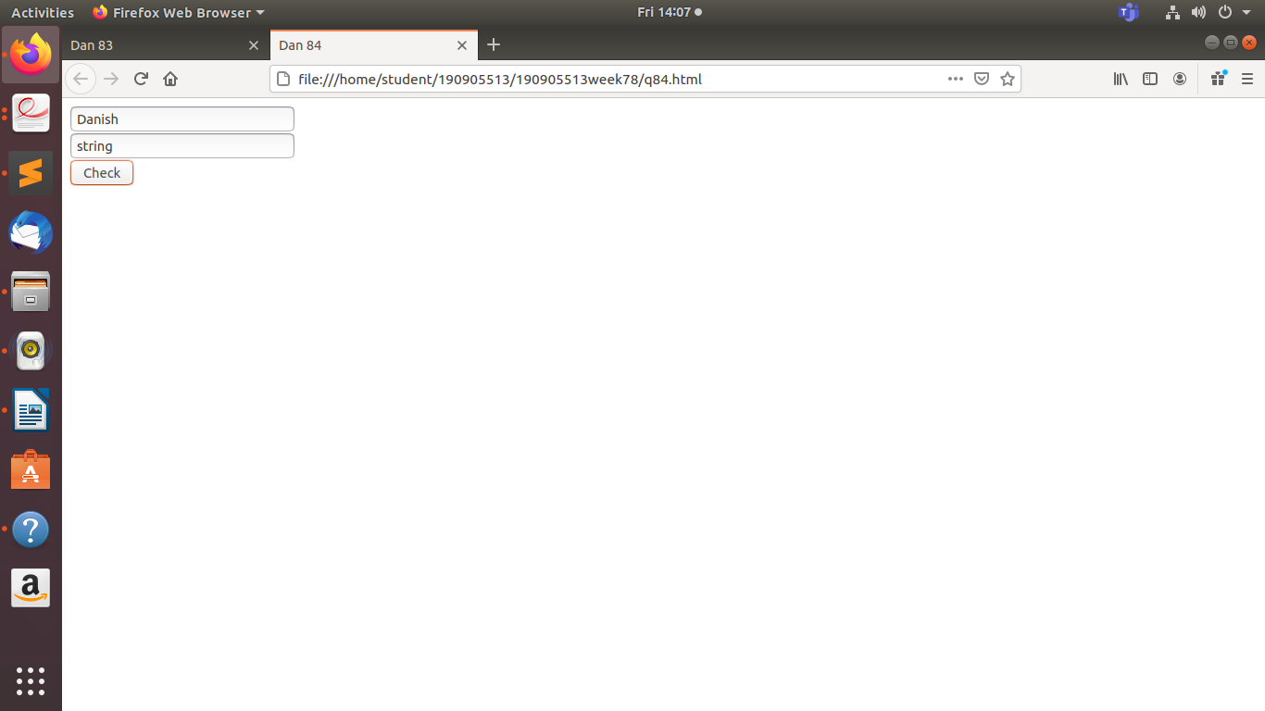

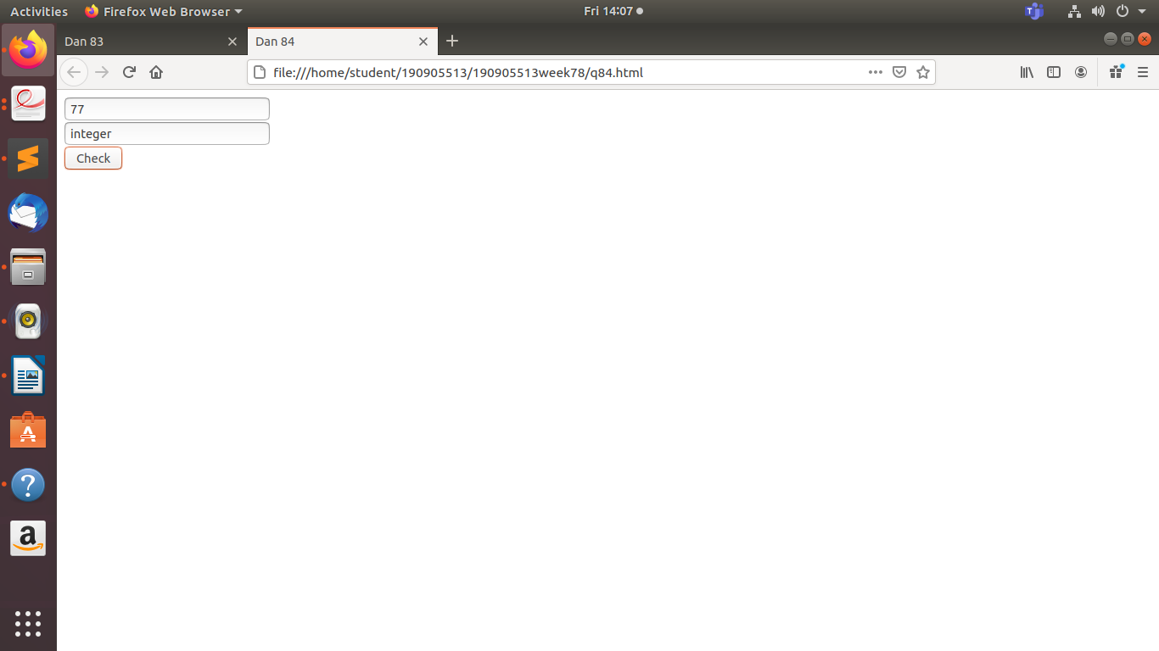

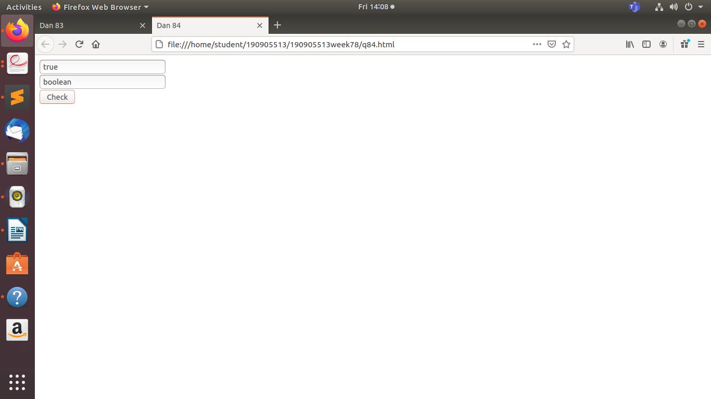



**Code:**

<!DOCTYPE html>

<html>

<head>

<title>Dan 85</title>

</head>

<body>

<canvas id="canvas" width="200" height="200">

</canvas>

<script type="text/javascript">

var canvas =document.getElementById('canvas');

var ctx =canvas.getContext('2d'); ctx.beginPath();

ctx.fillStyle = "aqua";

ctx.arc(75, 75, 70, 0,Math.PI * 2, true);

ctx.fill();

ctx.moveTo(110, 75);

ctx.arc(75, 75,35, 0, Math.PI, false);

ctx.moveTo(65,65);

ctx.arc(60, 65, 5, 0, Math.PI * 2,true);

ctx.moveTo(95, 65);

ctx.arc(90,65, 5, 0, Math.PI * 2, true);

ctx.stroke();

</script>

</body>

</html>

**Output:**

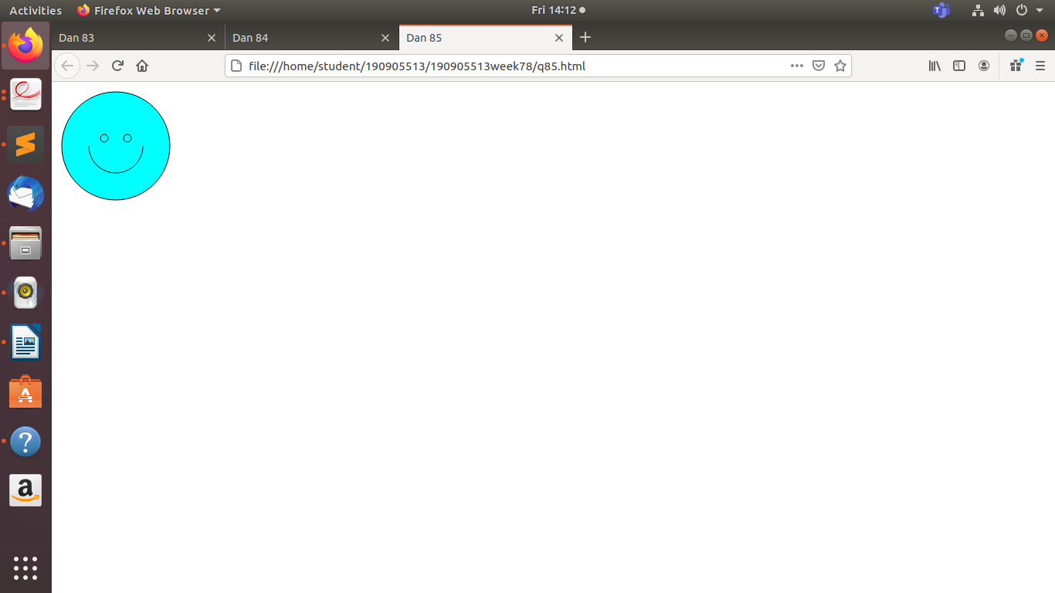



**Code:**

<!DOCTYPE html> <html>

<body>

<div id="sum"></div>

<button onclick="Insert()">Insert</button>

<button onclick="Delete()">Delete</button>

<button onclick="Display()">Display</button>

<div id="disp"></div>

<script>

var sum = 0;

var arr = Array();

var n; var i = 0;

function Insert()

{

var x = prompt("enter number");

arr[i++] = x;

}

function Delete()

{

var ele = prompt("enter element to be deleted");

for(var j = 0; j < arr.length; j = j+1)

{

if(ele == arr[j])

{

arr[j] = " ";

alert("found at location " + (j+1));

break;

}

}

}

function Display()

{

for(var j = 0; j < arr.length; j = j+1)

{

document.write(arr[j]);

console.log(arr[j]);

}

}

</script>

</body>

</html>

**Output:**

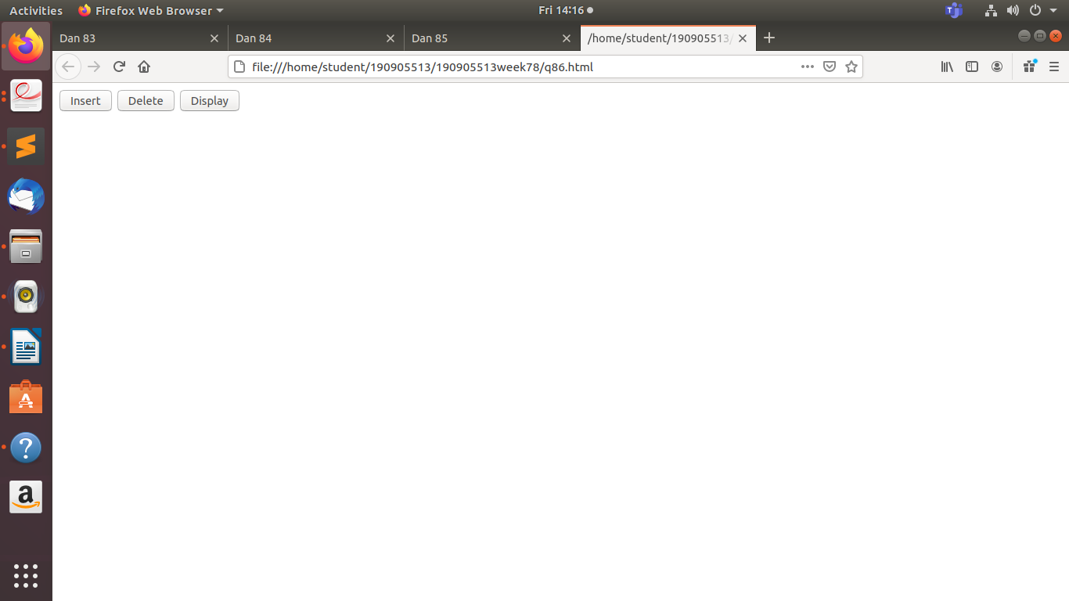

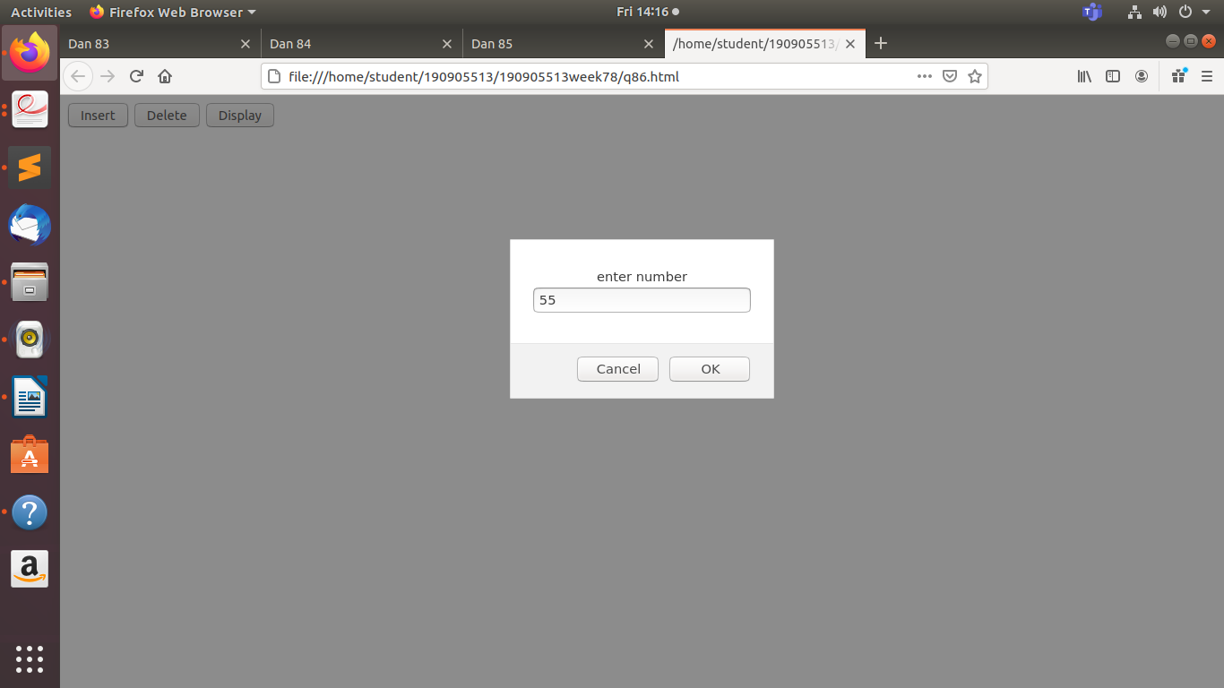

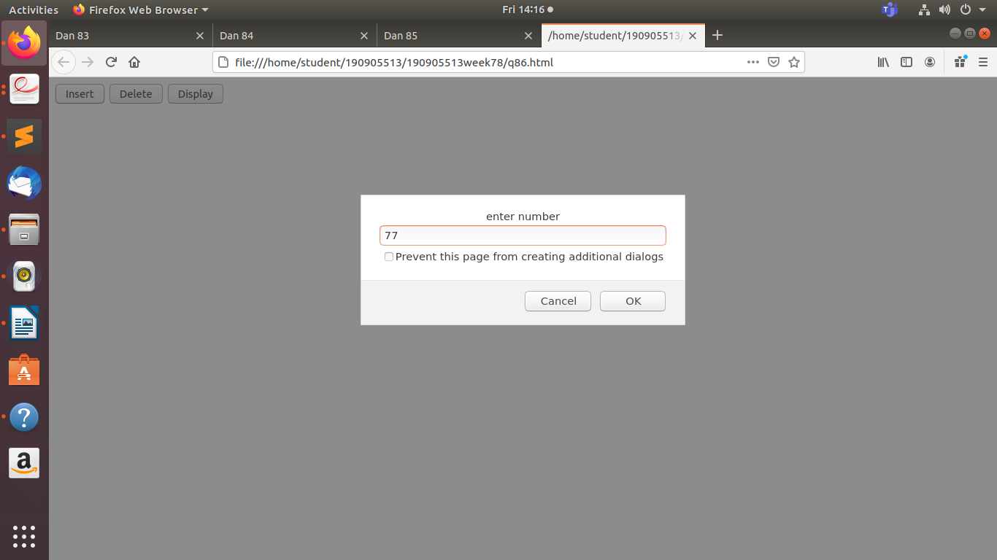

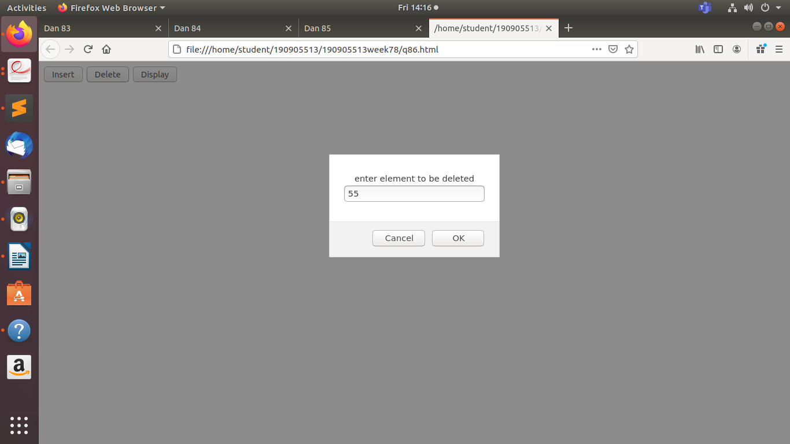

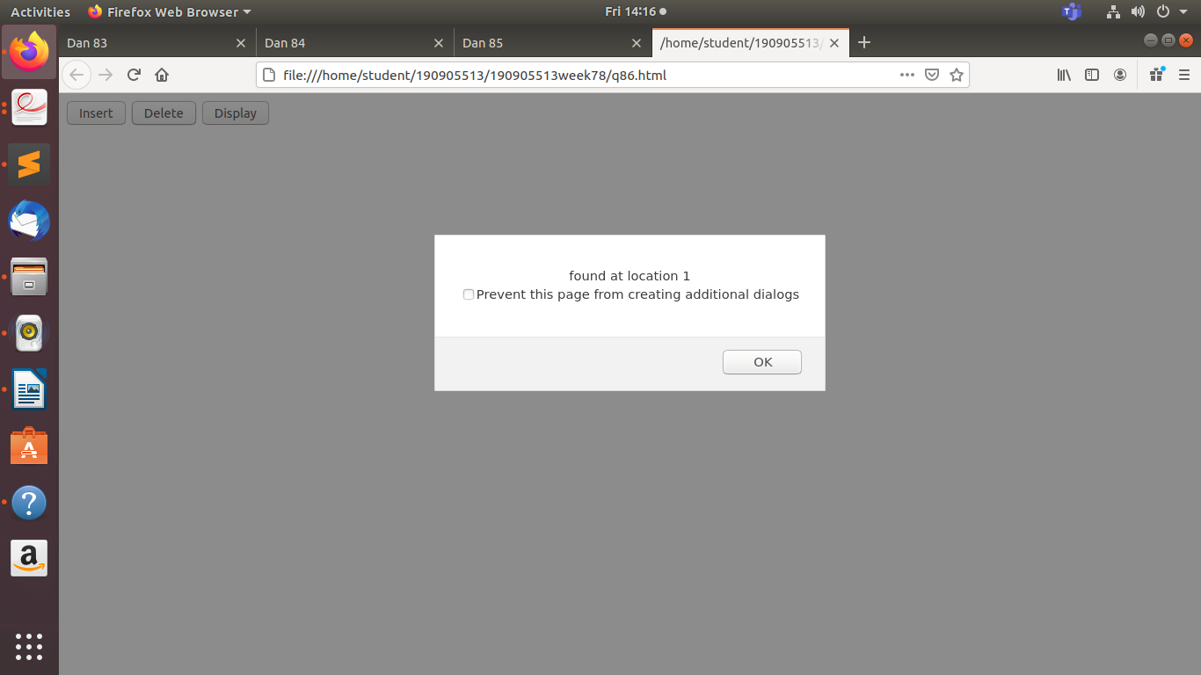

//After Clicking on Display

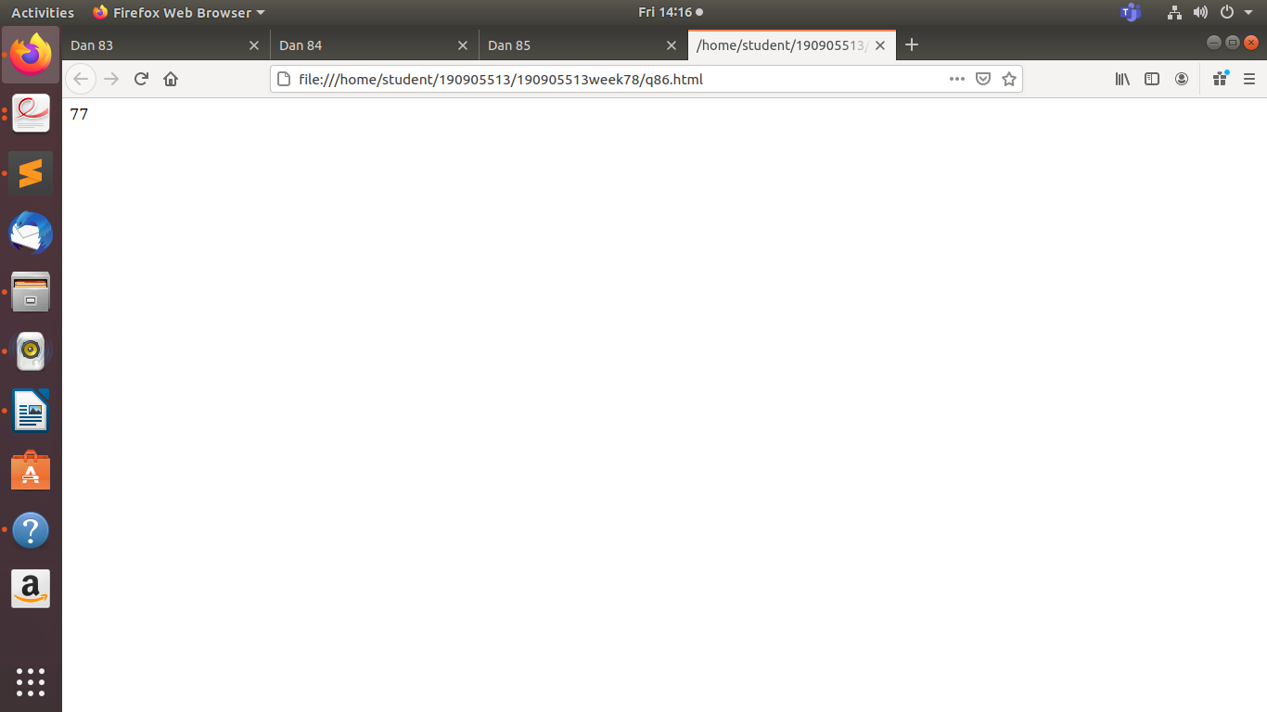



**Code:**

<!DOCTYPE html>

<html>

<head>

<title>Dan 87</title>

</head>

<body>

<script type="text/javascript">

function calc()

{ var sum=0;

for (var i = 1; i <= 4; i++)

{ sum += parseInt(document.getElementById('m'+i).value);

} var avg = sum/4; var grade = "";

if (avg <60) grade = 'Fail';

else if (avg < 70 && avg > 60) grade = 'D';

else if (avg < 80 && avg > 70) grade = 'C';

else if (avg < 90 && avg > 80) grade = 'B';

else grade = 'A';

alert(Grade);

}

</script>

Enter marks in COA: <input type="text" name="m1" id="m1"><br>

Enter marks in DSA: <input type="text" name="m2" id="m2"><br>

Enter marks in OOP: <input type="text" name="m3" id="m3"><br>

Enter marks in DSD: <input type="text" name="m4" id="m4"><br>

<button onclick="calc()">Calculate</button>

</body>

</html>

**Output:**



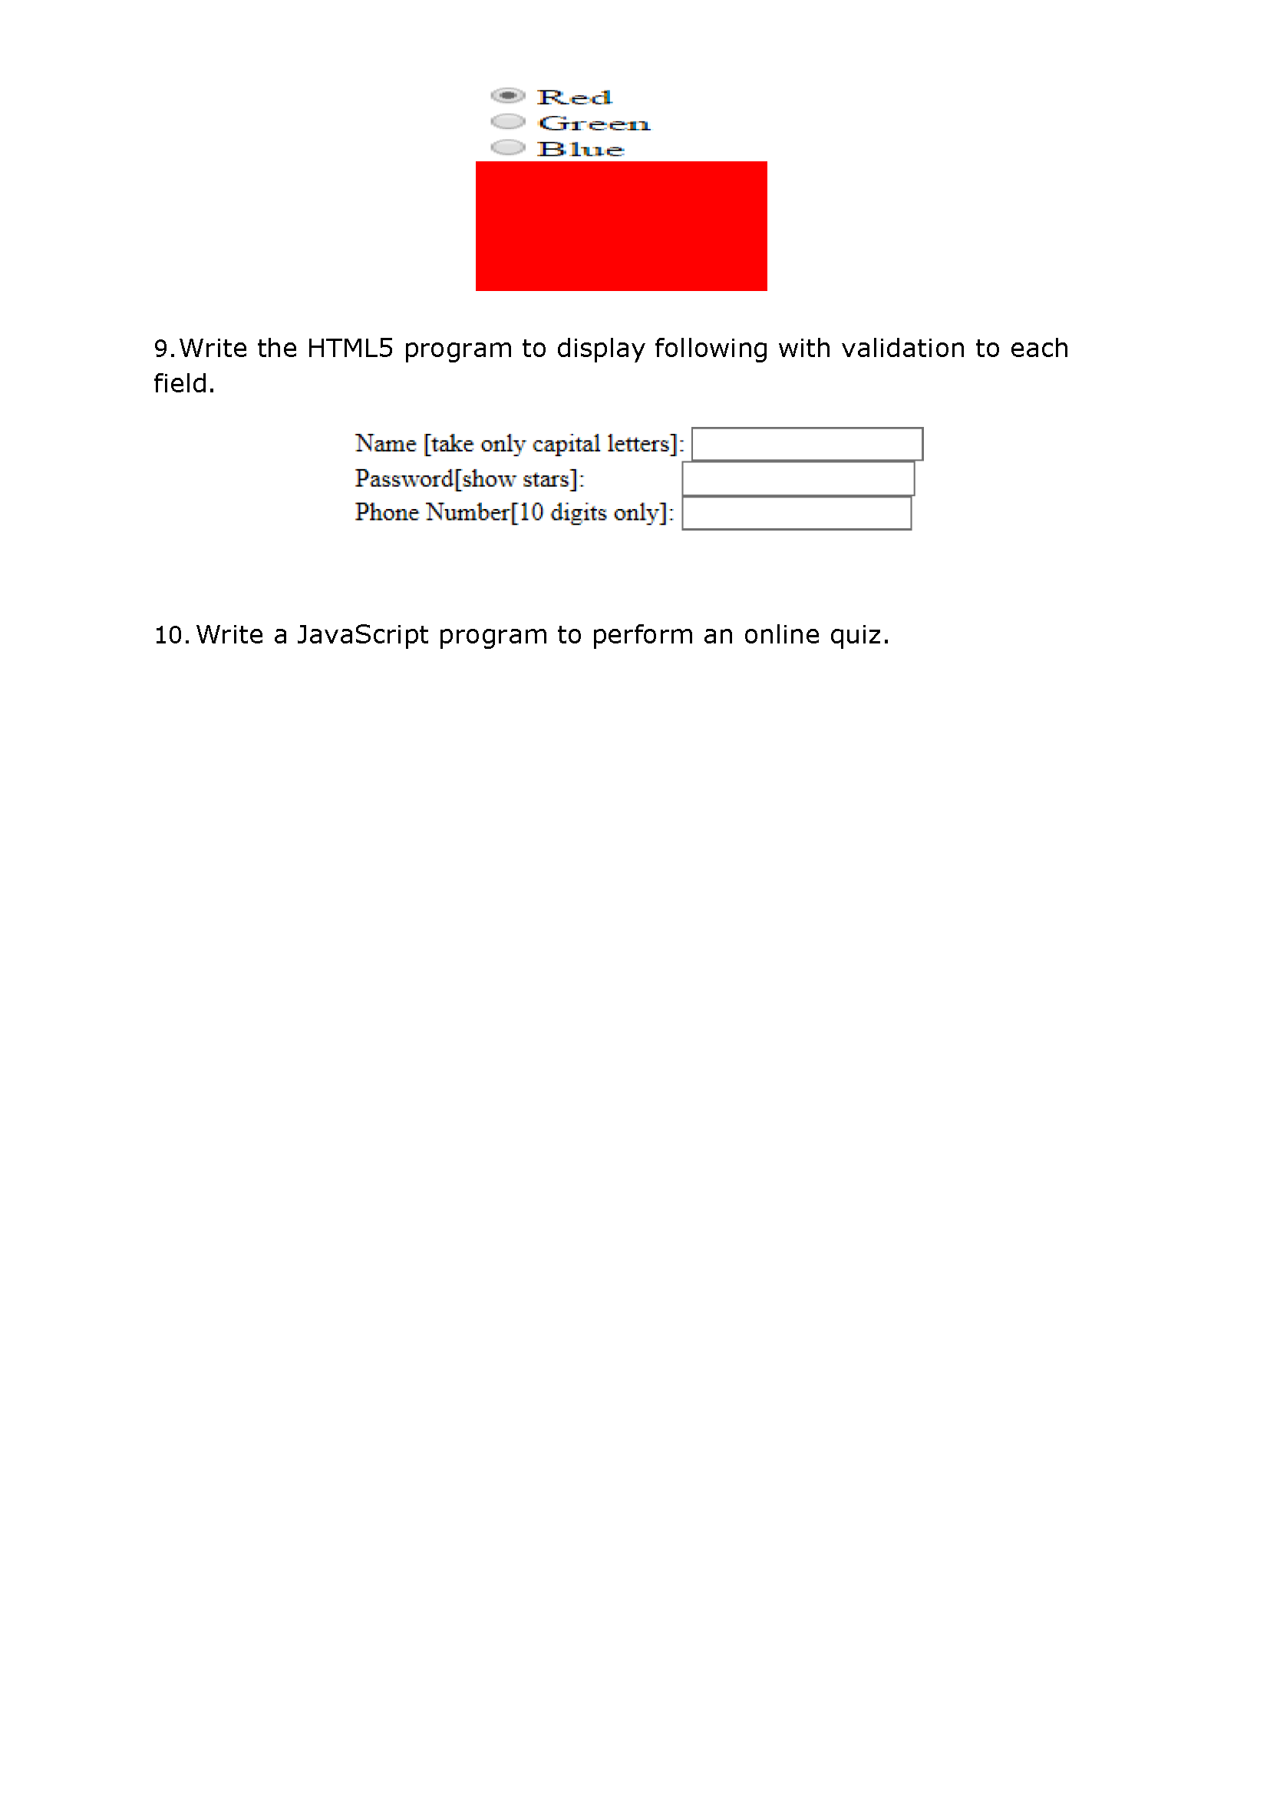

**Code:**

<!DOCTYPE html>

<html>

<head>

<title>Dan 88</title>

</head>

<body>

<script type="text/javascript">

function change()

{ var canv = document.getElementById('myCanvas'); if

(document.getElementById('red').checked) canv.style['background-color'] = "red";

else if (document.getElementById('blue').checked) canv.style['background-color'] =

"blue"; else if (document.getElementById('green').checked) canv.style['background-color'] =

"green";

}

</script>

<input type="radio" name="color" value="red" onchange="change()" id="red">Red <br>

<input type="radio" name="color" value="blue" onchange="change()" id="blue">Blue <br>

<input type="radio" name="color" value="green" onchange="change()" id="green">Green <br>

<canvas id="myCanvas" width="200" height="100"></canvas>

</body>

</html>

**Output:**

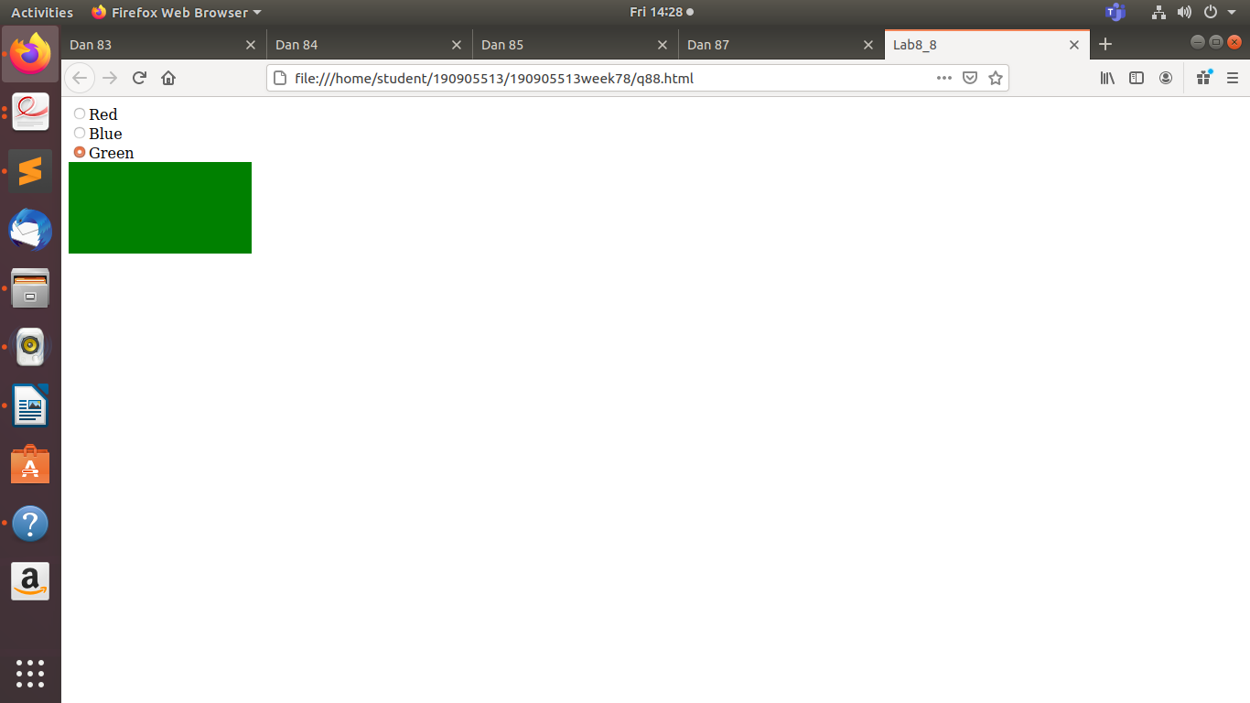

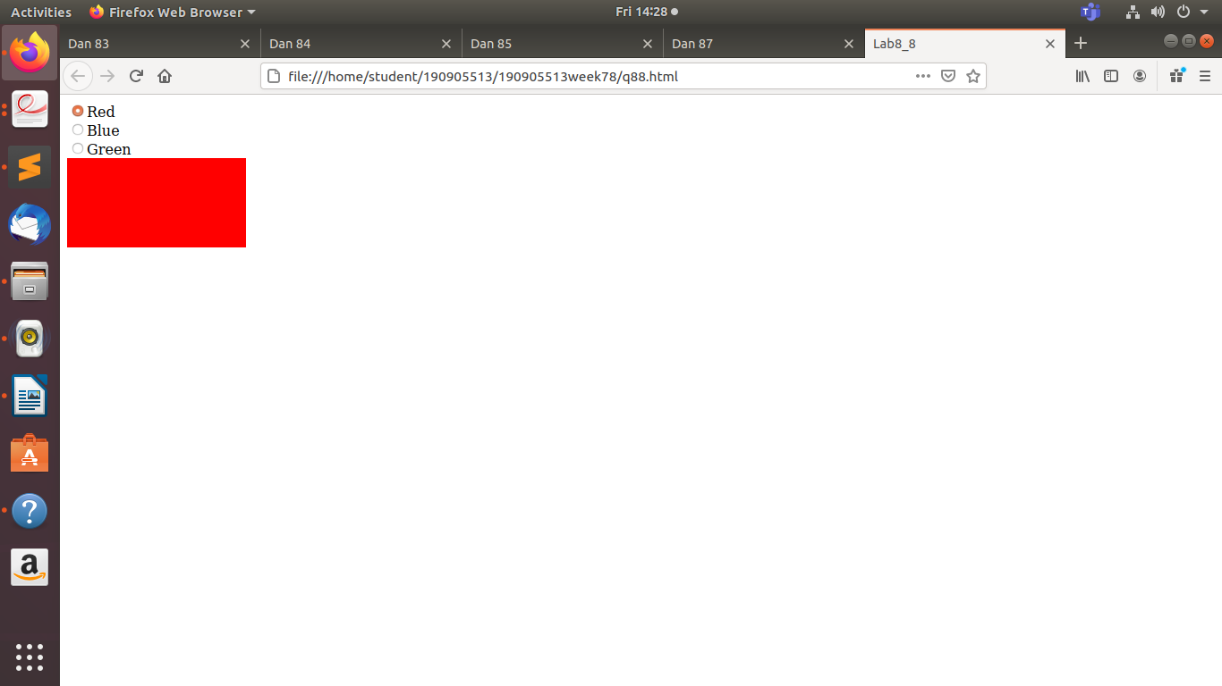

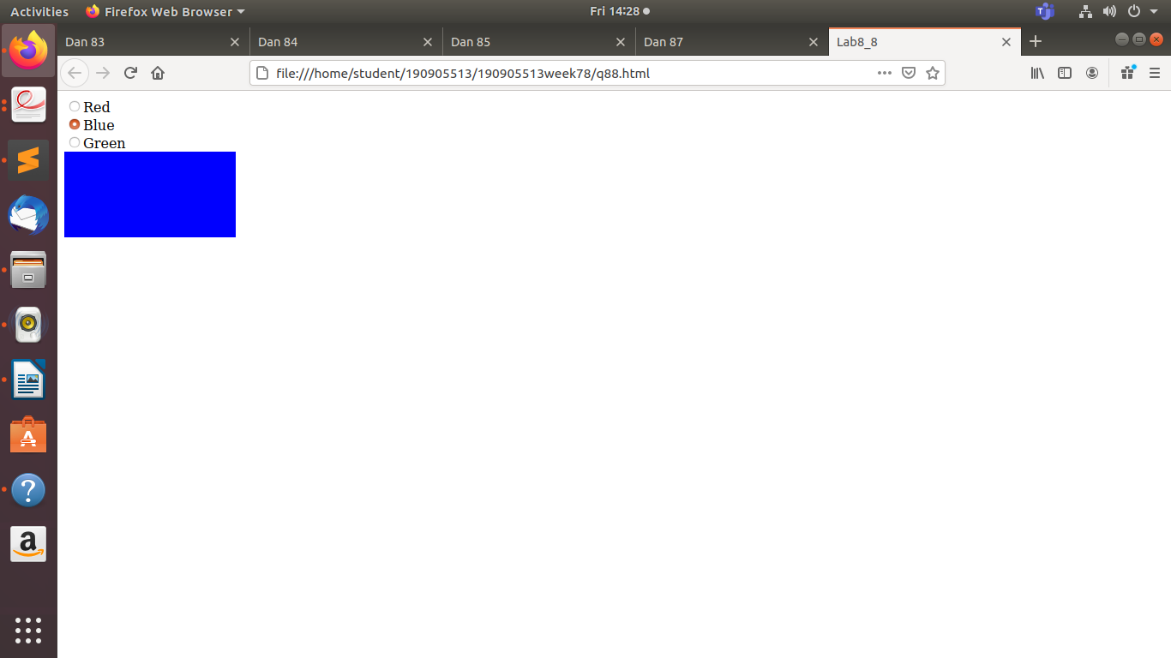



**Code:**

<!DOCTYPE html>

<html>

<head>

<title>Dan 89</title>

</head>

<body>

<script type="text/javascript"> function check_name() {

var name =document.getElementById('name').value;

if (name.match(/[a-z]/g)) {

document.getElementById('namesp').style.color = "red";

document.getElementById('namesp').innerHTML = ' ';Uh-Oh!!}

else { document.getElementById('namesp').style.color = "green";

document.getElementById('namesp').innerHTML = ' ALL GOOD'; }

}

function check_number() {

var phone =document.getElementById('pnum').value;

if (phone.length!= 10)

{ document.getElementById('psp').style.color ="red"; document.getElementById('psp').innerHTML = ' ';Uh-Oh!!}

else {

document.getElementById('psp').style.color = "green";

document.getElementById('psp').innerHTML = ' '; ALL GOOD }}

</script>

Name [Only CAPS]: <input type="text" name="name" onkeyup="check_name()"

id="name"><span id="namesp"></span><br>

Password: <input type="password" name="pswd"><br>

Phone Number: <input type="text" name="pnum" onkeyup="check_number()"

id="pnum"><span id="psp"></span>

</body>

</html>

**Output:**

**Code:**

<!DOCTYPE html><html>

<head>

<title>Dan 810</title>

</head>

<body>

<h1>Online Quiz</h1>

<script type="text/javascript"> function calculate_score() { var score = 0; if

(document.getElementById("q11").checked) score += 1; if

(document.getElementById("q23").checked) score += 1; if

(document.getElementById("q32").checked) score += 1; if

(document.getElementById("q42").checked) score += 1;

document.getElementById('Score').innerHTML = " "+score; }

</script>

Who was Iron Marshal of France ? <br>

<input type="radio" name="q1" id="q11">Davout<br>

<input type="radio" name="q1" id="q12">Suchet<br>

<input type="radio" name="q1" id="q13">Lannes<br>

<br>

When did Napoleon win Battle of Austerlitz ?<br>

<input type="radio" name="q2" id="q21">1812<br>

<input type="radio" name="q2" id="q22">1807<br>

<input type="radio" name="q2" id="q23">1805<br>

<br>

Which coup brought Napoleon to power?<br>

<input type="radio" name="q3" id="q31">Paris Coup<br>

<input type="radio" name="q3" id="q32">Coup of 18 Brummaire<br>

<input type="radio" name="q3" id="q33">Robbespiere Coup<br>

<br>

Napoleon's retreat from which country became a Poetic Legend?<br>

<input type="radio" name="q4" id="q41">Spain<br>

<input type="radio" name="q4" id="q42">Russia<br>

<input type="radio" name="q4" id="q43">Prussia<br>

<br>

<button onclick="calculate_score()">Submit</button>

<br><hr>

<b>Score:</b><span id="Score"></span>

</body>

</html>

**Output:**

