SESSION1
PART 1 :

Lab 1 :

4(a),
4(b):
a. Write a method isPrime to accept one integer parameter and to check whether that parameter is prime or not.
b. Using this method, generate first N prime numbers in the main method.

import java.util.Scanner;

class Prime {

public static int isPrime(int a) {

int f=1;

for(int c=2; c<a; c++){

if(a%c==0){

f=0;

break;

}

}

if(f==1)return 1;

else return 0;

}

public static void main(String args[]) {

Scanner scanner = new Scanner(System.in);

System.out.println("\n\t\t\tEnter the value for n : ");

int d=scanner.nextInt();

System.out.println("\n\t\t\tThe prime number are : \n");

for(int c=1; c<=d; c++){

if(isPrime(c)==1)

System.out.print("\t\t"+c);

}
System.out.println("\n\n");

System.out.println("\n\t\t\tEnter the number to check whether it is prime or not : ");

int b=scanner.nextInt();

scanner.nextLine();

int z=isPrime(b);
System.out.println("\n\n");

if(z==1) {

System.out.println("\n\t\t\tThe given number is prime \n");

}else {

System.out.println("\n\t\t\tThe given Number is not prime \n");

}

}

}
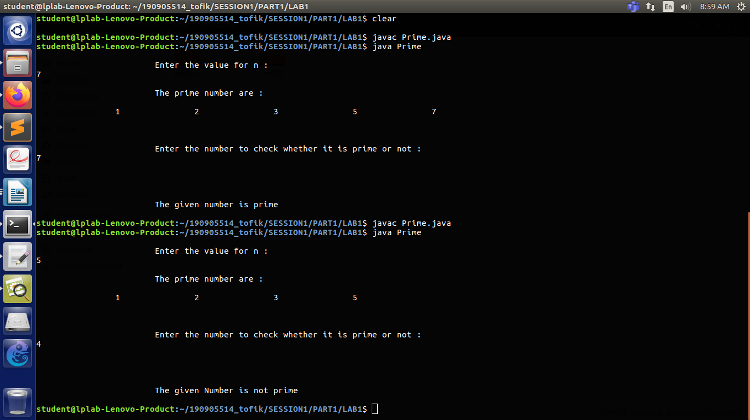

LAB 2 :
1. Arrange the elements in ascending and descending order using Bubble sort method.

1->
import java.util.Scanner;
public class AscendingDescendingOrder {
public static void main(String[] args) {

Scanner scanner = new Scanner(System.in);
int[] names = new int[100];
System.out.println("Enter the size ");
int n = scanner.nextInt();
names = new int[n];
System.out.println("Enter the Element ");
for (int i = 0; i < n; i++) {
names[i] = scanner.nextInt();
}
System.out.println("---BEFORE SORTING---");
for (int i = 0; i < n; i++) {
System.out.println("\t\t\t"+names[i]);
}
System.out.println("---BEFORE SORTING ---");
for (int i = 0; i < n; i++) {
System.out.println("\t\t\t"+names[i]);
}

/* For loop for Ascending order */

for (int i = 0; i < n - 1; i++) {
for (int j = 0; j < n - i - 1; j++) {
int temp;
if (names[j] > names[j + 1]) {
temp = names[j];
names[j] = names[j + 1];
names[j + 1] = temp;
}
}
}

System.out.println("--- SORTING IN ASCENDING ORDER---");
for (int i = 0; i < n; i++) {
System.out.println("\t\t\t"+names[i]);
}

for (int i = 0; i < n - 1; i++) {
for (int j = 0; j < n - i - 1; j++) {
int temp;
if (names[j] < names[j + 1]) {
temp = names[j];
names[j] = names[j + 1];
names[j + 1] = temp;
}
}
}

System.out.println("--- SORTING IN DESCENDING ORDER---");
for (int i = 0; i < n; i++) {
System.out.println("\t\t\t"+names[i]);
}

}

}

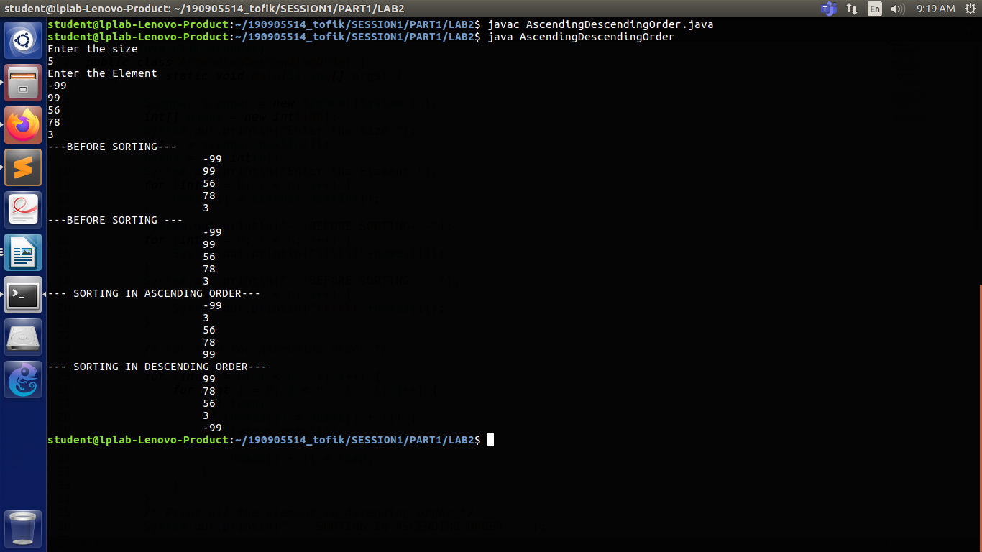

LAB 2 :
2.Find the addition of two matrices and display the resultant matrix.
4->

import java.util.Scanner;

public class AdditionOfTwoMatrix {
public static void main(String[] args) {

int c, d;
int i, j;

Scanner sc = new Scanner(System.in);

/** row and column matrix */

System.out.println("\n\t\t\tEnter the number of row and column of matrix :");
c = sc.nextInt();
d = sc.nextInt();

int first[][] = new int[c][d];
int second[][] = new int[c][d];
int sum[][] = new int[c][d];

/** row matrix */

System.out.println("\n\t\t\tEnter First matrix : ");
for (i = 0; i < c; i++) {
for (j = 0; j < d; j++) {
first[i][j] = sc.nextInt();
}
}
/** column matrix */

System.out.println("\n\t\t\tEnter the Second Matrix : ");
for (i = 0; i < c; i++) {
for (j = 0; j < d; j++) {
second[i][j] = sc.nextInt();
}
}

for (i = 0; i < c; i++) {
for (j = 0; j < d; j++) {
sum[i][j] = first[i][j] + second[i][j];
}
}

/** Result */
System.out.println("\n\t\t\tResultant Matrix is");

for (i = 0; i < c; i++) {
for (j = 0; j < d; j++) {
System.out.println("\t"+sum[i][j]);

}
}

}

}

