SESSION 1

PART 2 :

LAB 3 :
Define a class to represent a complex number called Complex. Provide the following methods:
- To assign initial values to the Complex object.
- To display a complex number in a+ib format.
- To add 2 complex numbers. (the return type should be Complex)
- To subtract 2 complex numbers Write a main method to test the class.

1->

public class Complex {

double real;
double imag;

public Complex(double r, double img) {

this.real = r;
this.imag = img;
}
/* Add() for two complex number */

public static Complex add(Complex n1, Complex n2) {

Complex complex = new Complex(0.0, 0.0);
complex.real = n1.real + n2.real;
complex.imag = n1.imag + n2.imag;
return complex;
}

/* Substracting tow number here */

public static Complex sub(Complex n1, Complex n2) {

Complex sb = new Complex(0.0, 0.0);
sb.real = n1.real - n2.real;
sb.imag = n1.imag - n2.imag;
return sb;

}

public static void main(String[] args) {

Complex z1 = new Complex(5.5, 4);
Complex z2 = new Complex(1.2, 3.5);

/* Displaying add of two complex number */
Complex complex = add(z1, z2);
System.out.printf("Addition is = \t" + complex.real + " + " + complex.imag + "i\n");

/* Displaying the substracting of two complex number */

Complex sb = sub(z1, z2);
System.out.printf("Subtraction is = \t" + sb.real + " - " + sb.imag + "i\n");

}

}

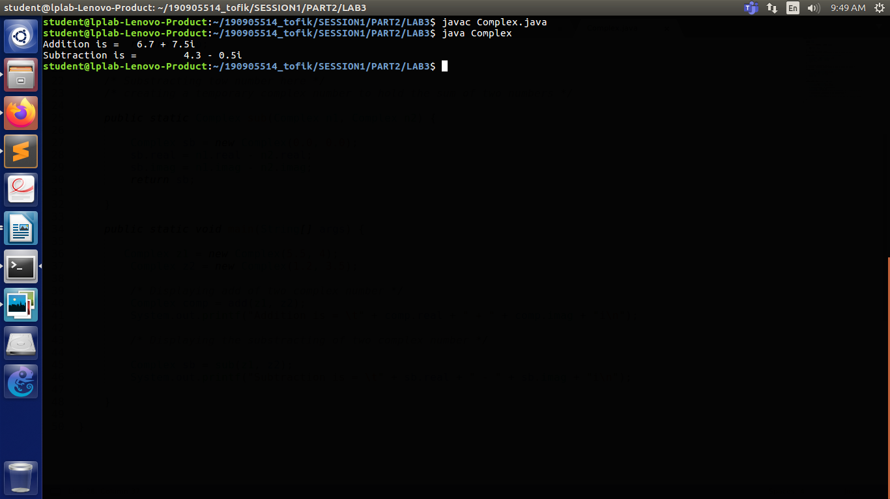

LAB 3 :
Create a class called Time that has instance variables to represent hours, minutes and seconds. Provide the following methods:
- To assign initial values to the Time object.
- To display a Time object in the form of hh:mm:ss {24 hours format}
- To add 2 Time objects (the return type should be a Time )
- To subtract 2 Time objects (the return type should be a Time )
- To compare 2 Time objects and to determine if they are equal or if the first is greater or smaller than the second one.

2->
import java.util.Scanner;

class Time {

int hours;
int minute;
int second;

public void assign(int a, int b, int c) {

this.hours = a;
this.minute = b;
this.second = c;
}

public void Display() {

System.out.println("The Time is = \n" + "" + this.hours + " :hours\t" + this.minute + " :minutes\t" + this.second+":Seconds");
}

/** Adding the time */
public Time add(Time c) {
Time Time_New = new Time();
int hours_h = this.hours + c.hours;
int minute_m = this.minute + c.minute;
int second_s = this.second + c.second;

if (hours_h > 24) {
hours_h = 1;
}
if (minute_m > 60) {
hours_h++;
}
if (second_s > 60) {
minute_m++;
}

Time_New.assign(hours_h, minute_m, second_s);

return Time_New;

}

/** Subtracting the two time */
public Time subtract(Time c) {

Time Time_New = new Time();
int hours_h = Math.abs(this.hours - c.hours);
int minute_m = Math.abs(this.minute - c.minute);
int second_s = Math.abs(this.second - c.second);

Time_New.assign(hours_h, minute_m, second_s);
return Time_New;

}

/** comparing the two time object */
public void compare(Time c) {

if (this.hours > c.hours)
System.out.println("Current object is Bigger\n\n");
else
System.out.println("Invoking object is bigger\n\n");
if (this.hours == c.hours && this.minute == c.minute && this.second == c.second)
System.out.println("Both object are equal");
else
System.out.println("Both object are not equal\n\n");
if (this.hours > c.hours) {

System.out.println("Firs time is greater than second\n\n");

} else {
System.out.println("Second time is greater than first\n\n");
}

}
}

public class TimePgm {
public static void main(String[] args) {

int x;
int y;
int z;
int a;
int b;
int c;
Scanner sc = new Scanner(System.in);
Time c1 = new Time();
Time c2 = new Time();
System.out.println("Enter the first time \n\n");
x = sc.nextInt();
y = sc.nextInt();
z = sc.nextInt();

c1.assign(x, y, z);
c1.Display();

System.out.println("Enter the second time\n\n");

a = sc.nextInt();
b = sc.nextInt();
c = sc.nextInt();
c2.assign(a, b, c); /* Assigning the value of date */
c2.Display(); /* Displaying the time */

c1.compare(c2);

Time add_new = new Time();
add_new = c1.add(c2);
Time student_time = new Time();
student_time = c1.subtract(c2);
add_new.Display();
student_time.Display();

}

}

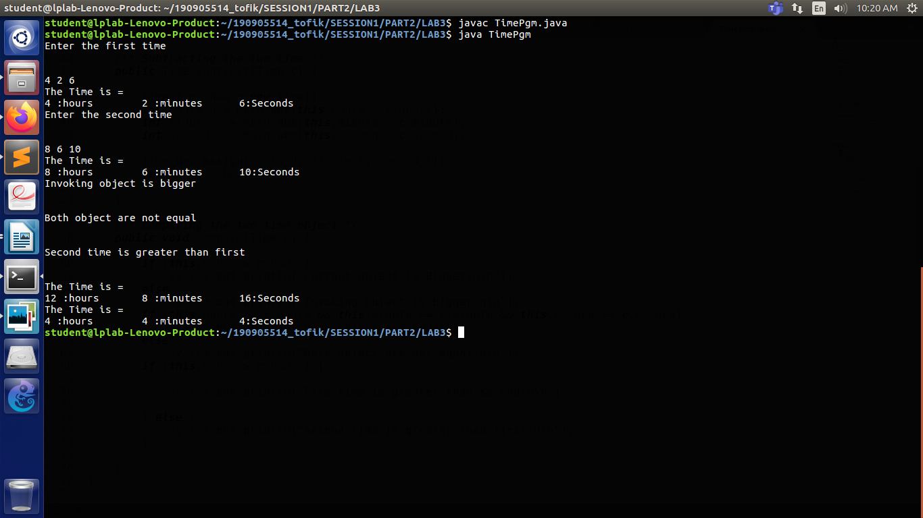

LAB 4 :
Consider the already defined Complex class. Provide a default constructor and parameterized constructor to this class. Also provide a display method. Illustrate all the constructors as well as the display method by defining Complex objects.

1->
import java.util.Scanner;
import java.lang.Math;

public class Complex
{
int real, imaginary;

public Complex()
{
System.out.println("Default constructor called");
this.real=0;
this.imaginary=0;
}

public Complex(int re, int im)
{
System.out.println("Parametrised constructor called");
this.real=re;
this.imaginary=im;
}

public Complex(Complex c)
{
System.out.println("Parametrised constructor called with Complex as parameter");
this.real=c.real;
this.imaginary=c.imaginary;
}

public static Complex getComplexNum()
{
Complex a = new Complex();
Scanner sc=new Scanner(System.in);
System.out.print("Enter real part: ");
a.real=sc.nextInt();
System.out.print("Enter imaginary part: ");
a.imaginary=sc.nextInt();

return a;
}

public void display()
{
System.out.println("Complex number: "+this.real+" + i("+this.imaginary+")");
}

public Complex addition(Complex a)
{
Complex c = new Complex();
c.real=a.real+this.real;
c.imaginary=a.imaginary+this.imaginary;
return c;
}

public Complex subtraction(Complex a)
{
Complex c = new Complex(0, 0);
c.real=this.real-a.real;
c.imaginary=this.imaginary-a.imaginary;
return c;
}

public static void main(String[] arg)
{

Complex obj1 = getComplexNum();
Complex obj2 = new Complex(getComplexNum());

//Display method
obj1.display();
obj2.display();

//Add and display
System.out.print("Sum: ");
(obj1.addition(obj2)).display();

//Subtract and display
System.out.print("Difference: ");
(obj1.subtraction(obj2)).display();

}
}
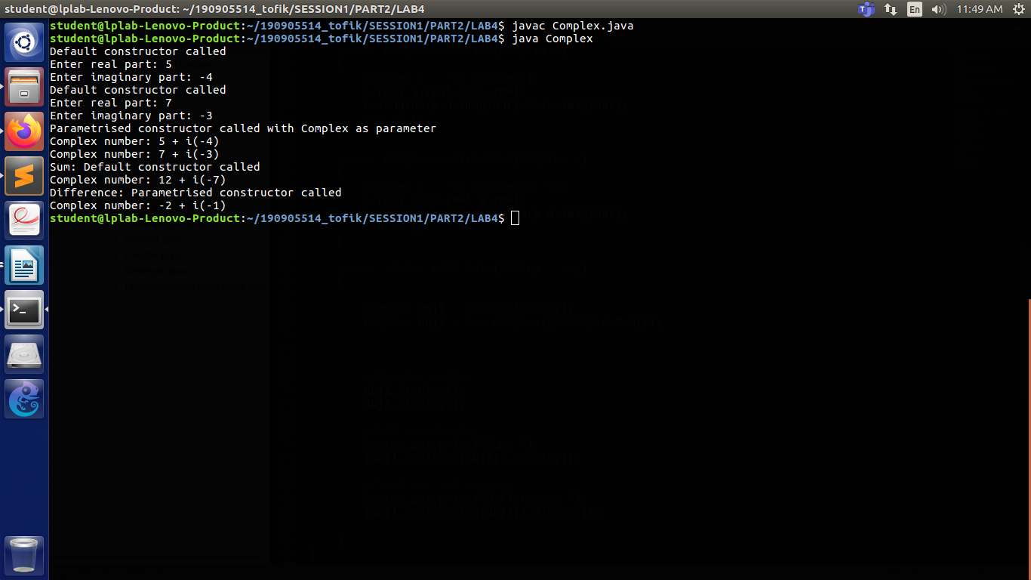

LAB 4 :
2->
Create a class called Counter that contains a static data member to count the number of Counter objects being created. Also define a static member function called showCount() which displays the number of objects created at any given point of time. Illustrate this.
import java.util.Scanner;
class Counter
{
static int n;

static void showCounter()
{
System.out.println(n);
}

Counter()
{
n = n + 1;
}

}
class counter
{
public static void main(String args[])
{
Counter c1 = new Counter();
Counter c2 = new Counter();
Counter c3 = new Counter();
c3.showCounter();
}
}

