190905514 MOHAMMAD TOFIK

WEEK3 LAB3

1. Design a class which represents a student. Every student record is made up of the following fields.
- Registration number (int)
- Full Name (String)
- Date of joining (Gregorian calendar)
- Semester (short)
- GPA (float)
- CGPA (float)
Whenever a student joins he will be given a new registration number. Registration number is calculated as follows. If year of joining is 2012 and he is the 80th student to join then his registration number will be 1280.
Write member functions to do the following.
- Provide default and parameterized constructors to this class
- Write display method which displays the record. Test the class by writing suitable main method.
- Create an array of student record to store minimum of 5 records in it. Input the records and display them.

Pgm1.java

import java.util.GregorianCalendar;
import java.util.Scanner;

class Student {

int regno;
String sname;
GregorianCalendar calendar;
short sem;
float gpa;
float cgpa;

/* Default constructor */
Student() {

regno = 0;
sname = "";
calendar = new GregorianCalendar(0, 0, 0);
gpa = 0;
cgpa = 0;

}

/* Parameterized constructor */
Student(String b, int yy, int mm, int dd, short d, float e, float f) {

this.sname = b;
this.calendar = new GregorianCalendar(yy, mm, dd);
this.sem = d;
this.gpa = e;
this.cgpa = f;
this.regno = (this.calendar.get(calendar.YEAR) % 100) * 100;

}

public void display() {

System.out.println("-------------------Student Details Given Below----------------------------");
System.out.println();
System.out.println("Student RegNo is = " + regno);
System.out.println("Student Name is = " + sname);
System.out.println("Date of Joining is = " + this.calendar.get(calendar.DATE) + "/"
+ this.calendar.get(calendar.MONTH) + "/" + this.calendar.get(calendar.YEAR));
System.out.println("Semester is = " + sem);
System.out.println("GPA is = " + gpa);
System.out.println("CGPA is = " + cgpa);
System.out.println();
}
}
public class pgm1 {

public static void main(String[] args) {

Scanner scanner = new Scanner(System.in);
System.out.println("---------------Enter the details of students-----------------");
System.out.println();

System.out.println("Enter the number of student");
int n = scanner.nextInt();

Student[] s = new Student[n];

for (int i = 0; i < n; i++) {
System.out.println("------Enter the details of " + (i + 1) + " student ------");
System.out.println();

System.out.println("Enter the Name of Student ");
String sname = scanner.nextLine();
sname = scanner.nextLine();

System.out.println("Enter the date of joining ");
int dd = scanner.nextInt();
int mm = scanner.nextInt();
int yy = scanner.nextInt();

System.out.println("Enter the semester ");
short sem = scanner.nextShort();
System.out.println("Enter the GPA ");
float gpa = scanner.nextFloat();
System.out.println("Enter CGPA ");
float cgpa = scanner.nextFloat();
s[i] = new Student(sname, dd, mm, yy, sem, gpa, cgpa);

}

for (int i = 0; i < n; i++) {

s[i].display();
}
}
}

OUTPUT :
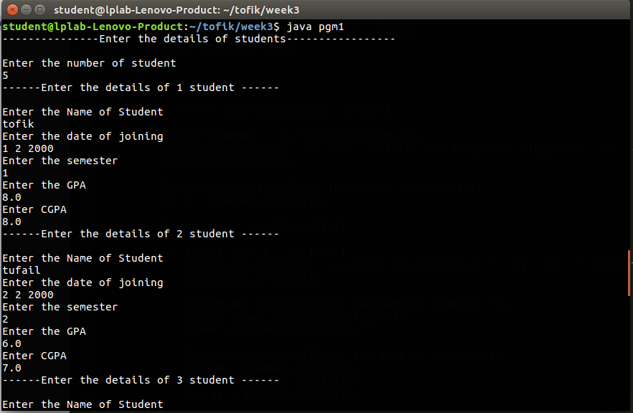

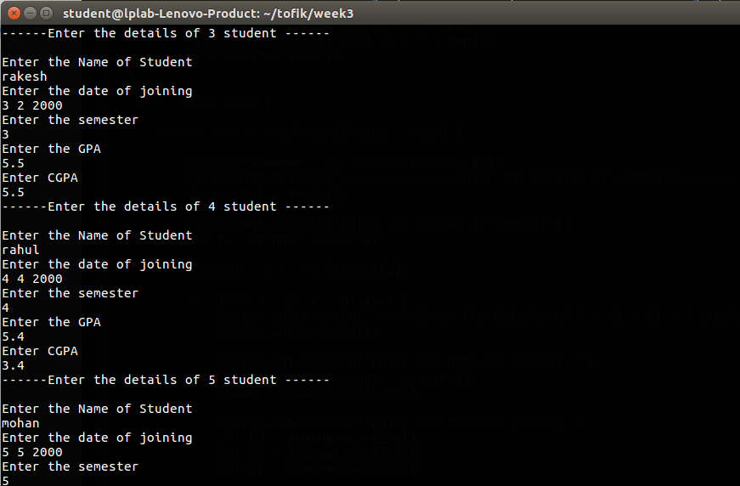

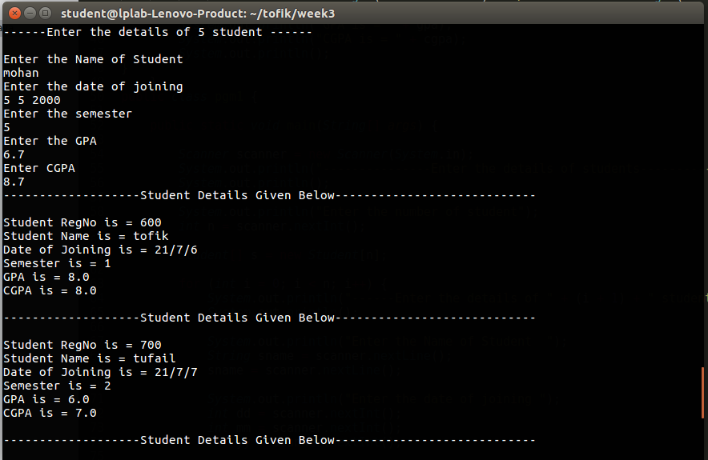

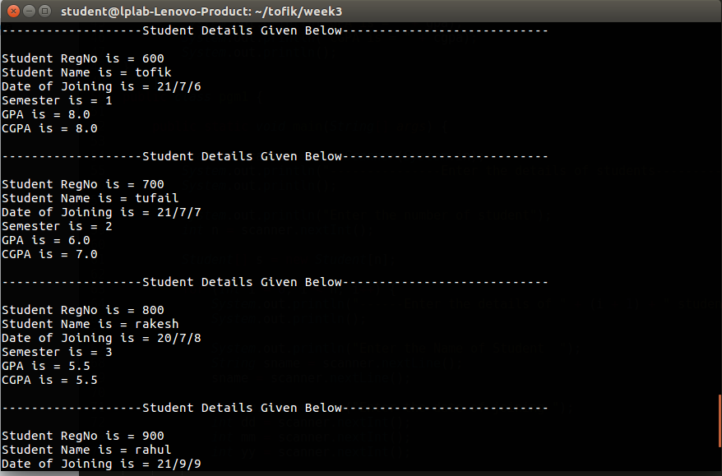
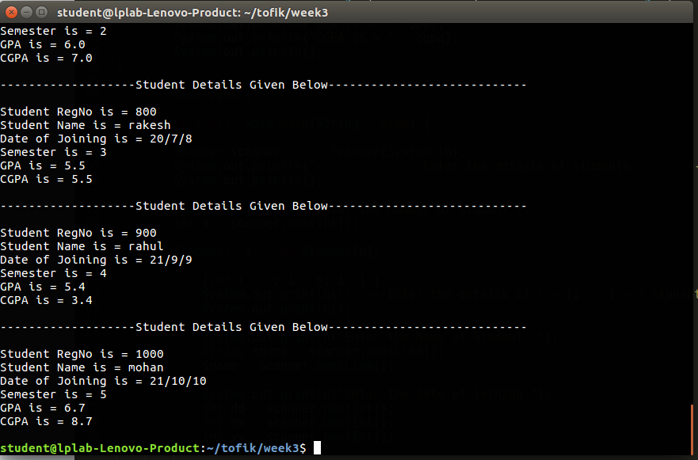

2. Create a Person class with private instance variables for the person’s name and birth date. Add appropriate accessor methods for these variables. Then create a subclass College Graduate with private instance variables for the student’s GPA and year of graduation and appropriate accessors for these variables. Include appropriate constructors for your classes. Then create a class with main() method that demonstrates your classes.

pgm3.java

import java.lang.*;
class person {

private String name;
private int date;
private int month;
private long year;

/*Constructor*/
person(String n, int d, int m, int y) {
this.name = n;
this.date = d;
this.month = m;
this.year = y;
}

/*Accessor method starting */
String getName() {
return name;
}

int getDate() {
return date;
}

int getMonth() {
return month;
}

long getYear() {
return year;
}
}

/*Sub class of super class*/
class collegeGraduate extends person {
private double gpa;
private long year_gpa;

collegeGraduate(String n, int d, int m, int y, double g, long y_g) {
super(n, d, m, y);
this.gpa = g;
this.year_gpa = y_g;

}

/*Accessor method*/
double getGpa() {
return gpa;
}

long getYearGpa() {
return year_gpa;
}

}

class pgm3 {
public static void main(String[] args) {
collegeGraduate cg = new collegeGraduate("Mohammad Tofik", 13, 9, 2021, 9.04, 2021);
System.out.println("Name is = " + cg.getName());
System.out.println("Date is = " + cg.getDate());
System.out.println("Month is = " + cg.getMonth());
System.out.println("Year is = " + cg.getYear());
System.out.println("GPA is = " + cg.getGpa());
System.out.println("Graduate year is = " + cg.getYearGpa());
System.out.println("Date of Birth is = " + cg.getDate() + "/" + cg.getMonth() + "/" + cg.getYear());

}
}

OUTPUT :

