190905514 MOHAMMAD TOFIK

WEEK 8 LAB 8 ;

1. product and sum using java script.

<!DOCTYPE html>
<html lang="en">
<head>
<meta charset="UTF-8">
<meta name="viewport" content="width=device-width, initial-scale=1.0">
<title> sum | product</title>
</head>
<body>
<script>
var arr=[0,0,0];
var size = 3;
for(var i=0; i<size; i++) {
arr[i] = prompt('ENTER ELEMENT ' + (i+1));
}
sum = 0,
product = 1,
j = 0;
for (j = 0; j < arr.length; j += 1)
{
sum += Number(arr[j]) ;
product *= arr[j];
}
alert('Sum is = '+ sum +' Product = ' +product);
</script>
</body>
</html>
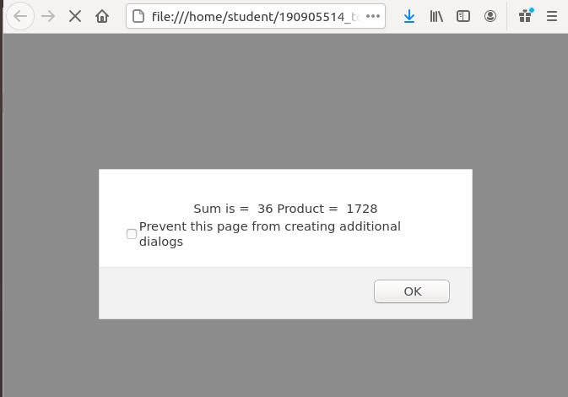

2. compute sum and product .

<!DOCTYPE html>
<html lang="en">
<head>
<meta charset="UTF-8">
<meta name="viewport" content="width=device-width, initial-scale=1.0">
<title>Sorting using conditional statement</title>
</head>
<body background="yellow">
<script>
var number1= 10;
var number2=21;
var number3= 42;
if (number1>number2 && number1>number3)
{
if (number2>number3)
{
alert(number1 + ", " + number2 + ", " +number3);
}
else
{
alert(number1 + ", " + number3 + ", " +number2);
}
}
else if (number2>number1 && number2 >number3)
{
if (number1>number3)
{
alert(number2 + ", " + number1 + ", " +number3);
}
else
{
alert(number2 + ", " + number3 + ", " +number1);
}
}
else if (number3>number1 && number3>number2)
{
if (number1>number2)
{
alert(number3 + ", " + number1 + ", " +number2);
}
else
{
alert(number3 + ", " + number2 + ", " +number1);
}
}
</script>
</body>
</html>

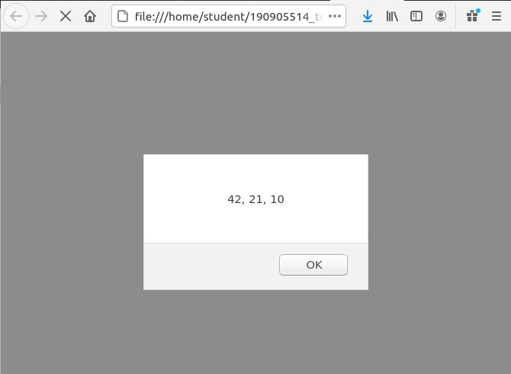
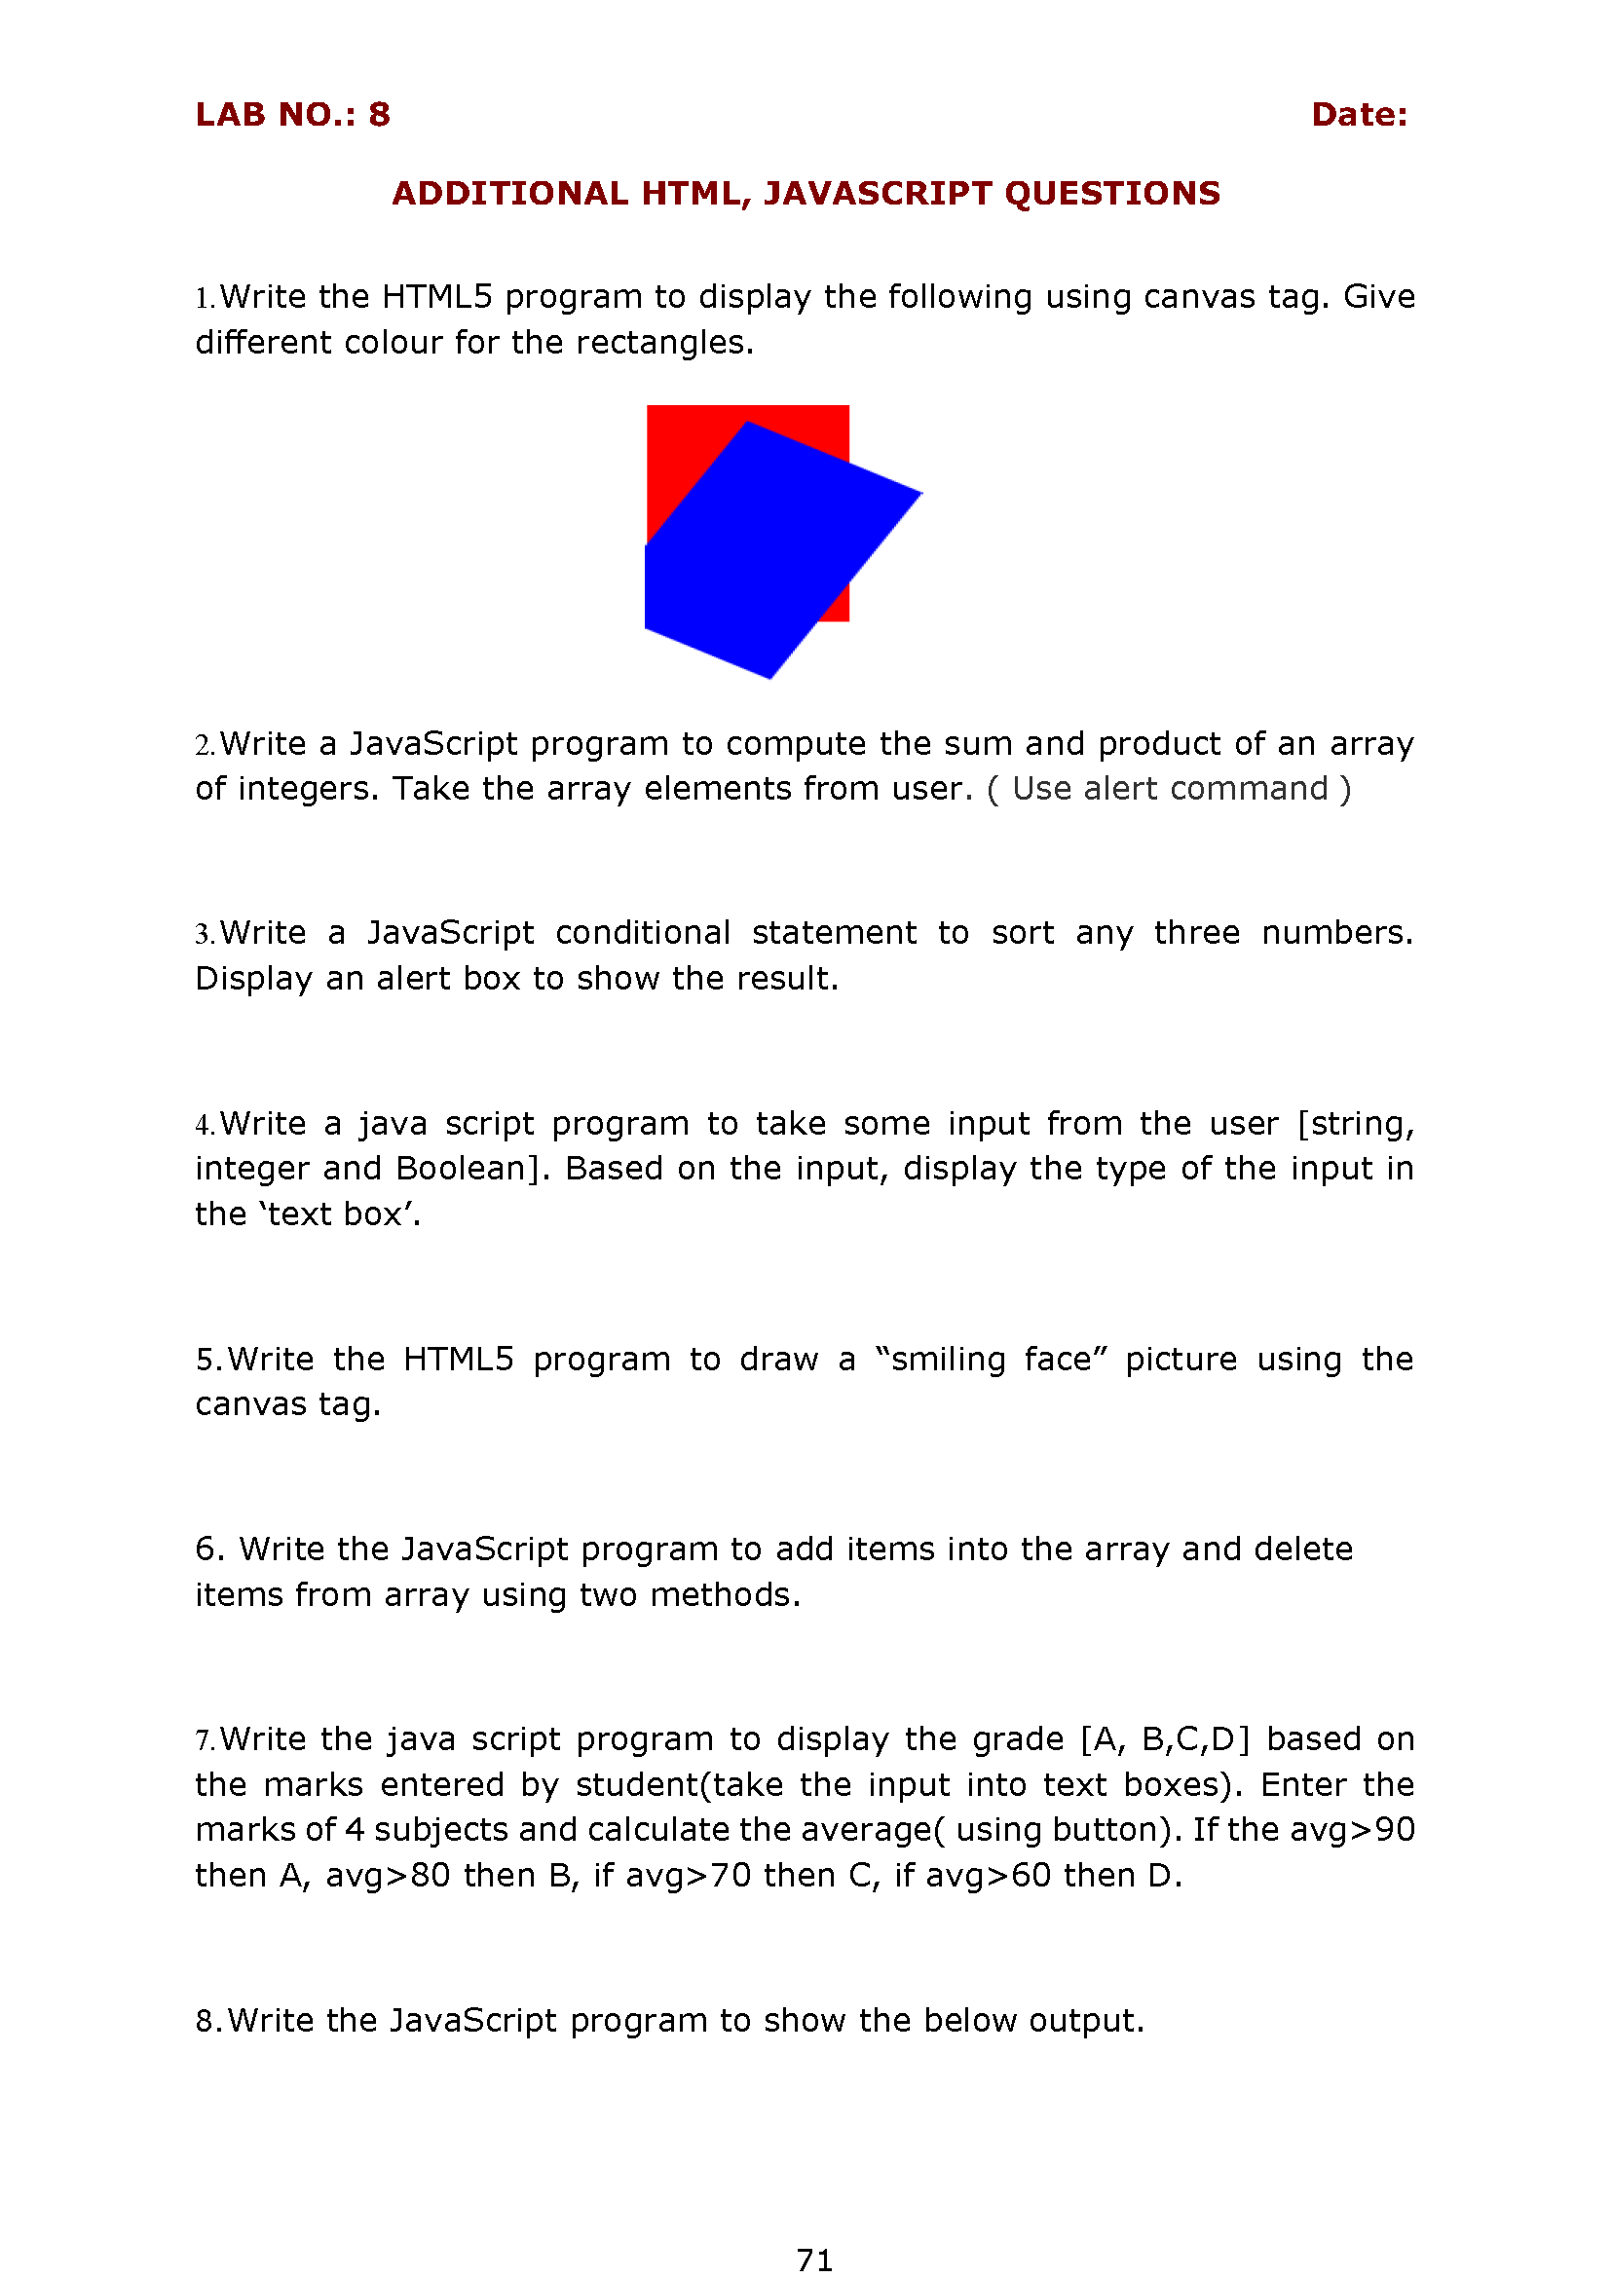

<!DOCTYPE html>
<html>
<head>
<title>Dan 83</title>
</head>
<body>
<script type="text/javascript">
var a =parseInt(prompt("Enter First Number"));
var b= parseInt(prompt("Enter Second Number"));
varc = parseInt(prompt("Enter Third Number"));
if(a > b) {
if(a > c) {
max = a; }
else {
max = c;
} } else
if( b > a) {
if(b > c) {
max = b;
}
else {
max = c;
}
}alert("Greatest Number = " + max);
if(a > b && c > b)
{
min= b;
}
else if(b > a && c > a)
{
min= a;
}
else{min = c;}
alert("Smallest Number = " + min);
</script>
</body>
</html>

4 .sorting of three number

<!DOCTYPE html>
<html lang="en">
<head>
<meta charset="UTF-8">
<meta name="viewport" content="width=device-width, initial-scale=1.0">
<title>Sorting using conditional statement</title>
</head>
<body background="yellow">
<script type="text/javascript">
var a = Array();
var n;
n=prompt("enter number");
for(var i=0;i<n; i++){
a[i]=prompt("Enter element ");
}
for(var i=0;i<n-1; i++){
for(var j=0;j<n-i-1; j++){
var temp;
if(a[j]< a[j+1]){temp=a[j];
a[j]=a[j+1];
a[j+1]=temp;
}
}
}
for(var i=0; i<n; i++){
alert("sorting number is " + a);
}
</script>
</body>
</html>

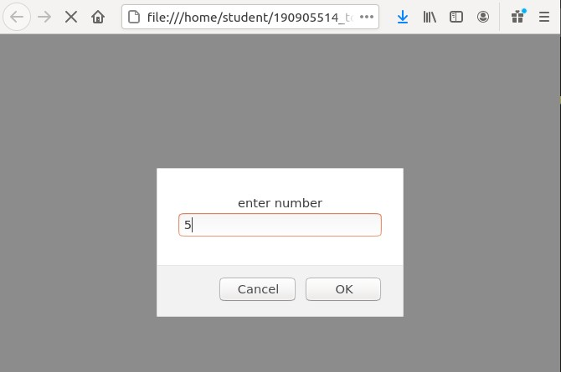

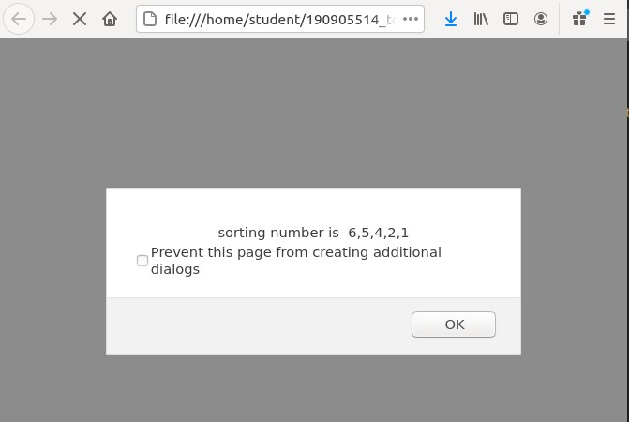

<!DOCTYPE html> <html>
<body>
<div id="sum"></div>
<button onclick="Insert()">Insert</button>
<button onclick="Delete()">Delete</button>
<button onclick="Display()">Display</button>
<div id="disp"></div>
<script>
var sum = 0;
var arr = Array();
var n; var i = 0;
function Insert()
{
var x = prompt("enter number");
arr[i++] = x;
}
function Delete()
{
var ele = prompt("enter element to be deleted");
for(var j = 0; j < arr.length; j = j+1)
{
if(ele == arr[j])
{
arr[j] = " ";
alert("found at location " + (j+1));
break;
}
}
}
function Display()
{
for(var j = 0; j < arr.length; j = j+1)
{
document.write(arr[j]);
console.log(arr[j]);
}
}
</script>
</body>
</html>

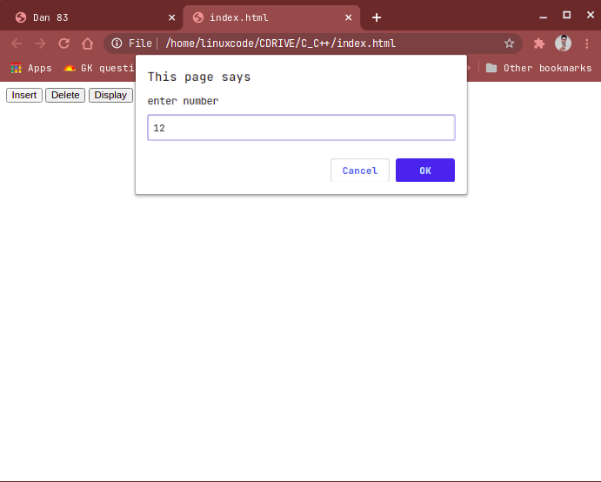
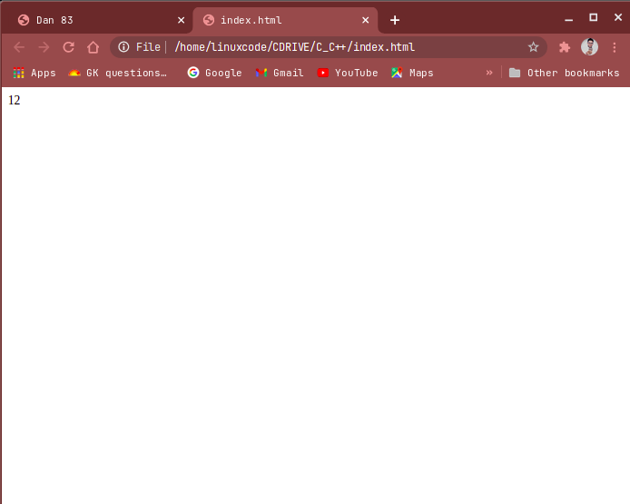

5. smiling face using java script

<!DOCTYPE html>
<html>
<head>
<title>
HTML CANVAS
</title> <!—a reference to the an external js file-->
<script src="script.js"></script>
</head>
<body onload="bodyLoad()">
<canvas id="mycanvas" width="400" height="200" ></canvas>
<script>
function myFace() {
var c = document.getElementById("mycanvas");
//to draw a surface on canvas element pass 2d as an argument in the getContext function
var draw = c.getContext("2d");
//to start a new path invoke BeginPath function.
//Call this function when you want to create a new path
draw.beginPath();
//to specify a color or style for your canvas use fillStyle property
draw.fillStyle = "yellow";
//to create a full circle invoke the arc method and in that method
//pass the value for x and y, radius, start point,
draw.arc(75, 75, 50, 0, Math.PI * 2, true);
//to close the path invoke the closePath functiondraw.closePath();
//invoke fill function to fill the canvas with a circle and in that circle a color of yellow
draw.fill();
}
function myEye() {
var c = document.getElementById("mycanvas");
var eye = c.getContext("2d");
//moveTo function is used to move the starting point of the canvas to a new point
//x value is 55 and y value is 50
eye.moveTo(55, 50);
//from the new point, begin a new path
eye.beginPath();
//fill the style with color black
eye.fillStyle = "black";
//left round eye
eye.arc(50, 50, 4, 0, Math.PI * 2, true);
eye.closePath();
eye.fill();
//move to the new sub path from the current point and create a right eye
eye.moveTo(103, 49);
eye.beginPath();
eye.fillStyle = "black";
//right round eye
eye.arc(100, 50, 4, 0, Math.PI * 2, true);
eye.closePath();
eye.fill();
}
function mySmile() {
var c = document.getElementById("mycanvas");
var smile = c.getContext("2d");
smile.moveTo(105, 75);
smile.beginPath();
smile.strokeStyle = "red";
smile.arc(75, 75, 30, 0, Math.PI, false);
function
smile.stroke();
}
function bodyLoad() {
myFace();
myEye();
mySmile();
}
</script>
</body>
</html>

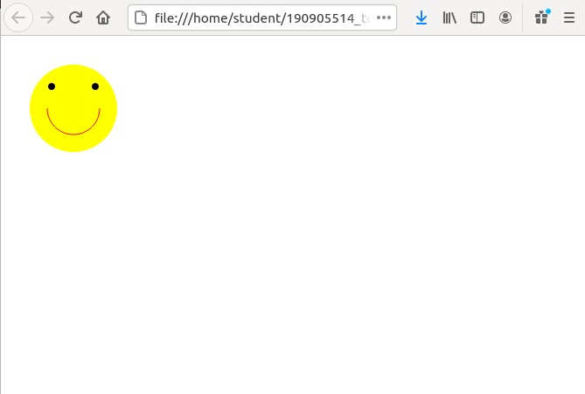

<!DOCTYPE html>
<html>
<head>
<title>Dan 88</title>
</head>
<body>
<script type="text/javascript">
function change()
{ var canv = document.getElementById('myCanvas'); if
(document.getElementById('red').checked) canv.style['background-color'] = "red";
else if (document.getElementById('blue').checked) canv.style['background-color'] =
"blue"; else if (document.getElementById('green').checked) canv.style['background-color'] =
"green";
}
</script>
<input type="radio" name="color" value="red" onchange="change()" id="red">Red <br>
<input type="radio" name="color" value="blue" onchange="change()" id="blue">Blue <br>
<input type="radio" name="color" value="green" onchange="change()" id="green">Green <br>
<canvas id="myCanvas" width="200" height="100"></canvas>
</body>
</html>
