190905514 MOHAMMAD TOFIK
WEEK 1 LAB 1 :

QUESTIONS :

LAB EXERCISES:

1. Create a table employee with ( emp_no, emp_name, emp_address)
2. Insert five employees information.
3. Display names of all employees.
4. Display all the employees from ‘udupi’.
5. Add a column named salary to employee table.
6. Assign the salary for all employees.
7. View the structure of the table employee using describe.
8. Delete all the employees from ‘udupi’
9. Rename employee as employee1.
10. Drop the table employee1.

ANSWER :

1. create table employee(emp_no char(5),emp_name varchar(20),emp_address varchar(30));

2. insert into employee values('11111','shahil','manipal');
insert into employee values('11112','kumar','udupi');
insert into employee values('11113','manoj','manipal');
insert into employee values('11114','sheikh','udupi');
insert into employee values('11111','kain','udupi');

3. select * from employee;
select emp_name from employee;

4. select emp_name from employee where emp_address='udupi';

5. alter table employee add(emp_salary numeric(6,2));
6. update employee set emp_salary=6000.00 where emp_name='shahil';
7. desc employee;
8. delete from employee where emp_name='udupi';
9. rename employee to employee1;
10. drop table employee1;

OUTPUT of 1 2 Questions :

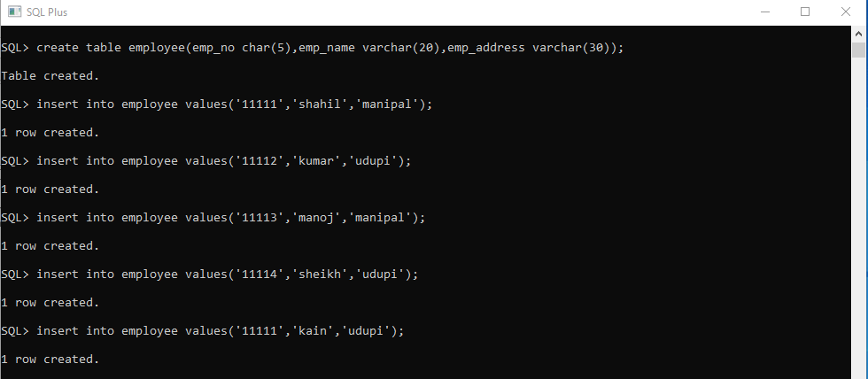

OUTPUT of 3 4 Questions :

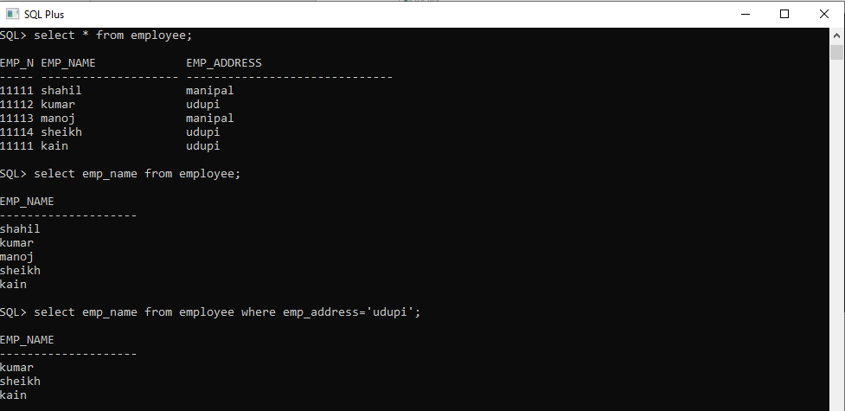

OUTPUT of 3 4 Questions :

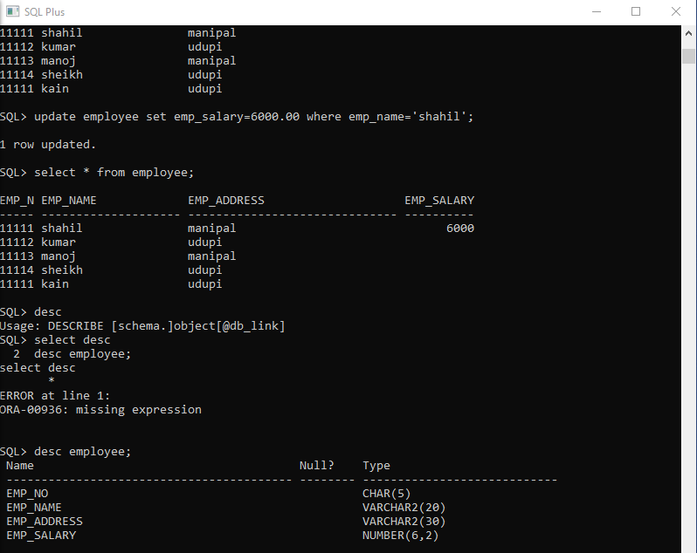

OUTPUT of 8 9 10 Questions :

