190905514 C SECTION 4th SEMESTER MOHAMMAD TOFIK

LAB 7 :
ANSWER-1.

CREATE TABLE salary_raise(
Instructor_ID NUMBER(5),
Raise_Date DATE,
Raise_Amt NUMERIC(8,2)
);
DECLARE
CURSOR c_raise IS
SELECT * FROM Instructor WHERE dept_name = 'Biology' FOR UPDATE;
r_amt NUMERIC(8, 2);
BEGIN
FOR i IN c_raise
LOOP
r_amt := i.salary * 1.05;
UPDATE Instructor
SET salary = salary * 1.05;
INSERT INTO salary_raise VALUES (i.ID, CURRENT_DATE, r_amt);
END LOOP;
END;
/
SELECT * FROM salary_raise;

OUTPUT :

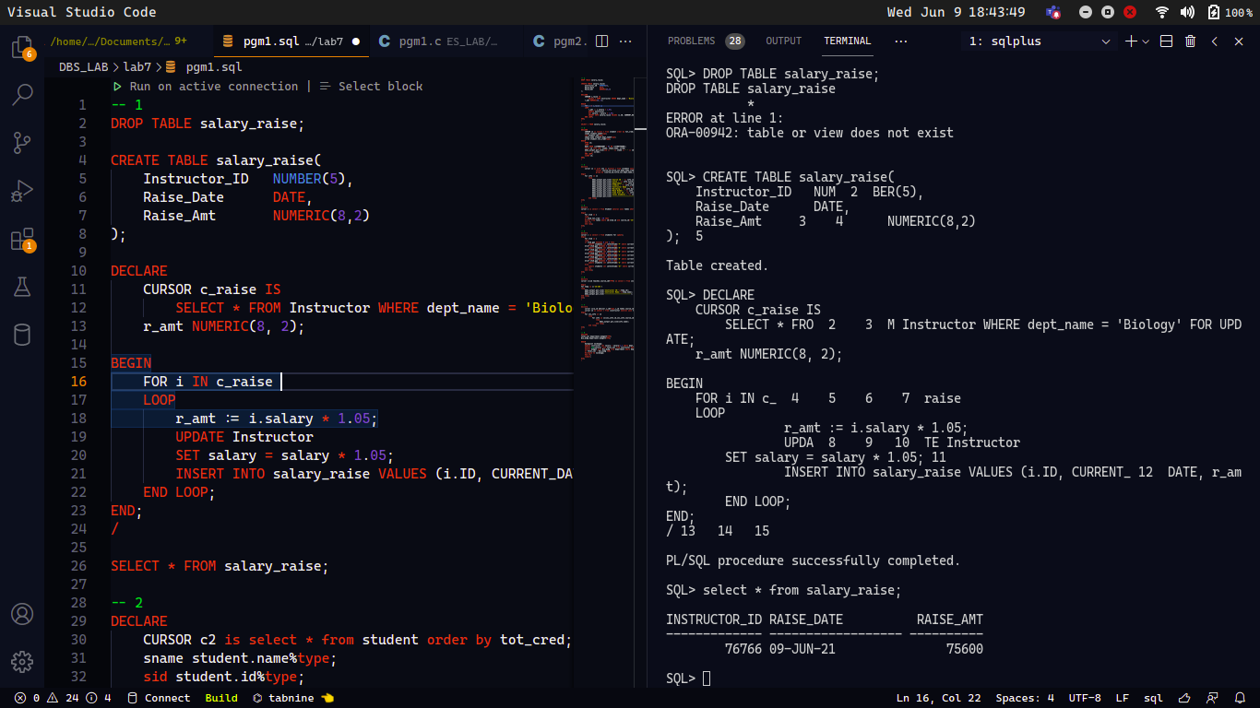

ANSWER-2.

DECLARE
CURSOR c2 is select * from student order by tot_cred;
sname student.name%type;
sid student.id%type;
sdept_name student.dept_name%type;
scred student.tot_cred%type;
BEGIN
OPEN c2;
LOOP
EXIT WHEN (c2%ROWCOUNT > 9) OR (c2%NOTFOUND);
fetch c2 into sid, sname, sdept_name, scred;
dbms_output.put_line(sid || ' ' || sname || ' ' || sdept_name
|| ' ' || scred);
END LOOP;
CLOSE c2;
END;
/
OUTPUT :

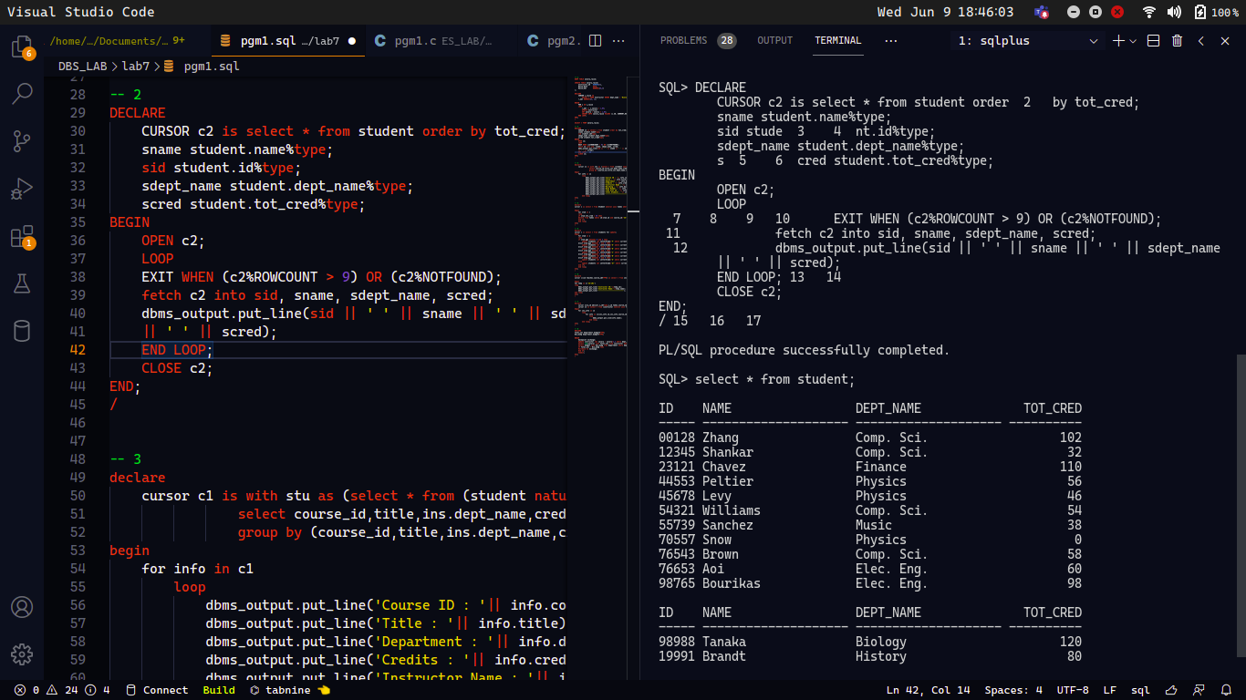
ANSWER-3.

declare
cursor c1 is with stu as (select * from (student natural join takes natural join section)),ins as (select * from (instructor natural join teaches natural join section))
select course_id,title,ins.dept_name,credits,ins.name,ins.building,ins.room_number,ins.time_slot_id,count(*) as no_of_students from stu inner join ins using(course_id,sec_id,semester,year) natural join course
group by (course_id,title,ins.dept_name,credits,ins.name,ins.building,ins.room_number,ins.time_slot_id);
begin
for info in c1
loop
dbms_output.put_line('Course ID : '|| info.course_id);
dbms_output.put_line('Title : '|| info.title);
dbms_output.put_line('Department : '|| info.dept_name);
dbms_output.put_line('Credits : '|| info.credits);
dbms_output.put_line('Instructor Name : '|| info.name);
dbms_output.put_line('Building : '|| info.building);
dbms_output.put_line('Room Number : '|| info.room_number);
dbms_output.put_line('Time Slot ID : '|| info.time_slot_id);
dbms_output.put_line('Total Students : '|| info.no_of_students);
dbms_output.put_line('---------------------------------------------------------------------');
end loop;
end;
/
OUTPUT :

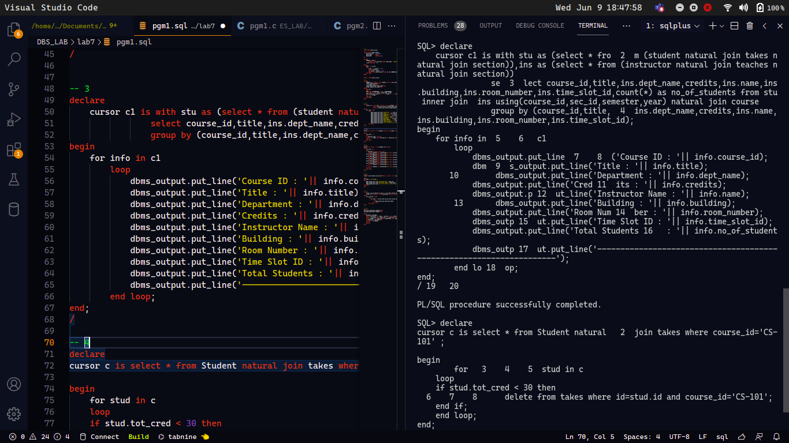

ANSWER-4.

declare
cursor c is select * from Student natural join takes where course_id='CS-101' ;
begin
for stud in c
loop
if stud.tot_cred < 30 then
delete from takes where id=stud.id and course_id='CS-101';
end if;
end loop;
end;
/
OUTPUT :

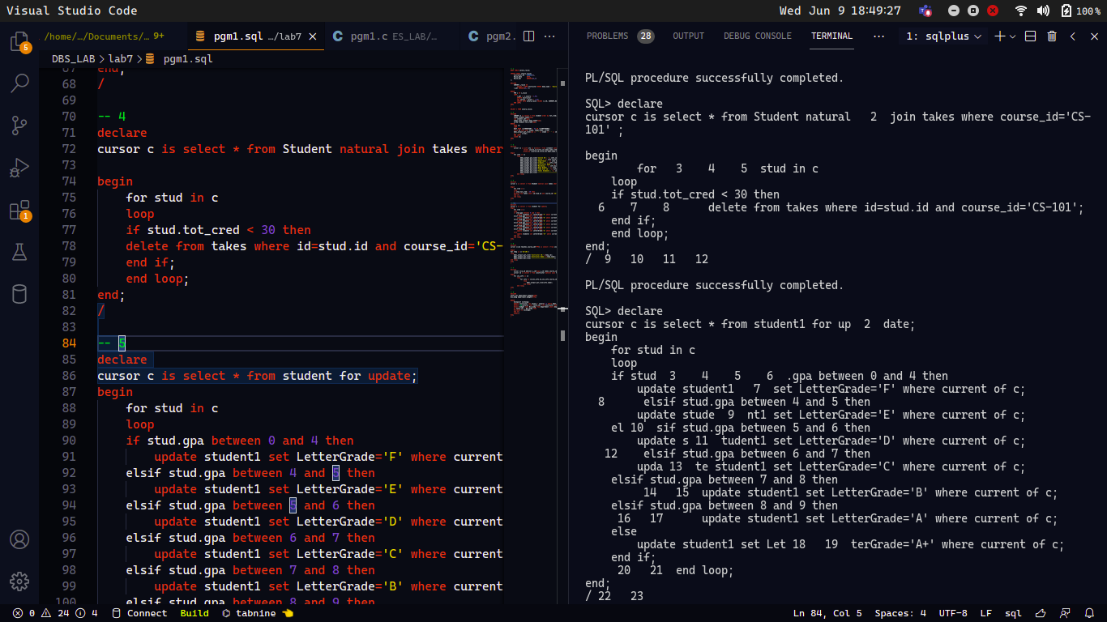
ANSWER-5.

declare
cursor c is select * from Studenttable for update;
begin
for stud in c
loop
if stud.gpa between 0 and 4 then
update Studenttable set LetterGrade='F' where current of c;
elsif stud.gpa between 4 and 5 then
update Studenttable set LetterGrade='E' where current of c;
elsif stud.gpa between 5 and 6 then
update Studenttable set LetterGrade='D' where current of c;
elsif stud.gpa between 6 and 7 then
update Studenttable set LetterGrade='C' where current of c;
elsif stud.gpa between 7 and 8 then
update Studenttable set LetterGrade='B' where current of c;
elsif stud.gpa between 8 and 9 then
update Studenttable set LetterGrade='A' where current of c;
else
update Studenttable set LetterGrade='A+' where current of c;
end if;
end loop;
end;
/

OUTPUT :

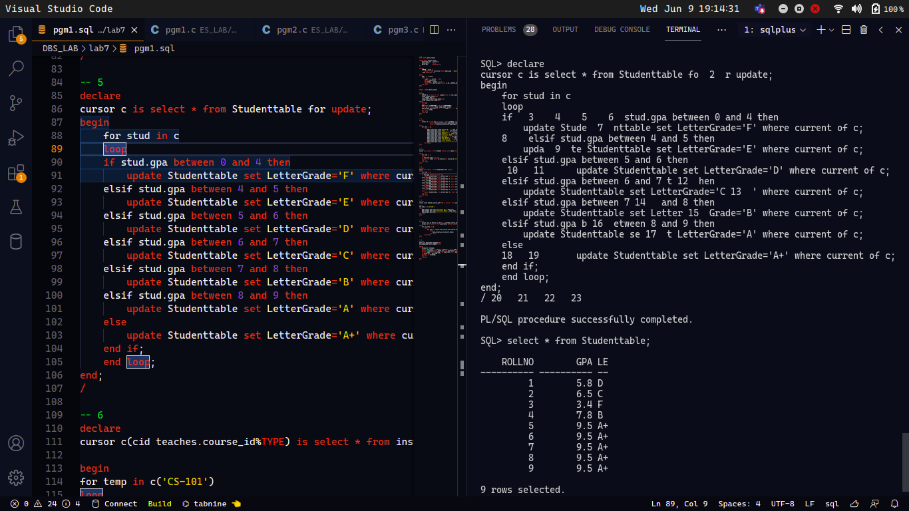

ANSWER-6.

declare
cursor c(cid teaches.course_id%TYPE) is select * from Instructor natural join teaches where course_id=cid;

begin
for temp in c('CS-101')
loop
dbms_output.put_line('Instructor ID:'||temp.id);
dbms_output.put_line('Instructor Name:'||temp.name);
dbms_output.put_line('---------------------------');
end loop;
end;
/
OUTPUT :

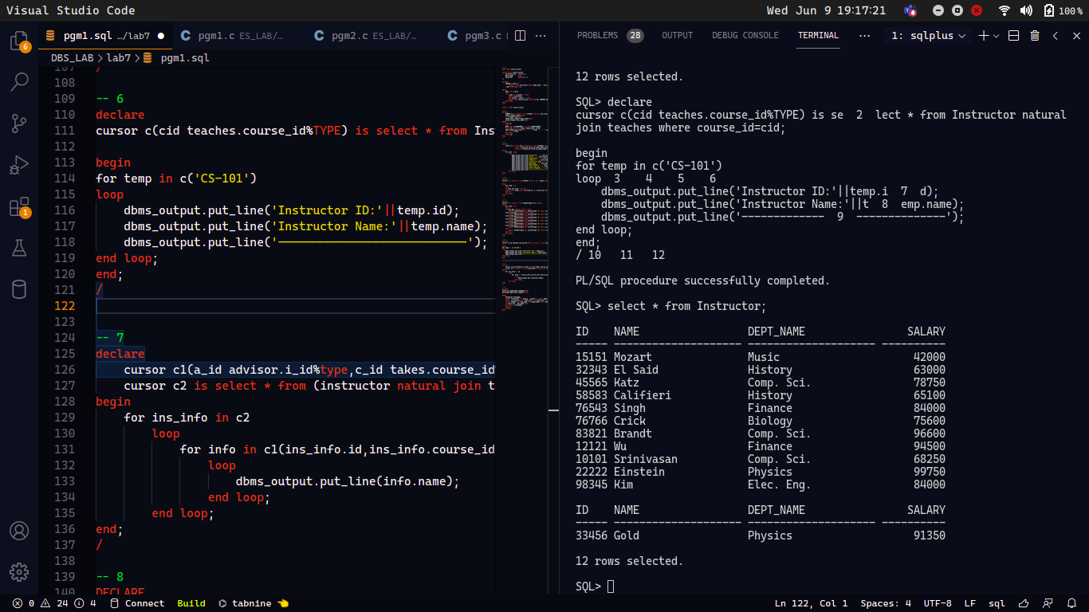

ANSWER-7.

declare
cursor c1(a_id advisor.i_id%type,c_id takes.course_id%type) is select * from ((student s natural join takes t) inner join advisor a on (id=a.s_id)) where course_id = c_id and a_id=i_id;
cursor c2 is select * from (instructor natural join teaches);
begin
for ins_info in c2
loop
for info in c1(ins_info.id,ins_info.course_id)
loop

dbms_output.put_line(info.name);
end loop;
end loop;
end;
/
OUTPUT :

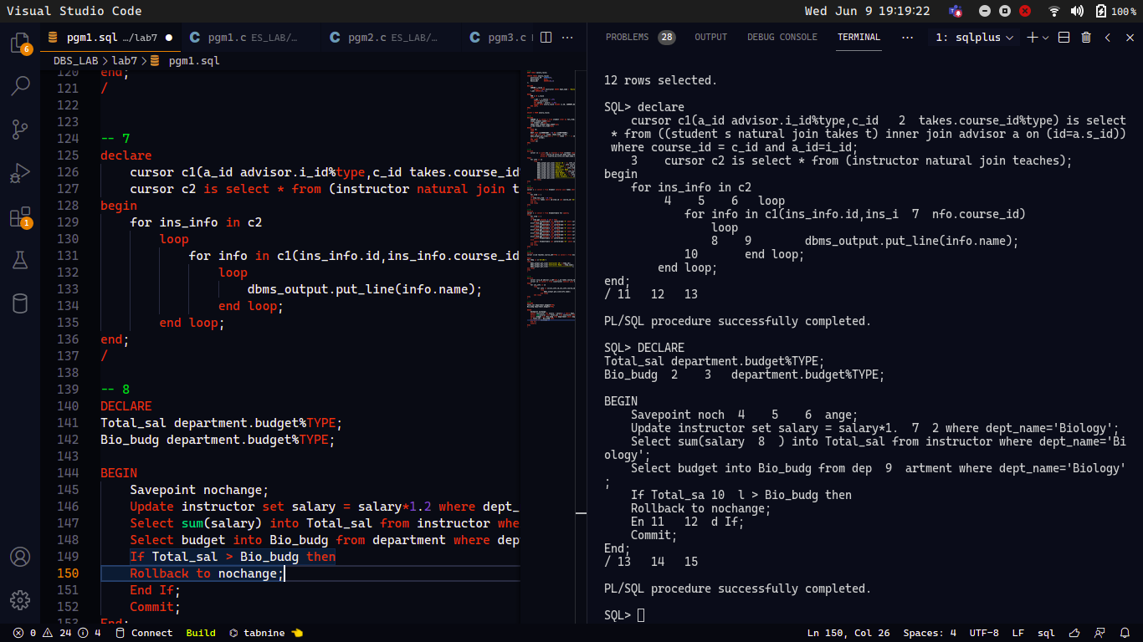

ANSWER-8.

DECLARE
Total_sal department.budget%TYPE;
Bio_budg department.budget%TYPE;

BEGIN
Savepoint nochange;
Update instructor set salary = salary*1.2 where dept_name='Biology';
Select sum(salary) into Total_sal from instructor where dept_name='Biology';
Select budget into Bio_budg from department where dept_name='Biology';
If Total_sal > Bio_budg then
Rollback to nochange;
End If;
Commit;
End;
/

OUTPUT :

