190905514 C SECTION 4th SMESTER MOHAMMAD TOFIK

WEEK2 LAB2 :
Solved Exercise :
Write a program to add two 32-bit numbers available in the code memory. Store the
result in the data memory.

AREA RESET, DATA, READONLY
EXPORT __Vectors
__Vectors
DCD 0x10001000 ; stack pointer value when stack is empty
DCD Reset_Handler ; reset vector
ALIGN
AREA mycode, CODE, READONLY
ENTRY
EXPORT Reset_Handler
Reset_Handler
LDR R0, =VALUE1 ;pointer to the first value1
LDR R1, [R0] ;load the first value into R1
LDR R0, =VALUE2 ;pointer to the second value
LDR R3, [R0] ;load second number into r3
ADDS R6, R1, R3 ;add two numbers and store the result in r6
LDR R2, =RESULT
STR R6, [R2]
STOP
B STOP
VALUE1 DCD 0X12345678 ; First 32 bit number
VALUE2 DCD 0XABCDEF12 ; Second 32 bit number
AREA data, DATA, READWRITE
RESULT DCD 0
END

OUTPUT :

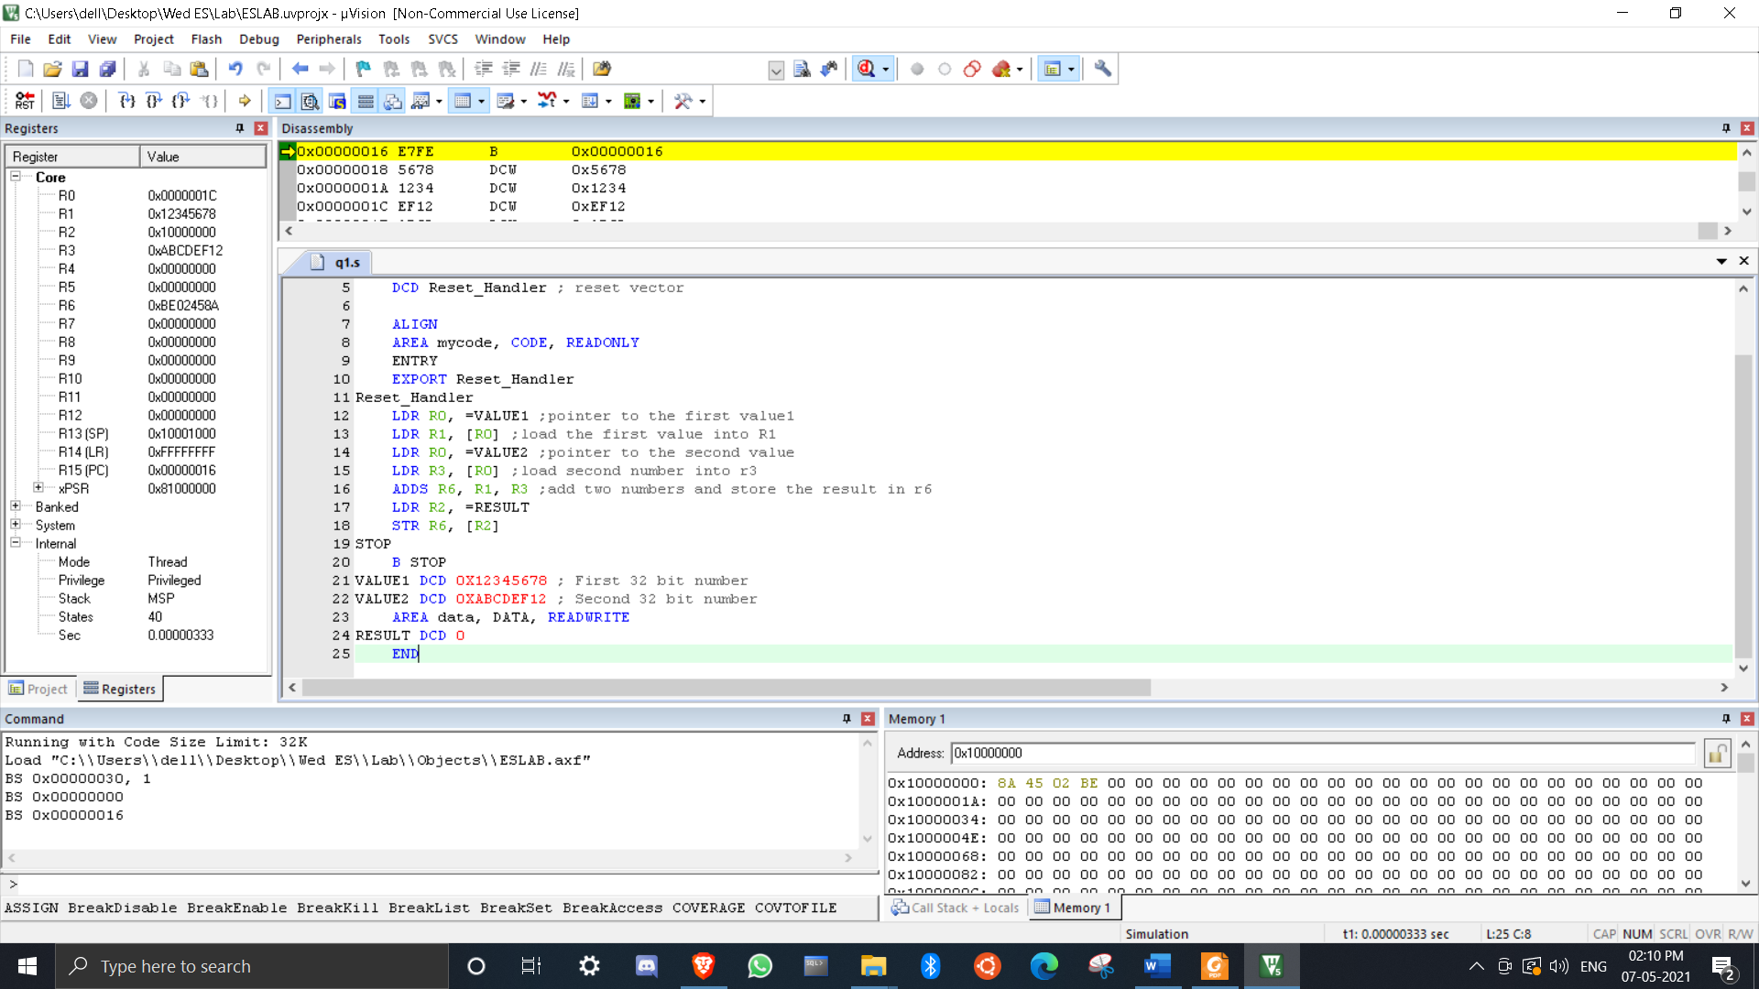

Lab Exercises:
1. Write a program to add ten 32-bit numbers available in code memory and store the result in data memory.

AREA RESET,DATA,READONLY
EXPORT __Vectors

__Vectors

DCD 0X10001000
DCD Reset_Handler
AREA mydata,DATA,READWRITE
DST DCD 0
AREA mycode,CODE,READONLY
ENTRY
SRC DCD 0xFFFFFFFF,0xFFFFFFFF,0xFFFFFFFF,0xFFFFFFFF,0xFFFFFFFF,
0xFFFFFFFF, 0xFFFFFFFF,0xFFFFFFFF,0xFFFFFFFF,0xFFFFFFFF
EXPORT Reset_Handler
Reset_Handler

LDR R0,=SRC
LDR R1,=DST
MOV R2,#0
MOV R5,#0
MOV R3,#10
UP LDR R4,[R0],#4
ADDS R2,R4
ADC R5,#0
SUBS R3,#1
BNE UP
STR R2,[R1],#4
STR R5,[R1]
STOP B STOP
END

OUTPUT :

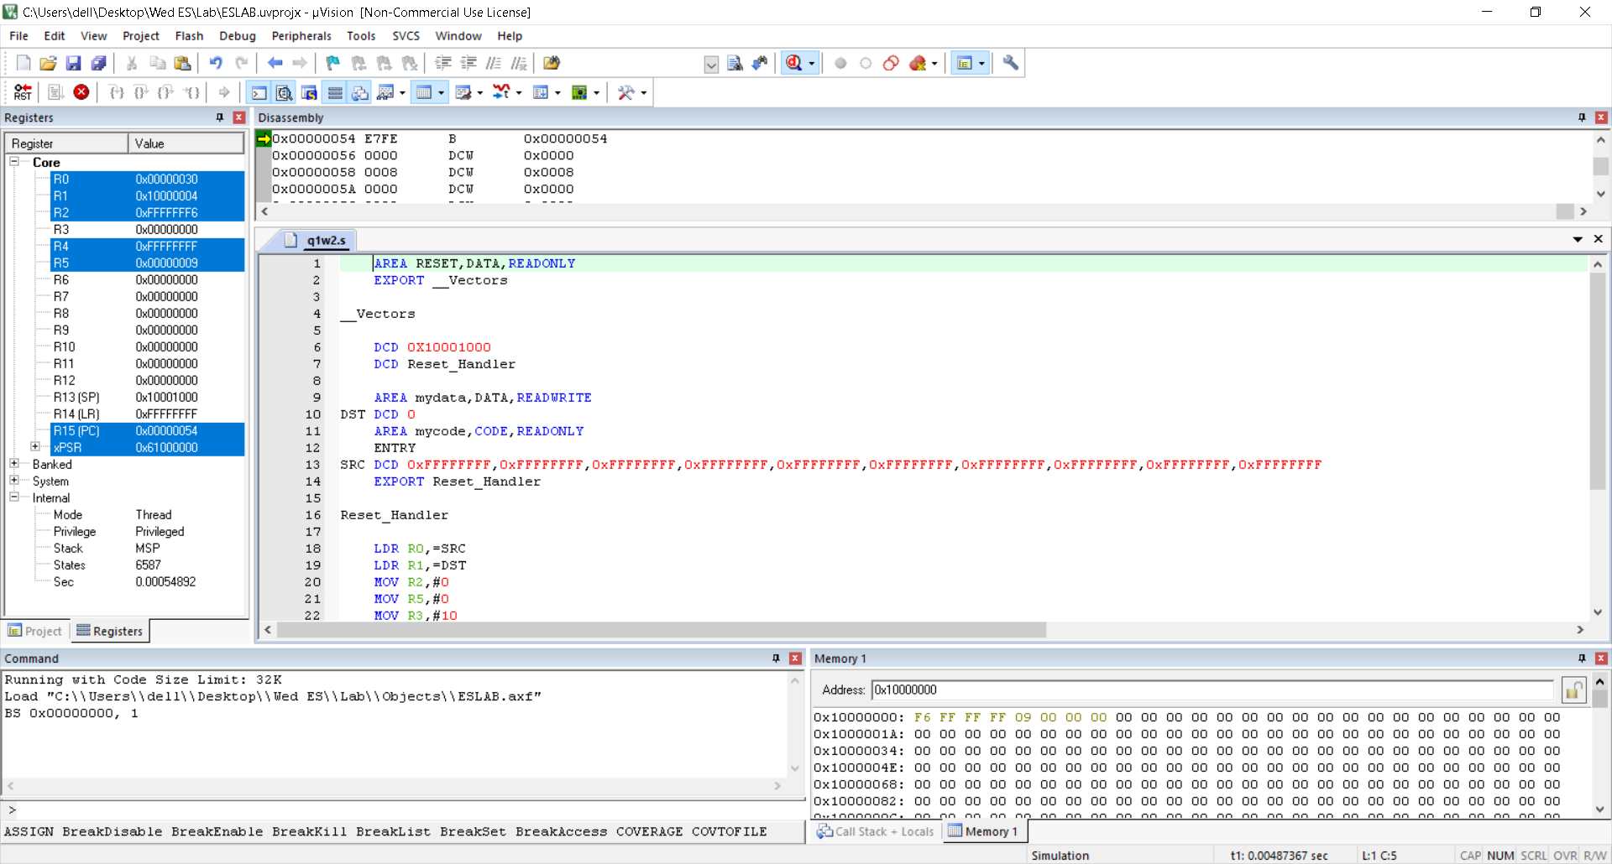

2. Write a program to add two 128-bit numbers available in code memory and store the result in data memory.
Hint: Use indexed addressing mode.

AREA RESET,DATA,READONLY
EXPORT __Vectors
__Vectors
DCD 0X10001000
DCD Reset_Handler
AREA mydata,DATA,READWRITE
DST DCD 0
AREA mycode,CODE,READONLY
NUM1 DCD 4,3,2,1
NUM2 DCD 4,3,2,1
ENTRY
EXPORT Reset_Handler
Reset_Handler
LDR R0,=NUM1
LDR R1,=NUM2
LDR R2,[R0]
LDR R3,[R1]
LDR R4 ,=DST
MOV R5,#4
MOV R6,#0
UP ADDS R2,R3
ADC R6,#0
STR R2,[R4],#4
LDR R2,[R0,#4]!
LDR R3,[R1,#4]!
SUBS R5,#1
BNE UP
STR R6,[R4]
ALIGN
STOP
B STOP
END

OUTPUT :

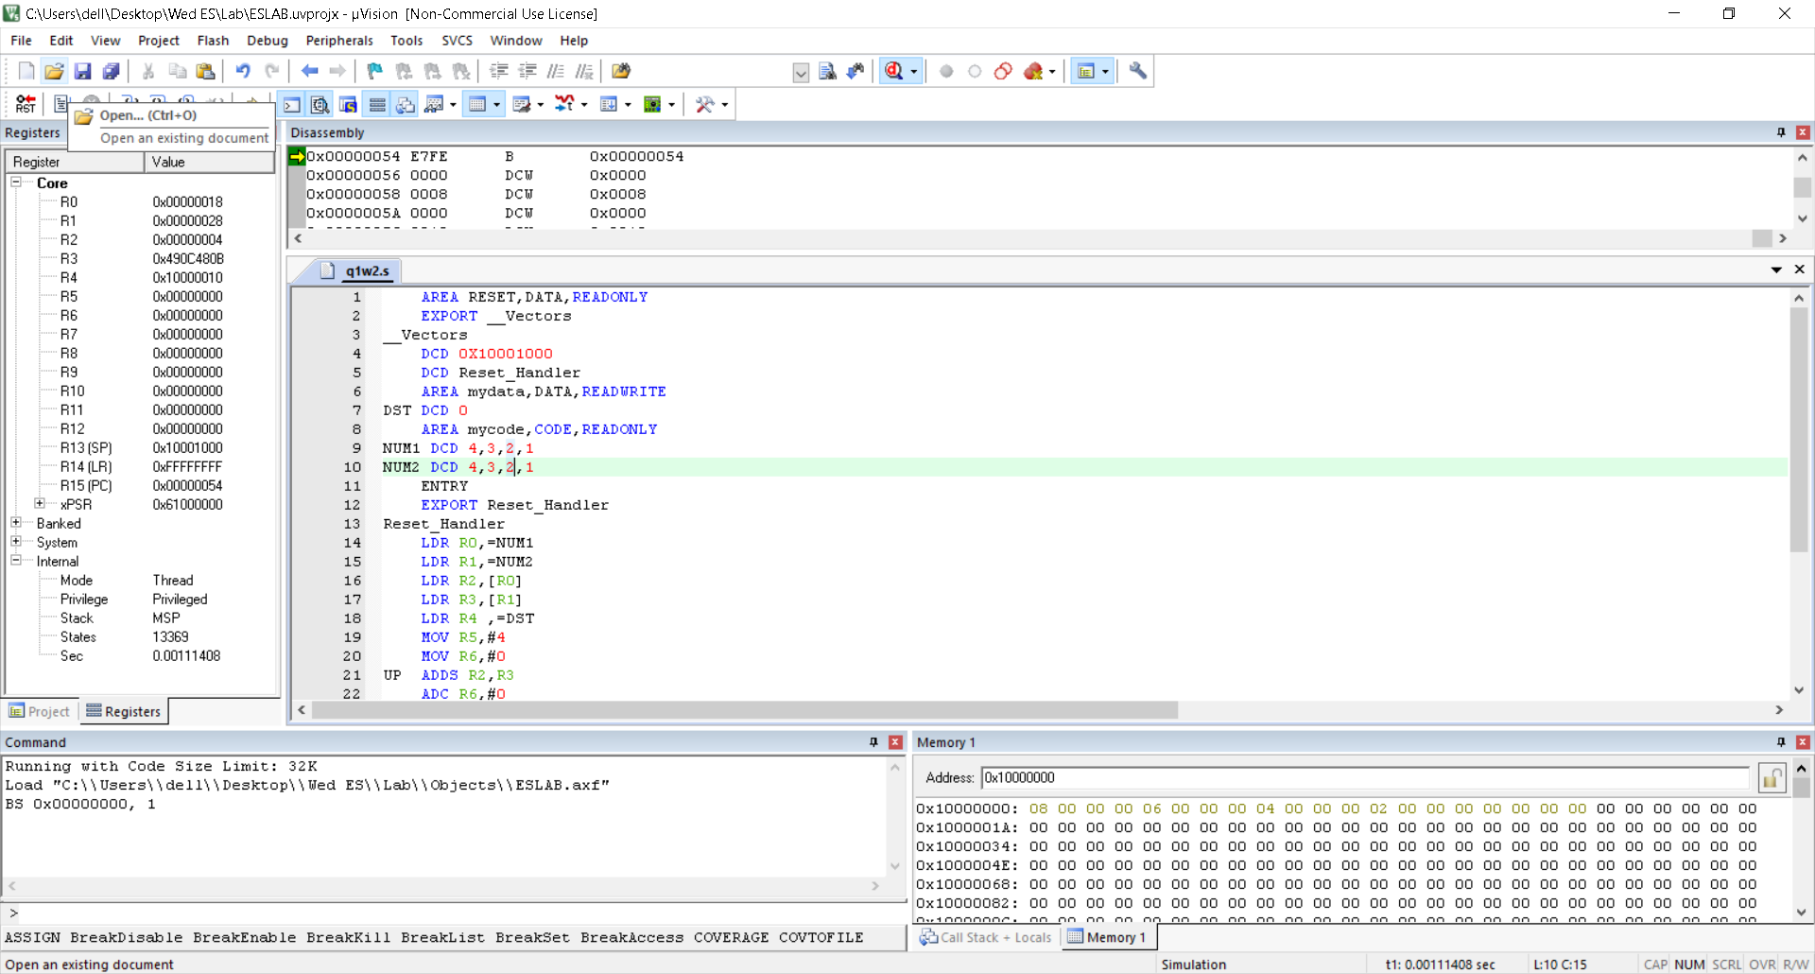

3. Write a program to subtract two 32-bit numbers available in the code memory and store the result in the data memory.

AREA RESET ,DATA, READONLY
EXPORT __Vectors

__Vectors
DCD 0X10001000
DCD Reset_Handler
AREA mydata,DATA,READWRITE
DST DCD 0
AREA mycode,CODE,READONLY
ENTRY
EXPORT Reset_Handler

Reset_Handler

LDR R0,=NUM1
LDR R1,[R0]
LDR R0,=NUM2
LDR R2,[R0]
MOV R3,#0
SUBS R3,R2,R1
ADC R3,#-1
LDR R0,=DST
STR R3,[R0]
ALIGN
NUM1 DCD 10
NUM2 DCD 15
STOP B STOP
END

OUTPUT :

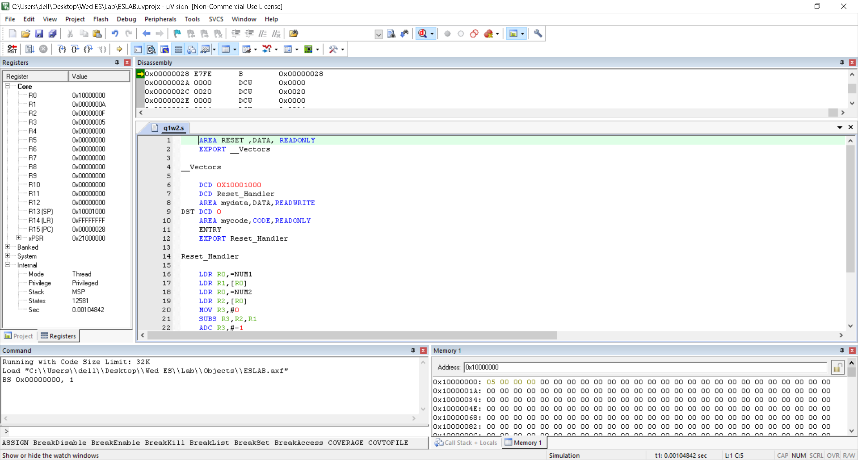

4. Write a program to subtract two 128-bit numbers available in the code memory and store the result in the data memory.

AREA RESET,DATA,READONLY
EXPORT __Vectors
__Vectors
DCD 0X10001000
DCD Reset_Handler
AREA mydata,DATA,READWRITE
DST DCD 0
AREA mycode,CODE,READONLY
NUM1 DCD 3,2,2,3
NUM2 DCD 1,0,0,1
ENTRY
EXPORT Reset_Handler
Reset_Handler
LDR R0,=NUM1
LDR R1,=NUM2
LDR R2,[R0]
LDR R3,[R1]
LDR R4 ,=DST
MOV R5,#4
MOV R6,#0
UP SUBS R2,R2,R3
ADC R6,#-1
STR R2,[R4],#4
LDR R2,[R0,#4]!
LDR R3,[R1,#4]!
SUBS R5,#1
BNE UP
STR R6,[R4]
ALIGN
STOP
B STOP
END

OUTPUT :

