190905514 SECTION C 4th SEMESTER MOHAMMAD TOFIK

1.Write an assembly language program to implement division by repetitive subtraction.

AREA RESET,DATA,READONLY
EXPORT __Vectors

__Vectors
DCD 0X10001000
DCD Reset_Handler
AREA mycode,CODE,READONLY
ENTRY
EXPORT Reset_Handler
Reset_Handler
LDR R1, =DIVIS
LDR R0, =DIVID
LDR R2, [R0]
LDR R3, [R1]
MOV R4, #0
LOOP
SUB R3, R3, R2
ADD R4, R4, #1
CMP R3, R2
BGE LOOP

STORE
LDR R5, =REM
LDR R6, =QUO
STR R3, [R5]
STR R4, [R6]

STOP B STOP
DIVIS DCD 20
DIVID DCD 4
AREA mydata,DATA,READWRITE
REM DCD 0
QUO DCD 0
END

OUTPUT :

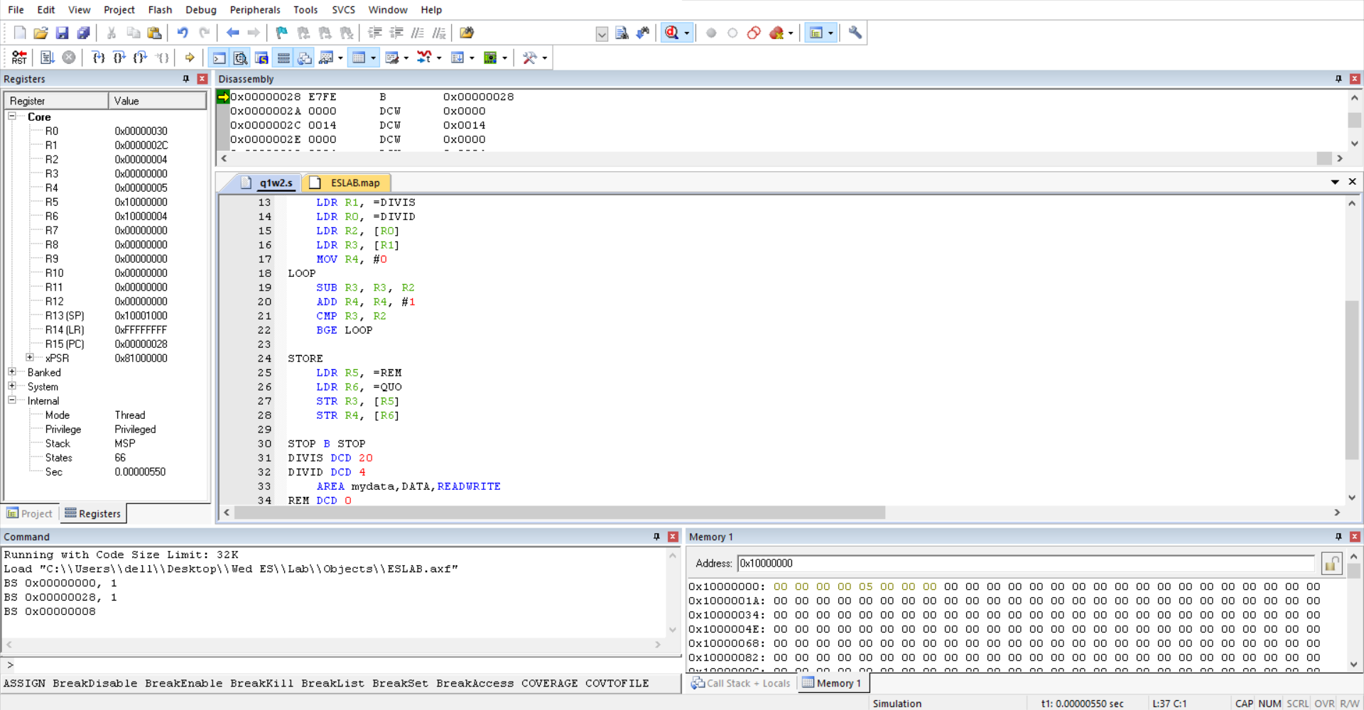

2.Find the sum of ‘n’ natural numbers using MLA instruction.
AREA RESET, DATA, READONLY
EXPORT __Vectors

__Vectors
DCD 0x1001000
DCD Reset_Handler
ALIGN
AREA mycode, CODE, READONLY
ENTRY
EXPORT Reset_Handler
Reset_Handler
LDR R0,=SRC
LDR R1,=DST
MOV R2,#0
LDR R3,[R0]
MLA R2,R3,R3,R3
LSR R2,#1
STR R2,[R1]
STOP
B STOP
SRC DCD 5 ;n
AREA mydata, DATA, READWRITE
DST DCD 0
END

OUTPUT :

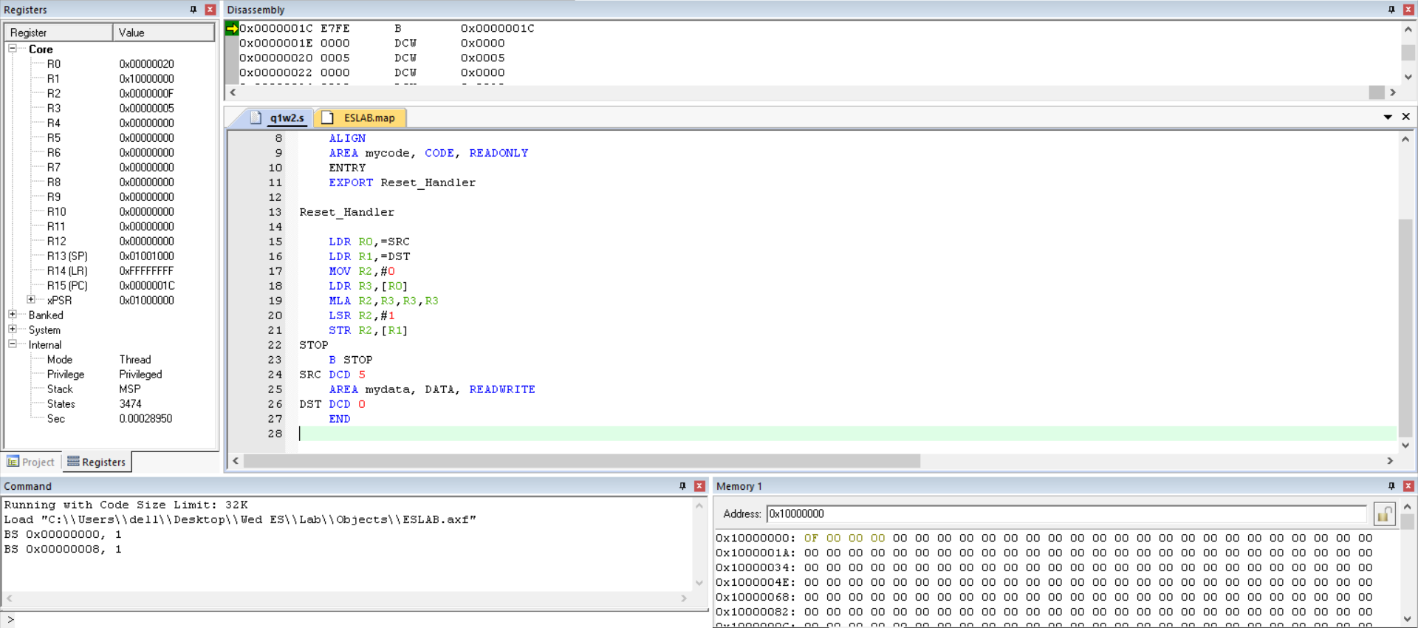

3.Write an assembly language program to find GCD and LCM of two 8 bit numbers.

AREA RESET, DATA, READONLY
EXPORT __Vectors

__Vectors
DCD 0X10001000
DCD Reset_Handler
AREA mycode,CODE,READONLY
ENTRY
EXPORT Reset_Handler
Reset_Handler
LDR R0, =N1
LDR R1, =N2
LDR R2, [R0]
LDR R3, [R1]
GCDT
CMP R2, R3
SUBLT R3, R3, R2
SUBGT R2, R2, R3
BNE GCDT

STRGCD
LDR R4, =GCD
STR R2, [R4]
LCMT
LDR R5, [R0]
LDR R6, [R1]
MOV R4, #0
MUL R7, R5, R6

DIVISION
SUB R7, R7, R2
ADD R4, R4, #1
CMP R7, R2
BGE DIVISION

STRLCM
LDR R8, =LCM
STR R4, [R8]

STOP B STOP
N1 DCD 48
N2 DCD 18
AREA mydata,DATA,READWRITE
GCD DCD 0
LCM DCD 0
END

OUTPUT :

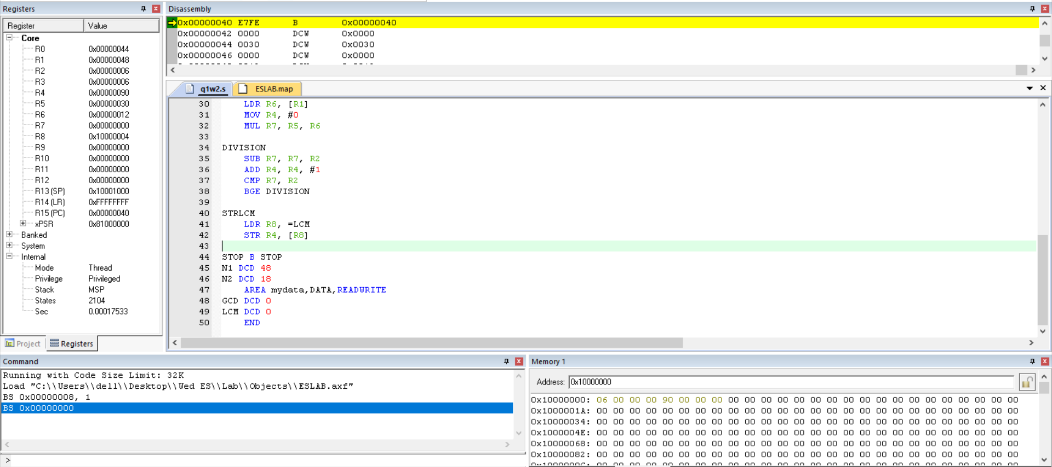

4. Write an ARM assembly language program to convert 2-digit hexadecimal number into ascii format.

AREA RESET,DATA,READONLY
EXPORT __Vectors
__Vectors
DCD 0X10001000
DCD Reset_Handler
ALIGN
AREA mycode,CODE,READONLY
ENTRY
EXPORT Reset_Handler
Reset_Handler
LDR R0, =SRC
LDR R1, [R0]
LDR R9, =DST
MOV R5, #100
BCD
CMP R1, R5
BLT DIV2
MOV R4, #0
DIV1
SUB R1, R1, R5
ADD R4, R4, #1
CMP R1, R5
BGE DIV1
ADD R4, R4, #48
STR R4, [R9], #4
CMP R5, #10
MOV R4, #0
BLT LEND ;loop end
DIV2
SUB R5, R5, #10
ADD R4, R4, #1
CMP R5, #10
BGE DIV2
LEND
MOV R5, R4
CMP R5, #0
BNE BCD
STOP
B STOP
SRC DCD 0x98
AREA mydata, DATA, READWRITE
DST DCD 0
END
OUTPUT :

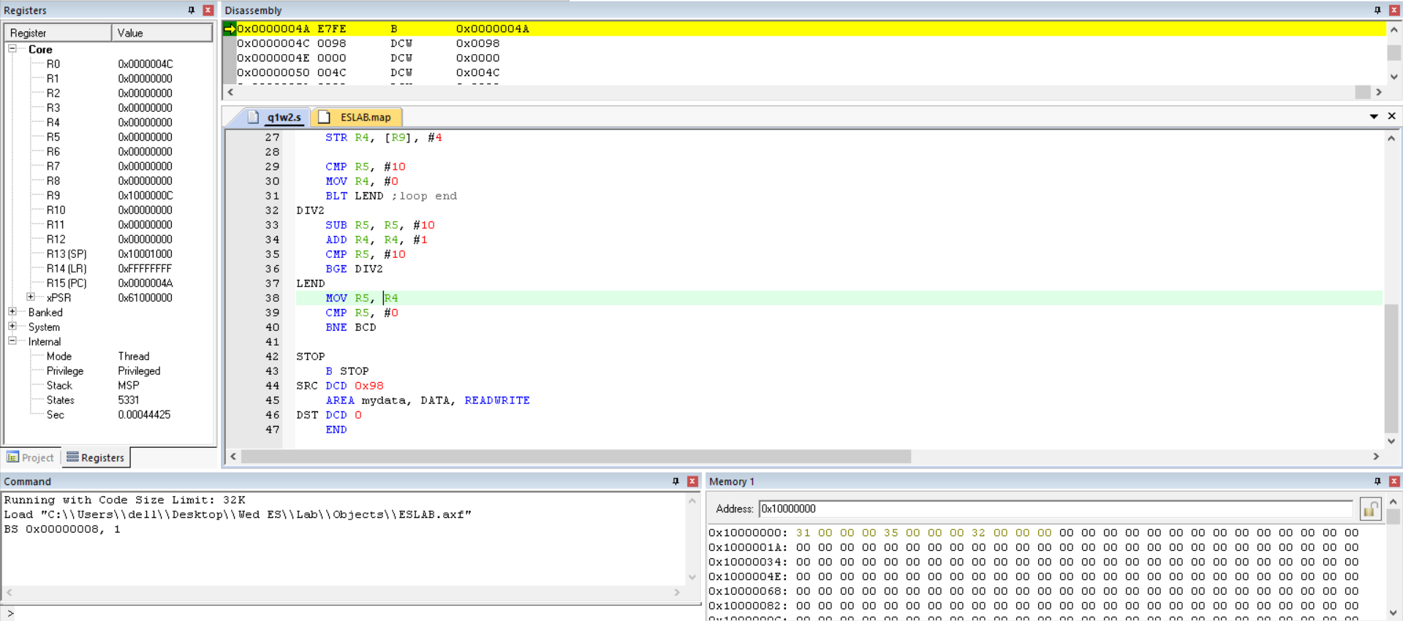

5. Write an ARM assembly language program to convert a 32-bit BCD number in the unpacked form into packed form.

AREA RESET,DATA,READONLY
EXPORT __Vectors
__Vectors
DCD 0X10001000
DCD Reset_Handler
ALIGN
AREA mycode,CODE,READONLY
ENTRY
EXPORT Reset_Handler
Reset_Handler
LDR R0, =SRC
LDR R1, =0x01
MOV R4, #4
UP STR R1,[R0],#1
ADD R1, #2
SUBS R4,#4
BNE UP ;POPULATING UNPACKED
LDR R0,=SRC
LDR R7,=DST
MOV R3,#2
LOOP LDRB R1,[R0],#1
ROR R1,#28
LDRB R2,[R0],#1
ORR R2,R2,R1
STRB R2,[R7],#1
SUBS R3,#1
BNE LOOP
STOP
B STOP
AREA mydata, DATA, READWRITE
SRC DCD 0
DST DCD 0
END

OUTPUT :

