190905514 C SECTION 4th SEMESTER MOHAMMAD TOFIK

SOLVED EXCERCISE :

1.Write an ARM ALP to sort a list using bubble sort.

AREA RESET,DATA,READONLY
EXPORT __Vectors
__Vectors
DCD 0x10001000
DCD Reset_Handler
ALIGN
AREA mycode,CODE,READONLY
ENTRY
EXPORT Reset_Handler
Reset_Handler
mov r4,#0
mov r1,#10
ldr r0, =list
ldr r2, =result
up ldr r3, [r0,r4]
str r3, [r2,r4]
add r4, #04
sub r1,#01
cmp r1,#00
bhi up
ldr r0, =result
mov r3, #10 ; inner loop counter
sub r3, r3, #1
mov r9, r3 ; R9 contain no of passes
; outer loop counter
outer_loop
mov r5, r0
mov r4, r3 ; R4 contains no of comparison in a pass
inner_loop
ldr r6, [r5], #4
ldr r7, [r5]
cmp r7, r6
; swap without swap instruction
strls r6, [r5]
strls r7, [r5, #-4]
subs r4, r4, #1
bne inner_loop
sub r3, #1
subs r9, r9, #1
bne outer_loop
list dcd 0x10,0x05,0x33,0x24,0x56,0x77,0x21,0x04,0x87,0x01
AREA data1, data, readwrite
result DCW 0,0,0,0,0,0,0,0,0,0
end
OUTPUT :

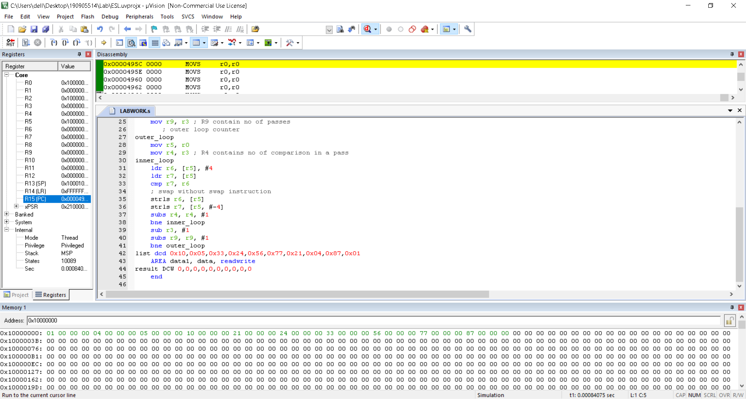

LAB EXCERCISE :

1.Write an assembly program to sort an array using selection sort.
Program:
AREA RESET,DATA,READONLY
EXPORT __Vectors
__Vectors
DCD 0x10001000
DCD Reset_Handler
ALIGN
AREA mycode,CODE,READONLY
ENTRY
EXPORT Reset_Handler
Reset_Handler
LDR R0, =SRC ;r0 is pointer to ith element
LDR R1, =N1
LDR R2,[r1] ;r2 stores number of elements
LDR R7, =DST
MOV R8,#0
up CMP R8,R2
BEQ out
ADD R8,#1
LDR R9,[R0],#4
STR R9,[R7],#4
B up
out LDR R0,=DST
MOV R1, R0 ;r1 is pointer to element to swap
MOV R3,R0 ;r3 is pointer to jth element
MOV R10,#0 ;r10 is counter for inner(j) loop
MOV R11,#0 ;r11 is counter for outer(i) loop
lp1 CMP R11, R2 ;comparing i<10
BEQ exit
ADD R3,R0,#4 ;sets jth pointer to A[i+1]
MOV R1,R0 ;sets swap element to A[i]
ADD R10,R11,#1 ;j=i+1
lp2 CMP R10,R2 ;j<10
BEQ oif
ADD R10,#1 ;j++
LDR R4,[R3],#4
LDR R5,[R1]
CMP R5,R4
BLT lp2
MOV R1,R3
SUB R1,#4
B lp2
oif ADD R11,#1
LDR R4,[R0]
LDR R5,[R1]
STR R4,[R1]
STR R5,[R0],#4
B lp1
exit
STOP
B STOP
N1 DCD 0xA
SRC DCD 0x32,0x63,0x10,0x19,0x28,0x39,0x86,0x67,0x23,0x13
AREA mydata,DATA,READWRITE
DST DCD 0,0,0,0,0,0,0,0,0,0
END

OUTPUT :

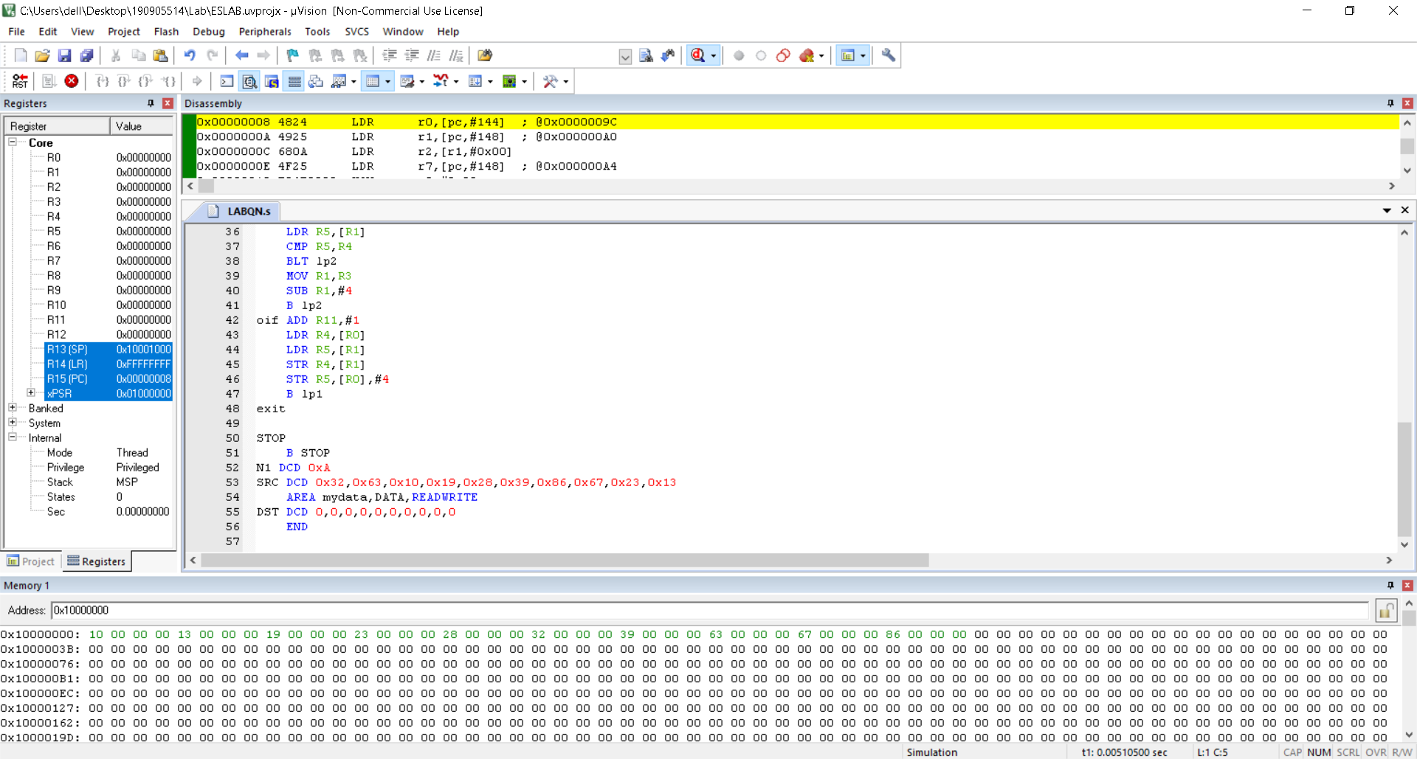

2.Write an assembly program to find the factorial of an unsigned number using recursion

AREA RESET, DATA, READONLY
EXPORT __Vectors
__Vectors
DCD 0X10001000
DCD Reset_Handler
ALIGN
AREA mycode, CODE, READONLY
ENTRY
EXPORT Reset_Handler
Reset_Handler

LDR R0,=input
LDR R1,=result
LDR R2,[R0]
BL fct
STR R2,[R1]
HERE B HERE
fct PUSH{R3,LR}
MOV R3,R2
CMP R2,#0
BNE dwn
MOV R2,#1
B dwn1
dwn SUB R2,#1
BL fct
MOV R4,R3
MUL R2,R4
dwn1 POP{R3,LR}
BX LR
input DCD 5
AREA mydata, DATA, READWRITE
result DCD 0
END

OUTPUT :

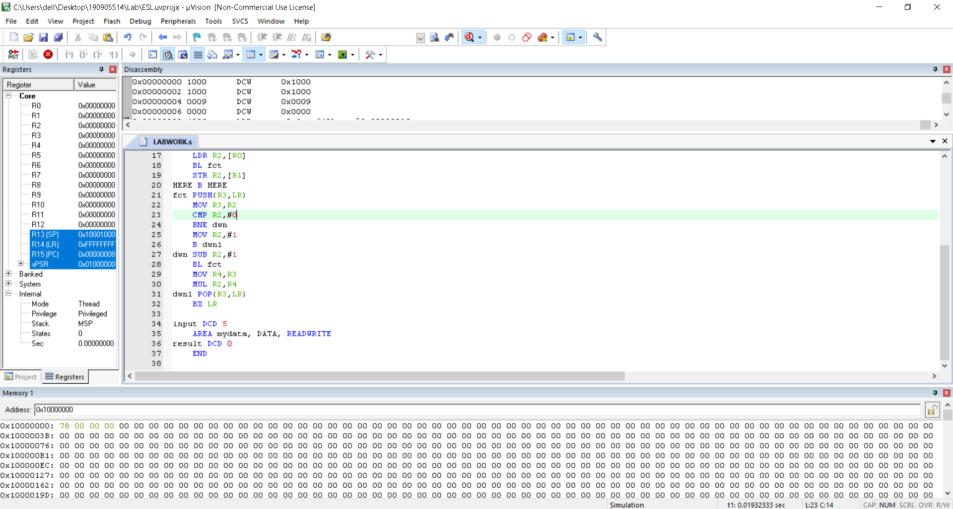

3.Write an assembly program to search an element in an array of ten 32 bit numbers using linear search.

AREA RESET, DATA, READONLY
EXPORT __Vectors

__Vectors
DCD 0X10001000
DCD Reset_Handler
ALIGN
AREA mycode, CODE,READONLY
ENTRY
EXPORT Reset_Handler

Reset_Handler
LDR R0,=SRC
LDR R1,=KEY
LDR R4,=DST
MOV R8,#10
LDR R3,[R1]
UP LDR R2,[R0],#4
CMP R3,R2
BEQ FOUND
SUBS R8,#1
CMP R8,#0
BEQ DOWN
BNE UP
DOWN MOV R9,#0
STRB R9,[R4]
B STOP
FOUND MOV R9,#1
STRB R9,[R4]
STOP
B STOP
SRC DCD 0,1,2,3,4,5,6,7,8,9
KEY DCD 3
AREA mydata,DATA,READWRITE
DST DCD 0
END

OUTPUT :

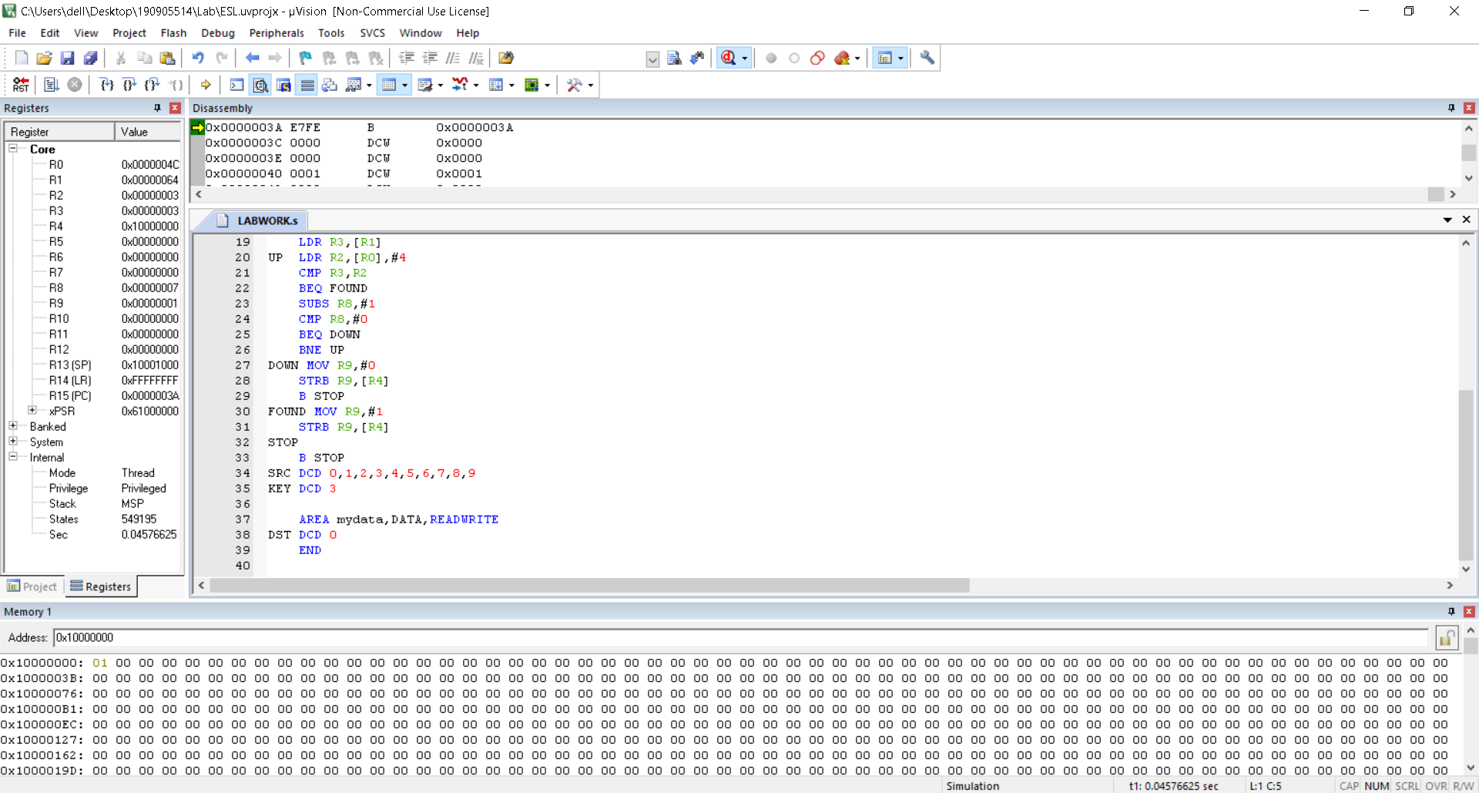

4.Assume that ten 32 bit numbers are stored in registers R1-R10. Sort these numbers in the empty ascending stack using selection sort and store the sorted array back into the registers. Use STM and LDMDB instructions wherever necessary.

AREA RESET,DATA,READONLY
EXPORT __Vectors
__Vectors
DCD 0x10001000
DCD Reset_Handler
ALIGN
AREA mycode,CODE,READONLY
ENTRY
EXPORT Reset_Handler
Reset_Handler
mov r1, #1
mov r2, #6
mov r3, #4
mov r4, #7
mov r5, #9
mov r6, #3
mov r7, #2
mov r8, #5
mov r9, #8
mov r10, #10
stmia r13!, {r1-r10}
mov r0, r13 ;r0 stores the stack top
mov r2, #10 ;r2 stores number of elements in stack
mov r8,#0 ;r8 is counter for outer loop
ol cmp r8,r2
beq exit
mov r1, r0
mov r3, r0
sub r3, #4
add r9,r8,#1
il cmp r9,r2
beq exin
add r9,#1
ldmdb r1,{r4}
ldmdb r3!,{r5}
cmp r5,r4
blt il
stmdb r1,{r5}
stm r3,{r4}
b il
exin sub r0,#4
add r8,#1
b ol
exit
ldmdb r13!,{r1-r10}
stop B stop
AREA mydata,DATA,READWRITE
END

OUTPUT :

