190905514 C SECTION 4th SEMESTER MOHAMMAD TOFIK

SOLVED EXCERSIZE :

/* Write a program to turn on/off the LEDs serially. */

#include <LPC17xx.h>
unsigned int i,j;
unsigned long LED = 0x00000010;
int main(void)
{
SystemInit(); //Add these two function for its internal operation
SystemCoreClockUpdate();
LPC_PINCON->PINSEL0 &= 0xFF0000FF;
//Configure Port0 PINS P0.4-P0.11 as GPIO function
LPC_GPIO0->FIODIR |= 0x00000FF0;
//Configure P0.4-P0.11 as output port
while(1)
{
LED = 0x00000010;
for(i=1;i<9;i++) //On the LED's serially
{
LPC_GPIO0->FIOSET = LED;
// Turn ON LED at LSB (LED connected to p0.4)
for(j=0;j<10000;j++){};
LED <<= 1;
} //loop for 8 times
LED = 0x00000010;

for(i=1;i<9;i++) //Off the LED's serially
{
LPC_GPIO0->FIOCLR = LED;
//Turn OFF LED at LSB (LED connected to p0.4)
for(j=0;j<10000;j++);
LED <<= 1;
}
}
}

OUTPUT :

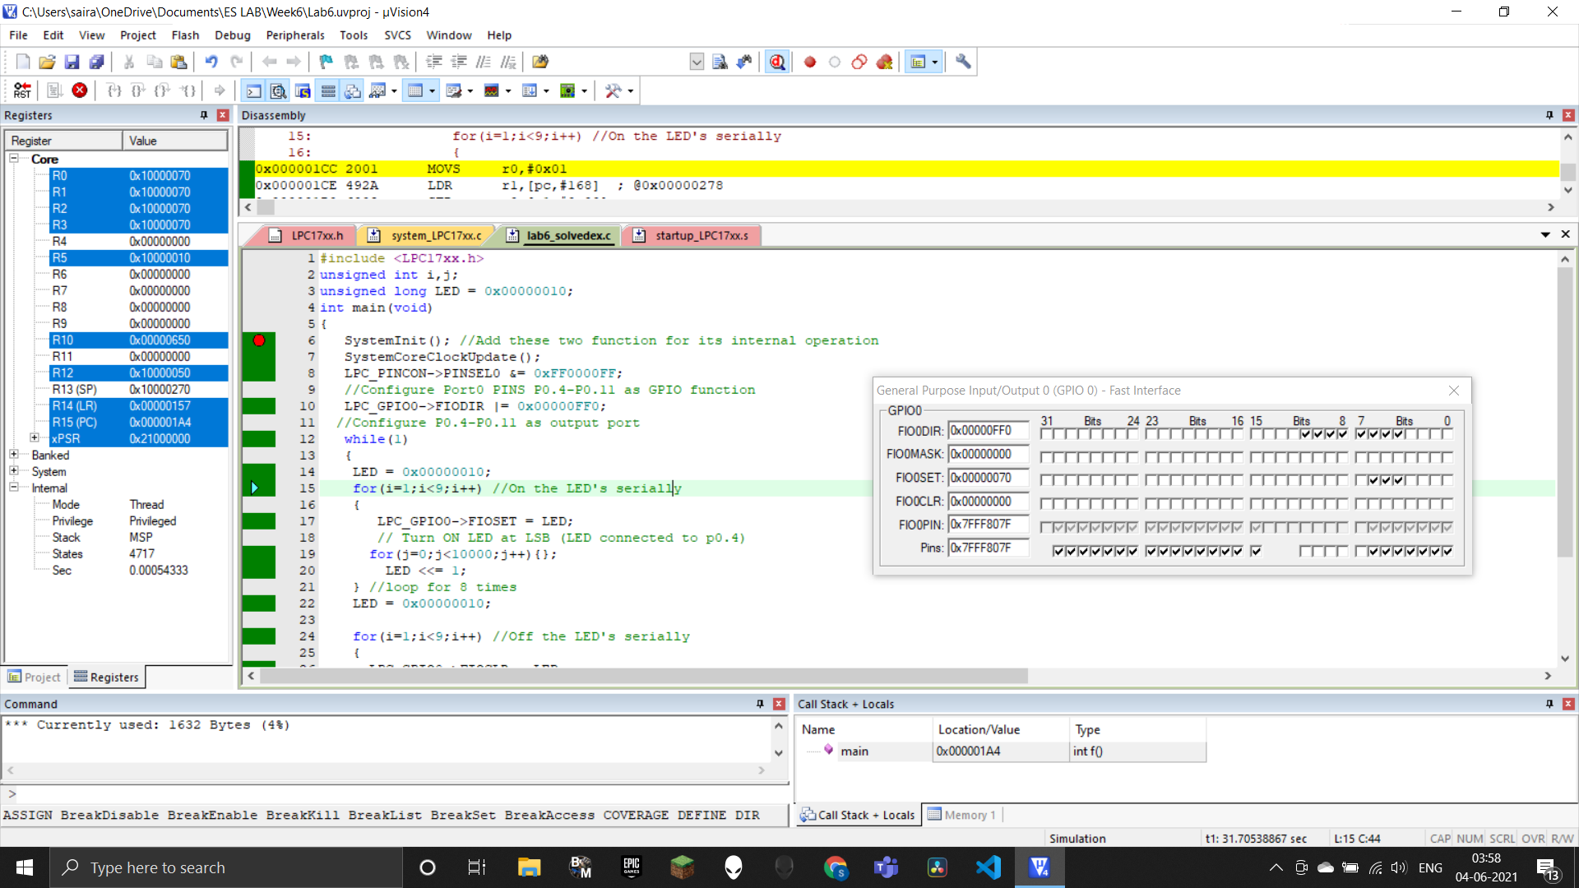

LAB EXCERSIZE :

1. Write a C program to display an 8-bit binary up counter on the LEDs

#include<LPC17xx.h>
unsigned int i, j, c = 0;
int main(void)
{
SystemInit();
SystemCoreClockUpdate();
LPC_PINCON->PINSEL0 &= 0xFF0000FF;
LPC_GPIO0->FIODIR |= 0x00000FF0;
while(1)
{
for(i=1;i<256;i++)
{
LPC_GPIO0->FIOPIN = c<<4;
for(j=0;j<30000;j++);
c++;
}
}
}

OUTPUT :

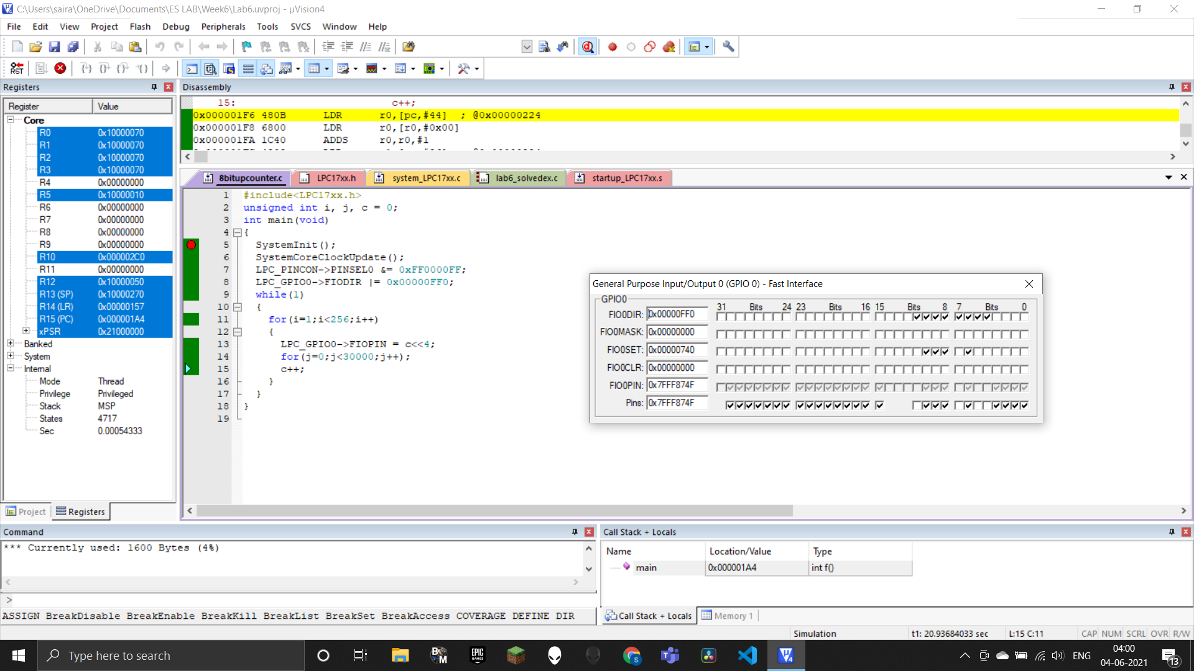

2. Write a C program to read a key and display an 8-bit up/down counter on the LEDs

#include<LPC17xx.h>
unsigned int i, j, c = 0;
int main(void)
{
SystemInit();
SystemCoreClockUpdate();
LPC_PINCON->PINSEL0 &= 0xFF0000FF;
LPC_GPIO0->FIODIR |= 0x00000FF0;
LPC_PINCON->PINSEL4 &= 0xFCFFFFFF;
LPC_GPIO2->FIODIR |= 0x0;
while(1)
{
if(LPC_GPIO2->FIOPIN & 1<<12)
c--;
else
c++;
if(c == -1)
c = 0xFF;
LPC_GPIO0->FIOPIN = c<<4;
if(c == 0x100)
c = 0x00;
for(i=0; i<20000; i++);
}
}
OUTPUT :

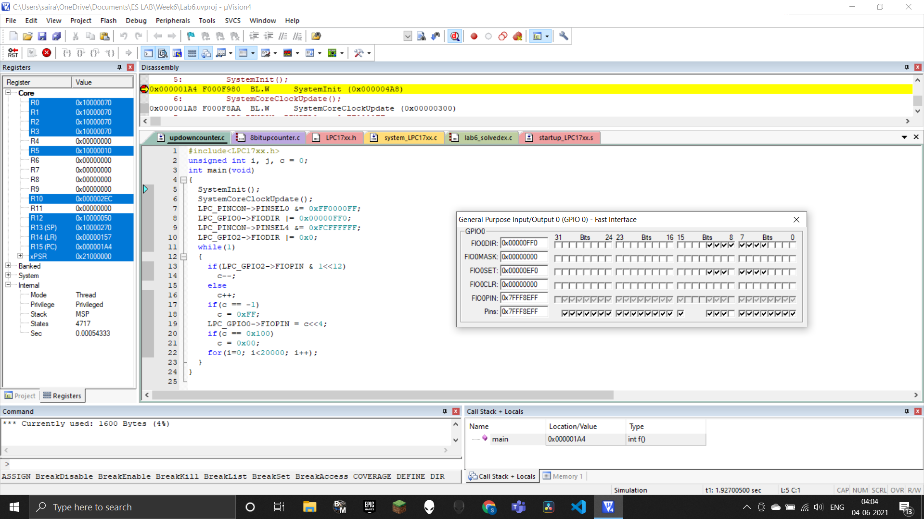

3. Write a program to simulate an 8- bit ring counter with key press (SW2).

#include<LPC17xx.h>
unsigned int i,j;
unsigned long int LED;
int main(void)
{
SystemInit();
SystemCoreClockUpdate();
LPC_PINCON->PINSEL0 &= 0xFF0000FF;
LPC_GPIO0->FIODIR |= 0x00000FF0;
while(1)
{
LED=0X00000010;
for(i=1;i<9;i++)
{
LPC_GPIO0->FIOSET=LED;
for(j=0;j<20000;j++);
LPC_GPIO0->FIOCLR=LED;
LED<<=1;
}
}

}

OUTPUT :

