190905514 MOHAMMAD TOFIK

WEEK 5 LAB 5
Q.
Implement a circular queue of Strings using structures. Include functions insertcq, deletecqand displaycq.

pgm1.c

#include<stdio.h>
#include<stdlib.h>
#include<string.h>
#define MAXIMUM 16
#define STRING 23
typedef struct
{
char cqueue[MAXIMUM][STRING];
int front;
int rear;
} CQUEUE;

void insert(CQUEUE *queue,char a[])
{
if((queue->rear+1)%(MAXIMUM+1)==queue->front)
{
printf("\n\t\t\t\tQueue is full :\n\n");
return;
}
queue->rear=(queue->rear+1)%(MAXIMUM+1);
strcpy(queue->cqueue[queue->rear],a);
}

void delete(CQUEUE *queue)
{
if(queue->rear==queue->front)
{
printf("\n\t\t\t\tQueue is empty : \n\n");
return;
}
char ch[STRING];
queue->front=(queue->front+1)%(MAXIMUM+1);
strcpy(ch,queue->cqueue[queue->front]);
printf("\n\t\t\t\t%s",ch);
}

void display(CQUEUE *queue)
{
if(queue->rear==queue->front)
{
printf(" \n\t\t\tQueue is empty : \n\n");
return;
}
int myName =(queue->front+1)%(MAXIMUM+1);
for(; myName!=queue->rear; myName =(myName+1)%(MAXIMUM+1))
{
printf("\n\t\t\t\t%s ",queue->cqueue[myName]);
}
printf("\n\t\t\t\t%s ",queue->cqueue[myName]);
}

int main()
{

char myName[MAXIMUM];
CQUEUE *queue,queue1;
queue=&queue1;
queue->rear=queue->front=-1;
while(1)
{
int choice;
printf("\n\t\t\t-------------------------------------------------\n");
printf("\n\t\t\t\tIMPLEMENTATION OF CIRCULAR QUEUE\n");
printf("\n\t\t\t-------------------------------------------------\n");
printf("\n\t\t\t\t1- INSERT\n");
printf("\n\t\t\t\t2- DELETE \n");
printf("\n\t\t\t\t3- DISPLAY\n");
printf("\n\t\t\t\t4-EXIT");
printf("\n\t\t\t-------------------------------------------------\n");
printf("\n\t\t\t\tEnter your choice : ");
scanf("%d",&choice);
printf("\n\t\t\t-------------------------------------------------\n");
switch(choice)
{
case 1:
printf("\n\t\t\t\tEnter the string : ");

scanf("%s",myName);

insert(&queue1,myName);
break;
case 2:
delete(&queue1);
break;
case 3:
display(&queue1);
break;
case 4:
exit(0);
break;
default :
printf("\n\t\t\t\tInvalid Choice \n\n");
}
}
return 0;
}

OUTPUT :
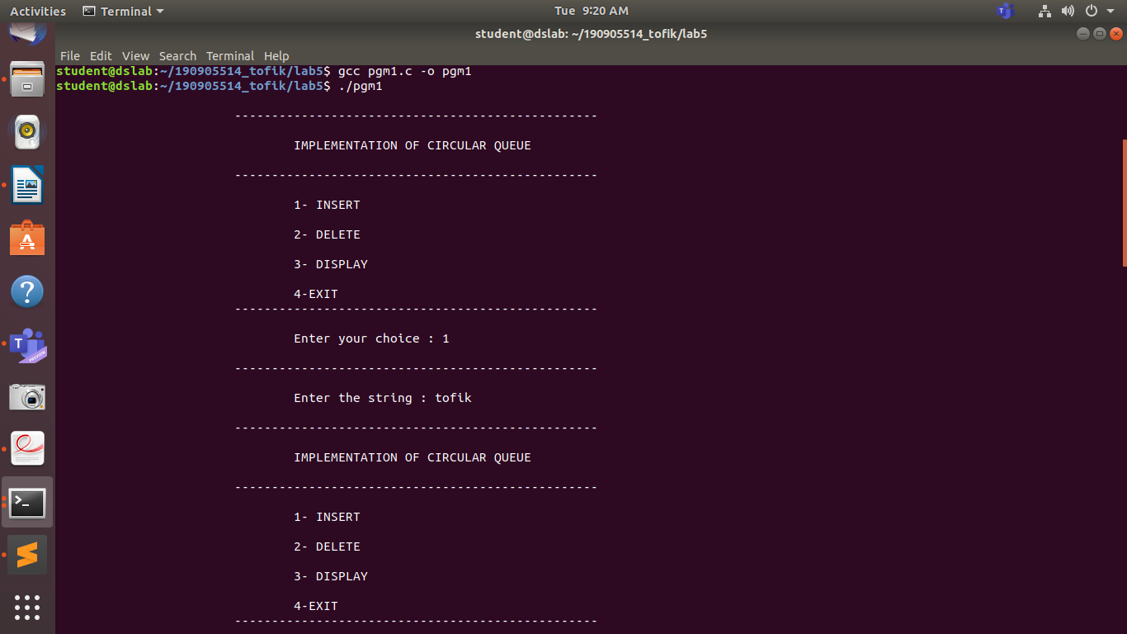
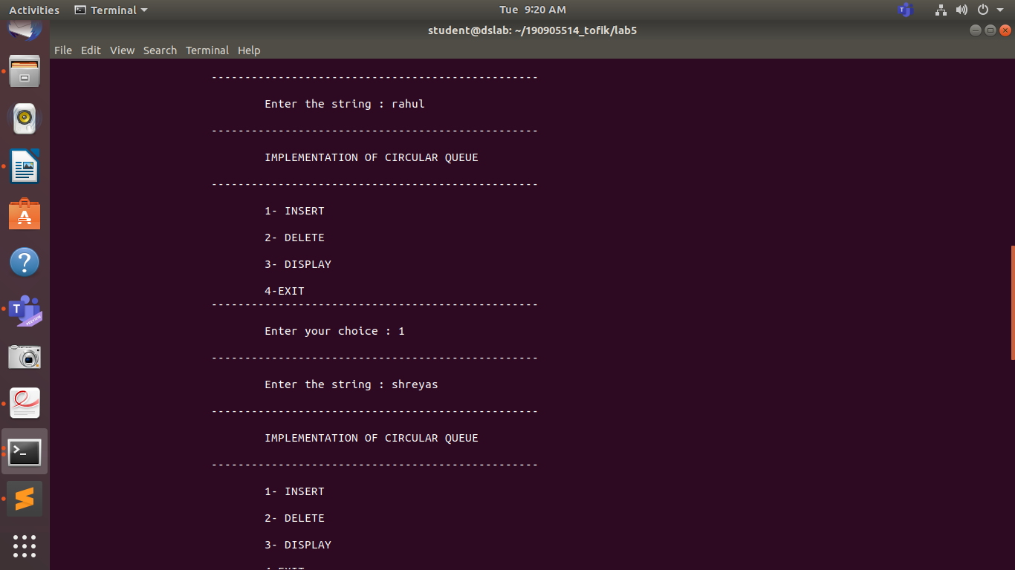
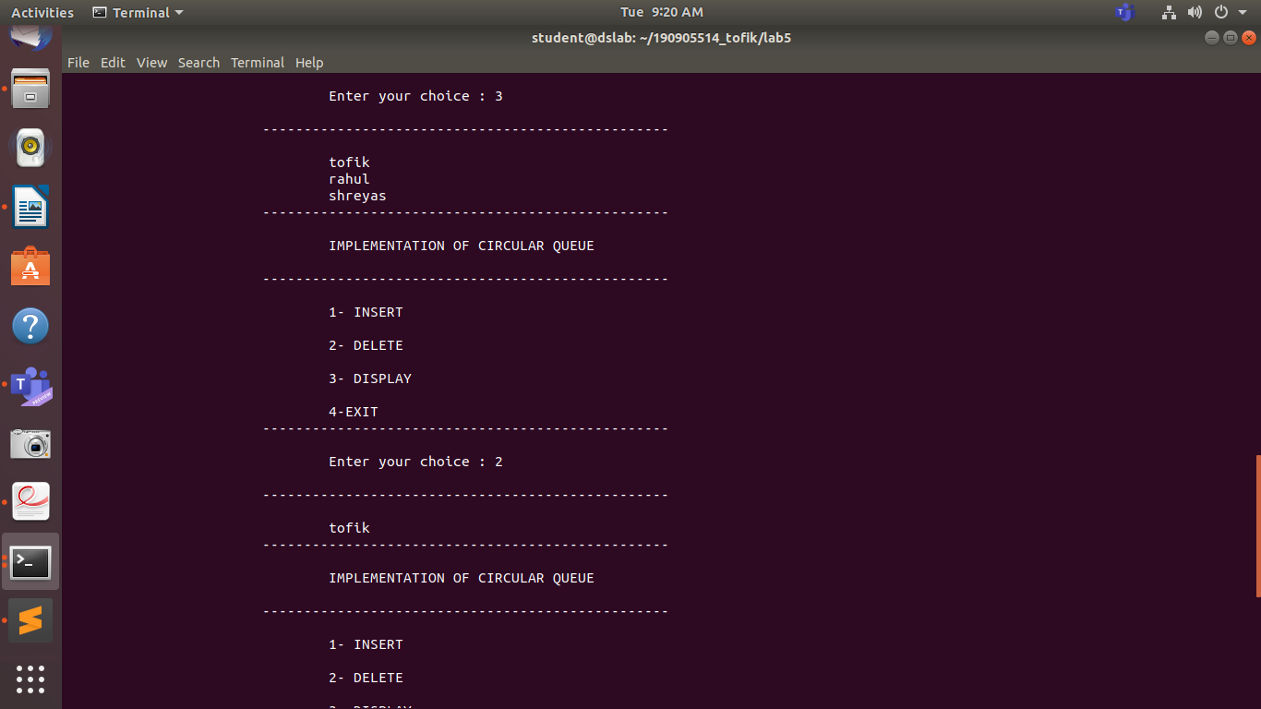
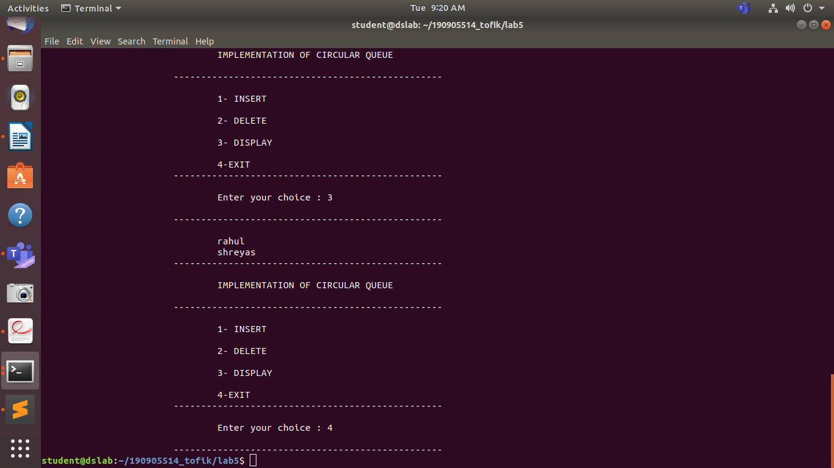

Q.

Implement two circular queues of integers in a single array where first queue will run from
0 to N/2 and second queue will run from N/2+1 to N-1 where N is the size of the array.

pgm2.c

#include<stdio.h>
#include<stdlib.h>
#include<string.h>
#define SIZE 20
#define n 2
int MAXIMUM = SIZE/n;
int queue[SIZE];
int front[n];
int rear[n];
void construct(){
rear[0]=front[0]=0;
rear[1]=front[1]=SIZE/n;

}
void insert(int i,int ch){
if((rear[i]+1)%(MAXIMUM)+ (i*MAXIMUM)==front[i]){
printf("\n\t\t\t\tQueue is empty: \n\n");
return;
}
rear[i]=(rear[i]+1)%(MAXIMUM)+ (i*MAXIMUM);
queue[rear[i]]=ch;
//printf("\nfront and rear %d and %d\n",front[i],rear[i]);
}

int delete(int i){
if(rear[i]==front[i]){
printf("\n\t\t\t\tQueue is empty: \n\n");
return -1;
}
front[i]=(front[i]+1)%(MAXIMUM)+ (i*MAXIMUM);
return queue[front[i]];
}

void display(int i){
if(rear[i]==front[i]){
printf("\n\t\t\t\tQueue is empty : \n\n\n");
return ;
}
int myName;
printf("\n\t\t\t\tQueue is : \n\n ");
for(myName=(front[i]+1)%MAXIMUM+(i*MAXIMUM);
myName!=rear[i];
myName=((myName+1)%MAXIMUM+(i*MAXIMUM)))
printf("%d ",queue[myName]);
printf("\n\t\t\t\t%d ",queue[myName]);
printf("\n\n");
}
int main(){

construct();

int myName,i,j;
while(1)
{
int choice;
printf("\n\t\t\t-------------------------------------------------\n");
printf("\n\t\t\t\tIMPLEMENTATION OF TWO CIRCULAR QUEUE IN AN ARRAY\n");
printf("\n\t\t\t-------------------------------------------------\n\n");
printf("\n\t\t\t\t1- INSERT\n");
printf("\n\t\t\t\t2- DELETE\n");
printf("\n\t\t\t\t3- DISPLAY\n");
printf("\n\t\t\t\t4- EXIT\n");
printf("\n\t\t\t-------------------------------------------------\n\n");
printf("\n\t\t\t\tEnter the choice : ");
scanf("%d",&choice);
switch(choice){
case 1:
printf("\n\t\t\t\tEnter the number : ");
scanf("%d",&myName);
printf("\n\t\t\t\t Enter the queue number : ");
scanf("%d",&i);
insert(i-1,myName);
break;
case 2:
printf("\n\t\t\t\tEnter the queue number : ");
scanf("%d",&i);
j = delete(i-1);
if(j!=-1)printf("\n\t\t\t\tELEMENT DELETED IS : %d\n",j);
break;

case 3:
printf("\n\t\t\t\tENTER QUEUE NO : ");
scanf("%d",&i);
display(i-1);
break;

case 4 :
printf("\n\t\t\t\texiting\n");
exit(0);

default:
printf("\n\t\t\t\twrong\n");
break;

}
}
return 0;
}

OUTPUT :

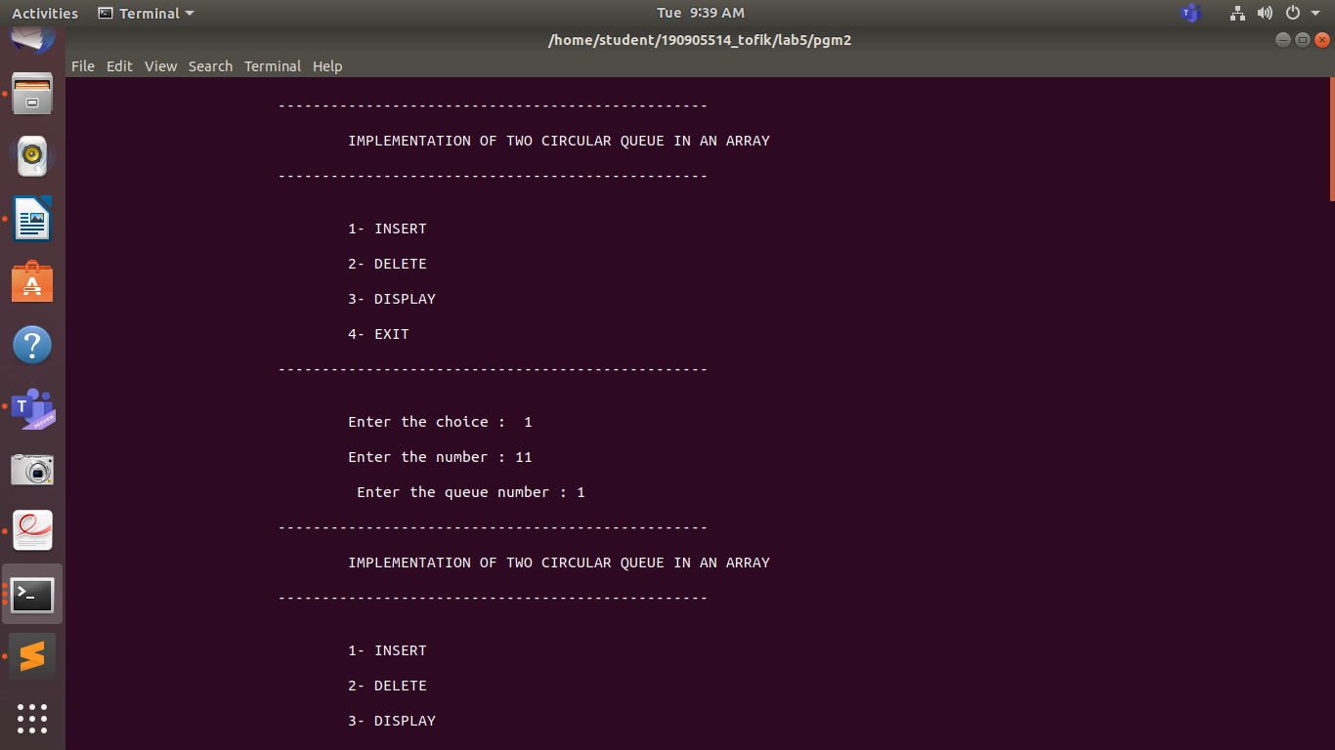
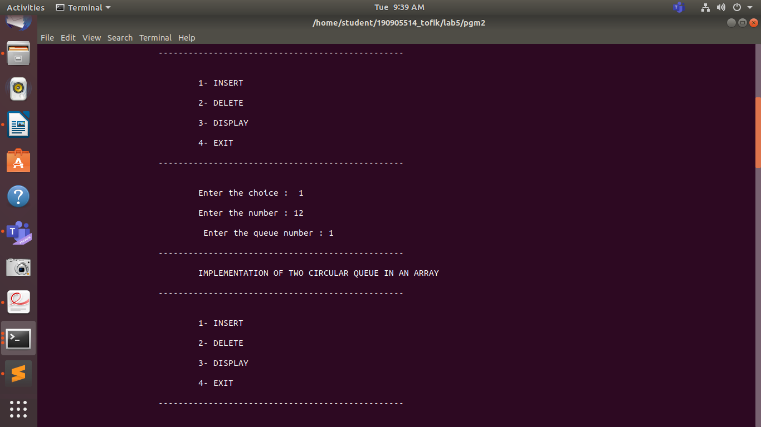
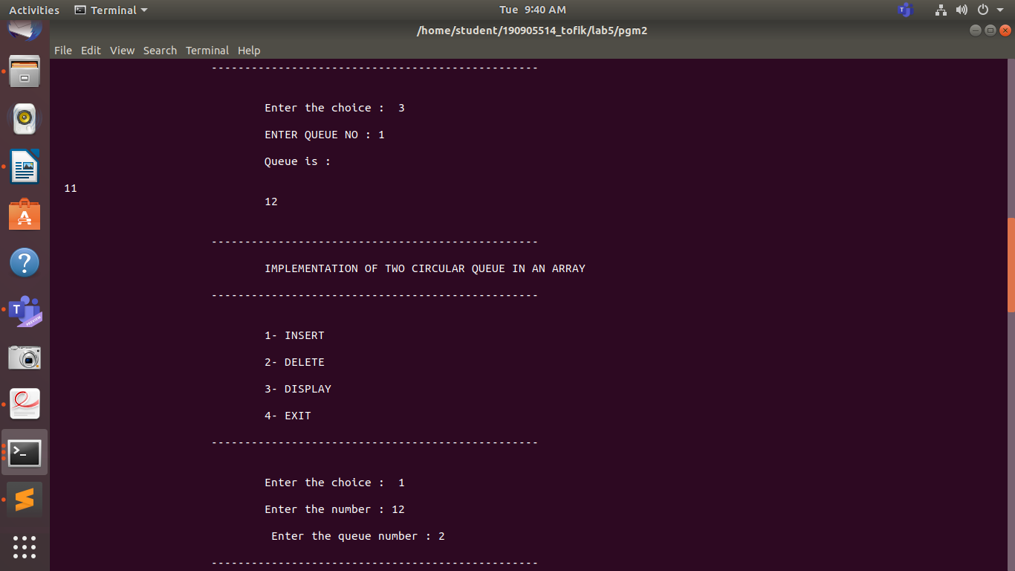
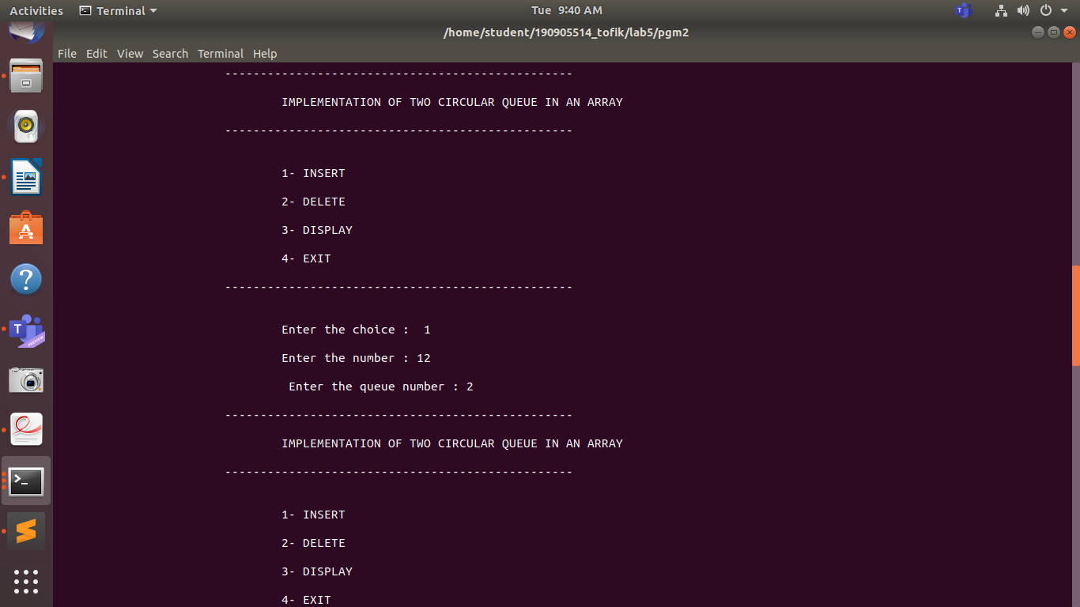
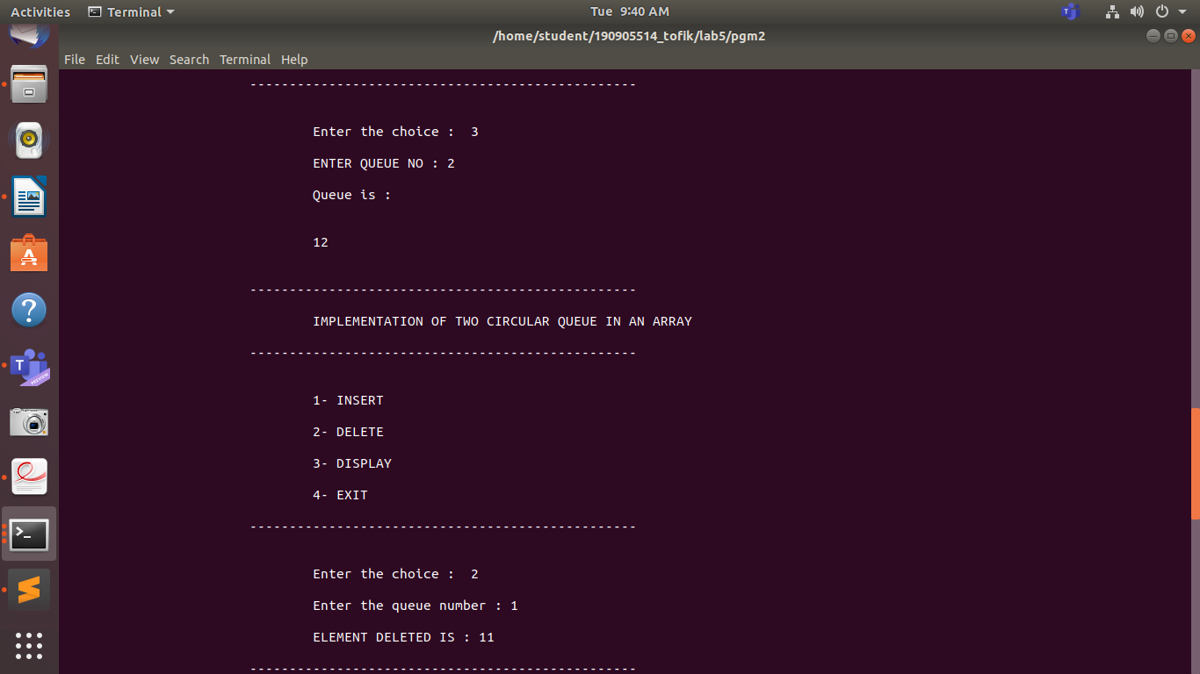
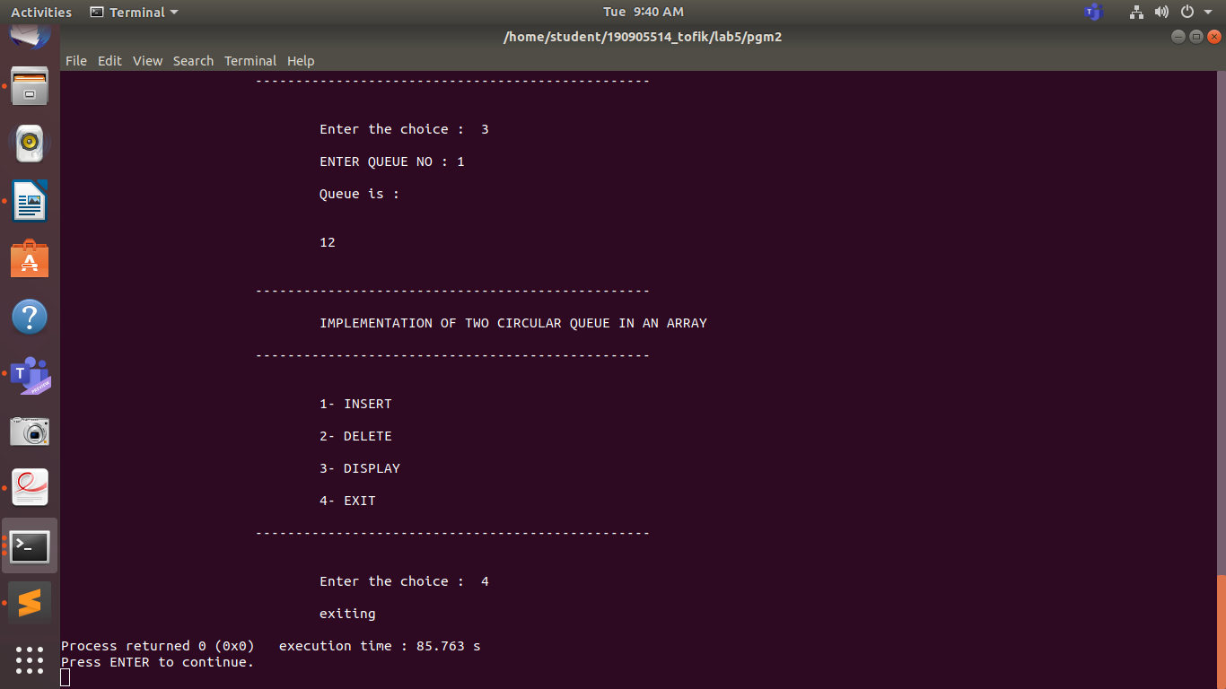

Q.
Implement a queue with two stacks without transferring the elements of the second stack
back to stack one. (use stack1 as an input stack and stack2 as an output stack).

pgm3.c

#include<stdio.h>
#include<stdlib.h>
#include<string.h>
#define MAXSIZE 10
int input[MAXSIZE];
int output[MAXSIZE];
int top1=-1,top2=-1;

void insert(int i){
if(top1==MAXSIZE-1){
printf("\n\t\t\t\tQUEUE IS FULL\n");
return;
}
input[++top1]=i;
}

int delete(){
if(top1==-1 && top2==-1){
printf("\n\t\t\t\tQUEUE IS EMPTY : \n");
return -1;
}
if(top2==-1){
while(top1!=-1){
output[++top2]=input[top1--];
}
}
return output[top2--];
}
void display(){
if(top1==-1 && top2==-1){
printf("\n\t\t\t\tQUEUE IS EMPTY : \n");
return ;
}
int myName = top2;
printf("\n\t\t\t\tQUEUE IS : ");
for(;myName>-1;myName--)
printf("\n\t\t\t%d ",output[myName]);
for(myName=0;myName<=top1;myName++)
printf("\n\t\t\t%d ",input[myName]);
printf("\n");
}

int main(){

int x,i,j;
while(1)
{
int choice;
printf("\n\t\t\t-------------------------------------------------\n");
printf("\n\t\t\t\tIMPLEMENTATION OF QUEUE WITH TWO STACK \n");
printf("\n\t\t\t-------------------------------------------------\n");
printf("\n\t\t\t\t1- INSERT\n");
printf("\n\t\t\t\t2- DELETE\n");
printf("\n\t\t\t\t3- DISPLAY\n");
printf("\n\t\t\t\t4- EXIT\n");
printf("\n\t\t\t-------------------------------------------------\n\n");
printf("\n\t\t\t\tEnter your choice : ");
scanf("%d",&choice);
switch(choice){
case 1:
printf("\n\t\t\t\tENTER THE ELEMENT : ");
scanf("%d",&x);
insert(x);
break;
case 2:
j = delete();
if(j!=-1)printf("\n\t\t\t\tELEMENT DELETED IS : %d",j);
break;

case 3:
display();
break;

case 4 :
printf("\n\t\t\t\tEXITTING .......\n");
exit(0);

default:
printf("\n\t\t\t\tInvalid choice\n");
break;

}
}
return 0;
}

OUTPUT :

