190905514 MOHAMMAD TOFIK

WEEK 5 LAB 5 :

Q1.Implement an ascending priority queue.
Note: An ascending priority queue is a collection of items into which items can be inserted
arbitrarily and from which only the smallest item can be removed. If apq is an ascending
priority queue, the operation pqinsert(apq,x) inserts element x into apq and
pqmindelete(apq) removes the minimum element from apq and returns its value.

pgm1.c

#include<stdio.h>
#include<stdlib.h>
#include<string.h>
#define MAXIMUM 45
typedef struct{
int QUEUE[MAXIMUM];
int front;
int rear;
}PQUEUE;

void insertPQ(PQUEUE *queue,int myName){
int i,j;
for(i=queue->front+1;i<=queue->rear;i++)
if(queue->QUEUE[i]>myName)
break;
if(i<=queue->rear){
for(j=queue->rear;j>=i;j--)
queue->QUEUE[j+1]=queue->QUEUE[j];
}
queue->QUEUE[i]=myName;
queue->rear++;
}

int deletePQ(PQUEUE *queue){
if (queue->front==queue->rear){
printf("\n\t\t\t\tQueue is Empty : \n\n");
return -1;
}
return queue->QUEUE[++queue->front];
}

void displayPQ(PQUEUE *queue){
if (queue->front==queue->rear){
printf("\n\t\t\t\tQueue is Empty \n\n");
return ;
}
int i;
printf("\n\t\t\t\tQueue is : ");
printf(“\n\n”);
for(i=queue->front+1;i<=queue->rear;i++)
printf("\n\t\t\t\t%d ",queue->QUEUE[i]);
printf("\n\n");
}

int main(){
PQUEUE queue1,*queue;
queue=&queue1;
queue->front=queue->rear=-1;
int myName,i,j;
while(1)
{
int choice;
printf("\n\t\t\t-------------------------------------------------\n");
printf("\n\t\t\t\tIMPLEMENTATION OF PRIORITY QUEUE\n");
printf("\n\t\t\t-------------------------------------------------\n\n");
printf("\n\t\t\t\t1- INSERT\n");
printf("\n\t\t\t\t2- DELETE\n");
printf("\n\t\t\t\t3- DISPLAY\n");
printf("\n\t\t\t\t4- EXIT\n");
printf("\n\t\t\t-------------------------------------------------\n");
printf("\n\t\t\t\tEnter your choice : ");
scanf("%d",&choice);
printf("\n\t\t\t-------------------------------------------------\n\n");
switch(choice){
case 1:
printf("\n\t\t\t\tEnter the element : ");
scanf("%d",&myName);
insertPQ(queue,myName);
break;
case 2:
j = deletePQ(queue);
if(j!=-1)printf("\n\t\t\t\tELEMENT DELETED IS : %d\n",j);
break;

case 3:
displayPQ(queue);
break;

case 4 :
printf("\n\t\t\t\tEXITTING.................\n\n");
exit(0);

default:
printf("\n\t\t\t\tInvalid choice ! \n\n");
break;

}
}
return 0;
}

OUTPUT :
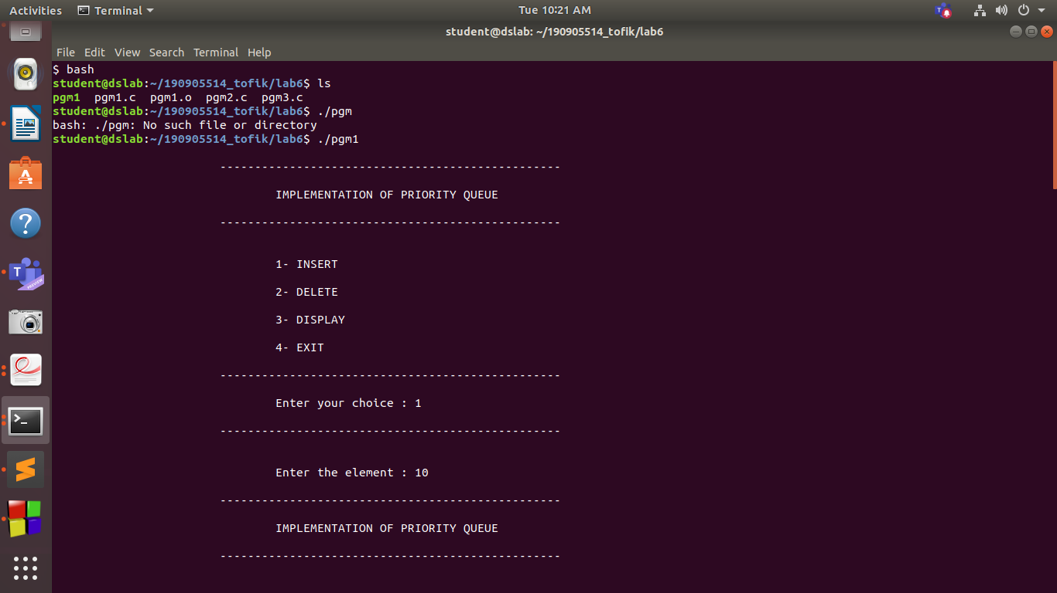
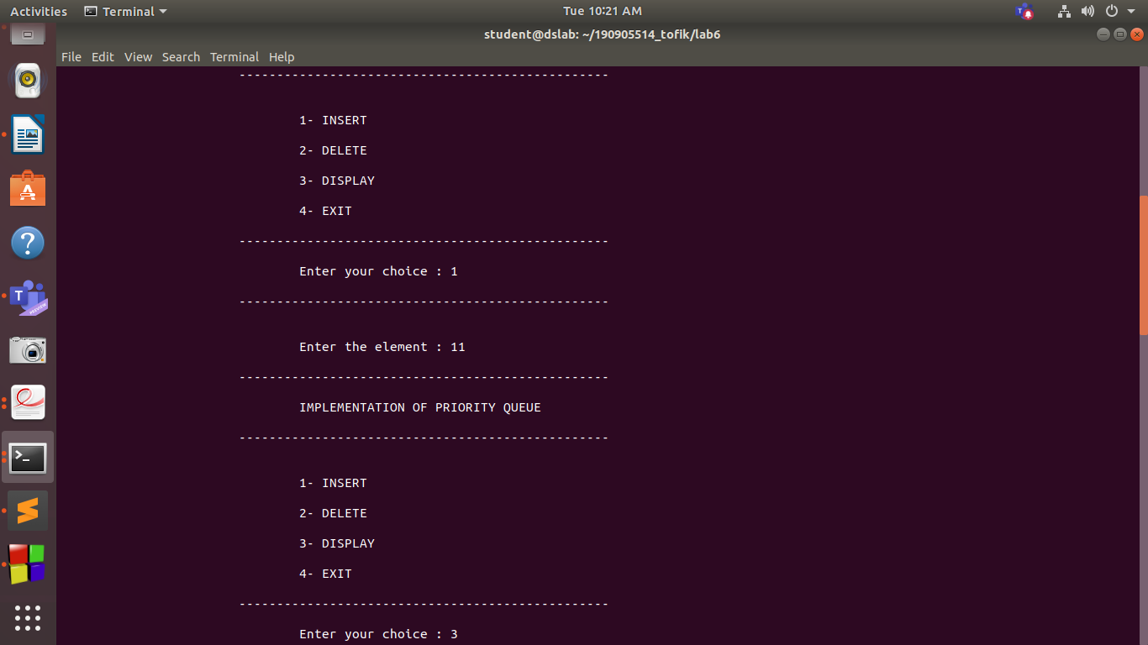
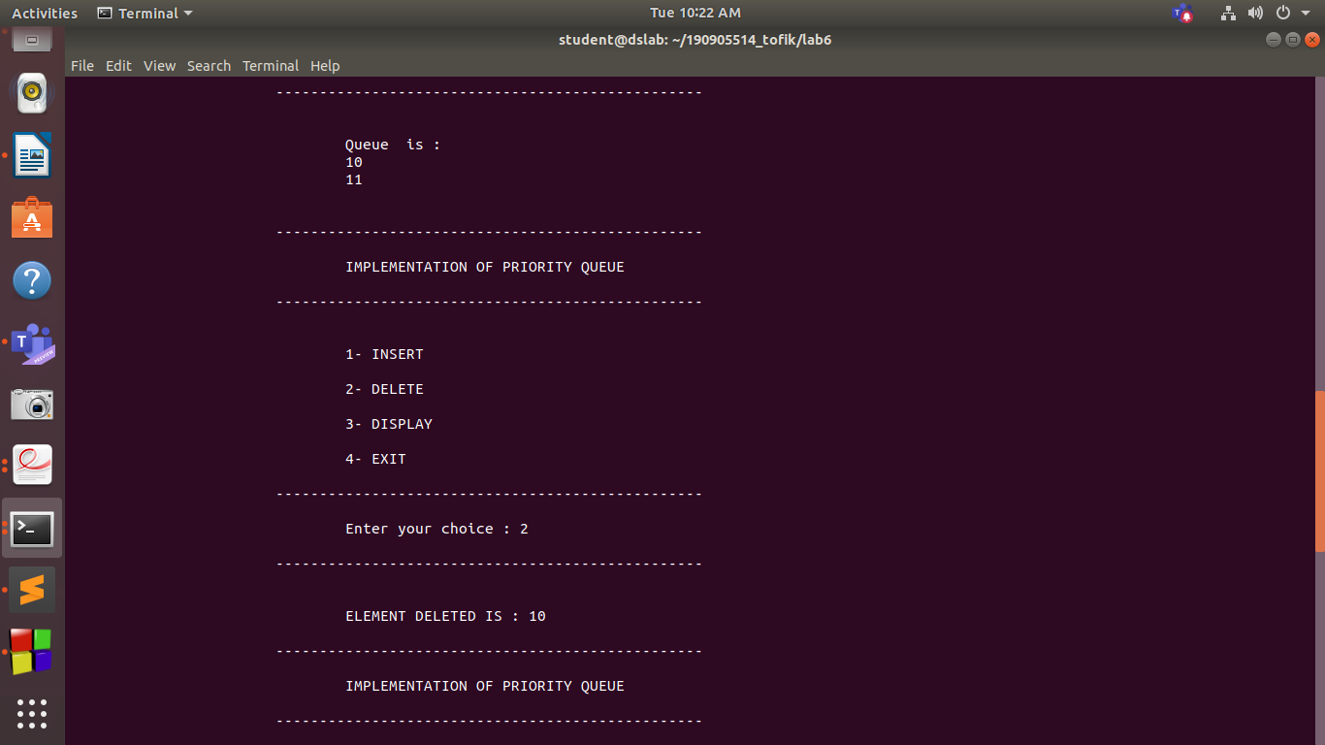
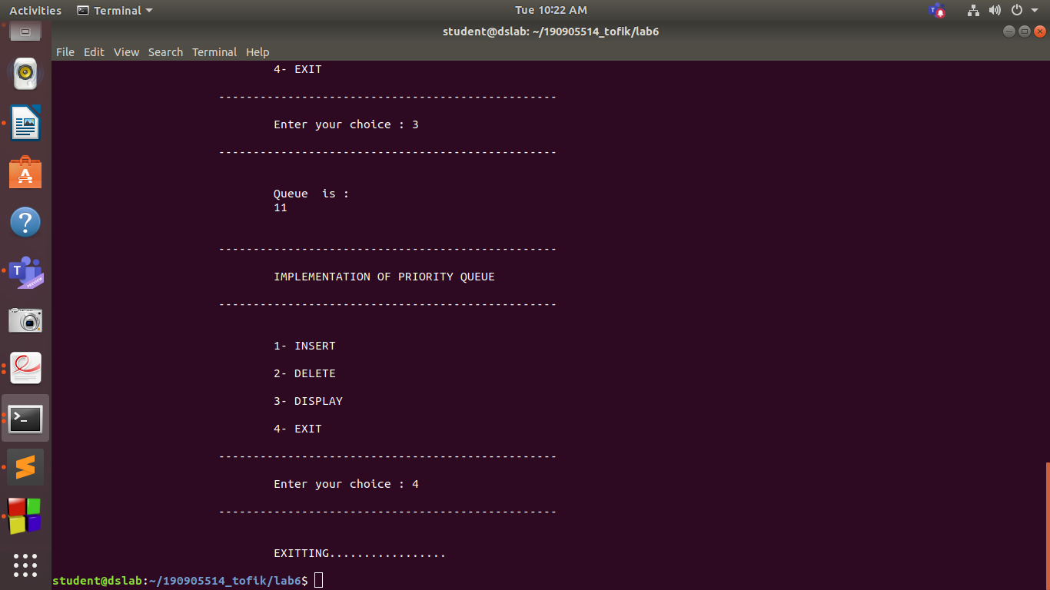

Q.2 Implement a queue of strings using an output restricted dequeue (no deleteRight).
Note: An output-restricted deque is one where insertion can be made at both ends, but
deletion can be made from one end only, where as An input-restricted deque is one where
deletion can be made from both ends, but insertion can be made at one end only.

pgm2.c

#include<stdio.h>
#include<stdlib.h>
#include<string.h>
#define MAXIMUM 60
#define STRING 26
typedef struct
{
char queue[MAXIMUM][STRING];
int front;
int rear;
} QUEUE;
void insertf(QUEUE *q,char ch[]);
void insertend(QUEUE *q,char ch[]);
void deletef(QUEUE *q);
void display(QUEUE *q);
int main()
{
char myName[STRING],j;
QUEUE *q,q1;
q = &q1;
q1.front = -1;
q1.rear = -1;
while(1)
{
int choice;
printf("\n\t\t\t-------------------------------------------------\n");
printf("\n\t\t\t\tIMPLEMENTATION OF CIRCULAR QUEUE\n");
printf("\n\t\t\t-------------------------------------------------\n\n");
printf("\n\t\t\t\t1- INSERT FROM FRONT");
printf("\n\t\t\t\t2- INSERT FRON END");
printf("\n\t\t\t\t3- DELETE FROM FRONT");
printf("\n\t\t\t\t4- DISPLAY");
printf("\n\t\t\t\t5- EXIT");
printf("\n\t\t\t-------------------------------------------------\n\n");
printf("\n\t\t\t\tEnter your choice :");
scanf("%d",&choice);
printf("\n\t\t\t-------------------------------------------------\n\n");
switch(choice)
{
case 1:
printf("\n\t\t\t\tEnter the string : ");

scanf("%s",myName);

insertf(&q1,myName);
break;
case 2:
printf("\n\t\t\t\tEnter the string : ");

scanf("%s",myName);

insertend(&q1,myName);
break;
case 3:
deletef(&q1);
break;
case 4:
display(&q1);
break;
case 5:
exit(0);
break;
default :
printf("\n\t\t\t\tInvalid choice ! \n");
}
}
return 0;
}

void insertf(QUEUE *q, char ch[])
{
if(q->rear==MAXIMUM-1 && q->front==0)
{
printf("\n\t\t\t\tQueue is full : \n");
return;
}
else if(q->front==-1)
{
q->front=q->rear=0;
strcpy(q->queue[q->front],ch);
}
else if(q->rear!=MAXIMUM-1)
{
int i=q->rear+1;
while(i>q->front)
{
strcpy(q->queue[i],q->queue[i-1]);
i=i-1;
}
strcpy(q->queue[q->front],ch);

q->rear++;
}
else
{
q->front--;
strcpy(q->queue[q->front],ch);
}
//printf("%d and %d\n",q->front,q->rear);
//printf("%s and %s\n",q->queue[q->front],q->queue[q->rear]);
}

void insertend(QUEUE *q, char ch[])
{
if(q->rear==MAXIMUM-1 && q->front==0)
{
printf("\n\t\t\t\tQueue is full : \n");
return;
}
else if(q->front==-1)
{
q->front=q->rear=0;
strcpy(q->queue[q->rear],ch);
}
else if(q->front!=0)
{
int i=q->front-1;
while(i<q->rear)
{
strcpy(q->queue[i],q->queue[i+1]);
i=i+1;
}
strcpy(q->queue[q->rear],ch);
q->front--;
}
else
{
q->rear++;
strcpy(q->queue[q->rear],ch);
}
//printf("%d and %d\n",q->front,q->rear);
//printf("%s and %s\n", q->queue[q->front], q->queue[q->rear]);
}

void deletef(QUEUE *q)
{
if(q->front==-1)
{

printf("\n\t\t\t\tQueue is empty : \n");
return ;
}
char ch[STRING] ;
strcpy(ch, q->queue[q->front]);
if(q->front==q->rear)
q->front=q->rear=-1;
else
q->front++;
printf("\n\t\t\t\t%s \n",ch);

}

void display(QUEUE *q)
{
if(q->front==-1)
{
printf("\n\t\t\t\tQueue is empty : \n");
return ;
}
int i;
printf("\n\t\t\t\tQUEUE IS : \n\n");
for(i=q->front; i!=q->rear; i++)
{
printf("\n\t\t\t\t%s ",q->queue[i]);
}
printf("\n\n");
printf("\n\t\t\t\t%s ",q->queue[i]);
printf("\n\n");
}

OUTPUT :

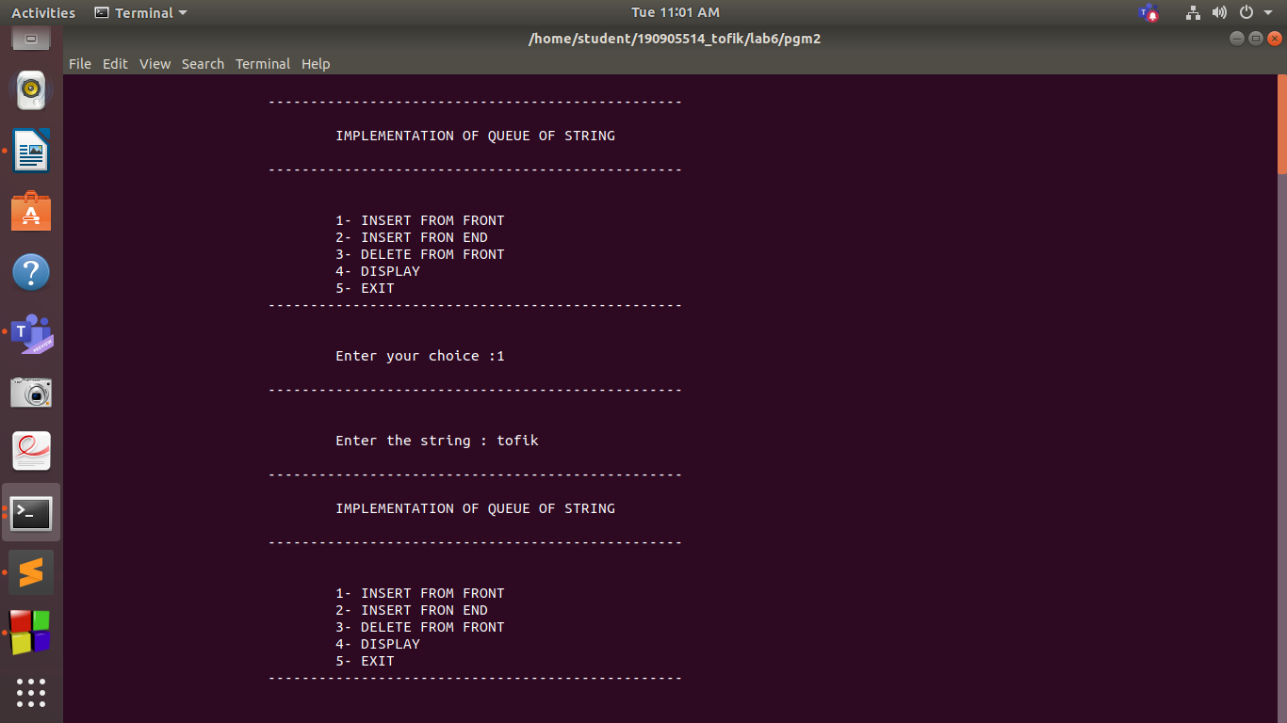
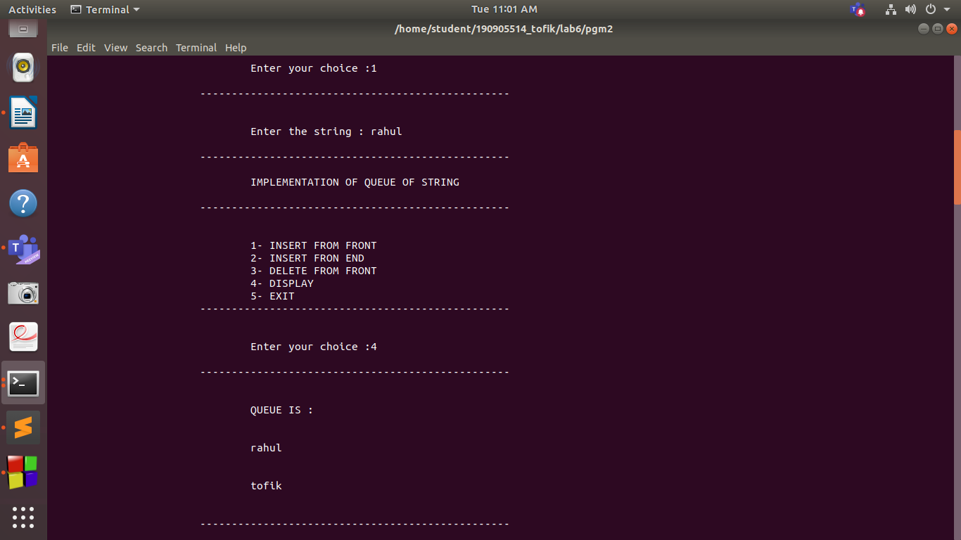
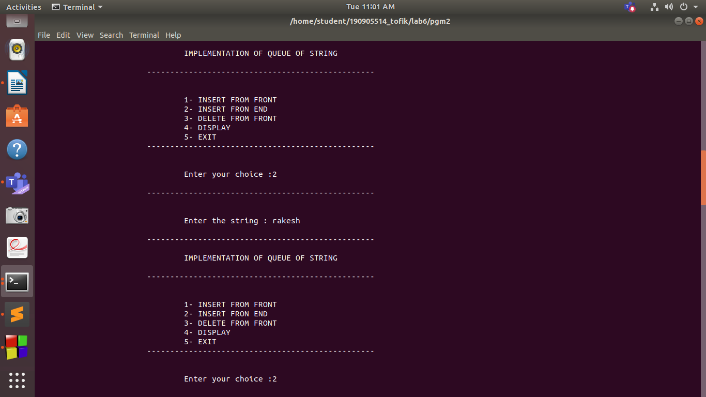
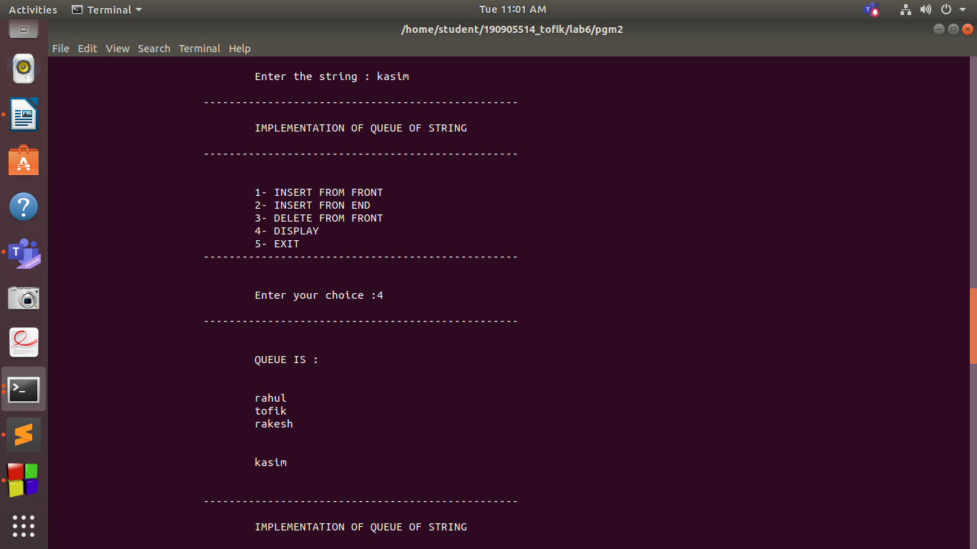
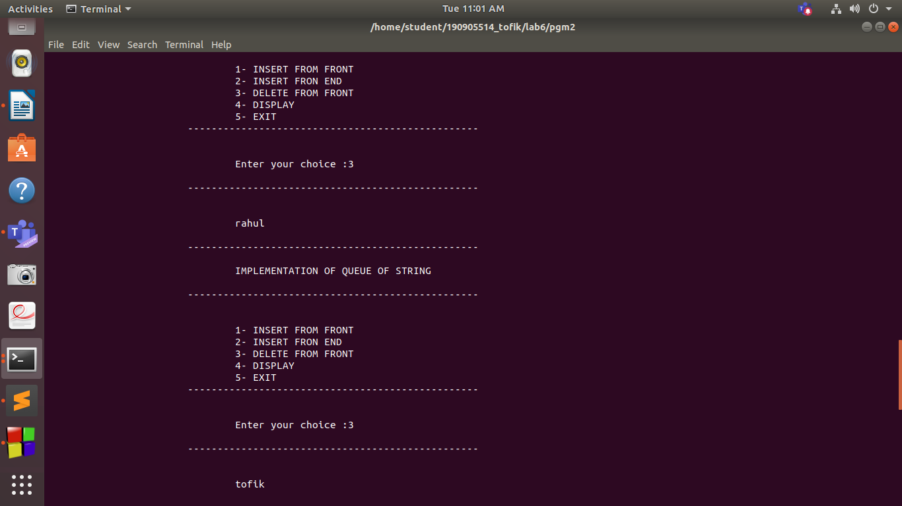
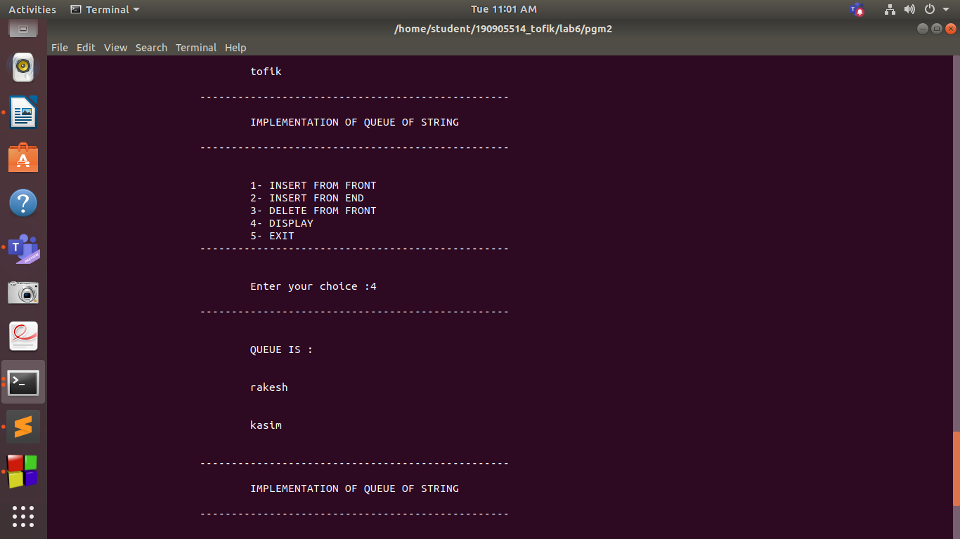
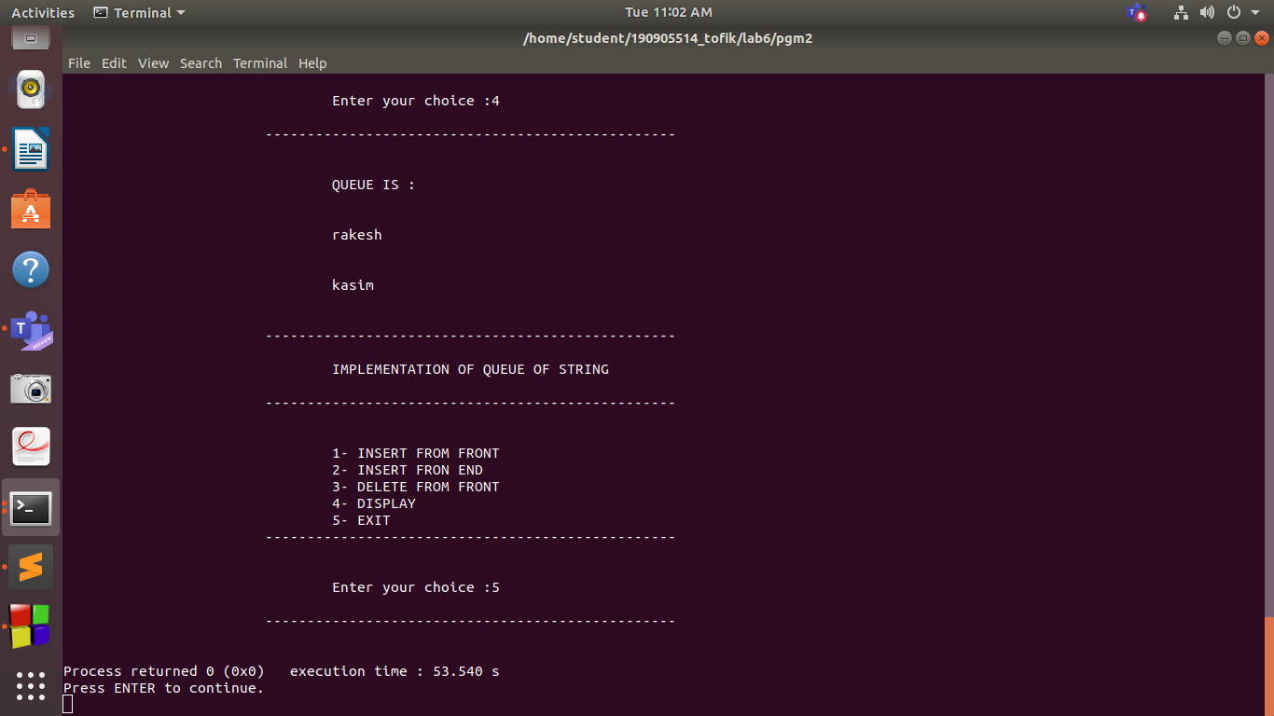

Q.3 Write a program to check whether given string is a palindrome using a dequeue.

pgm3.c

#include<stdio.h>
#include<stdlib.h>
#include<string.h>
#define MAXIMUM 50

typedef struct
{
int queue[MAXIMUM];
int front;
int rear;
} QUEUE;
void insertf(QUEUE *q,char c);
char deleteend(QUEUE *q);
char deletef(QUEUE *q);
void display(QUEUE *q);
int main()
{
int i,j;
QUEUE *q,q1;
q = &q1;
q1.front = -1;
q1.rear = -1;
char a,b;
int s;
char ch[20];
printf("\n\t\t\t-------------------------------------------------\n");
printf("\n\t\t\t\tPROGRAM TO CHECK WHETHER GIVEN STRING IS A PALINDROME OR NOT USING A DEQUEUE\n");
printf("\n\t\t\t-------------------------------------------------\n\n");
printf("\n\t\t\t\tenter the string : ");
scanf("%s",ch);
printf("\n\t\t\t-------------------------------------------------\n\n");
for(s=0; ch[s]!='\0'; s++)
{
insertf(q,ch[s]);
}
for(s=0; s<strlen(ch)/2; s++)
{
a=deleteend(q);
b=deletef(q);
if(a!=b)
{
printf("\n\t\t\t\tEntered string is not a palindrome\n");
exit(0);
}
}
printf("\n\t\t\t\tEntered string is a palindrome\n");

return 0;
}

void insertf(QUEUE *q, char ch)
{
if(q->rear==MAXIMUM-1 && q->front==0)
{
printf("\n\t\t\t\tQueue is full FULL\n");
return;
}
else if(q->front==-1)
{
q->front=q->rear=0;
q->queue[q->front]=ch;
}
else if(q->rear!=MAXIMUM-1)
{
int s=q->rear+1;
while(s>q->front)
{
q->queue[s]=q->queue[s-1];
s=s-1;
}
q->queue[q->front]=ch;
q->rear++;
}
else
{
q->front--;
q->queue[q->front]=ch;
}

}
char deleteend(QUEUE *q)
{
if(q->front==-1)
{
printf("EMPTY\n");
return -1;
}
int val = q->queue[q->rear];
if(q->front==q->rear)
q->front=q->rear=-1;
else
q->rear--;
return val;
}
char deletef(QUEUE *q)
{
if(q->front==-1)
{
printf("\n\t\t\t\tQueue is empty : \n\n");
return -1;
}
int val = q->queue[q->front];
if(q->front==q->rear)
q->front=q->rear=-1;
else
q->front++;
return val;
}
void display(QUEUE *q)
{
if(q->front==-1)
{
printf("\n\t\t\t\tQueue is empty : \n");
return ;
}
int i;
printf("\n\t\t\t\tQUEUE IS : \n\n");
for(i=q->front; i!=q->rear; i++)
{
printf("\n\t\t\t\t%d ",q->queue[i]);
}
printf("\n\n");
printf("\n\t\t\t\t%d ",q->queue[i]);
printf("\n\n");
}

OUTPUT :

