190905514 MHAMMAD TOFIK

WEEK 3 LAB3

1.find whether given number is odd or not.

oddoreven.sh

echo "Enter the number "
read number
temp=$(($number%2))
if [ $temp -eq 1 ]
then
echo "Entered $number number is odd "
else
echo "Entered $number number is even "
fi

OUTPUT :

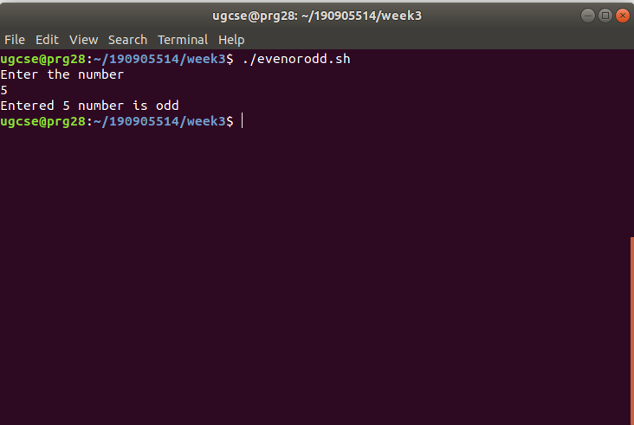

2.Print first n odd number .

printodd.sh

echo "Enter the that you want to print "
read oddnumber
x=0
odd=0
echo "printing $oddnumber odd number "
while [ $x -lt $oddnumber ]
do
odd=`expr $x \* 2 + 1`
echo $odd
x=$((x+1))
done

OUTPUT :

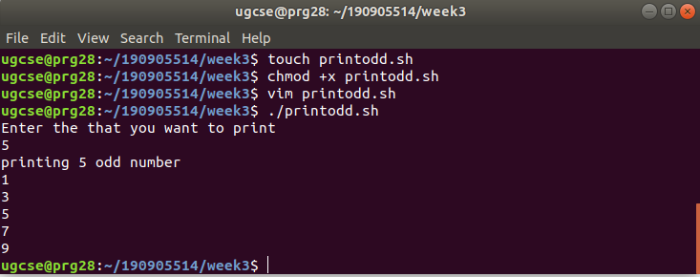

3.Find all the quadratic equation using case .

quadratic.sh

echo "Enter a,b and c"
read a
read b
read c
d=`expr $b \* $b - 4 \* $a \* $c`
if [ $d -ge 0 ]
then quad="r"
else quad="i"
fi
case $quad in "r")
sqt=`echo "scale=4;sqrt($d)" | bc` r1=`echo "( -1 * $b + $sqt ) / ( 2 * $a )" | bc` r2=`echo "( -1 * $b - $sqt ) / ( 2 * $a )" | bc`
echo "Root1: $r1 Root2: $r2" ;; "i")
de=`expr -1 \* $d`
sq=`echo "scale=4;sqrt($de)" | bc`
re=`echo "( -1 * $b ) / ( 2 * $a )" | bc`
im=`echo "$sq / (2 * $a)" | bc`
echo "Root1 : $re + i$im Root2 : $re - i$im " ;;
esac

OUTPUT :

