190905514 MOHAMMAD TOFIK

WEEK4 LAB 4

1. In c , write a c program to implement a stack with push,pop operations
using suitable functions.Create static libraries for varius operations on stack
.Create a header file for function declaration.

push.c

#include <stdio.h>
void push(int a[],int *top,int element){

a[++(*top)]=element;

}

pop.c

#include <stdio.h>
void pop(int a[],int *top, int element){
printf("Deleted item is = %d",a[*top]);
(*top--);
}

dsp.c

#include <stdio.h>
void display(int a[],int top){
int i;
printf("Stack is = ");
for(i=0; i<=top; i++){
printf("%d\n",a[i] );
}
}

stk.c

#include <stdio.h>
#include <stdlib.h>
#include "mystacklib.h"
int main(void){

int a[5];
int top=-1;
push(a,&top,5);
push(a,&top,10);
push(a,&top,15);
pop(a,&top,5);
display(a,top);
}

mystacklib.h

void pop(int a[],int *,int element);
void push(int a[],int *,int element);
void display(int a[],int top);

OUTPUT :

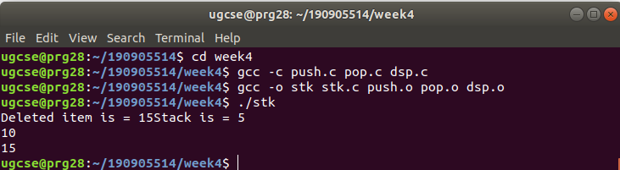
Q2. This is try out question.

hello.c
#include<stdio.h>
int main(void){
printf("hello world !");
}
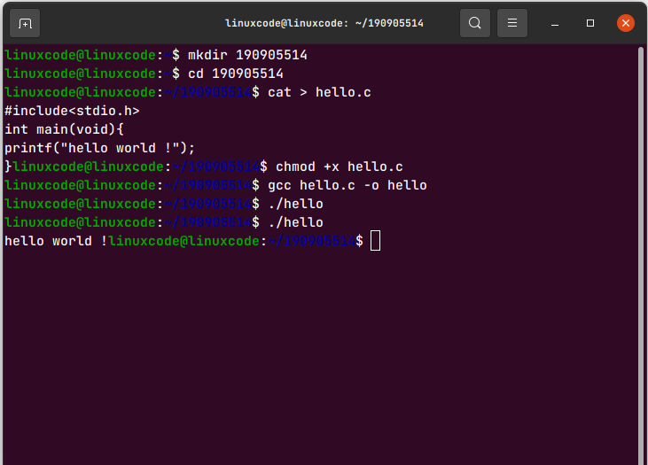
OUTPUT :

Q3. This is try out question
pw.c

#include<stdio.h>
void pw(int arg){
printf("pw : we crossed %d\n",arg);

}

pw1.c

#include<stdio.h>
void pw1(char *arg){
printf("pw : we crossed %s\n",arg);

}

pw2.c

#include <stdio.h>
#include <stdlib.h>
#include "lib.h"
int main(void){
pw1("hello world");
exit(0);
}

lib.h

void pw(int);
void pw1(char *);

OUTPUT:
