190905514 C SECTION 4th SEMESTER MOHAMMAD TOFIK

LAB 5:

/* 1). Write a program to determine the Topological sort of a given graph using
i. Depth-First technique
ii. Source removal technique */

#include <stdio.h>
#include <stdlib.h>

int a[50][50], visit[50], stack[100],n,t=0;

void dfs(int v)
{
visit[v]=1;

for(int i=0;i<n;i++)
{
if(a[v][i] && !visit[i])
{
dfs(i);
}
}

stack[t++]=v;
}

void printStack()
{
for(int i=n-1;i>=0;i--)
{
printf("%d\n",stack[i]);
}

printf("\n");
}

int main()
{
printf("Enter the Number of Vertices : \n");
scanf("%d", &n);
printf("Enter the Adjacency Matrix : \n");
for(int i = 0; i<n; i++)
{
for(int j = 0; j<n; j++)
{
scanf("%d", &a[i][j]);
}
}

for(int i = 0; i<n; i++)
{
if(!visit[i])
{
dfs(i);
}
}

printf("The Topological Sort Order is :\n");
printStack();

return 0;
}

OUTPUT :

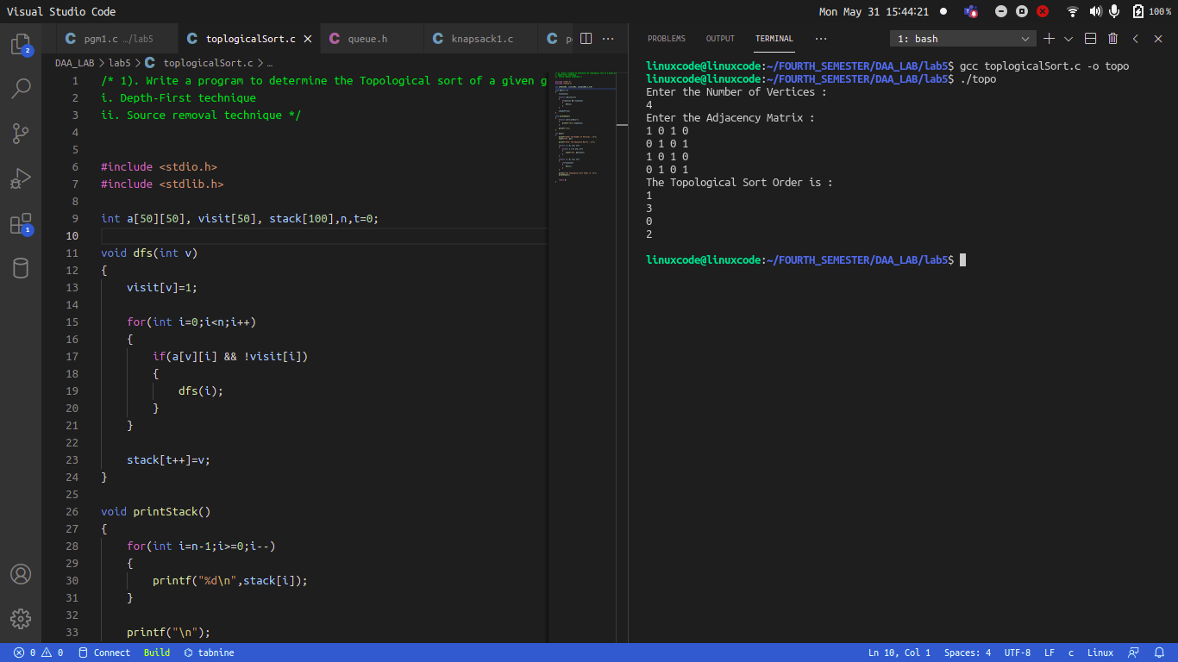

/* 1). Write a program to determine the Topological sort of a given graph using
i. Depth-First technique
ii. Source removal technique
*/

#include <stdio.h>
#include <stdlib.h>

int queue[100], k_1 = 0, k = 0, arr[100][100], n, indegree[100];
void calc()
{
for(int i = 0; i<n; i++)
{
for(int j = 0; j<n; j++)
{
if(arr[j][i] && i!=j)
{
indegree[i]++;
}
}
}
}

void initQueue()
{
for(int i = 0; i<n; i++)
{
queue[i] = -1;
}
}

void dec(int v)
{
for(int i = 0; i<n; i++)
{
if(arr[v][i])
{
indegree[i]--;
}
if(indegree[i] == 0)
{
queue[k++] = i;
}
}
}

int queueEmpty()
{
for(int i = 0; i<n; i++)
{
if(queue[i] != -1)
{
return 0;
}
}

return 1;
}

int main()
{
printf("Enter the Number of Vertices : \n");
scanf("%d", &n);
printf("Enter the Adjacency Matrix : \n");

for(int i = 0; i<n; i++)
{
for(int j = 0; j<n; j++)
{
scanf("%d", &arr[i][j]);
}
}
initQueue();
calc();
for(int i = 0; i<n; i++)
{
if(indegree[i] == 0)
{
queue[k++] = i;
}
}
printf("The Topological Sort Order is : \n");
while(!queueEmpty())
{
int vertex = queue[k_1++];
printf("%d ", vertex);
queue[k_1-1] = -1;
dec(vertex);

printf("%d ", vertex);
}
printf("\n");

return 0;
}

OUTPUT :

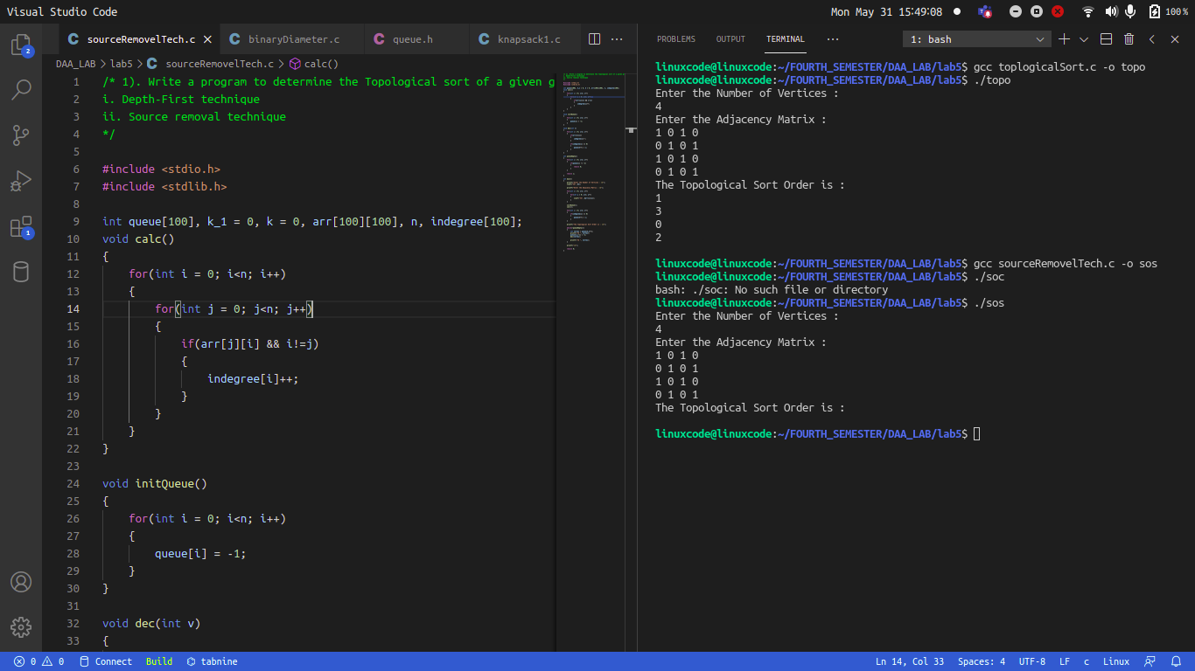

/*2. Write a program to find diameter of a binary tree. Diameter of a binary tree is
the longest path between any two nodes.
Program: */
#include <stdio.h>
#include <stdlib.h>
struct node {
int val;
struct node *left, *right;
};
struct node* newNode(int value)
{
struct node* node
= (struct node*)malloc(sizeof(struct node));
node->val = value;
node->left = NULL;
node->right = NULL;
return (node);
}
int max(int a, int b)
{
return (a > b) ? a : b;
}
int height(struct node* node)
{
if (node == NULL)
return 0;
return 1 + max(height(node->left), height(node->right));
}
int diameter(struct node* tree)
{
if (tree == NULL)
return 0;
int lheight = height(tree->left);
int rheight = height(tree->right);
int ldiam = diameter(tree->left);
int rdiam = diameter(tree->right);
return max(lheight + rheight + 1, max(ldiam, rdiam));
}
int main()
{
struct node* root = newNode(1);
root->left = newNode(2);
root->left->left = newNode(4);
root->left->right = newNode(5);
root->left->right->left= newNode(6);
root->left->right->right = newNode(7);

root->right = newNode(3);
root->right->right = newNode(8);
root->right->right->right = newNode(9);
root->right->right->right->right = newNode(10);
root->right->right->right->left= newNode(11);
root->right->right->right->left->left = newNode(12);
root->right->right->right->left->right = newNode(13);
root->right->right->right->left->right->left = newNode(14);
root->right->right->right->left->right->right = newNode(15);
printf("Diameter of the given binary tree is %d\n",
diameter(root));
return 0;
}

OUTPUT :

