190905514 C SECTION 4th SEMESTER MOHAMMAD TOFIK

SCHEMA :

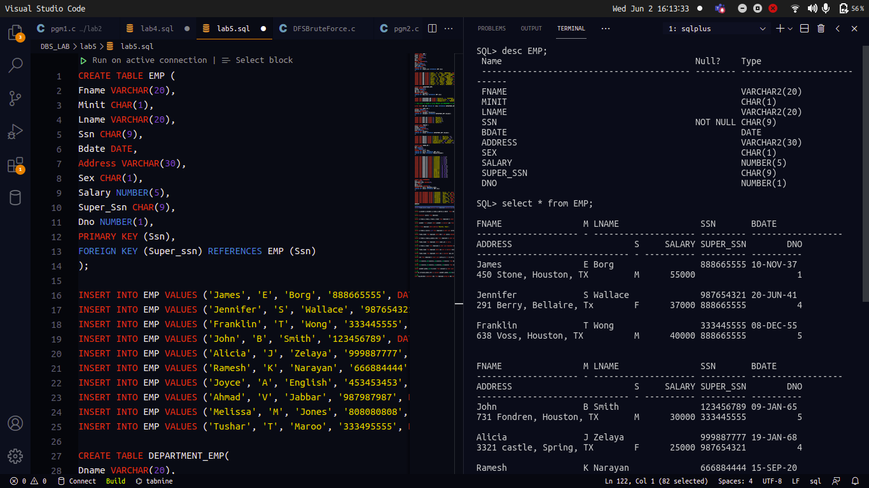

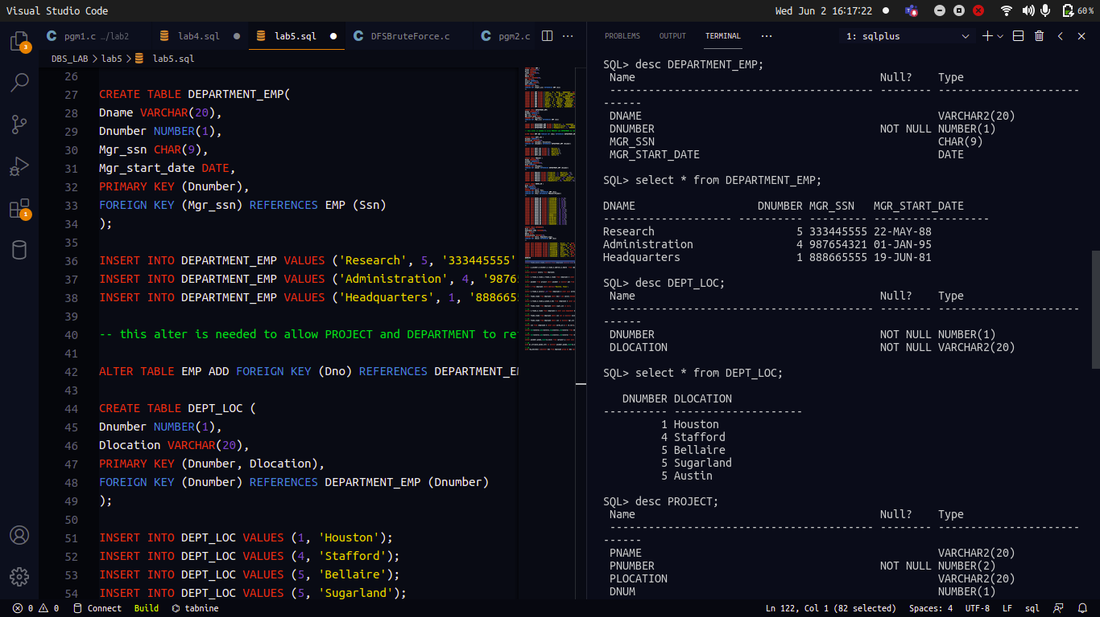

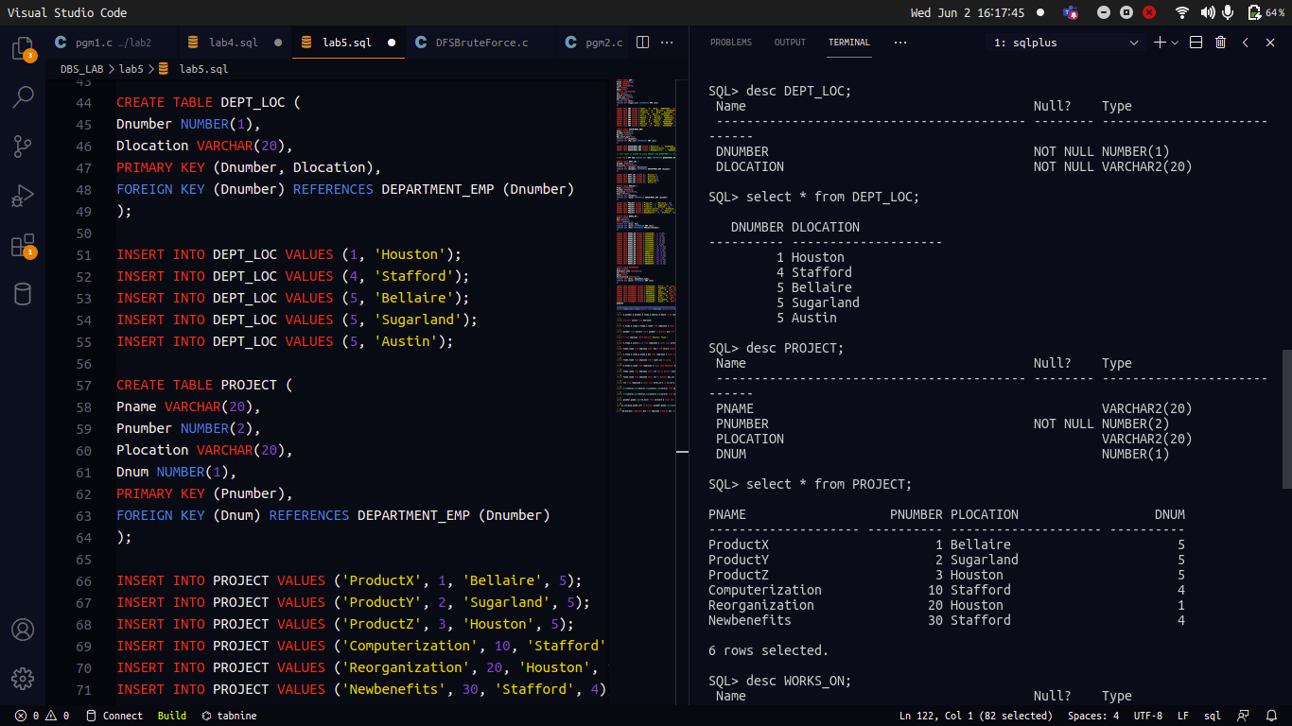

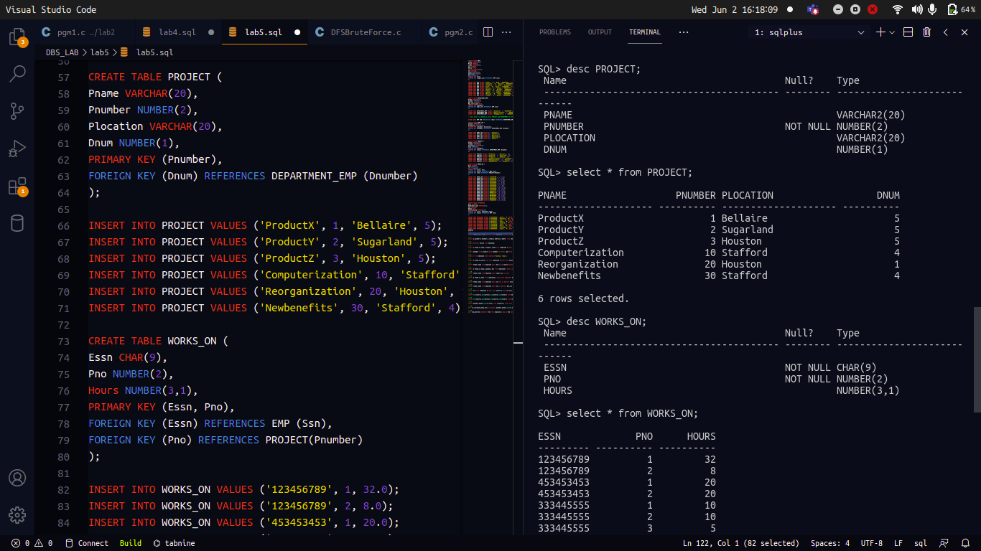

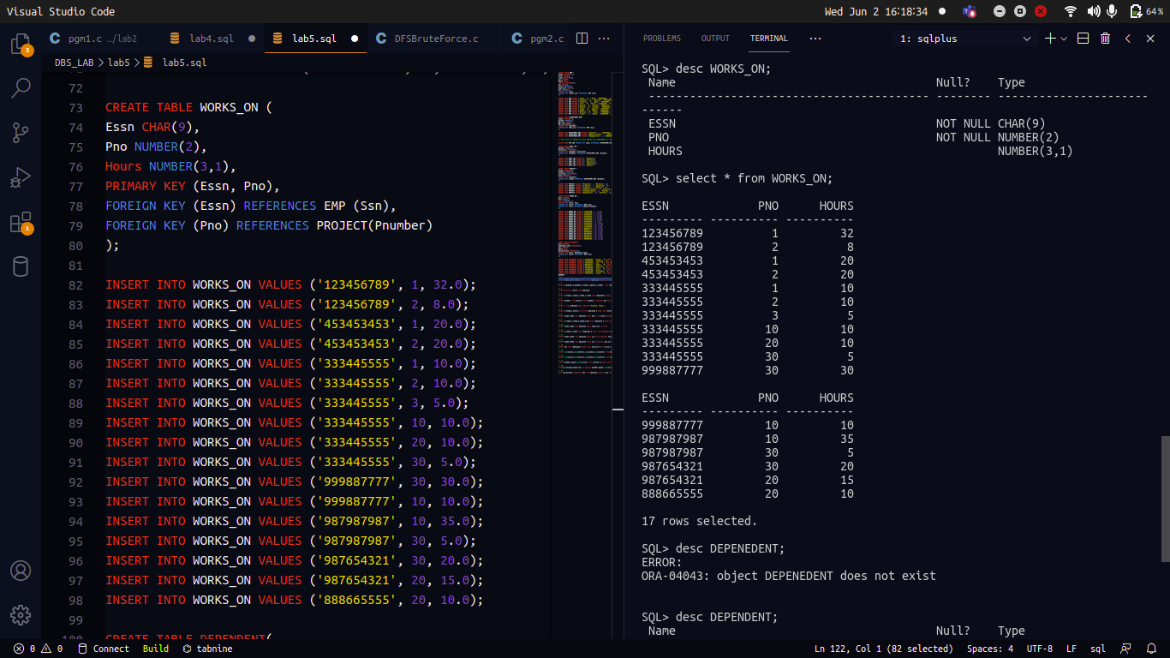

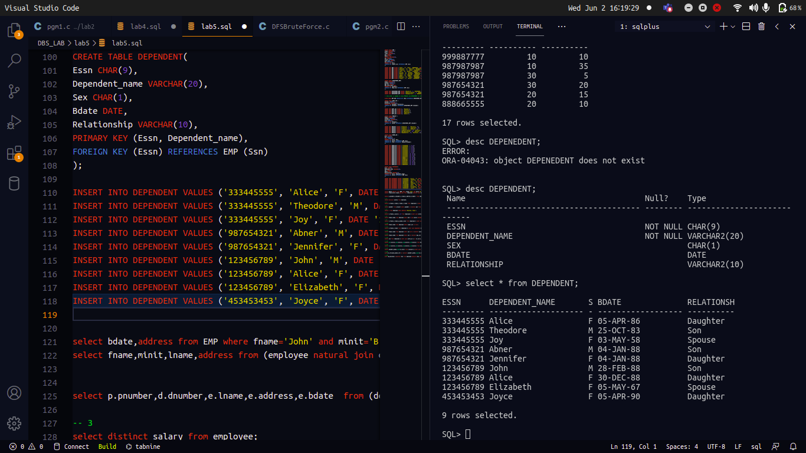

QUERIES :

1.
select bdate,address from EMP where fname='John' and minit='B' and lname='Smith';
select fname,minit,lname,address from (employee natural join department_emp) where dname='Research';

2.
select p.pnumber,d.dnumber,e.lname,e.address,e.bdate
from (department_emp d
inner join project p on
(d.dnumber=p.dnum) inner join
EMP e on (d.mgr_ssn=e.ssn));

3.
select distinct salary from EMP;

4.
select e.fname,e.lname,s.fname,s.lname
from
(EMP e inner join EMP s on (e.super_ssn=s.ssn));

5.
select pnumber from project where
pnumber in (select pno from
(EMP e inner join works_on w on (e.ssn=w.essn))
where e.lname='Smith') or pnumber in
(select p.pnumber from (department_emp d inner join
project p on (d.dnumber=p.dnum) inner join
EMP e on (d.mgr_ssn=e.ssn))
where e.lname='Smith');

6.
select * from EMP where address='Houston, Texas';

7.
select e.fname,e.salary*1.10 from
(EMP e inner join works_on w on
(e.ssn=w.essn) inner join project p on
(p.pnumber=w.pno)) where p.pname='ProductX';

8.
select fname,lname from EMP
where dno=5 and salary between 30000 and 40000;

9.
select e.fname,e.lname,p.pname,e.dno from
(EMP e inner join works_on w on (e.ssn=w.essn)
inner join project p on (p.pnumber=w.pno))
order by e.dno,e.fname,e.lname;

10.
select fname,lname from EMP where
super_ssn is null;

11.
select e.fname,e.lname from
(EMP e inner join dependent d on (e.ssn=d.essn))
where e.fname=d.dependent_name and e.sex=d.sex;

12.
select fname,lname from EMP where
ssn not in
(select essn from dependent);

13
select fname,lname from EMP where
ssn in
(select mgr_ssn from department_emp)
and ssn in
(select essn from dependent);

14
select ssn from
(EMP e inner join works_on w on (e.ssn=w.essn))
where pno<=3;

15.
select min(salary),max(salary),avg(salary),sum(salary) from EMP;

16.
select min(salary),max(salary),avg(salary),
sum(salary) from
(EMP natural join department_emp) where dname='Research';

17.
select pnumber,pname,count(w.essn) from
(project p inner join works_on w on (w.pno=p.pnumber))
group by p.pnumber,p.pname;

18.
with pr_cnt(pnum,pname,cnt) as
(select pnumber,pname,count(w.essn) from
(project p inner join works_on w on (w.pno=p.pnumber))
group by p.pnumber,p.pname)
select * from pr_cnt where cnt>2;

19.
with req_dno(dno) as(select dno from EMP group by
dno having count(ssn)>=5) ,
req_tab as (select * from
(EMP e natural join req_dno rd) where salary>40000)
select dno,count(ssn) from req_tab group by dno;

