<!-- Generated by scripts/build_bilingual_paper_drafts.py on 2026-06-28 -->
Geometry-Aware Multi-Step Forecasting of Synthetic Slow Slip Evolution from Sparse Geodetic Histories

Abstract
Slow slip events (SSEs) are transient fault-slip processes that release tectonic strain without strong seismic radiation. Their spatiotemporal evolution is relevant to fault-state monitoring, geodetic inversion, seismic-hazard background analysis, and scenario-based disaster assessment. Existing deep-learning studies on SSEs have mainly focused on event detection from GNSS time series, geodetic denoising, and alert-oriented spatial geodetic representation learning. In contrast, direct multi-step forecasting of future fault-slip fields remains less systematically evaluated.
This paper restructures an initially unsuccessful prototype into a clean future-slip forecasting loop. Given historical GNSS observations and historical fault slip, the task is to forecast the next 50 time steps of the fault-slip field. To avoid the physical inconsistency of applying a nonnegative output to per-dimension z-scored slip targets, the training target is changed to log1p(slip / slip_scale) and all reported metrics are computed after inverse transformation into physical slip units. The model uses a segmented residual architecture that respects the two disconnected subfaults, represented as 15x166 and 15x36 grids, rather than forcing them into a continuous 15x202 image.
On the full synthetic catalog of 6000 events, with a raw size of 74.202 GiB, the compressed training package is audited event by event and confirmed to be a lossless full-catalog representation. Full-data experiments on an Alibaba PAI-DSW A10 GPU show that the main segmented-residual model improves h50 RMSE over persistence by 97.60% on the random split and 97.50% on the blocked split, while also reducing relative error in the total-slip-moment proxy M0. The ablation matrix shows that historical slip is the dominant information source, GNSS history contributes a useful marginal constraint, GNSS-only forecasting fails under the current sparse-station setup, and the M0 auxiliary loss improves physical-scale consistency even when it does not minimize pointwise RMSE. The work should not be interpreted as real earthquake prediction or operational warning. Instead, it provides a reproducible baseline for synthetic SSE state evolution, GNSS-assisted inversion pipelines, and future physics-aware forecasting research.
Keywords: slow slip events; GNSS; fault-slip forecasting; geodetic deep learning; segmented residual network; synthetic catalog

Figure Overview
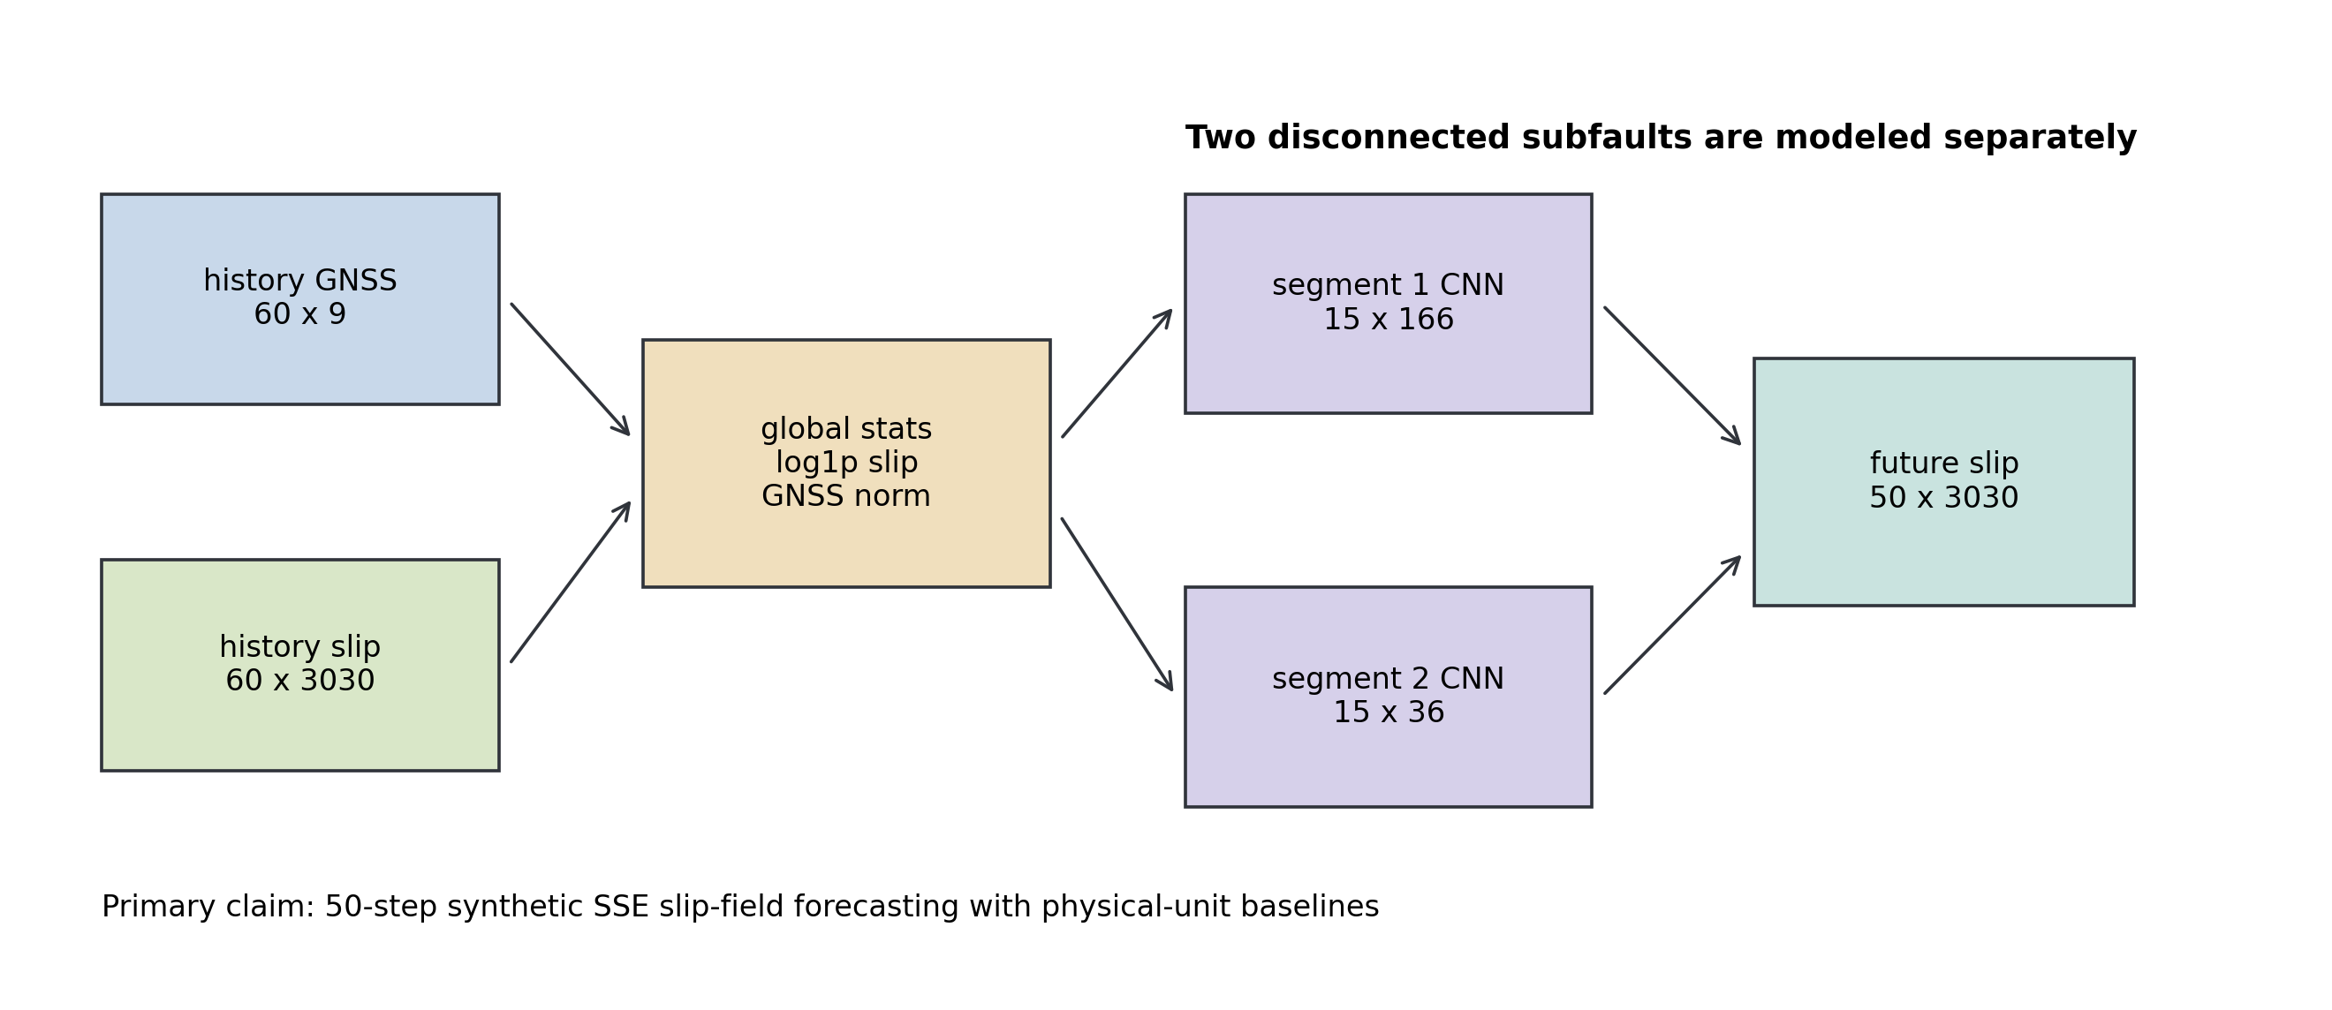
Figure 1. Geometry-aware forecasting workflow and two-subfault representation.
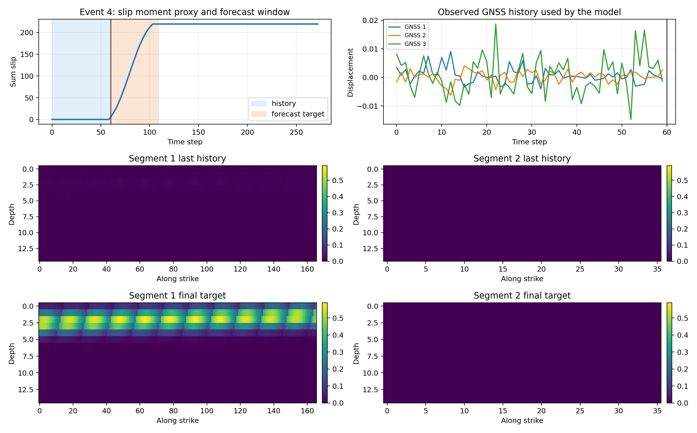
Figure 2. Data contract, event window, and history-to-future split.
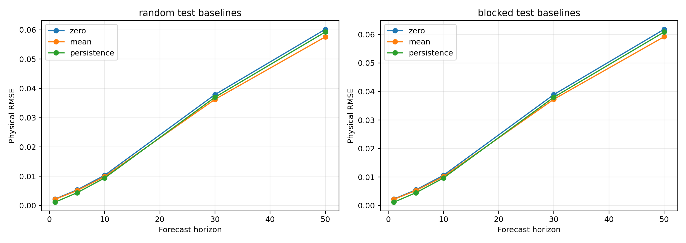
Figure 3. Baseline horizon curves for zero, mean, and persistence comparisons.
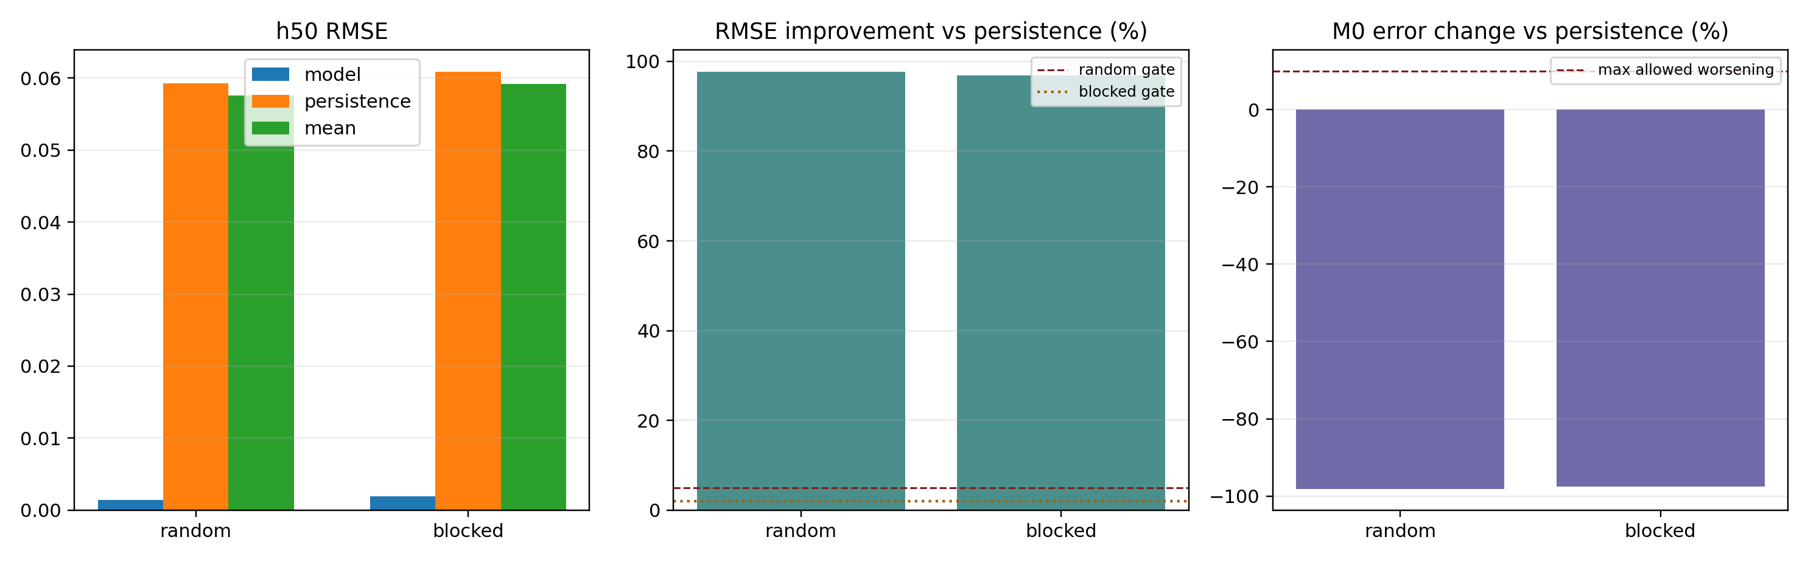
Figure 4. Full-data performance summary across random and blocked splits.
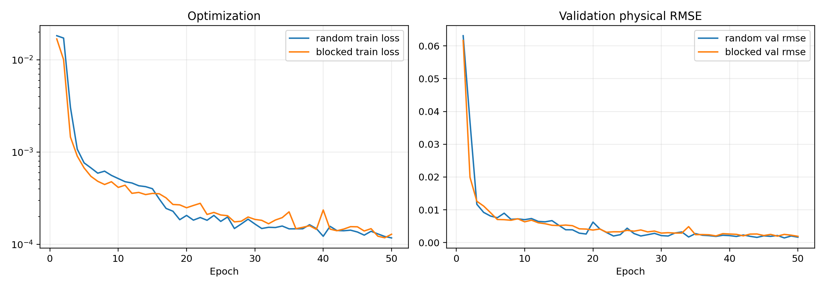
Figure 5. Training curves for the full experiment matrix.
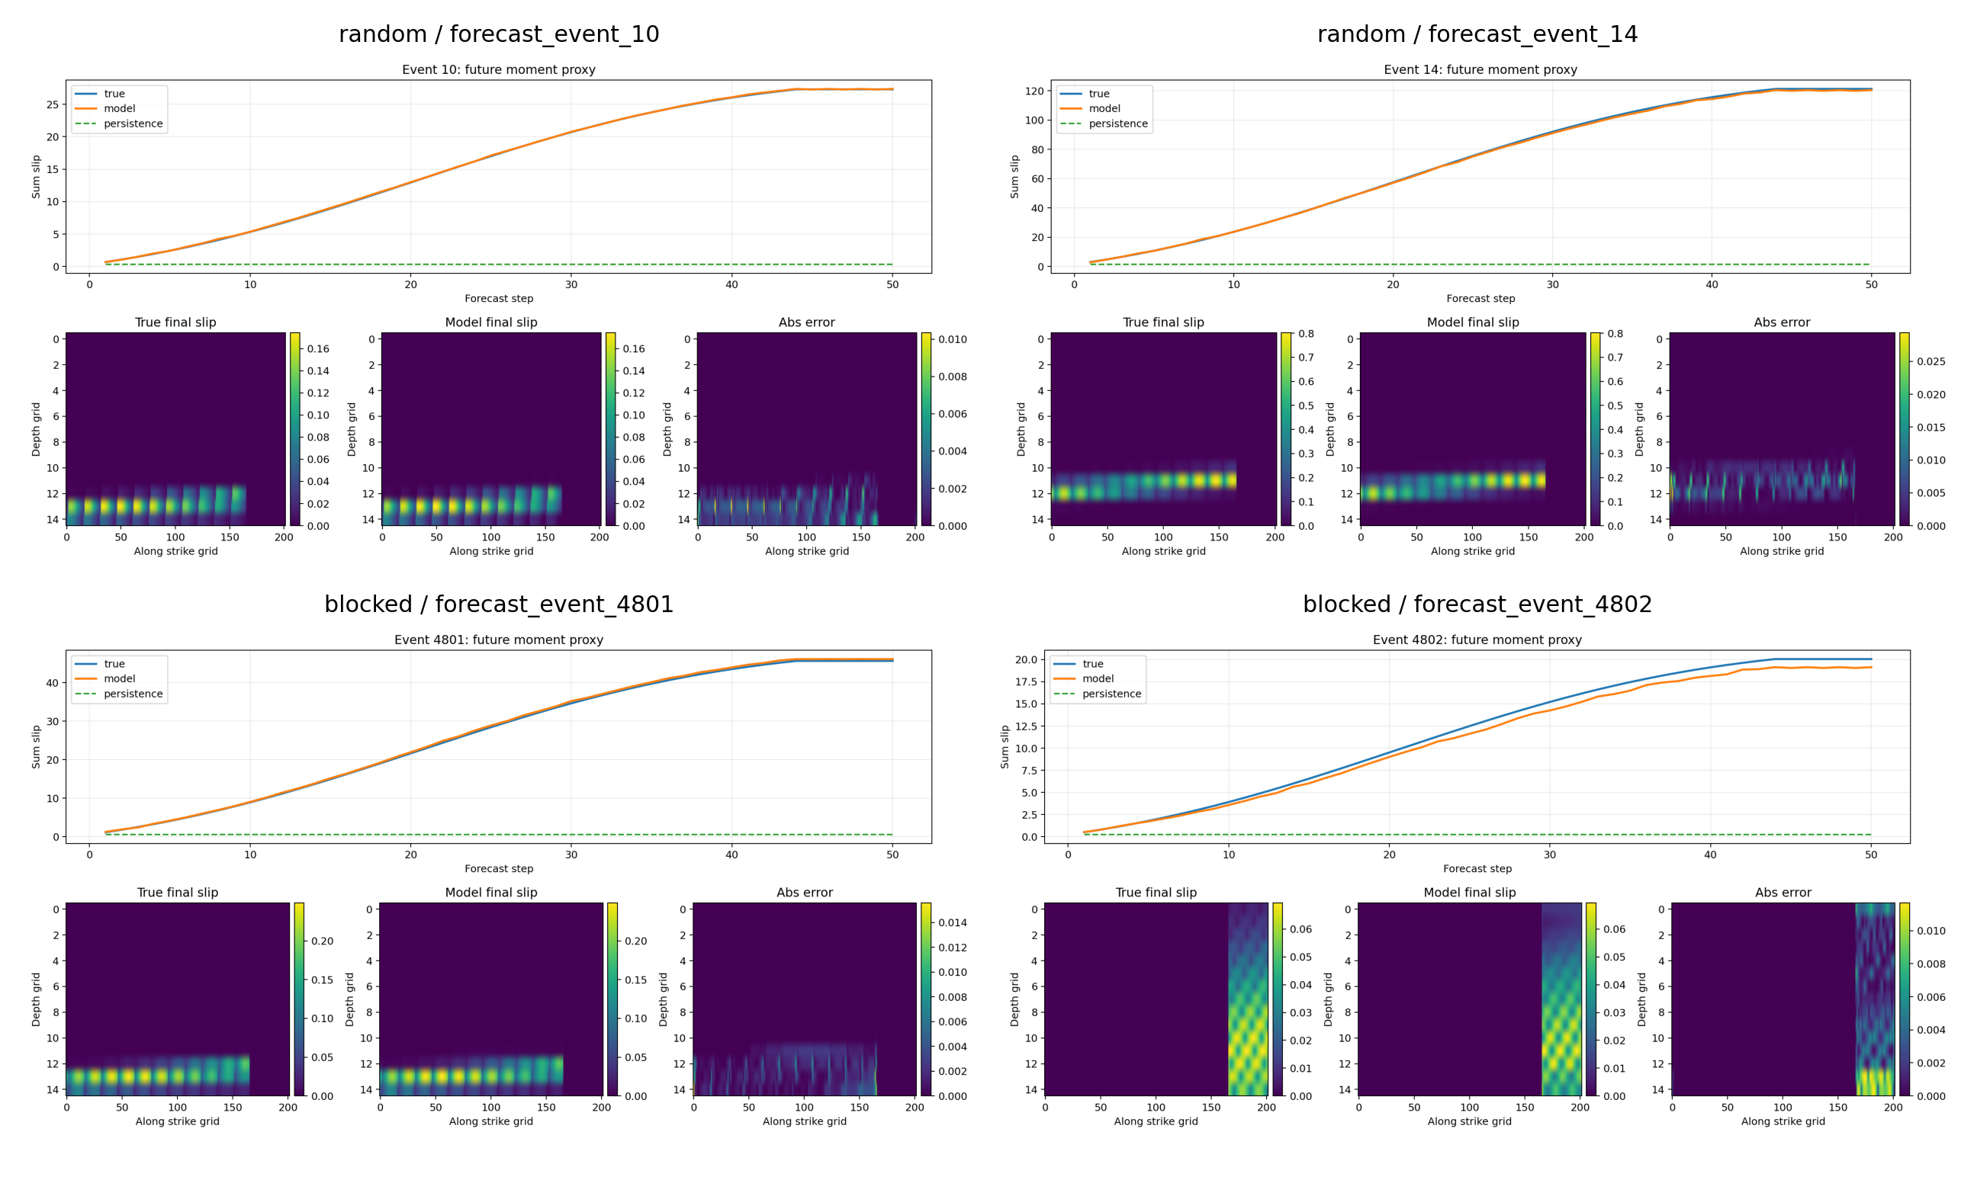
Figure 6. Event-level forecast montage and physical-space examples.

1. Introduction
Slow slip events occupy an important regime between stable creep and rapid seismic rupture. They often lack strong seismic waves but can produce measurable surface deformation over days to months and can modify the stress state of neighboring fault regions. Continuous GNSS networks have made it possible to observe such deformation with increasing temporal resolution and to infer hidden fault-slip processes through inversion or data-driven models.
Recent machine-learning work has demonstrated that SSE-related signals can be learned from geodetic time series. Multi-station neural detectors have been trained on realistic synthetic data to detect Cascadia SSEs from raw GNSS sequences. Graph and spatiotemporal denoising models have further shown that weak SSE-related displacements can be recovered from noisy geodetic observations. However, detecting whether an SSE occurred and forecasting how a fault-slip field will evolve are different problems. Detection outputs event labels, time windows, or probabilities. Forecasting must predict a future field in a physical fault coordinate system and must be evaluated in physical units.
This paper studies the latter problem. The goal is not to predict damaging earthquake occurrence or to issue operational warnings. Instead, we evaluate a more basic and falsifiable modeling layer: under a known two-subfault geometry and a controlled synthetic catalog, are historical slip and sparse GNSS histories sufficient to forecast the next 50 steps of fault-slip evolution? This framing is relevant because a practical geodetic workflow may first estimate the current slip state through inversion or data assimilation and then use that state for short-term evolution analysis.
The earlier project failed largely because the task definition and physical constraints were misaligned. It combined inversion, reconstruction, and forecasting objectives, used per-event GNSS robust scaling, and applied nonnegative outputs to z-scored slip targets. These choices obscured what was being learned and made the physical interpretation of outputs unstable. The refactored workflow therefore enforces a data contract, physical target transform, explicit baselines, small-overfit checks, full-data training, and inference reporting.
The contributions are:
- A reproducible future-slip forecasting loop for synthetic SSE data, including full-catalog audit, baselines, small overfit, full training, physical metrics, and demo reporting.
- A physically compatible log1p slip target and train-split global GNSS normalization that avoid the old z-score/softplus conflict.
- A geometry-aware segmented residual model for two disconnected subfaults.
- A full-data 6000-event experiment matrix showing strong gains over persistence and clearly identifying GNSS-only forecasting as infeasible in the current sparse-station setup.

2. Related Work

2.1 GNSS-Based SSE Detection
Deep-learning studies of SSEs have most often addressed detection. Multi-station convolutional and attention-based models trained on synthetic data have detected Cascadia SSEs from raw geodetic time series. Related BiLSTM and attention approaches have used signal-separation preprocessing such as vbICA before classification. These studies establish that GNSS time series can contain learnable slow-slip signatures, but their outputs are event-detection products rather than future fault-slip fields.

2.2 Geodetic Denoising and Graph Learning
Raw GNSS series include instrumental noise, environmental loading, seasonal terms, station artifacts, and nontectonic signals. Spatiotemporal graph networks such as SSEdenoiser combine station-network geometry and temporal dependence to recover SSE-related displacement from noisy GNSS data. Such work is highly relevant because high-quality GNSS representation is a prerequisite for inversion and forecasting. Nevertheless, denoising remains an observation-space task, not a future fault-space forecasting task.

2.3 Geodetic Slip Inversion
Traditional GNSS-to-slip inversion depends on dislocation Green's functions, regularization, station geometry, and prior constraints. Real slip inversion is affected by depth resolution, sparse station coverage, and multi-source data availability. The current paper does not claim to solve professional GNSS-only inversion. The included inversion demo is a ridge-regression proxy intended to show a possible data-flow interface; the main scientific contribution is future slip forecasting given a slip-state history.

2.4 General Time-Series Forecasting
TimesNet, PatchTST, iTransformer, Chronos, TimesFM, and related libraries provide strong reference points for long-horizon forecasting and foundation-style time-series modeling. They motivate future external baselines. The present task, however, is not an unstructured multivariate sequence problem: the 3030 slip values correspond to two known subfault grids. This motivates first evaluating a geometry-aware model before treating all dimensions as generic variables.

3. Data and Problem Formulation
The dataset contains 6000 synthetic slow-slip events. The raw data/ directory is organized into 12 subdirectories and has a total size of 79,673,958,000 bytes, or 74.202 GiB. Each event has T=273 time steps and 3040 columns: 3030 slip dimensions and 9 GNSS dimensions. The slip dimensions correspond to two disconnected subfaults:
- segment 1: 15x166
- segment 2: 15x36
For efficient training and remote transfer, the raw catalog is converted into hf_dataset_package/, a compressed full-catalog representation of approximately 2.838 GiB. The package contains manifest.csv, manifest.jsonl, and events/shard_*.npz. It is not a sample subset. A full audit reports 6000 raw events, 6000 manifest events, continuous event ids from 1 to 6000, 188 shards, 6000 raw-vs-package comparisons, and zero exact comparison failures.
The main task is:
history_gnss + history_slip -> future_slip
The default window uses history_steps = 60, forecast_horizon = 50, input = history_slip[0:60] + history_gnss[0:60], and target = future_slip[60:110]. Dataset records expose history_gnss, history_slip, future_slip, future_gnss, and metadata, but the training objective is fixed to future-slip prediction.
Two splits are used. The random split evaluates same-distribution generalization. The blocked split partitions events by event id or generation order and tests robustness to event-family or generation-order drift. The publication gate requires at least 5% h50 RMSE improvement over persistence on the random split, at least 2% improvement on the blocked split, and no unacceptable degradation of the M0 proxy.

4. Method

4.1 Slip Target Transform
Fault slip is physically nonnegative. The previous z-score target conflicted with a nonnegative output layer because many training targets became negative. The refactored target is:
encoded_slip = log1p(slip / slip_scale)
physical_slip = expm1(encoded_slip) * slip_scale
This transform preserves nonnegativity, compresses long-tail amplitudes, and keeps a reversible path back to physical units for evaluation.

4.2 Global GNSS Normalization
GNSS channels are normalized with train-split global means and standard deviations. This avoids test leakage and preserves event-to-event amplitude differences. Per-event robust scaling is avoided because it can erase the physical relation between GNSS amplitude and slip scale.

4.3 Segmented Residual Architecture
The model reshapes the two slip segments separately and processes them with independent convolutional branches. GNSS history is encoded by a temporal encoder and broadcast into the two segment branches. The output head predicts residual changes from the last historical slip state, making persistence a natural reference point.

4.4 Losses and Metrics
The training loss combines encoded-space MSE with an optional M0 auxiliary loss. The M0 proxy is:
M0_proxy(t) = sum_i slip_i(t)
Evaluation reports physical RMSE, physical R2, M0 relative absolute error, zero/mean/persistence baselines at multiple horizons, and h50 RMSE improvement over persistence.

5. Experiments
The baseline set includes zero, mean, and persistence. Persistence is the strongest physical baseline because it represents the assumption that the latest slip state remains unchanged. Small-overfit runs on 16-32 events verify the data contract, inverse transform, loss, checkpoint, and physical metrics before full training.
The full training configuration uses the 6000-event catalog, segmented_residual as the main model, history_slip + history_gnss as input, 50-step future_slip as target, 50 epochs, batch size 16, hidden channels 64, m0_loss_weight = 0.005, and an Alibaba PAI-DSW NVIDIA A10 GPU.
The ablation matrix includes plain, segmented, segmented-residual, no-GNSS, GNSS-only, last-slip-only, and no-M0-loss variants.

6. Results

6.1 Main Results
Split | Model h50 RMSE | Persistence h50 RMSE | Improvement | R2 | M0 rel abs | Gate
random | 0.00142173 | 0.0592355 | 97.60% | 0.999408 | 0.0155652 | PASS
blocked | 0.00152041 | 0.0608568 | 97.50% | 0.999359 | 0.0166794 | PASS

The main model strongly outperforms persistence on both splits. The h50 persistence baseline is poor because future active slip cannot be captured by simply freezing the last historical frame. The neural model learns both local slip distribution and total-release evolution.

6.2 Full Experiment Matrix

Main Full-Data Results
Split | Model | h50 RMSE | Persistence | Gain | R2 | M0 rel abs | Gate
blocked | segmented_residual | 0.00152 | 0.060857 | 97.50% | 0.999359 | 0.016679 | PASS
random | segmented_residual | 0.001422 | 0.059236 | 97.60% | 0.999408 | 0.015565 | PASS

Ablation Results
Run | Split | Model | Input | M0 loss | h50 RMSE | Gain | R2 | M0 rel abs | Gate
ablate_gnss_only | blocked | segmented_residual | gnss_only | 0.005 | 0.061813 | -1.57% | -0.059933 | 1 | FAIL
ablate_gnss_only | random | segmented_residual | gnss_only | 0.005 | 0.060166 | -1.57% | -0.060367 | 1 | FAIL
ablate_last_slip_only | blocked | segmented_residual | last_slip_only | 0.005 | 0.003041 | 95.00% | 0.997434 | 0.032517 | PASS
ablate_last_slip_only | random | segmented_residual | last_slip_only | 0.005 | 0.002089 | 96.47% | 0.998722 | 0.060937 | PASS
ablate_no_gnss | blocked | segmented_residual | no_gnss | 0.005 | 0.001927 | 96.83% | 0.99897 | 0.01731 | PASS
ablate_no_gnss | random | segmented_residual | no_gnss | 0.005 | 0.002351 | 96.03% | 0.998382 | 0.027774 | PASS
ablate_no_m0_loss | blocked | segmented_residual | full | 0 | 0.002783 | 95.43% | 0.997852 | 0.107937 | PASS
ablate_no_m0_loss | random | segmented_residual | full | 0 | 0.001121 | 98.11% | 0.999632 | 0.059485 | PASS
model_plain_full | blocked | plain | full | 0.005 | 0.005755 | 90.54% | 0.990813 | 0.02816 | PASS
model_plain_full | random | plain | full | 0.005 | 0.004315 | 92.72% | 0.994546 | 0.013652 | PASS
model_segmented_full | blocked | segmented | full | 0.005 | 0.005065 | 91.68% | 0.992884 | 0.032376 | PASS
model_segmented_full | random | segmented | full | 0.005 | 0.004737 | 92.00% | 0.993428 | 0.023861 | PASS

Auto Notes
- Main model best split result is random with h50 RMSE 0.001422.
- Best completed ablation so far is ablate_no_m0_loss/random with h50 RMSE 0.001121.
- Treat this file as generated evidence; interpretive claims should still be checked against the full experiment context.
The architecture ablation indicates that both plain and segmented models exceed persistence, but their h50 RMSE is roughly three to four times higher than the segmented-residual model. Geometry segmentation is most useful for structural generalization, while the residual formulation is the largest single contributor to predictive accuracy.
The input ablation shows that historical slip is the dominant information source. No-GNSS and last-slip-only variants are strong, but the full input remains better on the main split summary and gives more stable physical consistency. GNSS-only forecasting fails on both splits, implying that three-station GNSS history is insufficient to recover future full slip fields under the current task definition.
Removing the M0 loss improves random-split pointwise RMSE but substantially worsens M0 error, and on the blocked split it worsens both RMSE and M0 error. Therefore, the default model keeps the M0 auxiliary loss because the paper values physical-scale consistency rather than pointwise RMSE alone.

7. Scientific Significance and Application Boundary
Slow-slip forecasting is relevant to earthquake forecasting and early-warning research only as a state-estimation and scenario-analysis component. It should not be interpreted as direct prediction of damaging earthquake occurrence. The potential applications are: regional fault-state monitoring, seismic-hazard background analysis, chain-disaster scenario generation, GNSS inversion initialization, anomaly-window screening, and coupling with physics-based friction or dislocation models.
The current model cannot be used for operational warning, professional fault inversion, direct earthquake-time prediction, or deployment in unvalidated real-noise environments.

8. Limitations and Future Work
The major limitations are:
- The catalog is synthetic; real-GNSS robustness remains unproven.
- Historical slip is not directly observed in real applications and must be provided by inversion or assimilation.
- The sparse GNSS station setup has not yet been stress-tested under station dropout, noise changes, or station-geometry perturbation.
- The inversion demo is a proxy, not a scientific inversion module.
- Current blocked splits remain inside the same synthetic catalog and do not yet prove cross-region or cross-physics generalization.
- Predictive uncertainty is not quantified.
Future work should train a GNSS-dominant slip estimation module, inject realistic noise and missingness, evaluate cross-parameter and cross-region splits, add external time-series baselines, estimate uncertainty, and compare with real GNSS/SSE catalogs where available.

9. Conclusion
This work identifies and corrects the core reasons for failure in an earlier slow-slip deep-learning prototype: inconsistent target scaling, ambiguous task design, per-event GNSS normalization, and geometry-agnostic slip representation. The refactored pipeline forms a reproducible future-slip forecasting loop. Full-catalog experiments demonstrate that geometry-aware residual modeling can forecast synthetic short-term SSE slip evolution when historical slip state and sparse GNSS history are available. The results support using such models as research baselines for fault-state evolution and geodetic workflow design, while leaving real-data validation, uncertainty quantification, and physics-coupled inversion as required next steps before any operational interpretation.

References
- Costantino et al. Multi-station deep learning on geodetic time series detects slow slip events in Cascadia. Communications Earth & Environment, 2023.
- Wang et al. Detecting slow slip events in the Cascadia subduction zone from GNSS time series using deep learning. 2024. DOI: 10.1007/s10291-024-01701-y.
- Costantino et al. Denoising of Geodetic Time Series Using Spatiotemporal Graph Neural Networks: Application to Slow Slip Event Extraction. arXiv:2405.03320, 2024.
- Tong et al. Earthquake alerting based on spatial geodetic data by spatiotemporal information transformation learning. PNAS, 2023.
- Wu et al. TimesNet: Temporal 2D-Variation Modeling for General Time Series Analysis. arXiv:2210.02186, 2022.
- Nie et al. A Time Series is Worth 64 Words: Long-term Forecasting with Transformers. arXiv:2211.14730, 2022.
- Liu et al. iTransformer: Inverted Transformers Are Effective for Time Series Forecasting. arXiv:2310.06625, 2023.
- Ansari et al. Chronos: Learning the Language of Time Series. arXiv:2403.07815, 2024.
- Google Research. TimesFM. https://github.com/google-research/timesfm.
- THUML. Time-Series-Library. https://github.com/thuml/Time-Series-Library.

