**HarmonyOS智慧设备开发--LED灯开关控制案例**

1. **技术相关**

项目名称: led_kz

项目语言: C语言

开发板：Hi3861

工具：vscode

**二、效果如下**

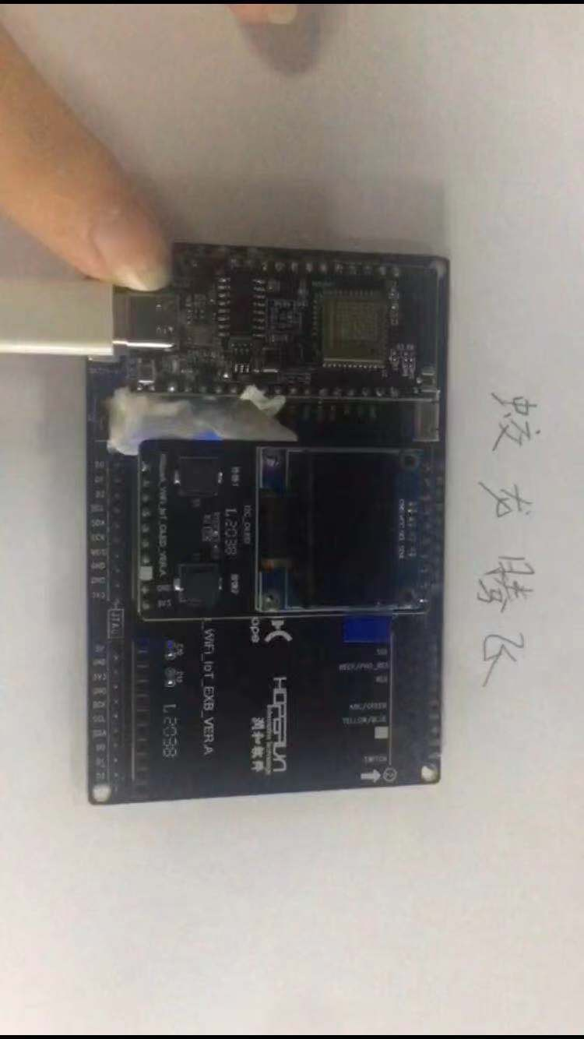

三、开发过程

**1.建立项目**

在applications/sample/wifi-iot/app/下新建一个文件夹用于存放项目文件，在文件中创建一个led_st.c文件用于存放业务代码，和一个BUILD.gn用于存放编译配置。

**2.编写代码**

控制原理：

在Hi361开发板中，GPIO09控制LED灯，GPIO05与user按钮连接，读取GPIO05状态进而决定GPIO09的状态，从而实现LED灯控制。

|  |
| --- |
| while (1){  hi_gpio_value val = HI_GPIO_VALUE0;  hi_gpio_get_input_val(LED_KZ_GPIO, &val);  IoTGpioSetOutputVal(LED_Out_GPIO, val);  } |

**3.运行代码**

修改applications/sample/wifi-iot/app/BUILD.gn文件,使其编译新建的led.c文件

|  |
| --- |
| import("//build/lite/config/component/lite_component.gni")  lite_component("app") {  features = [  "led_kz:led_kz"  ]  } |

然后进行编译烧录，按下res键运行项目后，按住user，led灯会随之亮起；松手就会熄灭

**三、关键代码**

led_kz.c

|  |
| --- |
| #include <stdio.h>  #include <unistd.h>  #include "ohos_init.h"  #include "cmsis_os2.h"  #include "hi_gpio.h"  #include "hi_io.h"  #define LED_TASK_STACK_SIZE 512  #define LED_TASK_PRIO 25  #define LED_Out_GPIO 9 // for hispark_pegasus  #define LED_KZ_GPIO 5  static void *kzLed(const char *arg)  {  while (1)  {  hi_gpio_value val = HI_GPIO_VALUE0;  hi_gpio_get_input_val(LED_KZ_GPIO, &val);  IoTGpioSetOutputVal(LED_Out_GPIO, val);  }  return NULL;  }  static void LedExampleEntry(void)  {  osThreadAttr_t attr;  hi_gpio_init();  hi_io_set_func(LED_Out_GPIO, HI_IO_FUNC_GPIO_9_GPIO);  hi_gpio_set_dir(LED_Out_GPIO, HI_GPIO_DIR_OUT);  hi_io_set_func(LED_KZ_GPIO, HI_IO_FUNC_GPIO_5_GPIO);  hi_gpio_set_dir(LED_KZ_GPIO, HI_GPIO_DIR_IN);  hi_io_set_pull(LED_KZ_GPIO, HI_IO_PULL_UP);  attr.name = "kzLed";  attr.attr_bits = 0U;  attr.cb_mem = NULL;  attr.cb_size = 0U;  attr.stack_mem = NULL;  attr.stack_size = LED_TASK_STACK_SIZE;  attr.priority = LED_TASK_PRIO;  if (osThreadNew((osThreadFunc_t)kzLed, NULL, &attr) == NULL) {  printf("[LedExample] Falied to create LedTask!\n");  }  }  SYS_RUN(LedExampleEntry); |

BUILD.gn：

|  |
| --- |
| static_library("led_kz") {  sources = [  "led_kz.c"  ]  include_dirs = [  "//utils/native/lite/include",  "//kernel/liteos_m/components/cmsis/2.0",  "//base/iot_hardware/peripheral/interfaces/kits",  ]  } |

完整代码地址：<https://gitee.com/jltfcloudcn/smart-devices/tree/master/led_st_kz>