King Mongkut's University of Technology Thonburi

B. Eng. Computer Engineering

Academic Year 2016

Experiment on 14 April 2017

Member

Rittichai Sriubolmas 57070503429

Sirada Ruantongdee 57070503435

Thitiya Trithipkaiwanpon 57070503449

Saranyu Pienpitak 57070503462

**Change the flower color by adding food coloring to the water**

**Abstract**

Plant absorbs water along with other substance through stem. The size, color, and health of the plants was effected by the liquid consumed. In this experiment, white flower, food coloring, and water, was used as materials to see the impact of the liquid it takes. The expected outcome is the color of petals should change to the same as food coloring. Second, two different food coloring should give two different color in flower. However, in this experiment, the result might not be perfect. We found that some factors such as the size of stem, the temperature, and the chemical make-up of the dye also affect the result.

**Introduction**

With the unlimited demand of a new product, it is an essential to find a new viable solution to make an alternative choices to satisfy the needs of people.

The aim of this experiment was to find a new design of a flower with low price materials that are not harmful to humans and environment.

The report presents the process and the product of an experiment which will include the following components: flower types, materials, and method.

**Method & materials**

Materials

* Any kind of cup but preferably a transparent one that size 300 ml

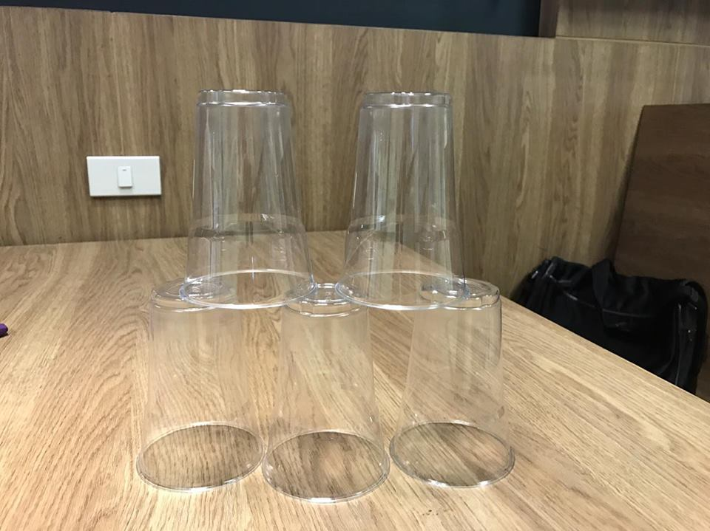

* Food coloring (any color)

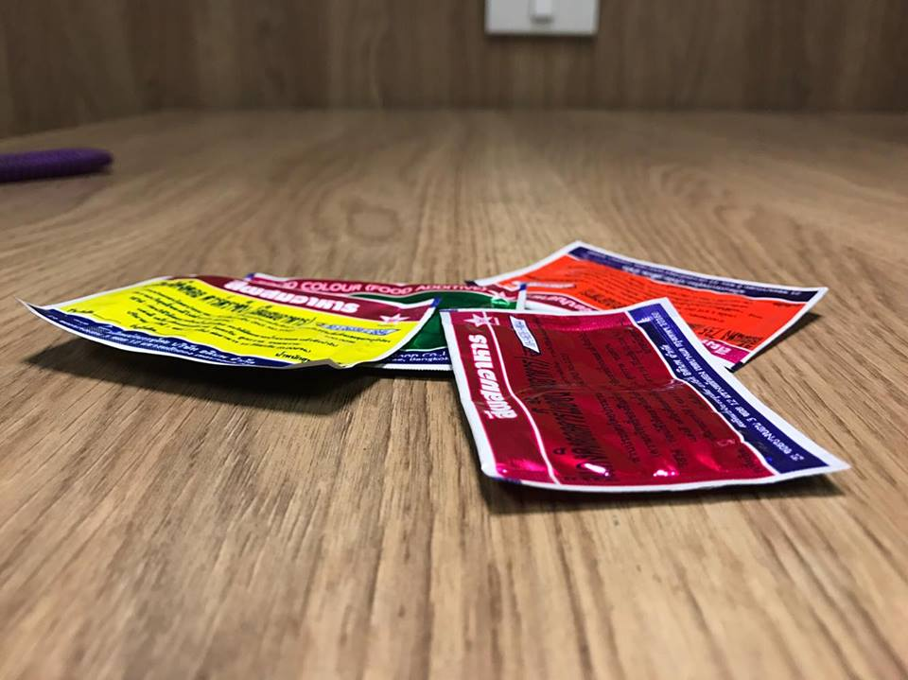

* Water (used to fill a cup)

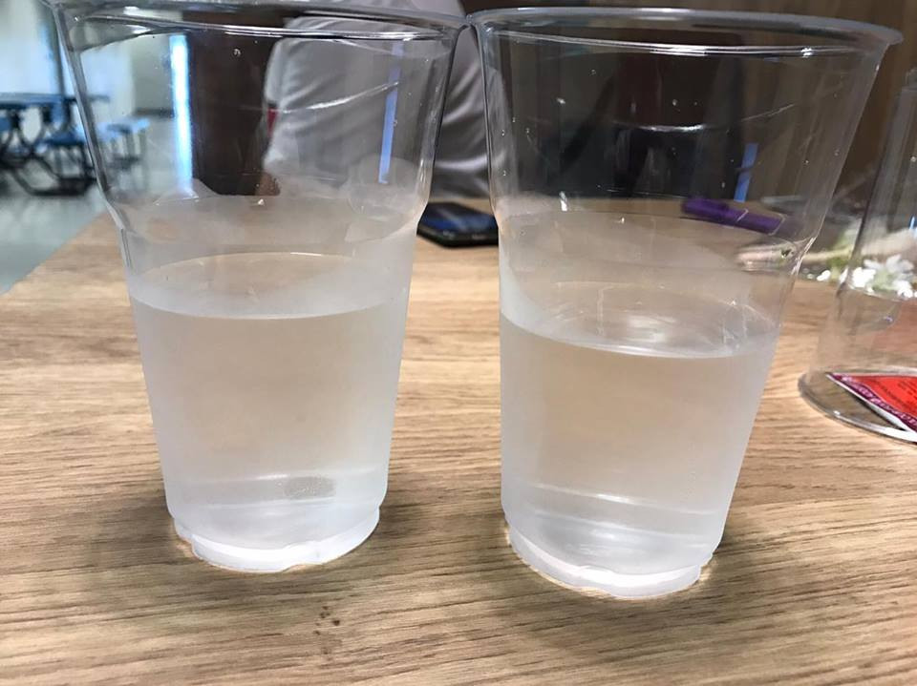

* Aglaonema costatum

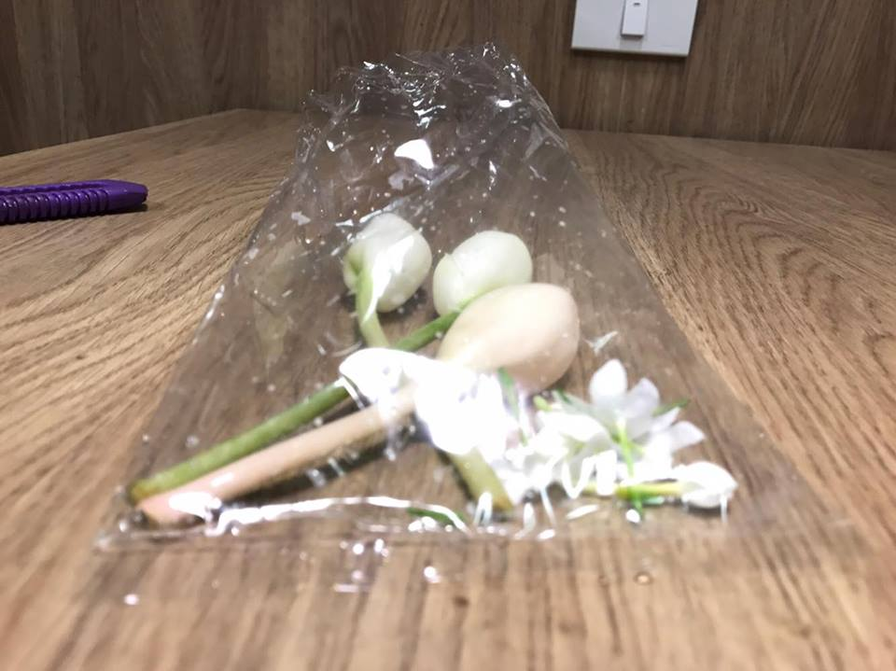

* Chrysanthemum indicum

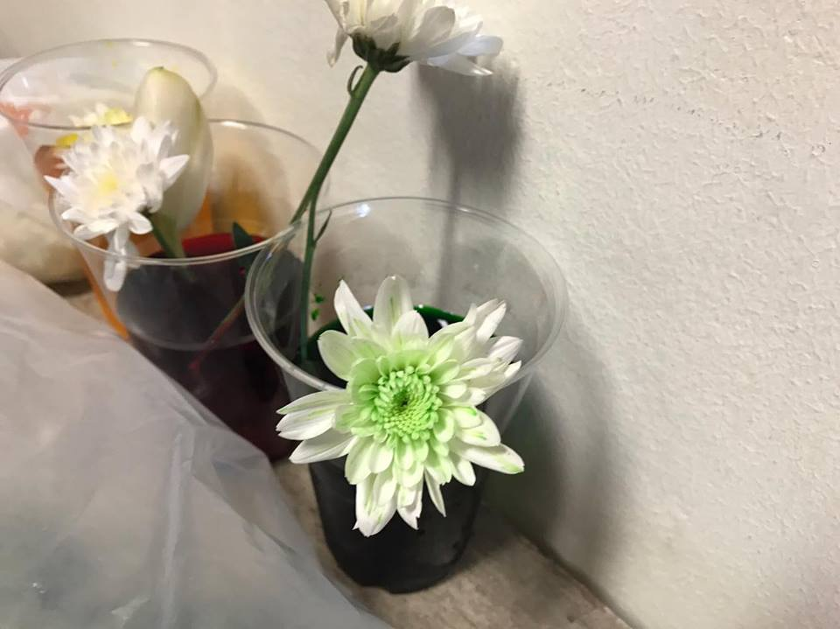

**Method**

Firstly, we brainstormed for material, time, and place to do the experiment. The result of brainstorming is the materials mentioned above. We chose to do an experiment on 11th floor of Witsawawattana building where the Computer Engineering Department is and we agree to work on 8 April 2017.

Secondly, we perform an experiment with 2 types of flowers Aglaonema and Chrysanthemum. By doing an experiment on both flowers we will analyze the reaction and time of change will tell that which flower is better at changing color. After that we will record the result and any information from the experiment.

**Procedure**

1. Cut the flowers stem diagonally.
2. Slit the stem of flower straight down to make it become to split stems.
3. Fill two cups of water. Each one has 100 milliliters.
4. Fill the cups with two different food colorings.
5. Place each half of a flower stem that we got from (2.) into a different cup of water from (4.).
6. Wait for 1 hour and see the result.

**Result**

We are experimenting on 2 flowers the Aglaonema and the Chrysanthemum because, both are white flower that suit our requirement. By putting the stalk of those flowers in the mixture of food coloring we wait for 1 hour for the change to occur.

Firstly, with Aglaonema the result came out poorer than we expected because the flower ability to consume the water is quite poor and the petal does not change color at all.

See figure 1.

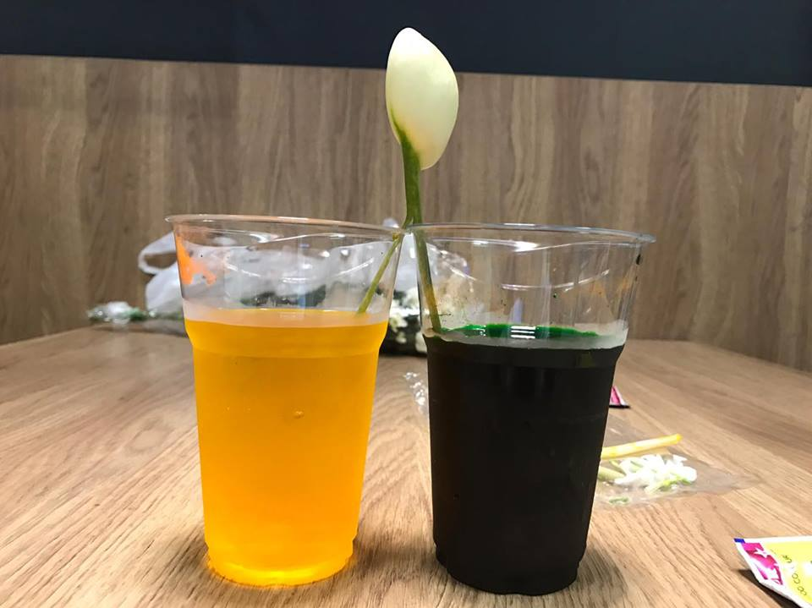

Figure1

The Chrysanthemum result came out poorer than we expected because the ability to osmosis is really great on this flower and the color of the petal began to change after an hour but it only change to one color not two as expected we using 2 food colorings as figure 2 show.

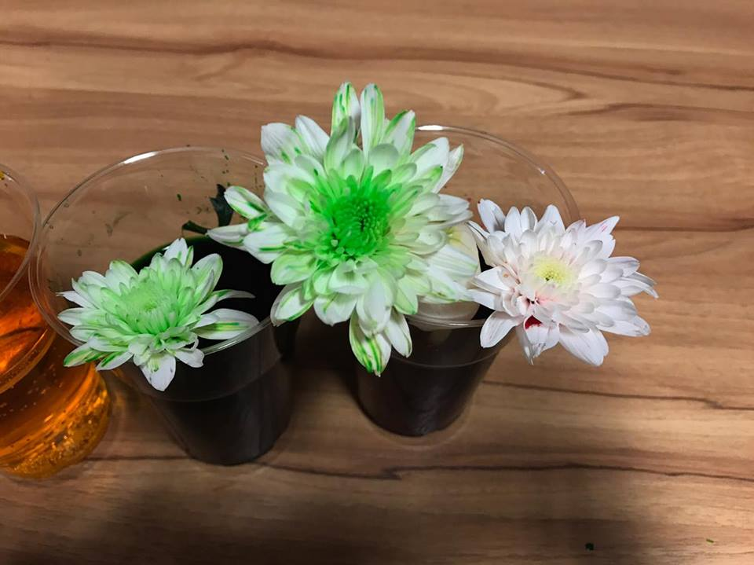

Figure2

**Conclusion**

So from the result we conclude that the flowers have an ability to consume the water with a mixture of food coloring and change their petal color according to the color of the food coloring but the amount of color needs to be precisely added to make the flower change the color.

**Discussion**

The major finding in this experiment is color of the flower changes according to food coloring. The hypothesis is that flower absorbing 2 food colors will change its color from white to the two colors we added into the water. But in our experiment the flower change to only one color instead of two.

The result of our experiment differs from scientist’s report that we use. The different things are our flower changed to only one color when using two colors. But in the scientist’s report the flower changes to two colors. This difference can occur from the different type of flower and the volume of water.

We can observe the process of osmosis where that water evaporates from the leaves, buds, and petals pulls water up the stem of the flower. Water that evaporates from leaves pulls up other water molecules behind it to fill the space it left. So that if other food coloring is denser than the other one, it will fill the space faster than another color so the other color cannot get into the space.

In the future, the result from this experiment can be used in everyday world. In the flower shop many people can use this experiment to make flowers more beautiful and colorful than the originals. The way to improve our experiment is to carry it out by optimizing method that makes the flower more colorful.

**Reference**

1. “Color Changing Carnation Flowers”

*Source: https://www.stevespanglerscience.com/lab/experiments/colorful-carnations*

1. “How Do Flowers Absorb Dye?”

*Source: https://www.hunker.com/12000193/how-do-flowers-absorb-dye*