This project is to simulation the authenticate operation

Enter ‘help’ for the command list.

help

Command list is shown below:

help

show all the command

user -c

create user by user name and password

user -d

delete user by user name

user -a

show all saved user

role -c

create role by role name

role -d

delete role by role name

role -a

show all saved roles

user -add

add role to user by user name and role name

auth

authenticate by user name and password and return a token

auth -i

invalidate the auth token

role -check

check roles by auth token and role name

user -a -r

get all roles for the user thru the auth token

exit

exit the program

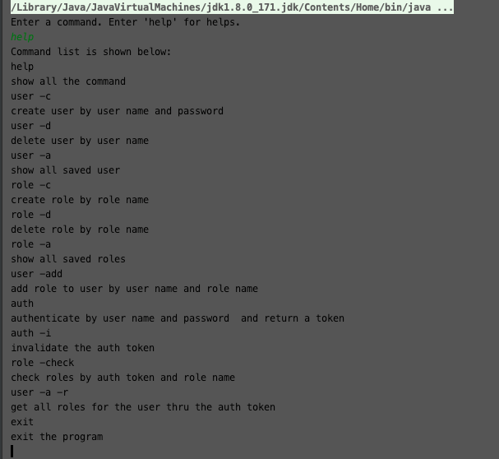

Provide a few examples ,

Create user

‘user -c’ then follow the instructions.

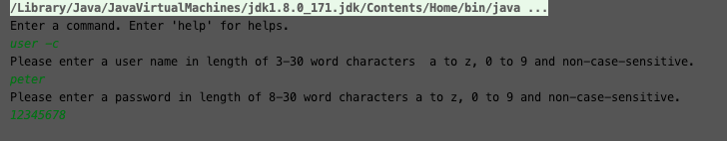

Authenticate

‘auth’

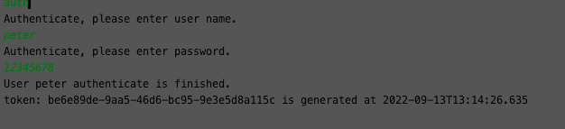

Check roles

‘role -check’

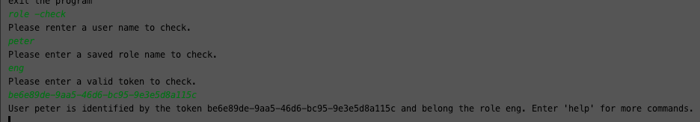

You may also can enter command during the main operation.

e.g. you need to check the token during the “check roles” operations by entering ‘token -a’ to print the token report. Therefor you can find the exact token that matches the specific username.

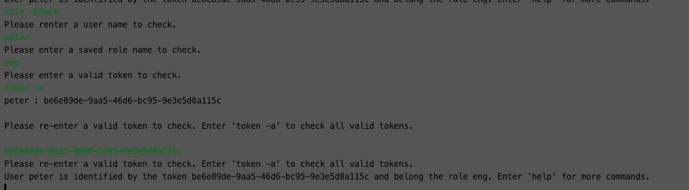

Enter ‘exit’ anytime to step over your current operation, and the program will exist if you are at the main menu.

