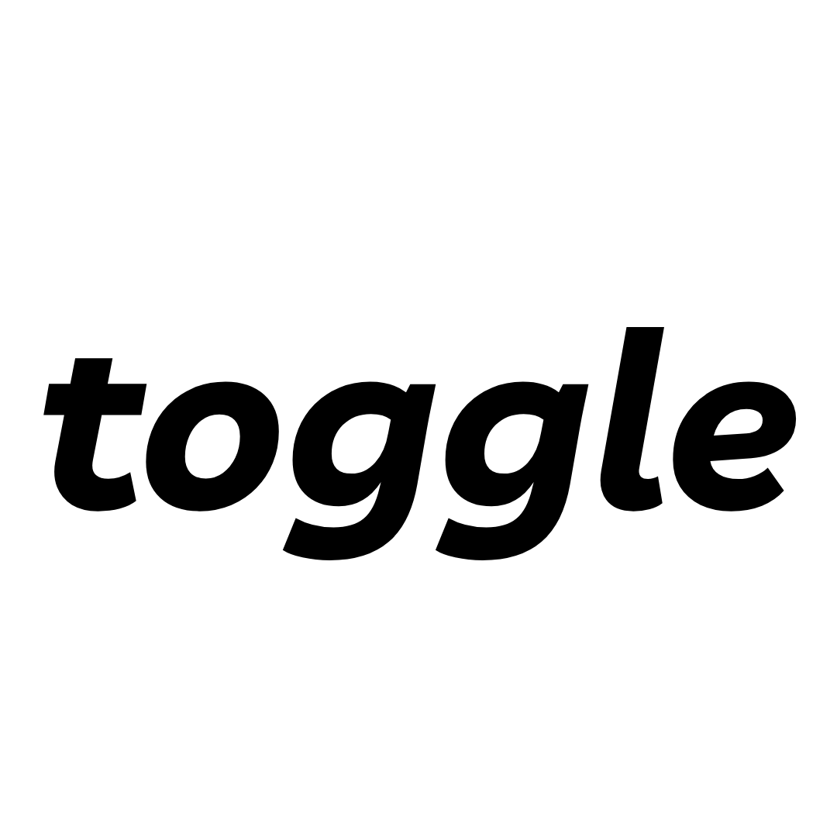
[ Your Digital Growth Partner ]
Scope of Services — Quotation Summary
Ikonik Eye Specialist Centre · Patient Lead Generation Programme
Toggle Solutions · July 2026 · For internal use: quotation preparation
Base servicing fee | RM 3,000 / month (ex-SST) — covers end-to-end management of all three platforms: TikTok, Google & Meta (standard rate is RM 3,000 per platform). The reduced base is possible because the balance of Toggle's fee is performance-tied: we earn it only when the enquiry targets are hit.
Performance fee | A tiered monthly performance fee on average daily PAID enquiries delivered (organic excluded — see tier table below). At the agreed target of 100+ paid enquiries/day (of which at least 75 quality), the total fee is RM 6,000. Total monthly fee ranges RM 3,000 (below 60/day) to RM 7,500 (cap, at 140+/day). Earned from Month 2 onward (Month 1 is the build month, base fee only).
Measurement & conditions | Paid enquiries = unique enquiries (messages, lead forms, WhatsApp conversations) generated by Toggle-managed geo-targeted campaigns, counted from platform reporting + the shared lead tracker; organic enquiries are excluded. Tiers assume media funded at the agreed plan of RM 18,000/month (TikTok RM 500/day + Google RM 1,500 + Meta RM 1,500) — thresholds pro-rate if media is funded lower. The quality bar (75+/day) applies at the target tier and above. The performance fee is invoiced monthly in arrears together with the performance report.
Rate condition | The base + performance fee structure is valid for up to RM 50,000/month in combined ad spend across all platforms. Should combined monthly ad spend exceed RM 50,000, the fee structure will be reviewed and re-quoted.
Contract term | This quotation is for a 3-month agreement · base fees RM 9,000 (ex-SST) + performance fees as earned per the tier table.
6-month incentive | If the client commits to a 6-month agreement, one (1) month of the BASE servicing fee is provided free of charge — pay 5 months' base, receive 6. A performance fee earned in the free month remains payable; the free month does not apply to optional add-ons or advertising media spend.
Validity | 30 days from date of quotation · media budget excluded — advertising spend of RM 18,000/month paid by client directly to TikTok / Google / Meta (client-owned ad accounts)

Performance fee tiers — measured monthly on average daily paid enquiries
Avg. paid enquiries / day (calendar month) | Monthly paid enquiries (approx.) | Performance fee | Total monthly fee
Below 60 | < 1,800 | — | RM 3,000 (base only)
60–99 | 1,800–2,999 | + RM 1,500 | RM 4,500
100–139 — the target (of which 75+ quality) | 3,000–4,199 | + RM 3,000 | RM 6,000
140 and above | 4,200+ | + RM 4,500 | RM 7,500 (cap)
At the agreed target of 100+ paid enquiries/day, the month closes at RM 6,000 — Toggle earns the upside only when Ikonik gets the volume. Below 60/day, Ikonik pays the base fee only.

A. Core services — covered by the base + performance fee structure
# | Service | Description
1 | TikTok Ads management (primary channel) | End-to-end setup and management of TikTok lead generation: LIVE stream ads (incl. Business Manager whitelisting request), Spark Ads on top organic posts, lead form and instant-message campaigns. Geo-targeted to Klang Valley. ~RM 15,000/month of the media plan.
2 | Google Search Ads management | Setup and management of search campaigns: brand protection, LASIK/refractive keywords (EN + BM), and competitor/comparison keywords. ~RM 1,500/month of the media plan.
3 | Meta Ads management (Facebook & Instagram) | Retargeting of website visitors and engagers, lead form campaigns for the 30–55 audience, and click-to-WhatsApp campaigns. ~RM 1,500/month of the media plan.
4 | Optimisation & testing | Daily budget management, weekly creative and audience testing, monthly channel rebalancing — all campaigns optimised to leads and appointments only. All ads vetted for KKLIU compliance before launch.
5 | Reporting | Weekly written performance summary + monthly report and review call (spend, leads, cost per lead, appointments booked). Full playbook handover at end of term.

B. Included at no additional charge — Toggle value-adds
Part of our expertise, provided as part of the partnership and not charged as line items:
Value-add | Description
Content strategy & direction | Ongoing advisory on which content formats, hooks, and livestream angles feed the paid engine best — folded into the clinic's existing content calendar. (Normally a chargeable consulting scope.)
Lead tracking & sales feedback loop | Shared lead tracker (every lead logged with its source), weekly 15-minute review with the clinic's sales/front-desk team, and lead quality scoring fed back into the campaigns.

C. Optional add-ons — quoted separately
Add-on | Description | Price
Landing page & conversion tracking | Dedicated campaign landing page — design, build, and conversion tracking setup (the conversion page ads land on — not SEO work). Recommended for the Google Search campaigns. | RM 1,000 per page; RM 500 per subsequent page
Static creative package | 10 static image ad creatives designed from the clinic's brand and content, each delivered in 2 sizings (20 exported files), KKLIU-vetted. | RM 3,000 per package

D. SEO & GEO Programme — optional, led by Julian Sieow (Organic Growth Lead)
Own the rankings the ads currently rent. Full scope in the SEO & GEO quotation summary; pricing and the agency guarantee below.
Programme | What it covers | Fee (ex-SST)
SEO | Full organic search programme: technical SEO, keyword & content (English), local SEO, link building, tracking & monthly reporting. | RM 6,000 / month
GEO | Full generative engine programme: AI visibility audit & monitoring (Google AI Overviews, ChatGPT, Gemini, Perplexity, Copilot), entity & schema optimisation, citation-worthy content, share-of-answer reporting. | RM 10,000 / month
SEO + GEO bundle | Both programmes under one integrated roadmap — saves RM 4,000/month (25%) versus RM 16,000 taken separately. | RM 12,000 / month
Bahasa Malaysia add-on | Extends keyword research, on-page optimisation, content production, and AI answer monitoring to Bahasa Malaysia. | RM 2,000 / month
3-month agreement totals: SEO RM 18,000 · GEO RM 30,000 · SEO + GEO bundle RM 36,000 (ex-SST). Delivery roadmap: Month 1 — technical & on-page audit, baseline · Month 2 — AI baseline audit, fixes & programme start · Month 3 — full execution & calibration.
THE AGENCY GUARANTEE — On a 6-month SEO engagement, Toggle guarantees the 20 target keywords (7 short-tail + 13 long-tail, each mapped to a target page — per the Keyword Targeting Proposal of 17 July 2026) rank within 6 months of optimisation work beginning. If the target is not met, the following 2 months of SEO service are provided FREE of charge. Ranking is measured from Google Search Console average position; the keyword list and measurement threshold are fixed in the service agreement.

Not included
- Advertising media spend of RM 18,000/month (paid by client directly to the platforms).
- New video content production — filming, photography, scripting, livestream hosting (client's in-house team continues these).
- Influencer / KOL engagements.
- Website development beyond the optional landing page add-on and on-page SEO/GEO changes; SST; third-party tool costs (passed through at cost with prior approval).
- Eye wellness (iSpa) and aesthetics segments — quoted separately if required later.

Toggle Solutions · Yi Yang Tee (yiyang@toggle.solutions) · Viknesh (+60 12 568 8681) · Julian Sieow — Organic Growth Lead, SEO & GEO (+60 12 799 0811 · seo@toggle.solutions)

