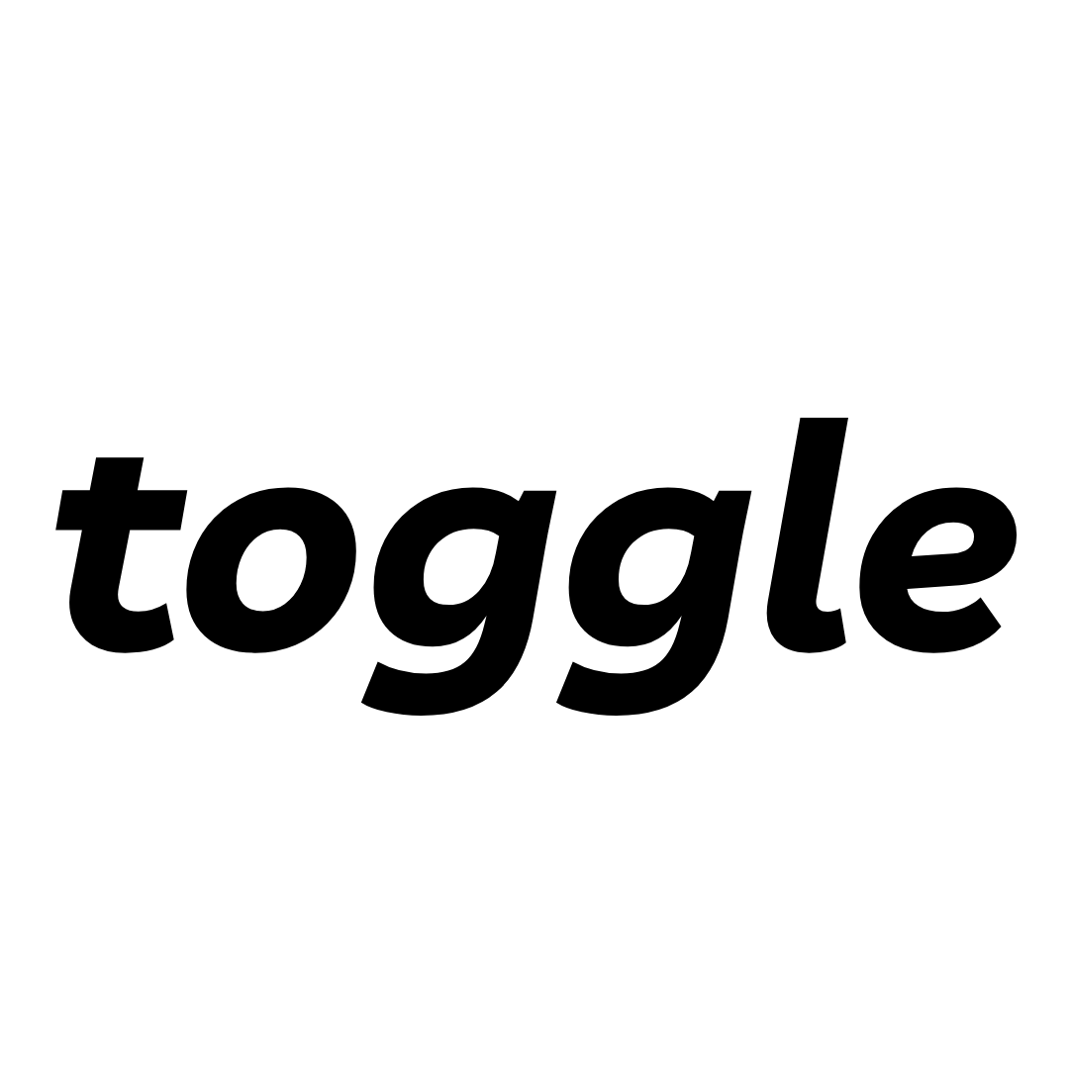
[ Your Digital Growth Partner ]
Scope of Services
Patient Lead Generation Programme — Ikonik Eye Specialist Centre
Prepared by Toggle Solutions · July 2026 · Supporting document to Quotation
Engagement: 3-month agreement (6-month option with incentive — see §5) · Base servicing fee RM 3,000/month + tiered performance fee on paid-enquiry results (total RM 3,000–7,500/month; RM 6,000 at the agreed target — see §5) · Advertising media budget of RM 18,000/month separate, paid by Client into Client-owned ad accounts
Confidential — prepared for Ikonik Eye Specialist Centre. This document describes in full the services covered by the fee structure, the complimentary value-adds, and the optional add-ons. It should be read together with the quotation and the proposal deck.

1. Engagement Overview
Toggle Solutions will design, build, and manage a full lower-funnel patient lead generation engine for Ikonik Eye Specialist Centre, focused on the eye surgery segment (LASIK-led) and targeted at the Klang Valley. The engagement covers end-to-end management of three advertising platforms — TikTok (primary), Google Search, and Meta (Facebook/Instagram) — together with the lead management process and measurement discipline required to turn advertising spend into booked appointments.
All campaigns are optimised exclusively to lower-funnel events — lead form submissions, instant message conversations, and website booking conversions. No budget is allocated to traffic, reach, or awareness objectives. Paid results are tracked and reported separately from Ikonik's organic enquiries: the programme's target is additive to everything organic already delivers.
The base agreement runs for three (3) consecutive months: Month 1 builds the infrastructure (no media spend), campaigns launch in Month 2, and Month 3 calibrates against real conversion data. A 6-month commitment extends the engagement into the optimise-and-scale phase — where compounding returns typically occur — and carries the free-month incentive described in §5. Media budget is agreed at RM 18,000/month (TikTok RM 500/day + Google RM 1,500 + Meta RM 1,500), targeting ~100 paid TikTok enquiries/day at full pace — within the RM 50,000/month rate ceiling.

2. Core Services — covered by the base fee + performance fee
All services below are covered by the base servicing fee of RM 3,000/month plus the tiered performance fee in §5 — Toggle's upside is earned only when the paid-enquiry targets are hit. Standard rate is RM 3,000 per platform (RM 9,000 value for three platforms). The fee structure is valid for up to RM 50,000/month in combined ad spend across all platforms; above that threshold it is reviewed and re-quoted.

2.1 Performance Strategy & Media Planning
- Baseline & forecasting. On execution of the NDA, Toggle will take access to Google Search Console, analytics, and existing conversion records to establish the current online patient volume baseline. Paid-enquiry performance is measured against this baseline, separately from organic.
- Media plan ownership. A living three-platform media plan — TikTok-led (~RM 15,000/month) with Google and Meta support (RM 1,500/month each) within the agreed RM 18,000/month budget — reviewed monthly and rebalanced toward the channels producing appointments at the lowest cost.
- Audience architecture. Klang Valley geo-fencing, LASIK-interest and procedure-intent segments, livestream viewer pools, engagement retargeting audiences, and lookalike audiences modelled on converted patients.
- Budget governance. Any proposal to increase media beyond RM 18,000/month is made only when cost-per-appointment holds within target for two consecutive weeks — spend scales when results are proven, not before.

2.2 TikTok Ads Management — End-to-End (Primary Channel)
- LIVE Stream Ads enablement. Preparation and submission of the Business Manager whitelisting request required to run ads on live streams (initiated in week 1 via the TikTok account manager, coordinated with Marcus). Once approved, live surgery streams are promoted to cold Klang Valley audiences in real time, optimised to messages and bookings rather than view count.
- Spark Ads programme. Identification and paid amplification of Ikonik's best-performing organic posts, preserving the organic look and social proof that already convert in TikTok search.
- Lead Generation & Instant Messaging campaigns. Instant Forms with qualifying questions so every lead arrives pre-scored, plus message ads routed into WhatsApp and the front-desk workflow.
- Full account operation. Campaign build, pixel/Events API configuration, bid and budget management (RM 500/day at full pace), audience management, and platform-policy compliance — including support through the account transition to Marcus. No influencer/KOL activity is included or recommended.

2.3 Google Search Ads Management
- Brand defence. Coverage of Ikonik brand terms to prevent competitor conquesting.
- Generic LASIK campaign. Coverage of the Klang Valley LASIK/refractive keyword cluster in English and Bahasa Malaysia (~590 searches/month core pool).
- Competitor & comparison campaign. Presence on comparison-stage searches where Ikonik's price anchor is most persuasive.
- Search infrastructure. Keyword research and expansion from GSC data, negative-keyword hygiene, ad copy testing, extensions, and bidding staged to data maturity — within the RM 1,500/month allocation.

2.4 Meta Ads Management (Facebook & Instagram)
- Retargeting engine. Structured re-engagement of website visitors, landing-page drop-offs, Instagram engagers, and unconverted WhatsApp enquiries — consistently the cheapest source of booked appointments in a considered-purchase category.
- Lead Ads. Conditional Instant Forms prospecting the 30–55 Klang Valley segment, qualified inside the ad.
- Click-to-WhatsApp campaigns. Conversations land in the same tracker and carry the same follow-up as all other leads — within the RM 1,500/month allocation.

2.5 Conversion Tracking & Measurement
- Full-funnel tracking stack. Installation and maintenance of TikTok Pixel + Events API, Meta Pixel + Conversions API, Google Ads conversion tracking with enhanced conversions, and GA4 — every lead attributed to its source platform, campaign, and creative.
- WhatsApp capture flow. Configuration of the click-to-WhatsApp pathway, first-touch qualification script for the front desk, and logging convention so WhatsApp enquiries enter the same tracker as form leads.
- Offline conversion feedback. Appointment and procedure outcomes fed back to the ad platforms as conversion events, so the algorithms learn to find patients who book — not people who merely fill forms.
- KKLIU / regulatory vetting. Every ad, claim, and destination is checked against Medicine Advertisements Board (KKLIU) requirements and platform healthcare-advertising policies before going live.
Note: the dedicated campaign landing page is an optional add-on (§4). Where no landing page is commissioned, campaigns direct to lead forms, WhatsApp, and Ikonik's existing website, all tracked as above.

2.6 Optimisation, Testing & Reporting
- Daily — budget pacing and rebalancing; underperformers paused against pre-agreed thresholds (e.g. CTR below 1%, CPL more than 50% above target).
- Weekly — creative and audience testing across hooks, offers, form depth, destinations, and languages (BM / EN / CN); written performance read-out including daily paid-enquiry count and quality rate.
- Monthly — performance report and review call in ringgit; tier result confirmed against the shared tracker; channel mix rebalance.
- End of term — documented playbook of what runs, what it costs, what converts, winning creative formats, and front-desk scripts — the system is Ikonik's asset, not a black box.
- Account ownership. All ad accounts, pixels, audiences, and data remain Ikonik's property at all times; media is billed by the platforms directly to Ikonik's accounts with 100% spend transparency.

3. Complimentary Value-Adds — included at no additional charge
Part of Toggle's expertise, provided as part of the partnership and not charged as line items:
- Content strategy & direction. Ongoing advisory on which content formats, hooks, and livestream angles feed the paid engine best — folded into the clinic's existing content calendar. Normally a chargeable consulting scope.
- Lead tracking & sales feedback loop. A shared lead tracker into which every lead auto-logs with source, campaign, creative, and qualifying answers; a standing 15-minute weekly review with the sales/front-desk team; and rolling lead-quality scoring per campaign and creative — the same data that verifies the monthly performance-fee tier.

4. Optional Add-Ons — quoted separately
Add-on | Description | Price
Landing page & conversion tracking | Dedicated campaign landing page — design, build, and on-page conversion tracking setup, iterated using real session data (the conversion page ads land on — not SEO work). Recommended for the Google Search campaigns. | RM 1,000 per page; RM 500 per subsequent page
Static creative package | 10 static image ad creatives designed from the clinic's brand and content, each delivered in 2 sizings (20 exported files), KKLIU-vetted. | RM 3,000 per package
Ad versioning of Ikonik's existing video content (cutdowns, captions, CTAs) for campaign use is handled within the core service. Net-new production — filming, photography, scripting, livestream hosting — remains with Ikonik's in-house team. The SEO programme is a separate proposal.

5. Commercial Summary
- Base servicing fee: RM 3,000 per month, ex-SST — end-to-end management of TikTok, Google & Meta (standard rate RM 3,000 per platform). No setup fee. The reduced base is possible because the balance of Toggle's fee is performance-tied.
- Performance fee: Tiered monthly fee on average daily PAID enquiries (organic excluded), earned from Month 2 onward (Month 1 is the build month, base fee only). Tiers: below 60/day — base only (RM 3,000 total) · 60–99/day — +RM 1,500 (RM 4,500) · 100–139/day, the agreed target, of which 75+ quality — +RM 3,000 (RM 6,000) · 140+/day — +RM 4,500 (RM 7,500 cap).
- Measurement & conditions: Paid enquiries = unique enquiries (messages, lead forms, WhatsApp conversations) generated by Toggle-managed geo-targeted campaigns, counted from platform reporting and the shared lead tracker; organic enquiries are excluded. Tiers assume media funded at the agreed plan of RM 18,000/month (TikTok RM 500/day) — thresholds pro-rate if media is funded lower. The quality bar applies at the target tier and above. The performance fee is invoiced monthly in arrears together with the performance report.
- Rate condition: The base + performance fee structure is valid for up to RM 50,000/month in combined ad spend across all platforms; above this threshold, the fee structure will be reviewed and re-quoted.
- Term: This quotation is for a three (3) month agreement — base fees RM 9,000, ex-SST, plus performance fees as earned per the tier structure.
- 6-month incentive: On a six (6) month commitment, one (1) month of the BASE servicing fee is provided free of charge — pay 5 months' base, receive 6. A performance fee earned in the free month remains payable; the free month does not apply to optional add-ons or advertising media spend.
- Media budget: Agreed at RM 18,000/month — TikTok RM 500/day (~RM 15,000), Google RM 1,500, Meta RM 1,500. Billed by the platforms directly to Ikonik's own ad accounts.
- Validity: This scope and the accompanying quotation are valid for 30 days from the date of issue.
Toggle Solutions — Your Digital Growth Partner
Yi Yang Tee — Strategy Lead · yiyang@toggle.solutions
Viknesh — Business Development Director · (+60) 12 568 8681 · toggle.solutions

