Supplementary Material
Training Randomness in Architecture Ablations: A Crossed Seed–Window Analysis with Preregistered Replication
Akylbek Tokhmetov ¹*, Saule Zhumagulovа ²*, Liliya Tanchenko ¹, Danel Musina ¹
¹ Department of Information Systems, L.N. Gumilyov Eurasian National University, Astana, Kazakhstan
² Department of applied mathematics and computer science, Karaganda National Research University named after Academician E.A. Buketov, Karaganda, Kazakhstan
*Corresponding author: tokhmetov_at_2@enu.kz
Journal: Machine Learning
Versioned reproducibility archive: https://doi.org/10.5281/zenodo.21935720
This document contains methods, diagnostics and sensitivity analyses moved from the main article. Section labels S1–S9 are used for cross-reference from the article.

Contents
S1. Data and protocol details
S2. Variance-model interval estimation
S3. Architecture and fusion-gate sensitivity
S4. Statistical assumptions, power and coverage
S5. Internal-state diagnostics and mechanistic controls
S6. Robustness and evaluation-design sensitivity
S7. OpenML-CC18 metric dependence and sensitivity
S8. Additional recommendations and computational cost
S9. Detailed threats to validity

S1. Data and protocol details

Experiment registry
Experiment | Domain / units | S | W | Component | Primary outcome | Status
Household primary | Energy / 17 households | 5 | 78–218 | Mode identity | Seed share; MAE effect | Exploratory
PatchTST | Energy / 17 households | 5 | 78–218 | RevIN | Seed share | Pre-specified
BiLSTM | Energy / 17 households | 5 | 78–218 | Attention pooling | Seed share | Pre-specified
ECL | Energy / 17 clients | 5 | 120; 157 | Mode identity | Median share / ratio | Preregistered
OpenML-CC18 | Tabular / 17 tasks | 5 | 146–6756 | Feature identity | Balanced error | Pre-specified scope probe
The machine-readable counterpart is results/results_manifest.csv in the reproducibility archive.

S1.1. Data-quality audit
We audit the resulting windows rather than assume their quality, and report the audit because it bears on the interpretation of three households. No missing values survive preprocessing in any dataset. The fraction of training data that is locally linear, and therefore either interpolated or constant, varies considerably: it reaches 29.2% on one REFIT household, mostly interpolated, and stays below 1.5% on most SHEERM households. Runs of constant meter readings up to 168 hours long occur in the training segments of four households and, in one REFIT household, in the test segment as well, where 14.8% of test targets are constant across the full forecast horizon and are therefore trivially predictable. That household behaves as an outlier throughout the results, and we flag it wherever it matters rather than removing it.

S1.2. Factorial design
Three binary factors are crossed; the resulting eight cells are listed in main-article Table 3. The auxiliary objective either drives the sum of the per-mode forecasts towards the target or requires each mode to predict the target individually. The aggregation either forms a convex combination of the per-mode forecasts or a sum. The identity embeddings are present or absent. Two of the four objective-aggregation cells are internally consistent and two are not, which is used in Section 5 to establish the mechanism. The full eight-cell design was run on six households; the two cells relevant to the ablation effect were run on all 17. A third cell was added as a control for effective loss weighting: the per-mode objective with convex aggregation and identity embeddings present, but with auxiliary weight 0.2/K rather than 0.2, trained on all 17 households with the same five seeds. Because the per-mode objective sums K Huber terms, at equal weight it carries roughly K times the auxiliary gradient of the summed objective; the control equalizes that without reintroducing the dimensional inconsistency of Section 5.1.2. The value 0.2/K follows from K and was not tuned.

S1.3. Interventions
Interventions are applied to trained models at inference and require no retraining. The correspondence between modes and identity embeddings is altered by cyclic shift, by random permutation averaged over fifty draws, by setting the embeddings to zero, or by permuting the modes independently in each window; separately, the aggregation weights alone are permuted. A null control permutes modes, embeddings and aggregation weights consistently, which is a pure relabeling and must leave the output unchanged; it is reported alongside every intervention.

S1.4. Pre-specified and post-hoc analyses
The preregistered ECL replication is separated from the exploratory analyses of the original household study. Within the OpenML-CC18 extension, the task set, exclusions, seeds, primary balanced-error metric, secondary cross-entropy metric and success criterion were registered before inspection of the final ablation outcomes. The restrictions to tasks with at least 150 or 250 test observations and the prediction-flip diagnostic are post-hoc sensitivity analyses. This classification is reported explicitly rather than presenting the complete project as planned from the outset.

S2. Variance-model interval estimation

S2.1. Interval estimation at five seeds
The seed share is itself an estimate, and with five training runs it is not a precise one. A nonparametric bootstrap over seeds fails here for a structural reason — duplicated seeds in a resample depress the between-seed mean square, the variance component truncates at zero, and the lower limit collapses to zero on 15 households of 17. The diagnostic below documents the failure; we use a model-based interval instead.
For the balanced crossed design, the conditional pivot concerns the seed-to-interaction variance ratio. Let θa=σ²seed/σ²interaction. Under independent normal seed and interaction effects with homogeneous interaction variance,
MSseed / [MSinteraction(1 + Wθa)] ~ F(S−1, (S−1)(W−1)). (S1)
The pivot is exact only conditionally under this crossed normal model. It does not yield an exact interval for the primary seed share, because the denominator of that share also contains the common-window term and serially dependent evaluation variance estimated by the joint moving-block bootstrap.
Quantiles of this F distribution bound θa. The primary reported share then uses Veval from the joint moving-block bootstrap, so its interval is explicitly labeled an F-based model interval. Coverage is assessed by simulation rather than asserted to be exact.
The model-based interval also settles the interpretation of the two households whose point estimate is zero. Their intervals are [0, 75] and [0, 81]%: a point estimate of zero reflects a component that cannot be separated from zero at five seeds, not an absence of seed variance. Both households have large and well-determined shares on the branch output, 96 and 83%.

S2.2. Training-seed contribution at the regime level
Table S1 reports the seed share for the four combinations of configuration and model output; Fig. 3 in the main text shows the decomposition of the variance at the household level. We distinguish the fused forecast, which is what an ablation study would normally report, from the output of the decomposition branch, which is where the ablated component acts.
Table S1. Share of variance of the ablation effect attributable to training seed, for four auxiliary‑objective/output combinations across 17 households. Median lower limit comes from F-based model intervals; in no case does the upper limit fall below one half.
Configuration and output | Mean | Median | Median lower limit | Households above 50%
Coherent, fused forecast | 67% | 83% | 51% | 10 of 17
Coherent, branch output | 83% | 91% | 74% | 13 of 17
Misaligned, fused forecast | 63% | 80% | 48% | 8 of 17
Misaligned, branch output | 96% | 99% | 98% | 16 of 17
Two statements are supported at conventional confidence levels, and they are not the same statement. First, in no household of any configuration does the upper confidence limit fall below one half, so a majority contribution from training randomness can be ruled out nowhere. Second, in between 8 and 16 households per configuration the lower limit exceeds one half, so a minority contribution can be ruled out there; on the primary combination this holds for 10 households of 17. An earlier version of this paper stated the first fact as though it established the second, which it does not: an interval running from 0 to 75% is consistent both with dominance and with a minority contribution. For the branch output of the misaligned configuration the result is close to deterministic, with seven households returning intervals of [99, 100] or [100, 100]%.
The share depends on S, W and the evaluation composition. We therefore also report the seed-to-evaluation variance ratio: its household median is 24 for the focal fused output, but it changes when additional, harder windows are included and is much smaller for the two external architectures. These quantities describe the stated architecture–component–training–evaluation regime; they are not invariant properties of an architecture.

S2.3. Consequences for inference
Recomputing the per-household intervals with the full standard error removes most of the nominally significant effects. In the coherent configuration the count falls from 7 of 17 households to 2; in the misaligned configuration, from 7 of 17 to 3. The direction of the change is not in doubt, since the window-only interval is a strict subset of the full one, but the magnitude is: more than half of the architectural effects that a conventional analysis would report as established are not distinguishable from training noise.
The reattribution also changes the picture at the pooled level. All figures below are on the normalized scale of Section 4.4, each household's effect expressed as a fraction of its own constant-predictor error, so that the practical threshold is a single line at ±2% rather than a band running from 0.8 to 9.8 W; the same analysis in watts is reported in main-article Table 4 and Fig. 4 and leads to the same conclusions. With window-only standard errors the random-effects summary carries τ = 0.66% and I² = 86.7%, suggesting substantial between-household heterogeneity; once seed variance is propagated to the correct level of the hierarchy, both collapse (τ = 0.30%, I² = 30.4%, Q(16) = 23.0, p = 0.11).
The consequence for sample size is real but smaller than it first appears, and the calculation needs an outlier-resistant estimate to be read at all. It rests on the mean within-household variance, and one household with degenerate test targets supplies 79% of the sum of the seventeen values, exceeding the median by two orders of magnitude. Detecting a mean effect of one% of household error at 80% power requires 8 households under window-only standard errors and 41 under full propagation; on a 10% trimmed mean the same figures are 6 and 11. At the 2% threshold they are 2 and 11 untrimmed, 2 and 3 trimmed. Leave-one-out over all seventeen households leaves the untrimmed requirement at the 2% threshold at 11 in fifteen cases and 10 in one, falling to 3 only when the degenerate household is removed — the same household flagged independently in the data audit of Section 4.2.1. What is robust is the direction and the fact that five households give no useful power at the 1% threshold under any variant; the individual figures are not, and we report the trimmed calculation as primary and the untrimmed one as an upper scenario. The study that originally motivated this work used five.
Correct attribution of variance narrows the pooled estimate while widening the individual ones, which is the expected behavior of a hierarchical model: dispersion removed from the household level is no longer available to inflate τ. The pooled estimate itself, its prediction interval, and the question of whether the heterogeneity collapse generalizes beyond this combination are taken up in Section 5.4.2.

S3. Architecture and fusion-gate sensitivity

S3.1. Does the decomposition transfer beyond this architecture?
The decomposition of Section 5.2.3 was measured on a model with two unusual features, signal decomposition and a learned fusion gate. To separate the regime from the architecture we repeated it on two external forecasters that have neither: a PatchTST on the undecomposed series with reversible instance normalization as the ablated component, and a BiLSTM with attention as the ablated component, on the same 17 households at five seeds. The remainder of this section gives the configurations and the per-household results.
Table S2 separates the qualitative claim from the quantitative one. Median seed shares are 34% for PatchTST and 69% for BiLSTM, and median seed-to-evaluation ratios are 3 and 11, versus 24 in the focal model. Training uncertainty is non-negligible in both checks, but it is not consistently the majority component and its balance is architecture- and component-dependent.
Table S2. Variance decomposition of the ablation effect for two external architectures, with the focal model in the last row. The seed-to-evaluation ratio compares the training-seed contribution to finite-evaluation uncertainty under the stated S and W.
Architecture | Ablated component | S | Median seed share | IQR | Median lower limit | Lower limit > ½ | Truncated at zero | Median seed-to-evaluation variance ratio
PatchTST (undecomposed) | RevIN | 5 | 34% | 9–57% | 7% | 2 of 17 | 3 of 17 | 3
BiLSTM | attention pooling | 5 | 69% | 48–74% | 30% | 3 of 17 | 1 of 17 | 11
Decomposition Transformer (Section 5.2.3) | identity embeddings | 5 | 83% | — | 51% | 10 of 17 | 2 of 17 | 24
Five seeds were used for both external architectures. The estimated seed component truncated at zero for 3/17 PatchTST households and 1/17 BiLSTM households, so the corresponding medians should be read with the wide five-seed intervals. Because the ablated components also differ (RevIN versus attention pooling), the transferable result is non-negligible training uncertainty, not a common numerical share.

S3.2. Is the fusion gate responsible?
The natural explanation for that difference is the fusion gate, and it can be tested directly. We retrained the coherent configuration with the gate removed, so that the model output is the decomposition branch itself, holding architecture, ablated component, households, seeds and training protocol fixed. The design and its primary statistic were fixed before the runs.
The gate makes no difference to the balance of the two components. The seed-to-evaluation variance ratio has a median of 24.1 with the gate and 12.8 without it (Wilcoxon p = 0.52), and the seed share 83 against 72% (p = 0.78). Reporting the components separately shows why: removing the gate raises the seed variance by a median factor of 2.4 and the window variance of the mean by 2.0, leaving their ratio where it was. The gate suppresses seed-driven variation at the output, as Section 5.1.3 reports, but suppresses evaluation variation to the same degree.
Two things follow, and a third does not. First, the estimated ordering reflects the evaluated regime—few expensive training runs against many evaluation points—rather than the fusion gate alone. Second, removing the gate raises both absolute variance components while leaving their ratio statistically unchanged. What does not follow is that the gate is inert or that a majority training contribution holds for every unit; the five-seed intervals remain too wide for that unit-level claim.

S4. Statistical assumptions, power and coverage

Assumptions box
Element | Primary treatment | Sensitivity / consequence
Design | Balanced S×W paired array | Same windows evaluated for every seed
Random effects | Normal seed effects; homogeneous interaction variance | Heavy-tail coverage ≈90.4%; heterogeneity stress tests reported
Window dependence | Moving blocks, ℓ=3, resampled jointly across seed rows | ℓ=1–10 leaves median share 79–85%
Interval | Conditional F pivot for variance ratio, mapped to share | Mapped share coverage ≈93–94%, not exact 95%
Meta-analysis | REML + modified Hartung–Knapp | Normal, Paule–Mandel and clustered/three-level sensitivities

S4.1. Statistical assumptions
The F pivot is exact conditionally for the seed-to-interaction variance ratio under the balanced crossed normal model. The primary seed-to-evaluation share is model-based because its denominator also includes the common-window contribution and evaluation variance supplied by the joint moving-block bootstrap. In d(h,s,w)=μ+a(h,s)+b(h,w)+c(h,s,w), a is the seed effect, b the common-window effect and c the seed × window interaction; identical window blocks are resampled jointly across all seed rows.
Reported forecast errors were previously computed from the average of five seed predictions, while the variance decomposition acts on per-seed effects; the two are different estimands and were reported side by side. All quantities in Sections 5.2 and 5.4 are now computed from the per-seed effect, and the ensemble figures are retained only where the deployed predictor is the subject, in Section 5.1.

S5. Internal-state diagnostics and mechanistic controls

S5.1. The internal state of the model
Table S3 characterizes the three outputs against a trivial baseline that predicts the training mean, pooled over all 17 households.
Table S3. State of the three model outputs under two auxiliary‑objective settings, pooled over 17 households. Reference is a constant‑mean predictor. Under the original objective neither path works individually, while their gated combination does; correction repairs the decomposition branch and compensatory bias of the direct path, without changing fused‑forecast error.
Quantity (17 households) | Original objective | Corrected objective
Decomposition path worse than constant | 11 of 17 | 1 of 17
Skip path worse than constant | 16 of 17 | 9 of 17
Fused forecast worse than constant | 0 of 17 | 1 of 17
Median sd ratio of decomposition branch | 0.086 | 0.313
Median absolute bias of direct branch, W | 461 | 29
Median error ratio of fused forecast | 0.726 | 0.767
Median MASE of fused forecast | 0.84 | 0.87
Under the original objective, the decomposition branch is a near-constant signal: its standard deviation is around nine% of the target standard deviation, and on 11 of 17 households, its error exceeds that of the constant predictor. The direct branch errs in the opposite direction, over-dispersed and biased upward on every household without exception, by between 149 and 618 W and worse than the constant predictor on 16 of 17. Neither path is individually a working forecast for most households; their combination is one everywhere.
The correlations with the target locate the defect. Under the original objective, the decomposition branch correlates with the target at a median of 0.49 across households, the direct branch at 0.52, and the fused forecast at 0.53; the median gain in correlation from either path to the fused output is 0.044 and never exceeds 0.124. Each path tracks the target almost as well as the model does as a whole. The paths therefore carry the shape of the signal and lack only scale and level, and the gate is not selecting between two forecasts but performing an affine recalibration of two mis-scaled ones, which is how a convex combination can outperform both of its inputs.
The constant predictor is the weaker of the two trivial baselines available. Against a seasonal naive forecast, which repeats the load of the same hour on the previous day, the fused forecast has a median MASE of 0.87 under the corrected objective and 0.84 under the original one, and is worse than that baseline on 6 households of 17 and on 5 of 17 respectively — while beating the constant predictor on every household but one. A model that clears the trivial baseline an ablation study would report can still lose to the one a forecaster would actually use, which is R6 of Section 6.1.2 in its sharpest form.

S5.2. The defect and its compensation
The compression of the decomposition branch is structural rather than a training failure. The auxiliary objective drives the sum of the per-mode forecasts towards the target, while the aggregation module combines the same terms with softmax weights that sum to one. A sum is required where an average is applied, so the path is shrunk by approximately the number of modes.
Three observations confirm this. Replacing the aggregation by the plain sum of the per-mode forecasts lowers the path error from 261 to 155 W on one household and from 253 to 176 W on another, improvements of 41 and 31%. Multiplying the aggregated output by the number of modes reproduces the summed forecast to within fractions of a watt, so the discrepancy is exactly a scale factor. And the learned aggregation weights are nearly uniform, with entropy 1.775 and 1.787 against 1.792 for the uniform distribution: the module introduced as an adaptive weighting is functionally a mean.
The second path compensates for the first (see Fig. S1 for amplitude behavior under different objectives and aggregation rules). Under the original objective the direct branch is biased upward on all 17 households, with a median absolute bias of 461 W; under the corrected objective the bias is small and of both signs, between −92 and +59 W, with a median absolute value of 29 W. Correcting an objective that formally concerns only the decomposition branch recalibrates both. The defect is therefore not localized in the component where it originates: training absorbs it by deforming the rest of the model, and any ablation performed inside the affected path is comparing two globally different operating regimes rather than two settings of one component.
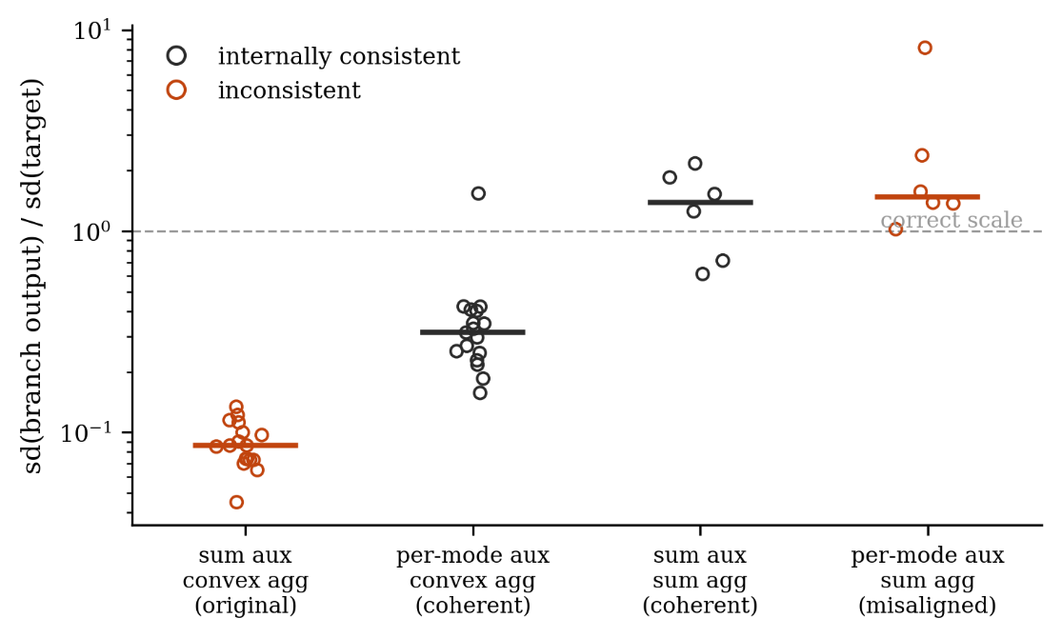
Fig. S1 Amplitude of the decomposition branch under four combinations of auxiliary objective and aggregation rule. Each point is one household; bars are medians. A dashed line marks the correct scale. Consistent cells keep amplitude near correct; inconsistent ones fail in opposite directions (sum+convex compresses by ≈ number of modes, reverse pairing overshoots). Vertical axis logarithmic. Eight‑cell design run on six households; two leftmost cells on all 17
Correcting the objective repairs the decomposition branch on every household: the standard deviation ratio rises in 17 cases of 17, its median tripling from 0.086 to 0.313, and the number of households on which the path is worse than a constant predictor falls from 11 to 1.

S5.3. The masking results
The fused forecast does not register any of this (Fig. S2). Its median error ratio is 0.726 under the original objective and 0.767 under the corrected one. The paired difference is significant and runs in the unexpected direction: the fused forecast is slightly better in the configuration whose internals are broken (Wilcoxon p = 0.017). Repairing the decomposition branch on 17 households of 17 does not improve the model output, and by this measure marginally degrades it. A model in which one branch is worse than a trivial predictor on two thirds of households and the other is biased upward on all of them is not merely indistinguishable, by the metric an ablation study would report, from a model in which neither is true; it scores slightly higher, though a control reported below shows that most of that difference reflects the weight of the auxiliary term rather than the state of the branch.
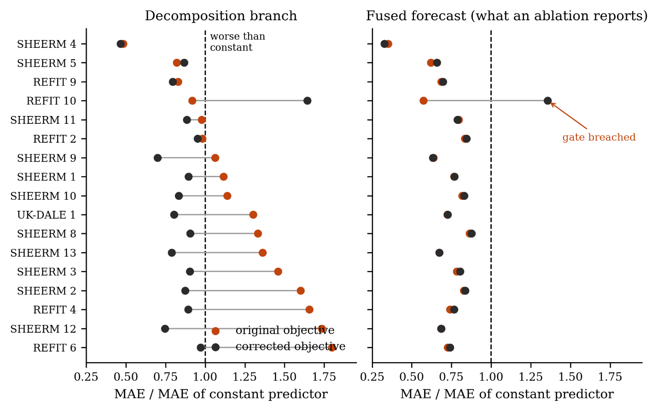
Fig. S2 Adaptive fusion masks branch state. Left: error of the decomposition branch relative to a constant‑mean predictor; right: error of the fused forecast. Each row is one household; paired points show original vs. corrected auxiliary objective. Correction reduces branch error (worse than constant on 11/17 → 1/17) and raises amplitude ratio in all 17. The fused forecast is stable (median error ratio 0.726 vs. 0.767; Wilcoxon p = 0.017, favoring uncorrected). The single household where gating fails is annotated; it also has degenerate test targets
A pre-specified control excludes the obvious alternative explanation, that the two objectives differ in effective weight rather than in coherence. A third configuration carrying the auxiliary weight of the original while repairing the branch reproduces the inversion in sign — paired difference +0.003 in error ratio, same sign on 14 of 17 households, p = 0.009 — but not its magnitude, which falls from +0.010 to +0.003, the two repaired configurations being indistinguishable (p = 0.28). Most of the gap reflects the strength of the auxiliary term; what survives is small, consistent in sign and still opposite to intuition. Supplementary Section S1 gives the design and the full results.
The same conclusion follows from the factorial experiment in the opposite direction (see Fig. S1). Across its eight cells the error of the decomposition branch varies by a factor of 5.3 to 14.4 depending on the household, while the fused forecast varies by between 1.5 and 11%; on the household with the largest test set the contrast is a factor of 6.9 in the path, from 162 to 1118 W, against 1.5% in the fused forecast. Degradation and repair are equally invisible, and the sign of the small residual movement is not the one intuition would predict.
The methodological consequence is direct. Component-wise ablation evaluated on end-task accuracy cannot distinguish a component that fails to do what it was designed to do from one that does exactly that and confers no benefit, and neither of these from a defect elsewhere in the same path. In the present architecture all three possibilities are simultaneously live, and the fused forecast separates none of them.
Compensation is not unbounded. On one household under the corrected objective the gate fails to absorb the state of the branch and the fused forecast falls below the constant baseline, with an error ratio of 1.36. This is the only such case in 17 households by two configurations, and it locates the boundary of the effect rather than contradicting it.
This household requires a caveat. It is also the household with the poorest data quality in the study, with degenerate test targets and week-long runs of constant readings in training (Section 4.2.1). We cannot separate the failure of compensation from the peculiarity of the data, and we do not claim to. The bound on compensation should be read as demonstrated in principle and not quantified.
The gate conceals more than the level of the path error. Comparing the seed component of variance at the two outputs, the seed standard deviation of the ablation effect falls from the path to the fused forecast in 14 of 17 households, with a median ratio of 0.50 under the corrected objective and 0.60 under the original one, and collapses to zero in several. An investigator who monitors only the fused forecast will therefore observe a model that appears both accurate and reproducible while the path inside it is neither.
The practical consequences of this are taken up in Section 6.

S5.4. Intervention rather than retraining
The preceding section established that the end-task metric is a poor instrument for observing a component. This section measures the mode-identity mechanism by a different route: instead of training a model with the component and another without it, we take a single trained model and alter the correspondence between modes and identity embeddings at inference time, leaving the weights untouched.
The two designs answer slightly different questions, and the intervention answers the narrower one: it asks what the trained forecast head does with the identity signal, not what the model would have become had the mechanism been absent during training. In exchange it removes the dominant source of noise. An ablation contrast is a difference between two independently trained models and inherits the initialization variance of both; an intervention contrast is taken within one model on fixed weights, and that variance cancels.
The gain is measurable. Re-estimating both quantities with five seeds instead of three, the per-household intervention estimates correlate at 0.81 (Pearson; 0.89 Spearman) with their three-seed counterparts, whereas the corresponding ablation estimates correlate at 0.05 (0.46 Spearman) and change sign on 3 of 17 households. At equal computational cost the intervention is the more precise instrument, and we recommend it wherever the question can be posed as a within-model contrast.

S5.5. Conditions and controls
Eight conditions were evaluated on every household and seed, and they differ in what they destroy. Under identity the model runs unaltered. Under cyclic, mode k receives the embedding of mode k+1, so the correspondence is broken while every embedding remains in use. Under random the rows of the embedding table are permuted, averaged over fifty non-identity permutations, with the per-window errors averaged rather than the predictions so that the averaging does not itself act as an ensemble; a variant averaging the predictions is reported alongside to show that it does not. Under mean every mode receives the average of the table, which removes the distinction between modes altogether. Under zeroed the embeddings are set to zero, which removes the vector as well as the distinction. Under shuffled the modes themselves are permuted independently in every test window. Under aggregation-permutation the aggregation weights alone are permuted, leaving embeddings intact.
The set is constructed so that the norm of the substituted vector is varied independently of the information it carries. Random and cyclic preserve the norm exactly and destroy only the correspondence; mean and zeroed also change the norm, the mean vector having about half the length of an individual row and the zero vector none. A response driven by the departure from the training distribution rather than by the loss of mode identity would therefore appear as a gradient across these conditions, and Section 5.3.3 reports that it does not.
A null control accompanies every measurement. When modes, embeddings and aggregation weights are permuted consistently, the operation is a pure relabeling and the output must be unchanged. Across all 17 households and both configurations the observed change in mean absolute error under this control lies between 7×10⁻⁸ and 4×10⁻⁶ W, which is the accumulation limit of the arithmetic. The intervention machinery is therefore sound, and the null effects reported below are properties of the model rather than of the measurement.

S5.6. The mechanism does what it was designed to do
A linear probe trained on the shared encoder representations recovers the identity of the mode from which each representation was produced. Under the original objective, probe accuracy has a median of 0.981 across households and never falls below 0.941, against a chance level of 0.167. A control probe trained on randomly permuted labels reaches only 0.15 to 0.19, so the selectivity of the probe is above 0.78 throughout: the encoder is not merely memorizing, it is encoding mode identity in a linearly accessible form.
That is what the mechanism was introduced to achieve, and the accuracy is high on every household of the three collections under both objectives: the median under the corrected objective is 0.946, with a minimum of 0.810. High accuracy alone, however, does not show that the mechanism produced it, because the modes are disjoint frequency bands by construction and the shared encoder may separate them regardless.
A control settles this. Repeating the probe on models trained without the embeddings — the same weights, the same test windows, a forward pass only — recovers mode identity at a median accuracy of 0.802 across the 85 household-seed pairs, against 0.968 with the embeddings and a chance level of 0.167; the shuffled-label control returns 0.164. Mode identity is therefore partly decodable without the mechanism, and the mechanism sharpens rather than creates it, by a median of 13 percentage points. We state the claim in that form and withdraw the stronger one.
The margin is not uniform, and its variation is informative. On SHEERM household 4 the representation carries no mode information at all without the embeddings — accuracy of 0.167 to 0.174 across all five seeds, indistinguishable from chance — against 0.98 with them; it is the only household of the seventeen on which accuracy without the mechanism falls below one half. At the other extreme, several households gain under ten percentage points. Per collection the median without embeddings is 0.720 on REFIT, 0.829 on SHEERM and 0.890 on UK-DALE, against 0.967, 0.970 and 0.966 with them. On the second domain of Section 5.5 the margin nearly vanishes, 0.961 against 0.975, so the sharpening is itself domain-dependent; we record that alongside the branch-heterogeneity difference of Section 5.5.3 and offer an explanation for neither.

S5.7. What the mechanism is worth
Breaking the mechanism at inference has a detectable but very small effect on the forecast, and this holds however the mechanism is broken. Under the corrected objective the median change in mean absolute error ranges from +0.19 W under aggregation-permutation to +0.92 W under zeroing, against a median household error of 129 W. Zeroing is positive on 14 of 17 households (sign test p = 0.013) and the norm-preserving permutation on 13 of 17; the direction is consistent enough to be established, and its magnitude is not.
The comparison across conditions rules out the objection that the effect merely reflects a model pushed outside its training distribution. Random permutation preserves the norm and the distribution of the substituted vectors exactly, destroying only the correspondence between mode and embedding, and it produces 0.50% of household error against 0.67% for zeroing. Replacing every embedding by the table mean, which destroys the distinction between modes but halves the norm, produces less, 0.33%. The response therefore tracks the loss of correspondence rather than the change in norm, and the intervention measures what it was intended to measure. Averaging predictions instead of per-window errors changes the permutation result from 0.50 to 0.42%, confirming that the averaging does not act as an ensemble.
One ordering in Table S4 is worth noting. Permuting the embeddings hurts more than removing the distinction between them altogether: 0.50% against 0.33. Misinformation costs more than missing information, which is what one would expect of a mechanism the model relies on to route mode-specific processing, and is a mild positive result for the mechanism. It is also the largest such result we obtain.
The magnitude is another matter, and it is the same under every condition. No intervention has a median effect above 0.67% of household error, against the 2% threshold of practical significance stated in the protocol. Under zeroing, five of 17 households exceed that threshold and three of them are the households flagged in the data audit (Section 4.2.1); excluding those three, the largest effect among the remaining 14 falls from 12.3 to 2.3% and only two households remain marginally above it. Under the mean substitution three households exceed it. The mechanism can be disabled in seven distinct ways. None of the seven interventions has a median effect reaching the ±2% margin, although several household-specific effects exceed it, primarily among the data-quality cases.
Table S4. Effect of disabling the identity mechanism at inference under the corrected objective, across 17 households, ordered by severity. Positive values mean forecasts worsen. All conditions use the same trained models, test windows and seeds and require no retraining. The null control is a consistent relabeling of modes, embeddings and aggregation weights, whose observed change lies between 7×10⁻⁸ and 4×10⁻⁶ W — the accumulation limit of the arithmetic. The practical-significance threshold is 2%; no condition’s median effect approaches it (individual households vary — see S5.7).
Condition | Median, % of household error | Worse on | What is destroyed
relabel_all (null control) | 0.00 | 1 of 17 | nothing; a pure relabeling
aggregation-permutation | 0.21 | 10 of 17 | aggregation weights only
shuffled per window | 0.26 | 9 of 17 | modes permuted in each window
mean substitution | 0.33 | 15 of 17 | distinction between modes; norm halved
random (predictions averaged) | 0.42 | 13 of 17 | correspondence; norm preserved
random (errors averaged) | 0.50 | 13 of 17 | correspondence; norm preserved
cyclic shift | 0.52 | 14 of 17 | correspondence; norm preserved
zeroed | 0.67 | 14 of 17 | embeddings entirely; norm removed
A second comparison answers the objection that the measurement is simply insensitive. Under the original objective, in which the decomposition branch is compressed to a near-constant, zeroing produces a median effect of 0.05 W with an even split of signs and no household anywhere near the practical threshold. Under the corrected objective, in which the path is a working forecaster, the median absolute effect is ten times larger and the sign is consistent. The instrument detects an effect where the mechanism has room to act and reports none where it does not, which is the behavior a valid instrument should show.

S5.8. An inversion of the representational account
Probe accuracy is significantly lower in the configuration where the mechanism matters more. Its median is 0.946 under the corrected objective against 0.981 under the original one, and the difference is consistent across households (Wilcoxon p = 0.0004, n = 17). Where the decomposition branch is compressed to a near-constant, mode identity is encoded almost perfectly and is worth nothing; where the path actually forecasts, identity is encoded less sharply and is worth slightly more.
The natural reading is that encoder capacity is finite and is spent on whichever task the objective makes binding. When the path is not required to produce a calibrated forecast, representing mode identity is the cheapest available structure and the encoder supplies it abundantly. Two conclusions follow, and the control of the preceding section is needed for both. The strength with which a property is encoded is not evidence that the property is used, and in our data the two are related inversely. And a difference in probe accuracy between configurations is not by itself a difference the mechanism produced, since most of the accuracy is present without it. A representational criterion alone cannot establish that a mechanism contributes; a representational criterion without a mechanism-absent control cannot even establish that the mechanism is responsible for what is measured.

S6. Robustness and evaluation-design sensitivity

S6.1. Why the original finding appeared
The hypothesis under test was formulated on five households of a single dataset (see Fig. S3 for required sample sizes under proper variance propagation), where the comparison favored the configuration containing the identity mechanism at p = 0.032. That study was never published, and the figures quoted here are taken from its final report; its preprocessing code was not the code used here and its trained artifacts were built on a different chronological split, so the comparison available to us is with its design and its reported statistic rather than with its intermediate outputs. Nothing in the present analysis suggests that this figure was computed incorrectly. It is, rather, what a study of that size will produce with some regularity when the effect is null and the uncertainty is understated.
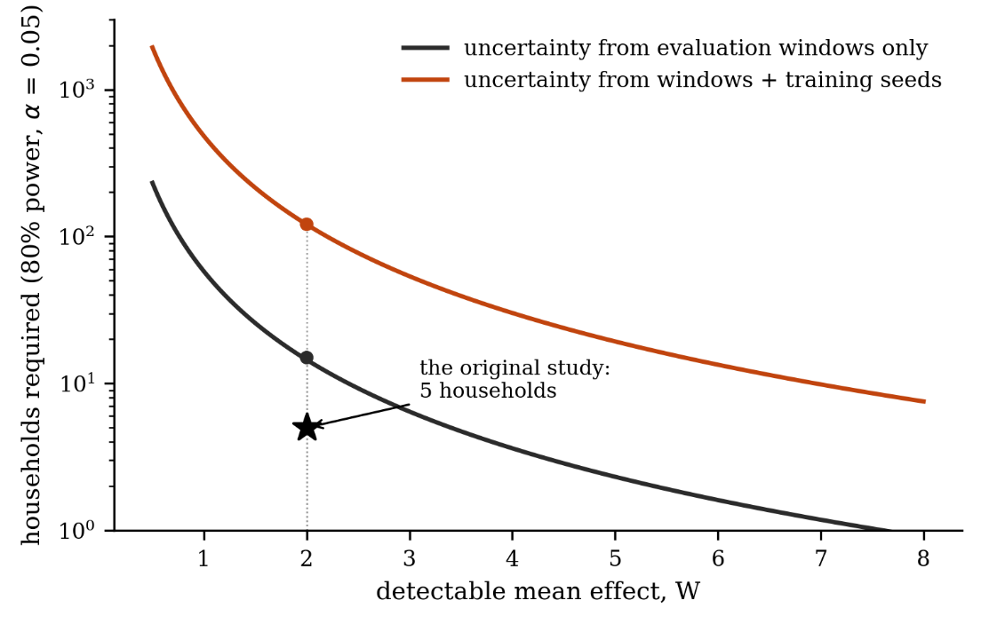
Fig. S3 Households required to detect a given mean effect at 80% power and a two-sided level of 0.05, computed from the variance components estimated here. The upper curve propagates both the evaluation and the training component; the lower curve propagates the evaluation component alone, as a study reporting a single training run per configuration would implicitly do. The star marks the design of the study that originated the hypothesis: five households, at an effect size of 2 W. The axes are in watts, matching the scale of the earlier study; the normalized counterparts are in main-article Table 5. Dashed curves repeat both calculations without the single household whose degenerate test targets supply 79% of the mean within-household variance, which bounds how far the individual figures should be trusted. The vertical axis is logarithmic
Two mechanisms compound. First, the standard error used at the time was estimated by resampling test observations alone and therefore captured about a fifth of the variance, as quantified in the preceding section. Second, five households provide no useful power against an effect of this size: with full variance propagation, detecting a mean effect of one% of household error at 80% power requires 41 households on the untrimmed estimate and 11 on the trimmed one. A study with five is not underpowered by a modest margin, and its significant results are dominated by whichever direction the sampling happened to take.
This is not a criticism specific to the earlier work. Five households is at the generous end of what is reported in the applied forecasting literature for cross-household architectural claims, and the practice of estimating uncertainty by resampling the evaluation set is close to universal. The point of reconstructing the original finding is not that it was carelessly obtained but that it was obtained by the standard procedure, and that the standard procedure produced it in the absence of any effect.

S6.2. Robustness
The three households flagged in the data audit are retained. Leave-one-out estimates keep the pooled normalized effect between −0.15% and −0.35%, and every prediction interval remains inside the study-specific decision margin. Figure S5 shows that the pooled effect and I² are stable, whereas untrimmed sample-size planning is sensitive to the degenerate household. We therefore designate the 10%-trimmed estimate as the primary planning scenario and the untrimmed 41-household result as a conservative upper scenario.
Individually, 2 of the 17 households show an effect distinguishable from zero after full variance propagation, against 7 under window-only standard errors. Neither of the two exceeds the practical threshold once expressed relative to its own error.
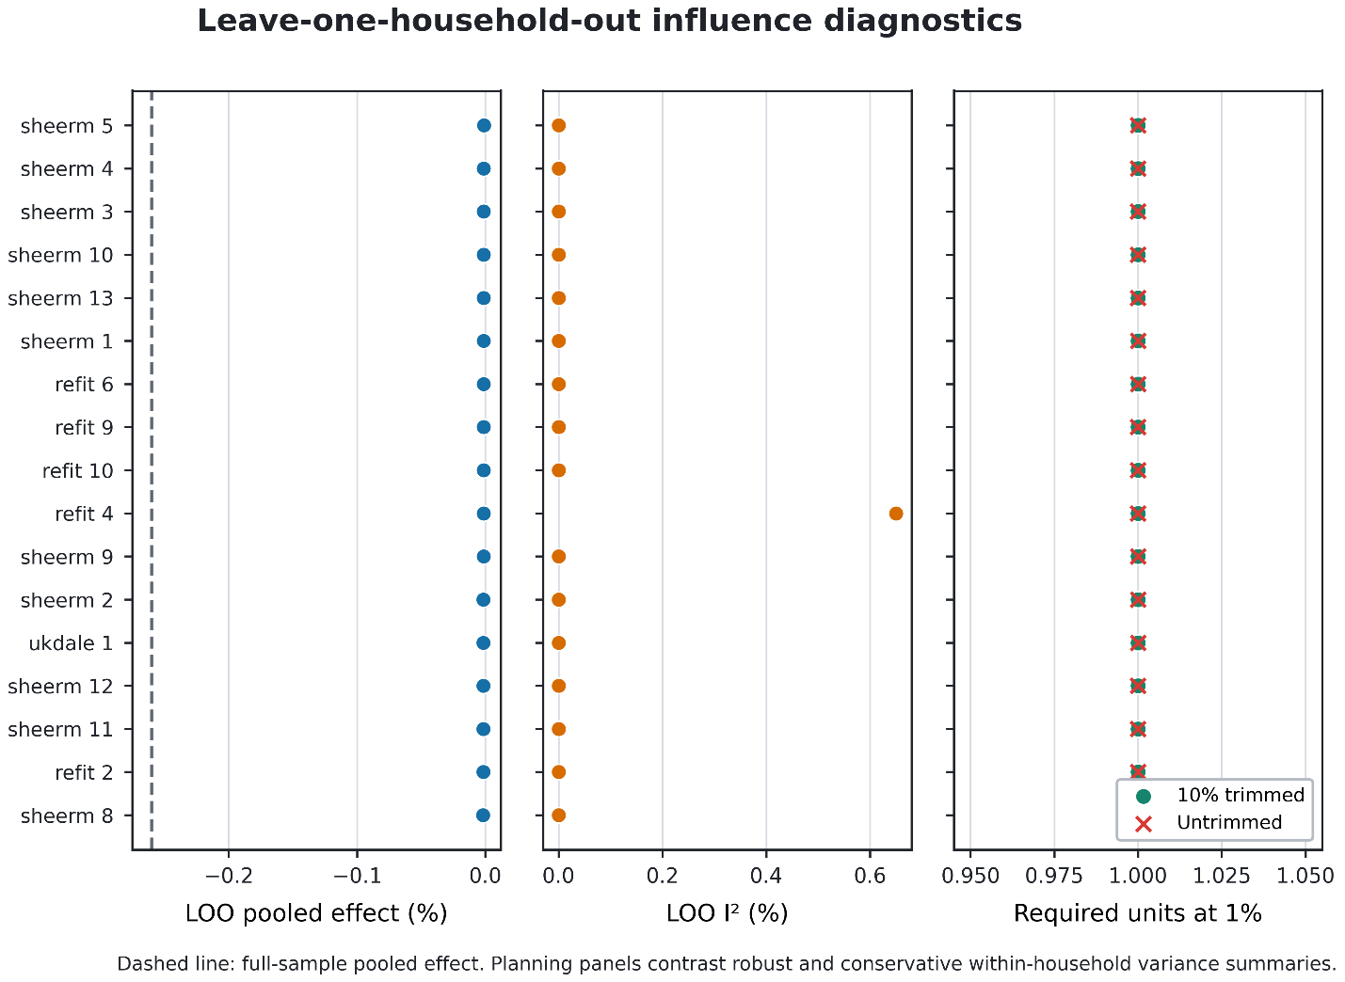
Fig. S4 Leave-one-household-out influence diagnostics for the primary normalized effect. Left: REML pooled effect; center: I²; right: estimated units required for 80% power at a 1% effect under the primary 10%-trimmed and conservative untrimmed planning summaries. The dashed line is the full-sample pooled effect. The pooled conclusion is stable, whereas untrimmed sample-size planning is sensitive to the degenerate household

S6.3. What replicated
The preregistered aggregate criteria reproduce: the median estimated seed share is 83% at the fused output, the median ratio is 4.9, and the F-based model interval excludes a minority contribution for 10/17 clients. Individual intervals remain wide, so the result supports the registered regime-level criteria rather than dominance for every client. Table S5 places the domains side by side.
Table S5. Replication of the variance result on a second domain. Household figures are the 17-household analysis of Sections 5.2 and 5.4; ECL figures are the preregistered replication of this section at the registered evaluation design (W = 120) and at the full test segment (W = 157), the latter computed from the same trained weights. Effects are in watts for the households and in units of the client's persistence error for ECL, so their magnitudes are not comparable; shares, ratios, heterogeneity and sign splits are.
Quantity | 17 households | ECL, W = 120 | ECL, W = 157
Seed share, fused output: mean / median | 67 / 83 % | 66 / 83 % | 74 / 81 %
F-based model interval, median lower limit | 51 % | 57 % | 54 %
Units whose 95% lower confidence limit exceeds ½ | 10 of 17 | 10 of 17 | 9 of 17
Units truncated at zero | 3 | 3 | 1
Seed-to-evaluation ratio, fused output | 24 (0–52) | 4.9 (0–11.4) | 4.1 (0–25.2)
Seed share, branch output: median | 91 % | 77 % | -
Summary effect, p | −0.28 W, 0.141 | ≈0, 0.752 | ≈0, 0.449
I²; Q(16); p | 30.4 %; 23.0; 0.11 | 18.4 %; 19.6; 0.238 | 0.0 %; 15.2; 0.513
Sign split (- / +) | 13 / 4 | 6 / 11 | 6 / 11
Units required at the smallest effect considered | - | 138 | 209
The variance ordering replicates, but its magnitude does not. The median seed-to-evaluation ratio is 4.9 versus 24 in households; how much larger the training contribution is remains a property of the regime.
Masking replicates in a sharper form. The error of the decomposition branch differs between the coherent and incoherent configurations by a median factor of 8.5, within the range of 5.3 to 14.4 observed on the households, while the fused forecast does not deteriorate. It improves: the incoherent configuration yields the lower fused error on 16 of the 17 clients, with a median paired difference of 0.010 in units of persistence error and a paired signed-rank p of 3.1 × 10⁻⁵, against 0.726 versus 0.767 at p = 0.017 on the households. The single exception differs by 0.0007, which is to say by nothing. We continue not to advance the defective configuration as preferable; the finding's role is to show, now on two domains, that repairing a branch need not improve the reported metric and that the metric can move in the wrong direction while the internals are corrected.

S6.4. What did not replicate
On the branch output the two domains disagree. The median seed share is 77% against 91, the median lower limit of the F-based model interval 48 against 74%, and the number of units confidently above one half falls from 13 to 8. More consequentially, the heterogeneity that was significant on the households for this output - I² of 54.1% with Q(16) = 34.9 at p = 0.0041 - is absent on ECL, where I² is 5.5% at p = 0.39. Section 5.4.2 records that the collapse of heterogeneity held only in the primary combination and not in the other three; that selectivity does not survive the change of domain, and the data available here do not explain why. We therefore restrict the claim about absent between-unit heterogeneity to the fused output, where it holds in both domains, and withdraw it for the branch output.
The direction of the embedding effect is also reversed, 6 negative against 11 positive on ECL where the households gave 13 against 4. Since the effect is indistinguishable from zero in both domains, opposite sign splits are evidence for the absence of an effect rather than a conflict between the domains, but the reversal should be reported rather than passed over.

S6.5. Sensitivity to the evaluation design
The truncation of the test segment to 120 windows was a design choice, and the registration document required that it be checked. Because truncation affects only the test slice, the training and validation segments being identical under both settings, the check was performed on the same trained weights and differs from the primary analysis in nothing but the evaluation set. Both criteria hold under both settings: the median share is 83 and 81% against a threshold of one half, the seed-to-evaluation variance ratio 4.9 and 4.1 against a threshold of one, the sign split is unchanged, and the summary effect is indistinguishable from zero in both.
The prediction we registered for this check was nonetheless wrong, and the reason is instructive. We expected the share to rise with the number of windows, since the window component of the variance of the mean is divided by it; instead it fell slightly. Enlarging the test set changes not only the divisor but the composition of the test set, and the additional 37 windows fall in a later and harder segment of the series: the mean within-client variance rose by a factor of 1.51 where a fall by a factor of 1.31 was expected, and the two effects canceled. The stability of the share across evaluation designs is thus produced by compensation between two opposing mechanisms, not by independence from the design. The seed-to-evaluation variance ratio would be invariant under pure 1/W scaling with unchanged evaluation composition; its observed 16% change reflects the harder additional evaluation segment.
A related observation bears on the interpretation of point estimates. The set of units whose share truncates at zero is itself design-dependent: three clients at 120 windows, one at 157. A point estimate of zero is a statement about the estimator at this sample size, not about the unit.
Table S6. Preregistered criteria and outcomes for the second-domain replication. Criteria and thresholds were fixed before the first training run; the primary analysis is at the registered evaluation design of 120 windows.
Criterion | Registered threshold | Result on ECL | Outcome
Seed share of the variance of the mean effect, fused output | median above one half | 83 % median; above one half on 14 of 17 (whose point estimate exceeds ½) | met
Seed-to-evaluation ratio | median above one | 4.9; above one on 14 of 17 | met
Branch error differs between configurations while the fused forecast does not | qualitative | branch factor 8.5; fused lower in the incoherent cell on 16 of 17, p = 3.1 × 10⁻⁵ | met, with the fused forecast moving in the unexpected direction
Pooled effect reported with heterogeneity and a prediction interval | reporting requirement | summary effect ≈0, p = 0.752; I2 = 18.4 %, Q(16) = 19.6, p = 0.238 | met
Two limitations of the replication should be stated with it. Five seeds give four degrees of freedom for the seed component, so intervals are wide and the median across units, rather than any individual estimate, is what the design supports. And clients were sampled at random from an eligible pool rather than stratified by sector or size, so the result is not a statement about ECL consumers in general. Two domains, finally, are not a sample of domains: the claim is strengthened, not established.

S7. OpenML-CC18 metric dependence and sensitivity

S7.1. Metric dependence and sensitivity
The median estimated seed share is 3.0% for balanced error and 50.4% for cross-entropy; the share exceeds one half on 2 and 9 tasks, respectively. This contrast is expected in part from metric discretization: balanced error changes only when an argmax label changes, whereas cross-entropy responds to every probability change. Prediction-flip rate itself spans two orders of magnitude across the suite, from 0.38% on kr-vs-kp to 29.35% on first-order-theorem-proving with a median of 7.63% (per-task values in Table S8). It has a moderate positive association with the balanced-error seed share (Pearson r=0.39; Spearman ρ=0.53), but the diagnostic is exploratory and the Pearson association is not significant at 0.05.
The official OpenML folds were smaller than the 20% hold-outs anticipated during selection. Restricting to n_test≥150 leaves 15 tasks and yields pooled effects of 0.629 percentage points for balanced error (95% CI [−0.166, 1.424]) and 0.0205 for cross-entropy (95% CI [−0.0024, 0.0434]). At n_test≥250, 11 tasks remain and the corresponding estimates are 0.614 [−0.185, 1.412] and 0.0175 [−0.0042, 0.0392]. Direction is stable, but the cross-entropy significance is not. The benchmark therefore supports a heterogeneous, metric-dependent identity benefit rather than a general performance law.

S7.2. Task selection and split protocol
The scope probe draws on OpenML-CC18 (suite 99). Table S8 lists the 17 tasks retained and their size characteristics; Table S9 states the criterion under which the remaining tasks of the suite were excluded. The task list and the exclusion rules were frozen before any final outcome was inspected, and the deviation log in the reproducibility archive records the frozen list.
Table S8. OpenML-CC18 tasks retained in the scope probe. Sizes are those of the official repeat-0, fold-0, sample-0 split; n is the full dataset size and the test fold is the official tenth. Feature counts exclude the target and are those of the OpenML version cited by the data ID. The flip rate is the percentage of test examples whose predicted label changes when the tokenizer identity term is removed, averaged over the five paired seeds; it is the diagnostic discussed in Section S7.1. The machine-readable counterparts are results/cc18_per_dataset_summary.csv and results/cc18_flip_diagnostic.csv in the reproducibility archive.
Task ID | Data ID | Dataset | n | Features | Classes | Test fold | Flip rate, %
7592 | 1590 | adult | 48 842 | 14 | 2 | 4 885 | 5.06
14965 | 1461 | bank-marketing | 45 211 | 16 | 2 | 4 522 | 4.83
146821 | 40975 | car | 1 728 | 6 | 4 | 173 | 0.69
23 | 23 | cmc | 1 473 | 9 | 3 | 148 | 20.0
146195 | 40668 | connect-4 | 67 557 | 42 | 3 | 6 756 | 13.18
167140 | 40670 | dna | 3 186 | 180 | 3 | 319 | 4.2
9985 | 1475 | first-order-theorem-proving | 6 118 | 51 | 6 | 612 | 29.35
3904 | 1053 | jm1 | 10 885 | 21 | 2 | 1 089 | 13.94
167119 | 41027 | jungle_chess_2pcs_raw_endgame_complete | 44 819 | 6 | 3 | 4 482 | 7.63
3917 | 1067 | kc1 | 2 109 | 21 | 2 | 211 | 8.91
3 | 3 | kr-vs-kp | 3 196 | 36 | 2 | 320 | 0.38
9977 | 1486 | nomao | 34 465 | 118 | 2 | 3 447 | 2.88
3903 | 1050 | pc3 | 1 563 | 37 | 2 | 157 | 13.38
3902 | 1049 | pc4 | 1 458 | 37 | 2 | 146 | 16.44
3021 | 38 | sick | 3 772 | 29 | 2 | 378 | 3.92
43 | 44 | spambase | 4 601 | 57 | 2 | 461 | 2.82
146817 | 40982 | steel-plates-fault | 1 941 | 27 | 7 | 195 | 22.67
Table S9. Exclusion criteria applied to the remaining tasks of OpenML-CC18 (suite 99).
Exclusion criterion | Rationale
Energy or load-related target | Overlaps the primary domain, so a positive result would not test generalization beyond it.
Image-derived features | Pixel or descriptor columns have no meaningful per-feature identity to remove; the tokenizer bias is not interpretable as an identity cue.
Anonymous or unnamed features | The intervention targets feature identity, which cannot be assessed when the features carry no distinguishable semantics.
Windowed sensor series | Adjacent columns are lags of one signal, so per-feature identity is confounded with temporal position.
Near-duplicate of an included task | Retaining both would violate the independence assumed by the random-effects pooling.
One limitation of this design should be read together with the results. Every task is evaluated on a single official OpenML split, so the uncertainty attributable to alternative train/test partitions is not estimated anywhere in Section S7. The components reported are the training-seed component and the finite-test-sample component at that fixed split; a study wishing to bound split-induced variation would need to repeat the analysis across the ten official folds, which we did not do. This also bounds the interpretation of the small official test folds discussed in Section S7.1: their effect on precision is visible, but their effect on the point estimate cannot be separated from the particular partition.
A second limitation concerns what the intervention removes. Deleting the per-feature bias of the tokenizer removes the identity cue, one free parameter per feature and a feature-specific calibration offset in a single operation, so an increase in balanced error is consistent with any of the three. A parameter-matched control that holds capacity fixed while destroying identity — a bias shared across features, or a bias permuted across features — would separate them and is the natural next experiment. Section 6.2.6 of the article states the same limitation.

S8. Additional recommendations and computational cost

S8.1. Seven further points
The remainder are summarized in Table S7. Each follows from a result reported above and none requires additional data.
Table S7. Seven further recommendations, with the result in this study from which each follows. The five practices judged most consequential are given in full in Section 6.1.1; none of the twelve requires data or computation beyond what an ablation study already performs, and their cost is discussed in Section 6.1.3.
 | Recommendation | Basis in this study
R6 | Benchmark each branch against a trivial predictor, not only against competing architectures. | The decomposition branch was worse than a constant forecast on 11 of 17 households and the direct branch on 16 of 17, while the model containing them beat that baseline everywhere.
R7 | Check that auxiliary objectives are dimensionally consistent with the rule used to aggregate the quantities they constrain. | An auxiliary term driving a sum towards the target, combined with an aggregation forming an average, shrank the branch by the number of components; the defect was silent in every end-task measurement.
R8 | Pair any representational justification with a control task, and do not treat decodability as evidence of use. | Median probe accuracy was 0.98 where removing the mechanism changed nothing and 0.95 where it changed something: the relation was, if anything, inverse.
R9 | Use at least three independent training runs per configuration; treat a decomposition based on two as uninformative. | The variance component truncates at zero when the between-run mean square falls below the within-run one; at two runs this halved the median estimate, at three and above it was stable.
R10 | Do not construct confidence intervals for a variance component by nonparametric bootstrap over few runs. | Resampling five seeds with replacement drove the lower limit to zero on 15 of 17 households; the F-based model interval for balanced designs is informative at the same sample size.
R11 | State a threshold of practical significance before the results, in units the reader can apply, and keep it separate from statistical detectability. | Our most reliable effect was established by a sign test across households and simultaneously below the practical threshold on 12 of 17 households.
R12 | Audit the evaluation data for degenerate segments before interpreting per-unit results. | Constant runs spanning the full horizon made 14.8% of one household’s test targets trivially predictable; that household was the outlier in every analysis.

S8.2. What this costs
A reader may reasonably ask whether this protocol is affordable. The experiments behind this paper required five training runs for each of seventeen households and eight configurations, plus 255 runs for the replication of Section 5.5, which is a substantial budget and larger than most groups will want to spend. It is also more than the recommendations require, and the distinction matters: the generality check of Section 5.2.6 added 204 runs at about seven GPU-hours, the auxiliary-weight control of Section 5.1.3 a further 85, and the gate experiment of Section 5.2.7 a further 170.
The branch diagnostics of R1 and R6, the consistency check of R7 and the data audit of R12 are free: they read artifacts that training has already produced. The variance decomposition of R2 needs three runs rather than one, which triples the cost of the ablation but not of the study, since the data preparation and the evaluation are unchanged. The power calculation of R4 needs only a pilot decomposition and is best done before the expensive part rather than after.
The intervention route of R3 is the honest answer to the cost question. Its estimates were an order of magnitude more stable than the retraining comparison at the same number of seeds, and it requires no training at all beyond the models one has already fitted. Where the scientific question can be posed as a within-model contrast, and for a component that acts at inference it usually can, an investigator obtains a better-determined answer for the cost of a forward pass. The expensive protocol is what we needed to establish that this is so; it is not what we recommend as routine.

S8.3. Study-specific decision margin
The ±2% household margin is a study-specific decision aid, not a universal economic threshold. System-level generation-cost estimates do not transfer directly to a household, and household value depends on storage, tariff structure and the operational decision. The margin was selected within a range whose interpretation is empirically stable here: 7/17, 4/17 and 0/17 households exceed 1%, 2% and 5%, respectively. No corresponding margin is imposed on OpenML-CC18.

S9. Detailed threats to validity

S9.1. Scope of the variance result
The estimated training-seed share is a property of the architecture–training–metric–evaluation design. It changes with S and W, falls from 83% in the focal architecture to 69% for the BiLSTM attention-pooling ablation and 34% for the PatchTST RevIN ablation, and is strongly metric-dependent on OpenML. We therefore report regime-level ordering and avoid universal or unit-by-unit dominance claims.
The share is imprecisely estimated at five seeds. The primary median lower limit is 51% and the median width about 47 percentage points. A minority contribution is excluded for 10/17 households, while no household excludes a majority contribution; this distinction is the basis of the regime-level wording.
The ±2% margin is study-specific. Its economic meaning depends on storage, tariffs and the household decision, so sensitivity at 1%, 2% and 5% is reported and no margin is transferred to OpenML-CC18.

S9.2. Sample and data
The 17 households are unbalanced across three collections (11 SHEERM, 5 REFIT, 1 UK-DALE), which are not a representative sample of datasets. A three-level sensitivity is retained, but dataset-level variance is weakly identified with only three clusters. Data-quality and influence diagnostics therefore bound claims to the evaluated regime.
Data quality varies substantially. Up to 29% of the training data of one REFIT household is interpolated rather than measured, and four households contain runs of constant readings lasting up to a week. One household has degenerate test targets and behaves as an outlier throughout; we retain it and report sensitivity analyses rather than removing it, and the conclusions do not depend on it, but its presence should be borne in mind when reading per-household figures.

S9.3. The architectural findings
The reconstruction of the earlier result is incomplete. The preprocessing code that produced the original figures was not the code used here, and it has not been examined; the trained artifacts from that study were built on a different chronological split and cannot be evaluated against the present test sets. We can therefore state what the effect is under a controlled protocol, and we can identify a defect that plausibly contributed to the original result, but we cannot demonstrate the causal chain from that defect to the specific numbers reported previously.
The finding that the fused forecast is slightly better in the configuration whose internals are broken is statistically established but small in absolute terms, amounting to a few% of the error ratio. We do not advance the defective configuration as preferable, and we would not expect the direction to be stable in another setting. Its role in the argument is to show that repairing a branch need not improve the reported metric, not to rank the two configurations. A control that equalizes the effective weight of the auxiliary term (Section 5.1.3) reduces the difference by roughly two thirds without removing it, so most of it reflects the strength of that term rather than the state of the branch; the residual is small and we do not build on it.
One further limitation bears on the compensation bound. The single case in which the gate fails to absorb a branch failure is also the household with degenerate test data, so the boundary of compensation is demonstrated but not located.

S9.4. Analyses added after the fact
This study contains analyses with different inferential status. The household variance decomposition and branch diagnostics are exploratory. The ECL study is confirmatory: eligibility, sampled units, estimand, analysis and success criteria were registered before training. The OpenML-CC18 extension was added to assess generalization beyond energy; within that extension, the task selection, seeds, metrics and success criterion were registered before final outcomes, whereas the prediction-flip and minimum-test-size analyses are post-hoc sensitivities. The registration and complete deviation logs do not guarantee correctness, but they make the analytical sequence auditable.

References
Ahajjam, M. A., Bonilla Licea, D., Ghogho, M., & Kobbane, A. (2022). Experimental investigation of variational mode decomposition and deep learning for short-term multi-horizon residential electric load forecasting. Applied Energy, 326, 119963. https://doi.org/10.1016/j.apenergy.2022.119963
Belinkov, Y. (2022). Probing classifiers: Promises, shortcomings, and advances. Computational Linguistics, 48(1), 207–219. https://doi.org/10.1162/coli_a_00422
Bischl, B., Casalicchio, G., Feurer, M., Hutter, F., Lang, M., Mantovani, R. G., van Rijn, J. N., & Vanschoren, J. (2021). OpenML benchmarking suites. In Proceedings of the Neural Information Processing Systems Track on Datasets and Benchmarks, 1.
Bouthillier, X., Delaunay, P., Bronzi, M., Trofimov, A., Nichyporuk, B., Szeto, J., Sepah, N., Raff, E., Madan, K., Voleti, V., Ebrahimi Kahou, S., Michalski, V., Serdyuk, D., Arbel, T., Pal, C., Varoquaux, G., & Vincent, P. (2021). Accounting for variance in machine learning benchmarks. In Proceedings of Machine Learning and Systems (Vol. 3, pp. 747–769).
Challu, C., Olivares, K. G., Oreshkin, B. N., Garza Ramirez, F., Mergenthaler Canseco, M., & Dubrawski, A. (2023). N-HiTS: Neural hierarchical interpolation for time series forecasting. Proceedings of the AAAI Conference on Artificial Intelligence, 37(6), 6989–6997. https://doi.org/10.1609/aaai.v37i6.25854
Dodge, J., Ilharco, G., Schwartz, R., Farhadi, A., Hajishirzi, H., & Smith, N. (2020). Fine-tuning pretrained language models: Weight initializations, data orders, and early stopping. arXiv:2002.06305.
Dong, Q., Huang, R., Cui, C., Towey, D., Zhou, L., Tian, J., & Wang, J. (2025). Short-term electricity-load forecasting by deep learning: A comprehensive survey. Engineering Applications of Artificial Intelligence, 154, 110980. https://doi.org/10.1016/j.engappai.2025.110980
Dragomiretskiy, K., & Zosso, D. (2014). Variational mode decomposition. IEEE Transactions on Signal Processing, 62(3), 531–544. https://doi.org/10.1109/TSP.2013.2288675
Errica, F., Podda, M., Bacciu, D., & Micheli, A. (2020). A fair comparison of graph neural networks for graph classification. In The Eighth International Conference on Learning Representations.
Fernandes, P., Faria, P., & Vale, Z. (2024). SHEERM: Sustainable household energy and environment resources management dataset [Data set]. Zenodo. https://doi.org/10.5281/zenodo.13619621
Ferrari Dacrema, M., Cremonesi, P., & Jannach, D. (2019). Are we really making much progress? A worrying analysis of recent neural recommendation approaches. In Proceedings of the 13th ACM Conference on Recommender Systems (pp. 101–109). ACM. https://doi.org/10.1145/3298689.3347058
Gao, B., Ni, Q., Ju, F., Chen, Y., & Zhao, Z. (2025). A multi-scale representation learning framework for long-term time series forecasting. arXiv:2505.08199.
Gao, J., Hu, W., & Chen, Y. (2023). Client: Cross-variable linear integrated enhanced transformer for multivariate long-term time series forecasting. arXiv:2305.18838.
Gorishniy, Y., Rubachev, I., Khrulkov, V., & Babenko, A. (2021). Revisiting deep learning models for tabular data. Advances in Neural Information Processing Systems, 34, 18932–18943.
Gundersen, O. E., Shamsaliei, S., Kjærnli, H. S., & Langseth, H. (2023). On reporting robust and trustworthy conclusions from model comparison studies involving neural networks and randomness. In Proceedings of the 2023 ACM Conference on Reproducibility and Replicability (pp. 37–61). ACM. https://doi.org/10.1145/3589806.3600044
Han, L., Chen, X.-Y., Ye, H.-J., & Zhan, D.-C. (2024). SOFTS: Efficient multivariate time series forecasting with series-core fusion. In Advances in Neural Information Processing Systems 37 (NeurIPS 2024).
Henderson, P., Islam, R., Bachman, P., Pineau, J., Precup, D., & Meger, D. (2018). Deep reinforcement learning that matters. Proceedings of the AAAI Conference on Artificial Intelligence, 32(1), 3207–3214. https://doi.org/10.1609/aaai.v32i1.11694
Hewitt, J., & Liang, P. (2019). Designing and interpreting probes with control tasks. In Proceedings of the 2019 Conference on Empirical Methods in Natural Language Processing and the 9th International Joint Conference on Natural Language Processing (EMNLP-IJCNLP) (pp. 2733–2743). Association for Computational Linguistics. https://doi.org/10.18653/v1/D19−1275
Kelly, J., & Knottenbelt, W. (2015). The UK-DALE dataset, domestic appliance-level electricity demand and whole-house demand from five UK homes. Scientific Data, 2(1), 150007. https://doi.org/10.1038/sdata.2015.7
Liu, Y., Hu, T., Zhang, H., Wu, H., Wang, S., Ma, L., & Long, M. (2024). iTransformer: Inverted transformers are effective for time series forecasting. In The Twelfth International Conference on Learning Representations.
Murad, M. M. N., Aktukmak, M., & Yilmaz, Y. (2025). WPMixer: Efficient multi-resolution mixing for long-term time series forecasting. Proceedings of the AAAI Conference on Artificial Intelligence, 39(18), 19581–19588. https://doi.org/10.1609/aaai.v39i18.34156
Murray, D., Stankovic, L., & Stankovic, V. (2017). An electrical load measurements dataset of 20 UK households from a two-year longitudinal study. Scientific Data, 4(1), 160122. https://doi.org/10.1038/sdata.2016.122
Musgrave, K., Belongie, S., & Lim, S.-N. (2020). A metric learning reality check. In A. Vedaldi, H. Bischof, T. Brox, & J.-M. Frahm (Eds.), Computer Vision – ECCV 2020. Lecture Notes in Computer Science (Vol. 12370, pp. 681–699). Springer. https://doi.org/10.1007/978−3−030−58595−2_41
Oreshkin, B. N., Carpov, D., Chapados, N., & Bengio, Y. (2020). N-BEATS: Neural basis expansion analysis for interpretable time series forecasting. In The Eighth International Conference on Learning Representations.
Picard, D. (2021). torch.manual_seed(3407) is all you need: On the influence of random seeds in deep learning architectures for computer vision. arXiv:2109.08203.
Summers, C., & Dinneen, M. J. (2021). Nondeterminism and instability in neural network optimization. In Proceedings of the 38th International Conference on Machine Learning (Vol. 139, pp. 9913–9922). PMLR.
Tokhmetov, A., Serikbayeva, S., Tanchenko, L., & Kenesbay, M. (2026). AI-based energy forecasting and improved demand management in smart homes. Herald of the Kazakh-British Technical University, 23(2), 133–149. https://doi.org/10.55452/1998−6688−2026−23−2−133−149
Vanschoren, J., van Rijn, J. N., Bischl, B., & Torgo, L. (2014). OpenML: Networked science in machine learning. ACM SIGKDD Explorations Newsletter, 15(2), 49–60. https://doi.org/10.1145/2641190.2641198
Wang, H., Peng, J., Huang, F., Wang, J., Chen, J., & Xiao, Y. (2023). MICN: Multi-scale local and global context modeling for long-term series forecasting. In The Eleventh International Conference on Learning Representations.
Wang, S., Wu, H., Shi, X., Hu, T., Luo, H., Ma, L., Zhang, J. Y., & Zhou, J. (2024). TimeMixer: Decomposable multiscale mixing for time series forecasting. In The Twelfth International Conference on Learning Representations.
Wang, Z., Xu, X., Zhang, W., Trajcevski, G., Zhong, T., & Zhou, F. (2022). Learning latent seasonal-trend representations for time series forecasting. In Advances in Neural Information Processing Systems 35 (NeurIPS 2022).
Woo, G., Liu, C., Sahoo, D., Kumar, A., & Hoi, S. (2022a). CoST: Contrastive learning of disentangled seasonal-trend representations for time series forecasting. In The Tenth International Conference on Learning Representations.
Woo, G., Liu, C., Sahoo, D., Kumar, A., & Hoi, S. (2022b). ETSformer: Exponential smoothing transformers for time-series forecasting. arXiv:2202.01381.
Wu, H., Hu, T., Liu, Y., Zhou, H., Wang, J., & Long, M. (2023). TimesNet: Temporal 2D-variation modeling for general time series analysis. In The Eleventh International Conference on Learning Representations.
Wu, H., Xu, J., Wang, J., & Long, M. (2021). Autoformer: Decomposition transformers with auto-correlation for long-term series forecasting. In Advances in Neural Information Processing Systems 34 (NeurIPS 2021).
Xue, W., Zhou, T., Wen, Q., Gao, J., Ding, B., & Jin, R. (2024). CARD: Channel aligned robust blend transformer for time series forecasting. In The Twelfth International Conference on Learning Representations.
Zeng, A., Chen, M., Zhang, L., & Xu, Q. (2023). Are transformers effective for time series forecasting? Proceedings of the AAAI Conference on Artificial Intelligence, 37(9), 11121–11128. https://doi.org/10.1609/aaai.v37i9.26317
Zhang, Y., & Yan, J. (2023). Crossformer: Transformer utilizing cross-dimension dependency for multivariate time series forecasting. In The Eleventh International Conference on Learning Representations.
Zhou, S., Li, Y., Guo, Y., Yang, X., Shahidehpour, M., Deng, W., Mei, Y., Ren, L., Liu, Y., Kang, T., & You, J. (2024). A load forecasting framework considering hybrid ensemble deep learning with two-stage load decomposition. IEEE Transactions on Industry Applications. vol. 60, no. 3, pp. 4568−4582, https://doi.org/10.1109/TIA.2024.3354222
Zhou, T., Ma, Z., Wen, Q., Wang, X., Sun, L., & Jin, R. (2022a). FEDformer: Frequency enhanced decomposed transformer for long-term series forecasting. In Proceedings of the 39th International Conference on Machine Learning (Vol. 162, pp. 27268–27286). PMLR.
Zhou, T., Ma, Z., Wang, X., Wen, Q., Sun, L., Yao, T., Yin, W., & Jin, R. (2022b). FiLM: Frequency improved Legendre memory model for long-term time series forecasting. In Advances in Neural Information Processing Systems 35 (NeurIPS 2022).

