Họ và Tên: Tô Hoàng Tuấn
Mssv: 1250080221
Lớp: 12_ĐH_CNTT5
THỰC HÀNH 4
BÀI 1 – VIEW
Câu 1.1: Tạo view vw_course_summary - thông tin tổng quan môn học
Code:
CREATE OR REPLACE VIEW vw_course_summary AS
SELECT co.MaMon,
co.TenMon,
co.HocPhi,
COUNT(DISTINCT cl.MaLopID) AS so_lop,
COUNT(e.MaSV) AS tong_sv
FROM MON_HOC co
LEFT JOIN LOP_HOC cl ON co.MaMon = cl.MaMon
LEFT JOIN DANG_KY_HOC e ON cl.MaLopID = e.MaLopID
GROUP BY co.MaMon, co.TenMon, co.HocPhi
ORDER BY tong_sv DESC;

-- Kiem tra view:
SELECT * FROM vw_course_summary;

Kết quả:
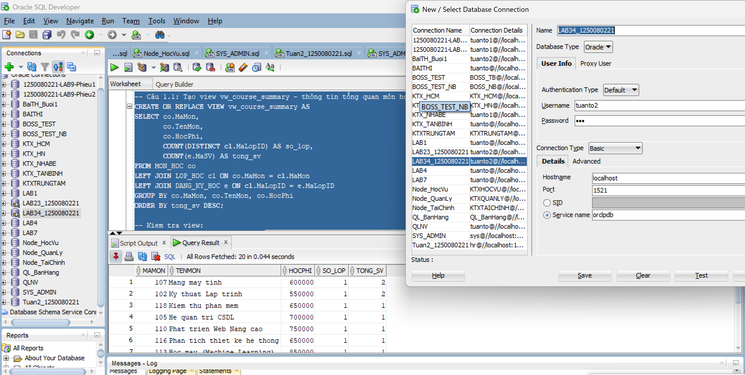
Câu 1.2: Tạo view vw_student_status - thông tin sinh viên và tình trạng học tập
Code:
CREATE OR REPLACE VIEW vw_student_status AS
SELECT s.MaSV,
s.Ho || ' ' || s.Ten AS ho_ten,
COUNT(e.MaLopID) AS so_lop_hoc,
NVL(SUM(co.HocPhi), 0) AS tong_hoc_phi,
ROUND(AVG(e.DiemTongKet), 2) AS diem_tb
FROM SINH_VIEN s
JOIN DANG_KY_HOC e ON s.MaSV = e.MaSV
JOIN LOP_HOC cl ON e.MaLopID = cl.MaLopID
JOIN MON_HOC co ON cl.MaMon = co.MaMon
GROUP BY s.MaSV, s.Ho, s.Ten
HAVING COUNT(e.MaLopID) >= 1
ORDER BY s.MaSV;

SELECT * FROM vw_student_status;

Kết quả:
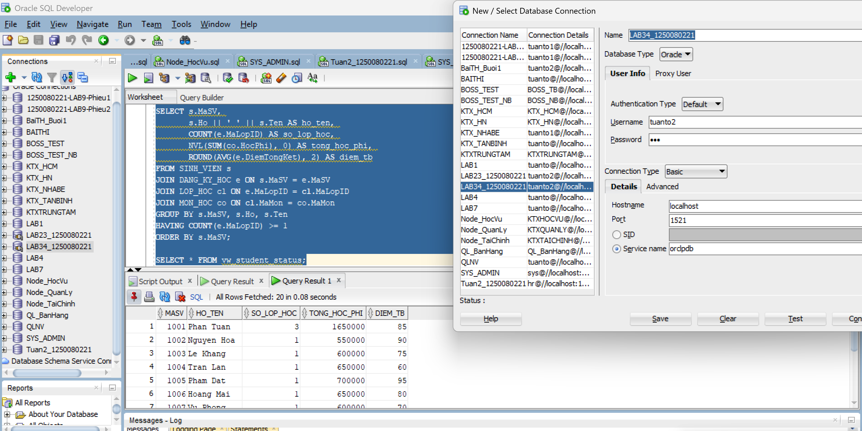Câu 1.3: Tạo view vw_class_availability - lớp học còn chỗ trống
Code:
CREATE OR REPLACE VIEW vw_class_availability AS
SELECT cl.MaLopID,
cl.MaMon,
co.TenMon,
i.Ho || ' ' || i.Ten AS ten_giao_vien,
cl.SiSoToiDa,
COUNT(e.MaSV) AS so_da_dk,
cl.SiSoToiDa - COUNT(e.MaSV) AS cho_trong,
CASE
WHEN cl.SiSoToiDa - COUNT(e.MaSV) > 0 THEN 'Con cho'
ELSE 'Het cho'
END AS trang_thai
FROM LOP_HOC cl
JOIN MON_HOC co ON cl.MaMon = co.MaMon
JOIN GIAO_VIEN i ON cl.MaGV = i.MaGV
LEFT JOIN DANG_KY_HOC e ON cl.MaLopID = e.MaLopID
GROUP BY cl.MaLopID, cl.MaMon, co.TenMon, i.Ho, i.Ten, cl.SiSoToiDa
HAVING cl.SiSoToiDa - COUNT(e.MaSV) > 0
ORDER BY cl.MaLopID;

SELECT * FROM vw_class_availability;
Kết quả:
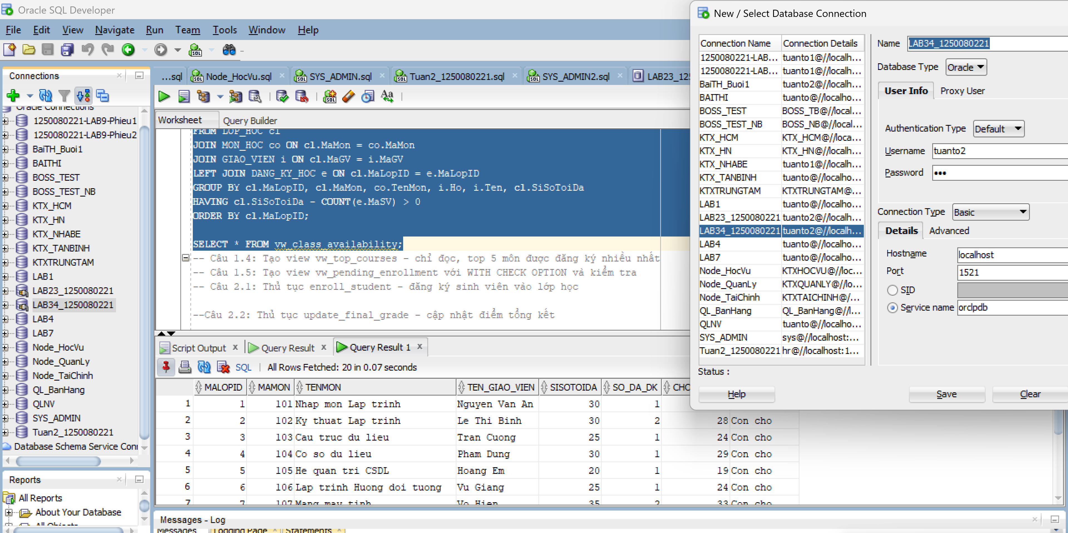
Câu 1.4: Tạo view vw_top_courses - chỉ đọc, top 5 môn được đăng ký nhiều nhất
Code:
CREATE OR REPLACE VIEW vw_top_courses AS
SELECT MaMon, TenMon, HocPhi, tong_dk, hang
FROM (
SELECT co.MaMon,
co.TenMon,
co.HocPhi,
COUNT(e.MaSV) AS tong_dk,
RANK() OVER (ORDER BY COUNT(e.MaSV) DESC) AS hang
FROM MON_HOC co
LEFT JOIN LOP_HOC cl ON co.MaMon = cl.MaMon
LEFT JOIN DANG_KY_HOC e ON cl.MaLopID = e.MaLopID
GROUP BY co.MaMon, co.TenMon, co.HocPhi
)
WHERE hang <= 5
ORDER BY hang
WITH READ ONLY;

SELECT * FROM vw_top_courses;

-- Thu INSERT vao view nay (se bao loi ORA-42399):
INSERT INTO vw_top_courses (MaMon, TenMon, HocPhi)
VALUES (999, 'Test', 100);
-- Oracle bao: ORA-42399: cannot perform a DML operation on a read-only view
Kết quả:
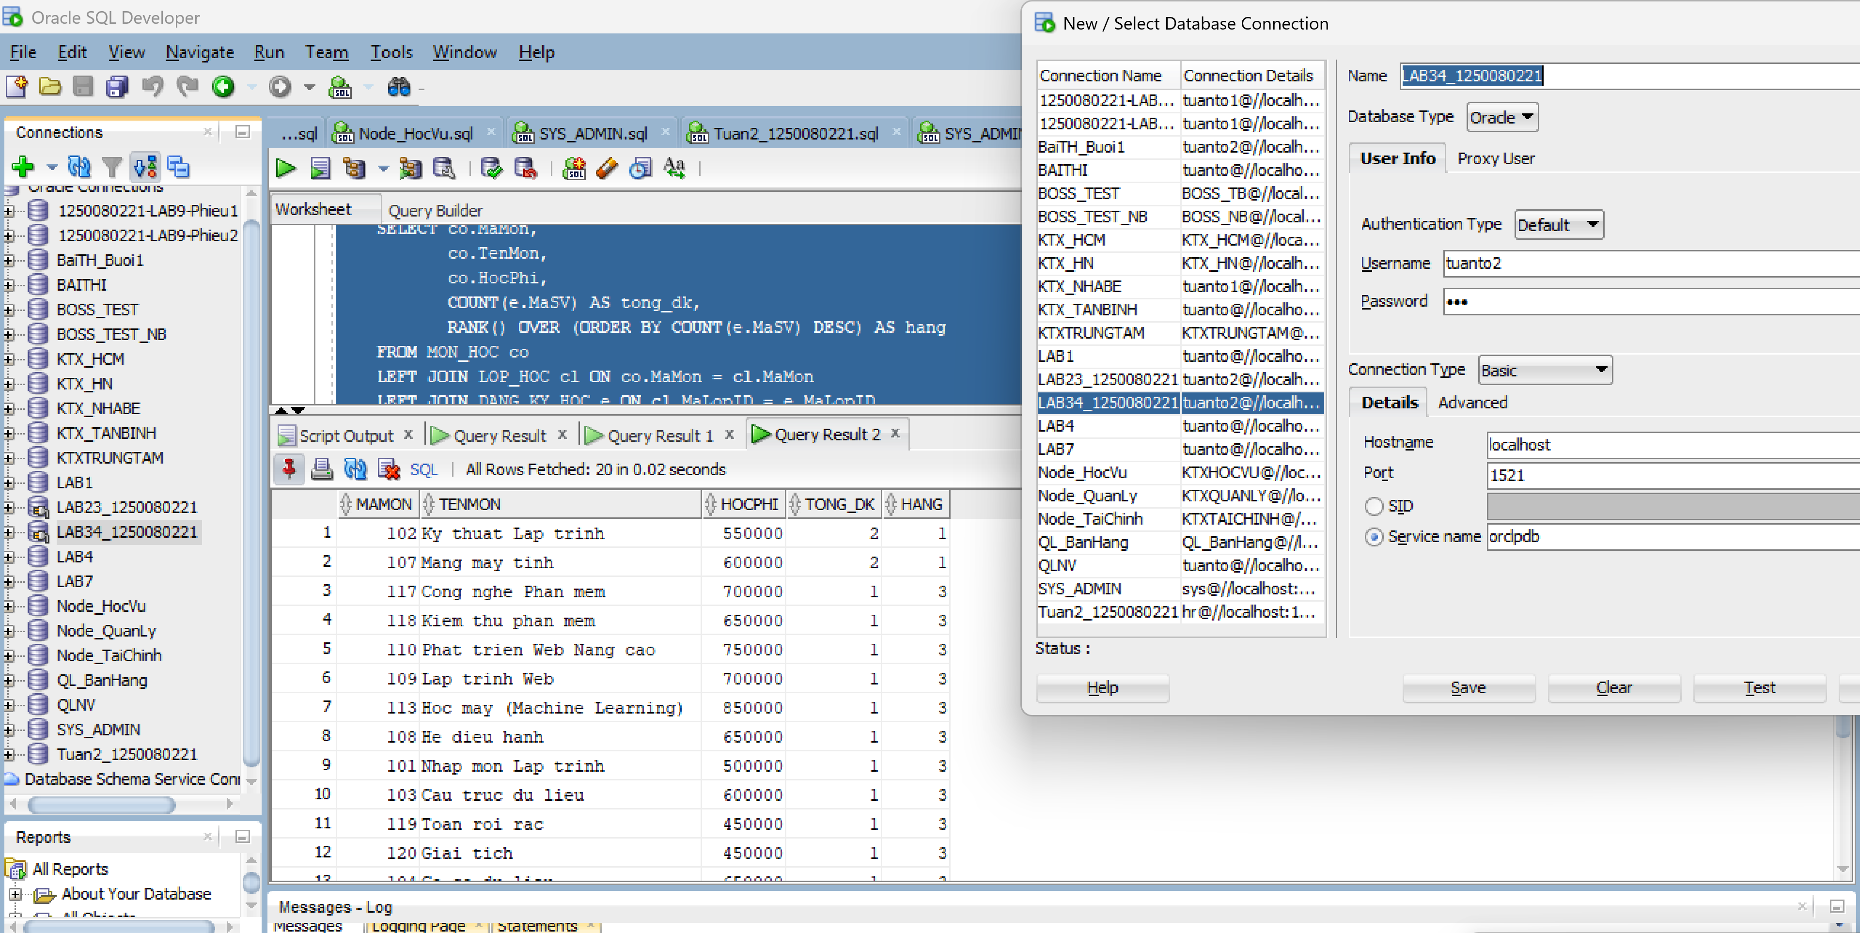
Câu 1.5: Tạo view vw_pending_enrollment với WITH CHECK OPTION và kiểm
Tra
Code:
CREATE OR REPLACE VIEW vw_pending_enrollment AS
SELECT MaSV, MaLopID, NgayDK, DiemTongKet,
NguoiTao, NgayTao, NguoiSua, NgaySua
FROM DANG_KY_HOC
WHERE DiemTongKet IS NULL
WITH CHECK OPTION;

SELECT * FROM vw_pending_enrollment;

-- INSERT 1: FinalGrade = NULL -> THANH CONG (thoa dieu kien WHERE)
INSERT INTO vw_pending_enrollment
(MaSV, MaLopID, NgayDK, DiemTongKet,
NguoiTao, NgayTao, NguoiSua, NgaySua)
VALUES (999, 1, SYSDATE, USER, SYSDATE, USER, SYSDATE);
-- INSERT 2: FinalGrade = 85 -> LOI ORA-01402 (vi pham WITH CHECK OPTION)
INSERT INTO vw_pending_enrollment
(MaSV, MaLopID, NgayDK, DiemTongKet,
NguoiTao, NgayTao, NguoiSua, NgaySua)
VALUES (998, 1, SYSDATE, 85, USER, SYSDATE, USER, SYSDATE);
-- ORA-01402: view WITH CHECK OPTION where-clause violation
Kết quả:
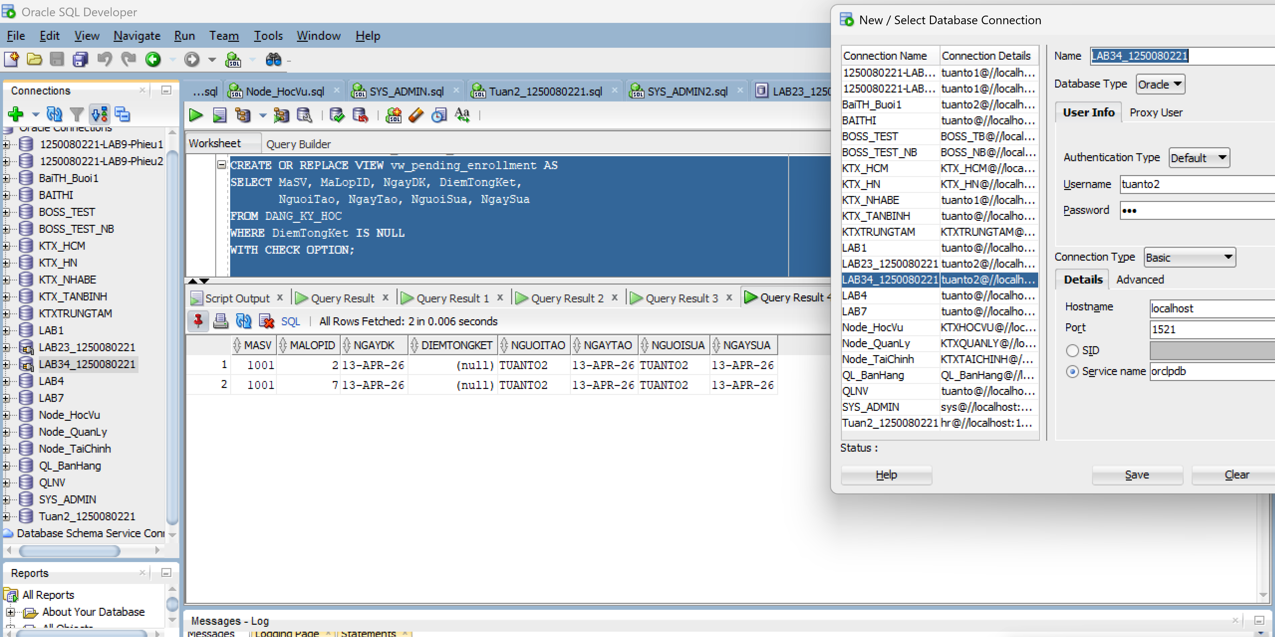
BÀI 2 - STORED PROCEDURE
Câu 2.1: Thủ tục enroll_student - đăng ký sinh viên vào lớp học
Code:
CREATE OR REPLACE PROCEDURE enroll_student
(p_studentid IN NUMBER,
p_classid IN NUMBER)
IS
v_check NUMBER;
v_capacity NUMBER;
v_enrolled NUMBER;
BEGIN
-- DK1: Sinh vien phai ton tai
SELECT COUNT(*) INTO v_check FROM SINH_VIEN WHERE MaSV = p_studentid;
IF v_check = 0 THEN
DBMS_OUTPUT.PUT_LINE('[LOI] Sinh vien ' || p_studentid || ' khong ton tai!');
RETURN;
END IF;

-- DK2: Lop hoc phai ton tai
SELECT COUNT(*) INTO v_check FROM LOP_HOC WHERE MaLopID = p_classid;
IF v_check = 0 THEN
DBMS_OUTPUT.PUT_LINE('[LOI] Lop hoc ' || p_classid || ' khong ton tai!');
RETURN;
END IF;

-- DK3: Kiem tra con cho trong
SELECT SiSoToiDa INTO v_capacity FROM LOP_HOC WHERE MaLopID = p_classid;
SELECT COUNT(*) INTO v_enrolled FROM DANG_KY_HOC WHERE MaLopID = p_classid;
IF v_enrolled >= v_capacity THEN
DBMS_OUTPUT.PUT_LINE('[LOI] Lop' || p_classid || ' da day! (' || v_enrolled || '/' || v_capacity || ')');
RETURN;
END IF;

-- DK4: Sinh vien chua dang ky lop nay
SELECT COUNT(*) INTO v_check FROM DANG_KY_HOC
WHERE MaSV = p_studentid AND MaLopID = p_classid;
IF v_check > 0 THEN
DBMS_OUTPUT.PUT_LINE('[LOI] Sinh vien da dang ky lop nay roi!');
RETURN;
END IF;

-- DK5: Sinh vien chua qua 3 lop
SELECT COUNT(*) INTO v_check FROM DANG_KY_HOC WHERE MaSV = p_studentid;
IF v_check >= 3 THEN
DBMS_OUTPUT.PUT_LINE('[LOI] Sinh vien da dang ky du 3 lop!');
RETURN;
END IF;

-- Tat ca OK: INSERT
INSERT INTO DANG_KY_HOC
(MaSV, MaLopID, NgayDK, NguoiTao, NgayTao, NguoiSua, NgaySua)
VALUES
(p_studentid, p_classid, SYSDATE, USER, SYSDATE, USER, SYSDATE);

COMMIT;
DBMS_OUTPUT.PUT_LINE('[OK] Dang ky thanh cong! SV' || p_studentid || ' -> Lop' || p_classid);

EXCEPTION
WHEN OTHERS THEN
ROLLBACK;
DBMS_OUTPUT.PUT_LINE('[LOI HE THONG] ' || SQLERRM);
END enroll_student;
/

-- Kiem tra:
BEGIN
enroll_student(101, 5); -- Hop le
enroll_student(999, 5); -- SV khong ton tai
enroll_student(101, 999); -- Lop khong ton tai
END;
/
Kết quả:
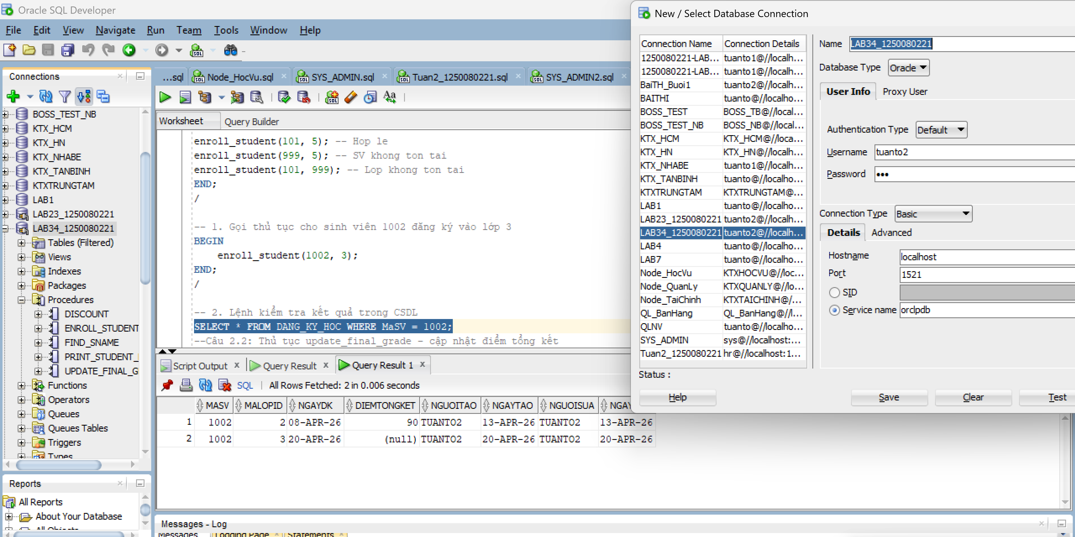

Câu 2.2: Thủ tục update_final_grade - cập nhật điểm tổng kết
Code:
CREATE OR REPLACE PROCEDURE update_final_grade
(p_studentid IN NUMBER,
p_classid IN NUMBER,
p_grade IN NUMBER)
IS
v_check NUMBER;
v_old_grade NUMBER;
BEGIN
-- Kiem tra diem hop le
IF p_grade < 0 OR p_grade > 100 THEN
DBMS_OUTPUT.PUT_LINE('[LOI] Diem khong hop le! Phai tu 0 den 100.');
RETURN;
END IF;

-- Kiem tra cap (StudentID, ClassID) ton tai trong ENROLLMENT
SELECT COUNT(*) INTO v_check FROM DANG_KY_HOC
WHERE MaSV = p_studentid AND MaLopID = p_classid;
IF v_check = 0 THEN
DBMS_OUTPUT.PUT_LINE('[LOI] Sinh vien chua dang ky lop nay!');
RETURN;
END IF;

-- Luu diem cu
SELECT DiemTongKet INTO v_old_grade FROM DANG_KY_HOC
WHERE MaSV = p_studentid AND MaLopID = p_classid;

-- Cap nhat ENROLLMENT
UPDATE DANG_KY_HOC
SET DiemTongKet = p_grade,
NguoiSua = USER, NgaySua = SYSDATE
WHERE MaSV = p_studentid AND MaLopID = p_classid;

-- Dong bo sang bang GRADE bang MERGE INTO
MERGE INTO DIEM_SO g
USING (SELECT p_studentid AS sid, p_classid AS cid FROM DUAL) src
ON (g.MaSV = src.sid AND g.MaLopID = src.cid)
WHEN MATCHED THEN
UPDATE SET g.Diem = p_grade,
g.NguoiSua = USER, g.NgaySua = SYSDATE
WHEN NOT MATCHED THEN
INSERT (MaSV, MaLopID, Diem, NguoiTao, NgayTao, NguoiSua, NgaySua)
VALUES (p_studentid, p_classid, p_grade, USER, SYSDATE, USER, SYSDATE);

COMMIT;
DBMS_OUTPUT.PUT_LINE('[OK] Da cap nhat diem SV ' || p_studentid
|| ' lop' || p_classid
|| ': Cu=' || NVL(TO_CHAR(v_old_grade),'NULL')
|| ' -> Moi=' || p_grade);
EXCEPTION
WHEN OTHERS THEN
ROLLBACK;
DBMS_OUTPUT.PUT_LINE('[LOI] ' || SQLERRM);
END update_final_grade;

Kết quả:
-Kiểm tra xem điểm đã được lưu vào bảng DANG_KY_HOC chưa
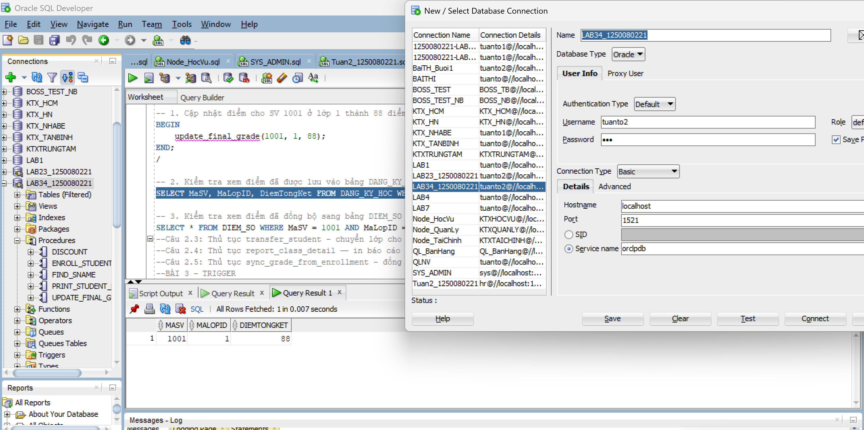
- Kiểm tra xem điểm đã đồng bộ sang bảng DIEM_SO chưa
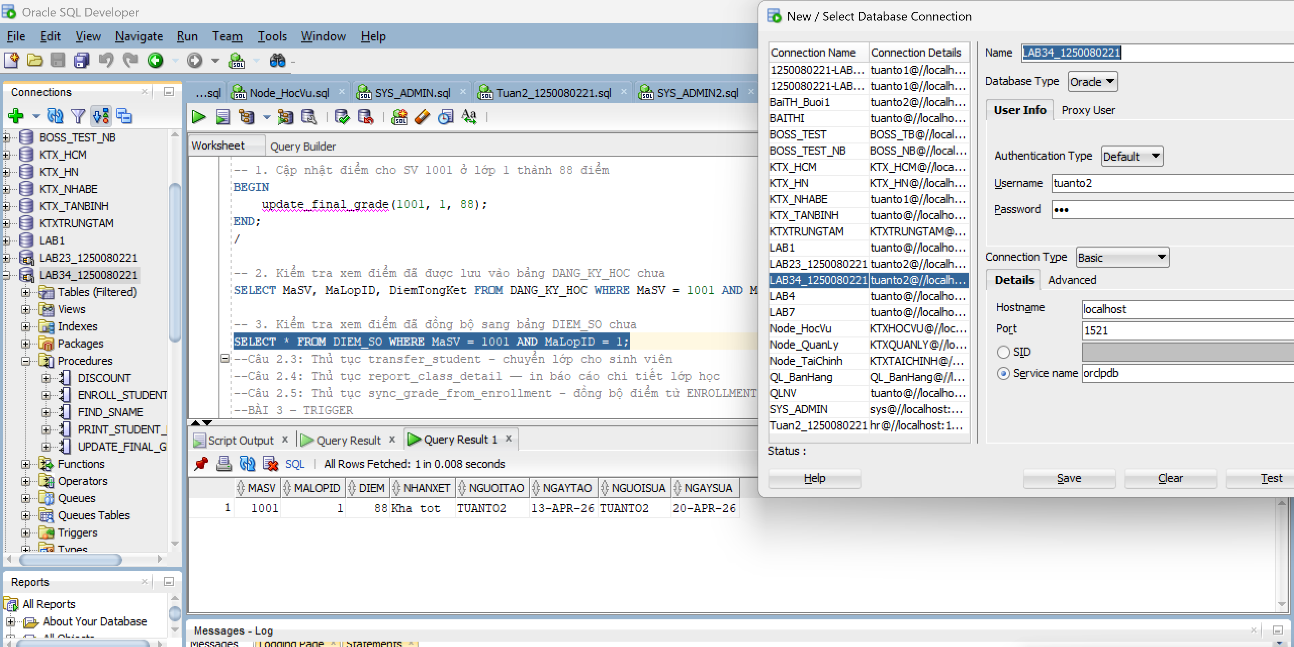
Câu 2.3: Thủ tục transfer_student - chuyển lớp cho sinh viên
Code:
CREATE OR REPLACE PROCEDURE transfer_student
(p_studentid IN NUMBER,
p_old_classid IN NUMBER,
p_new_classid IN NUMBER)
IS
v_check NUMBER;
v_capacity NUMBER;
v_enrolled NUMBER;
BEGIN
-- DK1: Sinh vien dang hoc o lop cu
SELECT COUNT(*) INTO v_check FROM DANG_KY_HOC
WHERE MaSV = p_studentid AND MaLopID = p_old_classid;
IF v_check = 0 THEN
DBMS_OUTPUT.PUT_LINE('[LOI] Sinh vien khong dang hoc lop' || p_old_classid);
RETURN;
END IF;

-- DK2: Lop moi con cho trong
SELECT SiSoToiDa INTO v_capacity FROM LOP_HOC WHERE MaLopID = p_new_classid;
SELECT COUNT(*) INTO v_enrolled FROM DANG_KY_HOC WHERE MaLopID = p_new_classid;
IF v_enrolled >= v_capacity THEN
DBMS_OUTPUT.PUT_LINE('[LOI] Lop moi ' || p_new_classid || ' da day!');
RETURN;
END IF;

-- DK3: Sinh vien chua dang ky lop moi
SELECT COUNT(*) INTO v_check FROM DANG_KY_HOC
WHERE MaSV = p_studentid AND MaLopID = p_new_classid;
IF v_check > 0 THEN
DBMS_OUTPUT.PUT_LINE('[LOI] Sinh vien da o trong lop moi roi!');
RETURN;
END IF;

-- Tat ca OK: thuc hien chuyen lop
SAVEPOINT sp_truoc_chuyen;

-- Buoc 1: Xoa khoi lop cu
DELETE FROM DANG_KY_HOC
WHERE MaSV = p_studentid AND MaLopID = p_old_classid;
SAVEPOINT sp_sau_xoa;

-- Buoc 2: Them vao lop moi
INSERT INTO DANG_KY_HOC
(MaSV, MaLopID, NgayDK, NguoiTao, NgayTao, NguoiSua, NgaySua)
VALUES
(p_studentid, p_new_classid, SYSDATE, USER, SYSDATE, USER, SYSDATE);

COMMIT;
DBMS_OUTPUT.PUT_LINE('[OK] Da chuyen SV ' || p_studentid
|| ' tu lop' || p_old_classid
|| ' sang lop' || p_new_classid);
EXCEPTION
WHEN OTHERS THEN
ROLLBACK TO sp_truoc_chuyen;
DBMS_OUTPUT.PUT_LINE('[LOI] Chuyen lop that bai: ' || SQLERRM);
DBMS_OUTPUT.PUT_LINE('Da rollback ve trang thai ban dau.');
END transfer_student;
/

-- 1. Giả sử chuyển SV 1001 từ lớp 1 sang lớp 4
BEGIN
transfer_student(1001, 1, 4);
END;
/

-- 2. Kiểm tra danh sách các lớp sinh viên 1001 đang học
SELECT * FROM DANG_KY_HOC WHERE MaSV = 1001;
Kết quả:
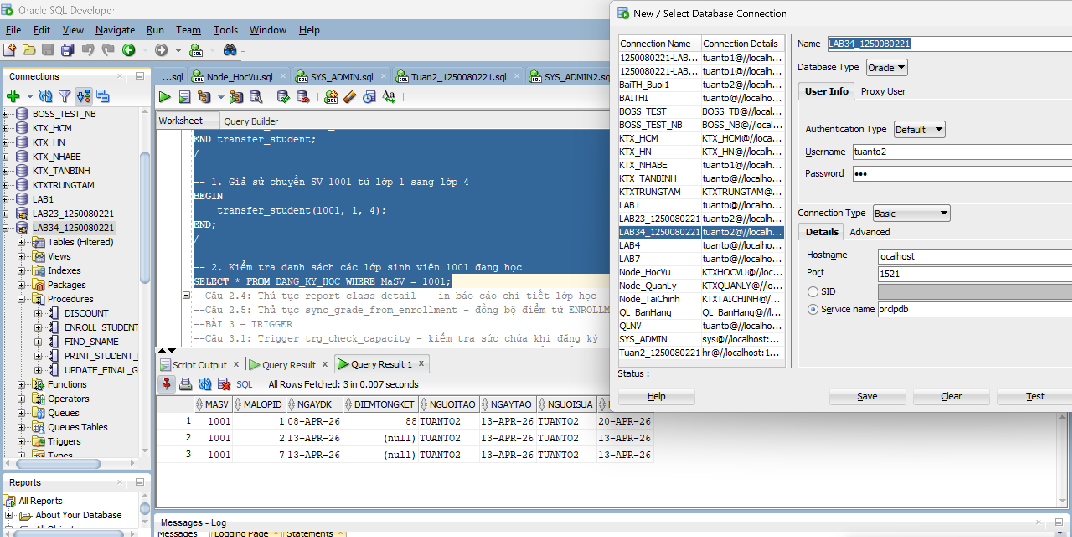
Câu 2.4: Thủ tục report_class_detail — in báo cáo chi tiết lớp học
Code:
CREATE OR REPLACE PROCEDURE report_class_detail
(p_classid IN NUMBER)
IS
v_check NUMBER;
v_course VARCHAR2(50);
v_courseno NUMBER;
v_gv VARCHAR2(50);
v_loc VARCHAR2(50);
v_cap NUMBER;
v_stt NUMBER := 0;
v_tong NUMBER := 0;
v_sum_d NUMBER := 0;
v_co_d NUMBER := 0;
v_grade_txt VARCHAR2(15);
BEGIN
-- Kiem tra lop ton tai
SELECT COUNT(*) INTO v_check FROM LOP_HOC WHERE MaLopID = p_classid;
IF v_check = 0 THEN
DBMS_OUTPUT.PUT_LINE('Lop hoc ' || p_classid || ' khong ton tai!');
RETURN;
END IF;

-- Lay thong tin lop
SELECT co.TenMon, co.MaMon,
i.Ho || ' ' || i.Ten,
cl.PhongHoc, cl.SiSoToiDa
INTO v_course, v_courseno, v_gv, v_loc, v_cap
FROM LOP_HOC cl
JOIN MON_HOC co ON cl.MaMon = co.MaMon
JOIN GIAO_VIEN i ON cl.MaGV = i.MaGV
WHERE cl.MaLopID = p_classid;

-- In header bao cao
DBMS_OUTPUT.PUT_LINE('BAO CAO LOP HOC: ' || p_classid || ' =');
DBMS_OUTPUT.PUT_LINE('Mon hoc : ' || v_courseno || ' - ' || v_course);
DBMS_OUTPUT.PUT_LINE('Giao vien: ' || v_gv);
DBMS_OUTPUT.PUT_LINE('Phong hoc: ' || NVL(v_loc, 'Chua xep phong'));
DBMS_OUTPUT.PUT_LINE('Suc chua: ' || v_cap || ' cho');
DBMS_OUTPUT.PUT_LINE(RPAD('-',50,'-'));
DBMS_OUTPUT.PUT_LINE('DANH SACH SINH VIEN:');
DBMS_OUTPUT.PUT_LINE(RPAD('STT',4) || ' | ' || RPAD('Ho Ten',20)
|| '|' || LPAD('Diem TK',8) || ' | Xep loai');
DBMS_OUTPUT.PUT_LINE(RPAD('-',50,'-'));

-- Duyet danh sach sinh vien
FOR rec IN (
SELECT s.Ho || ' ' || s.Ten AS ho_ten,
e.DiemTongKet
FROM DANG_KY_HOC e
JOIN SINH_VIEN s ON e.MaSV = s.MaSV
WHERE e.MaLopID = p_classid
ORDER BY s.Ho, s.Ten
) LOOP
v_stt := v_stt + 1;
v_tong := v_tong + 1;

-- Xep loai
IF rec.DiemTongKet IS NULL THEN
v_grade_txt := 'Chua co diem';
ELSIF rec.DiemTongKet >= 90 THEN
v_grade_txt := 'A';
v_sum_d := v_sum_d + rec.DiemTongKet; v_co_d := v_co_d + 1;
ELSIF rec.DiemTongKet >= 80 THEN
v_grade_txt := 'B';
v_sum_d := v_sum_d + rec.DiemTongKet; v_co_d := v_co_d + 1;
ELSIF rec.DiemTongKet >= 70 THEN
v_grade_txt := 'C';
v_sum_d := v_sum_d + rec.DiemTongKet; v_co_d := v_co_d + 1;
ELSIF rec.DiemTongKet >= 50 THEN
v_grade_txt := 'D';
v_sum_d := v_sum_d + rec.DiemTongKet; v_co_d := v_co_d + 1;
ELSE
v_grade_txt := 'F';
v_sum_d := v_sum_d + rec.DiemTongKet; v_co_d := v_co_d + 1;
END IF;

DBMS_OUTPUT.PUT_LINE(
LPAD(v_stt,3) || ' | '
|| RPAD(rec.ho_ten, 20) || '|'
|| LPAD(NVL(TO_CHAR(rec.DiemTongKet), 'NULL'), 7) || ' | '
|| v_grade_txt
);
END LOOP;

-- In footer bao cao
DBMS_OUTPUT.PUT_LINE(RPAD('-',50,'-'));
DBMS_OUTPUT.PUT_LINE('Tong so sinh vien : ' || v_tong);
IF v_co_d > 0 THEN
DBMS_OUTPUT.PUT_LINE('Diem trung binh lop: ' ||
ROUND(v_sum_d/v_co_d, 2));
ELSE
DBMS_OUTPUT.PUT_LINE('Diem trung binh lop: Chua co diem');
END IF;
END report_class_detail;
/

-- Goi thu tuc:
BEGIN
report_class_detail(1);
END;
/
Kết quả:
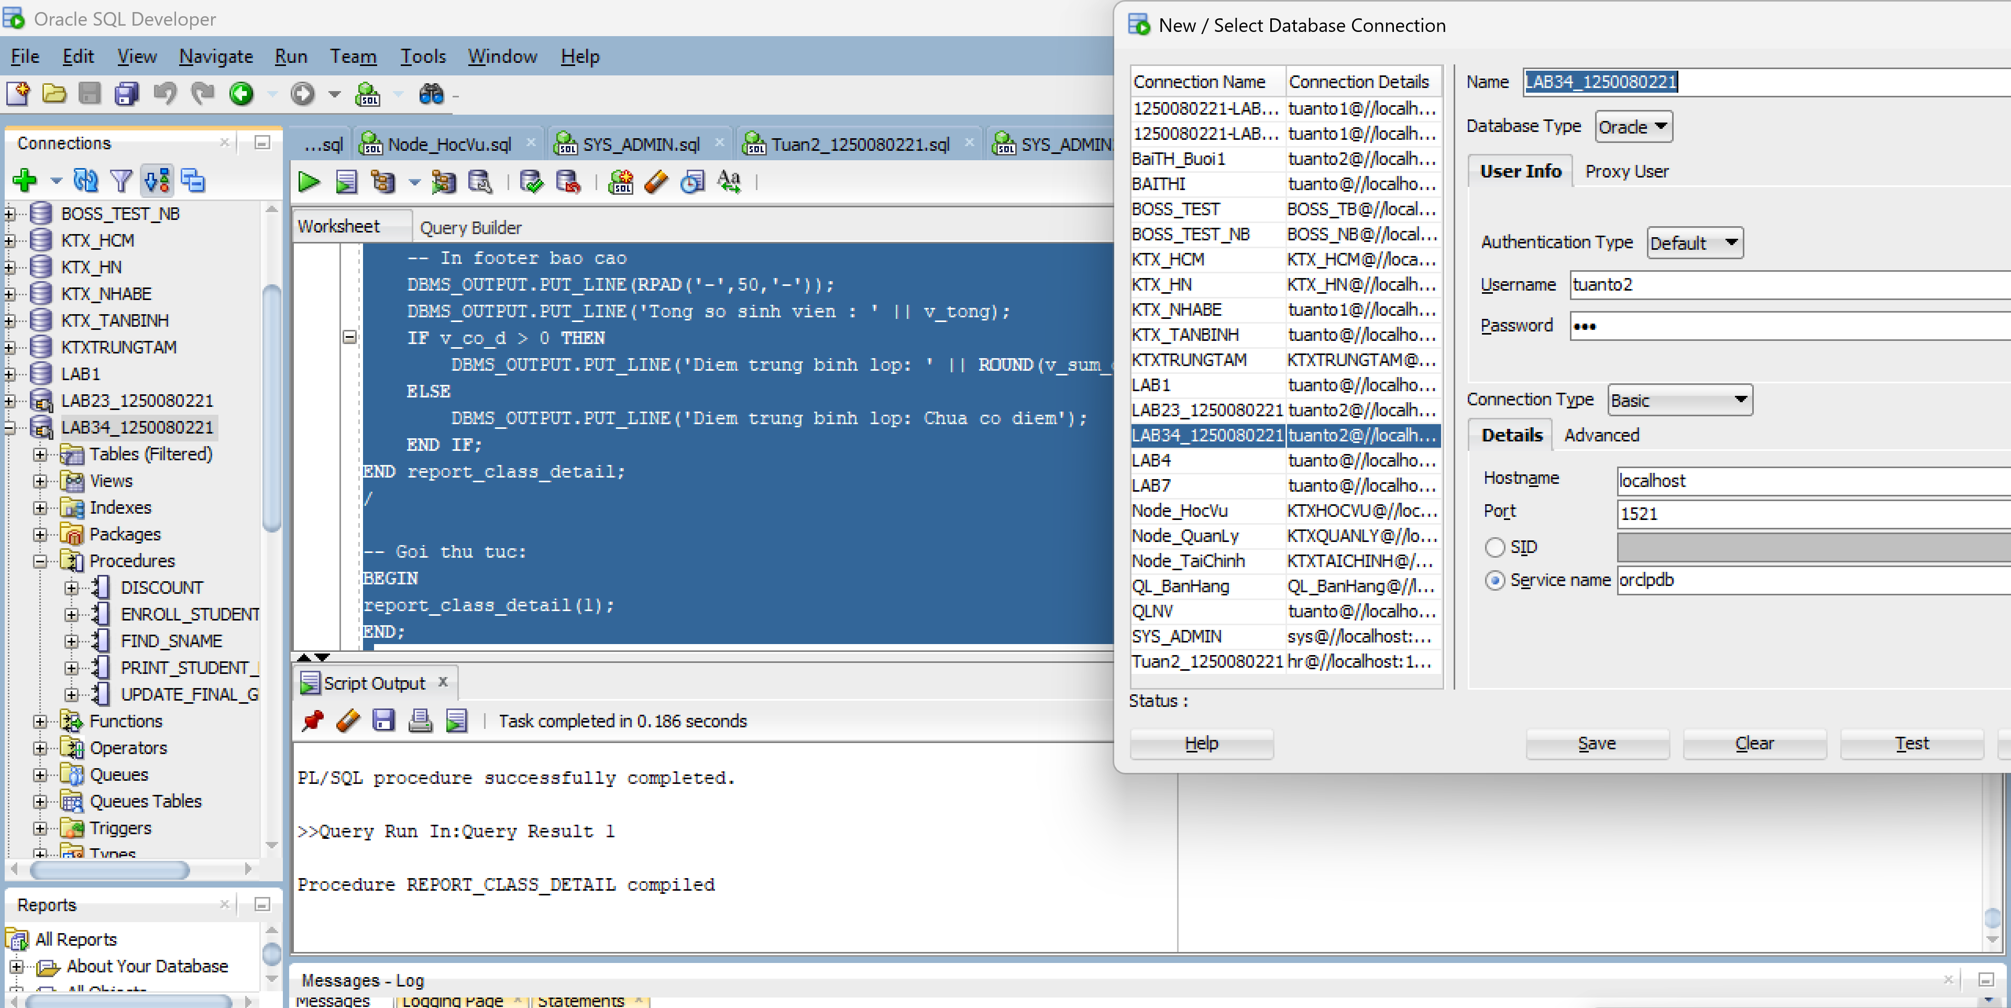
Câu 2.5: Thủ tục sync_grade_from_enrollment - đồng bộ điểm từ ENROLLMENT
sang GRADE
Code:
CREATE OR REPLACE PROCEDURE sync_grade_from_enrollment
IS
v_check NUMBER;
v_dem_insert NUMBER := 0;
v_dem_update NUMBER := 0;
BEGIN
FOR rec IN (
SELECT MaSV, MaLopID, DiemTongKet
FROM DANG_KY_HOC
WHERE DiemTongKet IS NOT NULL
) LOOP
-- Kiem tra trong GRADE da co chua
SELECT COUNT(*) INTO v_check FROM DIEM_SO
WHERE MaSV = rec.MaSV AND MaLopID = rec.MaLopID;

IF v_check = 0 THEN
-- Chua co -> INSERT moi
INSERT INTO DIEM_SO
(MaSV, MaLopID, Diem, NguoiTao, NgayTao, NguoiSua, NgaySua)
VALUES
(rec.MaSV, rec.MaLopID, rec.DiemTongKet, USER, SYSDATE, USER, SYSDATE);
v_dem_insert := v_dem_insert + 1;
ELSE
-- Da co -> UPDATE
UPDATE DIEM_SO
SET Diem = rec.DiemTongKet,
NguoiSua = USER, NgaySua = SYSDATE
WHERE MaSV = rec.MaSV AND MaLopID = rec.MaLopID;
v_dem_update := v_dem_update + 1;
END IF;
END LOOP;

COMMIT;
DBMS_OUTPUT.PUT_LINE('[OK] Dong bo hoan tat!');
DBMS_OUTPUT.PUT_LINE(' So ban ghi INSERT moi : ' || v_dem_insert);
DBMS_OUTPUT.PUT_LINE(' So ban ghi UPDATE : ' || v_dem_update);
EXCEPTION
WHEN OTHERS THEN
ROLLBACK;
DBMS_OUTPUT.PUT_LINE('[LOI] ' || SQLERRM);
END sync_grade_from_enrollment;
/

BEGIN sync_grade_from_enrollment;
END;
/
Kết quả:
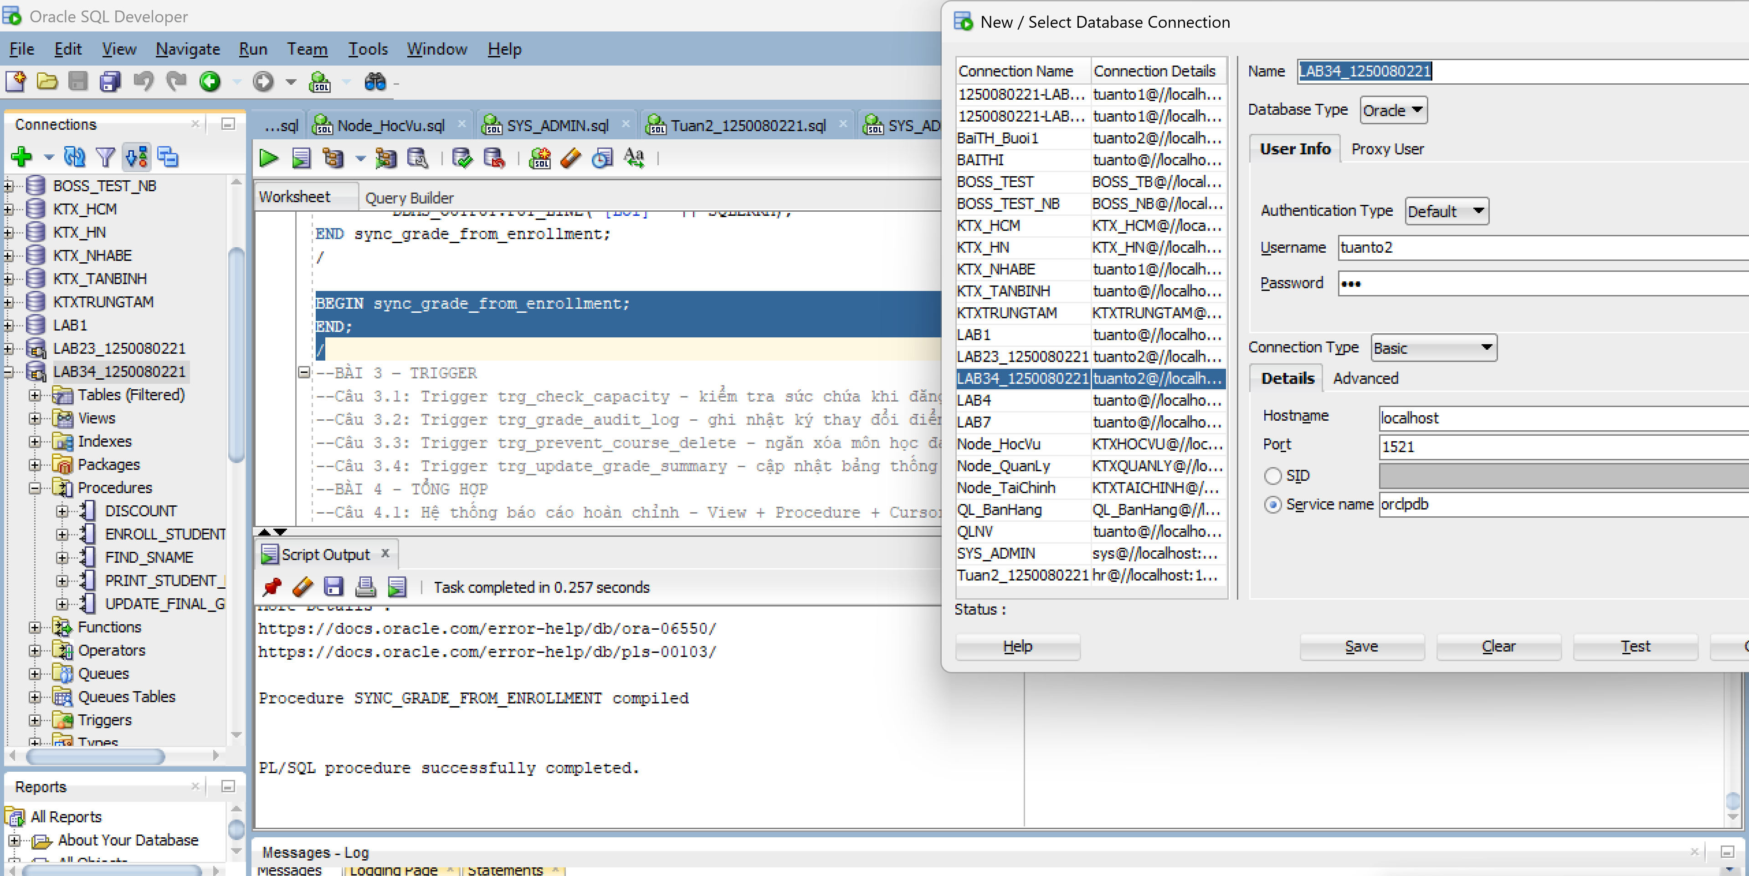

BÀI 3 – TRIGGER
Câu 3.1: Trigger trg_check_capacity - kiểm tra sức chứa khi đăng ký
Code:
CREATE OR REPLACE TRIGGER trg_check_capacity
BEFORE INSERT ON DANG_KY_HOC
FOR EACH ROW
DECLARE
v_capacity NUMBER;
v_enrolled NUMBER;
BEGIN
-- Lay suc chua lop hoc
SELECT SiSoToiDa INTO v_capacity
FROM LOP_HOC WHERE MaLopID = :NEW.MaLopID;

-- Dem so SV hien da dang ky
SELECT COUNT(*) INTO v_enrolled
FROM DANG_KY_HOC WHERE MaLopID = :NEW.MaLopID;

-- Tu choi neu lop da day
IF v_enrolled >= v_capacity THEN
RAISE_APPLICATION_ERROR(
-20010,
'LOI: Lop' || :NEW.MaLopID || ' da day! (' || v_enrolled || '/' || v_capacity || ' cho)'
);
END IF;
END trg_check_capacity;
/

-- Kiem tra trigger (dang ky vao lop da day):
INSERT INTO DANG_KY_HOC
(MaSV, MaLopID, NgayDK,
NguoiTao, NgayTao, NguoiSua, NgaySua)
VALUES (1003, 1, SYSDATE, USER, SYSDATE, USER, SYSDATE);
SELECT * FROM DANG_KY_HOC WHERE MaSV = '1003'
Kết quả:
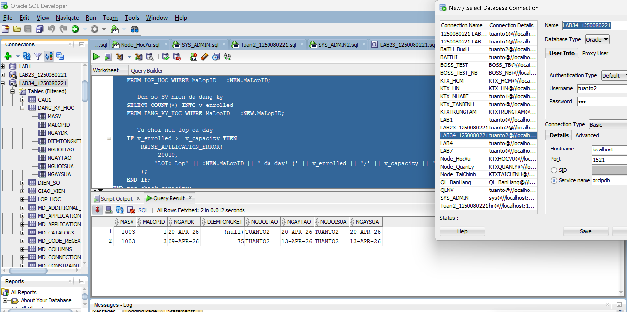

Câu 3.2: Trigger trg_grade_audit_log - ghi nhật ký thay đổi điểm
Code:
CREATE TABLE grade_audit_log (
log_id NUMBER GENERATED ALWAYS AS IDENTITY,
MaSV NUMBER(8),
MaLopID NUMBER(8),
grade_cu NUMBER(3),
grade_moi NUMBER(3),
nguoi_sua VARCHAR2(30),
thoi_gian DATE
);

CREATE OR REPLACE TRIGGER trg_grade_audit_log
AFTER UPDATE OF DiemTongKet ON DANG_KY_HOC
FOR EACH ROW
BEGIN
-- Chi ghi log khi diem THUC SU thay doi
IF (:OLD.DiemTongKet IS NULL AND :NEW.DiemTongKet IS NOT NULL)
OR (:OLD.DiemTongKet IS NOT NULL AND :NEW.DiemTongKet IS NULL)
OR (:OLD.DiemTongKet != :NEW.DiemTongKet)
THEN
INSERT INTO grade_audit_log
(MaSV, MaLopID, grade_cu, grade_moi, nguoi_sua, thoi_gian)
VALUES
(:OLD.MaSV, :OLD.MaLopID, :OLD.DiemTongKet, :NEW.DiemTongKet, USER, SYSDATE);
END IF;
END trg_grade_audit_log;
/

-- Kiem tra trigger:
UPDATE DANG_KY_HOC
SET DiemTongKet = 85
WHERE MaSV = 1001 AND MaLopID = 1;

COMMIT;

-- Xem ket qua log da duoc luu
SELECT * FROM grade_audit_log;
Kết quả:
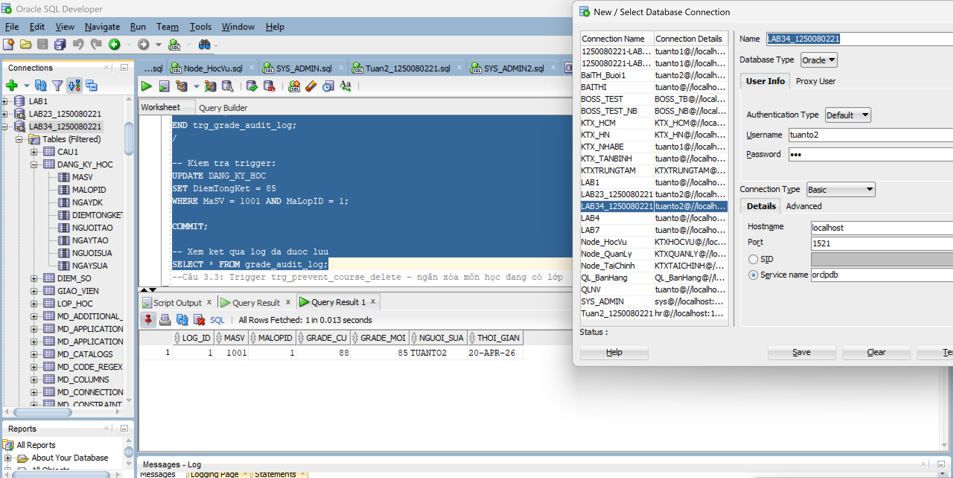
Câu 3.3: Trigger trg_prevent_course_delete - ngăn xóa môn học đang có lớp
Code:
CREATE TABLE grade_audit_log (
log_id NUMBER GENERATED ALWAYS AS IDENTITY,
MaSV NUMBER(8),
MaLopID NUMBER(8),
grade_cu NUMBER(3),
grade_moi NUMBER(3),
nguoi_sua VARCHAR2(30),
thoi_gian DATE
);

CREATE OR REPLACE TRIGGER trg_grade_audit_log
AFTER UPDATE OF DiemTongKet ON DANG_KY_HOC
FOR EACH ROW
BEGIN
-- Chi ghi log khi diem THUC SU thay doi
IF (:OLD.DiemTongKet IS NULL AND :NEW.DiemTongKet IS NOT NULL)
OR (:OLD.DiemTongKet IS NOT NULL AND :NEW.DiemTongKet IS NULL)
OR (:OLD.DiemTongKet != :NEW.DiemTongKet)
THEN
INSERT INTO grade_audit_log
(MaSV, MaLopID, grade_cu, grade_moi, nguoi_sua, thoi_gian)
VALUES
(:OLD.MaSV, :OLD.MaLopID, :OLD.DiemTongKet, :NEW.DiemTongKet, USER, SYSDATE);
END IF;
END trg_grade_audit_log;
/

-- Kiem tra trigger:
UPDATE DANG_KY_HOC
SET DiemTongKet = 85
WHERE MaSV = 1001 AND MaLopID = 1;

COMMIT;

-- Xem ket qua log da duoc luu
SELECT * FROM grade_audit_log;
-- Kiem tra: xoa mon co lop (se bao loi ORA-20020 do trigger chan)
DELETE FROM MON_HOC WHERE MaMon = 101;

-- Kiem tra: xoa mon khong co lop (thanh cong)
-- Lưu ý: Bạn cần chắc chắn môn 999 đã được tạo trước đó (như ví dụ mình đã hướng dẫn ở trên)
DELETE FROM MON_HOC WHERE MaMon = 999;
ROLLBACK;
Kết quả:
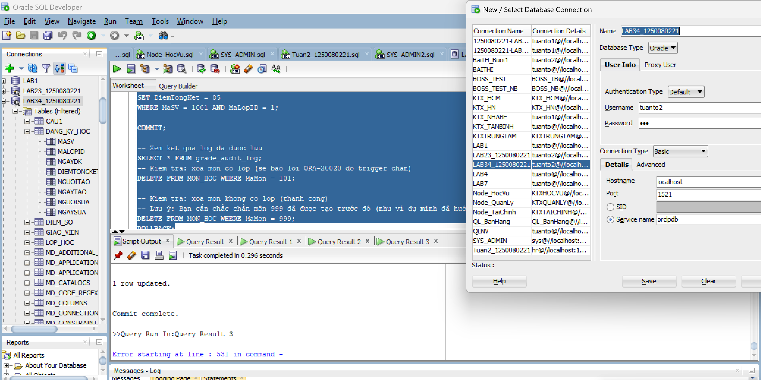
Câu 3.4: Trigger trg_update_grade_summary - cập nhật bảng thống kê tự động
Code:
CREATE TABLE class_grade_summary (
MaLopID NUMBER(8) PRIMARY KEY,
so_sv NUMBER,
diem_tb NUMBER(5,2),
diem_cao_nhat NUMBER(3),
diem_thap_nhat NUMBER(3),
cap_nhat_luc DATE
);

CREATE OR REPLACE TRIGGER trg_update_grade_summary
AFTER INSERT OR UPDATE OR DELETE ON DANG_KY_HOC
FOR EACH ROW
DECLARE
v_classid NUMBER;
v_so_sv NUMBER;
v_diem_tb NUMBER;
v_max_d NUMBER;
v_min_d NUMBER;
BEGIN
-- Lay MaLopID dua tren loai su kien
IF INSERTING OR UPDATING THEN
v_classid := :NEW.MaLopID;
ELSE -- DELETING
v_classid := :OLD.MaLopID;
END IF;

-- Tinh lai thong ke cho lop bi anh huong
SELECT COUNT(DiemTongKet),
ROUND(AVG(DiemTongKet), 2),
MAX(DiemTongKet),
MIN(DiemTongKet)
INTO v_so_sv, v_diem_tb, v_max_d, v_min_d
FROM DANG_KY_HOC
WHERE MaLopID = v_classid AND DiemTongKet IS NOT NULL;
-- MERGE INTO cap nhat hoac them moi
MERGE INTO class_grade_summary cgs
USING (SELECT v_classid AS cid FROM DUAL) src
ON (cgs.MaLopID = src.cid)
WHEN MATCHED THEN
UPDATE SET
so_sv = v_so_sv,
diem_tb = v_diem_tb,
diem_cao_nhat = v_max_d,
diem_thap_nhat = v_min_d,
cap_nhat_luc = SYSDATE
WHEN NOT MATCHED THEN
INSERT (MaLopID, so_sv, diem_tb, diem_cao_nhat, diem_thap_nhat, cap_nhat_luc)
VALUES (v_classid, v_so_sv, v_diem_tb, v_max_d, v_min_d, SYSDATE);
END trg_update_grade_summary;
/
-- Kiem tra trigger: Cập nhật điểm để kích hoạt trigger tính toán lại thống kê
UPDATE DANG_KY_HOC
SET DiemTongKet = 90
WHERE MaSV = 1001 AND MaLopID = 1;
COMMIT;
SELECT * FROM class_grade_summary WHERE MaLopID = 1;
Kết quả:
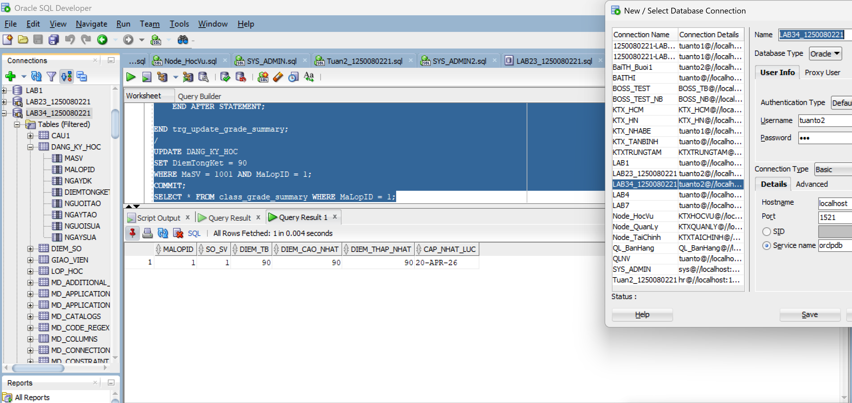
BÀI 4 - TỔNG HỢP
Câu 4.1: Hệ thống báo cáo hoàn chỉnh - View + Procedure + Cursor
Code:
Bước 1:
CREATE OR REPLACE VIEW vw_instructor_workload AS
SELECT i.MaGV,
i.Ho || ' ' || i.Ten AS ho_ten,
COUNT(DISTINCT cl.MaLopID) AS so_lop,
COUNT(e.MaSV) AS tong_sv,
ROUND(AVG(e.DiemTongKet), 2) AS diem_tb_chung,
CASE
WHEN COUNT(DISTINCT cl.MaLopID) >= 3 THEN 'Ban nhieu'
WHEN COUNT(DISTINCT cl.MaLopID) = 2 THEN 'Binh thuong'
ELSE 'Nhe nhang'
END AS muc_ban
FROM GIAO_VIEN i
LEFT JOIN LOP_HOC cl ON i.MaGV = cl.MaGV
LEFT JOIN DANG_KY_HOC e ON cl.MaLopID = e.MaLopID
GROUP BY i.MaGV, i.Ho, i.Ten
ORDER BY so_lop DESC;

SELECT * FROM vw_instructor_workload;
Bước 2:
CREATE OR REPLACE PROCEDURE print_system_report
IS
v_so_mon NUMBER;
v_so_lop NUMBER;
v_so_sv NUMBER;
v_so_gv NUMBER;
BEGIN
-- Lay so lieu tong the
SELECT COUNT(*) INTO v_so_mon FROM MON_HOC;
SELECT COUNT(*) INTO v_so_lop FROM LOP_HOC;
SELECT COUNT(*) INTO v_so_sv FROM SINH_VIEN;
SELECT COUNT(*) INTO v_so_gv FROM GIAO_VIEN;

-- In header
DBMS_OUTPUT.PUT_LINE(' BAO CAO TOAN HE THONG QUAN LY KHOA HỌC');
DBMS_OUTPUT.PUT_LINE('=');
DBMS_OUTPUT.PUT_LINE('Tong so mon hoc: ' || v_so_mon);
DBMS_OUTPUT.PUT_LINE('Tong so lop hoc: ' || v_so_lop);
DBMS_OUTPUT.PUT_LINE('Tong so sinh vien: ' || v_so_sv);
DBMS_OUTPUT.PUT_LINE('Tong so giao vien: ' || v_so_gv);
DBMS_OUTPUT.PUT_LINE(RPAD('-',50,'-'));

-- Phan 1: Thong ke giao vien (dung view vw_instructor_workload)
DBMS_OUTPUT.PUT_LINE('THONG KE GIAO VIEN:');
FOR rec IN (SELECT * FROM vw_instructor_workload) LOOP
DBMS_OUTPUT.PUT_LINE(
'' || RPAD(rec.ho_ten, 25)
|| '|' || LPAD(rec.so_lop, 2) || ' lop'
|| '|' || LPAD(rec.tong_sv, 3) || ' SV'
|| ' | DTB: ' || NVL(TO_CHAR(rec.diem_tb_chung),'--')
|| ' | ' || rec.muc_ban
);
END LOOP;
DBMS_OUTPUT.PUT_LINE(RPAD('-',50,'-'));

-- Phan 2: Top 3 mon hoc (dung view vw_top_courses)
DBMS_OUTPUT.PUT_LINE('TOP 3 MON HOC DUOC DANG KY NHIEU NHAT:');
FOR rec IN (SELECT * FROM vw_top_courses WHERE hang <= 3) LOOP
DBMS_OUTPUT.PUT_LINE(
'' || rec.hang || '.'
|| RPAD(rec.TenMon, 30)
|| '-' || rec.tong_dk || ' luot dang ky'
);
END LOOP;
DBMS_OUTPUT.PUT_LINE('=');
END print_system_report;
/
-- Chay bao cao:
SET SERVEROUTPUT ON SIZE 1000000;
BEGIN print_system_report; END;
/
Kết quả:
Bước 1:
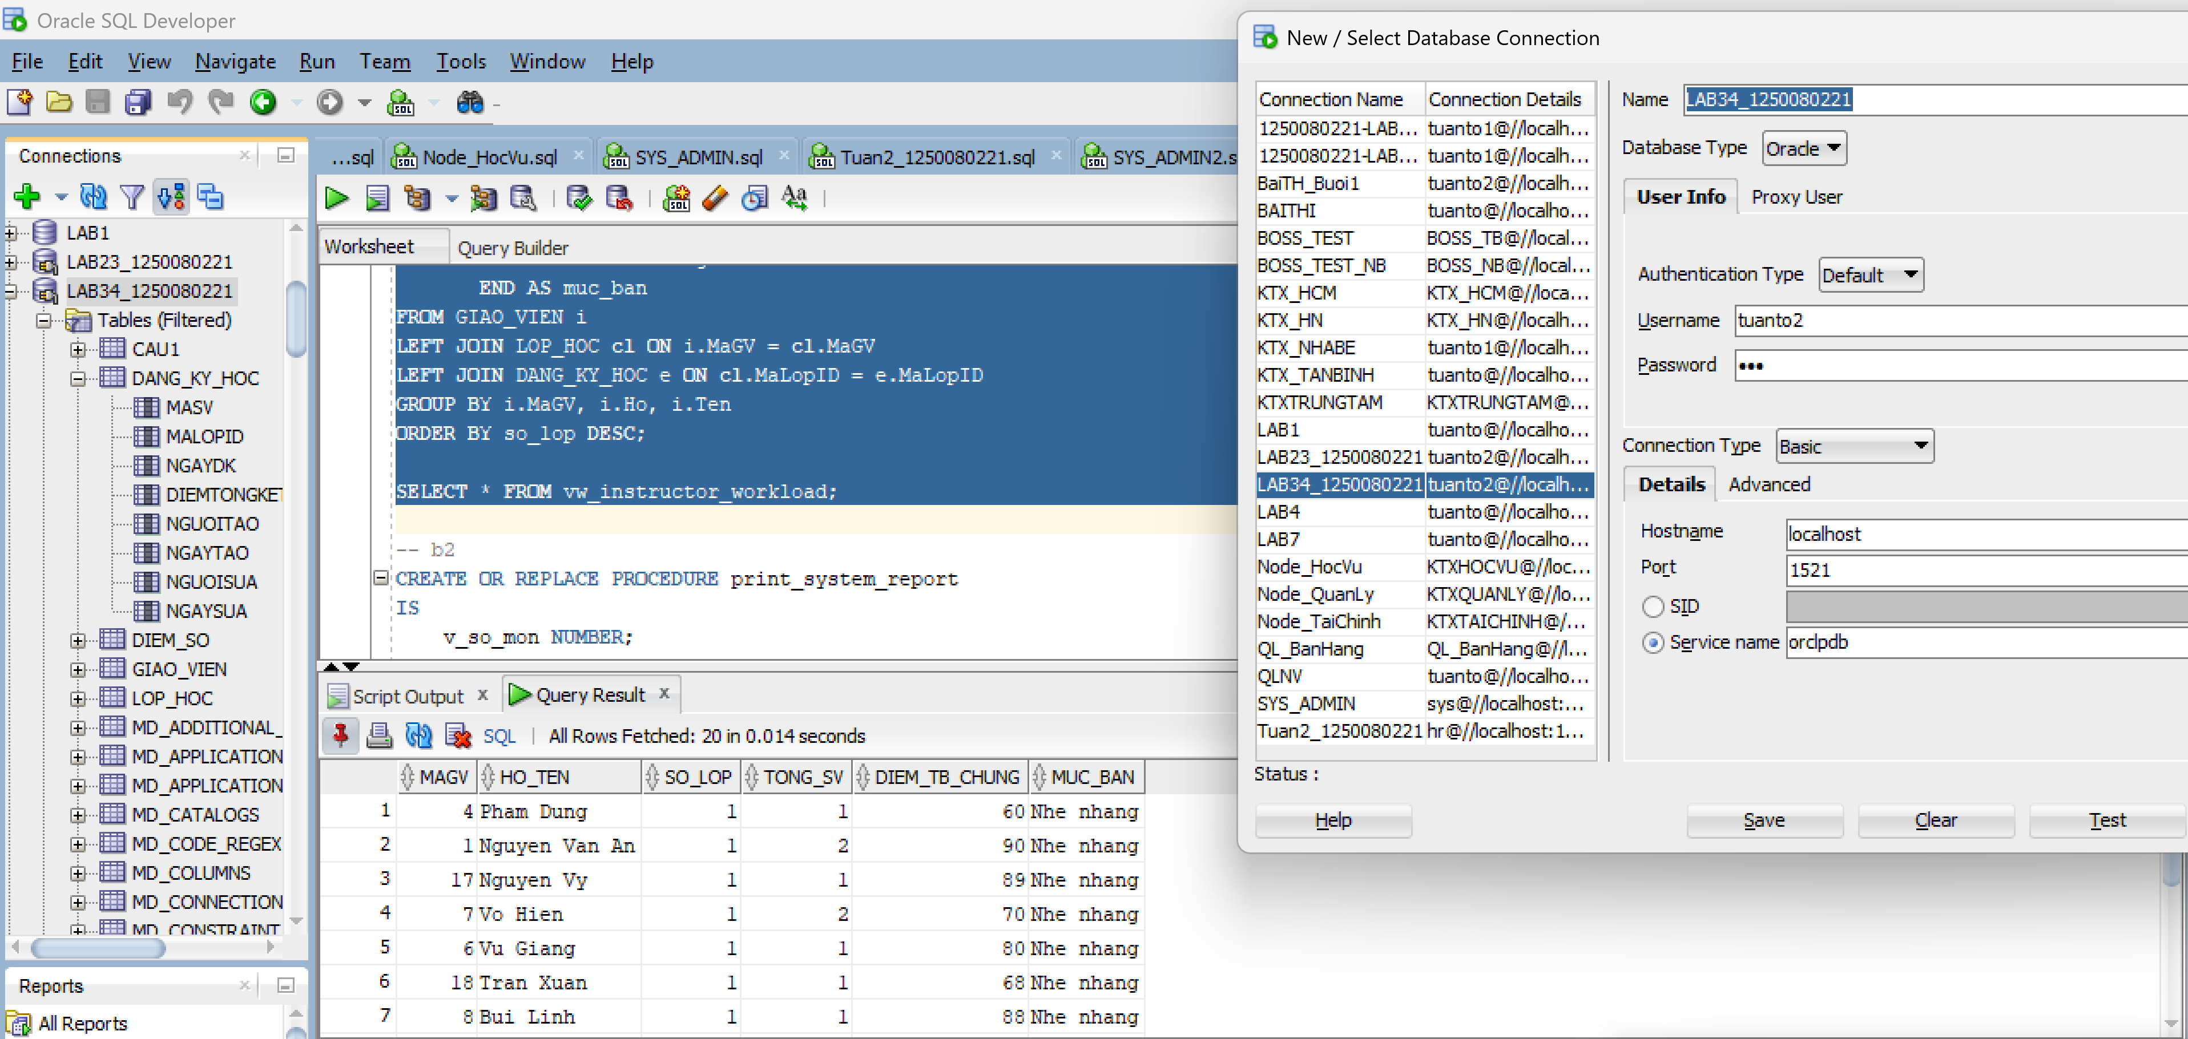

Bước 2:
