The Current Iran Conflict – Summary Report (2026)

1. Overview
As of 2025–2026, tensions involving Iran remain high in the Middle East. The conflict is characterized by indirect confrontations between Iran, Israel, and the United States, as well as proxy groups operating in Lebanon, Gaza, Iraq, Syria, and Yemen. While there is no officially declared full-scale regional war, repeated airstrikes, missile exchanges, and maritime incidents have significantly increased instability.
Major issues driving the conflict include Iran’s nuclear program, regional power competition, military operations in Gaza and Lebanon, and attacks on shipping routes in the Red Sea and Gulf region. These developments have raised global concerns about energy security, international trade, and humanitarian conditions.

2. Visual Overview
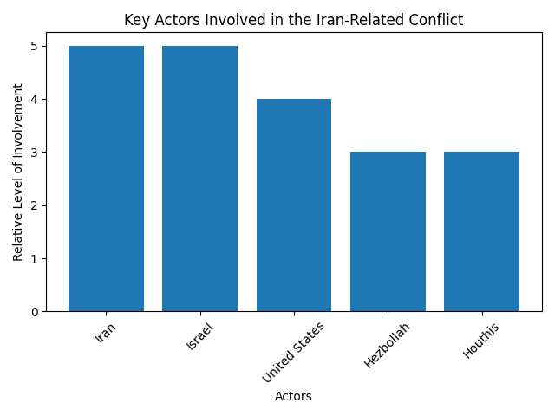
Figure 1: Key actors involved in the ongoing Iran-related regional tensions.

3. Key Facts Table
Aspect | Details
Nature of Conflict | Indirect regional confrontation with periodic direct strikes
Main Parties | Iran, Israel, United States, and allied proxy groups
Key Regions Affected | Gaza, Lebanon, Syria, Iraq, Red Sea, Persian Gulf
Core Issues | Nuclear program, regional influence, maritime security
Global Impact | Energy markets, trade routes, humanitarian concerns
Current Status (2026) | Ongoing tensions with risk of wider escalation

