A Historical Overview of Iran

1. Introduction
Iran is one of the world's oldest continuous civilizations, with a history stretching back thousands of years. Known historically as Persia, Iran has been home to powerful empires, major religious developments, and significant cultural achievements that have shaped regional and global history.

2. Historical Development
Ancient Iran saw the rise of early civilizations such as Elam, followed by the Median and Achaemenid Empires. The Achaemenid Empire (c. 550–330 BC), founded by Cyrus the Great, became one of the largest empires of the ancient world.
After the conquest by Alexander the Great, Iran experienced Hellenistic influence, followed by Parthian and Sassanian rule. In the 7th century, the Arab Muslim conquest introduced Islam, which became central to Iranian identity.
The Safavid dynasty (1501–1736) established Shi'a Islam as the state religion. In the 20th century, the Pahlavi dynasty pursued modernization. The 1979 Islamic Revolution transformed Iran into an Islamic Republic, shaping its modern political system.

3. Visual Timeline
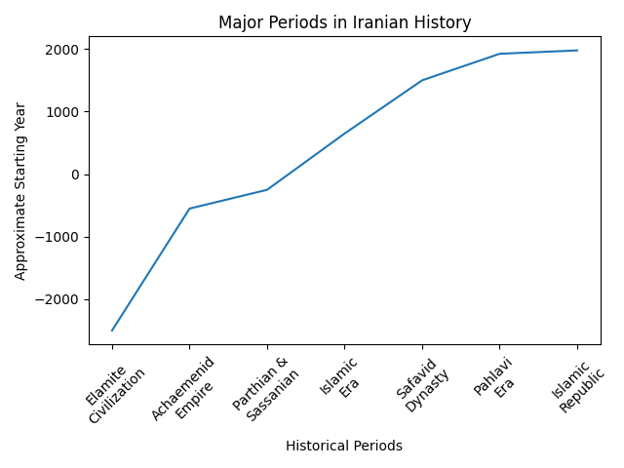
Figure 1: Major historical periods in Iran.

4. Key Historical Periods (Table)
Period | Description
Elamite Civilization (c. 3000 BC) | One of the earliest civilizations on the Iranian plateau.
Achaemenid Empire (550–330 BC) | Founded by Cyrus the Great; vast multi-ethnic empire.
Parthian & Sassanian (247 BC–651 AD) | Revival of Persian power before Islamic conquest.
Islamic Era (from 7th century) | Introduction and spread of Islam across Iran.
Safavid Dynasty (1501–1736) | Established Shi'a Islam as the state religion.
Pahlavi Dynasty (1925–1979) | Modernization and centralization under the Shah.
Islamic Republic (1979–Present) | Established after the Islamic Revolution.

