Redserver vLLM Change Guide (Detailed Runbook)
Goal: switch QAGRedo on redserver from older vLLM runtime (for example 0.5.3) to vLLM 0.18.1 safely, validate functionality, and keep a fast rollback path.

Flow Diagram (Image)
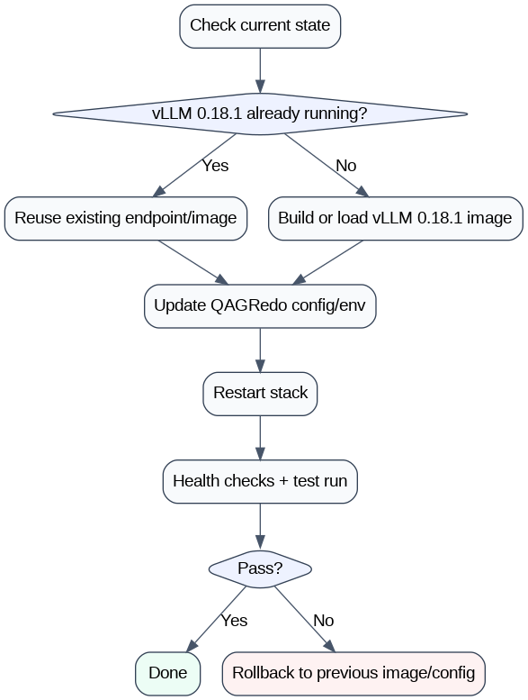
Redserver vLLM Change Flow

Key rule (most important)
- Changing .env / config/*.yaml controls endpoints, model names, and behavior.
- It does not change the vLLM binary version by itself.
- To use vLLM 0.18.1, your runtime must actually be 0.18.1 (existing service endpoint or compose image).

Scope and assumptions
- You run QAGRedo with bash run.sh.
- You use vLLM profile (QAGREDO_PROFILE=vllm).
- Generator and judge may be separate vLLM services.
- Models can stay in the same shared folder; only runtime wiring changes.

What success looks like
- run.sh --show-config points to intended vLLM generator/judge endpoints.
- Compose (or external service) is truly on 0.18.1.
- One-document smoke run succeeds.
- Output JSON is produced without repeated generator/judge failures.

Part A: Pre-change checklist

A1) Capture current state (for rollback and diff)
Run and save outputs:
- id -u && id -g
- docker ps
- docker images | rg -i vllm
- bash run.sh --show-config
- bash run.sh --status
Backup files:
- .env
- config/config.vllm.yaml
- Any compose override used by vLLM profile:
  - docker-compose.vllm-stack.yml
  - docker-compose.vllm-redserver.yml (if used)
Recommended backup command:
- cp .env .env.bak.before-vllm0181
- cp config/config.vllm.yaml config/config.vllm.yaml.bak.before-vllm0181

A2) Confirm ownership settings
- Ensure .env has HOST_UID and HOST_GID matching id -u and id -g.
- Keep QAGREDO_ALLOW_FOREIGN_OWNERSHIP unset or 0 unless intentional.

A3) Decide your switch path
Pick one:
- Path 1: existing 0.18.1 service already running (external endpoint reuse).
- Path 2: existing 0.18.1 image on redserver (compose uses this image).
- Path 3: no local 0.18.1 image/service (load/build first, then Path 2).

Part B: Detailed procedures by path

Path 1: Reuse already-running vLLM 0.18.1 endpoint
Use when 0.18.1 is known working in another code stack on same server.

B1.1) Confirm endpoint health
- curl -sf http://<gen-host>:<gen-port>/health
- curl -sf http://<judge-host>:<judge-port>/health
If health endpoint differs in your service wrapper, use that wrapper’s check.

B1.2) Update config/config.vllm.yaml
Set:
- llm.base_url: http://<gen-host>:<gen-port>/v1
- judge.base_url: http://<judge-host>:<judge-port>/v1
- llm.model: <exact served generator model name>
- judge.model: <exact served judge model name>
Keep provider fields consistent with your pipeline expectations.

B1.3) Restart QAGRedo runner cleanly
- bash run.sh --down
- bash run.sh --show-config (verify final values)
- bash run.sh

B1.4) Validate
- Run smoke test: bash run.sh -- --num-documents 1
- Check no repeated connection or model-not-found errors.

Path 2: Use local compose with 0.18.1 image
Use when image already exists locally but compose is launching older tag.

B2.1) Identify the exact local image/tag
- docker images | rg -i "vllm|0.18.1"
Record the exact tag you will use.

B2.2) Update compose service image tags
In the compose file(s) used by vLLM profile, set generator/judge image tags to your 0.18.1 image tag.
If using override via .env:
- QAGREDO_VLLM_COMPOSE_EXTRA=docker-compose.vllm-redserver.yml
ensure the override references 0.18.1 image tags.

B2.3) Align config/config.vllm.yaml
Set base URLs to match exposed service ports and set model names to served names.

B2.4) Restart
- bash run.sh --down
- bash run.sh --status
- bash run.sh --show-config
- bash run.sh

B2.5) Validate
- Health:
  - curl -sf http://localhost:7100/health
  - curl -sf http://localhost:7101/health
- Smoke run:
  - bash run.sh -- --num-documents 1

Path 3: 0.18.1 not available locally

B3.1) Obtain runtime
Either:
- Load image tar that contains 0.18.1, or
- Build image from Dockerfile pinned to vllm==0.18.1.

B3.2) Verify image exists
- docker images | rg -i "vllm|0.18.1"
Then continue with Path 2.

Special scenario you asked: 0.18.1 not running now, but tested elsewhere
Yes, you can switch and run via run.sh if:
- You point QAGRedo to that already-tested 0.18.1 runtime (external endpoint), or
- You make compose launch a local 0.18.1 image.
You cannot activate 0.18.1 by config only if compose still launches old runtime.

Part C: Exact config mapping checklist
Before run:
- .env
  - QAGREDO_PROFILE=vllm
  - HOST_UID=<id -u>
  - HOST_GID=<id -g>
  - optional: QAGREDO_VLLM_COMPOSE_EXTRA=<override file> if required
- config/config.vllm.yaml
  - llm.base_url ends with /v1
  - judge.base_url ends with /v1
  - llm.model exact served generator model name
  - judge.model exact served judge model name
- Compose
  - generator image is 0.18.1
  - judge image is 0.18.1 (if judge uses vLLM)

Part D: End-to-end execution sequence
- Backup config files.
- Apply runtime wiring change (external endpoint or image tag).
- Update config/config.vllm.yaml.
- bash run.sh --down
- bash run.sh --status
- bash run.sh --show-config
- bash run.sh -- --num-documents 1
- Review output under output/.
- Run normal workload.

Part E: Verification matrix
Check these in order:
- Connectivity:
  - generator endpoint reachable
  - judge endpoint reachable
- Model resolution:
  - no model not found errors
- Runtime behavior:
  - no repeated 5xx / timeout loops
- Pipeline outcome:
  - analysis JSON generated
  - grading present
  - no persistent fallback warnings

Part F: Troubleshooting quick map
- Symptom: health ok, but pipeline fails immediately
  - likely model name mismatch in config/config.vllm.yaml
- Symptom: config updated, but logs still show old runtime behavior
  - compose still using old image tag
- Symptom: passes preflight, fails during grading only
  - judge endpoint/model mismatch, generator may be fine
- Symptom: permission warnings or write failures
  - UID/GID mismatch; fix .env HOST_UID/HOST_GID
- Symptom: works in one stack, fails in QAGRedo
  - endpoint path mismatch (/v1) or different served model alias

Part G: Rollback plan (ready before change)
Rollback triggers:
- repeated generator/judge failures after config correction
- incompatible runtime behavior
- unstable response under smoke test
Rollback steps:
- Restore .env backup.
- Restore config/config.vllm.yaml backup.
- Restore compose image tags (if changed).
- bash run.sh --down && bash run.sh
- Smoke test --num-documents 1.

Part H: Print-friendly operator checklist
- ☐ Backup .env and config/config.vllm.yaml
- ☐ Confirm QAGREDO_PROFILE=vllm
- ☐ Confirm correct UID/GID values
- ☐ Confirm 0.18.1 runtime source (external endpoint or local image)
- ☐ Update compose image tags if needed
- ☐ Update llm.base_url / judge.base_url
- ☐ Update llm.model / judge.model
- ☐ Run restart sequence (--down, --status, --show-config, smoke run)
- ☐ Validate output and logs
- ☐ Keep rollback artifacts until completion sign-off

Part I: Where to change GPU count, GPU devices, model path, and input data path
This section answers exactly where to edit for redserver operations.

I1) Change to 4 GPUs (vLLM tensor parallel / capacity)
Primary places:
- .env
  - QAGREDO_GPU_COUNT=4 (overall GPU request used by profile stack)
  - VLLM_TP_SIZE=2 and VLLM_JUDGE_TP_SIZE=2 for 4-GPU split (2 for generator, 2 for judge), or choose your intended split
  - QAGREDO_VLLM_COMPOSE_EXTRA=docker-compose.vllm-redserver.yml (recommended when using 4-GPU override compose file)
- Compose override file (usually docker-compose.vllm-redserver.yml)
  - Set per-service GPU device mapping (device_ids) to explicit GPU indices
  - Ensure generator and judge services each get the intended GPUs
Recommended validation:
- bash run.sh --show-config
- bash run.sh --status
- docker compose -f docker-compose.vllm-stack.yml -f docker-compose.vllm-redserver.yml config (inspect rendered final config)

I2) Change which GPU devices are used (the GPU itself)
Where to edit:
- docker-compose.vllm-redserver.yml (or whichever compose file is active)
  - In each vLLM service (vllm, vllm-judge), edit GPU device selectors (device_ids)
  - Example strategy:
    - generator -> GPUs 0,1
    - judge -> GPUs 2,3
Notes:
- Keep device mapping non-overlapping unless intentionally sharing.
- If the server has MIG or custom scheduling, follow site GPU policy.

I3) Change model paths
Depends on profile:
- vLLM profile:
  - .env:
    - VLLM_MODEL (generator model path)
    - VLLM_JUDGE_MODEL (judge model path)
  - Ensure path exists on host and is mounted/visible in container according to compose.
- kubeflow profile:
  - .env:
    - QAGREDO_MODELS_DIR=<host-model-dir>
  - This mounts into container at /opt/ollama/models per current stack.
Model name alignment:
- config/config.vllm.yaml llm.model / judge.model must match served model names.
- Paths define what runtime loads; config model names define what pipeline requests.

I4) Change input data path
Primary location:
- .env
  - DATA_DIR=<host-input-folder>
  - or use shortcut variables already supported by run.sh:
    - QAGREDO_DATA_DIR
    - QAGREDO_OFFLINE_HOST + QAGREDO_OFFLINE_INPUT
How pipeline reads files:
- run.sh maps host DATA_DIR to container /workspace/data.
- Actual file selection is controlled in profile YAML:
  - config/config.vllm.yaml -> run.input_file or run.input_folder.
So input path setup has two layers:
- .env points mount root (DATA_DIR).
- config/config.vllm.yaml chooses file(s) under that mounted root.

I5) Quick examples (copy pattern)
- 4-GPU with redserver override:
  - .env: QAGREDO_VLLM_COMPOSE_EXTRA=docker-compose.vllm-redserver.yml
  - .env: QAGREDO_GPU_COUNT=4
  - .env: VLLM_TP_SIZE=2
  - .env: VLLM_JUDGE_TP_SIZE=2
- Model paths:
  - .env: VLLM_MODEL=/models/<generator-model-dir>
  - .env: VLLM_JUDGE_MODEL=/models/<judge-model-dir>
- Input path:
  - .env: DATA_DIR=/data/local/tyewhong/Data/json
  - config/config.vllm.yaml: run.input_file: your_input.jsonl

I6) Restart after any of these changes
Always apply with clean restart:
- bash run.sh --down
- bash run.sh --show-config
- bash run.sh --status
- bash run.sh -- --num-documents 1
If behavior is not as expected, check rendered compose + logs before changing more settings.

