An Evidence Scoped Architecture for Natural Language Synthesis of Marlowe Financial Contracts

Abstract
Large language models can generate a structurally valid financial contract that contradicts a user's intended payments, deadlines, or branch conditions. This paper presents an architecture and prototype for synthesizing Marlowe Core V1 candidates while separating requirement interpretation, reviewed intent, contract construction, and behavioral evidence. The architecture associates findings with the candidate, intent version, checking method, and evaluated scope. It distinguishes successful stage execution from a favorable semantic verdict and from permission to make a broader claim. We describe the implemented control flow, including clarification, bounded regeneration, independent reference expectations, bounded exploration, and unresolved outcomes. We also specify an evidence composition policy as a design target, without treating the existing metadata interfaces as proof of universal enforcement. A worked escrow example illustrates why warning freedom and successful traces cannot establish complete intent preservation. An internal, simulation-labeled batch report records four of twenty scheduled cases reaching local transaction-size analysis, one provider-blocked case, and fifteen unattempted cases. These observations demonstrate limited pipeline reachability, not a measured reduction in semantic error. We define an independent evaluation protocol with explicit acceptance decisions, false-acceptance denominators, coverage, matched budgets, and hidden final scenarios. The contribution is a bounded assurance architecture and an auditable implementation account; comparative effectiveness remains unmeasured.
Keywords: Marlowe; natural language program synthesis; intent preservation; semantic hallucination; scoped evidence; smart contracts

1 Introduction
Financial contract synthesis has at least two opportunities for semantic failure. A model can interpret a requirement incorrectly, and it can encode an accepted interpretation incorrectly. A contract that parses and runs can therefore transfer the right amount to the wrong recipient, use an unjustified token identity, or omit a refund branch. A checker addressing a different property may legitimately pass that contract. The research problem is to identify what has actually been checked and prevent that evidence from being reported as a stronger conclusion.
We use semantic hallucination operationally to denote unsupported or contradicted financial commitments introduced during synthesis. The term includes invented actors, assets, amounts, deadlines, and branch outcomes. It does not attribute every generation failure to hallucination: malformed syntax, unavailable infrastructure, and underspecified requirements are distinct outcomes. This distinction matters because an intervention may increase structural validity without improving financial meaning.
Our target is Marlowe Core V1, a financial domain-specific language. Existing Marlowe semantics and analysis provide a useful checking substrate [2], but they do not decide which interpretation a user intended. We therefore make the accepted interpretation an explicit artifact and preserve the boundaries between acceptance of that artifact, observations of candidate behavior, and downstream operational checks.
Three contributions follow. First, we specify two translation boundaries and a scope-aware evidence policy with non-promotion rules. Second, we document the implemented route, including a reference scenario that passes while intent alignment remains inconclusive. Third, we define a protocol that separates bad-candidate detection from generation quality. These are architectural and methodological contributions, not evidence of a new proof system or measured superiority.

2 Background and related work
Marlowe represents financial behavior through a restricted contract language with accounts, payments, choices, deposits, and timeouts. Its executable semantics support simulation, and published work establishes language-level properties using Isabelle and develops specialized analysis [2]. These foundations are valuable because candidate behavior can be evaluated within a financial semantics rather than inferred from model explanations. The present prototype invokes reference and SMT tools; it does not invoke Isabelle to prove each generated candidate.
Language properties, candidate properties, and deployment conditions occupy different levels. A semantic theorem does not identify the intended payee. A candidate warning analysis does not authenticate approval. A successful reference execution establishes observations for supplied inputs and an initial state, while ledger behavior introduces additional implementation and environment assumptions [2]. The architecture keeps these levels separate.
FSM-SCG uses a finite-state intermediate representation to guide Solidity generation and refines results through compilation and security feedback [1]. LeVer combines generation, verification, attack, and repair, using Lean-based formalization for Solidity [3]. These systems already demonstrate that intermediate representations and verification feedback are relevant to contract synthesis. Their reported outcomes should not be compared numerically with the present Marlowe observations because the languages, datasets, properties, and protocols differ.
The distinction pursued here concerns the provenance of accepted financial intent and the admissible use of heterogeneous evidence. Targeting Marlowe allows selected checks to use its reference semantics directly. This choice relocates rather than eliminates trust obligations: requirement interpretation, scenario quality, implementation correspondence, and review authority still require scrutiny. Evidence provenance and intermediate representations are not claimed as individually novel. The research hypothesis is that an explicit composition policy improves the precision of acceptance decisions, at a measurable cost in coverage and review effort. Establishing that hypothesis requires the study in Section 7.
This positioning also draws on established work in provenance and assurance. W3C PROV-O represents relationships among entities, activities, and agents [7], while the OMG Structured Assurance Case Metamodel organizes claims, arguments, and evidence [8]. Traceability and evidence records are therefore not, by themselves, a novelty claim. The proposed specialization is an admissibility decision for financial-intent claims: a reference observation, an SMT verdict, a reviewer decision, and a ledger-size result may each support only a claim whose candidate identity, intent version, assumptions, and behavioral scope match. The prototype does not claim conformance to PROV-O or SACM.

3 Problem definition and assurance scope

3.1 Two translation boundaries
Let a requirement history contain the original request and attributable clarification messages. The extraction stage proposes claims and behavioral scopes. Human review may produce an accepted intent snapshot, after which generation produces a candidate contract. The first boundary is requirement history to accepted intent; the second is accepted intent to candidate behavior. Acceptance at the first boundary records a review decision, not objective correctness of the interpretation.
Requirement-to-intent error occurs when the snapshot contradicts the available requirement history or resolves a material ambiguity without a supported clarification. Intent-to-contract error occurs when candidate behavior contradicts the accepted snapshot within a specified scope. The two errors must be scored separately: a candidate can faithfully implement an incorrect interpretation. End-to-end evaluation must additionally compare the accepted interpretation with independently adjudicated requirements.
For this study, scope identifies the relevant actors, assets, amounts, temporal conditions, branches, initial state, and permitted inputs. A finite scenario set is an evaluated scope, not automatically the entire input domain. An inconclusive result means that the available method or evidence cannot settle the specified claim. It is neither a confirmed violation nor a successful check.
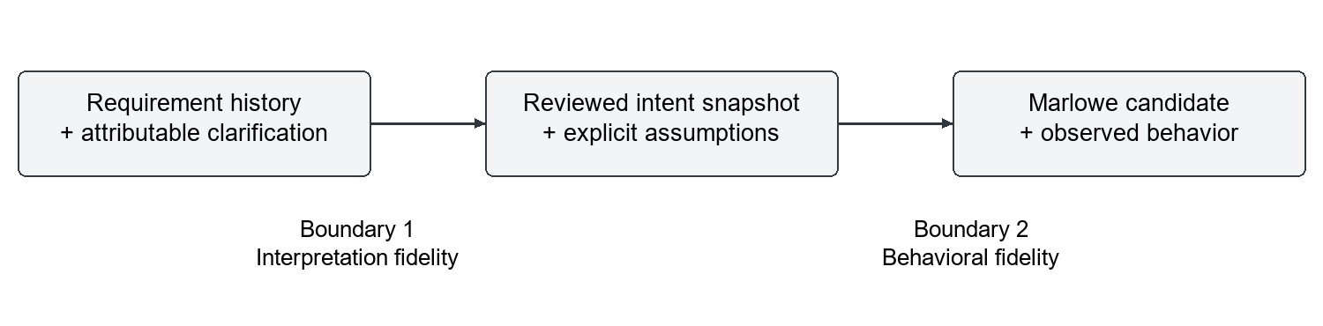
Figure 1. Two translation boundaries. Review records an interpretation; independent adjudication is still needed to evaluate its fidelity.

3.2 Threat model and exclusions
The model may invent unsupported facts, produce incorrect structure, misidentify a branch, or supply an incorrect mapping from a claim to an AST location. Reviewers can misunderstand requirements or approve an incomplete interpretation. Tools can be unavailable, time out, or operate over an insufficiently specified domain. Cached evidence can become stale after a contract or intent change. These are the principal failure modes addressed by the architecture.
The prototype does not establish reviewer identity through external authentication, protect signing keys, guarantee the integrity of a compromised tool binary, or prove arbitrary off-chain facts. Roleplay answers and synthetic assets are simulation assumptions. They cannot establish actual customer approval or real asset provenance. Public testnet deployment and production authorization remain outside the implemented route.

3.3 Evidence admissibility as a design policy
An evidence record should identify its subject artifact, accepted-intent version when relevant, tool and version, property, evaluated scope, assumptions, verdict, and supporting artifacts. A conclusion is admissible only when these identities agree with the current candidate and the evidence covers the conclusion being made. Additional evidence may expand a documented set of observations; it does not silently expand the quantification of a claim.
We specify five policy obligations. Identity binding prevents evidence about one candidate from validating another. Intent binding requires renewed review and downstream checking after a meaning-changing intent update. Scope preservation prevents a trace result from becoming an all-input guarantee. Verdict separation prevents execution success, missing evidence, or an empty finding set from becoming semantic success. Authority separation prevents technical findings from becoming authenticated approval or deployment permission.
These obligations are a proposed composition contract, not a theorem about the implementation. The repository includes artifact identities, evidence references, scoped assurance schemas, stage results, and local checks [4]. However, the existence of those structures does not demonstrate that every path is mediated by one complete composition checker. A systematic enforcement audit and negative tests remain necessary before claiming that inadmissible promotion is impossible.
Operationally, an evidence item is admissible for a proposed claim only if its candidate identity and relevant intent identity match, its method addresses the claim's property, its assumptions hold, and its evaluated scope covers the exact claim being reported. A timeout, missing record, or inconclusive verdict cannot satisfy a mandatory check. Several passing finite scenarios enlarge the recorded observation set but do not change its quantifier to all possible transactions. If a candidate is regenerated, the new artifact requires fresh checking unless a separately justified reuse rule proves the old evidence applicable. These rules define the intended policy; Appendix A lists tests needed to establish enforcement.

4 Implemented architecture and control flow
Figure 2 summarizes the route. The following subsections distinguish implemented behavior from the composition policy proposed in Section 3.
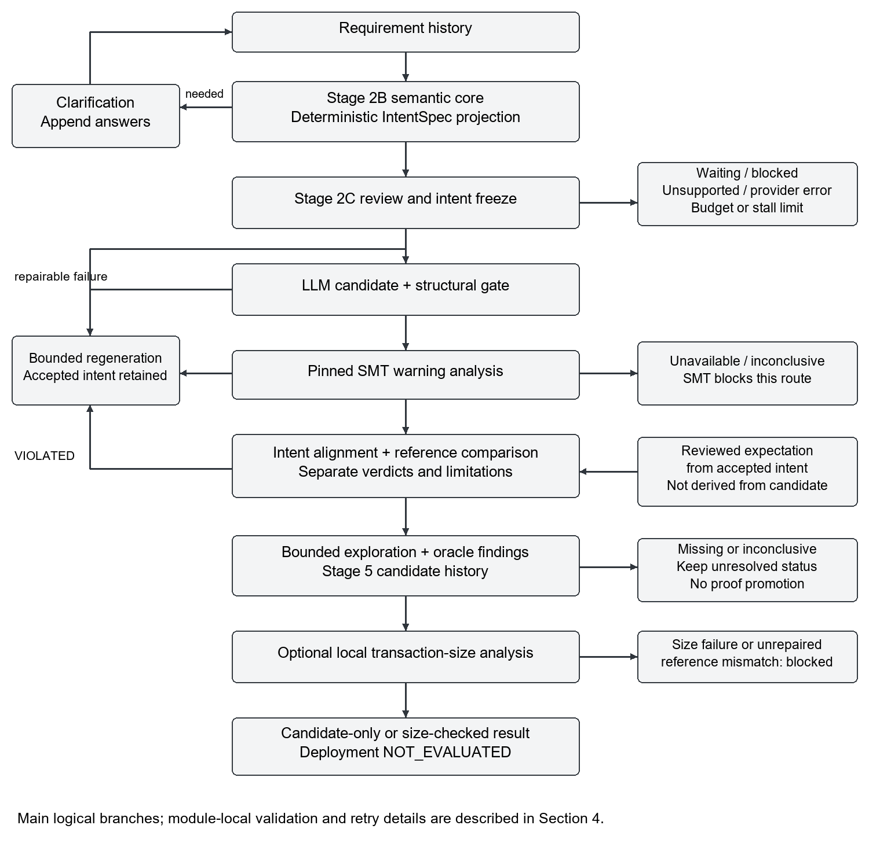
Figure 2. Implemented route and principal branches. Positive paths do not erase scope limits. Reference satisfaction may coexist with inconclusive alignment; optional or unresolved stages preserve their own status.

4.1 Requirement extraction and review
The supported CLI route uses the Stage 2B semantic-core V3 path by default, with a V2 option. The model produces structured claims, source spans, behavior scopes, clarification needs, and resolution information. A deterministic projection constructs an IntentSpec. Source attribution makes an interpretation inspectable; it does not certify that the cited text entails the claim.
If material decisions remain unresolved, clarification answers are appended to the requirement history and extraction is repeated. The system may instead stop because the request is unsupported, the user has not accepted the interpretation, the provider fails, or a limit is reached. Stage 2C records explicit acceptance of the exact proposed intent. The local reviewer identifier and confirmation are evidence of the configured review process, not independent identity verification.

4.2 Candidate construction and checking
After acceptance, an LLM generates a Marlowe Core V1 AST candidate. The stage named compile in the implementation is part of candidate construction and structural checking; that name does not imply a verified natural-language compiler. Structural validation, graph linting, and a pinned SMT analyzer provide distinct diagnostics. Repairable generation or analysis failures can trigger bounded regeneration while retaining the accepted intent. Unavailable or inconclusive SMT outcomes block that route rather than supplying a successful semantic verdict.
Reference comparison receives a separately reviewed expectation associated with accepted intent. It executes supplied transactions under the pinned reference semantics and compares specified observables, such as payments, warnings, status, final state, and remaining contract. Abstract choice inputs must bind to a unique enabled choice; ambiguous binding remains inconclusive. A model-supplied AST path is not sufficient evidence of semantic correspondence.
Intent alignment and reference comparison remain distinct judgments. The implementation can report reference SATISFIED while retaining an INCONCLUSIVE intent-alignment limitation. In that situation the scenario observations matched; the whole interpretation was not proven. A comparison verdict of VIOLATED can trigger regeneration and rechecking. The route does not treat every inconclusive comparison as repairable, and reaching a later stage does not remove an earlier limitation.

4.3 Exploration and property records
When a reviewed scenario is supplied, the CLI derives a declared action domain and uses bounded reference exploration. The inspected configuration uses at most eight traces and a depth bound equal to the larger of two and the supplied transaction count [4]. These are execution limits, not evidence that all relevant behaviors have been enumerated. Failed transactions do not advance the simulated state. The configured NoWarningsOracle evaluates observed traces; warning absence on those traces does not establish business correctness.
The adversarial adapter selects violated oracle findings and explicitly records that no additional search was performed. It must not be described as a functioning autonomous attack generator. Stage 5 creates property candidates and maintains in-memory status history. Its statements are review candidates linked to findings, not necessarily executable properties. Terminal validation or refutation requires evidence identifiers and a reviewer identifier, but checking that such fields exist does not verify the referenced evidence's truth or applicability.
The default route has no property checker, durable cross-process retrieval, or training pipeline. An empty candidate set can yield successful stage execution with NO_CANDIDATES while validated remains false. This example illustrates why stage success and assurance must be reported independently.

4.4 Termination and operational boundary
Default CLI limits include eight iterations, forty physical model calls, and an extraction stall threshold of two repeated states; generation also stops on repeated diagnostic feedback [4]. Different loops use these controls differently, so the run manifest must record the actual configuration and termination reason. Clarification, user review, provider errors, exhausted budgets, repeated failures, reference mismatches, and ledger-size failures are explicit branches, not missing successes.
An optional adapter performs local Marlowe CLI transaction-size analysis. Its successful status means that the configured size analysis completed for the supplied setup. It does not mean signing, submission, confirmation, full ledger validity, or production readiness. Final CLI results remain candidate-only or ledger-size-checked, with simulation-specific labels in roleplay mode. Testnet and deployment stages are not evaluated.
Table 1. Gate contracts in the implemented route and the maximum claim each gate can support.
Gate | Passing or recorded condition | Failure or unresolved path and maximum claim
Intent review | Exact IntentSpec candidate is accepted under the configured local reviewer policy. | Unresolved clarification, decline, or provider failure stops progress. Acceptance records a reviewed interpretation, not authenticated truth.
Core V1 structure | Candidate passes structural validation and graph linting. | Malformed or exhausted repair remains a candidate failure. Passing establishes analyzable structure only.
Pinned SMT analysis | Analyzer returns its verdict for the modeled warning property. | Unavailable or inconclusive results block the route. A favorable verdict does not establish all business requirements.
Reference and alignment | Authorized expectation executes; named observables match. Intent alignment is reported separately. | Mismatch may trigger regeneration; ambiguous binding or unavailable observables remains inconclusive. A match is scenario scoped even if alignment is inconclusive.
Bounded exploration | Declared trace and depth bounds are executed; observed oracle findings are recorded. | Failed transactions do not advance state. No observed warning is not exhaustive or business-level correctness.
Stage 5 registry | Finding-linked candidates and status history are stored in memory. | NO_CANDIDATES may accompany stage success. No default checker or cross-run retrieval validates a reusable property.
Local size adapter | Configured Marlowe CLI size analysis completes within its local limit. | Failure or absence does not grant ledger approval. Success supports only the configured size check.

5 Worked example and failure analysis
Consider an illustrative escrow requirement: a buyer deposits 100 ADA before a deposit deadline; an arbiter may release the deposit to the seller or refund it to the buyer before a later decision deadline; if no decision arrives, the buyer receives a refund; without a deposit, the contract closes without payment. This is an explanatory example, not an additional experimental result. Concrete deadlines, identities, account ownership, units, and decision codes must be resolved during review before constructing a runnable instance.
The accepted intent would explicitly distinguish four branches: release, refund, decision timeout, and no deposit. Independent scenarios should specify the relevant initial state, transaction intervals, inputs, and expected observables. Deadline boundary tests must use the pinned semantics' interval rules rather than an informal assumption about the word before. A scenario whose interval is ambiguous cannot establish a successful boundary test.
A candidate that pays the buyer on the release branch can be structurally valid and need not trigger a modeled warning. A reference scenario expecting payment to the seller would expose that contradiction if the branch is reached and the expectation is correct. Conversely, a release-only scenario says nothing about an erroneous timeout continuation. A wrong refund account could remain undetected until a timeout or closing behavior is evaluated. Warning analysis and business-outcome scenarios therefore address different claims.
An unsupported asset identity belongs to the first boundary if introduced into accepted intent without evidence. If the intent correctly specifies ADA but generation substitutes a different token representation, the error belongs to the second boundary. The current generation feedback explicitly distinguishes native ADA from a token whose name happens to be ADA [4]. Neither source spans nor a positive ledger-size outcome can justify an invented asset policy identifier.
The corresponding evidence report should state which branch scenarios matched, which intent checks remained unresolved, the exploration bounds, and the exact candidate version. If a candidate changes after a counterexample, its previous trace results must be rerun or explicitly justified for reuse under a sound policy. This example motivates the policy obligations in Section 3 without assuming they are universally enforced by the current prototype.
Table 2. Illustrative escrow discrepancies and the checks needed to expose them. The rows are predictions for a worked example, not observed test results.
Hypothetical discrepancy | Potential detection | What still remains unknown
Release pays buyer instead of seller | A reviewed release scenario expecting a seller payment would witness the mismatch if that branch executes. | Structural validity and warning freedom may still pass; other branches are not covered.
Timeout refund omitted | A deadline-boundary scenario using pinned interval semantics is required. | Release and refund-by-choice scenarios alone do not cover the timeout branch.
Unsupported asset identity | Independent requirement adjudication and explicit clarification can challenge the invented policy ID. | Source spans and ledger-size analysis cannot authenticate an asset.
Contract changes after a passing trace | Candidate identity binding must invalidate the old trace or justify reuse and rerun affected checks. | The current prototype has not been shown to enforce this rule on every path.

6 Available implementation observations
The available evidence is an internal progress report dated 6 October 2026 [5]. It describes one sequential, simulation-labeled run of twenty scheduled cases. Four cases reached local transaction-size analysis and jointly exercised twelve successful pinned-reference scenarios. A fifth case was blocked by a provider limit after clarification, and the remaining fifteen cases were not attempted. The report is a bounded engineering observation, not a controlled benchmark.
Table 3. Reported local observations from the simulation batch [5].
Case | Size in bytes | Reference scenarios
Third-party choice | 12,194 / 16,384 | 1
Rental deposit | 12,246 / 16,384 | 4
Three-party escrow | 12,176 / 16,384 | 4
Swap | 12,222 / 16,384 | 3
Milestone case | No passing revised candidate | Provider-blocked after clarification
Remaining 15 cases | Not attempted | Not evaluated

The additional scenarios for cases two through four replayed the same stored candidate for each respective case. They are correlated observations of four contracts, not twelve independent successful synthesis cases. The report records fifty-seven locally reserved physical request attempts across the first five cases, including interrupted attempts. These counts are not provider billing totals. The raw local journals are not committed in the cited repository revision, so this manuscript does not independently recompute them.
Size analysis used a local private Babbage node and a configured 16,384-byte threshold. The four reported sizes are configuration-specific transaction-analysis outputs, not measurements of semantic quality. The swap case used an explicitly synthetic native-token identity, and roleplay responses supplied simulation assumptions. No public testnet signing, submission, or confirmation was reported. Earlier batches used a different adaptive protocol and are not pooled with these observations.
These data support the narrow conclusion that parts of the configured route were reached for four simulated cases. They do not identify the proportion of semantically correct contracts, the reduction in false acceptance, or generalization to new users. Neither four out of twenty nor four out of four is an appropriate semantic accuracy estimate: unattempted cases lack outcomes, and the reached subset is selected by the execution process. The current study therefore reports progress categories and raw counts rather than an effectiveness percentage.

7 Evaluation protocol for semantic effectiveness

7.1 Research questions and decision point
RQ1 asks whether reviewed intent preserves independently adjudicated requirements. RQ2 asks whether evidence gates reject known behavioral contradictions without rejecting an excessive number of acceptable candidates. RQ3 asks whether the complete synthesis workflow improves final behavioral agreement under matched resources. RQ4 asks how much model usage, latency, human review, and abstention these controls require. Property reuse and adaptation are separate future experiments, not prerequisites for testing these questions.
The prespecified primary comparison should use the fixed-candidate detection experiment: the complete evidence policy versus a structured-intent condition without that policy, applied to exactly the same adjudicated candidate records. The hypothesis is lower observed false acceptance among witnessed-incorrect candidates, with acceptance coverage and review cost reported alongside it. End-to-end synthesis is a separate secondary comparison because it can change the candidates and information available to each method. Neither comparison has been executed for this manuscript.
We define evaluation acceptance as a frozen policy's decision that a candidate is eligible for further engineering review within a named scope. It is not user approval or deployment. The policy is evaluated externally on frozen candidate records; it is not inferred from the current CLI's candidate-only status. A proposed strict policy requires reviewed intent and expectation identities to match the candidate record, required structural and SMT checks to succeed, all required reference scenarios to match, and no unresolved mandatory intent-alignment check. Optional exploration or ledger conditions must be declared before the run. Otherwise the policy rejects a confirmed contradiction or abstains when evidence is insufficient.
This policy deliberately differs from a reference SATISFIED result. A record with satisfied scenarios but mandatory alignment still inconclusive is an abstention under the policy. Applying the policy retrospectively to existing runs is possible only when all required artifacts are available; missing fields cannot be reconstructed as positive evidence. Policies must be fixed before inspecting hidden outcomes.
The decision rule has three outcomes for a frozen candidate and named scope. REJECT follows a confirmed structural invalidity or an applicable witnessed contradiction. ABSTAIN follows missing, unavailable, timed-out, or inconclusive mandatory evidence, including mandatory alignment. ACCEPT requires matching identities and successful mandatory checks with no blocking limitation. A repaired candidate receives a new identity and a new decision record. A policy that abstains on nearly every case may achieve a low observed false-acceptance rate without being useful, which is why coverage is co-primary.

7.2 Ground truth and independent scenarios
At least two reviewers should independently label requirements, reconcile disagreement, and retain the adjudication history. Labels cover roles, assets, amounts, timing, branch outcomes, unresolved ambiguities, and unsupported requests. Agreement is measured before reconciliation. An accepted intent is scored against this independent record rather than against the generating model's explanation. Semantically equivalent representations are normalized or adjudicated; different scope identifiers alone are not counted as meaning errors.
Each case has two scenario collections. Development scenarios may be shown to the generator and used in repair. Hidden final scenarios are authored from adjudicated requirements, withheld from generation and repair, and executed only after the final candidate and acceptance decision have been committed. Independence from the generated AST is necessary but insufficient: a scenario exposed in feedback has become development information. Figure 3 shows the required separation.
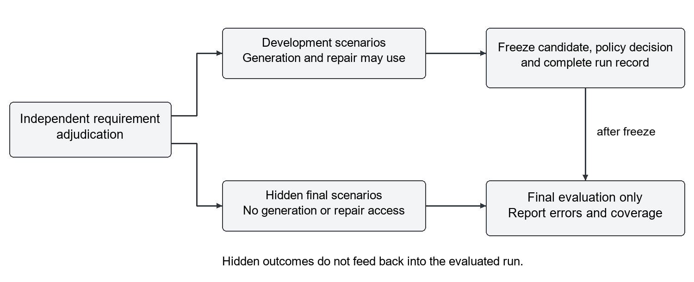
Figure 3. Proposed evaluation separation. Final scenarios remain hidden until the candidate and policy decision are frozen. No hidden outcome is used to repair the evaluated candidate.
A witnessed contradiction in a valid, applicable scenario establishes an error within that scope. Passing a finite hidden suite establishes agreement with that suite, not universal correctness. Evaluation labels should therefore distinguish witnessed-incorrect, suite-conformant, and unresolved candidates. Stronger ground truth requires a complete finite-domain argument or an applicable proof. Disputed or invalid scenarios are reported and adjudicated without silently removing unfavorable outcomes.

7.3 Datasets and leakage control
The supplied Stage 2A corpus contains thirty-two draft records: twenty canonical cases and twelve mutations [6]. These records are neither thirty-two independent requests nor reviewed gold labels. The public validation material was exposed during development and must not be relabeled as a hidden test set. It can support engineering and annotation refinement after review.
The evaluation should include direct payments, escrow, third-party decisions, deposits, staged payments, vesting, swaps, ambiguous requirements, and unsupported requests. Canonical cases and their mutations stay in the same split. A held-out template split tests familiar families with new formulations; a held-out family split addresses the harder question of transfer. These settings must be reported separately. Sample size is selected before outcome inspection using a practically meaningful effect and a precision or power target; the present twenty-case schedule supplies no such justification.

7.4 Baselines and causal separation
All primary baselines target Marlowe and use the same model version, decoding settings where supported, tools, and resource accounting. The minimum conditions are direct generation, structured intent without the proposed evidence policy, and the complete reviewed workflow. Ablations remove one component at a time, such as source attribution, explicit review, or a checker. A removed checker must not reappear through an equivalent hidden prompt or feedback channel.
Two experiments are needed. A fixed-candidate detection experiment presents identical adjudicated correct, incorrect, and unresolved candidates to different gate policies. This isolates detection from generation. An end-to-end experiment permits generation and repair and compares final outcomes on the same requirements. For clarification, include a matched-information condition in which all methods receive the same adjudicated answers, as well as a practical workflow condition that counts each method's review effort. Otherwise, access to extra facts can be mistaken for a benefit of verification.
Methods receive matched ceilings for physical model calls, tokens where available, elapsed time, and human interactions. Actual consumption is reported rather than assumed equal. Repeated generations use recorded seeds when supported and independent repetitions otherwise. Checker versions and timeout policies remain fixed. Provider-blocked and infrastructure-failed runs remain visible as operational outcomes and are not recoded as semantic errors or successes.

7.5 Metrics and analysis
Let W be the number of independently witnessed-incorrect candidates in the fixed-candidate evaluation, A the number accepted by a policy, AW the number both accepted and witnessed-incorrect, and N the number submitted to that policy. The false-acceptance rate among witnessed-incorrect candidates is AW divided by W. The observed error fraction among accepted candidates is AW divided by A. Acceptance coverage is A divided by N. A zero denominator is undefined, never a zero error rate. Because some accepted candidates may remain unresolved, the observed error fraction is only a lower bound on their true error fraction; unresolved acceptance must be reported separately.
Additional metrics include requirement-to-intent fidelity, unsafe-assumption frequency, clarification recall, intent-to-contract contradictions, hidden-suite agreement, rejection, abstention, and operational failure. Clarification recall uses reviewer-labeled cases that actually require clarification as its denominator. Behavioral metrics report both case-level and branch-level results. A candidate passing several branches does not count as several independent synthesized contracts. No single composite score should conceal a trade-off between low false acceptance and low acceptance coverage.
For end-to-end results, report all scheduled cases through attempted, completed, and accepted subsets with explicit denominators. Include per-family counts, scenario exposure, generation attempts, token usage where available, review actions, latency, and configured size outcomes. Report uncertainty intervals and paired differences across methods. Resampling or inferential models should account for clustering of mutations, scenarios, and repeated generations within a canonical case. Predeclare the primary comparison and treat additional subgroup analyses as exploratory.

8 Reproducibility and implementation status
The implementation account was rechecked against repository revision ac1aad4c35e698fcc605e26e48b7cb3fbe86c420 [4] and its dated progress and Stage 2A documentation [5,6]. The full revision is resolvable at the cited remote, whereas the earlier short identifier alone was insufficient for a reader to identify an immutable source state. This manuscript does not report a newly executed live-model benchmark or reproduce the local ledger experiments. The report's ignored run journals are not part of the revision, so the published summary remains insufficient to reconstruct every observation.
Reproduction requires a versioned release or full commit, archive and dataset hashes, model and provider identifiers, prompts, decoding configuration, tool versions or binary digests, initial states, input scenarios, resource limits, and complete stage outcomes. Raw model responses and review decisions need stable links to candidate and intent identities. Sensitive details may be redacted, but the transformation and its effect on reproducibility must be documented. The internal report alone is insufficient to reconstruct every observation.
Appendix A maps implementation claims to source components and proposes negative conformance checks. General evidence-composition enforcement, authenticated review, persistent property retrieval, and parameter training remain unestablished capabilities.

9 Discussion and future work
Circular evidence remains the strongest validity threat: an invented interpretation, matching contract, and matching explanation can all be wrong. Review and independent scenarios address this risk only when review is meaningful and scenario exposure is controlled. Independent requirement adjudication must evaluate the accepted interpretation itself.
Construct validity depends on preserving the meaning of each outcome. Warning freedom, scenario agreement, a successful software stage, and transaction size are different constructs. An all-abstaining policy can avoid false acceptance while being useless; a permissive policy can increase coverage by accepting unresolved cases. Both error and coverage are therefore necessary. External validity is limited by simulation, developer-shaped examples, one target language, changing model services, and the absence of a representative hidden sample.
Property memory is a promising extension only after findings become checkable specifications. The required path is an observed finding, a reviewed property hypothesis, an executable predicate or formal specification, an applicability check, and fresh checking of a new candidate. Historical validation does not validate a different contract. The current registry is an audit seam for that work, not a demonstrated cumulative verifier. Future experiments should freeze the registry before evaluation and measure additional violations, scope-related false alarms, retrieval coverage, and overhead.
Future adaptation experiments should compare prompt-only, supervised-intent, and verification-informed conditions on identical hidden cases, with training and model selection restricted to development data. Verifier outcomes cannot substitute for intent labels. No training pipeline or measured adaptation benefit exists in the present study.

10 Conclusion
This work presents a Marlowe synthesis architecture that separates accepted intent, candidate construction, and scoped evidence. A successful reference scenario can coexist with incomplete intent assurance. The proposed composition policy and independent evaluation make that boundary testable while accounting for abstention, review effort, and cost.
Four simulated cases reached local transaction-size analysis; this does not establish reduced semantic hallucination. The defensible contribution is an implementation-grounded assurance design. Demonstrating effectiveness requires independently reviewed requirements, hidden final scenarios, matched baselines, and reproducible artifacts.

References
[1] H. Luo, Y. Lin, X. Yan, X. Hu, Y. Wang, Q. Zeng, H. Wang, and J. Jiang. Guiding LLM-based Smart Contract Generation with Finite State Machine. Proceedings of IJCAI, pp. 5869–5877, 2025. https://doi.org/10.24963/ijcai.2025/653.
[2] P. Lamela Seijas, A. Nemish, D. Smith, and S. Thompson. Marlowe: Implementing and Analysing Financial Contracts on Blockchain. Financial Cryptography and Data Security, LNCS 12063, pp. 496–511, 2020. https://doi.org/10.1007/978-3-030-54455-3_35.
[3] B. Zhang, H. Liu, Q. Tian, S. Chen, Z. Wang, and Q. Qi. Towards Trustworthy Smart Contract Synthesis: A Multi-Agent Framework with Lean-Based Verification. Proceedings of ACL, Volume 1, pp. 39548–39582, 2026. https://doi.org/10.18653/v1/2026.acl-long.1836.
[4] Marlowe AI Agent project. Source repository, revision ac1aad4c35e698fcc605e26e48b7cb3fbe86c420. https://github.com/tohyung/AI-Agent-SC/tree/ac1aad4c35e698fcc605e26e48b7cb3fbe86c420. Components include research/architecture/cli_runner.py, research/architecture/assurance.py, research/stage3/comparison.py, research/stage4/adversarial.py, and research/stage5/registry.py. Accessed 7 October 2026.
[5] Marlowe AI Agent project. Main-pipeline roleplay batch 20: progress report, 6 October 2026. https://github.com/tohyung/AI-Agent-SC/blob/ac1aad4c35e698fcc605e26e48b7cb3fbe86c420/docs/research/roleplay-main-batch20-progress.md. Internal engineering report; underlying ignored run journals are not committed.
[6] Marlowe AI Agent project. Stage 2A evaluation material and candidate corpus. https://github.com/tohyung/AI-Agent-SC/blob/ac1aad4c35e698fcc605e26e48b7cb3fbe86c420/research/stage2a/freeze/stage2a-v1.manifest.json and associated protocol and corpus artifacts. Draft development material, not an independently reviewed hidden benchmark.
[7] T. Lebo, S. Sahoo, and D. McGuinness, editors. PROV-O: The PROV Ontology. W3C Recommendation, 30 April 2013. https://www.w3.org/TR/2013/REC-prov-o-20130430/.
[8] Object Management Group. Structured Assurance Case Metamodel, version 2.3, October 2023. https://www.omg.org/spec/SACM/2.3/.

Appendix A Traceability and proposed conformance checks
The CLI orchestration in research/architecture/cli_runner.py supports the control-flow account in Section 4. The assurance module defines evidence references and scoped claims, while stage3/comparison.py preserves the distinction between alignment and reference findings. The adversarial adapter records search_performed as false. The Stage 5 registry stores candidate history and requires evidence and reviewer identifiers for selected terminal events. These locations identify implementation evidence; they do not replace an end-to-end policy audit. The code and documentation were inspected at revision ac1aad4c35e698fcc605e26e48b7cb3fbe86c420.
Table A1. Proposed negative tests for the evidence composition policy.
Perturbation | Required policy behavior
Change candidate after a passing trace | Prior result cannot validate the new candidate without justified reuse or rechecking
Change accepted intent after review | Require new review and invalidate affected downstream conclusions
Keep reference SATISFIED but alignment INCONCLUSIVE | Abstain if alignment is mandatory; retain both verdicts
Supply no traces or no oracle findings | Do not infer complete coverage or semantic correctness
Insert unresolved evidence IDs into registry history | Do not treat field presence as verified evidence
Replay evidence from a different initial state or tool version | Require applicability validation and preserve assumptions
Request unavailable mandatory checking | Abstain or block; do not record a successful semantic check

The proposed checks above are a conformance agenda, not newly reported test results. A reproducible study should publish each test input, expected policy decision, observed decision, and responsible implementation path. Results should distinguish an enforced invariant, an unsupported path that safely abstains, and a gap requiring implementation. This is necessary before strengthening the architecture's descriptive claims into guarantees about all execution paths.

