Evidence Scoped Assurance for Natural Language Synthesis of Marlowe Financial Contracts

Abstract
Large language models can produce syntactically valid smart contracts whose payment behavior does not match a user's financial intent. We present an evidence scoped architecture for synthesizing Marlowe Core V1 candidates from natural language requirements. The architecture separates source grounded intent extraction, explicit human acceptance, candidate generation, Marlowe specific analysis, independently specified reference traces, bounded exploration, and property records. Each result carries its scope and authority so that a local test or analyzer outcome cannot silently become a claim of end to end correctness. We explain why Marlowe's domain specific semantics make selected language properties amenable to existing formal analysis while leaving the natural language to contract translation as a separate research problem. We also specify a property memory design for reusing reviewed findings and a controlled study of verification informed fine tuning. A preliminary, simulation labeled 20 case run reached local transaction size analysis for four cases; this observation is not an accuracy estimate. The paper provides an implementation account, a falsifiable evaluation protocol, and explicit limits on current assurance.
Keywords Marlowe; smart contract synthesis; natural language requirements; formal semantics; property memory; large language models

1 Introduction
Natural language interfaces lower the cost of authoring financial contracts, but a generated contract may compile and still pay the wrong party, use the wrong deadline, or encode an unstated assumption. Compilation and generic vulnerability checks therefore leave an intent gap. For financial workflows, the relevant question is not only whether a contract executes, but whether each branch implements an interpretation that a user actually accepted.
We study a Marlowe synthesis architecture that assigns a distinct evidentiary role to every stage. An LLM proposes a structured interpretation of the requirement. A user review freezes a particular version of that interpretation. The system then generates a Marlowe Core V1 candidate and checks its structure and modeled warnings. Separately reviewed scenarios are executed under a pinned reference semantics. Bounded trace exploration and property candidates preserve the domain and version to which each finding applies. Figure 1 summarizes the two translation boundaries.
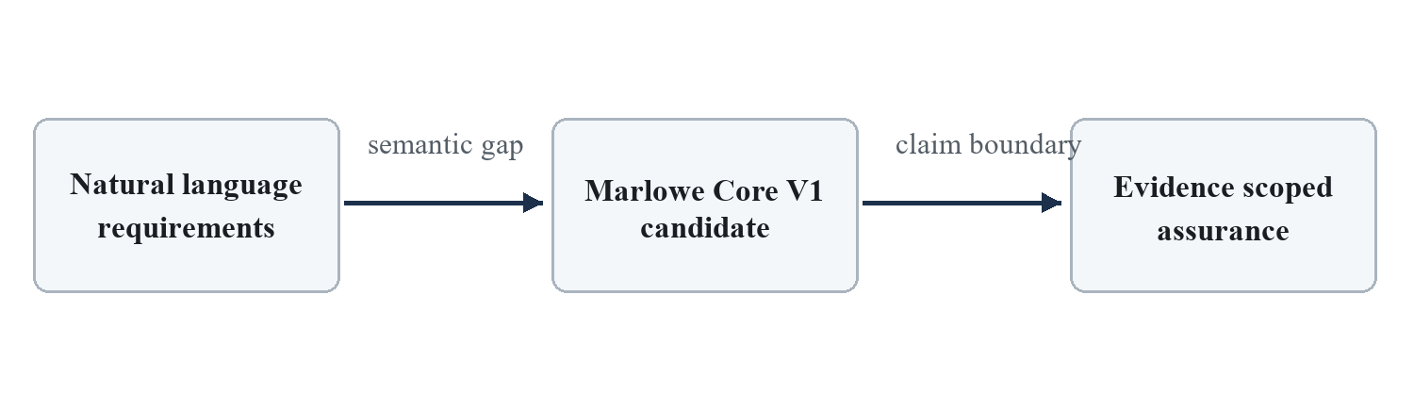
Figure 1 The intent translation and assurance boundaries in natural language to Marlowe synthesis
This work makes three design contributions. First, it specifies an artifact and authority model that keeps model output, user accepted intent, reference observations, and checker verdicts separate. Second, it describes an implementation path for Marlowe specific checking and a scoped property memory. Third, it defines an evaluation that can test whether these controls reduce false acceptance without hiding coverage and cost. The property retrieval loop and fine tuning study are research extensions; neither is reported as a measured result.

2 Why Marlowe
Marlowe is a domain specific language for financial contracts. Its small set of contract constructs expresses payments, conditional branches, externally supplied choices, deposits, timeouts, and closure. Account ownership and refunds are part of the operational model. These constraints are a practical advantage for escrow, staged payment, time release, and swap requirements because the analyst can inspect financial control flow without the general state and call surface of Solidity [2]. They also limit expressiveness: the architecture does not claim to synthesize arbitrary decentralized applications.
Marlowe has an executable reference semantics and an Isabelle specification. Published results include money preservation, termination, and timeout related properties of the language semantics [2]. The Marlowe Cardano specification relates the abstract semantics to the Plutus implementation and records assumptions about state validity, role tokens, and ledger behavior [4]. Figure 2 shows the relevant chain of interpretation.
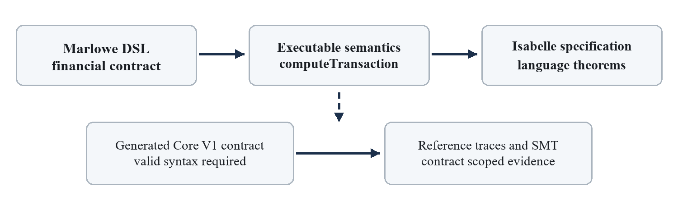
Figure 2 Language level proofs and contract specific checks occupy different parts of the assurance chain
Using a language with verified semantics does not prove that an LLM captured the user's intent. The Isabelle theorems concern Marlowe's semantic rules under their stated preconditions. A candidate contract still requires valid Core V1 structure, correct participants and assets, valid initial state, and relevant behavioral expectations. Pinned reference execution establishes observed behavior for the supplied input traces. SMT analysis addresses the warning property and model used by its analyzer. Neither result authenticates user approval, proves all business requirements, or establishes that an on chain transaction will be accepted under every ledger parameter.

3 Related Work and Research Gap
FSM SCG maps requirements to SmartFSM and then to Solidity, using compilation and Slither feedback; its reported benchmark includes compilation and vulnerability metrics [1]. LeVer generates Solidity with a verifier and attacker loop, translating code into Lean for property proving [3]. LeVer explicitly notes that its proof claims depend on the faithfulness of the Solidity to Lean translation. Marlowe research supplies the domain specific semantics and analysis tools, but it does not settle the problem of translating unconstrained natural language into accepted financial behavior [2].
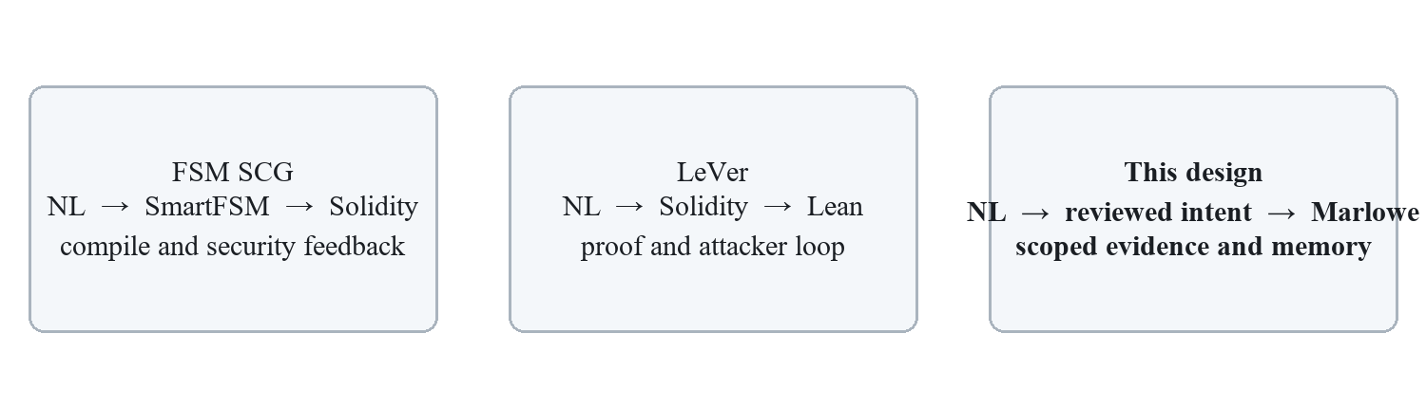
Figure 3 Different intermediate representations and assurance paths in the three reference works
The proposed gap is narrower than a claim that prior systems lack verification. It concerns the provenance of financial intent and the conditions under which evidence from several methods may justify a conclusion about one candidate. A Marlowe target avoids an additional learned code to proof translation for checks expressed directly against Marlowe semantics. It does not remove the upstream natural language interpretation gap, the need to establish applicability of a property, or the implementation assumptions between abstract semantics and on chain execution.
Work | Primary target | Main evaluation or guarantee | Open issue for this study
FSM SCG [1] | Solidity | Compilation and security tool outcomes | Accepted financial intent and Marlowe specific semantics
Marlowe [2] | Financial DSL | Semantics and language level analysis | Natural language interpretation
LeVer [3] | Solidity and Lean | Proofs over translated models and dynamic attacks | Translation faithfulness and intent provenance
This architecture | Marlowe Core V1 | Scoped, heterogeneous evidence | Requires independent outcome evaluation

4 System Architecture

4 1 Requirements and accepted intent
The input is a versioned requirement history rather than a single flattened prompt. Stage 2B requests a semantic core with claims, behavior scopes, source spans, clarifications, and resolution status, then applies deterministic projection to an IntentSpec. Source spans make a claim inspectable but do not by themselves establish that the interpretation is correct. Stage 2C displays unresolved decisions and requires an explicit review of the exact candidate. Its accepted snapshot represents reviewed intent only within the provided reviewer policy; the current simulation runs do not establish authenticated customer approval.

4 2 Candidate generation and independent checks
The supported user facing route generates a Marlowe Core V1 candidate with an LLM after intent acceptance. A structural gate and pinned SMT analyzer inspect that candidate. Reference comparison requires a separate behavior expectation derived from reviewed intent rather than from the generated AST. Its observables may include status, payments, warnings, final state, and remaining contract. Stage 4 explores only a declared transaction domain within explicit depth and trace bounds. Failed transactions do not advance state. An observed oracle satisfaction remains a trace local finding.
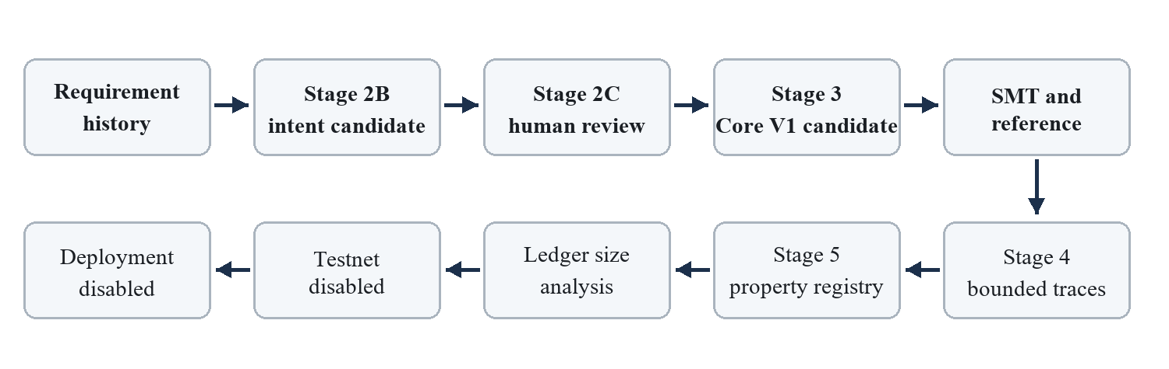
Figure 4 The implemented stage order and the external gates that remain disabled

4 3 Artifacts and authority
Artifacts carry type, schema version, immutable payload identity, and separate provenance records. Execution state, semantic verdict, coverage, and authority are distinct fields. A stage may execute successfully while returning CANDIDATE_ONLY or INCONCLUSIVE. The model generated contract remains a candidate; a reference success authorizes only a statement about the specified trace and pinned semantics. The current ledger adapter checks transaction size against configured local infrastructure. Testnet signing, submission, and deployment are not present in the supported route [5].

5 Scoped Property Memory
Stage 4 can turn an oracle violation on an observed trace into an adversarial finding candidate. Stage 5 assigns a property candidate to the implicated contract and trace, recording a version, source finding, scope, and chronological status. Its registry distinguishes CANDIDATE, VALIDATED_FOR_SCOPE, REFUTED, INCONCLUSIVE, and SUPERSEDED. A validated or refuted terminal event requires evidence identifiers and a reviewer identifier in the current interface. The event is not itself a general theorem.
The intended next step is a validator memory that selects reviewed properties for later candidates by contract family, schema version, applicable actors and assets, and behavioral scope. The selected property would be executed against a new candidate with fresh evidence. A refuted candidate can instead become a regression case. Figure 5 makes the proposed feedback edge explicit.
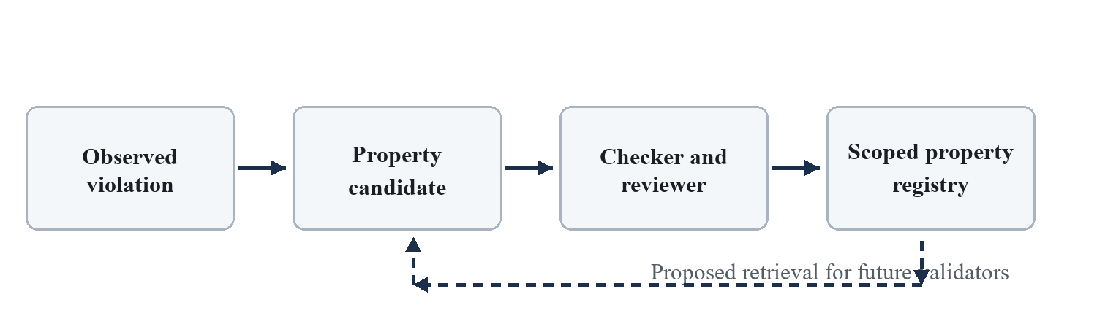
Figure 5 Proposed reuse of reviewed properties in later validator runs
The current implementation records candidate history in memory but provides no durable cross process property store, no applicability query, and no default formal checker. The main validator route does not retrieve Stage 5 properties on later runs. Consequently, the present system supports an auditable registry seam, while the claimed benefit of cumulative validator memory remains to be built and evaluated. The evaluation in Section 7 treats memory reuse as an experimental factor rather than an observed feature.

6 Verification Informed Model Adaptation
Fine tuning updates model parameters or lightweight adapters using labeled examples; repeated prompting or bounded regeneration does not. The present repository invokes an external model and contains no training pipeline. Its 32 Stage 2A annotations are draft candidates rather than independently reviewed gold labels, and its public validation split was exposed during development. These records cannot support a reliable improvement claim without adjudication and an unseen test set [6].
We propose a supervised adaptation task at the intent extraction boundary. Training examples would pair requirement histories with reviewer adjudicated claims, source spans, branch scopes, and decisions to ask for clarification. A second, optional training set would include behaviorally distinct candidate contracts found by reference or SMT counterexamples. Counterexamples could label contract behavior, but they must not substitute for human labels of the original intent. Parameter efficient adaptation such as LoRA provides a feasible implementation option when the model and weights permit it [7].
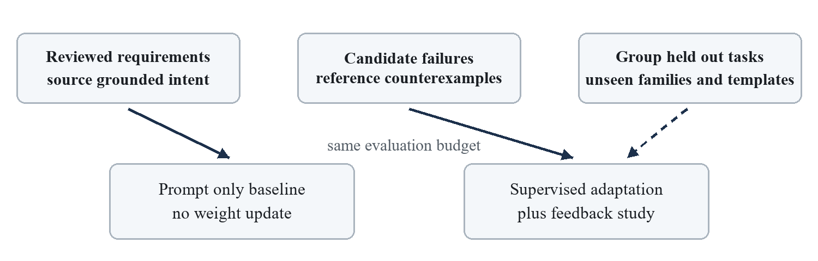
Figure 6 Proposed fine tuning study with independent intent labels and a held out evaluation
The scientific question is whether adaptation reduces unsafe assumptions and false acceptance, not merely whether more outputs pass structure or warning checks. The planned comparison holds the model family, prompt budget, verifier versions, and evaluation cases constant across a prompt only baseline, supervised intent adaptation, and verification informed adaptation. A family level split and a template level leakage audit are required. All training effects remain prospective.

7 Evaluation Protocol
The evaluation should answer four questions. RQ1 asks whether the system preserves reviewed financial intent. RQ2 asks whether evidence gates reduce false acceptance of behaviorally incorrect candidates. RQ3 asks what they cost in coverage, model calls, human review, and latency. RQ4 asks whether scoped property memory and intent focused adaptation provide gains on unseen contract families or merely memorize recurring templates.
Cases should cover direct payment, escrow, third party decisions, rental deposits, staged payments, vesting, swaps, and infeasible or underspecified requests. Each accepted case needs independently reviewed roles, assets, amounts, deadlines, branch outcomes, and behavior scenarios. At least two reviewers should label and reconcile disputed cases, with adjudication retained. A development split may include the existing draft corpus after review. A hidden, frozen holdout must be created outside the development view before reporting generalization.
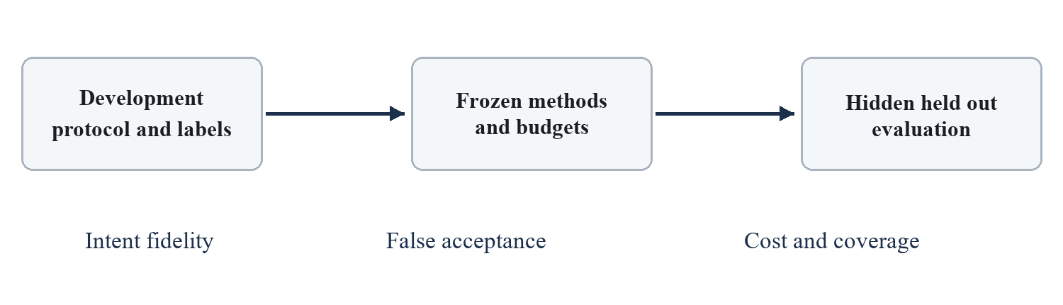
Figure 7 Separation of development, frozen methods, and held out evaluation
Baselines should all target Marlowe under the same model and call budget: direct natural language to Core V1, a structured prompt without acceptance or evidence gates, and ablations of the full route. A SmartFSM style intermediate representation may be adapted to Marlowe, but results from a Solidity dataset cannot be compared numerically to Marlowe outcomes. Metrics include exact claim and scope fidelity, required clarification recall, unsafe assumption rate, false acceptance rate, behavioral agreement on independently specified traces, family coverage, calls, latency, and local transaction size. Report counts and denominators, uncertainty intervals for rates, and every INCONCLUSIVE and NOT_ATTEMPTED outcome separately.
For property memory, freeze the registry after training cases and evaluate retrieval on new same family and cross family cases. Measure new violations found, false alarms due to overbroad scope, retrieval coverage, and runtime overhead. For fine tuning, isolate the effect of review labeled data from verifier derived examples. Neither ablation can be interpreted causally if it changes the verifier or the test set.

8 Preliminary Implementation Observations
The latest main route roleplay report describes a sequential 20 case simulation labeled batch. Four cases reached local Marlowe CLI transaction size analysis and together exercised 12 successful pinned reference scenarios. A fifth case was blocked by a provider limit after clarification; fifteen cases were not attempted. These counts measure progress through a particular run, not semantic accuracy or contract acceptance probability [5].
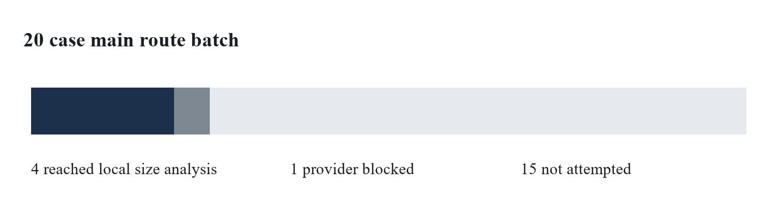
Figure 8 Observed progress in the 20 case roleplay batch reported on 6 October 2026
Case | Local size in bytes | Reference scenarios
Third party choice | 12,194 of 16,384 | 1
Rental deposit | 12,246 of 16,384 | 4
Three party escrow | 12,176 of 16,384 | 4
Swap | 12,222 of 16,384 | 3

The recorded size gate used a local private Babbage node and did not sign, submit, or confirm transactions on a public testnet. Some roleplay answers and the swap asset identity were explicit simulation assumptions. The local raw attempt journal was not published with the report. Earlier Batch 01 observations followed a different adaptive protocol and are not pooled with this run. These limitations prevent an unbiased end to end success or generalization estimate.

9 Discussion and Threats to Validity
The largest internal validity risk is circular evidence. Expectations derived from a generated AST can agree with that AST even when both contradict the user. The proposed protocol therefore obtains scenarios from independently reviewed intent, records their source, and prevents an AST path asserted by the model from serving as proof of meaning. Reviewer disagreement and changes to the requirement history must remain visible in the data.
Construct validity is also limited. SMT Valid refers to the warning property modeled by the pinned analyzer; bounded exploration is not exhaustive; a successfully executed stage is not a favorable verdict. Language level formal results depend on valid states and the correspondence between the formal specification, executable semantics, and on chain validator. Ledger limits, role token ownership, signing, and operational behavior are separate checks [2,4].
External validity depends on representative financial families, languages, model choices, and independently collected requirements. The current 20 case roleplay and draft annotations are useful for engineering and protocol refinement, but they do not establish performance for new users. A journal level claim of improvement requires a frozen study with sufficient reviewed cases, strong baselines, and release of code, data or a justified reproducibility substitute.

10 Conclusion
This paper specifies a Marlowe synthesis architecture that keeps intent acceptance, candidate construction, semantic observations, and authority decisions distinct. Marlowe offers a compact financial language with a formal semantic foundation, but that foundation does not prove that a model understood the user's request. The implemented prototype supports source grounded intent artifacts, candidate checking, pinned reference traces, bounded exploration, and a versioned property registry. Reusable property memory, fine tuning, and end to end semantic effectiveness remain research questions to be tested under the proposed independent protocol.

References
[1] H. Luo, Y. Lin, X. Yan, X. Hu, Y. Wang, Q. Zeng, H. Wang, and J. Jiang. Guiding LLM based smart contract generation with finite state machine. Proceedings of IJCAI, pp. 5869–5877, 2025. doi:10.24963/ijcai.2025/653.
[2] P. Lamela Seijas, A. Nemish, D. Smith, and S. Thompson. Marlowe implementing and analysing financial contracts on blockchain. Financial Cryptography and Data Security, LNCS 12063, pp. 496–511, 2020. doi:10.1007/978-3-030-54455-3_35.
[3] B. Zhang, H. Liu, Q. Tian, S. Chen, Z. Wang, and Q. Qi. Towards trustworthy smart contract synthesis a multi agent framework with Lean based verification. Proceedings of ACL, pp. 39548–39582, 2026. doi:10.18653/v1/2026.acl-long.1836.
[4] Marlowe Cardano contributors. On chain transaction specification for Marlowe. marlowe-lang/marlowe-cardano, accessed 7 October 2026. https://github.com/marlowe-lang/marlowe-cardano/blob/main/marlowe/specification/marlowe-cardano-specification.md.
[5] Marlowe AI Agent project. Main pipeline roleplay batch 20 progress report, 6 October 2026, repository commit ac1aad4.
[6] Marlowe AI Agent project. Stage 2A evaluation protocol and frozen candidate corpus, repository commit ac1aad4.
[7] E. J. Hu, Y. Shen, P. Wallis, Z. Allen Zhu, Y. Li, S. Wang, L. Wang, and W. Chen. LoRA low rank adaptation of large language models. Proceedings of ICLR, 2022. https://openreview.net/forum?id=nZeVKeeFYf9.

