**Introduction**

In this project, I will propose a security-focused network design for a small office. The organization has five departments: Administration, Human Resources, Marketing, Customer Service, and Warehouse. There are four servers on the network for web applications and file sharing. The employees should also have wireless access to the network.

|  |  |  |  |
| --- | --- | --- | --- |
| Hardware Budget | | | |
| Item | Price | Quantity | Total Price |
| Desktop (PC) | RM 2709.21 | 5 | RM 13546.05 |
| Lap Top | RM 2211.60 | 5 | RM 11058.00 |
| Printer | RM 1285.49 | 5 | RM 6427.45 |
| Router | RM 1313.14 | 5 | RM 6565.70 |
| Server | RM 13799.46 | 5 | RM 68997.3 |
| Access-point | RM 2759.89 | 5 | RM 13799.45 |
|  |  | Total | RM 120393.95 |

Network topology diagram

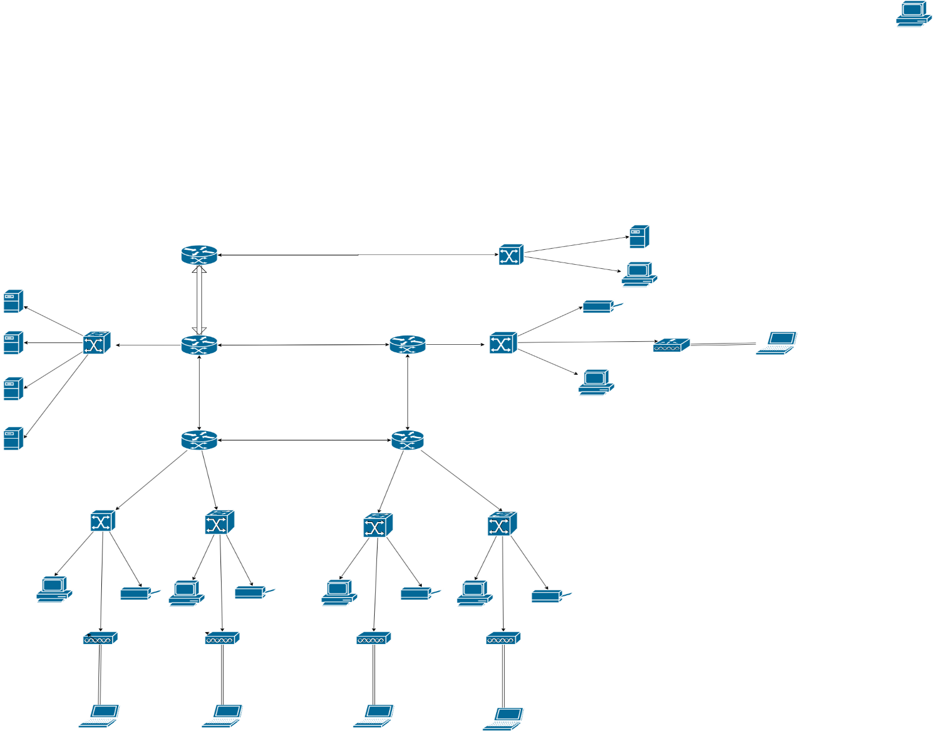

|  |  |
| --- | --- |
| Network device configuration | |
| Router 1 | Ipv6 unicast-routing  ip domain-name ys.com  interface GigabitEthernet0/0  ip address 192.168.24.1 255.255.255.0  ip nat inside  duplex auto  speed auto  ipv6 address 2002:DB8:24::1/64  ipv6 eigrp 88  no shutdown  !  interface GigabitEthernet0/1  ip address 172.168.34.2 255.255.255.0  ip access-group 100 in  ipv6 traffic-filter deny in  ip nat outside  duplex auto  speed auto  ipv6 address 2002:DB8:34::2/64  ipv6 eigrp 88  no shut  !  interface GigabitEthernet0/2  ip address 172.168.36.2 255.255.255.0  ip access-group 100 in  ipv6 traffic-filter deny in  ip nat outside  duplex auto  speed auto  ipv6 address 2002:DB8:36::2/64  ipv6 eigrp 88  no shutdown  !  interface Serial0/0/0  ip address 172.168.16.1 255.255.255.0  ipv6 address 2002:DB8:99::1/64  ipv6 eigrp 88  clock rate 2000000  no shutdown  !  interface Serial0/0/1  ip address 172.168.22.2 255.255.255.0  ipv6 address 2002:DB8:66::2/64  ipv6 eigrp 88  no shutdown  router eigrp 99  redistribute static  network 172.168.16.0 0.0.0.255  network 172.168.22.0 0.0.0.255  network 192.168.24.0  !  ipv6 router eigrp 88  eigrp router-id 1.1.1.1  no shutdown  redistribute static  !  ipv6 router eigrp 99  eigrp router-id 1.1.1.1  no shutdown  !  ip nat inside source static 192.168.24.3 8.8.8.8  ip classless  ip route 0.0.0.0 0.0.0.0 GigabitEthernet0/1  ip route 0.0.0.0 0.0.0.0 GigabitEthernet0/2 2  !  ip flow-export version 9  !  ipv6 route ::/64 2002:DB8:34::1  ipv6 route ::/64 2002:DB8:36::1 2  !  access-list 100 deny tcp 200.10.20.0 0.0.0.255 any eq ftp  access-list 100 deny tcp 200.10.20.0 0.0.0.255 any eq 22  access-list 100 deny icmp 200.10.20.0 0.0.0.255 192.168.24.0 0.0.0.255 echo  access-list 100 permit ip any any  ipv6 access-list deny  deny tcp 2002:DB8:2::/64 2002:DB8:24::/64 eq ftp  deny tcp 2002:DB8:2::/64 2002:DB8:24::/64 eq telnet  deny icmp 2002:DB8:2::/64 2002:DB8:24::/64 echo-request  deny tcp 2002:DB8:2::/64 2002:DB8:24::/64 eq 22  permit ipv6 any any  line vty 0 4  login local  transport input ssh  line vty 5 15  login local  transport input ssh |
| R2 | Ipv6 unicast-routing  ipv6 dhcp pool admin  address prefix 2002:db8:10::2/64 lifetime 172800 86400  dns-server 2002:DB8:24::4  domain-name Toh.com   interface GigabitEthernet0/0.10  encapsulation dot1Q 10  ip address 192.168.10.1 255.255.255.0  ip helper-address 192.168.24.2  ipv6 address 2002:DB8:10::1/64  ipv6 nd managed-config-flag  ipv6 eigrp 88  ipv6 dhcp server admin  interface Serial0/0/0  ip address 172.168.16.2 255.255.255.0  ip access-group 100 in  ipv6 traffic-filter deny in  ipv6 address 2002:DB8:99::2/64  ipv6 eigrp 88  no shutdown  interface Serial0/0/1  ip address 172.168.18.1 255.255.255.0  ipv6 address 2002:DB8:88::1/64  ipv6 eigrp 88  clock rate 2000000  router eigrp 99  network 192.168.10.0  network 172.168.16.0 0.0.0.255  network 172.168.18.0 0.0.0.255  no shutdown  access-list 100 deny icmp 200.10.20.0 0.0.0.255 192.168.10.0 0.0.0.255 echo  access-list 100 permit ip any any  ipv6 access-list deny  deny icmp 2002:DB8:2::/64 2002:DB8:10::/64 echo-request  permit ipv6 any any  no shutdown |
| R3 | Ipv6 unicast-routing  ipv6 dhcp pool HR  address prefix 2002:db8:20::2/64 lifetime 172800 86400  dns-server 2002:DB8:20::24  domain-name Toh.com  ipv6 dhcp pool Marketing  address prefix 2002:db8:30::2/64 lifetime 172800 86400  dns-server 2002:DB8:24::4  domain-name Toh.com  interface GigabitEthernet0/0.10  encapsulation dot1Q 10  ip address 192.168.20.1 255.255.255.0  ip helper-address 192.168.24.2  ipv6 address 2002:DB8:20::1/64  ipv6 nd managed-config-flag  ipv6 eigrp 88  ipv6 dhcp server HR  interface GigabitEthernet0/2.10  encapsulation dot1Q 10  ip address 192.168.30.1 255.255.255.0  ip helper-address 192.168.24.2  ipv6 address 2002:DB8:30::1/64  ipv6 nd managed-config-flag  ipv6 eigrp 88  ipv6 dhcp server Marketing  interface Serial0/0/0  ip address 172.168.14.1 255.255.255.0  ip access-group 100 in  ipv6 traffic-filter deny in  ipv6 address 2002:DB8:77::1/64  ipv6 eigrp 88  clock rate 2000000  no shutdown  interface Serial0/0/1  ip address 172.168.18.2 255.255.255.0  ip access-group 100 in  ipv6 traffic-filter deny in  ipv6 address 2002:DB8:88::2/64  ipv6 eigrp 88  no shutdown  router eigrp 99  network 172.168.14.0 0.0.0.255  network 172.168.18.0 0.0.0.255  network 192.168.20.0  network 192.168.30.0  ipv6 router eigrp 88  eigrp router-id 3.3.3.3  no shutdown  access-list 100 deny icmp 200.10.20.0 0.0.0.255 192.168.20.0 0.0.0.255 echo  access-list 100 deny icmp 200.10.20.0 0.0.0.255 192.168.30.0 0.0.0.255 echo  access-list 100 permit ip any any  ipv6 access-list deny  deny icmp 2002:DB8:2::/64 2002:DB8:20::/64 echo-request  deny icmp 2002:DB8:2::/64 2002:DB8:30::/64 echo-request  permit ipv6 any any |

|  |  |
| --- | --- |
| R4 | Ipv6 unicast-routing  ipv6 dhcp pool WR  address prefix 2002:db8:50::2/64 lifetime 172800 86400  dns-server 2002:DB8:24::4  domain-name Toh.com  ipv6 dhcp pool CS  address prefix 2002:db8:40::2/64 lifetime 172800 86400  dns-server 2002:DB8:24::4  domain-name Toh.com  interface GigabitEthernet0/0.10  encapsulation dot1Q 10  ip address 192.168.40.1 255.255.255.0  ip helper-address 192.168.24.2  ipv6 address 2002:DB8:40::1/64  ipv6 nd managed-config-flag  ipv6 eigrp 88  ipv6 dhcp server CS  interface GigabitEthernet0/1.10  encapsulation dot1Q 10  ip address 192.168.50.1 255.255.255.0  ip helper-address 192.168.24.2  ipv6 address 2002:DB8:50::1/64  ipv6 nd managed-config-flag  ipv6 eigrp 88  ipv6 dhcp server WR   interface Serial0/0/0  ip address 172.168.14.2 255.255.255.0  ip access-group 100 in  ipv6 traffic-filter deny in  ipv6 address 2002:DB8:77::2/64  ipv6 eigrp 88  interface Serial0/0/1  ip address 172.168.22.1 255.255.255.0  ip access-group 100 in  ipv6 traffic-filter deny in  ipv6 address 2002:DB8:66::1/64  ipv6 eigrp 88  clock rate 2000000  router eigrp 99  network 192.168.40.0  network 192.168.50.0  network 172.168.14.0 0.0.0.255  network 172.168.22.0 0.0.0.255  ipv6 router eigrp 88  eigrp router-id 4.4.4.4  no shutdown  access-list 100 deny icmp 200.10.20.0 0.0.0.255 192.168.40.0 0.0.0.255  access-list 100 deny icmp 200.10.20.0 0.0.0.255 192.168.50.0 0.0.0.255  access-list 100 permit ip any any  ipv6 access-list deny  deny icmp 2002:DB8:2::/64 2002:DB8:40::/64 echo-request  deny icmp 2002:DB8:2::/64 2002:DB8:50::/64 echo-request  permit ipv6 any any |
| ISP router | ipv6 unicast-routing  interface GigabitEthernet0/0  ip address 200.10.20.1 255.255.255.0  ip access-group 100 out  duplex auto  speed auto  ipv6 address 2002:DB8:2::1/64  no shutdown  !  interface GigabitEthernet0/1  ip address 172.168.34.1 255.255.255.0  ip access-group 100 out  ipv6 traffic-filter deny out  ip nat outside  duplex auto  speed auto  ipv6 address 2002:DB8:34::1/64  no shutdown  !  interface GigabitEthernet0/2  ip address 172.168.36.1 255.255.255.0  ip access-group 100 out  ip nat outside  duplex auto  speed auto  ipv6 address 2002:DB8:36::1/64  ipv6 eigrp 88  no shutdown  ip route 8.0.0.0 255.0.0.0 172.168.36.2  ip route 8.0.0.0 255.0.0.0 172.168.34.2  ip route 0.0.0.0 0.0.0.0 GigabitEthernet0/1  ip route 0.0.0.0 0.0.0.0 GigabitEthernet0/2 2  !  ip flow-export version 9  !  ipv6 route ::/64 2002:DB8:34::2  ipv6 route ::/64 2002:DB8:36::2 2 |
| Admin Switch | In range f0/1-20  Switch mode access  Switch access vlan 10  interface GigabitEthernet0/1  switchport trunk allowed vlan 10  switchport mode trunk | |
| HR Switch | In range f0/1-20  Switch mode access  Switch access vlan 10  interface GigabitEthernet0/1  switchport trunk allowed vlan 10  switchport mode trunk | |
| Marketing Switch | In range f0/1-20  Switch mode access  Switch access vlan 10  interface GigabitEthernet0/2  switchport trunk allowed vlan 10  switchport mode trunk | |
| Customer Service Switch | In range f0/1-20  Switch mode access  Switch access vlan 10  interface GigabitEthernet0/1  switchport trunk allowed vlan 10  switchport mode trunk | |
| Warehouse Switch | In range f0/1-20  Switch mode access  Switch access vlan 10  interface GigabitEthernet0/2  switchport trunk allowed vlan 10  switchport mode trunk | |

**IP Address Table**

|  |  |  |  |  |  |
| --- | --- | --- | --- | --- | --- |
| **Addressing Table v4** | | | | | |
| Device | Interface | IP Address | Subnet Mask | Default-gateway | DNS-SERVER |
| R1 | G0/0 | 192.168.24.1 | 255.255.255.0 | n/a | n/a |
| G0/1 | 172.168.34.2 | 255.255.255.0 | n/a | n/a |
| G0/2 | 172.168.36.2 | 255.255.255.0 | n/a | n/a |
| S0/0/0 | 172.168.22.2 | 255.255.255.0 | n/a | n/a |
| R2 | G0/0.10 | 192.168.10.1 | 255.255.255.0 | n/a | n/a |
| S0/0/0 | 172.168.16.2 | 255.255.255.0 | n/a | n/a |
| S0/0/1 | 172.168.18.1 | 255.255.255.0 | n/a | n/a |
| R3 | G0/0.10 | 192.168.20.1 | 255.255.255.0 | n/a | n/a |
| G0/2.10 | 192.168.30.1 | 255.255.255.0 | n/a | n/a |
| S0/0/0 | 172.168.14.1 | 255.255.255.0 | n/a | n/a |
| S0/0/1 | 172.168.18.2 | 255.255.255.0 | n/a | n/a |
| R4 | G0/0.10 | 192.168.40.1 | 255.255.255.0 | n/a | n/a |
| G0/1.10 | 192.168.50.1 | 255.255.255.0 | n/a | n/a |
| S0/0/0 | 172.168.14.2 | 255.255.255.0 | n/a | n/a |
| S0/0/1 | 172.168.22.1 | 255.255.255.0 | n/a | n/a |
| DHCP Server | NIC | 192.168.24.2 | 255.255.255.0 | 192.168.24.1 | n/a |
| DNS Server | NIC | 192.168.24.3 | 255.255.255.0 | 192.168.24.1 | n/a |
| WEB Server | NIC | 192.168.24.4 | 255.255.255.0 | 192.168.24.1 | n/a |
| FTP Server | NIC | DHCPv4 | 255.255.255.0 | 192.168.24.1 | n/a |
| Admin PC | NIC | DHCPv4 | 255.255.255.0 | 192.168.10.1 | 192.168.24.4 |
| HR PC | NIC | DHCPv4 | 255.255.255.0 | 192.168.20.1 | 192.168.24.4 |
| Marketing PC | NIC | DHCPv4 | 255.255.255.0 | 192.168.30.1 | 192.168.24.4 |
| Customer Service PC | NIC | DHCPv4 | 255.255.255.0 | 192.168.40.1 | 192.168.24.4 |
| Warehouse PC | NIC | DHCPv4 | 255.255.255.0 | 192.168.50.1 | 192.168.24.4 |
| Admin.P | NIC | DHCPv4 | 255.255.255.0 | 192.168.10.1 | n/a |
| HR.P | NIC | DHCPv4 | 255.255.255.0 | 192.168.201 | n/a |
| MR.P | NIC | DHCPv4 | 255.255.255.0 | 192.168.30.1 | n/a |
| CS.P | NIC | DHCPv4 | 255.255.255.0 | 192.168.40.1 | n/a |
| WH.P | NIC | DHCPv4 | 255.255.255.0 | 192.168.50.1 | n/a |
| Admin Lap | NIC | DHCPv4 | 255.255.255.0 | 192.168.10.1 | n/a |
| HR Lap | NIC | DHCPv4 | 255.255.255.0 | 192.168.20.2 | n/a |
| MR Lap | NIC | DHCPv4 | 255.255.255.0 | 192.168.30.3 | n/a |
| CS Lap | NIC | DHCPv4 | 255.255.255.0 | 192.168.40.4 | n/a |
| WH Lap | NIC | DHCPv4 | 255.255.255.0 | 192.168.50.5 | n/a |
| ISP Router | G0/0 | 172.168.2.1 | 255.255.255.0 | n/a | n/a |
| G0/1 | 172.168.34.1 | 255.255.255.0 | n/a | n/a |
| G0/2 | 172.168.36.1 | 255.255.255.0 | n/a | n/a |
| S0/0/0 | 200.10.10.1 | 255.255.255.252 | n/a | n/a |
| S0/0/1 | 200.11.11.1 | 255.255.255.252 | n/a | n/a |
| Internet User | NIC | 200.10.20.2 | 255.255.255.0 | 200.10.20.1 | n/a |
| Web Server(out) | NIC | 200.10.20.3 | 255.255.255.0 | 200.10.20.1 | n/a |

|  |  |  |  |  |  |
| --- | --- | --- | --- | --- | --- |
| Adressing Table v6 | | | | | |
| Device | Interface | IP Address | Prefix | Default-gateway | DNS-SERVER |
| R1 | G0/0 | 2002:DB8:24::1 | /64 | n/a | n/a |
| G0/1 | 2002:DB8:34::2 | /64 | n/a | n/a |
| G0/2 | 2002:DB8:36::2 | /64 | n/a | n/a |
| S0/0/0 | 2002:DB8:99::1 | /64 | n/a | n/a |
| S0/0/1 | 2002:DB8:66::2 | /64 | n/a | n/a |
| S0/1/0 | 2002:DB8:55::1 | /64 | n/a | n/a |
| R2 | G0/0.10 | 2002:DB8:10::1 | /64 | n/a | n/a |
| S0/0/0 | 2002:DB8:99::2 | /64 | n/a | n/a |
| S0/0/1 | 2002:DB8:88::1 | /64 | n/a | n/a |
| S0/1/0 | 2002:DB8:55::2 | /64 | n/a | n/a |
| R3 | G0/0.10 | 2002:DB8:20::1 | /64 | n/a | n/a |
| G0/2.10 | 2002:DB8:30::1 | /64 | n/a | n/a |
| S0/0/0 | 2002:DB8:77::1 | /64 | n/a | n/a |
| S0/0/1 | 2002:DB8:88::2 | /64 | n/a | n/a |
| R4 | G0/0.10 | 2002:DB8:40::1 | /64 | n/a | n/a |
| G0/1.10 | 2002:DB8:50::1 | /64 | n/a | n/a |
| S0/0/0 | 2002:DB8:77::2 | /64 | n/a | n/a |
| S0/0/1 | 2002:DB8:66::1 | /64 | n/a | n/a |
| DHCP Server | NIC | 2002:DB8:24::2 | /64 | 2002:DB8:24::1 | n/a |
| WEB Server | NIC | 2002:DB8:24::3 | /64 | 2002:DB8:24::1 | n/a |
| DNS Server | NIC | 2002:DB8:24::4 | /64 | 2002:DB8:24::1 | n/a |
| FTP Server | NIC | 2002:DB8:24::5 | /64 | 2002:DB8:24::1 | n/a |
| Admin PC | NIC | DHCPv6 | /64 | DHCP ass | 2002:DB8:24:4 |
| HR PC | NIC | DHCPv6 | /64 | DHCP ass | 2002:DB8:24::4 |
| Marketing PC | NIC | DHCPv6 | /64 | DHCP ass | 2002:DB8:24::4 |
| Customer Service PC | NIC | DHCPv6 | /64 | DHCP ass | 2002:DB8:24::4 |
| Warehouse PC | NIC | DHCPv6 | /64 | DHCP ass | 2002:DB8:24::4 |
| Admin.P | NIC | DHCPv6 | /64 | DHCP ass | 2002:DB8:24::4 |
| HR.P | NIC | DHCPv6 | /64 | DHCP ass | 2002:DB8:24::4 |
| MR.P | NIC | DHCPv6 | /64 | DHCP ass | 2002:DB8:24::4 |
| CS.P | NIC | DHCPv6 | /64 | DHCP ass | 2002:DB8:24::4 |
| WH.P | NIC | DHCPv6 | /64 | DHCP ass | 2002:DB8:24::4 |
| Admin Lap | NIC | DHCPv6 | /64 | DHCP ass | 2002:DB8:24::4 |
| HR Lap | NIC | DHCPv6 | /64 | DHCP ass | 2002:DB8:24::4 |
| MR Lap | NIC | DHCPv6 | /64 | DHCP ass | 2002:DB8:24::4 |
| CS Lap | NIC | DHCPv6 | /64 | DHCP ass | 2002:DB8:24::4 |
| WH Lap | NIC | DHCPv6 | /64 | DHCP ass | 2002:DB8:24::4 |
| ISP Router | G0/0 | 2002:DB8:2::1 | /64 | n/a | n/a |
| G0/1 | 2002:DB8:34::1 | /64 | n/a | n/a |
| G0/2 | 2002:DB8:36::1 | /64 | n/a | n/a |
| Web Server(out) | NIC | 2002:DB8:2::2 | /64 | 2002:DB8:2::1 | n/a |
| Internet User | NIC | 2002:DB8:2::3 | /64 | 2002:DB8:2::1 | n/a |

**Verify**

(outside Internet User to Internal Web & User)

NAT

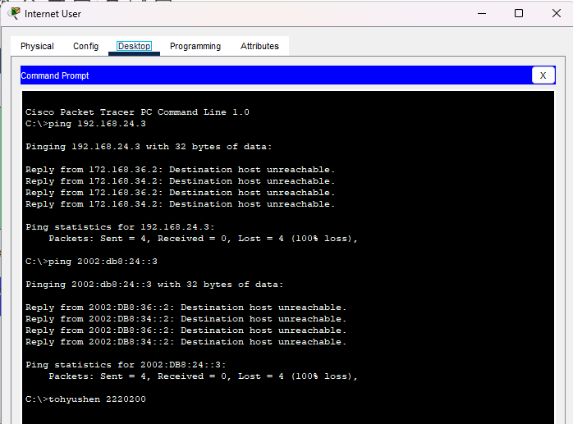

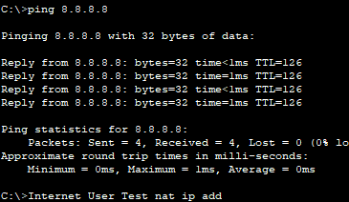

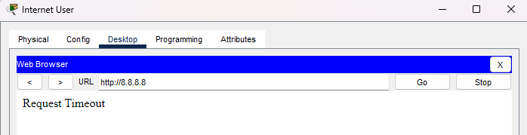

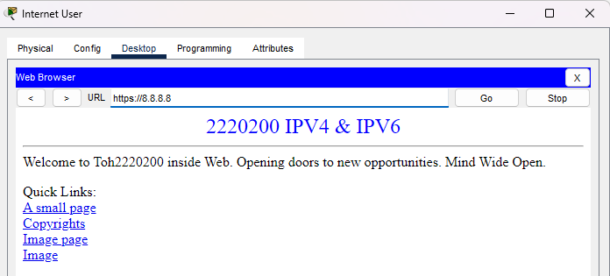

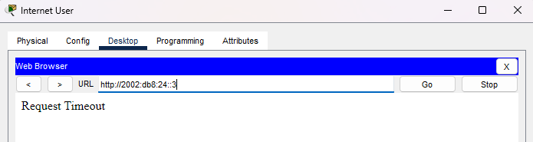

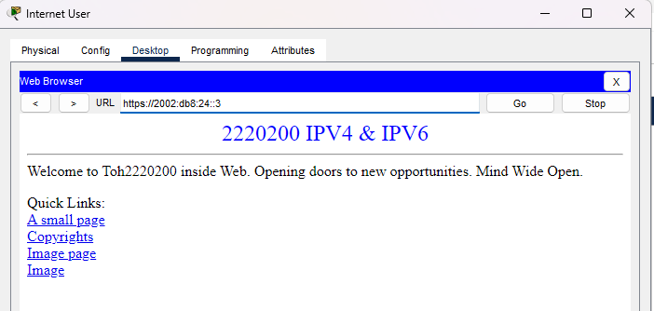

After ACL intranet user to outside Internet User & Server

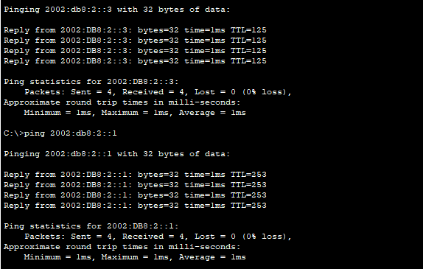

Outside website

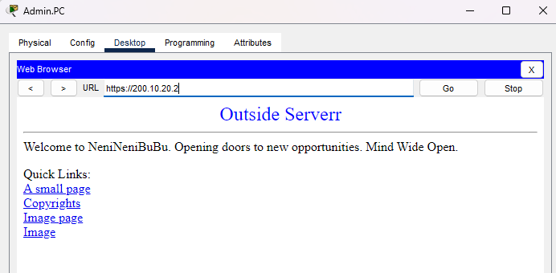

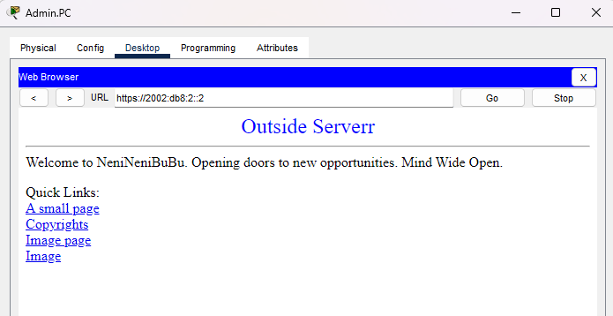

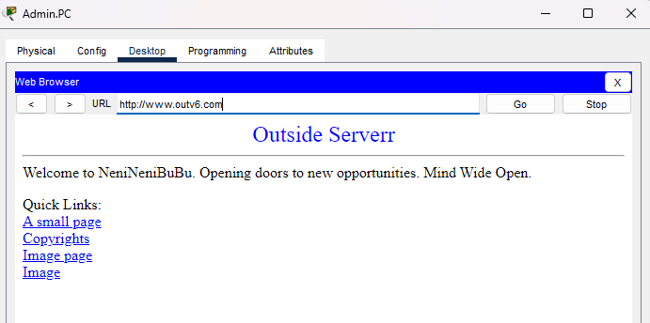

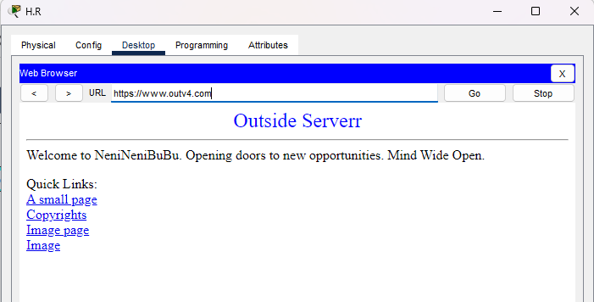

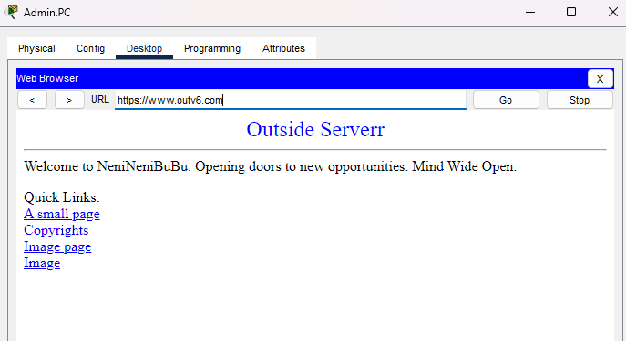

Intranet User log in Ssh control router 1 (Ipv6 & Ipv4)

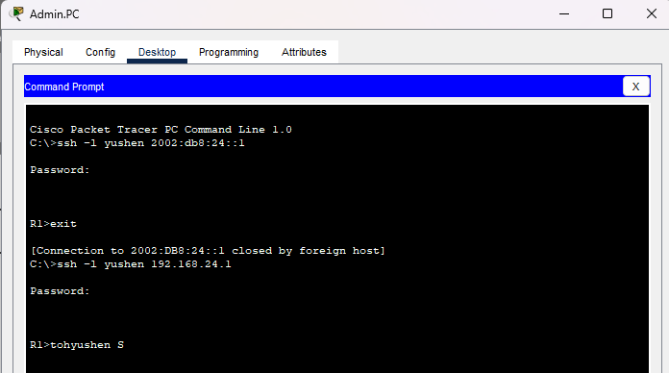

Internet User Can’t log in ssh control router 1

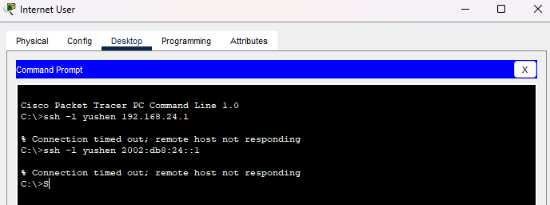

Ping outside

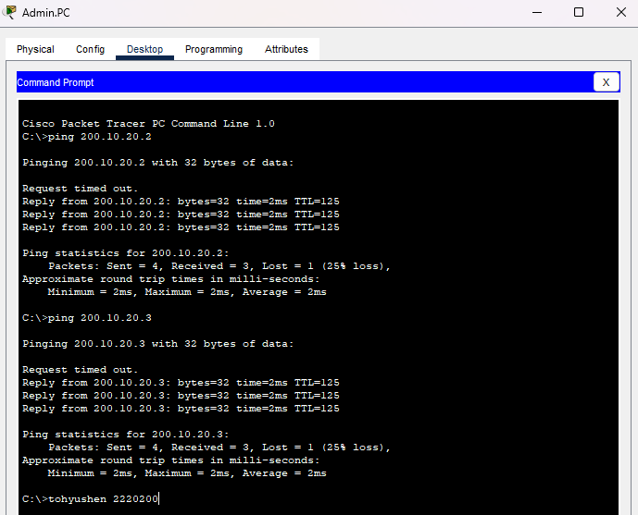

Internet can’t access ftp but intranet can

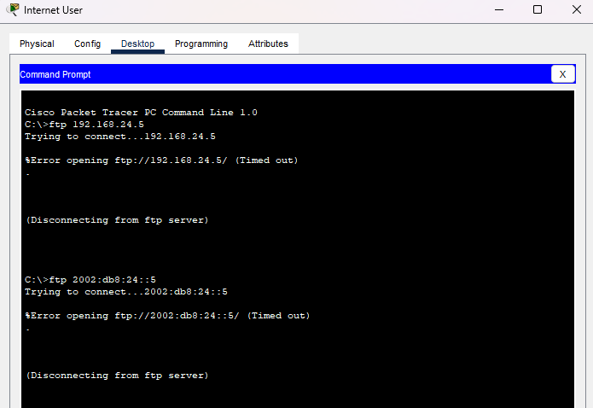

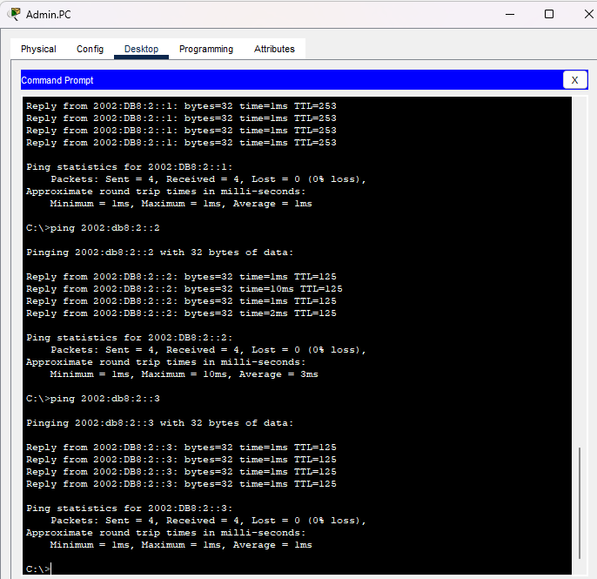

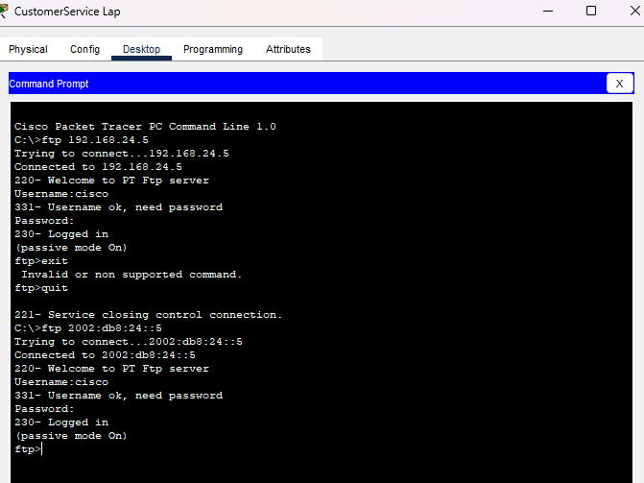

Internet ping Intranet

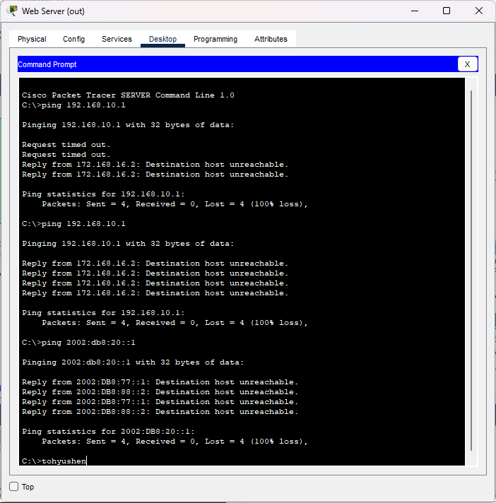

Intranet ping Internet

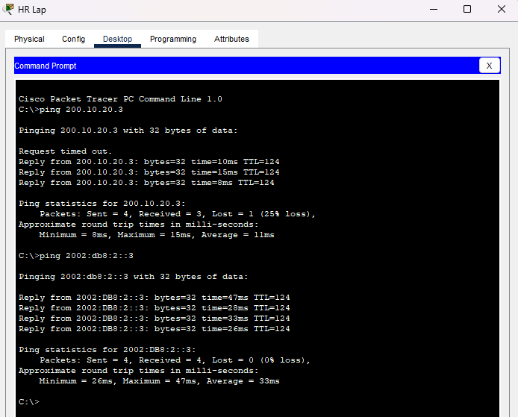

Conclusion  
Finally, by completing all the steps I have completed the network setup and set up all the devices.

I did ssh on router 1, it can only be accessed by people on the intranet, the extranet cannot access any address on the intranet except the private address of the web server nat, which can be converted to a public address and the extranet can only access the public address of the web server on the intranet.

In this project I learned how to use cisco packet tracer virtual TCP/IP to make a small company, also learned how to use IPV4 & IPV6 at the same time can coexist and use, also learned the original private address can also be converted to public address through nat.