
Requirement & Design Specification
HotelHub Management System
GROUP ____
Class: ____________
Lê Trần Trọng Đạt - HE 194235
Lê Đức Anh - ____________
______________________ - ____________
______________________ - ____________
______________________ - ____________
Lecturer : ______________________
Version: 2.0
– Hanoi, November 2026 –

Record of Changes
Date | A* M, D | In charge | Change Description
10/11/2026 | A | DatLTT | Version 2.0 rebuilt from the System Design and Overall Architecture document
10/11/2026 | A | DatLTT | I. Overview: context diagram, actors, use case diagrams and descriptions, overall functionalities
10/11/2026 | A | DatLTT | II. Functional Requirements: 20 use case specifications with class and sequence diagrams
10/11/2026 | A | DatLTT | III. System Design: architecture, package diagram, database design, state diagrams
*A - Added, M - Modified, D - Deleted

Contents
I. Overview 5
1. Context Diagram 5
2. User Requirements 5
2.1 Introduction 5
2.2 Actors 6
2.3 Use Case Diagram(s) 7
3. Overall Functionalities 20
3.1 Screens Flow 20
3.2 Screen Descriptions 20
3.3 Screen Authorization 22
3.4 Non-UI Functions 23
II. Functional Requirements 24
1. Inventory & Pricing 24
1.1 UC-M09 Update Room Info 24
1.2 UC-R13 Update Room Status 27
1.3 UC-M20 Create Promotion Code 30
1.4 UC-G11 Apply Discount Code / Voucher 33
2. Auth & Administration 36
2.1 UC-G17 Login 36
2.2 UC-G16 Register Account 40
2.3 UC-C03 Reset Forgotten Password 43
2.4 UC-A06 Assign Role to Account 46
3. Booking & Customer 50
3.1 UC-G01 Search Available Rooms 50
3.2 UC-G07 Book Room 54
3.3 UC-G14 Cancel Booking 59
3.4 UC-G13 Check Booking Status 63
4. Billing & Payment 66
4.1 UC-G10 Pay for Booking 66
4.2 UC-R15 Process Payment 70
4.3 UC-C17 Request Refund 74
4.4 UC-M14 Approve Refund Request 78
5. Front Desk & HR 81
5.1 UC-R06 Check In Guest 81
5.2 UC-R09 Check Out Guest 85
5.3 UC-E15 Submit Leave Request 89
5.4 UC-M06 Approve / Reject Leave Request 92
III. System Design 97
1. Architecture 97
1.1 Architectural Style 97
1.2 Layered Architecture 98
1.3 Subsystem Decomposition 99
1.4 Package Diagram 100
1.5 Deployment 101
2. Database Design 101
2.1 Class Diagrams 101
2.2 Collection Descriptions 106
2.3 State Diagrams 108

I. Overview

1. Context Diagram
The context diagram shows the HotelHub Management System as a single aggregate class surrounded by the external users and external systems it communicates with: the six human actors, the payOS payment gateway and the email / SMS provider.
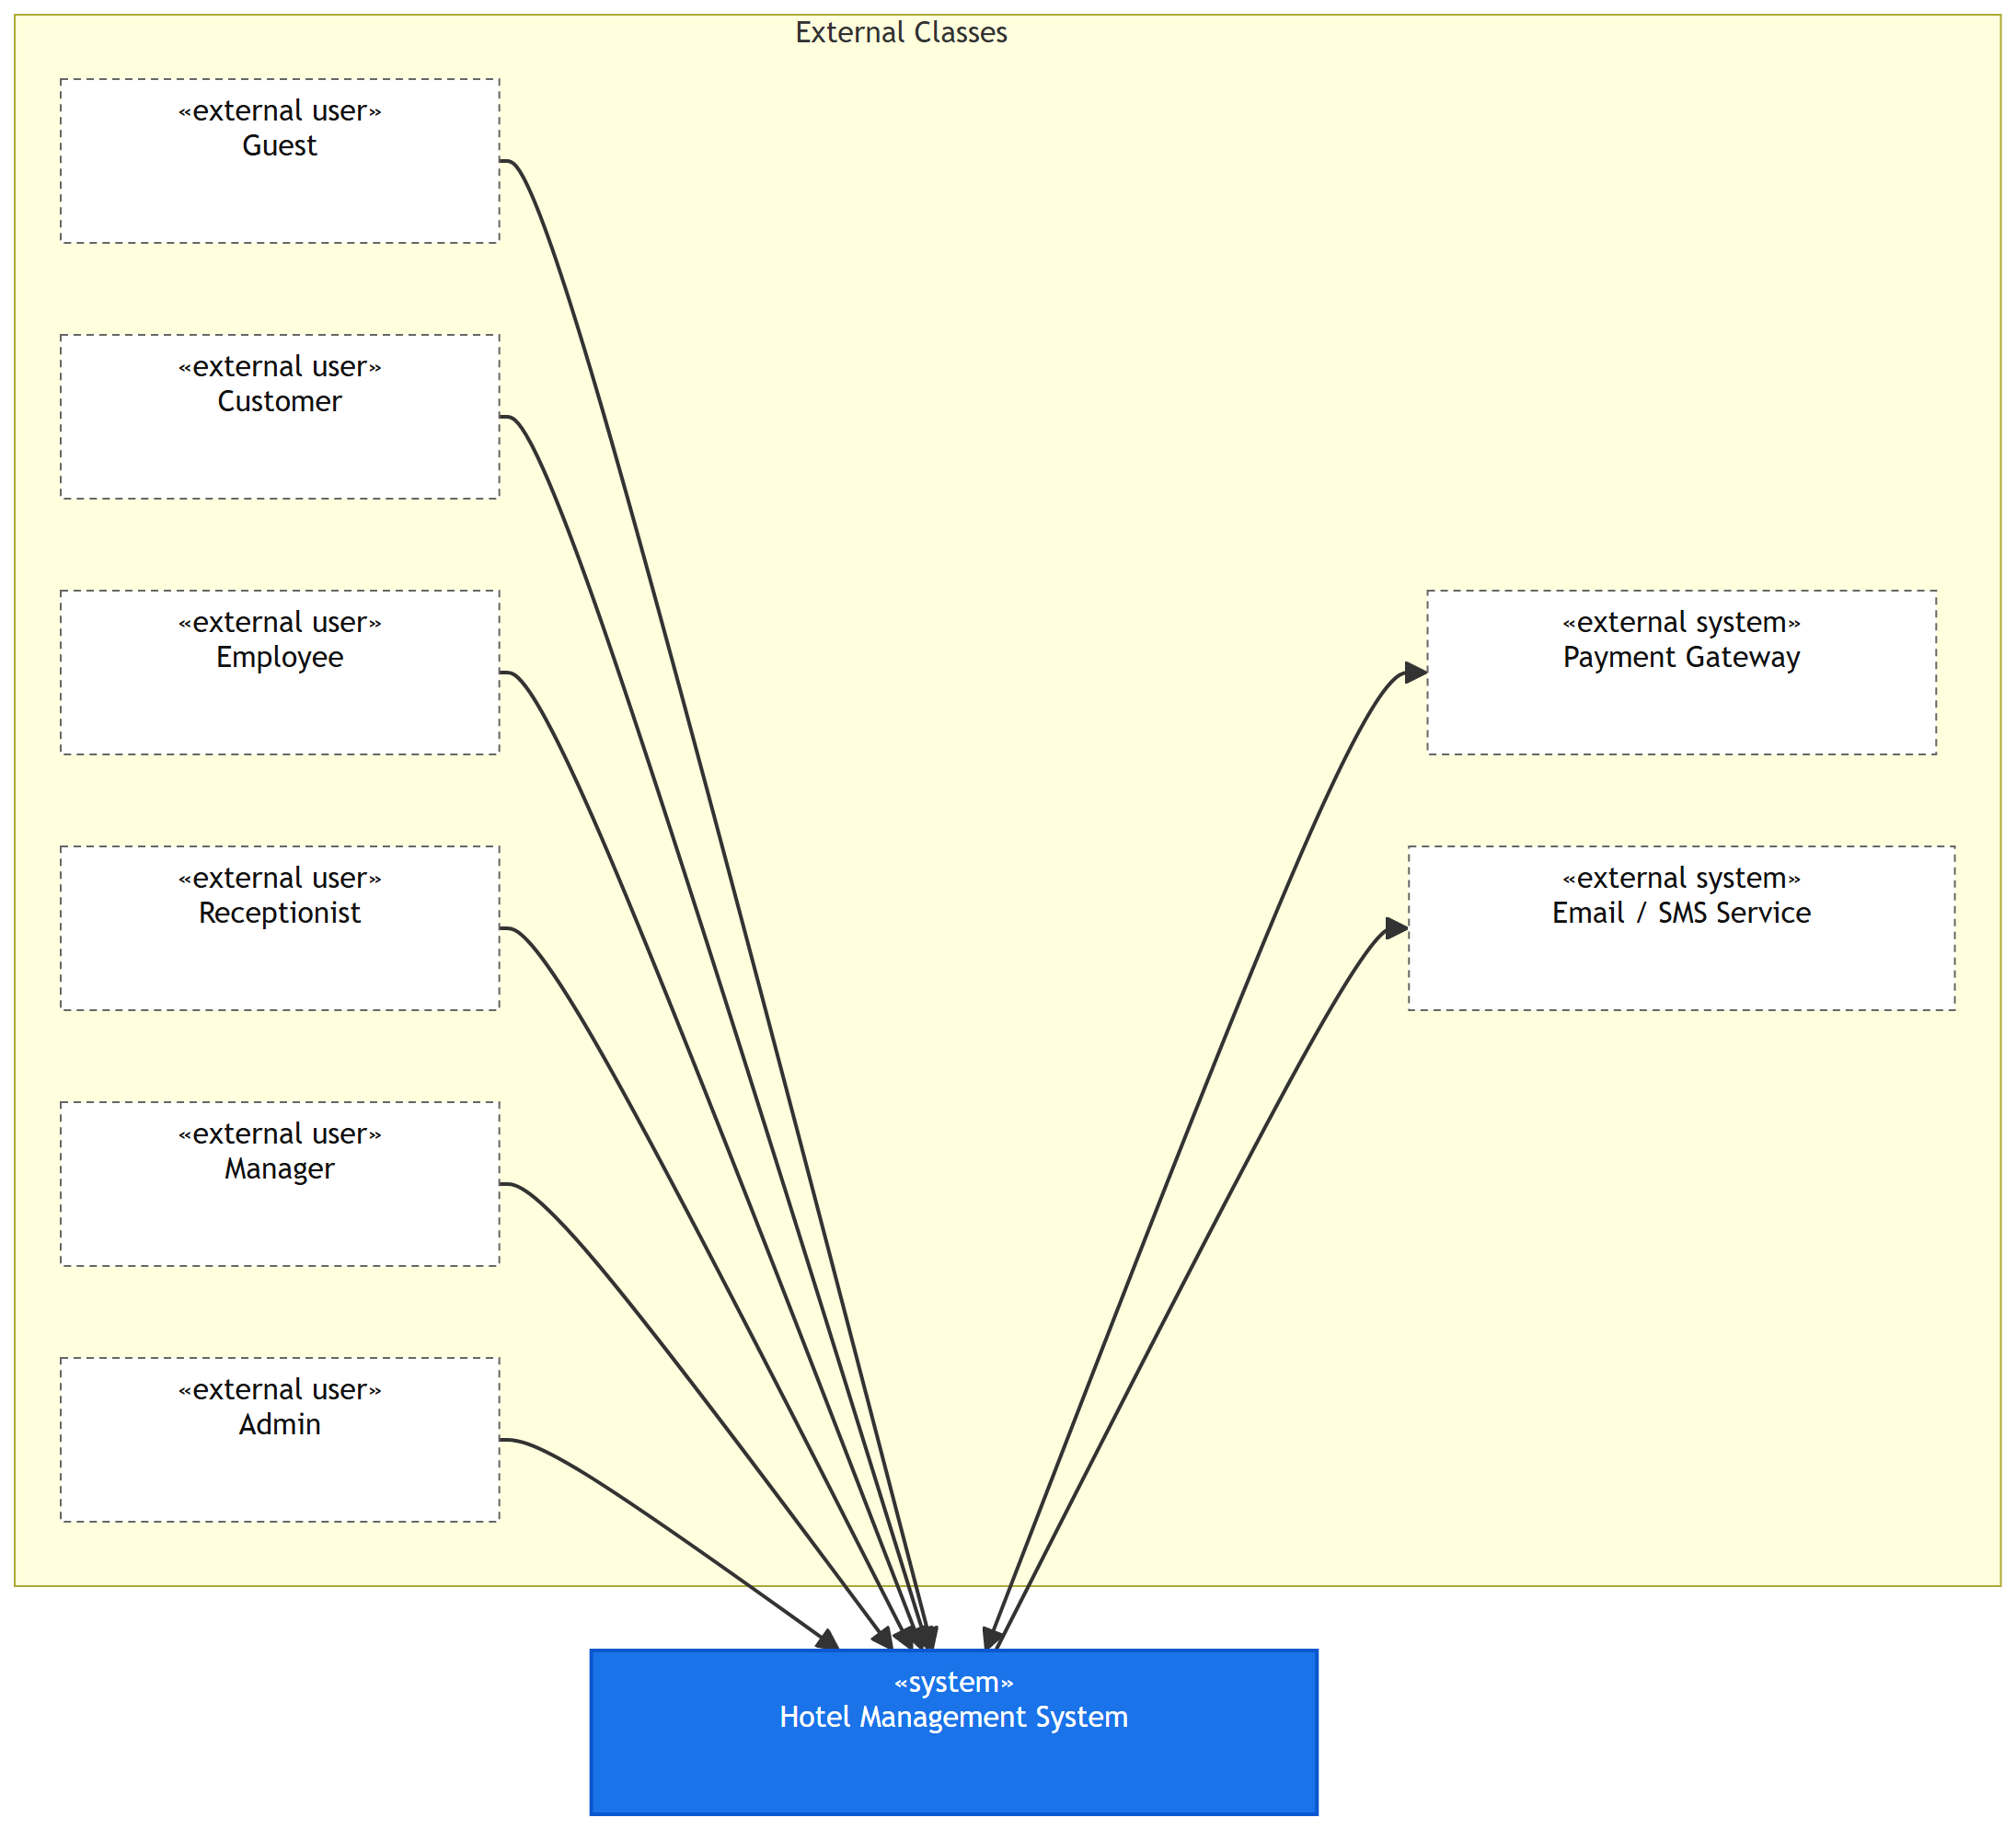
Figure 1.1 Context Diagram

2. User Requirements

2.1 Introduction
HotelHub is a hotel management system that covers the complete hotel operation lifecycle: public room search and online booking with payment, the front office (check-in, check-out, room status, folios and payments), customer self-service, human resources (attendance, leave, payroll), management (approvals, room inventory, pricing and promotion codes, reports) and administration (accounts, roles, configuration and audit). This document specifies the requirements of the system and the design of the twenty use cases selected for detailed design.
Domain | Coverage
Sales channel | Public room search, online booking, payment, voucher, confirmation
Front office | Walk-in booking, check-in / check-out, room assignment, invoicing, refunds
Customer self-service | Profile, booking history, invoices, reviews, loyalty points
Human resources | Attendance, shift scheduling, leave, payroll, task assignment
Management | Salary structure, approvals, room inventory, pricing, promotions, reporting
Administration | Accounts, roles & permissions, system configuration, audit, backup

Layer | Technology
Client | React 18 + TypeScript + Vite, React Router, TanStack Query, Axios
Server | Node.js + Express + TypeScript
Data | MongoDB + Mongoose ODM
Authentication | JWT access + refresh token, bcrypt password hashing, RBAC middleware
Integration | Payment gateway payOS (VietQR / bank transfer), Email / SMS provider

2.2 Actors
ID | Actor | Description
1 | Guest | An unregistered visitor. Can browse rooms, services, policies, reviews and promotions; can book a room and pay without an account; can register or log in.
2 | Customer | A registered guest. Generalizes Guest: inherits every Guest capability and adds profile, booking history, invoices, reviews and loyalty features.
3 | Employee | Any hotel staff member with an account. Base actor for internal self-service: attendance, schedule, leave, payslip, tasks.
4 | Receptionist | Front-desk staff. Generalizes Employee. Handles walk-in bookings, check-in/out, room status and payments.
5 | Manager | Department / hotel manager. Generalizes Employee. Approves HR and refund requests, manages inventory, pricing and promotions, views reports.
6 | Admin | System administrator. Generalizes Employee. Manages accounts, roles, system configuration, audit and backup.
7 | payOS (Payment Gateway) | Secondary, external system. Creates VietQR / bank-transfer payment links, confirms payments by signed webhook and processes refunds.
8 | Email / SMS Service | Secondary, external system. Delivers confirmations, one-time codes and notifications.

2.3 Use Case Diagram(s)

a. UCs for Guest
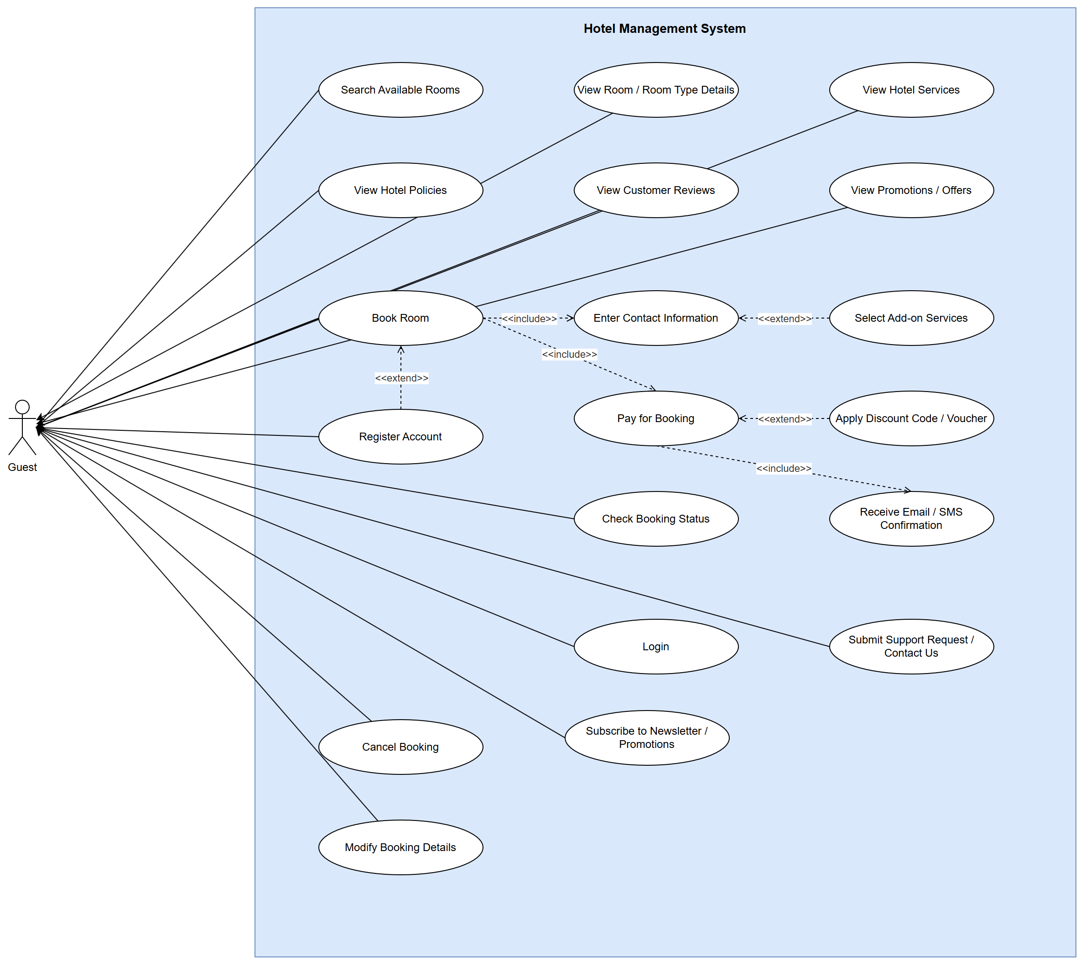
Figure 1.2 Use Case Diagram - Guest

b. UCs for Customer
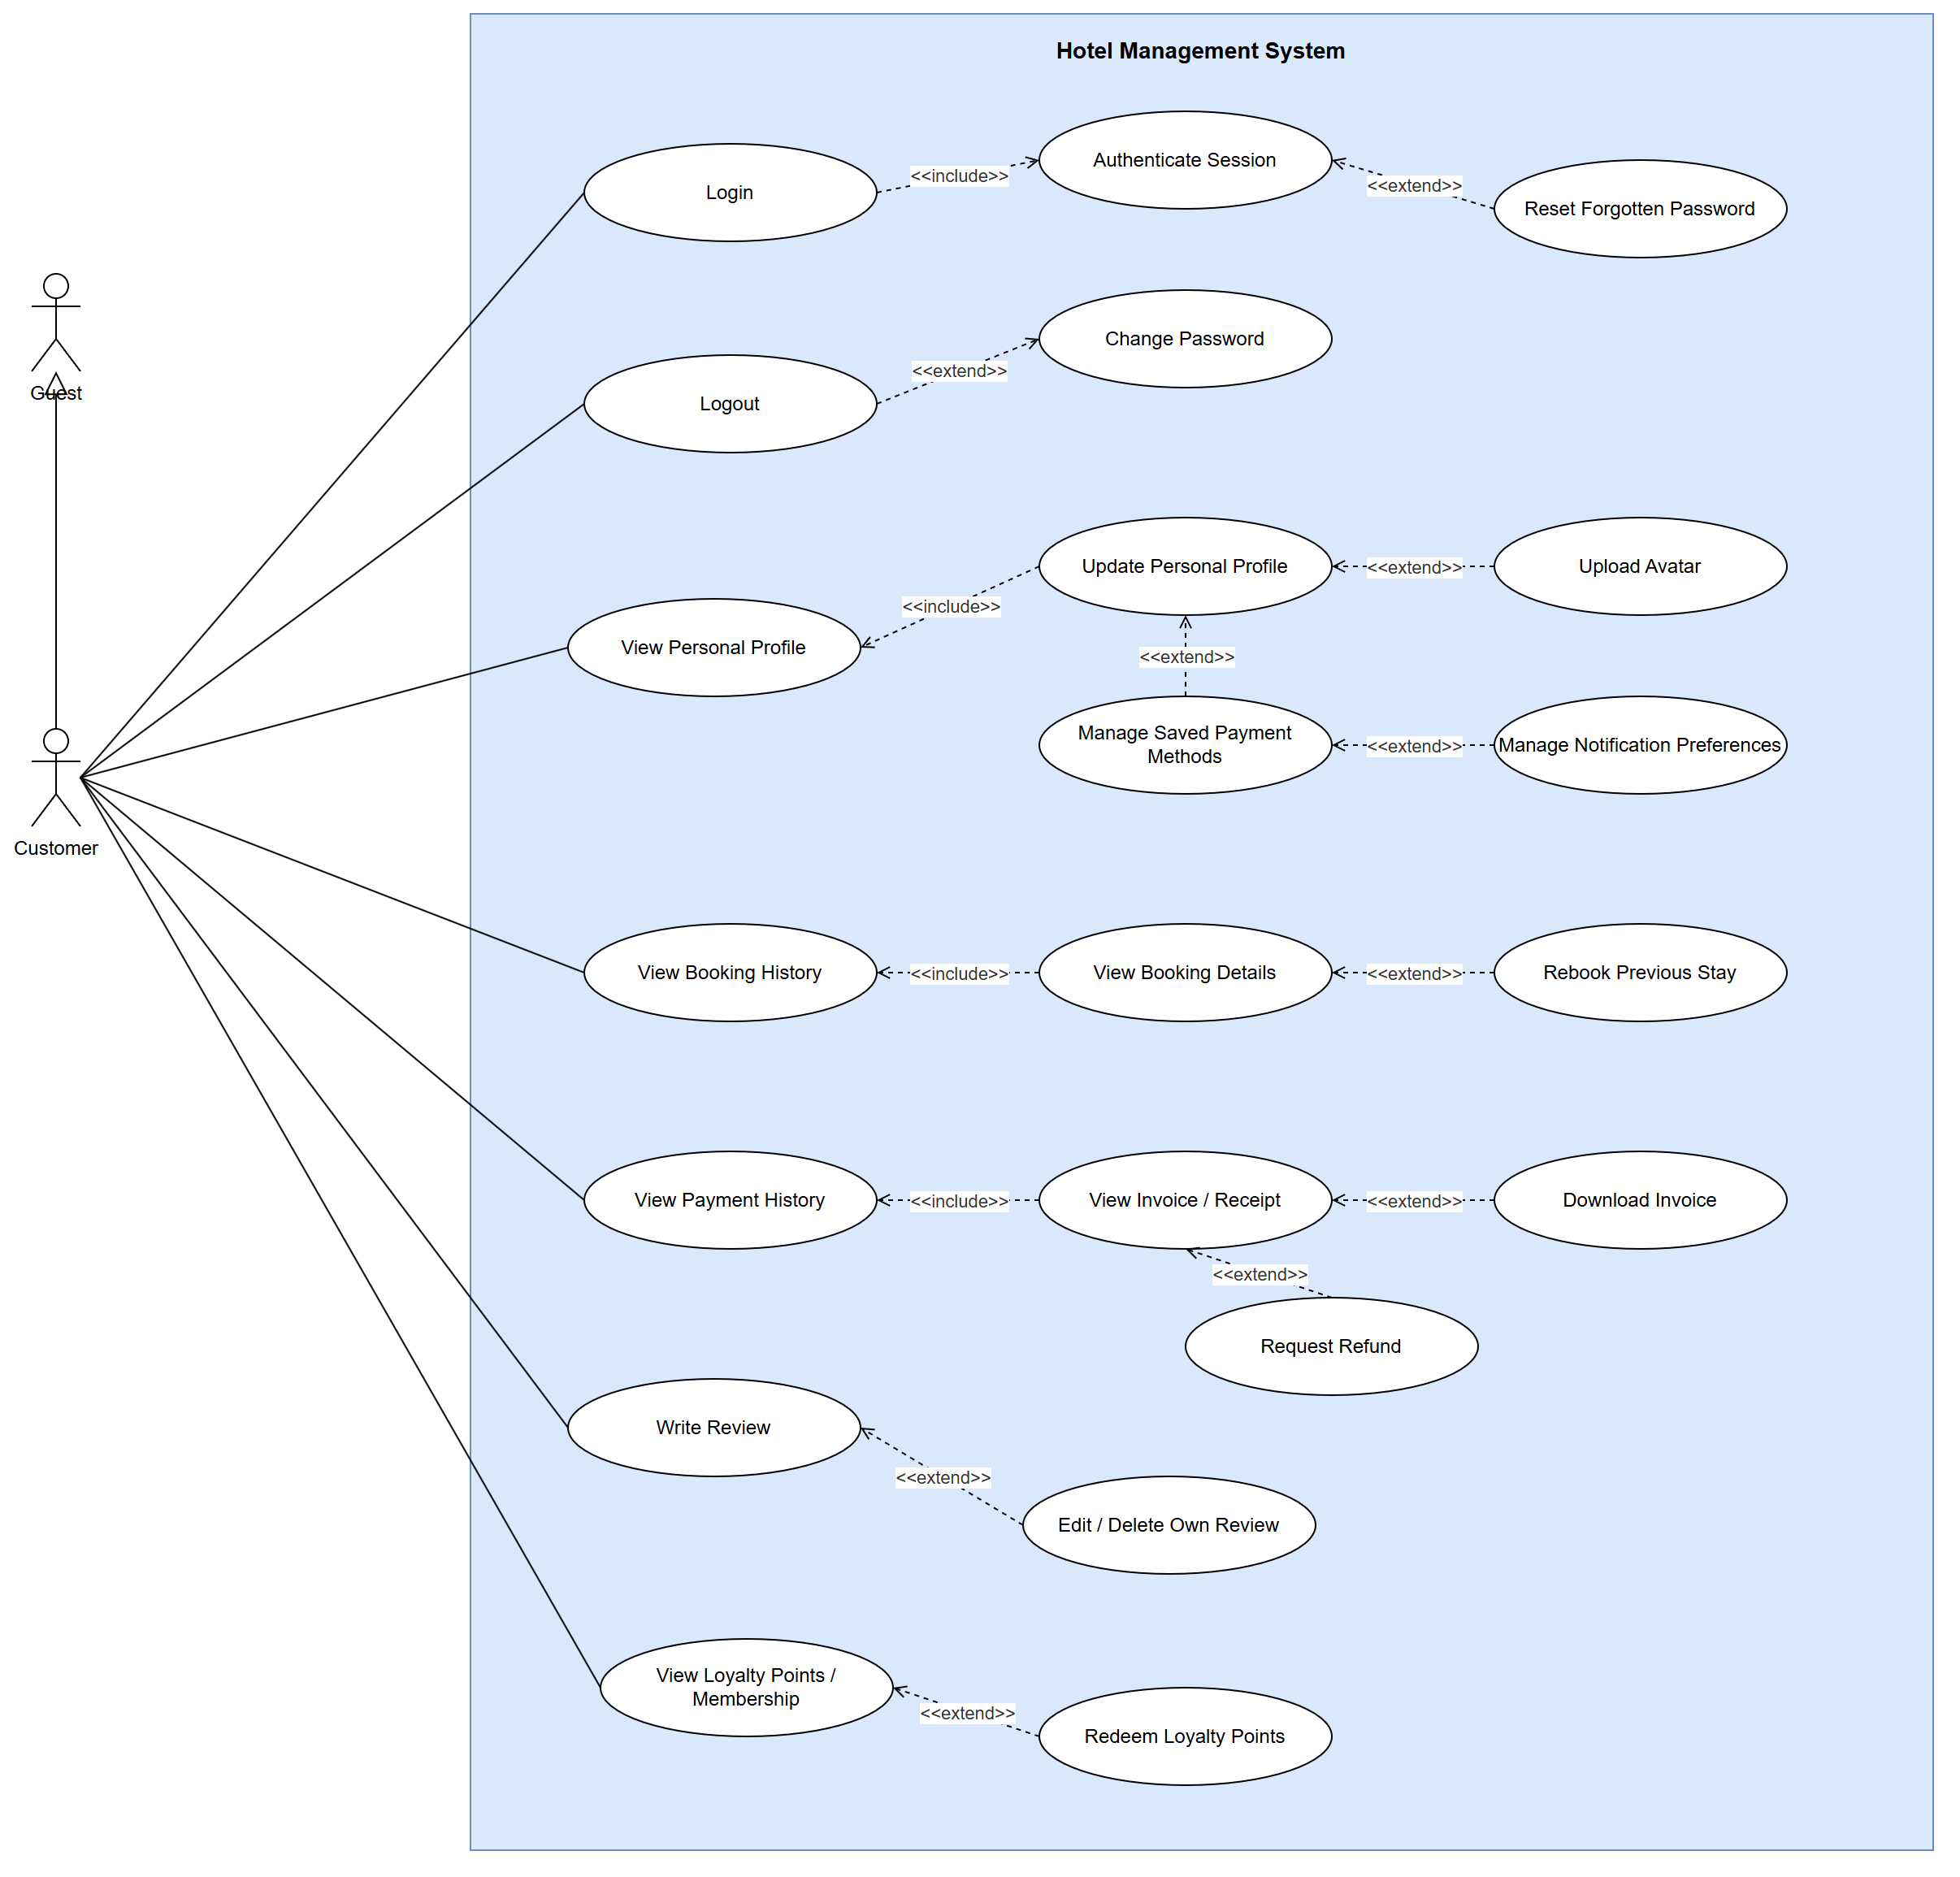
Figure 1.3 Use Case Diagram - Customer

c. UCs for Employee
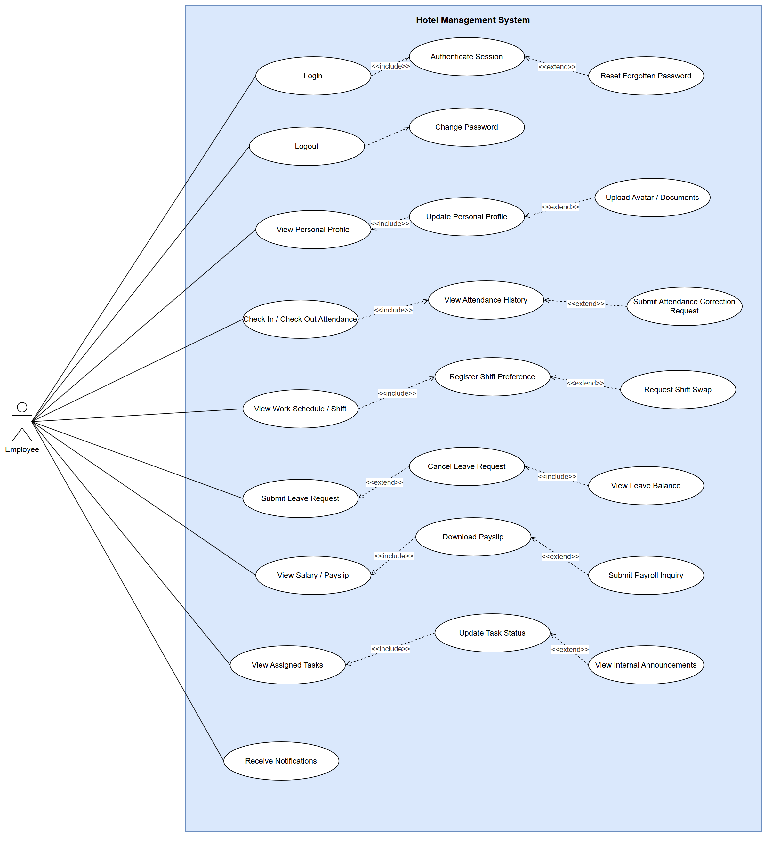
Figure 1.4 Use Case Diagram - Employee

d. UCs for Receptionist
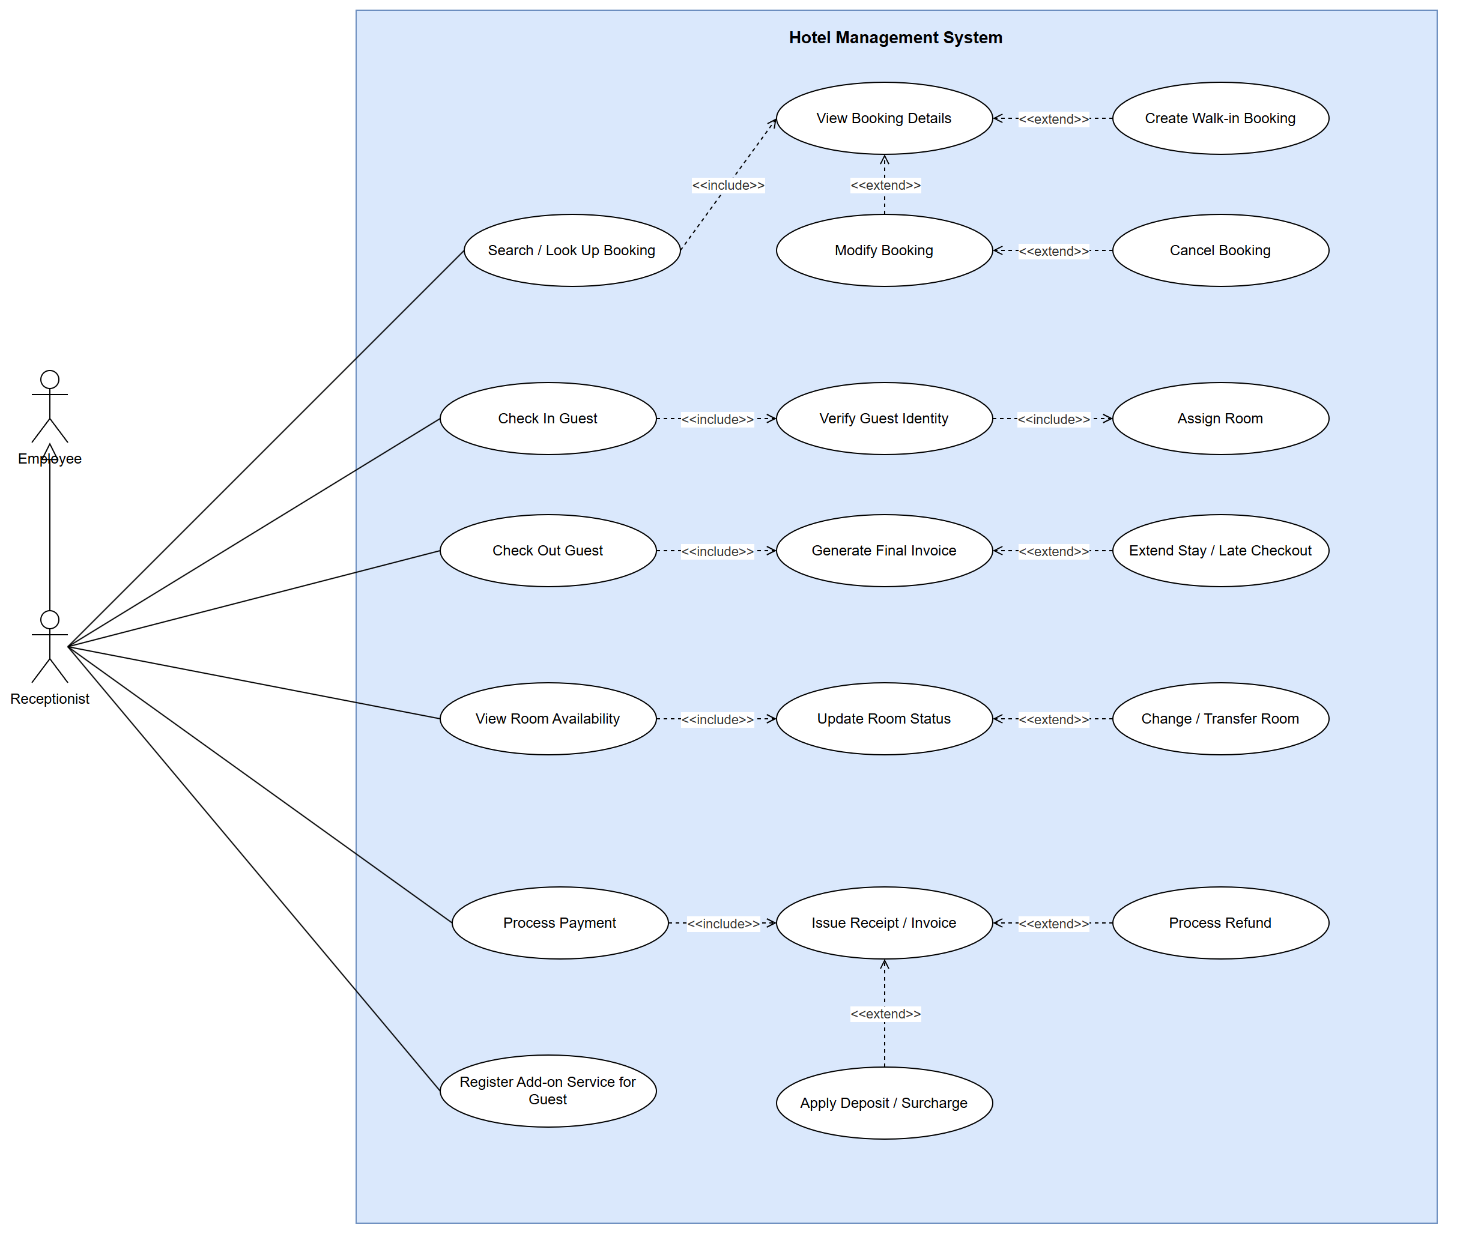
Figure 1.5 Use Case Diagram - Receptionist

e. UCs for Manager
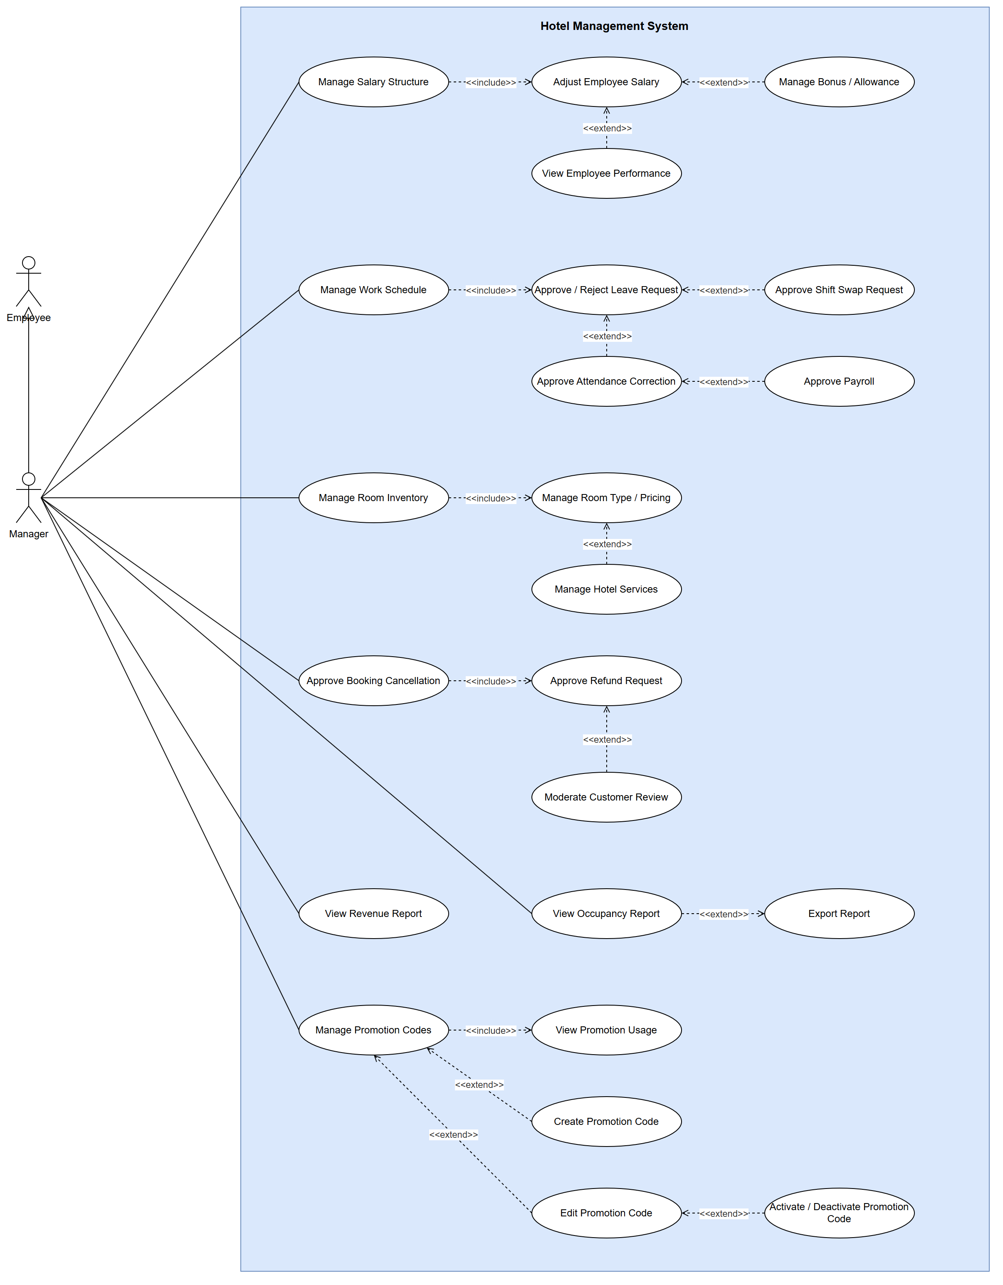
Figure 1.6 Use Case Diagram - Manager

f. UCs for Admin
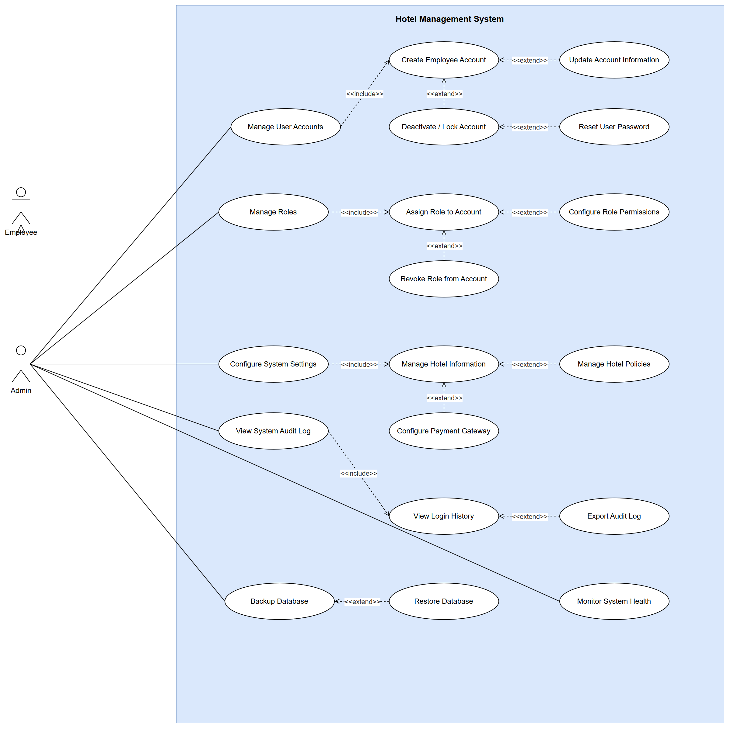
Figure 1.7 Use Case Diagram - Admin

g. Descriptions
ID | Feature | Author | Use Case | Description
UC-G01 | Booking & Reservation | Lê Đức Anh | Search Available Rooms | Search rooms by date range, occupancy, room type and price.
UC-G02 | Booking & Reservation |  | View Room / Room Type Details | View photos, amenities, capacity and rate of a room type.
UC-G03 | Inventory & Pricing |  | View Hotel Services | Browse spa, restaurant, shuttle and other add-on services.
UC-G04 | Administration & Audit |  | View Hotel Policies | Read check-in/out times, cancellation, pet and smoking policies.
UC-G05 | Customer & Loyalty |  | View Customer Reviews | Read published reviews and aggregate rating.
UC-G06 | Inventory & Pricing |  | View Promotions / Offers | See the promotion codes the hotel lists publicly, with their terms (private codes are never listed).
UC-G07 | Booking & Reservation | Lê Đức Anh | Book Room | Reserve one or more rooms (up to 5, any mix of types) for the same dates in one payment.
UC-G08 | Booking & Reservation |  | Enter Contact Information | Supply guest name, email, phone and special requests.
UC-G09 | Booking & Reservation |  | Select Add-on Services | Add breakfast, airport pickup, spa to the booking.
UC-G10 | Billing & Payment |  | Pay for Booking | Pay deposit or full amount via the payment gateway.
UC-G11 | Inventory & Pricing | Lê Trần Trọng Đạt | Apply Discount Code / Voucher | Enter a promotion code; the system checks it and shows the discount and new total before payment.
UC-G12 | Booking & Reservation |  | Receive Email / SMS Confirmation | Receive booking confirmation with reference code.
UC-G13 | Booking & Reservation | Lê Đức Anh | Check Booking Status | Look up a reservation by code and email.
UC-G14 | Booking & Reservation | Lê Đức Anh | Cancel Booking | Cancel a reservation subject to the cancellation policy.
UC-G15 | Booking & Reservation |  | Modify Booking Details | Change dates, occupancy or room type of a reservation.
UC-G16 | Auth & Identity |  | Register Account | Create a customer account, becoming a Customer.
UC-G17 | Auth & Identity |  | Login | Authenticate with username and password.
UC-G18 | Customer & Loyalty |  | Submit Support Request / Contact Us | Send an inquiry or complaint to the hotel.
UC-G19 | Customer & Loyalty |  | Subscribe to Newsletter / Promotions | Opt in to marketing email/SMS.
UC-C01 | Auth & Identity |  | Login | Authenticate and open a session.
UC-C02 | Auth & Identity |  | Authenticate Session | Validate credentials and issue access/refresh tokens.
UC-C03 | Auth & Identity |  | Reset Forgotten Password | Request an OTP by email/SMS and set a new password.
UC-C04 | Auth & Identity |  | Logout | Terminate the session and revoke the refresh token.
UC-C05 | Auth & Identity |  | Change Password | Replace the current password with a new one.
UC-C06 | Customer & Loyalty |  | View Personal Profile | Display stored personal information.
UC-C07 | Customer & Loyalty |  | Update Personal Profile | Edit name, phone, address, date of birth.
UC-C08 | Customer & Loyalty |  | Upload Avatar | Upload a profile picture.
UC-C09 | Customer & Loyalty |  | Manage Saved Payment Methods | Add or remove tokenized cards.
UC-C10 | Customer & Loyalty |  | Manage Notification Preferences | Choose which notifications to receive and by which channel.
UC-C11 | Booking & Reservation |  | View Booking History | List all past and upcoming reservations.
UC-C12 | Booking & Reservation |  | View Booking Details | Show full detail of one reservation.
UC-C13 | Booking & Reservation |  | Rebook Previous Stay | Create a new booking pre-filled from a past stay.
UC-C14 | Billing & Payment |  | View Payment History | List all payment transactions.
UC-C15 | Billing & Payment |  | View Invoice / Receipt | Display the invoice for a stay.
UC-C16 | Billing & Payment |  | Download Invoice | Export the invoice as PDF.
UC-C17 | Billing & Payment |  | Request Refund | Submit a refund request for a cancelled or disputed charge.
UC-C18 | Customer & Loyalty |  | Write Review | Publish a rating and comment for a completed stay.
UC-C19 | Customer & Loyalty |  | Edit / Delete Own Review | Modify or remove a previously published review.
UC-C20 | Customer & Loyalty |  | View Loyalty Points / Membership | Show point balance and membership tier.
UC-C21 | Customer & Loyalty |  | Redeem Loyalty Points | Convert points into a discount voucher.
UC-E01 | Auth & Identity |  | Login | Staff authentication into the internal portal.
UC-E02 | Auth & Identity |  | Authenticate Session | Validate staff credentials, issue tokens with role claims.
UC-E03 | Auth & Identity |  | Reset Forgotten Password | OTP-based staff password reset.
UC-E04 | Auth & Identity |  | Logout | End the staff session.
UC-E05 | Auth & Identity |  | Change Password | Staff-initiated password change.
UC-E06 | HR & Payroll |  | View Personal Profile | View own employee record.
UC-E07 | HR & Payroll |  | Update Personal Profile | Edit own contact details.
UC-E08 | HR & Payroll |  | Upload Avatar / Documents | Upload photo, ID scan, certificates.
UC-E09 | HR & Payroll |  | Check In / Check Out Attendance | Record shift start and end times.
UC-E10 | HR & Payroll |  | View Attendance History | List attendance records for a period.
UC-E11 | HR & Payroll |  | Submit Attendance Correction Request | Request correction of a wrong attendance record.
UC-E12 | HR & Payroll |  | View Work Schedule / Shift | View the assigned shift roster.
UC-E13 | HR & Payroll |  | Register Shift Preference | Declare preferred shifts for the next period.
UC-E14 | HR & Payroll |  | Request Shift Swap | Ask a colleague to exchange shifts.
UC-E15 | HR & Payroll |  | Submit Leave Request | Apply for annual, sick or unpaid leave.
UC-E16 | HR & Payroll |  | Cancel Leave Request | Withdraw a pending leave request.
UC-E17 | HR & Payroll |  | View Leave Balance | Show remaining leave days by type.
UC-E18 | HR & Payroll |  | View Salary / Payslip | View monthly payslip breakdown.
UC-E19 | HR & Payroll |  | Download Payslip | Export the payslip as PDF.
UC-E20 | HR & Payroll |  | Submit Payroll Inquiry | Raise a question about a payslip item.
UC-E21 | HR & Payroll |  | View Assigned Tasks | List housekeeping/maintenance tasks assigned.
UC-E22 | HR & Payroll |  | Update Task Status | Mark a task in-progress, done or blocked.
UC-E23 | HR & Payroll |  | View Internal Announcements | Read hotel-wide announcements.
UC-E24 | HR & Payroll |  | Receive Notifications | Receive push/email alerts for assignments and approvals.
UC-R01 | Booking & Reservation |  | Search / Look Up Booking | Find a booking by code, guest name, phone or date.
UC-R02 | Booking & Reservation |  | View Booking Details | Show full reservation, guest and charge detail.
UC-R03 | Booking & Reservation |  | Create Walk-in Booking | Create a reservation for a guest at the desk.
UC-R04 | Booking & Reservation |  | Modify Booking | Change dates, room type or occupancy at the desk.
UC-R05 | Booking & Reservation |  | Cancel Booking | Cancel a reservation and compute the penalty.
UC-R06 | Front Desk Operations |  | Check In Guest | Admit an arriving guest and activate the stay.
UC-R07 | Front Desk Operations |  | Verify Guest Identity | Validate passport/ID against the reservation.
UC-R08 | Front Desk Operations |  | Assign Room | Allocate a specific vacant-clean room.
UC-R09 | Front Desk Operations |  | Check Out Guest | Settle the folio and release the room.
UC-R10 | Front Desk Operations |  | Generate Final Invoice | Produce the final folio with all charges and taxes.
UC-R11 | Front Desk Operations |  | Extend Stay / Late Checkout | Prolong the stay or grant late checkout with surcharge.
UC-R12 | Front Desk Operations |  | View Room Availability | Show the room rack by status and date.
UC-R13 | Front Desk Operations | Lê Trần Trọng Đạt | Update Room Status | Set room to clean, dirty, inspected or out-of-order.
UC-R14 | Front Desk Operations |  | Change / Transfer Room | Move an in-house guest to another room.
UC-R15 | Billing & Payment |  | Process Payment | Take cash or card payment against a folio.
UC-R16 | Billing & Payment |  | Issue Receipt / Invoice | Print or email the payment receipt.
UC-R17 | Billing & Payment |  | Process Refund | Return money for a cancellation or overcharge.
UC-R18 | Billing & Payment |  | Apply Deposit / Surcharge | Charge a security deposit or an incidental surcharge.
UC-R19 | Front Desk Operations |  | Register Add-on Service for Guest | Post a spa/restaurant/laundry charge to the folio.
UC-M01 | HR & Payroll |  | Manage Salary Structure | Define pay grades, base salary bands and allowance rules.
UC-M02 | HR & Payroll |  | Adjust Employee Salary | Change an individual employee's salary with effective date.
UC-M03 | HR & Payroll |  | Manage Bonus / Allowance | Grant performance bonus or position allowance.
UC-M04 | HR & Payroll |  | View Employee Performance | Review KPI, attendance rate and task completion.
UC-M05 | HR & Payroll |  | Manage Work Schedule | Build and publish the shift roster for a period.
UC-M06 | HR & Payroll |  | Approve / Reject Leave Request | Decide on pending leave applications.
UC-M07 | HR & Payroll |  | Approve Shift Swap Request | Authorize a shift exchange between two employees.
UC-M08 | HR & Payroll |  | Approve Attendance Correction | Accept or reject an attendance correction request.
UC-M08b | HR & Payroll |  | Approve Payroll | Lock and approve the monthly payroll run.
UC-M09 | Inventory & Pricing | Lê Trần Trọng Đạt | Manage Room Inventory | Add, retire and configure physical rooms.
UC-M10 | Inventory & Pricing |  | Manage Room Type / Pricing | Define room types, base rates and seasonal pricing.
UC-M11 | Inventory & Pricing |  | Manage Promotion Codes | List every promotion code with its status and usage; entry point to create, edit and switch codes on or off.
UC-M12 | Inventory & Pricing |  | Manage Hotel Services | Configure add-on services and their prices.
UC-M13 | Billing & Payment |  | Approve Booking Cancellation | Authorize cancellations that exceed policy limits.
UC-M14 | Billing & Payment |  | Approve Refund Request | Approve or reject a customer refund request.
UC-M15 | Customer & Loyalty |  | Moderate Customer Review | Publish, hide or reply to a customer review.
UC-M16 | Reporting & Analytics |  | View Revenue Report | Revenue by period, channel, room type; ADR and RevPAR.
UC-M17 | Reporting & Analytics |  | View Occupancy Report | Occupancy rate, arrivals, departures, forecast.
UC-M18 | Reporting & Analytics |  | Export Report | Export a report to Excel or PDF.
UC-M19 | Inventory & Pricing |  | View Promotion Usage | Uses against the limit, reservations, rooms, discount given and revenue per code.
UC-M20 | Inventory & Pricing | Lê Trần Trọng Đạt | Create Promotion Code | Define a code: discount, validity days, usage limit, minimum spend, public or private.
UC-M21 | Inventory & Pricing |  | Edit Promotion Code | Change dates, limit, minimum spend, wording or visibility; the discount is fixed once used.
UC-M22 | Inventory & Pricing |  | Activate / Deactivate Promotion Code | Switch a code off (refused at once for new bookings) or back on.
UC-A01 | Administration & Audit |  | Manage User Accounts | Central account administration entry point.
UC-A02 | Administration & Audit |  | Create Employee Account | Provision a new staff account with initial role.
UC-A03 | Administration & Audit |  | Update Account Information | Modify account attributes and department.
UC-A04 | Administration & Audit |  | Deactivate / Lock Account | Disable an account on termination or security event.
UC-A04b | Administration & Audit |  | Reset User Password | Force-reset a user password administratively.
UC-A05 | Administration & Audit |  | Manage Roles | Define the role catalogue.
UC-A06 | Administration & Audit |  | Assign Role to Account | Grant a role to a user account.
UC-A07 | Administration & Audit |  | Configure Role Permissions | Edit the permission set of a role.
UC-A08 | Administration & Audit |  | Revoke Role from Account | Remove a role from an account.
UC-A09 | Administration & Audit |  | Configure System Settings | Global system configuration entry point.
UC-A10 | Administration & Audit |  | Manage Hotel Information | Maintain hotel name, address, contact, branding.
UC-A11 | Administration & Audit |  | Manage Hotel Policies | Edit check-in/out, cancellation and deposit policies.
UC-A12 | Administration & Audit |  | Configure Payment Gateway | Set gateway credentials, currency and modes.
UC-A13 | Administration & Audit |  | View System Audit Log | Inspect the immutable audit trail.
UC-A14 | Administration & Audit |  | View Login History | Review authentication attempts per account.
UC-A15 | Administration & Audit |  | Export Audit Log | Export audit entries for compliance.
UC-A16 | Administration & Audit |  | Backup Database | Trigger or schedule a database backup.
UC-A17 | Administration & Audit |  | Restore Database | Restore the database from a backup set.
UC-A18 | Administration & Audit |  | Monitor System Health | View uptime, error rate, queue depth, resource usage.

3. Overall Functionalities

3.1 Screens Flow
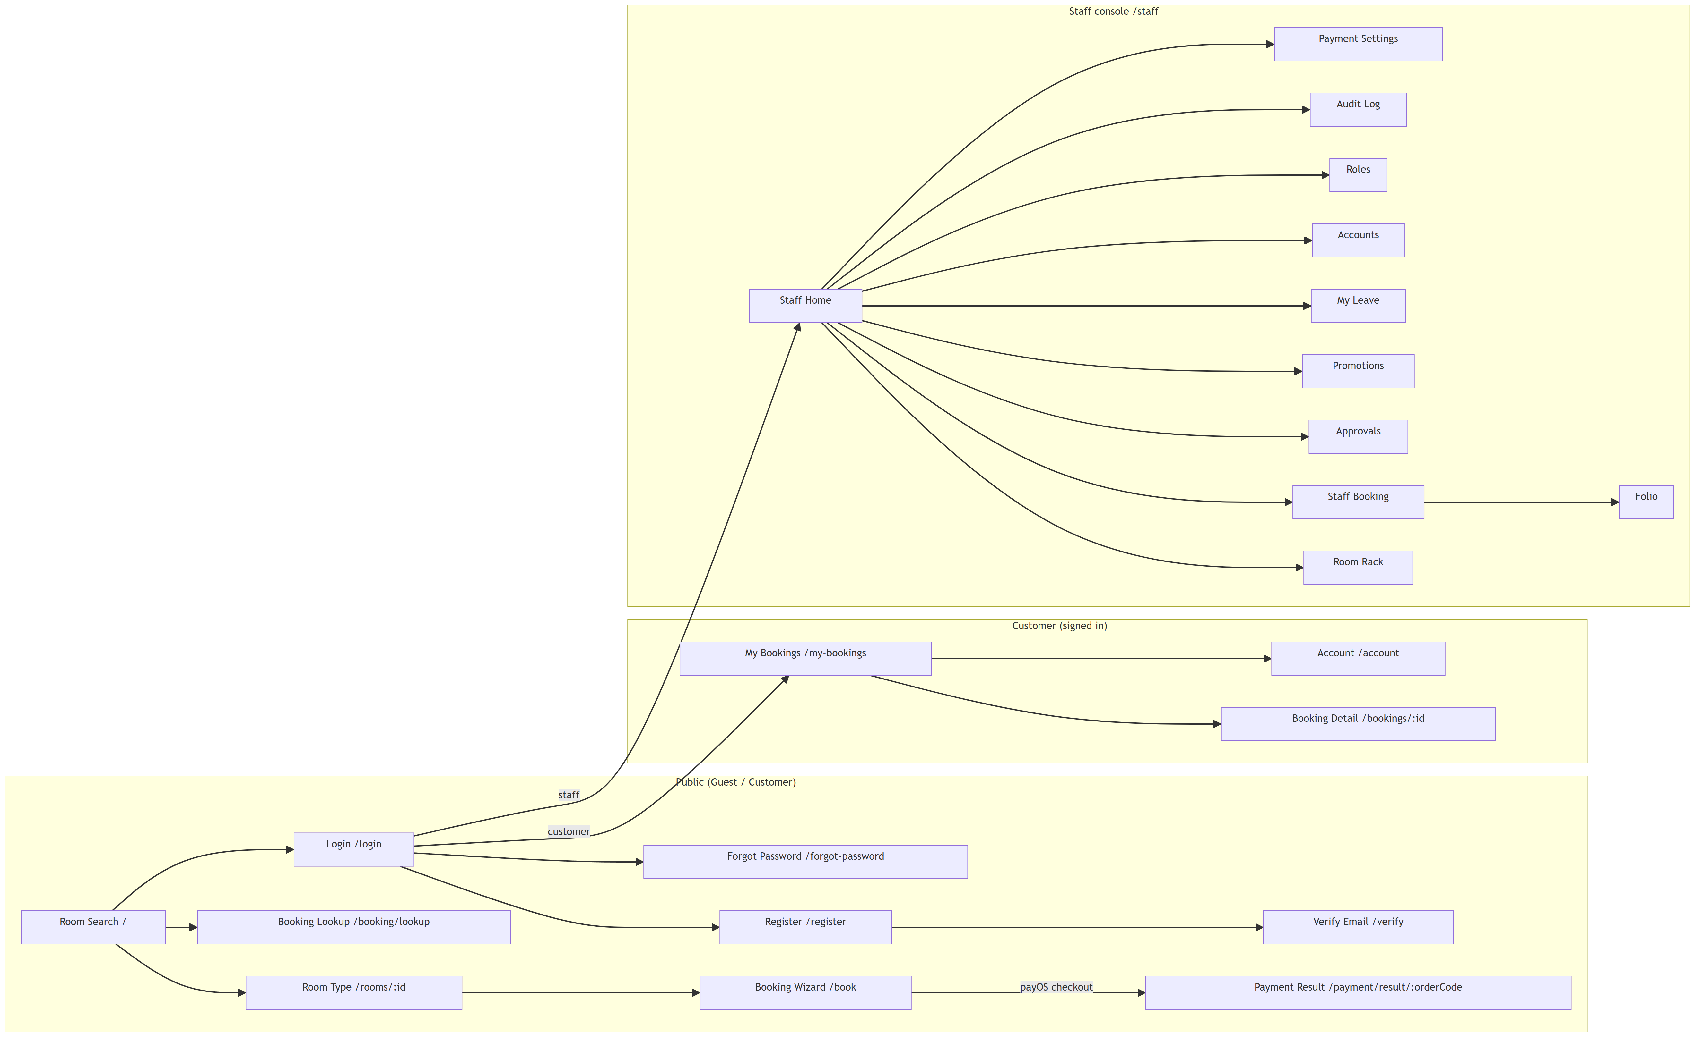
Figure 1.8 Screens Flow

3.2 Screen Descriptions
ID | Feature | Screen | Description
1 | Public | Room Search (/) | Search available room types by dates and number of guests (UC-G01).
2 | Public | Room Type Detail (/rooms/:id) | Photos, amenities, capacity and rate of a room type (UC-G02).
3 | Public | Booking Wizard (/book) | Multi-step booking of up to five rooms: rooms, guest details, add-ons, discount code and payment (UC-G07, UC-G11).
4 | Public | Payment Result (/payment/result/:orderCode) | Shows the outcome of the payOS payment and the confirmed reservation (UC-G10).
5 | Public | Booking Lookup (/booking/lookup) | Finds a reservation by booking code and email (UC-G13).
6 | Authentication | Login (/login) | Signs a user in with email and password (UC-G17).
7 | Authentication | Register (/register) | Creates a customer account (UC-G16).
8 | Authentication | Verify Email (/verify) | Activates an account from the verification link (UC-G16).
9 | Authentication | Forgot Password (/forgot-password) | Resets a password with a one-time code (UC-C03).
10 | Customer | My Bookings (/my-bookings) | Lists the customer's past and upcoming reservations (UC-C11).
11 | Customer | Booking Detail (/bookings/:id) | Booking detail with cancellation and refund request (UC-C12, UC-G14, UC-C17).
12 | Account | Account (/account, /staff/account) | Personal profile and password change (UC-C05).
13 | Front Desk | Staff Home (/staff) | Today's arrivals, in-house guests and departures.
14 | Front Desk | Room Rack (/staff/rack) | Room availability and housekeeping status board (UC-R12, UC-R13).
15 | Front Desk | Staff Booking (/staff/bookings/:id) | Booking at the desk: check-in and check-out (UC-R06, UC-R09).
16 | Front Desk | Folio (/staff/folios/:id) | Charges and payments of a stay (UC-R15, UC-R19).
17 | Management | Approvals (/staff/approvals) | Pending leave and refund decisions (UC-M06, UC-M14).
18 | Management | Promotions (/staff/promotions) | Promotion codes with usage; create, edit, switch on/off (UC-M11, UC-M19…M22).
19 | Management | Room Inventory (planned) (—) | Edit room number, floor and notes (UC-M09, designed in this document).
20 | HR | My Leave (/staff/leave) | Submit and cancel leave requests, view balance (UC-E15, UC-E16).
21 | Administration | Accounts (/staff/admin/accounts) | Staff accounts, status and role assignment (UC-A01…A08).
22 | Administration | Roles (/staff/admin/roles) | Role catalogue and permissions (UC-A05, UC-A07).
23 | Administration | Audit Log (/staff/admin/audit) | Audit trail, login history and export (UC-A13…A15).
24 | Administration | Payment Settings (/staff/admin/payments) | payOS webhook configuration (UC-A12).

3.3 Screen Authorization
Screen | Guest | Customer | Receptionist | Manager | Admin
Room Search | X | X | X | X | X
Room Type Detail | X | X | X | X | X
Booking Wizard | X | X | X | X | X
Payment Result | X | X | X | X | X
Booking Lookup | X | X | X | X | X
Login | X | X | X | X | X
Register | X | X | X | X | X
Verify Email | X | X | X | X | X
Forgot Password | X | X | X | X | X
My Bookings |  | X
Booking Detail |  | X
Account |  | X | X | X | X
Staff Home |  |  | X | X | X
Room Rack |  |  | X | X
Staff Booking |  |  | X | X
Folio |  |  | X | X
Approvals |  |  |  | X
Promotions |  |  |  | X
Room Inventory (planned) |  |  |  | X
My Leave |  |  | X | X | X
Accounts |  |  |  |  | X
Roles |  |  |  |  | X
Audit Log |  |  |  |  | X
Payment Settings |  |  |  |  | X
Access is enforced on the server by the RBAC middleware (authenticate, requirePermission) from the role permissions: Receptionist — booking, check-in/out, room status, payment and refund permissions; Manager — booking read, leave / refund / payroll approval, inventory, pricing and reports; Admin — accounts, roles, settings, audit log and backup. Receptionist, Manager and Admin also hold the Employee role.

3.4 Non-UI Functions
ID | Feature | System Function | Description
1 | Authentication | RBAC middleware | Verifies the JWT access token and the permission of every protected endpoint.
2 | Booking | HoldExpiryTimer | Releases inventory holds after 15 minutes when the booking is not paid (BR-10).
3 | Booking | AvailabilityCalculator | Computes available rooms per room type over a date range: total rooms minus overlapping bookings, blocked rooms and holds.
4 | Booking | PricingRule | Nightly seasonal rate, taxes and totals (BR-09).
5 | Booking | CancellationPolicyRule | Penalty tiers by notice period (BR-17…BR-19).
6 | Pricing | PromotionRule | Code status and whether a code applies, including minimum spend (BR-52…BR-57).
7 | Payment | payOS webhook | Receives the signed payment result, verifies the HMAC signature and confirms the reservation once.
8 | Payment | PaymentGatewayProxy | Encapsulates the payOS protocol: payment links, status lookup, refunds.
9 | Front Desk | RoomAllocator | Race-free selection of a vacant-clean room using the room version (BR-25).
10 | Front Desk | Booking / Room state machines | Allow only the legal status transitions of bookings and rooms.
11 | Billing | InvoiceNumberGenerator | Gapless sequential invoice numbers (BR-30).
12 | HR | LeavePolicyRule | Leave balance, coverage and blackout checks (BR-40…BR-44).
13 | HR | PayrollRunTimer | Triggers the monthly payroll run.
14 | Notification | NotificationProxy | Sends confirmations, one-time codes and decisions by email / SMS.
15 | Audit | AuditService | Append-only audit trail of every significant change (BR-49).

II. Functional Requirements

1. Inventory & Pricing

1.1 UC-M09 Update Room Info

1.1.1 Use Case Specification
ID UC and Name: | UC-M09 - Update Room Info
Created By: | Lê Trần Trọng Đạt | Date Created: | 10/11/2026
Primary Actor: | Manager | Secondary Actors: | None
Trigger: | The Manager opens a room in the room inventory and selects Save after editing it.
Description: | Lets a Manager correct the descriptive information of a physical room — its room number, floor and notes. The room type and the housekeeping status are not edited here: the type drives availability (UC-M10) and the status follows the room state machine (UC-R13).
Preconditions: | PRE-1: The Manager is signed in and holds the MANAGE_INVENTORY permission.  PRE-2: The room exists in the inventory.
Postconditions: | POST-1: The room is stored with the new room number, floor and notes; its version is incremented.  POST-2: Other screens show the updated information on their next refresh.
Normal Flow: | 1.0: Update room information  - The Manager opens the room inventory and selects a room.  - The system shows the room number, floor and notes with the current version.  - The Manager edits the information and selects Save.  - The system validates the request: the user is permitted, the room number is not empty and the floor is a whole number.  - The system saves the changes on the condition that the room still has the version the Manager loaded.  - The system confirms the update and shows the updated room details.
Alternative Flows: | 1.1: Cancel editing  The Manager closes the form without saving; nothing is changed.
Exceptions: | 1.0.E1 — Room number already exists  "Room number already exists." The unique index on the room number refuses the save. Return to step 3.  1.0.E2 — Room changed meanwhile  Another user changed the room after it was opened (version mismatch): "The room changed meanwhile — refresh and retry." Nothing is stored.  1.0.E3 — Invalid input  An empty room number or a non-numeric floor is refused with the field named. Return to step 3.
Priority: | High
Frequency of Use: | Occasional — when rooms are renumbered or noted for maintenance.
Business Rules: | BR-R1 A room number is unique across the hotel. BR-R2 A room's type and status are not changed through this use case.
Other Information: | Optimistic locking on the room version prevents a lost update when two users edit the same room.
Assumptions: | The room type catalogue (UC-M10) is already configured.

1.1.2 Class Diagram
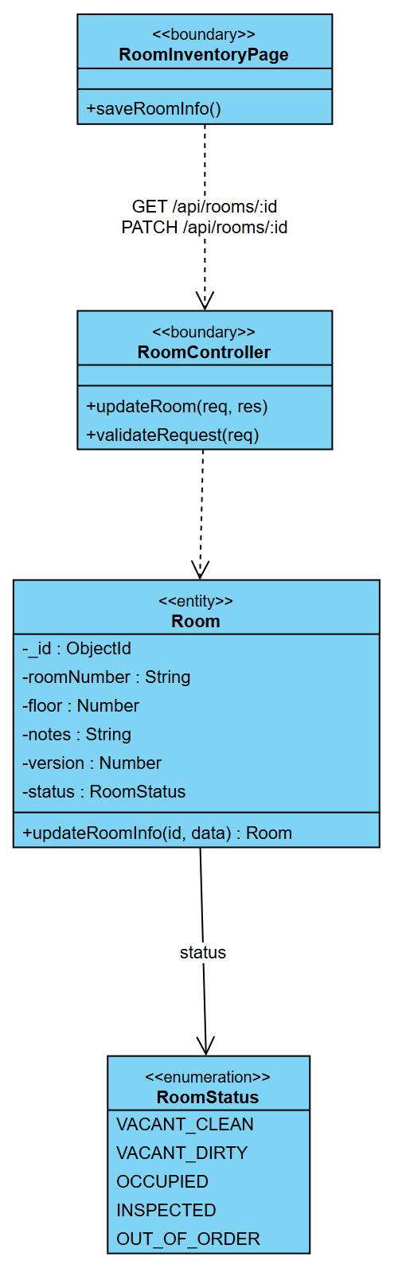
Figure 2.1 CD-01 Class Diagram - UC-M09 Update Room Info

1.1.3 Sequence Diagram
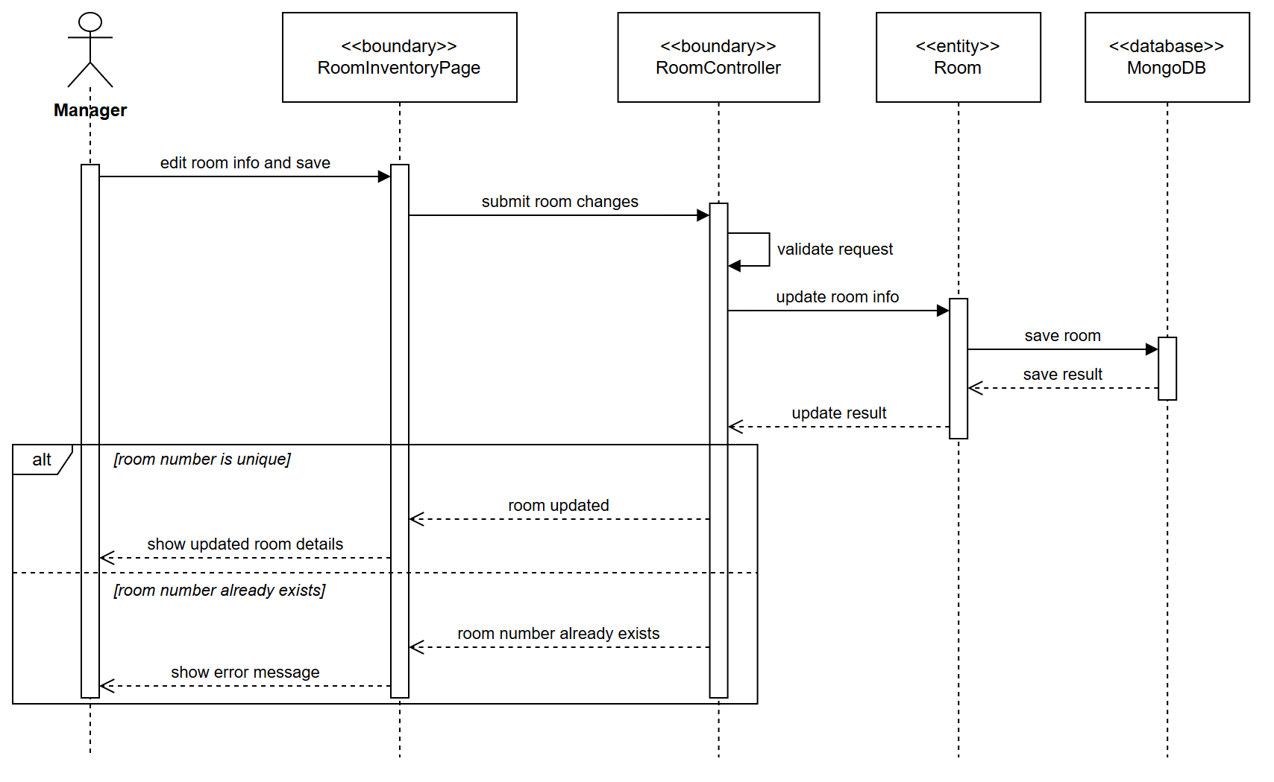
Figure 2.2 SD-01 Sequence Diagram - UC-M09 Update Room Info

1.2 UC-R13 Update Room Status

1.2.1 Use Case Specification
ID UC and Name: | UC-R13 - Update Room Status
Created By: | Lê Trần Trọng Đạt | Date Created: | 10/11/2026
Primary Actor: | Receptionist | Secondary Actors: | None
Trigger: | The Receptionist selects a room on the room rack and chooses a new housekeeping status.
Description: | Lets front-desk staff move a room through its housekeeping states — dirty, inspected, clean or out of order — so that the room rack shows which rooms can be allocated. Every change goes through the room state machine, so an impossible move is refused instead of corrupting the rack.
Preconditions: | PRE-1: The Receptionist is signed in and holds the ROOM_STATUS_UPDATE permission.  PRE-2: The room exists.
Postconditions: | POST-1: The room has the new status and its version is incremented.  POST-2: The room rack shows the new status.
Normal Flow: | 1.0: Change the status of a room  - The Receptionist opens the room rack.  - The system shows every room with its current status.  - The Receptionist selects a room and the new status (event).  - The system validates the request.  - The system loads the room and asks the room state machine for the next status.  - The system saves the new status on the condition that the room version is unchanged.  - The system refreshes the room rack.
Alternative Flows: | 1.1: Add a note  The Receptionist adds a note (for example the defect found); the note is stored with the status.
Exceptions: | 1.0.E1 — Status change not allowed  The event is not allowed from the current status (for example an occupied room marked clean): "Invalid status change." Nothing is stored.  1.0.E2 — Check-in or check-out event  ASSIGN and CHECK_OUT are refused here: "Use the check-in or check-out workflow."  1.0.E3 — Room changed meanwhile  A check-in claimed the room after it was read: "The room changed meanwhile — refresh and retry."  1.0.E4 — Room not found  "Room not found."
Priority: | High
Frequency of Use: | Many times per day, after every departure and inspection.
Business Rules: | BR-25 A room has at most one active stay. BR-R3 Status transitions follow the room state machine: VACANT_CLEAN, VACANT_DIRTY, INSPECTED, OCCUPIED, OUT_OF_ORDER.
Other Information: | The update is guarded by the room version, like the room allocator, so it cannot overwrite a concurrent check-in.
Assumptions: | Housekeeping reports finished rooms to the front desk.

1.2.2 Class Diagram
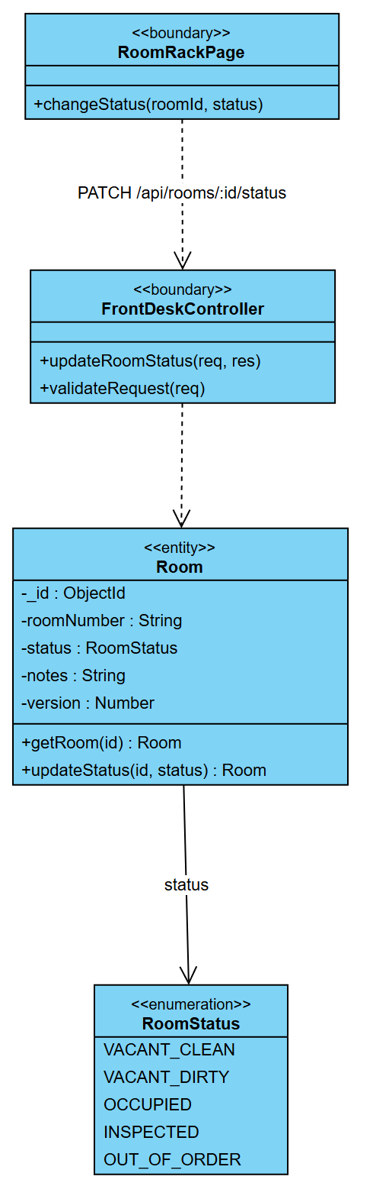
Figure 2.3 CD-02 Class Diagram - UC-R13 Update Room Status

1.2.3 Sequence Diagram
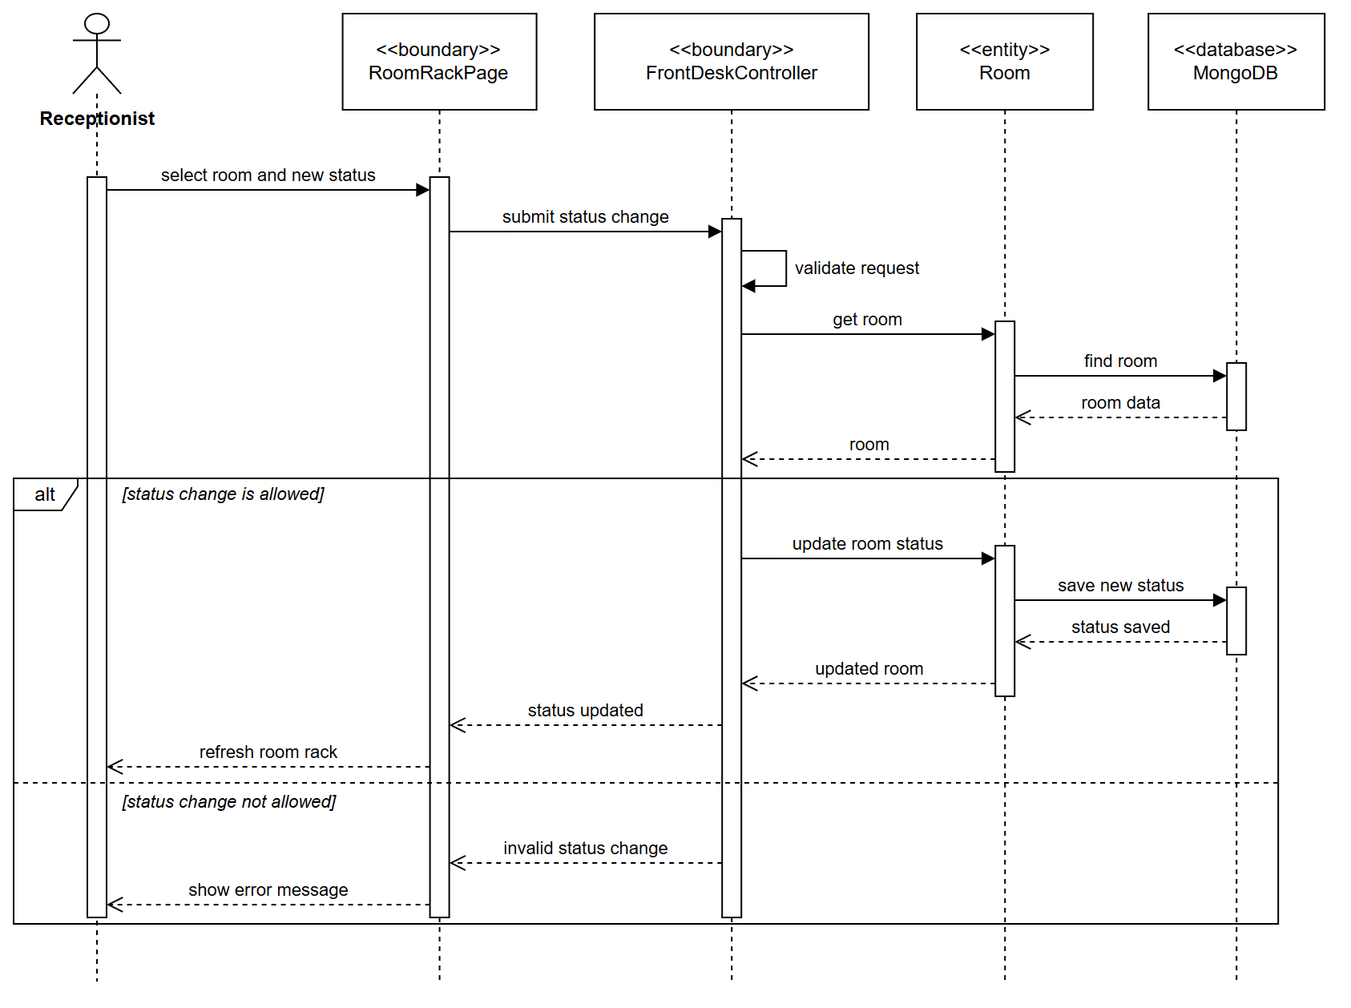
Figure 2.4 SD-02 Sequence Diagram - UC-R13 Update Room Status

1.3 UC-M20 Create Promotion Code

1.3.1 Use Case Specification
ID UC and Name: | UC-M20 - Create Promotion Code
Created By: | Lê Trần Trọng Đạt | Date Created: | 10/11/2026
Primary Actor: | Manager | Secondary Actors: | Guest / Customer, who later use the code (UC-G11)
Trigger: | The Manager selects New code on the Promotion codes screen.
Description: | Lets a Manager define a new discount code: the code, a description guests will see, a percentage or fixed discount, the first and last valid day, a usage limit, a minimum spend and whether the code is listed publicly. It extends UC-M11 Manage Promotion Codes.
Preconditions: | PRE-1: The Manager is signed in and holds the MANAGE_PRICING permission.
Postconditions: | POST-1: The new promotion is stored as active with no uses and the Manager as its creator.  POST-2: PROMOTION_CREATED is recorded in the audit log (BR-49).
Normal Flow: | 1.0: Create a promotion code  - The Manager opens Promotion codes and selects New code.  - The system shows the form with defaults: 10 %, from today for 30 days, no limit, no minimum spend, not listed.  - The Manager enters the code and its terms and selects Create code.  - The system validates the request: it converts the code to upper case and checks the terms (BR-52…BR-56).  - The system checks that no code with the same letters exists.  - The system stores the new promotion.  - The system shows the new code in the list.
Alternative Flows: | 1.1: Private code  The Manager leaves List on website unticked; the code works at booking but is never shown on the offers page (UC-G06).
Exceptions: | 1.0.E1 — Code already exists  "The code WELCOME10 already exists — choose another." If two Managers create the same code at the same moment, the unique index admits one and refuses the other.  1.0.E2 — Invalid terms  Each problem is named — "A percentage discount cannot exceed 100 %", "The end date must be on or after the start date", "Code must be 4 to 20 letters or digits, with no spaces". Nothing is stored. Return to step 3.
Priority: | High
Frequency of Use: | A few codes a month.
Business Rules: | BR-52 A code is 4–20 letters or digits, stored upper-case and unique. BR-53 A percentage is 1–100; a fixed amount is above zero. BR-54 A code is valid on a range of hotel days, judged on the day of booking. BR-55 The usage limit counts reservations (0 = no limit). BR-56 Minimum spend is measured on the reservation before tax.
Other Information: | One rule object (PromotionRule) checks the terms for the Manager's form, the guest's preview and the booking.
Assumptions: | The Manager has agreed the campaign terms beforehand.

1.3.2 Class Diagram
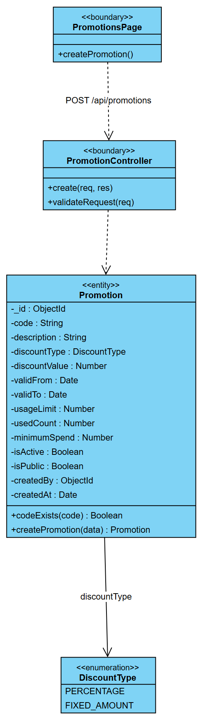
Figure 2.5 CD-03 Class Diagram - UC-M20 Create Promotion Code

1.3.3 Sequence Diagram
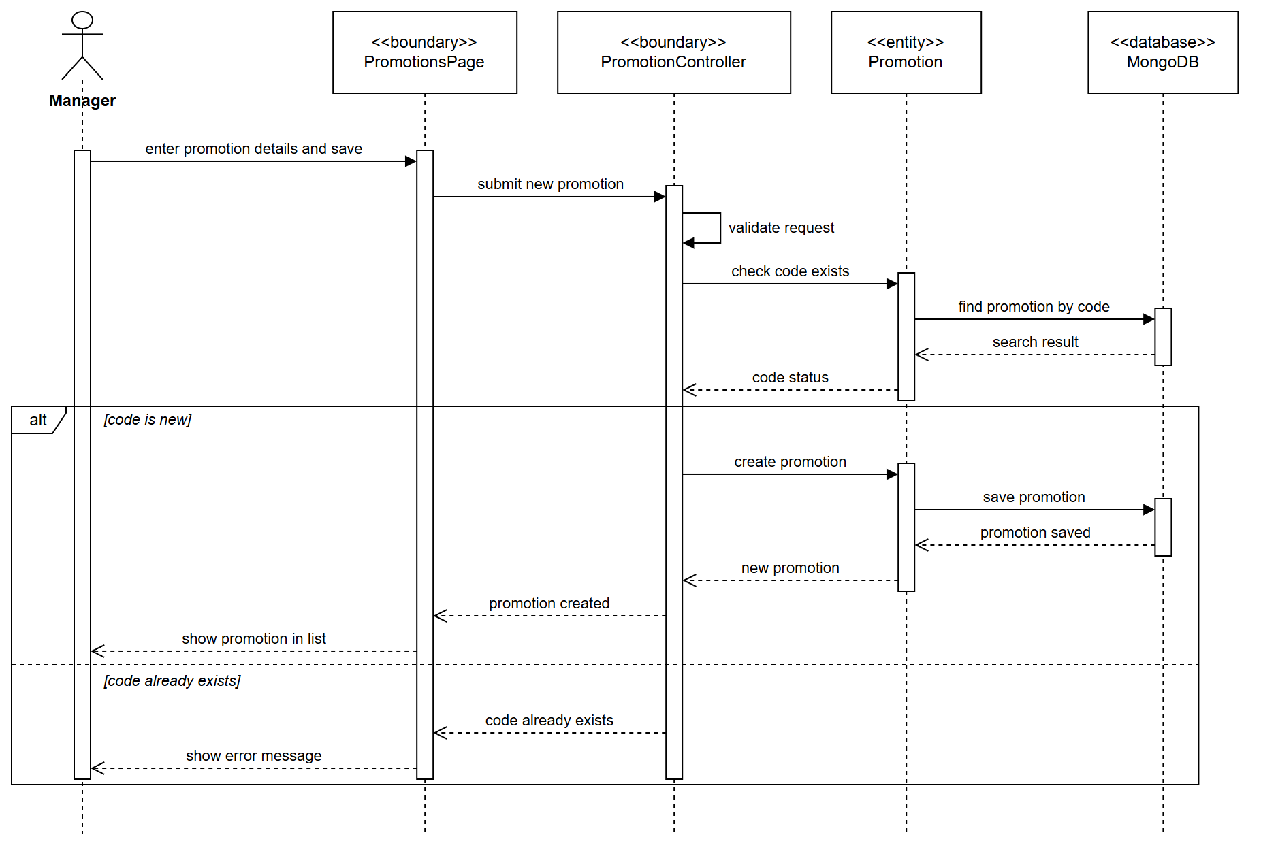
Figure 2.6 SD-03 Sequence Diagram - UC-M20 Create Promotion Code

1.4 UC-G11 Apply Discount Code / Voucher

1.4.1 Use Case Specification
ID UC and Name: | UC-G11 - Apply Discount Code / Voucher
Created By: | Lê Trần Trọng Đạt | Date Created: | 10/11/2026
Primary Actor: | Guest | Secondary Actors: | None
Trigger: | The guest enters a promotion code in the booking wizard and selects Apply.
Description: | Lets a guest check a promotion code before paying. The system shows the discount and the new total, or explains why the code cannot be used. The code is only consumed when the booking is paid (UC-G07, UC-G10).
Preconditions: | PRE-1: The guest is on the review step of the booking wizard with a subtotal.
Postconditions: | POST-1: The wizard shows the discount and the new total, or the reason the code was refused.  POST-2: No usage is recorded at this point.
Normal Flow: | 1.0: Check a promotion code  - The guest enters the code and selects Apply.  - The system validates the request: a code is present and the subtotal is a valid amount.  - The system finds the promotion by its code.  - The system checks that the code is active, inside its valid days, not used up and that the subtotal reaches the minimum spend.  - The system returns the discount amount and the new total.  - The wizard shows the discounted total.
Alternative Flows: | 1.1: Remove the code  The guest removes the code; the wizard returns to the original total.
Exceptions: | 1.0.E1 — Code cannot be applied  The code does not exist, is switched off, starts later, has ended or is used up: the wizard shows the reason (for example "This voucher is no longer available").  1.0.E2 — Minimum spend not reached  The system shows the amount still needed to use the code.
Priority: | Medium
Frequency of Use: | On many online bookings during campaigns.
Business Rules: | BR-54 A code is valid on its days, judged on the booking day. BR-55 A used-up code is refused. BR-56 Below the minimum spend the code is refused with the amount needed.
Other Information: | The preview uses the same PromotionRule as the booking, so the discount shown is the discount charged.
Assumptions: | The guest received the code from the offers page or from a partner.

1.4.2 Class Diagram
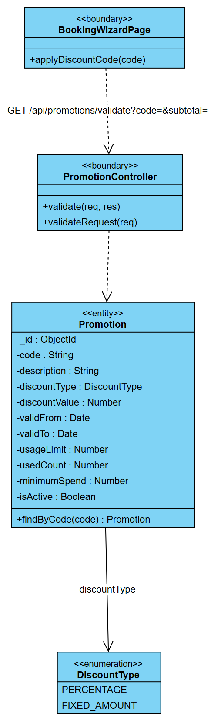
Figure 2.7 CD-04 Class Diagram - UC-G11 Apply Discount Code / Voucher

1.4.3 Sequence Diagram
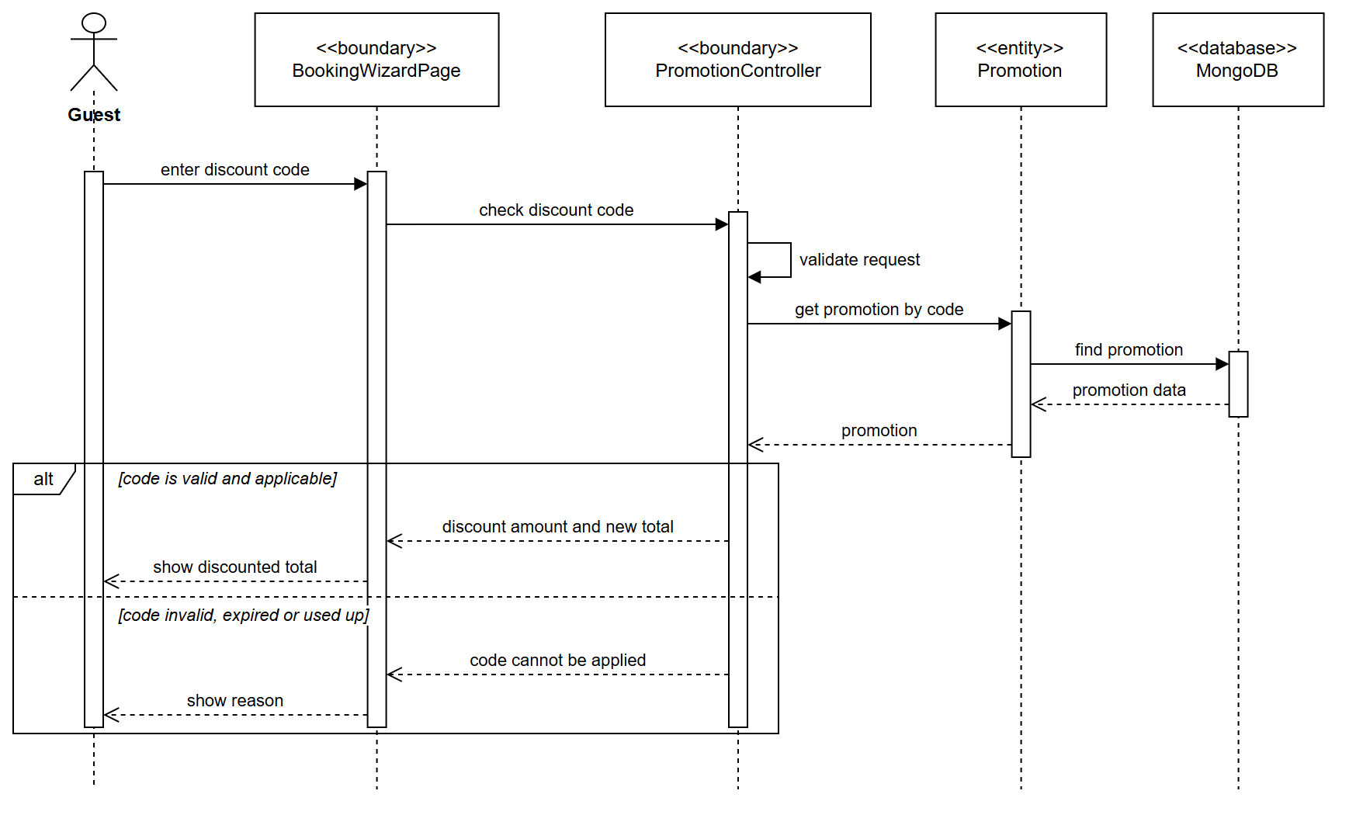
Figure 2.8 SD-04 Sequence Diagram - UC-G11 Apply Discount Code / Voucher

2. Auth & Administration

2.1 UC-G17 Login

2.1.1 Use Case Specification
ID UC and Name: | UC-G17 - Login
Created By: |  | Date Created: | 10/11/2026
Primary Actor: | Guest (becoming Customer), Employee | Secondary Actors: | Email / SMS Service
Trigger: | The user clicks the Login button and submits credentials.
Description: | Allows a registered user (Customer or Employee) to authenticate with the HMS using a valid username/email and password, receiving a session token whose role claims determine the functions available to them.
Preconditions: | PRE-1: The user has a registered account in the system.  PRE-2: The account status is ACTIVE (not locked or deactivated).
Postconditions: | POST-1: The user is authenticated; an access token and refresh token are issued.  POST-2: The user is redirected to the landing page matching their role.  POST-3: A login record is written to the audit log.
Normal Flow: | 1.0: Login with username and password  - The user opens the login page.  - The system displays the login form (username/email, password).  - The user enters valid credentials.  - The user clicks Login.  - The system validates that both fields are non-empty.  - The system looks up the account and verifies the password hash. («include» UC-C02 Authenticate Session)  - The system checks that the account is active and not locked.  - The system issues an access token (15 min) and a refresh token (7 days).  - The system resets the failed-attempt counter and records the login in the audit log.  - The system redirects the user to the role-appropriate dashboard.
Alternative Flows: | 1.1: Login with Google (OAuth)  - The user clicks Login with Google.  - The system redirects to the Google consent screen.  - The user authorizes the application.  - The system receives the profile; if no local account exists it creates one and links it.  - Continue from step 8 of the Normal Flow.  1.2: Forgotten password  («extend» UC-C03 Reset Forgotten Password)  - The user clicks Forgot password.  - The system sends an OTP via the Email/SMS Service.  - The user submits the OTP and a new password.  - The system updates the password hash and returns to step 2 of the Normal Flow.
Exceptions: | 1.0.E1 — Empty field  "Username and password must not be empty." Return to step 3.  1.0.E2 — Account not found  "Invalid username or password." Return to step 3. (The message is deliberately generic to prevent account enumeration.)  1.0.E3 — Wrong password  Increment the failed counter, show "Invalid username or password." Return to step 3.  1.0.E4 — Account locked after 5 failures  Set status LOCKED, notify the user by email, show "Account locked. Contact the administrator." Terminate.  1.0.E5 — Account deactivated  "This account has been deactivated." Terminate.  1.0.E6 — Email not verified  the credentials are correct but the account is still PENDING_VERIFICATION (PRE-2). "Please verify your email address before signing in." Offer to resend the link. (Checked only after the password is proven, so the status is never revealed to someone without the credentials.)
Priority: | High
Frequency of Use: | Every session; several hundred per day.
Business Rules: | BR-01 Password ≥ 8 chars with upper, lower, digit. BR-02 Lock after 5 consecutive failures. BR-03 Access token 15 min, refresh token 7 days.
Other Information: | Response ≤ 1 s at 200 concurrent logins; passwords hashed with bcrypt cost ≥ 10; TLS mandatory.
Assumptions: | The user has network access; the email/SMS provider is available for OTP.

2.1.2 Class Diagram
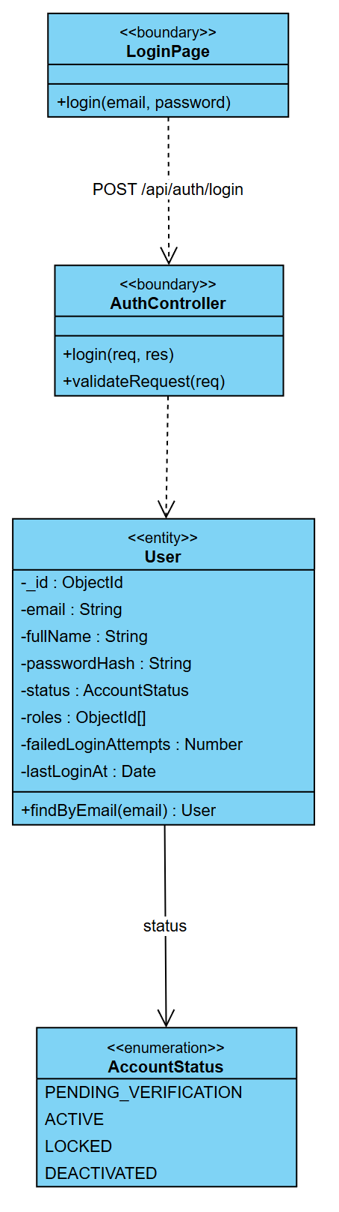
Figure 2.9 CD-05 Class Diagram - UC-G17 Login

2.1.3 Sequence Diagram
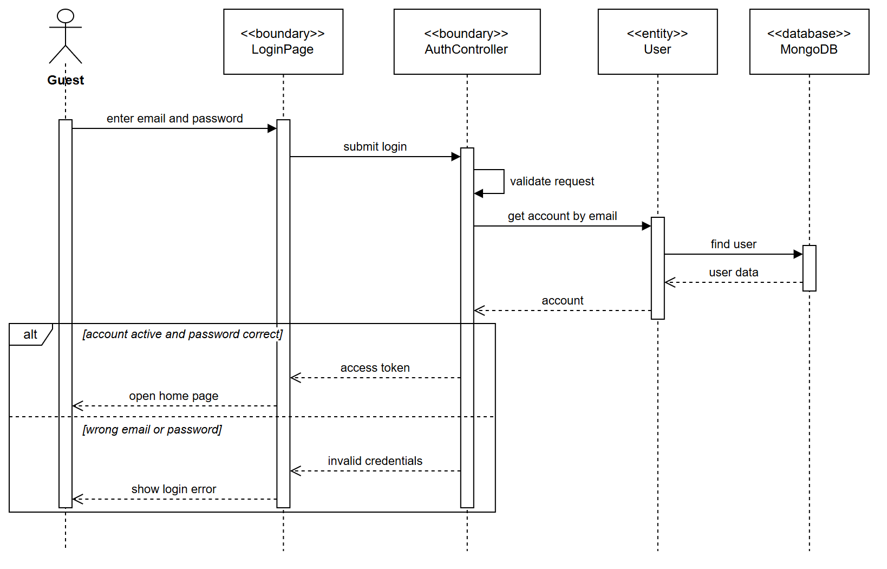
Figure 2.10 SD-05 Sequence Diagram - UC-G17 Login

2.2 UC-G16 Register Account

2.2.1 Use Case Specification
ID UC and Name: | UC-G16 - Register Account
Created By: |  | Date Created: | 10/11/2026
Primary Actor: | Guest | Secondary Actors: | Email / SMS Service
Trigger: | The Guest clicks Sign up and submits the registration form.
Description: | Allows an unregistered Guest to create a Customer account, after which they gain access to profile, booking history, invoice, review and loyalty features.
Preconditions: | PRE-1: The email address is not already registered.
Postconditions: | POST-1: A new account is created with status PENDING_VERIFICATION and role CUSTOMER.  POST-2: A verification email is sent.  POST-3: After verification the status becomes ACTIVE and a loyalty account is opened with 0 points.
Normal Flow: | 1.0: Self-registration  - The Guest opens the registration page.  - The system displays the form: full name, email, phone, password, confirm password.  - The Guest fills the form and accepts the terms of service.  - The Guest clicks Register.  - The system validates format, password strength and password match.  - The system checks that the email and phone are not already in use.  - The system hashes the password and creates the account with status PENDING_VERIFICATION.  - The system creates a linked loyalty account with a zero balance.  - The system sends a verification link valid for 24 hours.  - The system shows "Please check your email to verify your account."  - The Guest clicks the link; the system sets the status to ACTIVE and redirects to login.
Alternative Flows: | 1.1: Registration during checkout  the Guest ticks "Create an account" on the booking form; the system reuses the contact data already entered and continues from step 5.  1.2: Social sign-up  the Guest registers via Google; the email is treated as verified and the status is set directly to ACTIVE.
Exceptions: | 1.0.E1 — Email already registered  "This email is already in use. Log in instead?" Return to step 3.  1.0.E2 — Weak password  Show the strength rule that failed. Return to step 3.  1.0.E3 — Passwords do not match  "Passwords do not match." Return to step 3.  1.0.E4 — Verification link expired  Offer to resend; a new link is generated.
Priority: | High
Frequency of Use: | Tens per day.
Business Rules: | BR-04 One account per email. BR-05 Verification link valid 24 h. BR-06 Terms must be accepted.
Other Information: | Verification email delivered within 60 s.
Assumptions: | —

2.2.2 Class Diagram
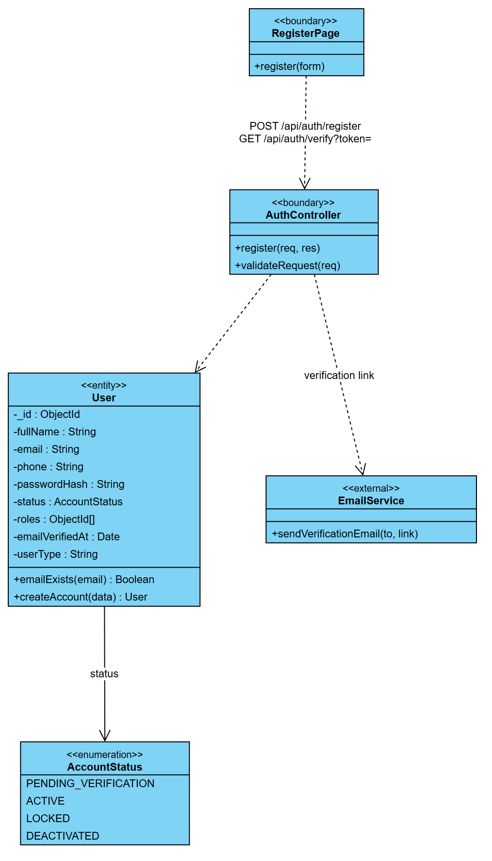
Figure 2.11 CD-06 Class Diagram - UC-G16 Register Account

2.2.3 Sequence Diagram
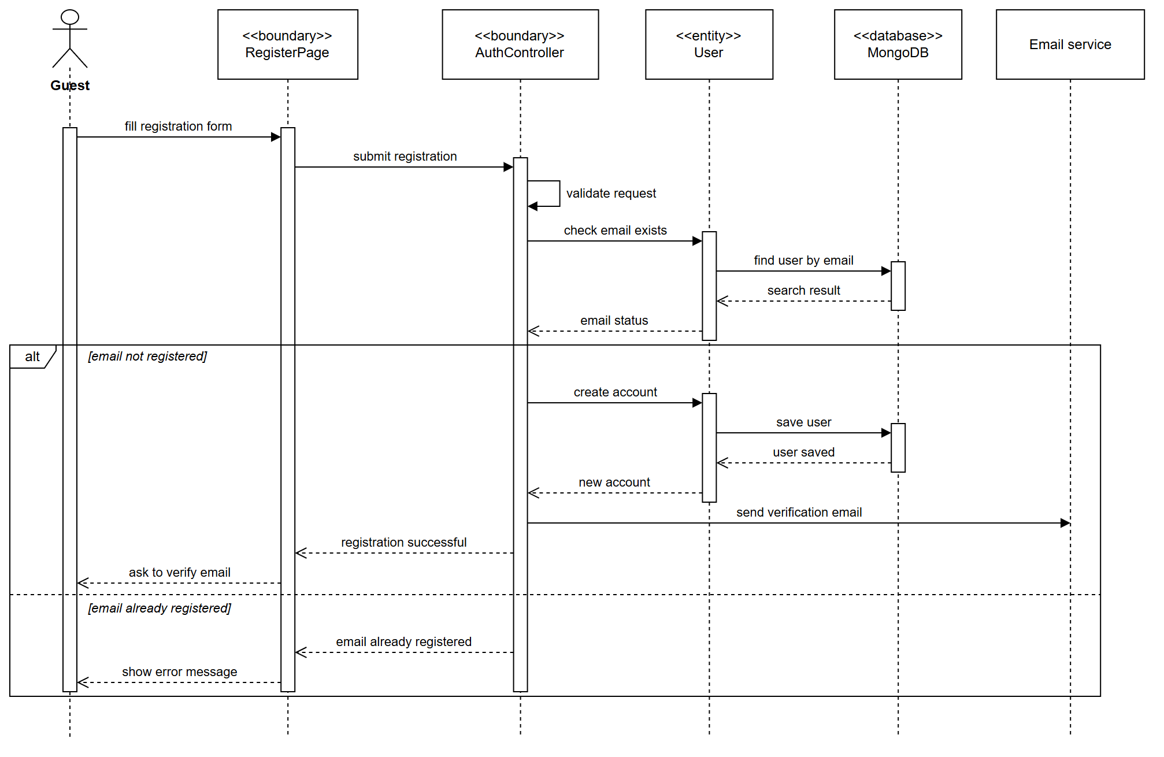
Figure 2.12 SD-06 Sequence Diagram - UC-G16 Register Account

2.3 UC-C03 Reset Forgotten Password

2.3.1 Use Case Specification
ID UC and Name: | UC-C03 - Reset Forgotten Password
Created By: |  | Date Created: | 10/11/2026
Primary Actor: | Customer | Secondary Actors: | Email / SMS Service
Trigger: | The user selects Forgot password on the login page.
Description: | Lets a user who has forgotten the password set a new one with a one-time code sent to the registered email address.
Preconditions: | PRE-1: The user has a registered account.  PRE-2: The user can read the registered mailbox.
Postconditions: | POST-1: The password is replaced and the failed-login counter is reset; a locked account is unlocked.  POST-2: The one-time code is cleared and PASSWORD_RESET is recorded in the audit log.
Normal Flow: | 1.0: Reset the password with a one-time code  - The user enters the email address and requests a reset code.  - The system stores a hashed six-digit code with an expiry time on the account.  - The system sends the code by email.  - The system asks for the code and a new password.  - The user enters the code and the new password.  - The system validates the request, including the password strength (BR-01).  - The system checks the code and its expiry, then stores the new password.  - The system confirms the change and sends the user to the login page.
Alternative Flows: | 1.1: Unknown email  When no account has the email, the system answers exactly as in step 4 and sends nothing, so the existence of an account is never revealed.
Exceptions: | 1.0.E1 — Code wrong or expired  "The code is invalid or has expired." The password is unchanged. The user may request a new code.  1.0.E2 — Weak password  The password does not meet BR-01 and is refused with the rule named. Return to step 5.
Priority: | High
Frequency of Use: | Occasional.
Business Rules: | BR-01 Password of at least 8 characters with upper case, lower case and a digit. BR-R4 The reset code is single-use and expires.
Other Information: | The code is stored only as a bcrypt hash.
Assumptions: | The email provider is available.

2.3.2 Class Diagram
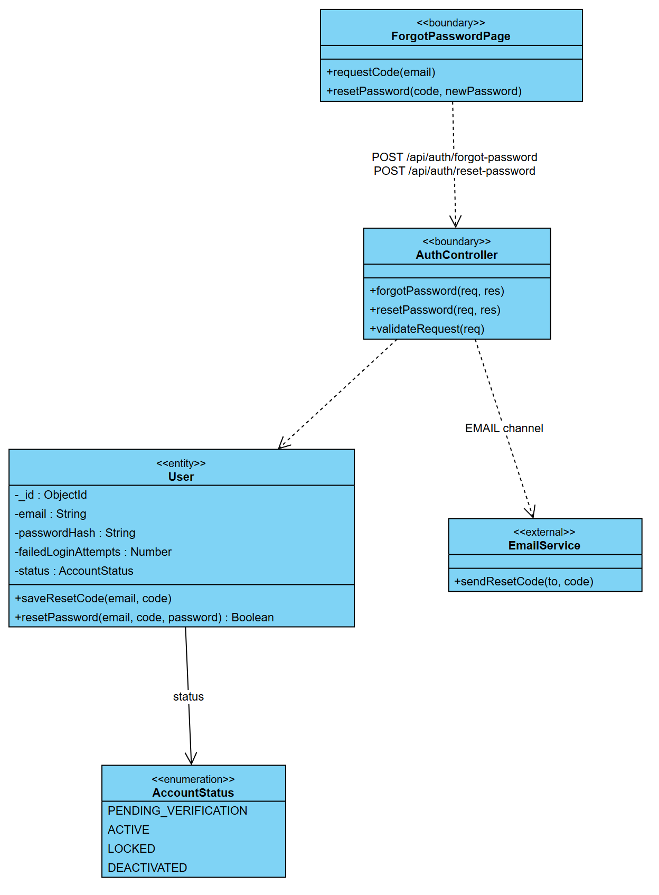
Figure 2.13 CD-07 Class Diagram - UC-C03 Reset Forgotten Password

2.3.3 Sequence Diagram
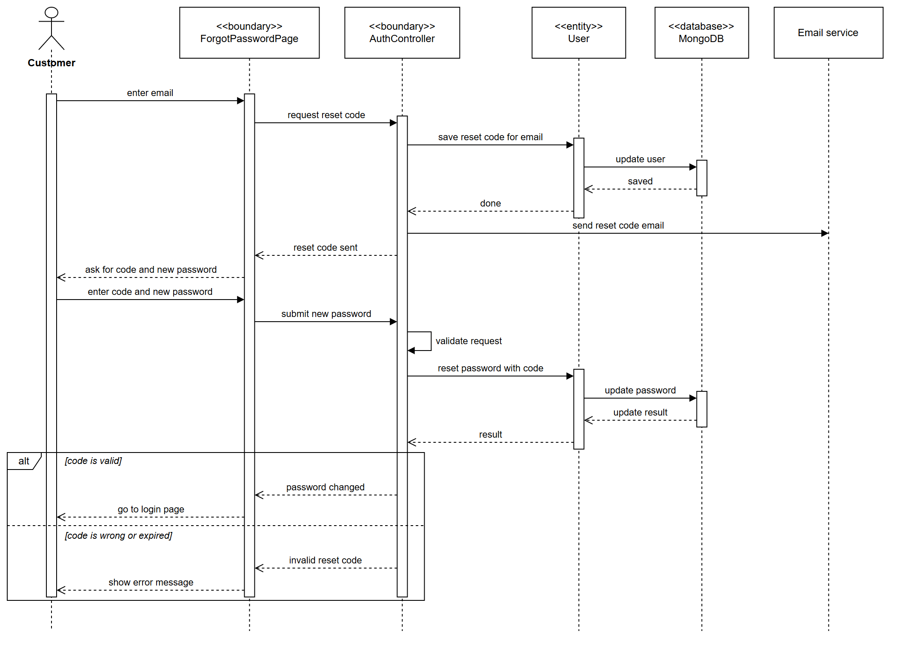
Figure 2.14 SD-07 Sequence Diagram - UC-C03 Reset Forgotten Password

2.4 UC-A06 Assign Role to Account

2.4.1 Use Case Specification
ID UC and Name: | UC-A06 - Assign Role to Account
Created By: |  | Date Created: | 10/11/2026
Primary Actor: | Admin | Secondary Actors: | Notification Service
Trigger: | The Admin opens an account and selects Assign role, typically on hire, promotion or transfer.
Description: | Grants a role — and with it a permission set — to a user account, determining which use cases that user may perform. This is the security-critical heart of the RBAC model.
Preconditions: | PRE-1: The target account exists.  PRE-2: The role exists in the role catalogue (UC-A05).  PRE-3: The Admin has the MANAGE_ROLES permission.
Postconditions: | POST-1: The role is attached to the account with an effective date.  POST-2: The user's effective permission set is recalculated.  POST-3: Existing sessions of that user are invalidated so the new claims take effect.  POST-4: The assignment is written to the audit log.
Normal Flow: | 1.0: Assign a role  - The Admin searches for and opens the account. («include» UC-A01)  - The system displays the account with its current roles and effective permissions.  - The Admin clicks Assign role.  - The system lists the assignable roles, excluding those already held.  - The Admin selects a role and optionally an effective date and expiry.  - The system validates the assignment against the segregation-of-duties rules.  - The system shows the resulting permission set for confirmation, highlighting newly granted permissions.  - The Admin confirms.  - The system attaches the role, recalculates the effective permissions and invalidates the user's active sessions.  - The system writes an audit entry with the actor, target, role, timestamp and reason.  - The system notifies the affected user of their new access.
Alternative Flows: | 1.1: Assign at account creation  the role is chosen as part of UC-A02; steps 4–9 are executed inline as part of provisioning.  1.2: Temporary role  the Admin sets an expiry date; a scheduled job revokes the role automatically when it lapses.  1.3: Revoke a role  («extend» UC-A08) the Admin removes a role; the permissions are recalculated and the sessions invalidated in the same way.  1.4: Replace a role  a promotion revokes the old role and assigns the new one in a single atomic operation.
Exceptions: | 1.0.E1 — Role already assigned  "This account already holds that role." Terminate.  1.0.E2 — Segregation-of-duties conflict  for example Auditor together with Payroll Approver. The system blocks the assignment and names the conflicting rule.  1.0.E3 — Account is locked or deactivated  "Roles cannot be assigned to an inactive account." Require reactivation first.  1.0.E4 — Privilege escalation attempt  an Admin tries to grant a role above their own authority; the system blocks it and raises a security alert.  1.0.E5 — Last Super Admin  revoking the final Super Admin role is refused to prevent lockout.
Priority: | High
Frequency of Use: | On hire, promotion, transfer and termination.
Business Rules: | BR-45 Permissions are granted through roles only, never directly to accounts. BR-46 An account may hold several roles; the effective set is their union. BR-47 Segregation-of-duties rules are enforced at assignment time. BR-48 At least one Super Admin must always exist. BR-49 Every role change is audit-logged and irreversible in the log.
Other Information: | Permission recalculation ≤ 1 s; new permissions effective on the next login; audit entries retained ≥ 5 years.
Assumptions: | —

2.4.2 Class Diagram
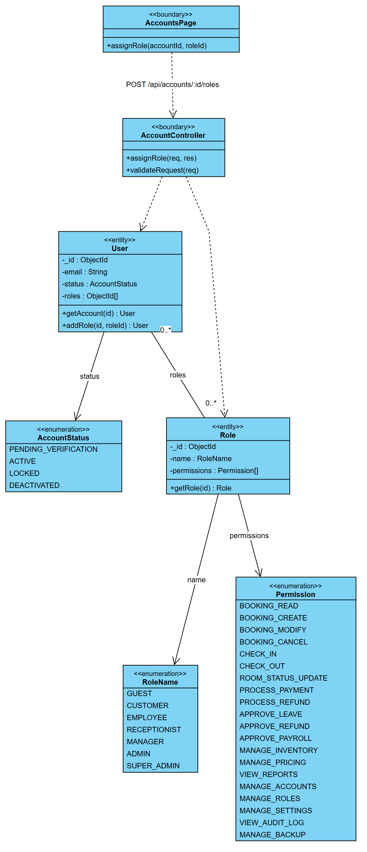
Figure 2.15 CD-08 Class Diagram - UC-A06 Assign Role to Account

2.4.3 Sequence Diagram
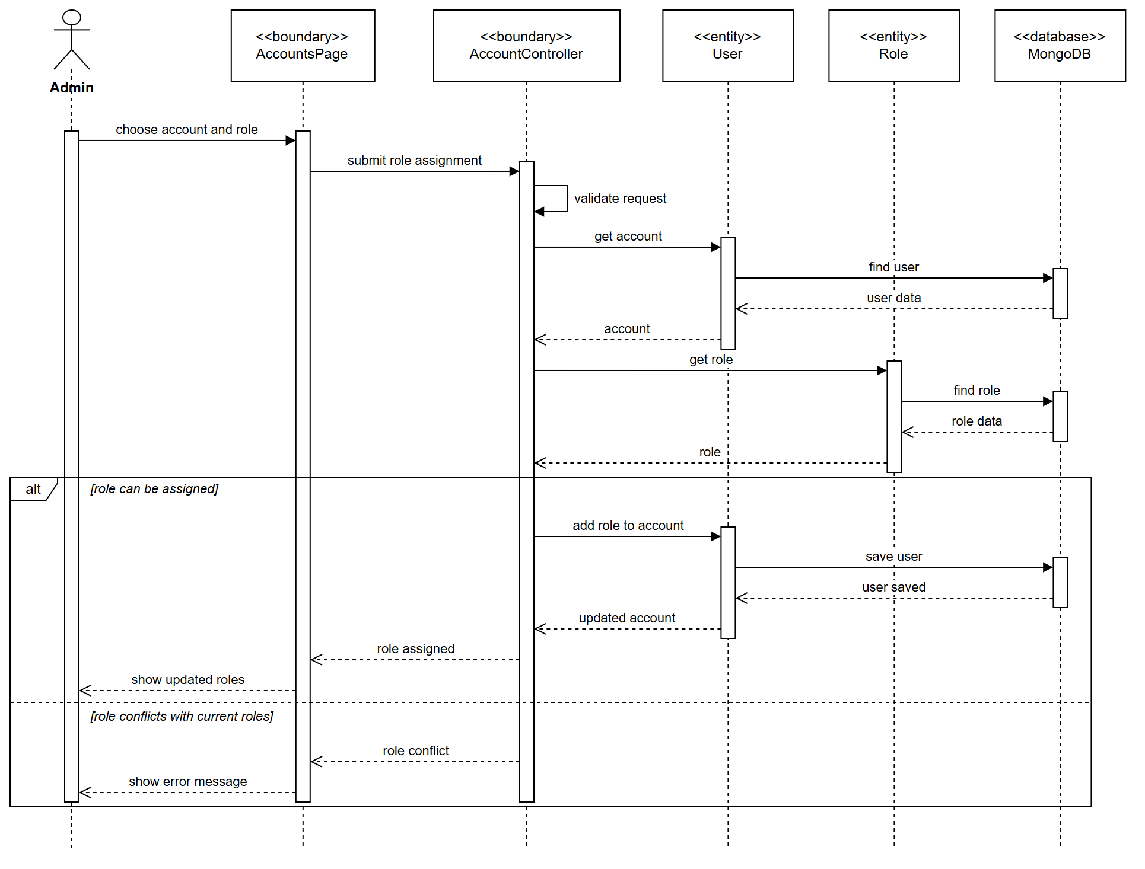
Figure 2.16 SD-08 Sequence Diagram - UC-A06 Assign Role to Account

3. Booking & Customer

3.1 UC-G01 Search Available Rooms

3.1.1 Use Case Specification
ID UC and Name: | UC-G01 - Search Available Rooms
Created By: | Lê Đức Anh | Date Created: | 10/11/2026
Primary Actor: | Guest | Secondary Actors: | —
Trigger: | The Guest submits the search form with dates and occupancy.
Description: | Lets a Guest find room types that are available for a given date range and occupancy, with live prices reflecting the applicable seasonal rate and active promotions.
Preconditions: | PRE-1: Room types and rate plans are configured (UC-M10).
Postconditions: | POST-1: A list of available room types with prices is displayed.  POST-2: No system state is changed (read-only use case).
Normal Flow: | 1.0: Search by date and occupancy  - The Guest opens the home or search page.  - The system displays the search form: check-in date, check-out date, adults, children, room count.  - The Guest enters the criteria and clicks Search.  - The system validates that check-in ≥ today and check-out > check-in.  - The system computes, for each room type, availableCount = totalRooms − confirmedOverlappingBookings − blockedRooms.  - The system filters out room types whose availableCount is 0 or whose capacity is below the requested occupancy.  - The system computes the price per room type for the stay, applying the seasonal rate for each night.  - Before a search, the system lists the promotion codes currently offered to everyone, with their terms. («extend» UC-G06) Codes are never applied automatically: the Guest enters one when booking (UC-G11).  - The system displays the result list sorted by price, with photos, capacity, amenities and total price.
Alternative Flows: | 1.1: Refine with filters  the Guest applies price range, bed type, view or amenity filters; the system re-filters the current result set without another availability computation.  1.2: View details  («extend» UC-G02) the Guest clicks a room type and the system shows the full gallery, amenity list, policy and review summary.  1.3: Flexible dates  the Guest selects "± 3 days"; the system returns an availability calendar for the surrounding window.
Exceptions: | 1.0.E1 — Check-in in the past  "Check-in date cannot be in the past." Return to step 3.  1.0.E2 — Check-out not after check-in  "Check-out must be after check-in." Return to step 3.  1.0.E3 — Stay exceeds 30 nights  "For stays longer than 30 nights please contact us." Return to step 3.  1.0.E4 — No availability  "No rooms available for these dates." The system suggests the nearest available dates.
Priority: | High
Frequency of Use: | Highest-volume use case; thousands per day.
Business Rules: | BR-07 Max 30 nights per booking. BR-08 At most 5 rooms in one reservation. BR-09 Price = Σ nightly seasonal rate − promotion. The search lists every room type with a free room, not only those that sleep the whole party — a party of six may take three doubles; types that fit the party in one room are listed first.
Other Information: | Response ≤ 2 s for a 30-day window; availability results cached 60 s; must handle 500 concurrent searches.
Assumptions: | —

3.1.2 Class Diagram
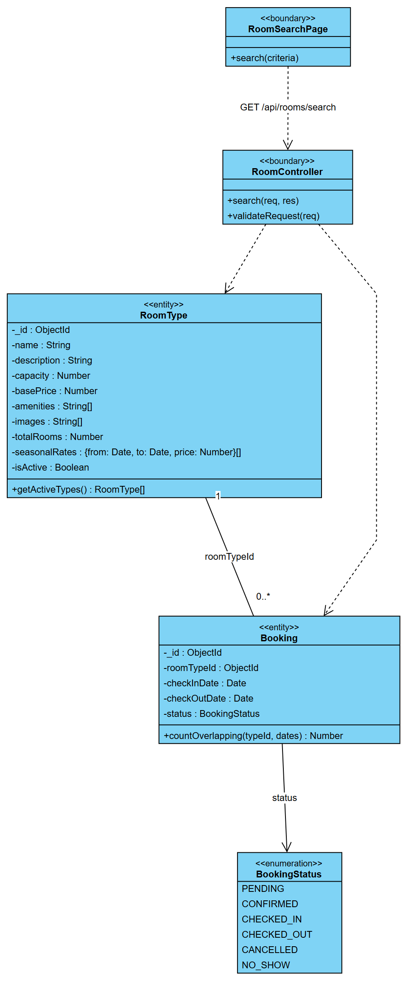
Figure 2.17 CD-09 Class Diagram - UC-G01 Search Available Rooms

3.1.3 Sequence Diagram
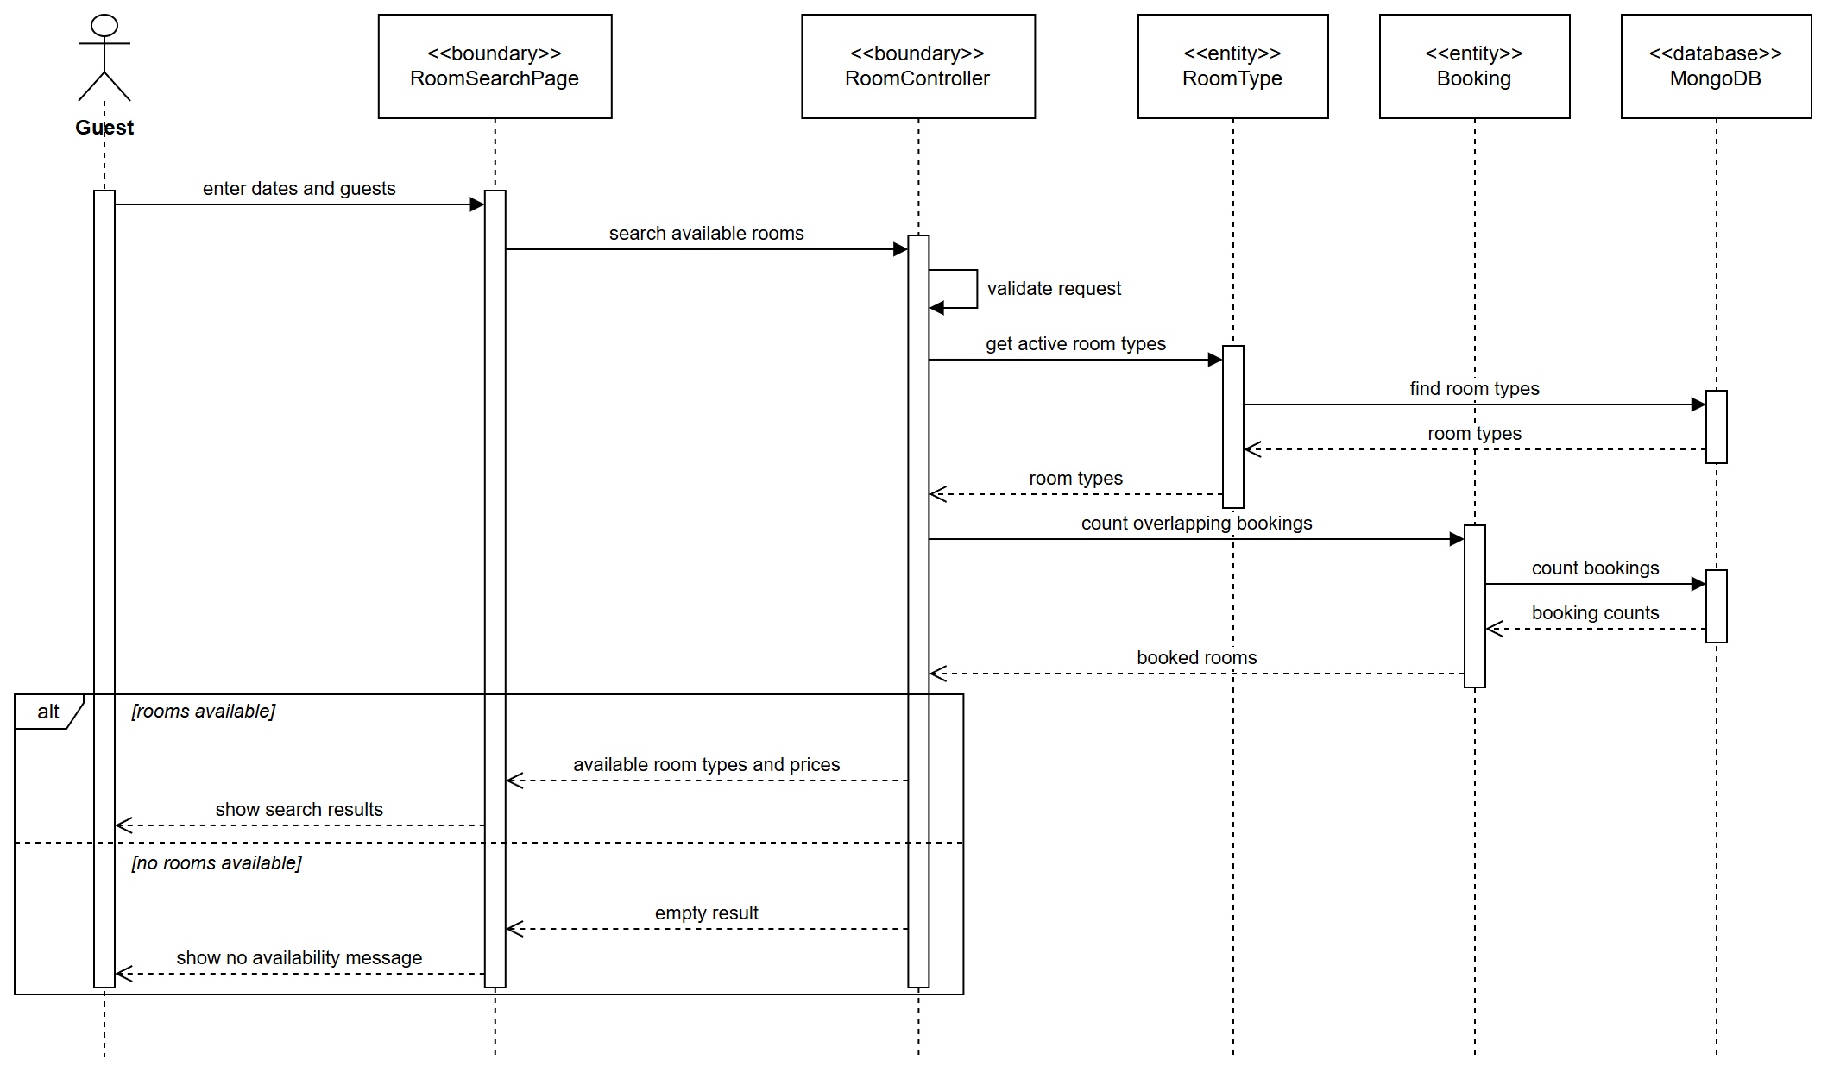
Figure 2.18 SD-09 Sequence Diagram - UC-G01 Search Available Rooms

3.2 UC-G07 Book Room

3.2.1 Use Case Specification
ID UC and Name: | UC-G07 - Book Room
Created By: | Lê Đức Anh | Date Created: | 10/11/2026
Primary Actor: | Guest (or Customer) | Secondary Actors: | Payment Gateway (payOS), Email / SMS Service
Trigger: | The Guest chooses one or more rooms on the search results and clicks Continue (or Book one room).
Description: | Reserves one or more rooms for the same dates in a single transaction — a couple takes one room, a family of seven a suite and two doubles. The Guest gives their contact details and says who sleeps in which room; the rooms are paid together with one payOS payment and confirmed together. This is the central revenue-producing use case of the system. A booking of several rooms is a reservation: one Booking per room, sharing a reservationCode, the dates and one payOS payment. Each room keeps its own lifecycle — rooms of the same family may arrive at different times, and one room can be cancelled while the others stay (see §5.4).
Preconditions: | PRE-1: Every chosen room type has enough free rooms for the dates (UC-G01).  PRE-2: The Guest has completed a search and chosen at least one room.
Postconditions: | POST-1: One Booking per room exists with status CONFIRMED, all sharing a reservation code; each room has its own booking code (<reservation>-1, -2, …; a single room's code equals the reservation code).  POST-2: Room inventory is decremented by one room per booking.  POST-3: One Payment per room exists with status PAID, all carrying the same payOS order code.  POST-4: One confirmation email lists every room of the reservation.  POST-5: If the actor is a Customer, every room is linked to their account; loyalty points are credited later, per room, on check-out (BR-29).
Normal Flow: | 1.0: Book one or more rooms, pay online  - On the search results the Guest sets how many rooms of each type they want. The system keeps a running total and checks that the rooms sleep the whole party and number at most five (BR-08).  - The Guest continues. The system shows the contact form. («include» UC-G08 Enter Contact Information)  - The Guest enters full name, email, phone and any special request.  - The system spreads the party over the rooms — one adult per room first, then the rest wherever there is a bed — and shows it. The Guest may change who sleeps where, and may name the person staying in each room if it is not themselves.  - The system optionally offers add-on services per room. («extend» UC-G09 Select Add-on Services)  - The system displays the summary: dates, nights, every room with its guests and price, taxes, total.  - The Guest may enter a voucher code, or pick one of the listed offers, and apply it. The system checks it — active, within its days, not used up, minimum spend met — and shows the discount and the new total before payment. («extend» UC-G11 Apply Discount Code / Voucher)  - The Guest confirms. The system re-verifies availability and holds every room for 15 minutes — all or nothing: if any room cannot be held, the rooms already held are released.  - The system prices each room, spreads the voucher discount over the rooms in proportion to their price, and records one PENDING booking per room under a new reservation code.  - The system creates one payOS payment link for the total, with one line per room, and one PENDING payment per room carrying its order code. («include» UC-G10 Pay for Booking)  - The Guest pays once, by scanning the VietQR.  - On confirmation from payOS the system confirms every room (PENDING → CONFIRMED, §6.4), commits the inventory and releases the holds.  - The system sends one confirmation listing every room («include» UC-G12) and counts one use of the voucher.  - The system displays the confirmation with the reservation code.
Alternative Flows: | 1.1: Pay at hotel  the Guest reserves with a card guarantee and pays on arrival. (Specified, not yet implemented: every booking is prepaid through payOS.)  1.2: Booking as a logged-in Customer  the contact form is pre-filled from the profile and every room is linked to the Customer's account. Loyalty points (1 % of room revenue, BR-12) are credited only when each stay completes (BR-29) — crediting at booking time would let a guest book, collect points and cancel.  1.3: One room  a room type that sleeps the whole party offers Book one room, which skips the selection bar; the flow is otherwise identical with a reservation of one room.
Exceptions: | 1.0.E1 — Not enough rooms left  at step 8 a room cannot be held because others were booked meanwhile. "Only N {type} rooms left for these dates — you asked for M." Nothing is held, booked or charged. Return to UC-G01 with the criteria preserved.  1.0.E2 — Hold expired (15 min)  "The hold has ended. Search again." The payOS link closes a minute before the holds, so the Guest cannot pay for released rooms.  1.0.E3 — Payment declined or cancelled  (see UC-G10) every room moves PENDING → CANCELLED and its hold is released; the Guest may retry. On a gateway timeout the rooms stay PENDING with their holds until payOS confirms or fails the payment.  1.0.E4 — A room over capacity or without an adult  "Room 2 (Standard Double) sleeps at most 2." / "Room 3 needs at least one adult." Return to step 4.  1.0.E5 — More than five rooms  "At most 5 rooms can be booked together — for a group, please contact the hotel." (BR-08)  1.0.E6 — Confirmation delivery failure  the reservation remains valid; the system queues a retry and shows the reservation code on screen.  1.0.E7 — Voucher refused  at step 7, or again at step 8 because a code can be used up or switched off meanwhile. The reason is given — "This voucher has reached its usage limit", "This voucher applies to bookings of 3.000.000 ₫ or more, before tax" — and nothing is held or charged. The Guest removes the code or tries another (rules BR-52…BR-57, UC-M11).
Priority: | High
Frequency of Use: | The primary revenue transaction; dozens to hundreds per day.
Business Rules: | BR-08 At most 5 rooms per reservation, all for the same dates. BR-10 Holds expire after 15 min. BR-11 Code format HMS-YYYYMMDD-XXXXX; rooms of a multi-room reservation add -1, -2, …. BR-12 Loyalty accrual 1 % of room revenue for Customers, credited per room on check-out (BR-29). BR-13 Each room's occupancy must not exceed its capacity, and each room needs an adult. BR-51 A voucher applies to the whole reservation: its discount is spread over the rooms in proportion to their price, and it counts as one use, when the payment is confirmed.
Other Information: | Holding the rooms is all-or-nothing, so a failed reservation never leaves rooms locked. Confirming a multi-room payment is exactly-once per room and sends exactly one email, even when payOS's webhook and the returning guest arrive together (verified by test: without the guard, ten concurrent confirmations sent ten emails). End-to-end ≤ 5 s excluding gateway latency.
Assumptions: | payOS is reachable; rates and taxes are configured.

3.2.2 Class Diagram
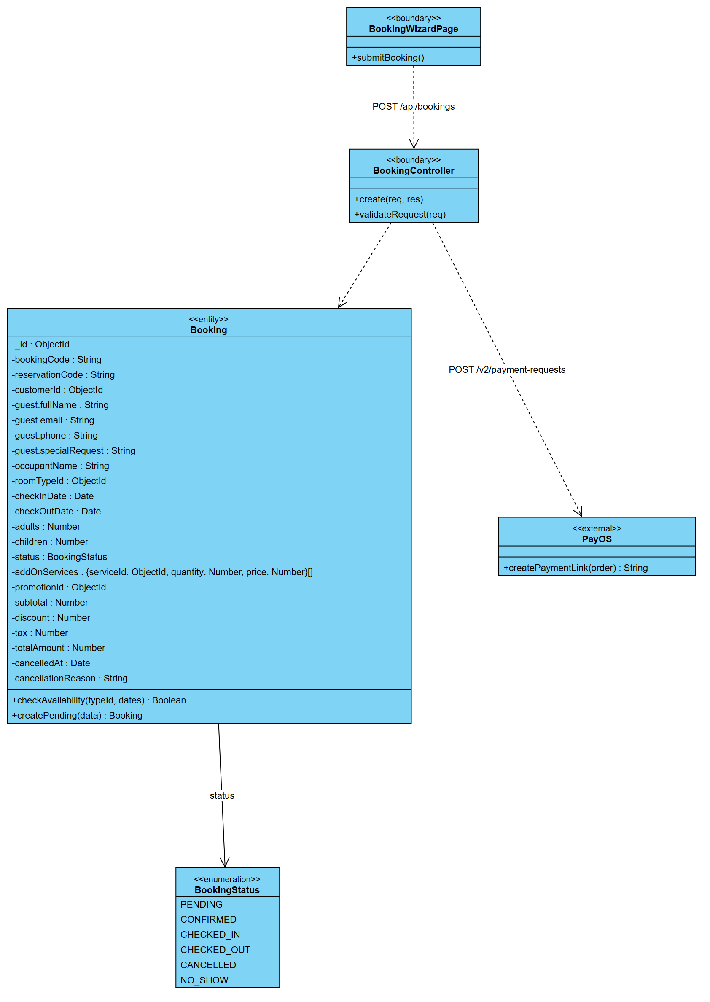
Figure 2.19 CD-10 Class Diagram - UC-G07 Book Room

3.2.3 Sequence Diagram
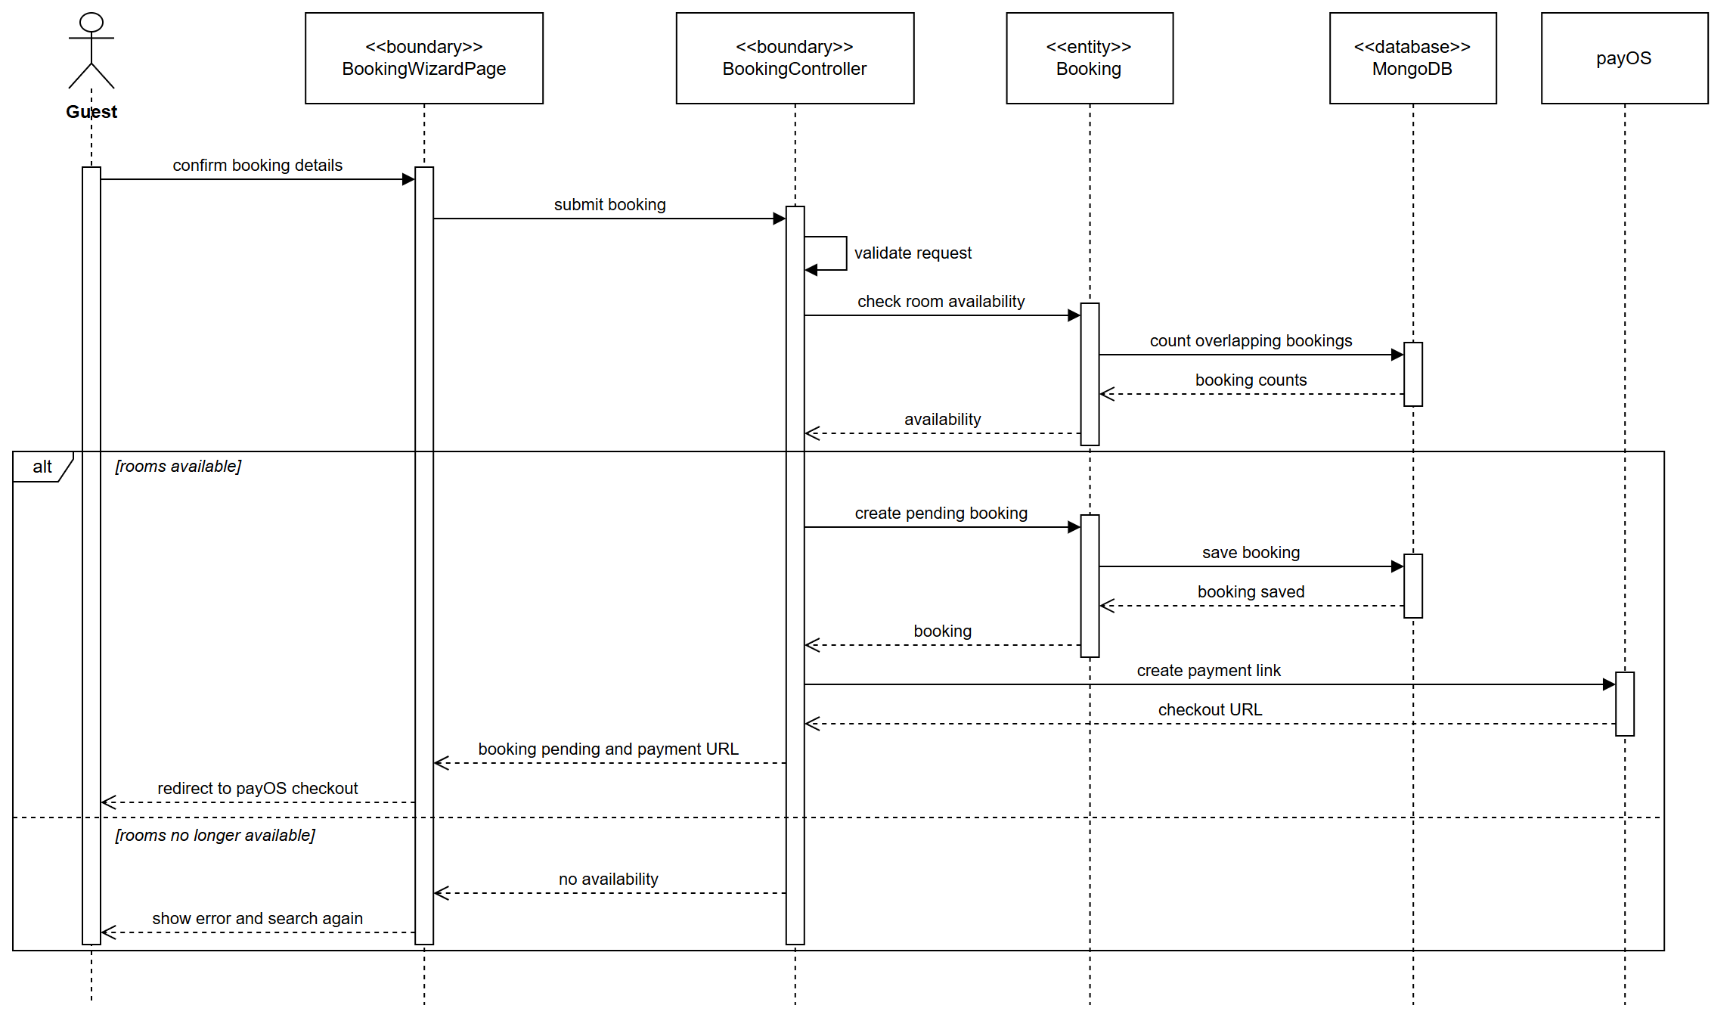
Figure 2.20 SD-10 Sequence Diagram - UC-G07 Book Room

3.3 UC-G14 Cancel Booking

3.3.1 Use Case Specification
ID UC and Name: | UC-G14 - Cancel Booking
Created By: | Lê Đức Anh | Date Created: | 10/11/2026
Primary Actor: | Guest / Customer | Secondary Actors: | Manager (for out-of-policy cases), Payment Gateway, Email Service
Trigger: | The user opens a booking and clicks Cancel booking.
Description: | Cancels a booked room, computes the cancellation penalty from the hotel policy, releases the inventory and initiates any refund due. In a multi-room reservation each room is cancelled on its own — the policy and the refund apply to that room's price, and the other rooms stay booked.
Preconditions: | PRE-1: The booking exists with status CONFIRMED.  PRE-2: The booking has not yet been checked in.
Postconditions: | POST-1: The booking status becomes CANCELLED (or PENDING_APPROVAL when out of policy).  POST-2: The room inventory for those dates is released.  POST-3: A refund is initiated for the refundable portion, if any.  POST-4: A cancellation notice is emailed to the guest.
Normal Flow: | 1.0: Cancel within the free-cancellation window  - The user opens the booking (UC-G13 / UC-C12) and clicks Cancel booking.  - The system verifies that the booking is CONFIRMED and not yet checked in.  - The system evaluates the cancellation policy against the current time and the check-in date.  - The system computes the penalty and the refundable amount and displays them for confirmation.  - The user confirms the cancellation and optionally selects a reason.  - The system sets the booking status to CANCELLED and records the reason and timestamp.  - The system releases the inventory for the affected dates.  - The system initiates the refund through the gateway for the refundable amount.  - The system sends the cancellation confirmation email.  - The system displays the cancellation summary.
Alternative Flows: | 1.1: Cancellation outside the policy window  when the penalty is 100 % or the check-in is within 24 h, the system creates a RefundRequest with status PENDING and routes it to the Manager. (→ UC-M14 Approve Refund Request) The booking is cancelled immediately but the refund waits for approval.  1.2: Non-refundable rate  the system shows "This rate is non-refundable. No refund will be issued." and proceeds without a refund.  1.3: Cancellation by the Receptionist  (UC-R05) the Receptionist cancels at the desk on the guest's behalf, with an override privilege to waive the penalty subject to Manager approval.
Exceptions: | 1.0.E1 — Booking already checked in  "A booking that has been checked in cannot be cancelled. Please contact the front desk." Terminate.  1.0.E2 — Booking already cancelled  "This booking has already been cancelled." Terminate.  1.0.E3 — Refund failure at the gateway  the cancellation stands; the refund is queued for retry and the Admin is alerted.  1.0.E4 — Stay already in progress  redirect to the early-departure procedure at the front desk.
Priority: | High
Frequency of Use: | Roughly 10–15 % of bookings.
Business Rules: | BR-17 Free cancellation ≥ 48 h before check-in. BR-18 50 % penalty between 48 h and 24 h. BR-19 100 % penalty inside 24 h. BR-20 Non-refundable rates are never auto-refunded.
Other Information: | The inventory release must be transactional with the status change; refunds initiated within 24 h and settled within 7 working days.
Assumptions: | —

3.3.2 Class Diagram
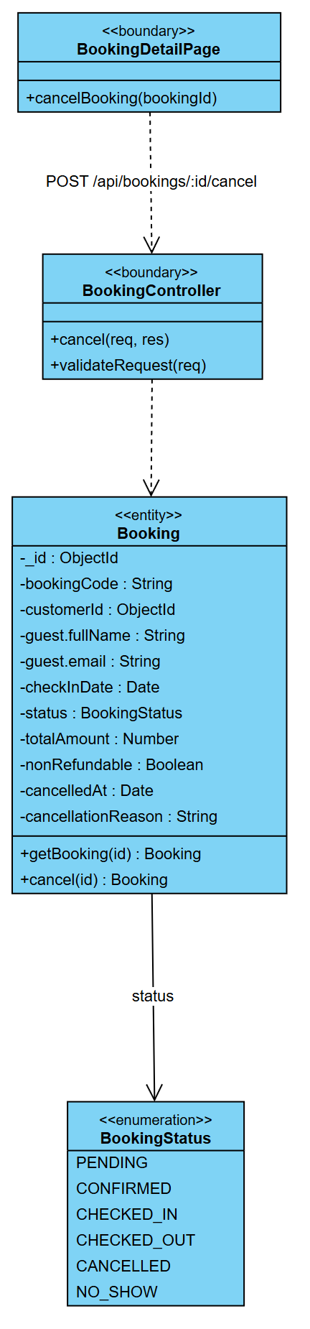
Figure 2.21 CD-11 Class Diagram - UC-G14 Cancel Booking

3.3.3 Sequence Diagram
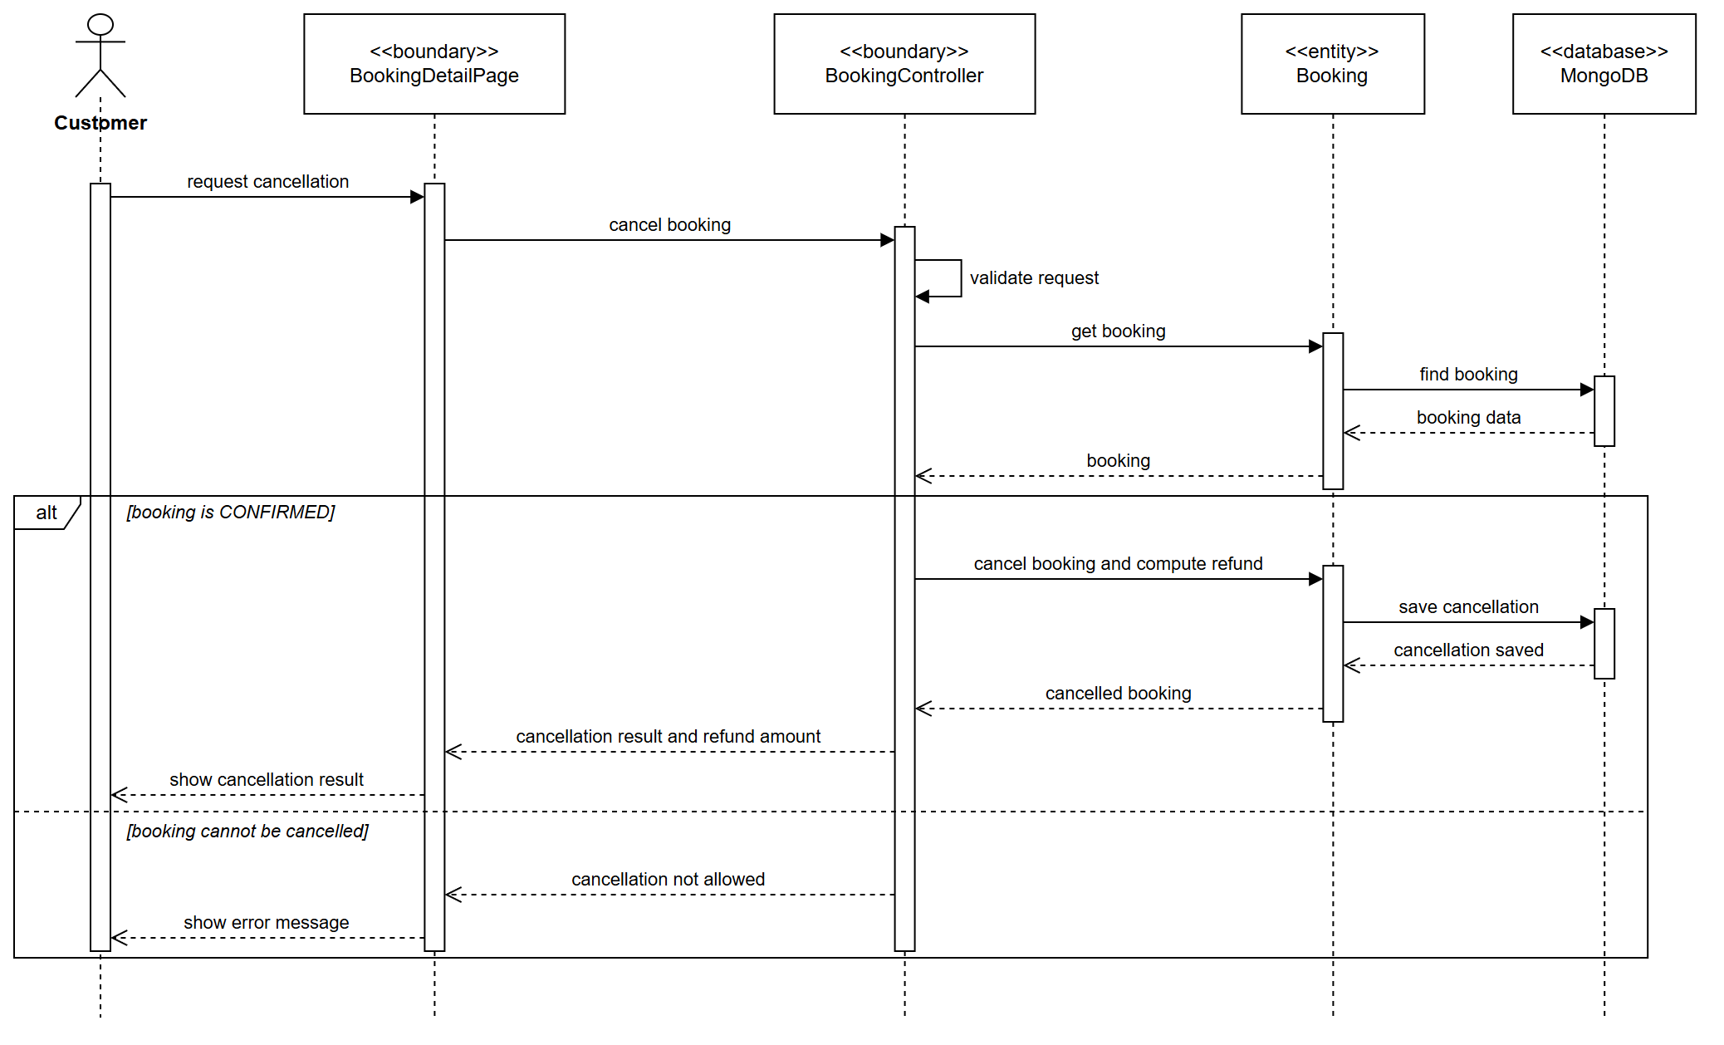
Figure 2.22 SD-11 Sequence Diagram - UC-G14 Cancel Booking

3.4 UC-G13 Check Booking Status

3.4.1 Use Case Specification
ID UC and Name: | UC-G13 - Check Booking Status
Created By: | Lê Đức Anh | Date Created: | 10/11/2026
Primary Actor: | Guest | Secondary Actors: | None
Trigger: | The guest opens Find my booking and enters a booking code and the booking email.
Description: | Lets anyone who holds a booking code and the email used for the booking see the reservation, its rooms and their status, without signing in. The email acts as a shared secret so that a code alone discloses nothing.
Preconditions: | PRE-1: The guest has a booking or reservation code and the email used to book.
Postconditions: | POST-1: The reservation is shown with every room, its dates, price and status.
Normal Flow: | 1.0: Look up a booking  - The guest enters the booking code and the email.  - The system validates the request.  - The system finds the booking whose booking code or reservation code and guest email match.  - The system loads every room of that reservation.  - The system shows the reservation with each room's code, status and price.
Alternative Flows: | 1.1: Look up from the confirmation email  The link in the confirmation email carries the code and email; the system starts at step 2.
Exceptions: | 1.0.E1 — No matching booking  "No booking matches that code and email." The message does not say which of the two was wrong.  1.0.E2 — Missing input  The form asks for the missing code or a valid email.
Priority: | High
Frequency of Use: | Several times per booking.
Business Rules: | BR-R5 A booking is disclosed only when the code and the booking email match.
Other Information: | The same message is returned for every mismatch to prevent probing.
Assumptions: | The guest kept the confirmation email.

3.4.2 Class Diagram
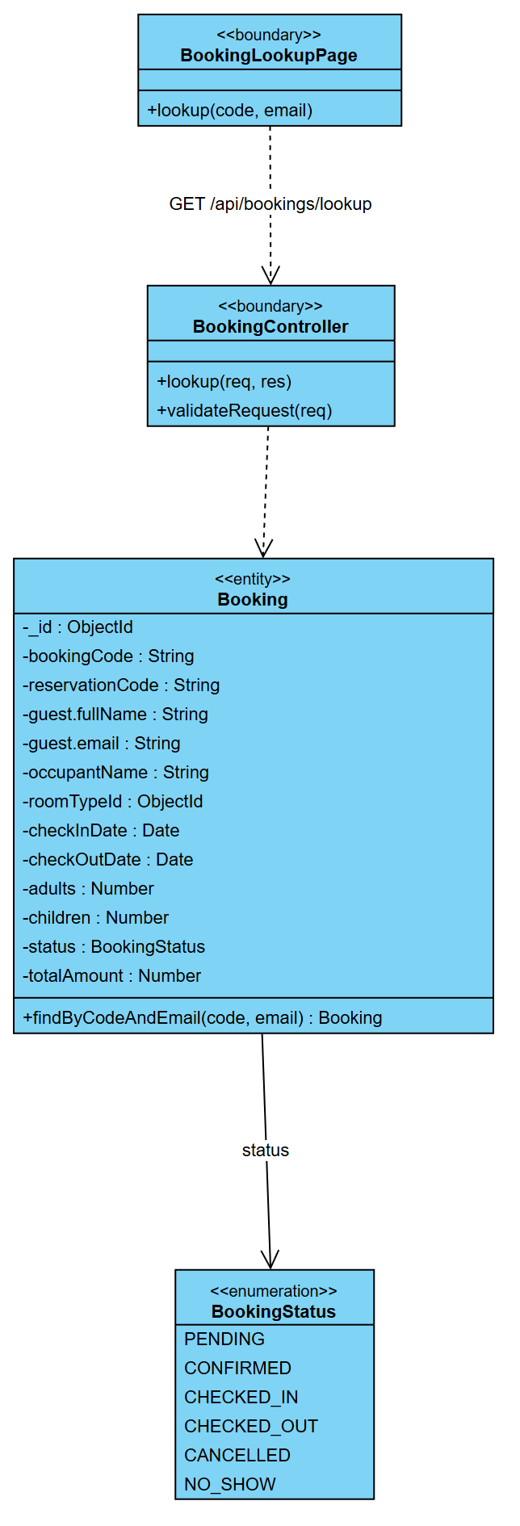
Figure 2.23 CD-12 Class Diagram - UC-G13 Check Booking Status

3.4.3 Sequence Diagram
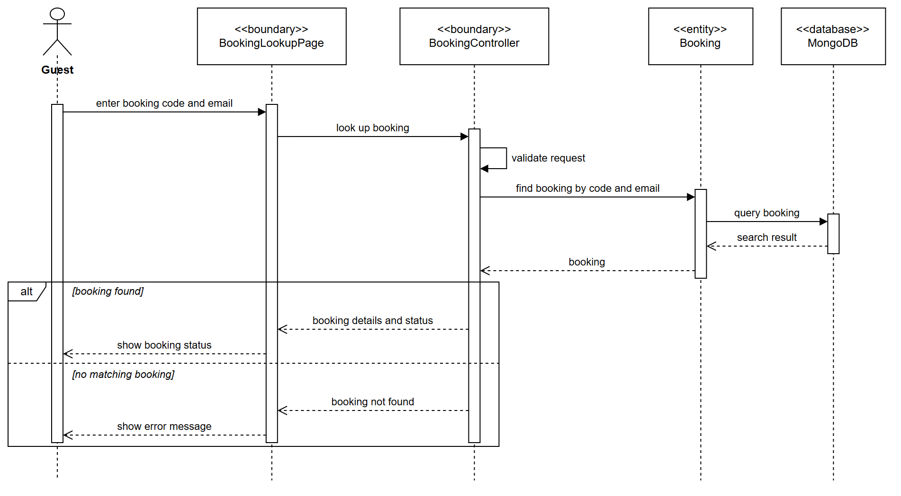
Figure 2.24 SD-12 Sequence Diagram - UC-G13 Check Booking Status

4. Billing & Payment

4.1 UC-G10 Pay for Booking

4.1.1 Use Case Specification
ID UC and Name: | UC-G10 - Pay for Booking
Created By: |  | Date Created: | 10/11/2026
Primary Actor: | Guest (or Customer) | Secondary Actors: | Payment Gateway — payOS (VietQR / bank transfer, https://payos.vn)
Trigger: | Included from UC-G07 step 9.
Description: | Collects payment for a booking through payOS and records the resulting transaction, guaranteeing that the booking is only confirmed when the money has actually arrived. payOS is asynchronous: the guest pays from their own banking app by scanning a VietQR, and payOS reports the result afterwards. A payment is therefore never approved in the same request that creates it.
Preconditions: | PRE-1: A PENDING booking exists with a computed payable amount > 0 (UC-G07 step 9).  PRE-2: payOS credentials are configured and the webhook URL is registered (UC-A12).
Postconditions: | POST-1: One Payment record per room exists with status PAID, FAILED or PENDING; the rooms of one reservation all carry the same integer payOS orderCode.  POST-2: On success the bank transfer reference is stored and the booking moves PENDING → CONFIRMED.  POST-3: On failure, cancellation or expiry the booking moves PENDING → CANCELLED and the inventory hold is released.
Normal Flow: | 1.0: VietQR payment via payOS  - The system displays the amount due.  - The Guest may apply a voucher. («extend» UC-G11) The system revalidates the code and recomputes the amount.  - The system creates one Payment record per room with status PENDING and an idempotency key, all sharing a new payOS orderCode — before calling payOS, so a timeout still leaves records to reconcile against. Keeping one payment per room keeps refunds, folios and invoices per room.  - The system creates one payOS payment link for the reservation's total, with one item per room, signed with HMAC-SHA256, a bank memo of at most 9 characters and an expiry one minute before the 15-minute inventory holds.  - The system redirects the Guest to the payOS checkout page.  - The Guest scans the VietQR with a banking app and transfers the money.  - payOS sends a signed webhook to the system.  - The system verifies the webhook signature and checks that the amount received equals the amount due.  - The system checks the amount against the sum of the rooms, atomically sets each room's Payment to PAID (exactly once), stores the bank reference, confirms every room, and sends one confirmation for the reservation.  - payOS redirects the Guest to the result page, which shows the confirmation.
Alternative Flows: | 1.1: Webhook not received  (e.g. a development machine that payOS cannot reach, or a lost delivery) — when the Guest reaches the result page, the system asks payOS server-to-server for the link status and applies it (steps 8–9). The status in the return URL's query string is never trusted, because anyone can type it.  1.2: Webhook and returning Guest arrive together  both paths converge on one conditional atomic update; only one applies, so the money is booked once. (Verified by test: without the guard, ten concurrent confirmations booked the payment ten times.)  1.3: Guest cancels on the payOS page  the Guest is sent to the cancel URL; the system reads the link status CANCELLED and moves the booking to CANCELLED, releasing the room.  1.4: Front-desk payment (UC-R15)  the same link is created at the desk; the Receptionist shows its VietQR; the folio balance falls when the webhook arrives.
Exceptions: | 1.0.E1 — payOS refuses to create the link  the Payment becomes FAILED, the booking CANCELLED, the hold is released; "Payment could not be started." The Guest may retry.  1.0.E2 — Transfer of the wrong amount (UNDERPAID)  the payment is not confirmed automatically; it stays PENDING and an audit entry PAYMENT_AMOUNT_MISMATCH is raised for staff to resolve.  1.0.E3 — payOS timeout while creating the link  the Payment stays PENDING with its orderCode; the webhook or the reconciler settles it. No second link can be created for the same payment, because payOS rejects a reused orderCode.  1.0.E4 — Invalid webhook signature  the request is rejected with 400, nothing changes, and the attempt is logged. The webhook endpoint is public, so the signature is its only authentication.  1.0.E5 — Voucher no longer valid  "This voucher has expired or reached its usage limit." Recompute without it and return to step 2.  1.0.E6 — Guest abandons the payOS page  the link expires before the inventory hold and the room returns to inventory when the hold lapses. The PENDING payment is marked FAILED the next time it is reconciled. (A periodic sweeper for never-reconciled links is future work.)
Priority: | High
Frequency of Use: | Once per booking.
Business Rules: | BR-14 A booking is confirmed only after PAID. BR-15 Every payment carries an idempotency key and a payOS orderCode unique for all time. BR-16 Bank data never touches HMS servers — payOS hosts the checkout. BR-50 payOS has no refund API: refunds are made by manual bank transfer (UC-G14, UC-C17).
Other Information: | payOS calls time out at 30 s; signatures use HMAC-SHA256 with the checksum key and are checked byte-for-byte against the official @payos/node SDK; webhook signatures are compared in constant time; amounts are integer VND.
Assumptions: | —

4.1.2 Class Diagram
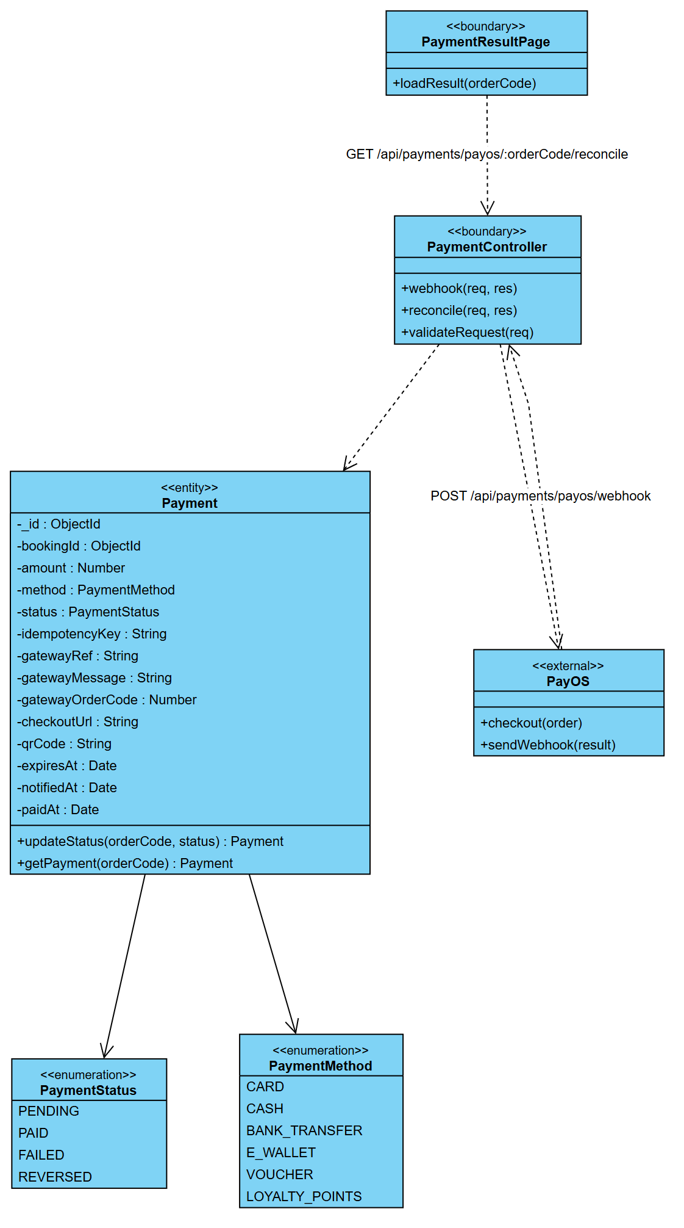
Figure 2.25 CD-13 Class Diagram - UC-G10 Pay for Booking

4.1.3 Sequence Diagram
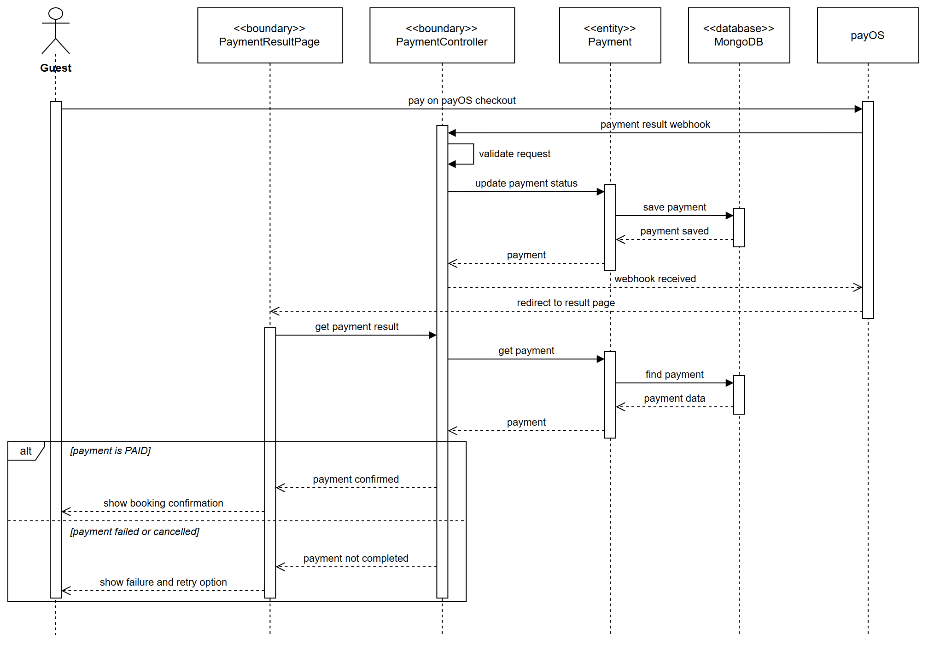
Figure 2.26 SD-13 Sequence Diagram - UC-G10 Pay for Booking

4.2 UC-R15 Process Payment

4.2.1 Use Case Specification
ID UC and Name: | UC-R15 - Process Payment
Created By: |  | Date Created: | 10/11/2026
Primary Actor: | Receptionist | Secondary Actors: | Payment Gateway
Trigger: | A balance is due at check-in, at check-out, or when a guest settles a charge at the desk.
Description: | Records a payment taken at the front desk against a booking folio, by cash, card, bank transfer or voucher, and issues the corresponding receipt.
Preconditions: | PRE-1: A folio exists with a positive balance.  PRE-2: The Receptionist has the PROCESS_PAYMENT permission.
Postconditions: | POST-1: A Payment record exists with status PAID.  POST-2: The folio balance is reduced by the amount paid.  POST-3: A receipt is issued.  POST-4: The cash-drawer session total is updated for a cash payment.
Normal Flow: | 1.0: Card payment at the desk  - The Receptionist opens the folio and selects Take payment.  - The system displays the outstanding balance.  - The Receptionist enters the amount and selects the method Card.  - The system creates a Payment with status PENDING and an idempotency key.  - The system sends the amount to the card terminal / gateway.  - The guest authorizes on the terminal.  - The gateway returns an approval with a transaction reference.  - The system sets the Payment to PAID and stores the reference.  - The system reduces the folio balance and issues the receipt. («include» UC-R16)
Alternative Flows: | 1.1: Cash payment  the Receptionist selects Cash, enters the tendered amount; the system computes the change, records the payment and updates the cash-drawer session.  1.2: Split payment  the balance is settled across several methods; steps 3–8 repeat until the balance reaches zero.  1.3: Voucher / loyalty redemption  a voucher or redeemed points cover part of the balance; the system validates the instrument and records a non-cash settlement.  1.4: Partial payment  the guest pays less than the balance; the folio keeps the remainder open.
Exceptions: | 1.0.E1 — Card declined  set Payment to FAILED, inform the guest, return to step 3 for another method.  1.0.E2 — Terminal offline  fall back to manual card entry or cash; the Receptionist records the method used.  1.0.E3 — Amount exceeds the balance  "The amount exceeds the outstanding balance." Offer to record the excess as a deposit or reduce the amount.  1.0.E4 — Gateway timeout  the payment stays PENDING; the Receptionist must not retry blindly — the idempotency key prevents a double charge; the transaction is reconciled from the terminal batch.  1.0.E5 — Cash drawer not opened for the shift  require the Receptionist to open a drawer session first.
Priority: | High
Frequency of Use: | Several times per stay.
Business Rules: | BR-31 Every payment must be attributed to a folio and a cashier. BR-32 Cash payments must belong to an open drawer session. BR-33 Payments are immutable — corrections are made by a reversal entry. BR-34 A receipt is mandatory for every payment.
Other Information: | Payment recorded in ≤ 2 s excluding terminal time; full audit of cashier, terminal, timestamp and amount; amounts in integer minor units.
Assumptions: | —

4.2.2 Class Diagram
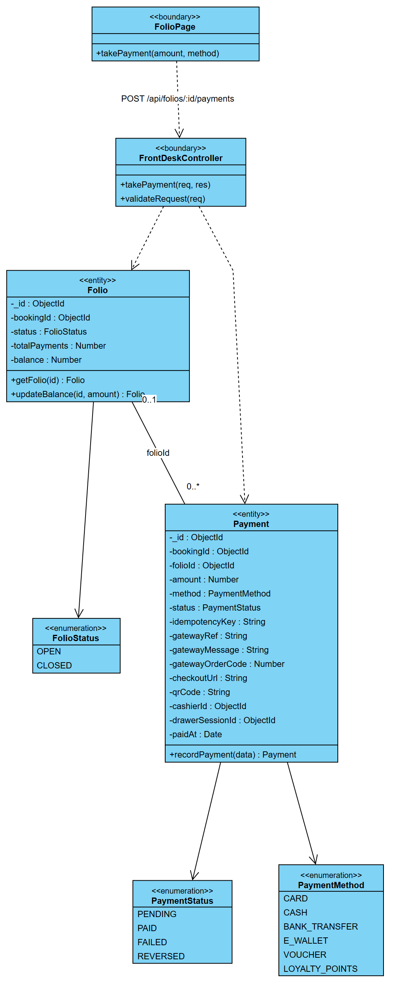
Figure 2.27 CD-14 Class Diagram - UC-R15 Process Payment

4.2.3 Sequence Diagram
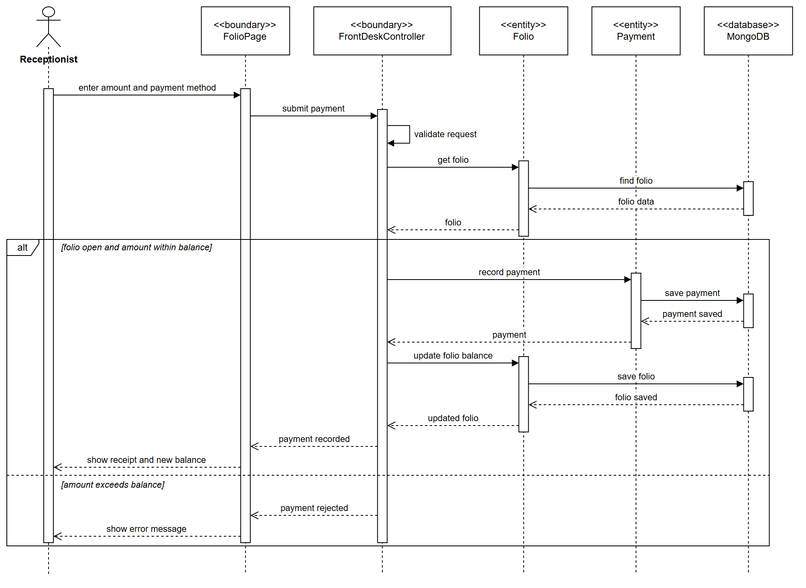
Figure 2.28 SD-14 Sequence Diagram - UC-R15 Process Payment

4.3 UC-C17 Request Refund

4.3.1 Use Case Specification
ID UC and Name: | UC-C17 - Request Refund
Created By: |  | Date Created: | 10/11/2026
Primary Actor: | Customer | Secondary Actors: | Manager (approver), Payment Gateway, Email Service
Trigger: | The Customer opens an invoice and clicks Request refund.
Description: | Lets a Customer ask for money back on a cancelled, overcharged or disputed booking. The request enters an approval workflow; on approval the money is returned through the original payment channel.
Preconditions: | PRE-1: A Payment with status PAID exists for the booking.  PRE-2: The Customer is authenticated and owns the booking.  PRE-3: No refund request is already pending for the same payment.
Postconditions: | POST-1: A RefundRequest exists with status PENDING.  POST-2: The Manager is notified for approval.  POST-3: On approval a refund transaction is issued to the original method and the request becomes COMPLETED.
Normal Flow: | 1.0: Refund request and approval  - The Customer opens the booking or invoice. («include» UC-C15)  - The Customer clicks Request refund.  - The system checks eligibility: the payment is PAID, within the 90-day refund window, and has no pending request.  - The system displays the refund form: refundable amount, reason category, description, attachments.  - The Customer selects a reason and submits the request.  - The system creates a RefundRequest with status PENDING and a reference number.  - The system notifies the Manager and emails the Customer an acknowledgement with the reference.  - The Manager reviews the request. (→ UC-M14 Approve Refund Request)  - The Manager approves the full or a partial amount with a note.  - The system sets the request to APPROVED and issues the refund to the original payment method through the gateway.  - The gateway confirms; the system sets the request to COMPLETED and records the refund transaction.  - The system emails the Customer the outcome and the expected settlement date.
Alternative Flows: | 1.1: Automatic refund within policy  where the cancellation falls in the free window (UC-G14), the system approves automatically at step 8 without Manager involvement.  1.2: Partial approval  the Manager approves less than requested with a justification; the Customer is informed of the amount and the reason.  1.3: Refund to an alternative method  the original card has expired; after identity verification the Manager authorizes a bank transfer to the Customer's account.  1.4: Rejection  the Manager rejects with a reason; the request becomes REJECTED and the Customer is notified with the appeal channel.
Exceptions: | 1.0.E1 — Payment not refundable (non-refundable rate)  "This booking was made under a non-refundable rate." Offer the support channel.  1.0.E2 — Refund window expired  "Refund requests must be made within 90 days of payment." Terminate.  1.0.E3 — A request already exists  show the existing request and its status instead of creating a duplicate.  1.0.E4 — Gateway cannot refund  the request stays APPROVED with a REFUND_FAILED flag; the Admin is alerted and a manual transfer is arranged. With payOS this is the normal path, not an exception: payOS has no refund API (BR-50).  1.0.E5 — Refund exceeds the amount paid  the system caps the refundable amount at the sum actually captured.
Priority: | High
Frequency of Use: | A few per week.
Business Rules: | BR-35 Refunds go to the original payment method by default. BR-36 The refund window is 90 days from payment. BR-37 A refund may never exceed the captured amount. BR-38 Refunds above a threshold require Manager approval. BR-39 Every refund decision is audit-logged with the approver.
Other Information: | Manager decision within 3 working days; settlement within 7–14 working days depending on the issuer; the whole chain is traceable from request to gateway reference.
Assumptions: | —

4.3.2 Class Diagram
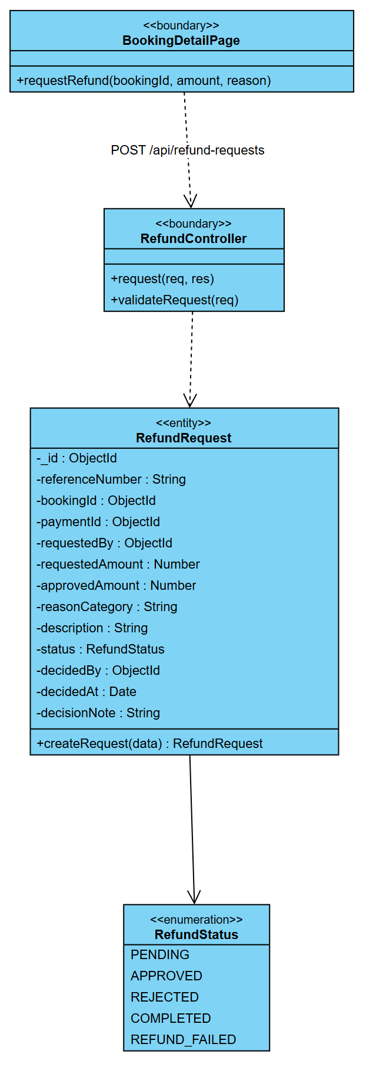
Figure 2.29 CD-15 Class Diagram - UC-C17 Request Refund

4.3.3 Sequence Diagram
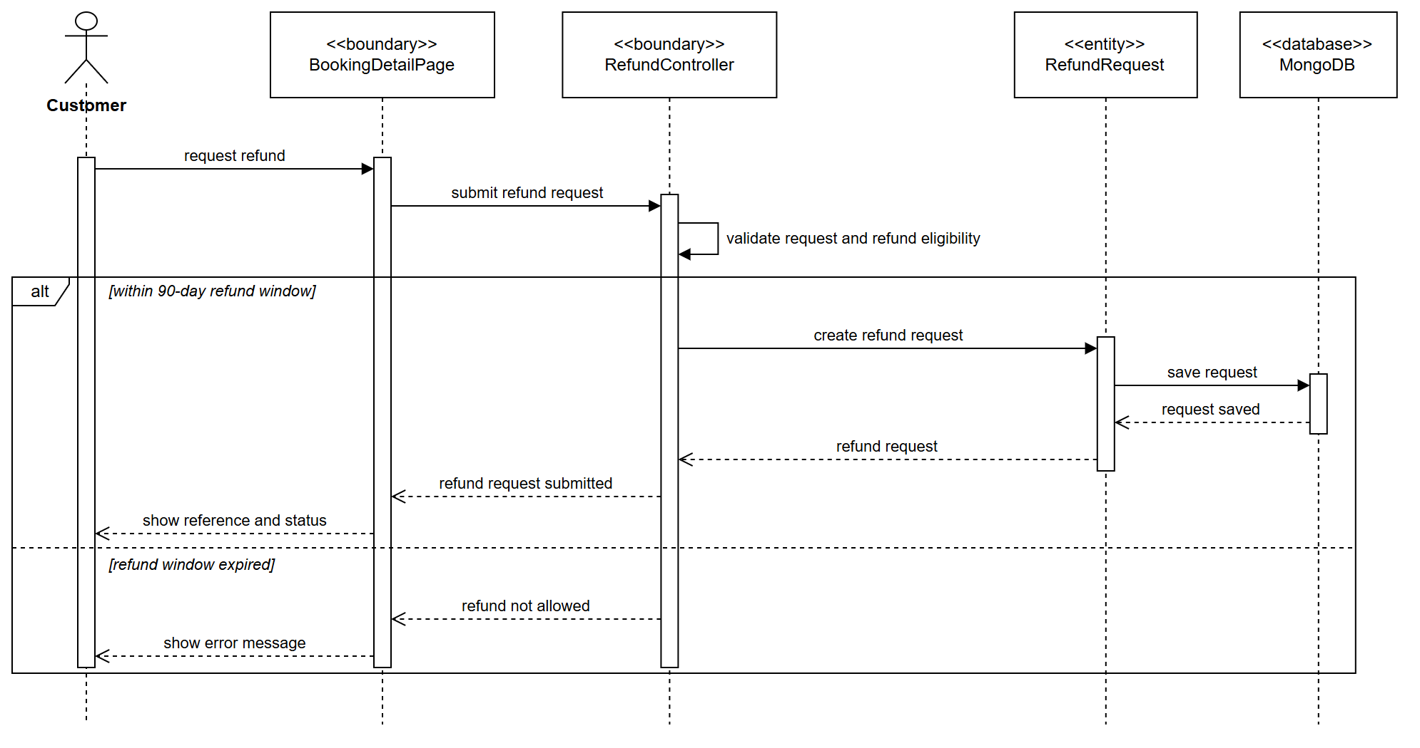
Figure 2.30 SD-15 Sequence Diagram - UC-C17 Request Refund

4.4 UC-M14 Approve Refund Request

4.4.1 Use Case Specification
ID UC and Name: | UC-M14 - Approve Refund Request
Created By: |  | Date Created: | 10/11/2026
Primary Actor: | Manager | Secondary Actors: | Payment Gateway, Email / SMS Service
Trigger: | The Manager opens the approvals queue, or is notified of a new refund request.
Description: | Lets a Manager decide on refund requests that are above the automatic threshold: approve the full amount, approve part of it, or reject with a reason. It is included by UC-M13 and follows UC-C17 Request Refund.
Preconditions: | PRE-1: The Manager is signed in and holds the APPROVE_REFUND permission.  PRE-2: The refund request is PENDING.
Postconditions: | POST-1: The request is APPROVED with the approved amount, or REJECTED with the reason.  POST-2: The customer is notified of the decision.
Normal Flow: | 1.0: Approve a refund request  - The Manager opens the pending refund requests.  - The system lists the pending requests with the booking and the amounts.  - The Manager selects a request, enters the amount to approve and selects Approve.  - The system validates the request.  - The system records the approval with the approved amount, the Manager and the time.  - The system removes the request from the queue and notifies the customer.
Alternative Flows: | 1.1: Reject the request  The Manager rejects with a mandatory reason; the request becomes REJECTED and the customer is notified with the reason.  1.2: Partial approval  The Manager approves less than requested with a note; the approved amount is stored.
Exceptions: | 1.0.E1 — Amount exceeds the captured total  The approved amount is more than was paid: "Invalid refund amount." Nothing is stored. (BR-37)  1.0.E2 — Already decided  Another Manager decided first: "This request has already been approved / rejected."  1.1.E1 — Rejection without reason  "A rejection requires a reason."
Priority: | High
Frequency of Use: | A few requests per week.
Business Rules: | BR-37 A refund may never exceed the captured amount. BR-38 Refunds above the threshold require Manager approval. BR-39 Every refund decision is audit-logged with the approver.
Other Information: | The Manager's decision is expected within 3 working days.
Assumptions: | The original payment is still refundable through the gateway.

4.4.2 Class Diagram
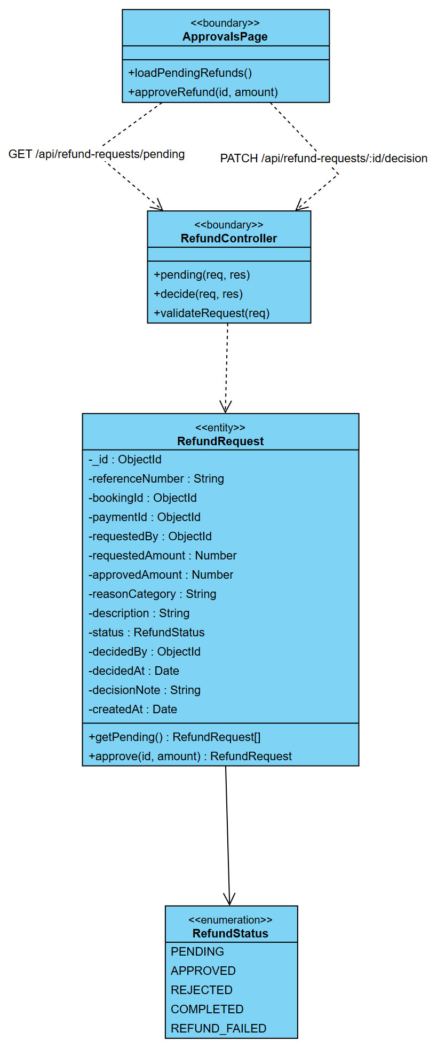
Figure 2.31 CD-16 Class Diagram - UC-M14 Approve Refund Request

4.4.3 Sequence Diagram
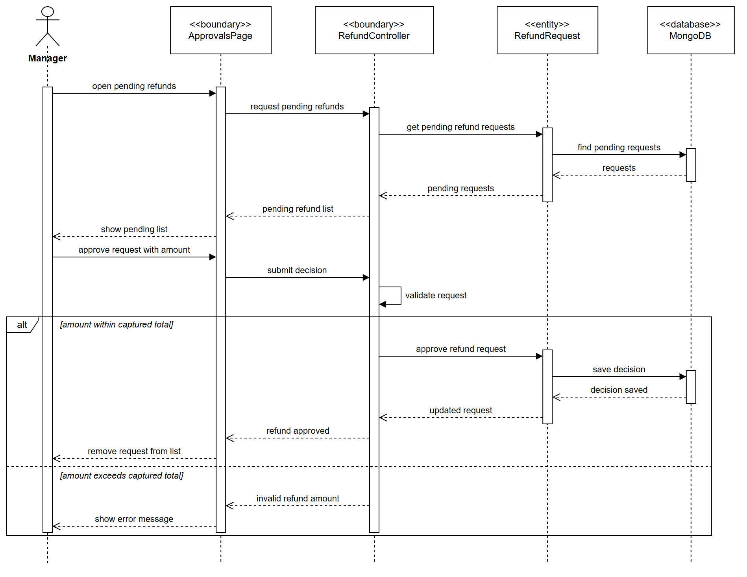
Figure 2.32 SD-16 Sequence Diagram - UC-M14 Approve Refund Request

5. Front Desk & HR

5.1 UC-R06 Check In Guest

5.1.1 Use Case Specification
ID UC and Name: | UC-R06 - Check In Guest
Created By: |  | Date Created: | 10/11/2026
Primary Actor: | Receptionist | Secondary Actors: | —
Trigger: | A guest arrives at the front desk and presents a booking code or identity document.
Description: | Admits an arriving guest: verifies identity against the reservation, allocates a specific vacant-clean room, collects any outstanding balance or deposit, and activates the stay so the folio can receive charges.
Preconditions: | PRE-1: A booking exists with status CONFIRMED for today.  PRE-2: The Receptionist is authenticated with the CHECK_IN permission.  PRE-3: At least one room of the booked type is in status VACANT_CLEAN.
Postconditions: | POST-1: The booking status becomes CHECKED_IN with the actual arrival time recorded.  POST-2: A specific room is allocated and its status becomes OCCUPIED.  POST-3: An open folio exists for the stay.  POST-4: Guest identity details are recorded for legal registration.
Normal Flow: | 1.0: Standard check-in of a confirmed booking  - The Receptionist searches for the booking. («include» UC-R01 / UC-R02)  - The system displays the reservation: guest, room type, dates, occupancy, balance.  - The Receptionist requests the guest's identity document.  - The Receptionist records the document type, number and expiry, and matches the name against the reservation. («include» UC-R07 Verify Guest Identity)  - The system validates that the document is not expired and that the guest is of legal age.  - The system lists the rooms of the booked type in status VACANT_CLEAN. («include» UC-R08 Assign Room)  - The Receptionist selects a room, honouring any preference (floor, view, quiet).  - The system locks the selected room to prevent double allocation.  - The system shows any outstanding balance and required deposit.  - The Receptionist collects the balance and/or deposit. («include» UC-R15 Process Payment, «extend» UC-R18 Apply Deposit)  - The Receptionist confirms the check-in.  - The system sets the booking to CHECKED_IN, sets the room to OCCUPIED, records the arrival timestamp, and opens the folio.  - The system issues the key card and prints the registration card for signature.
Alternative Flows: | 1.1: Walk-in check-in  no prior reservation. The Receptionist first creates one («extend» UC-R03 Create Walk-in Booking) and then continues from step 3.  1.2: Early check-in  the guest arrives before the standard time. The system applies the early-check-in surcharge if a room is ready, or places the guest on a waiting list.  1.3: Room upgrade  no room of the booked type is ready but a higher type is. The Receptionist assigns the upgrade, complimentary or charged, and the system records the reason.  1.4: Rooms booked together  a multi-room reservation is checked in room by room, each with its own room and folio, so a family arriving at different times is not held up. The desk sees "room 2 of 3 booked together" to place the rooms near each other. The identity check accepts the person named as staying in that room, or the booker.
Exceptions: | 1.0.E1 — Booking not found  offer to search by name/phone or to create a walk-in booking.  1.0.E2 — Identity mismatch  "The document does not match the reservation holder." The document must belong to the booker or, when one is named, to the person staying in that room (UC-G07 step 4). Otherwise require authorization; do not proceed.  1.0.E3 — Expired identity document  "The identity document has expired." Escalate to the Manager.  1.0.E4 — No vacant-clean room of the booked type  the system offers an upgrade (1.3), or flags housekeeping to prioritize a dirty room, or places the guest on a waiting list.  1.0.E5 — Outstanding balance unpaid  the check-in cannot be completed until the balance is settled or the Manager authorizes an exception.  1.0.E6 — Room allocated concurrently by another Receptionist  the optimistic lock at step 8 fails. "This room has just been taken." Return to step 6 with a refreshed list.  1.0.E7 — Guest under the legal age without a guardian  refuse the check-in per BR-24.
Priority: | High
Frequency of Use: | Once per stay; peaks around the standard 14:00 check-in time.
Business Rules: | BR-21 Standard check-in from 14:00. BR-22 Identity registration is legally mandatory for all adult occupants. BR-23 A deposit is required for incidentals. BR-24 Minimum age 18 unless accompanied by a guardian. BR-25 A room may be allocated to exactly one active stay.
Other Information: | Check-in completed in ≤ 3 minutes of desk time; room allocation must be race-free under concurrent Receptionists; must remain operable in a degraded offline mode with later reconciliation.
Assumptions: | —

5.1.2 Class Diagram
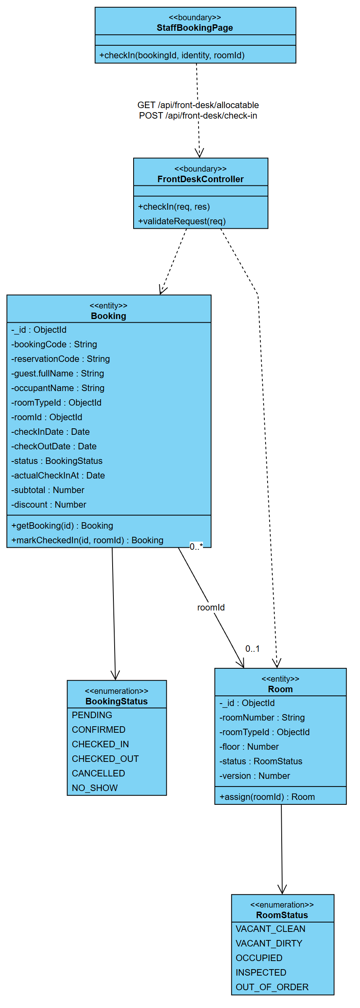
Figure 2.33 CD-17 Class Diagram - UC-R06 Check In Guest

5.1.3 Sequence Diagram
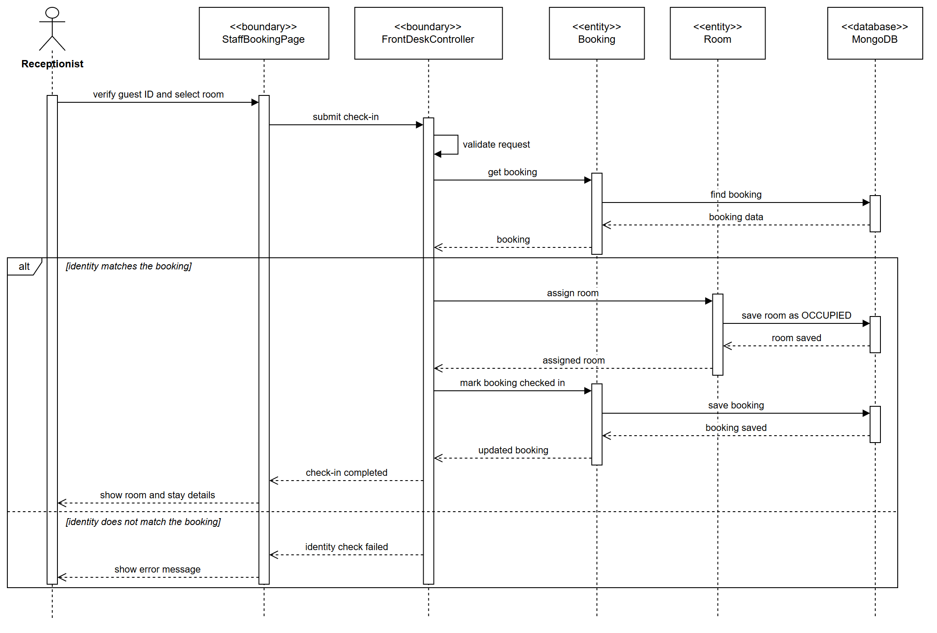
Figure 2.34 SD-17 Sequence Diagram - UC-R06 Check In Guest

5.2 UC-R09 Check Out Guest

5.2.1 Use Case Specification
ID UC and Name: | UC-R09 - Check Out Guest
Created By: |  | Date Created: | 10/11/2026
Primary Actor: | Receptionist | Secondary Actors: | Payment Gateway, Email Service
Trigger: | The guest presents at the desk to depart, or the departure is processed at the end of the stay.
Description: | Closes an in-house stay: consolidates all folio charges, produces the final invoice, settles the balance, returns the deposit and releases the room to housekeeping.
Preconditions: | PRE-1: The booking status is CHECKED_IN.  PRE-2: The Receptionist is authenticated with the CHECK_OUT permission.
Postconditions: | POST-1: The booking status becomes CHECKED_OUT with the actual departure time recorded.  POST-2: The folio is closed with a zero balance.  POST-3: A final invoice is generated and issued.  POST-4: The room status becomes VACANT_DIRTY and a housekeeping task is created.  POST-5: Loyalty points are credited for a Customer.
Normal Flow: | 1.0: Standard check-out  - The Receptionist opens the in-house stay by room number or guest name.  - The system displays the folio: room charges per night, add-on services, taxes, payments already made, balance.  - The Receptionist reviews the outstanding charges with the guest and posts any final items (minibar, late charges). («extend» UC-R19)  - The system recalculates the total and the taxes.  - The system generates the final invoice. («include» UC-R10 Generate Final Invoice)  - The Receptionist collects the outstanding balance. («include» UC-R15 Process Payment)  - The system releases or applies the security deposit.  - The system issues the invoice/receipt to the guest by print and email. («include» UC-R16)  - The Receptionist collects the key card and confirms the check-out.  - The system sets the booking to CHECKED_OUT, closes the folio and records the departure time.  - The system sets the room to VACANT_DIRTY and raises a housekeeping task. («include» UC-R13 Update Room Status)  - The system credits loyalty points if the guest is a registered Customer.  - The system schedules the post-stay review invitation. (→ UC-C18)
Alternative Flows: | 1.1: Late check-out  («extend» UC-R11) the guest departs after the standard time; the system applies the late-checkout surcharge or waives it per the Manager's authorization.  1.2: Early departure  the guest leaves before the booked departure date; the system recomputes the charges and applies any early-departure penalty.  1.3: Express check-out  the guest authorized the card on file; the system settles automatically, emails the invoice and performs steps 10–12 without the guest at the desk.  1.4: Company/corporate billing  the balance is transferred to the corporate account ledger instead of being collected; the invoice is issued to the company.
Exceptions: | 1.0.E1 — Payment declined at settlement  the check-out is blocked; the guest must supply another method; the Manager may authorize a debtor entry.  1.0.E2 — Disputed charge  the item is flagged DISPUTED, escalated to the Manager, and the check-out proceeds on the undisputed balance.  1.0.E3 — Room damage found  the Receptionist posts a damage charge against the deposit; if the damage exceeds the deposit a supplementary charge is raised.  1.0.E4 — Deposit refund fails at the gateway  the check-out completes; the refund is queued for retry and the guest is informed of the timeline.  1.0.E5 — Missing key card  a replacement fee is posted before completion.
Priority: | High
Frequency of Use: | Once per stay; peaks around the standard 12:00 check-out time.
Business Rules: | BR-26 Standard check-out by 12:00. BR-27 Late check-out to 18:00 is charged at 50 % of the nightly rate. BR-28 The folio must reach zero before the stay closes. BR-29 Loyalty points are credited only on completed stays. BR-30 Invoices are immutable once issued; corrections require a credit note.
Other Information: | Invoice generated in ≤ 3 s; invoice numbering strictly sequential and gapless for tax compliance; folio totals computed in integer minor units.
Assumptions: | —

5.2.2 Class Diagram
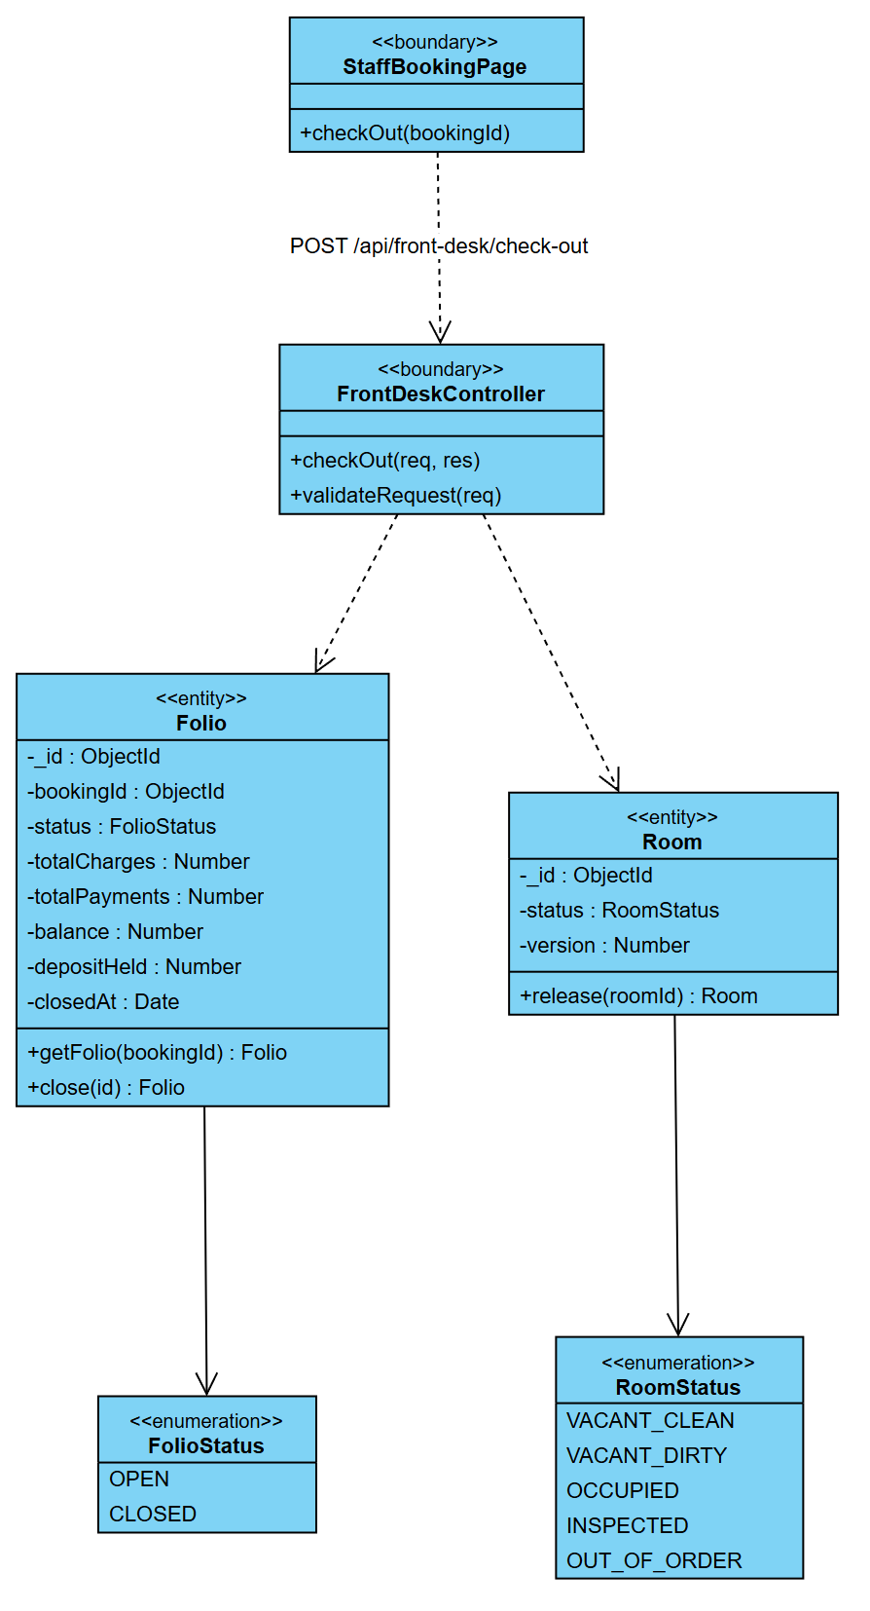
Figure 2.35 CD-18 Class Diagram - UC-R09 Check Out Guest

5.2.3 Sequence Diagram
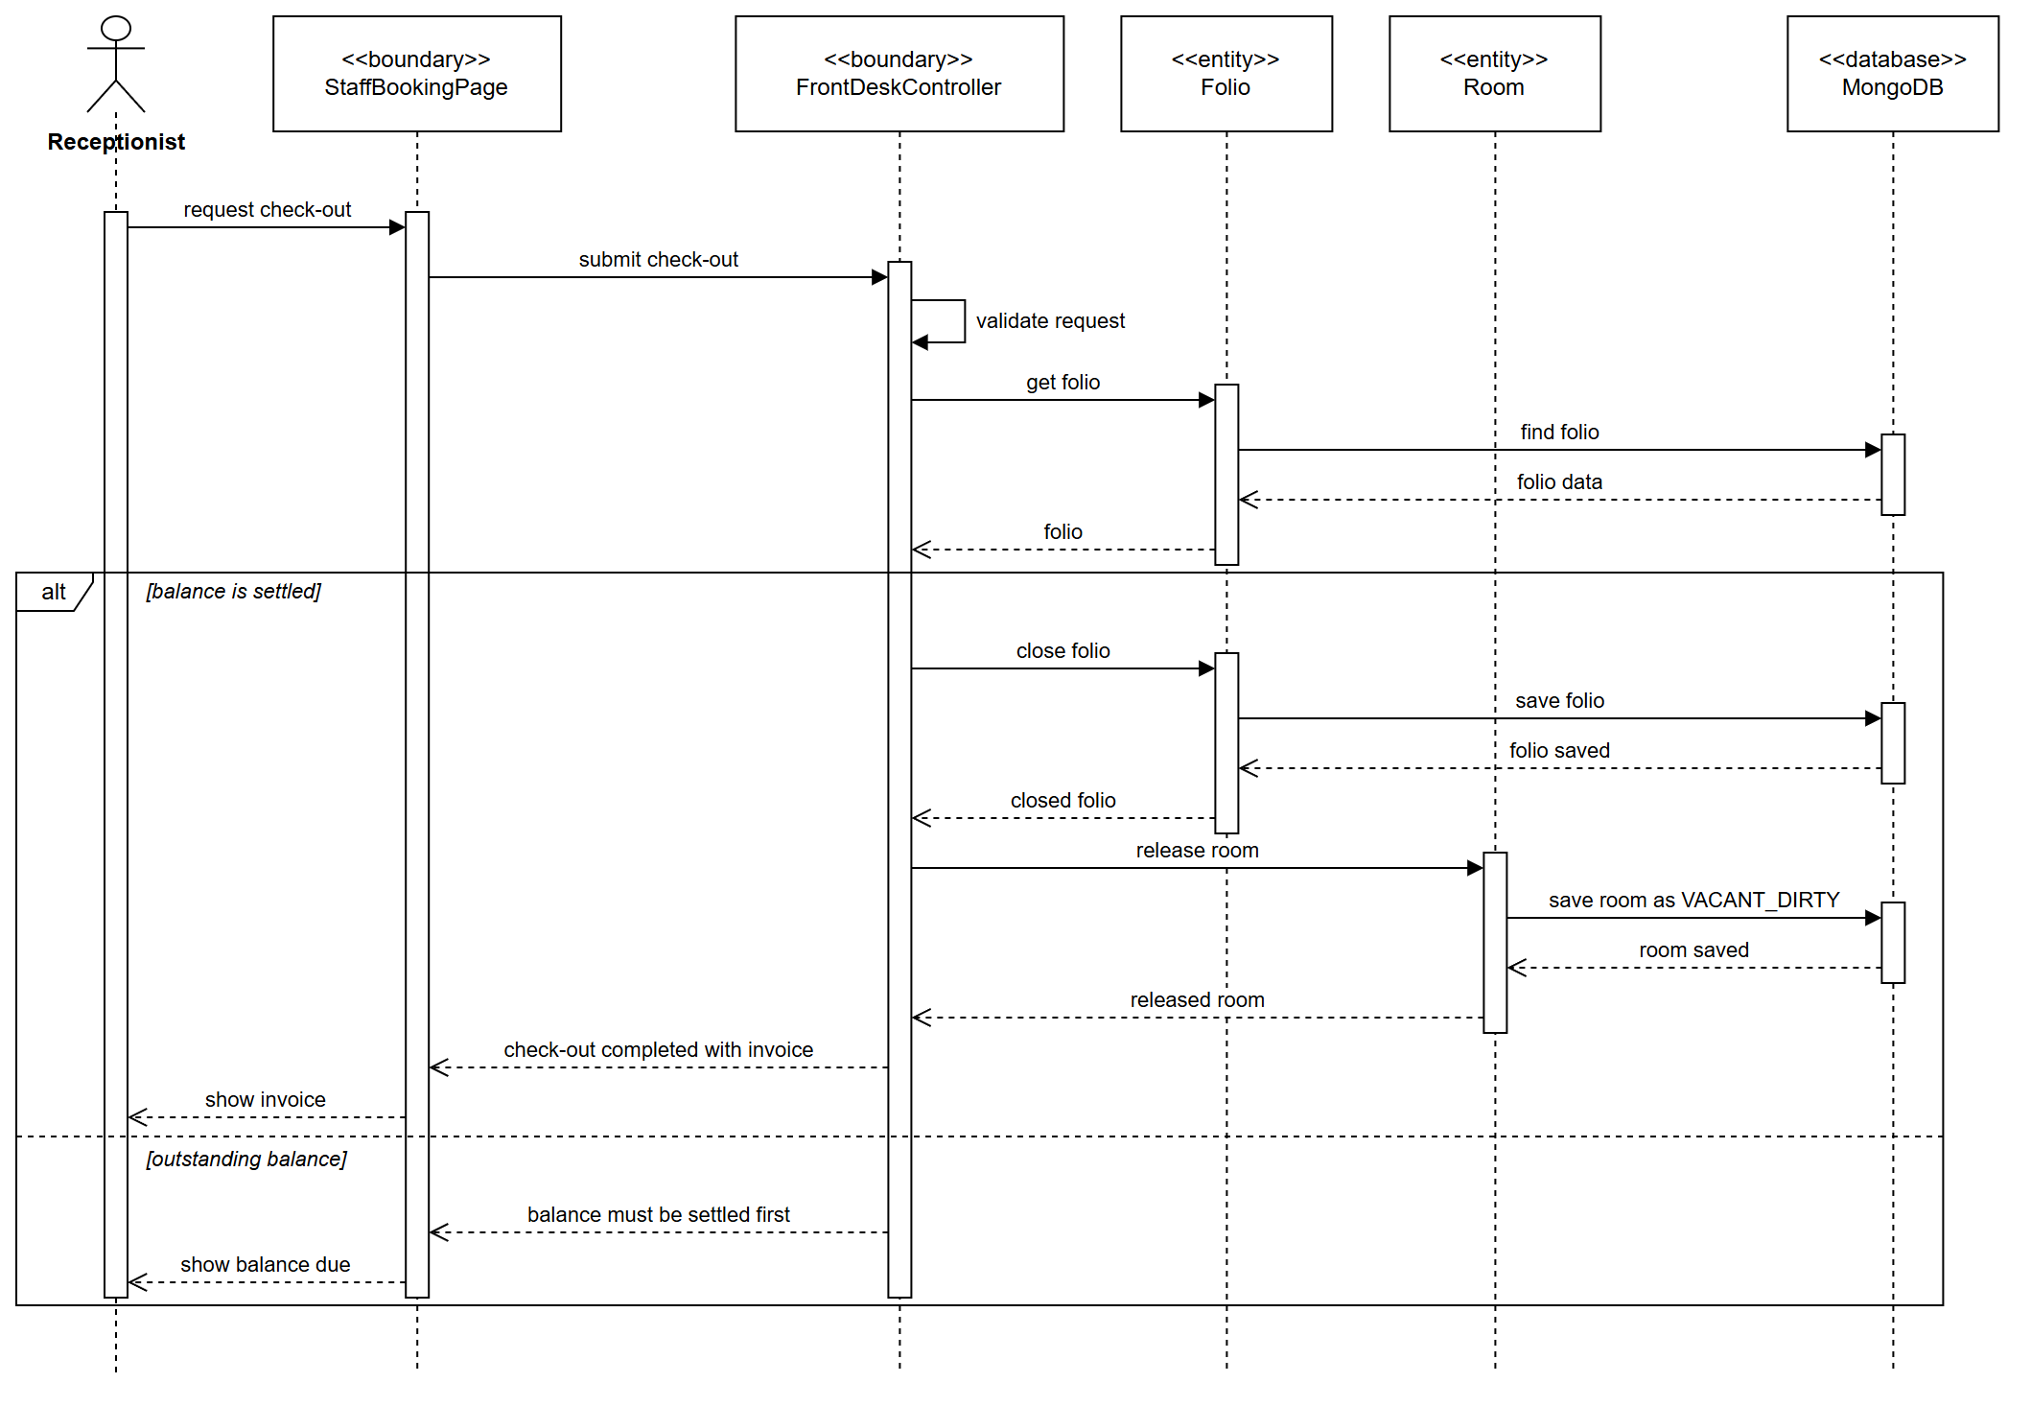
Figure 2.36 SD-18 Sequence Diagram - UC-R09 Check Out Guest

5.3 UC-E15 Submit Leave Request

5.3.1 Use Case Specification
ID UC and Name: | UC-E15 - Submit Leave Request
Created By: |  | Date Created: | 10/11/2026
Primary Actor: | Employee | Secondary Actors: | None
Trigger: | The employee opens My leave and selects New request.
Description: | Lets any employee apply for annual, sick, unpaid or maternity leave for a range of days. The request waits for a Manager's decision (UC-M06).
Preconditions: | PRE-1: The employee is signed in.
Postconditions: | POST-1: A leave request is stored as PENDING with the number of days counted by the system.  POST-2: LEAVE_REQUESTED is recorded in the audit log.
Normal Flow: | 1.0: Submit a leave request  - The employee opens My leave and selects New request.  - The employee enters the leave type, the first and last day and a reason, then submits.  - The system validates the request.  - The system counts the days and stores the request as PENDING.  - The system shows the request in the employee's list.
Alternative Flows: | 1.1: Cancel a pending request  While the request is still PENDING the employee may cancel it (UC-E16); it becomes CANCELLED.
Exceptions: | 1.0.E1 — End date before start date  "The end date must not precede the start date." Nothing is stored. Return to step 2.  1.0.E2 — Missing field  A missing type, date or reason is named and refused.
Priority: | High
Frequency of Use: | Several requests per employee per year.
Business Rules: | BR-40 Leave may not exceed the accrued balance unless approved as unpaid (checked at approval, UC-M06). BR-44 A Manager may not approve their own leave.
Other Information: | The balance is checked when the Manager decides, not when the request is submitted.
Assumptions: | Each employee belongs to a department with a Manager.

5.3.2 Class Diagram
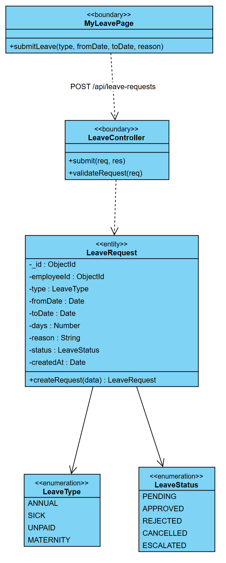
Figure 2.37 CD-19 Class Diagram - UC-E15 Submit Leave Request

5.3.3 Sequence Diagram
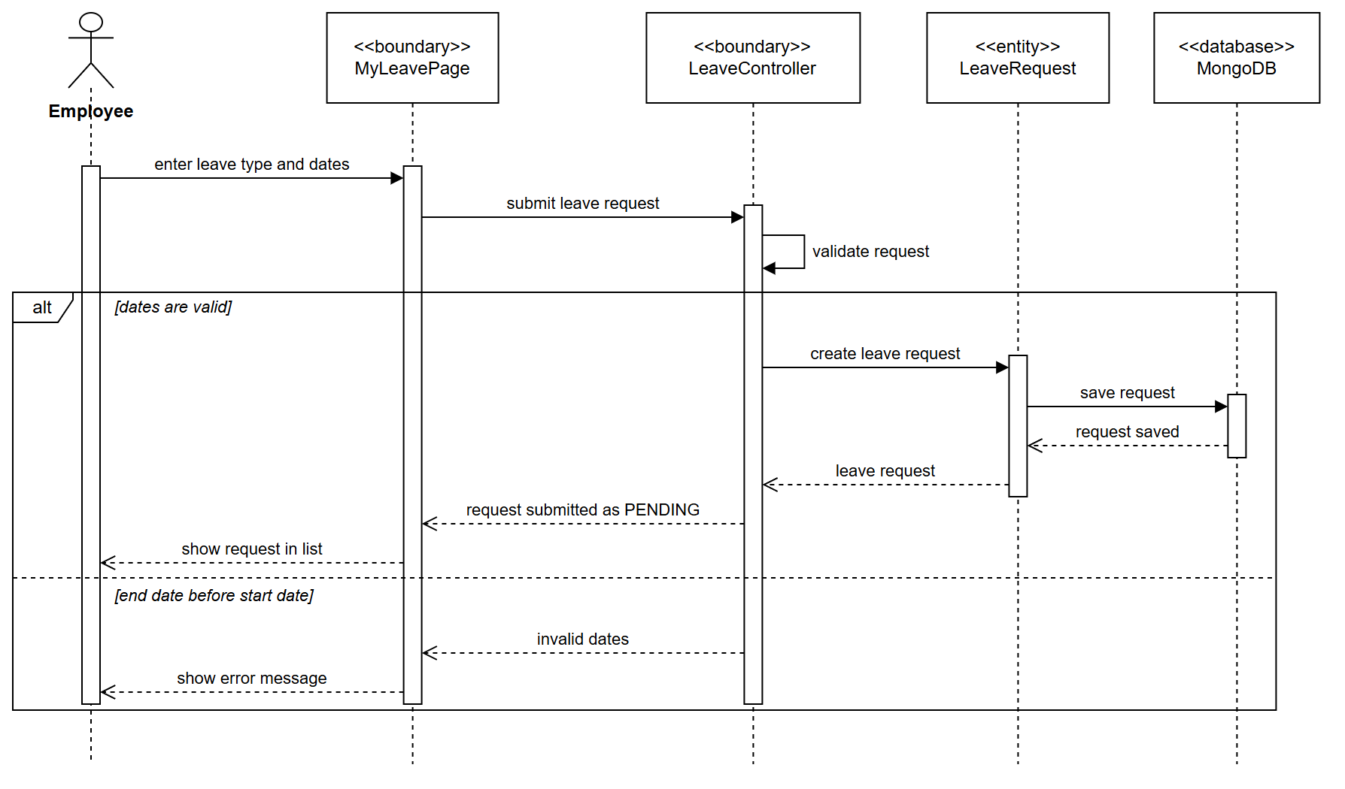
Figure 2.38 SD-19 Sequence Diagram - UC-E15 Submit Leave Request

5.4 UC-M06 Approve / Reject Leave Request

5.4.1 Use Case Specification
ID UC and Name: | UC-M06 - Approve / Reject Leave Request
Created By: |  | Date Created: | 10/11/2026
Primary Actor: | Manager | Secondary Actors: | Employee (requester), Notification Service
Trigger: | The Manager opens the pending-approvals queue, or is notified of a new leave request.
Description: | Lets a Manager decide on leave applications submitted by employees, checking the leave balance, the staffing impact on the roster, and the overlap with other approved leave.
Preconditions: | PRE-1: At least one LeaveRequest has status PENDING.  PRE-2: The Manager has the APPROVE_LEAVE permission for the requester's department.
Postconditions: | POST-1: The request status becomes APPROVED or REJECTED, with the decision maker and timestamp.  POST-2: On approval the employee's leave balance is decremented and the roster is marked.  POST-3: The employee is notified of the outcome.
Normal Flow: | 1.0: Approve a leave request  - The Manager opens the pending-approvals list.  - The system displays the pending requests with employee, leave type, dates, days, reason and submission time.  - The Manager selects a request.  - The system displays the detail together with the employee's remaining balance, the shifts affected, and other approved leave overlapping those dates.  - The system flags any staffing risk, for example when coverage would fall below the departmental minimum.  - The Manager approves with an optional note.  - The system sets the request to APPROVED, records the approver and the timestamp.  - The system decrements the employee's leave balance by the number of days.  - The system marks the affected shifts as on-leave and flags the roster gaps for reassignment.  - The system notifies the employee and updates the department leave calendar.
Alternative Flows: | 1.1: Reject the request  the Manager rejects with a mandatory reason; the status becomes REJECTED; the balance is untouched; the employee is notified with the reason.  1.2: Partial approval  the Manager approves a shorter period than requested; the system splits the request, approves the granted days and rejects the rest with a note.  1.3: Bulk approval  the Manager selects several low-risk requests and approves them in one action; the system applies steps 7–10 to each.  1.4: Escalation  leave longer than 10 consecutive days is escalated to a higher authority; the status becomes ESCALATED.
Exceptions: | 1.0.E1 — Insufficient leave balance  "The employee has only N days remaining." The Manager may reject, approve partially, or approve as unpaid leave.  1.0.E2 — Staffing below the minimum  the system warns and requires an explicit override justification, which is audit-logged.  1.0.E3 — The request was cancelled by the employee meanwhile  (UC-E16) "This request has been withdrawn." Refresh the queue.  1.0.E4 — Blackout period  the dates fall in a declared peak-season blackout; approval requires a higher-level override.  1.0.E5 — Concurrent decision by another Manager  the optimistic lock fails; show the decision already recorded and refresh.
Priority: | High
Frequency of Use: | Several per week per department.
Business Rules: | BR-40 Leave may not exceed the accrued balance unless approved as unpaid. BR-41 Departmental coverage must not fall below the minimum without an override. BR-42 A rejection requires a reason. BR-43 Requests must be decided within 5 working days. BR-44 A Manager may not approve their own leave.
Other Information: | The employee is notified within 1 minute of the decision; every decision is immutably audit-logged with the approver identity.
Assumptions: | —

5.4.2 Class Diagram
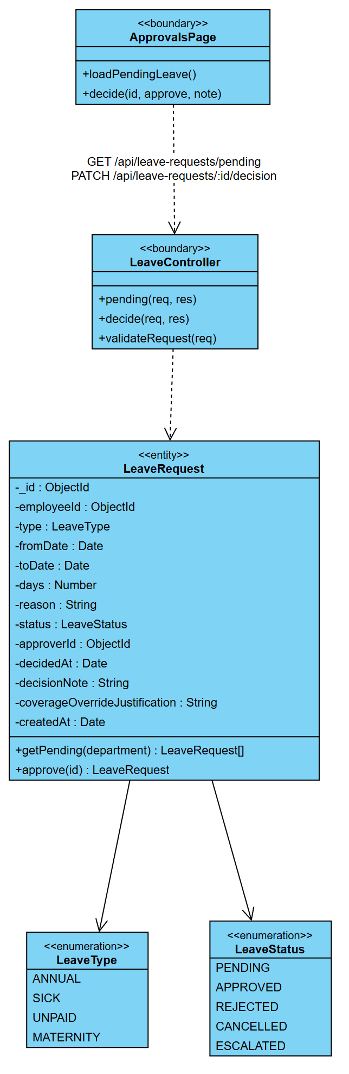
Figure 2.39 CD-20 Class Diagram - UC-M06 Approve / Reject Leave Request

5.4.3 Sequence Diagram
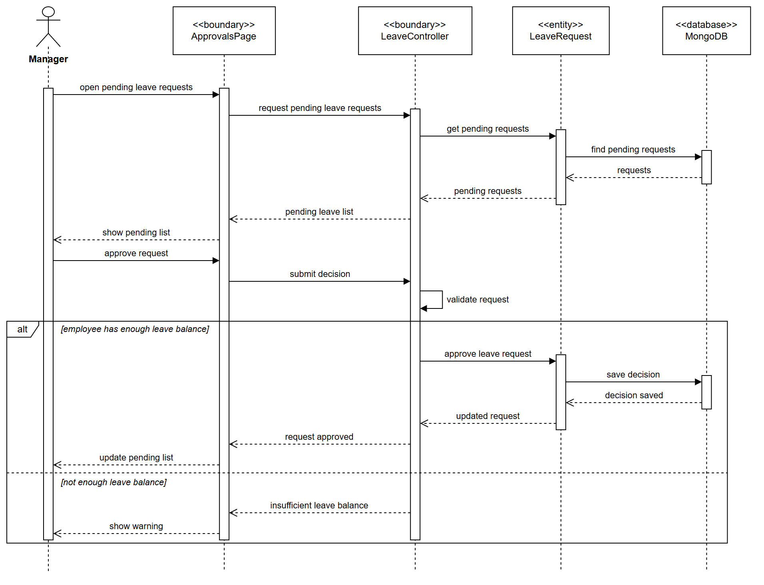
Figure 2.40 SD-20 Sequence Diagram - UC-M06 Approve / Reject Leave Request

III. System Design

1. Architecture

1.1 Architectural Style
HotelHub uses a layered client-server architecture with a React single-page client and an Express REST service. The server is organized into four layers that map onto the object structuring categories: boundary, control, application logic and entity objects.
Layer | Object category | Contents
Presentation | <<boundary>> user interaction | React pages, components, hooks
API / Boundary | <<boundary>> I/O, <<proxy>> | Express routes, controllers, external proxies
Business | <<control>>, <<application logic>> | Coordinators, state machines, rules, algorithms
Data | <<entity>> | Mongoose models and repositories

1.2 Layered Architecture
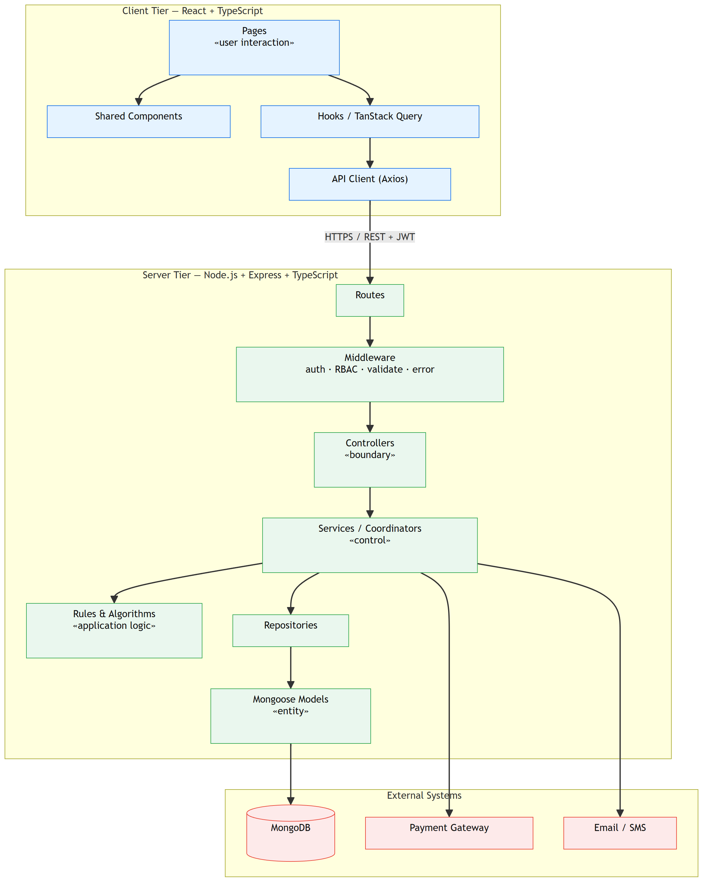
Figure 3.1 Layered Architecture

1.3 Subsystem Decomposition
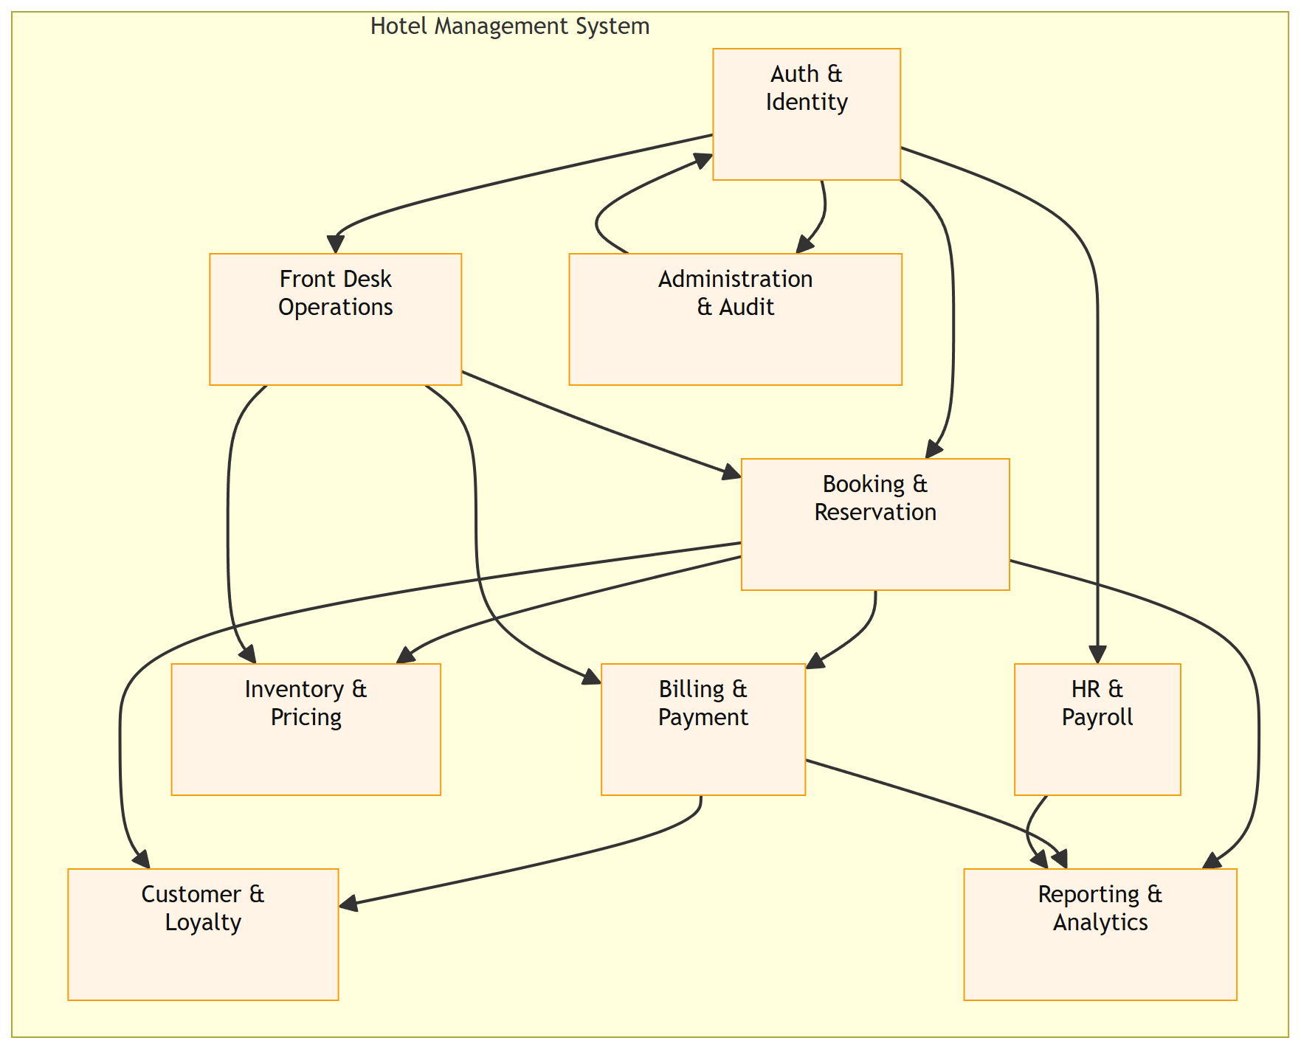
Figure 3.2 Subsystem Decomposition
Subsystem | Responsibility | Principal use cases
Auth & Identity | Authentication, session, RBAC enforcement | UC-G16, UC-G17, UC-C01…C05, UC-A06
Booking & Reservation | Search, book, modify, cancel | UC-G01, UC-G07, UC-G13…G15, UC-R03…R05
Front Desk Operations | Check-in/out, room status, folio | UC-R06…R14, UC-R19
Billing & Payment | Payments, invoices, refunds | UC-G10, UC-R15…R18, UC-C17, UC-M14
Inventory & Pricing | Rooms, room types, rates, promotion codes | UC-M09…M12, UC-M19…M22, UC-G06, UC-G11
HR & Payroll | Attendance, shifts, leave, payroll | UC-E09…E24, UC-M01…M08b
Customer & Loyalty | Profile, reviews, points | UC-C06…C21, UC-M15
Reporting & Analytics | Revenue, occupancy, exports | UC-M16…M18
Administration & Audit | Accounts, roles, settings, audit, backup | UC-A01…A18

1.4 Package Diagram
Every package dependency points downward: a package may only depend on packages in the layers below it, so a change in a lower layer never forces a change in a higher one.
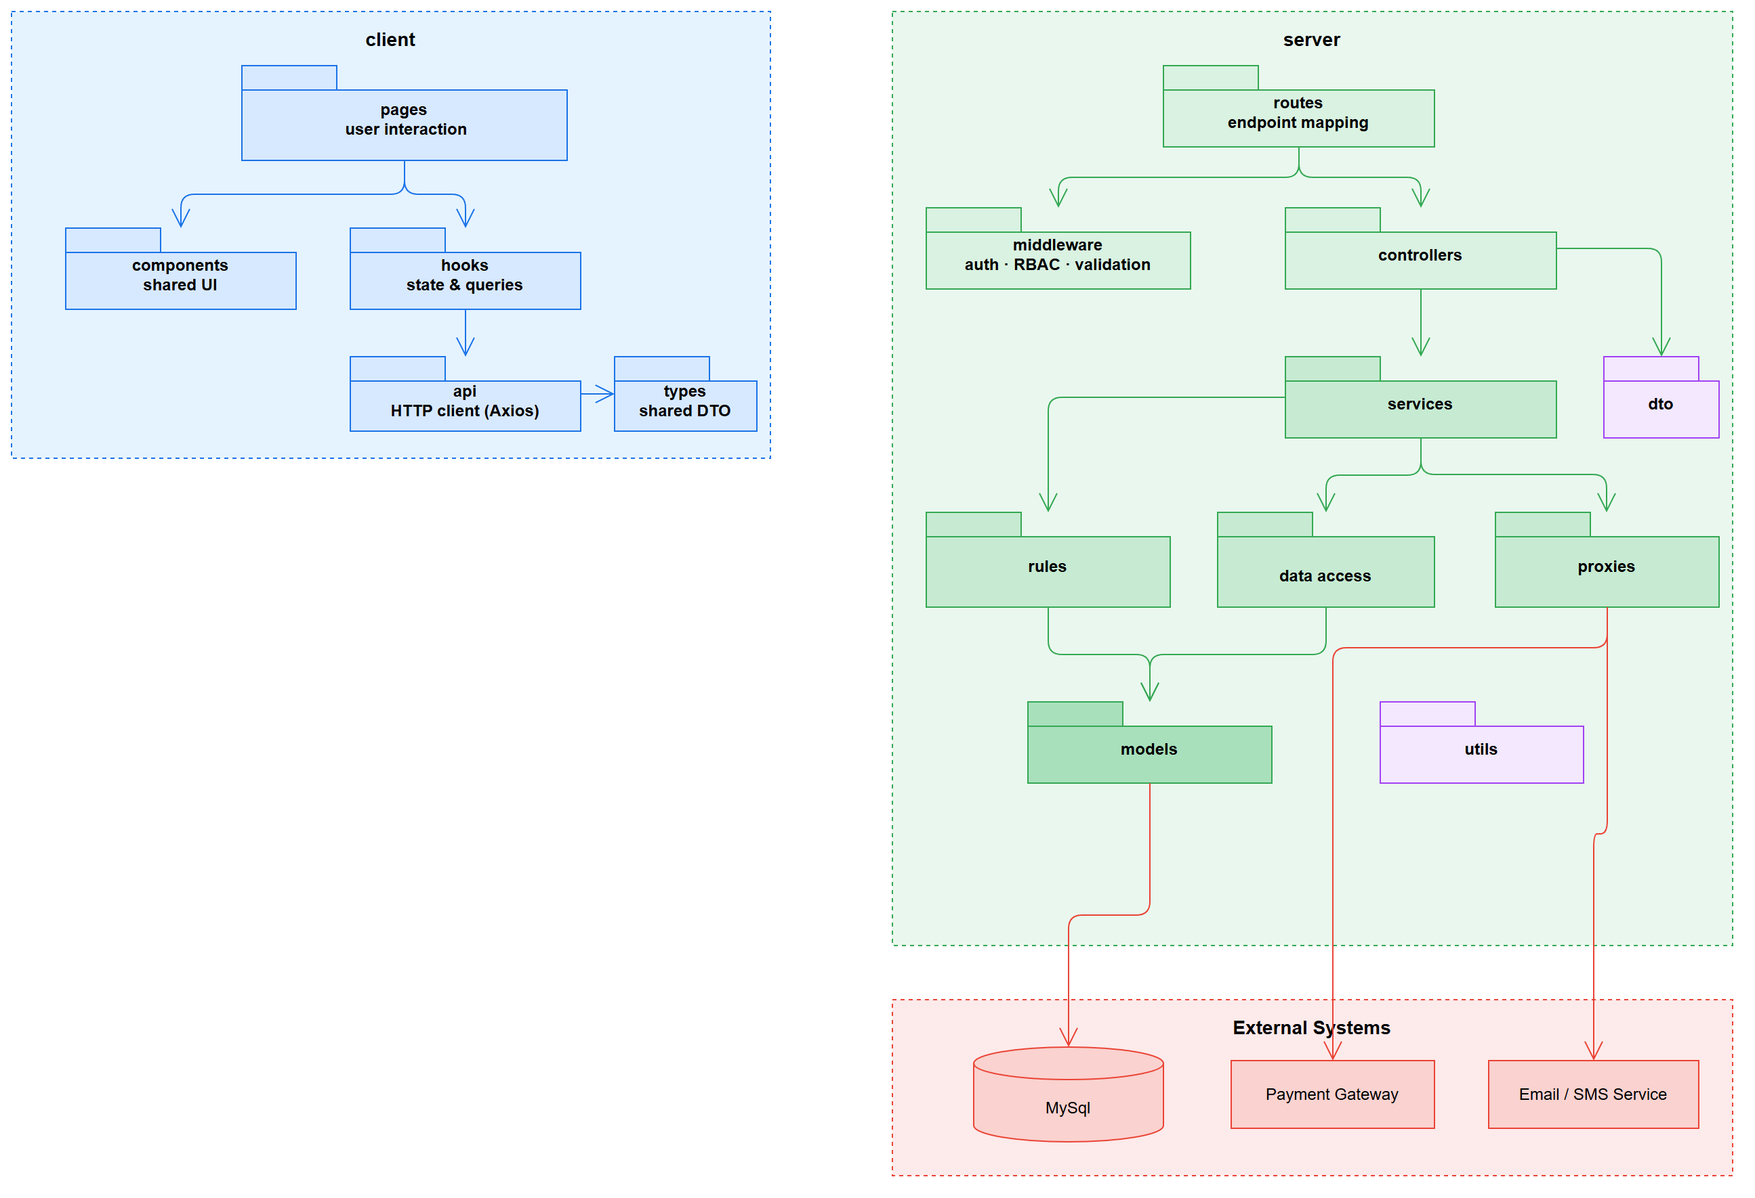
Figure 3.3 Package Diagram
Package | Category | May depend on | Must not depend on
client/pages | <<boundary>> user interaction | components, hooks, types | server internals
client/hooks | — | api, types | pages
client/api | <<boundary>> I/O | types | pages, hooks
server/routes | — | controllers, middleware | services, models
server/middleware | <<boundary>> | utils, models (auth only) | controllers, services
server/controllers | <<boundary>> I/O | services, dto, utils | models, repositories
server/services | <<control>> | rules, repositories, proxies, dto, utils | controllers, routes
server/rules | <<application logic>> | models, utils | services, repositories, proxies
server/repositories | — | models | services, controllers
server/models | <<entity>> | utils | everything above
server/proxies | <<boundary>> external | utils, dto | services, models

1.5 Deployment
The React client is served from a static host; the API runs as several Node.js instances behind an HTTPS load balancer, sharing a MongoDB replica set and a Redis cache. payOS and the email / SMS provider are reached through their proxies.
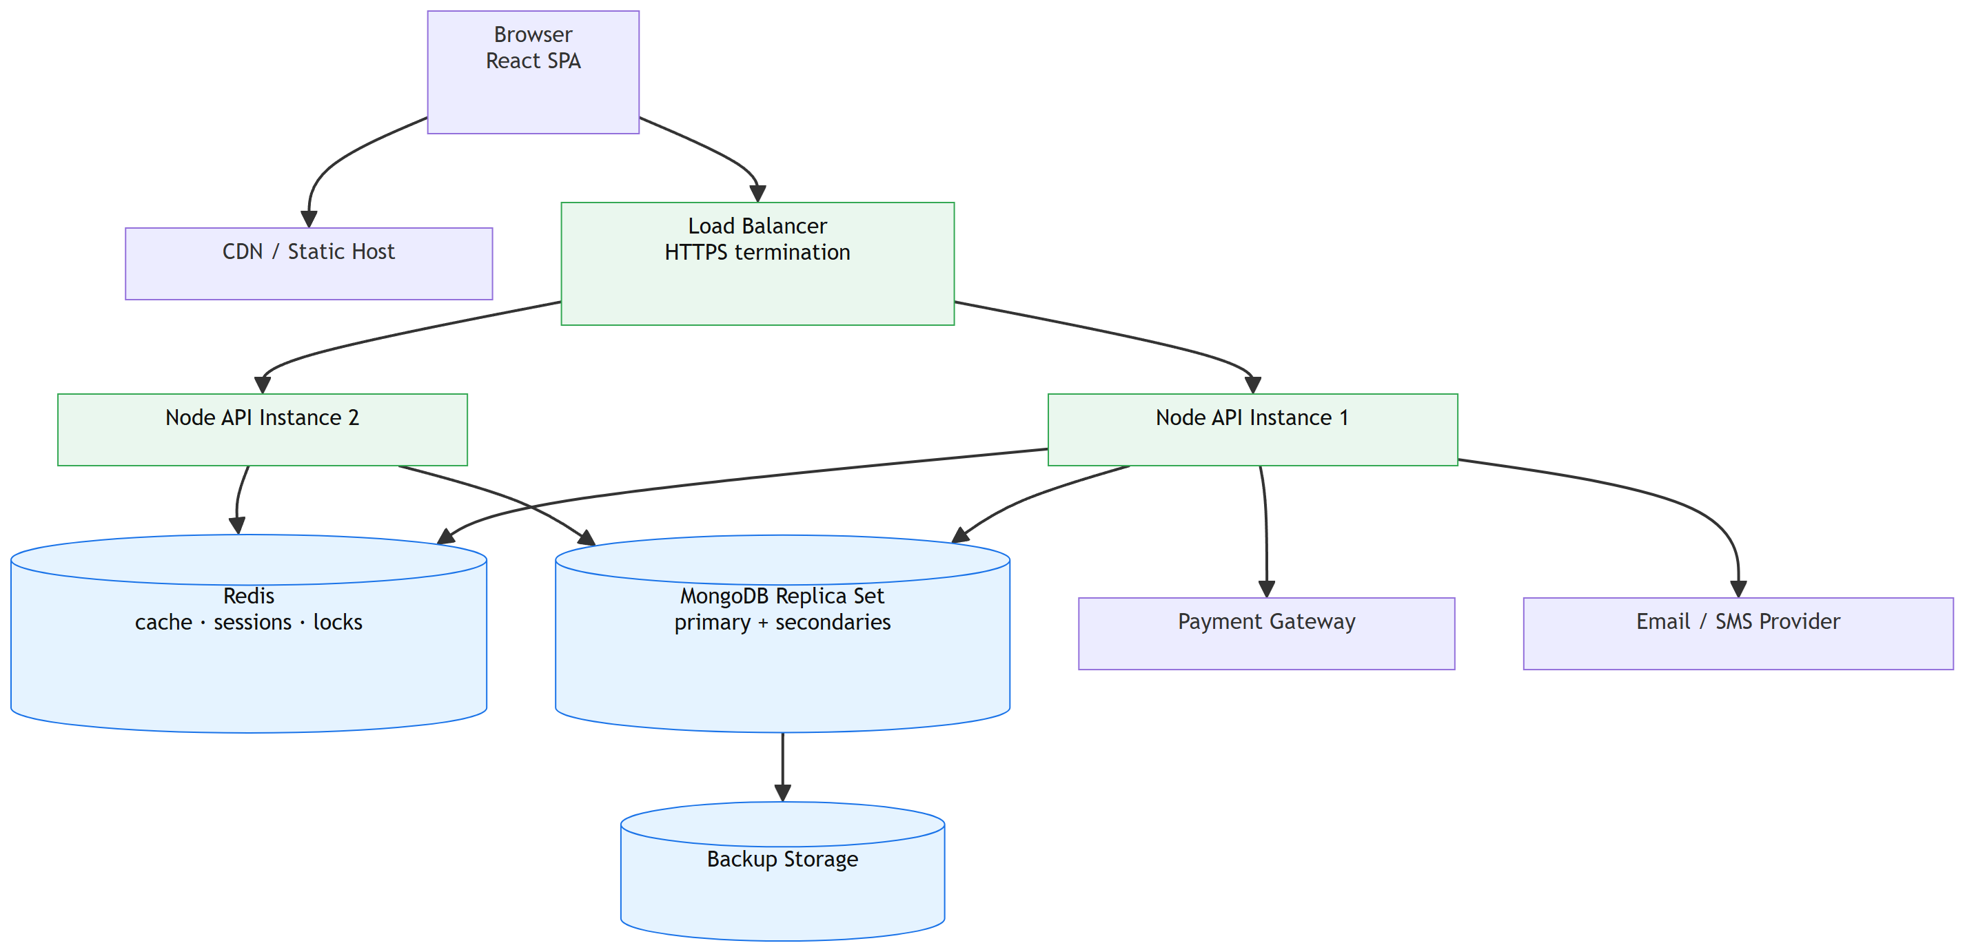
Figure 3.4 Deployment Diagram

2. Database Design

2.1 Class Diagrams
The persistent data is modelled as Mongoose entity classes, grouped by subsystem.
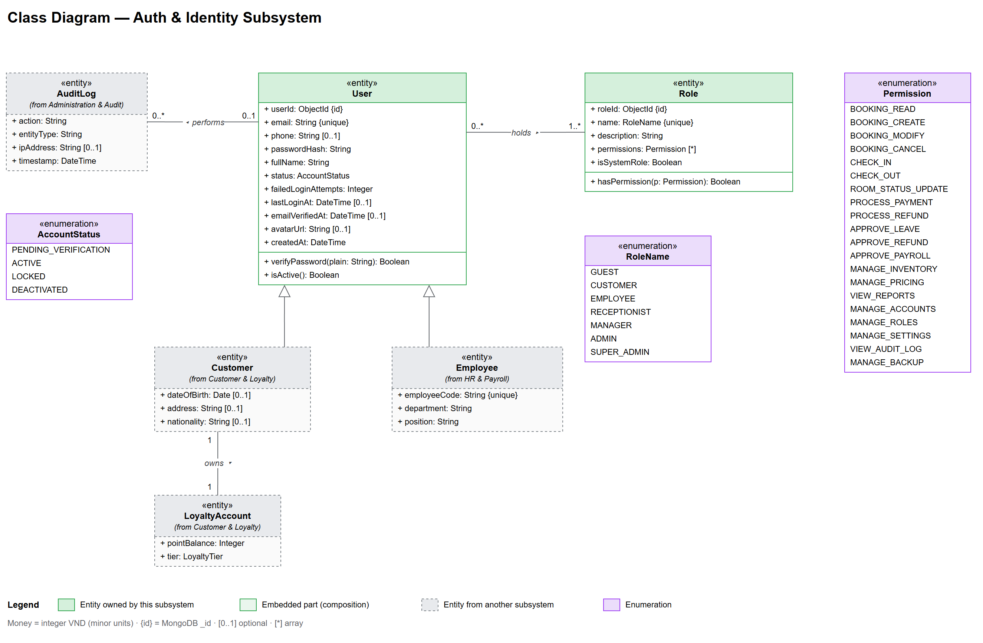
Figure 3.5 Class Diagram - Auth & Identity
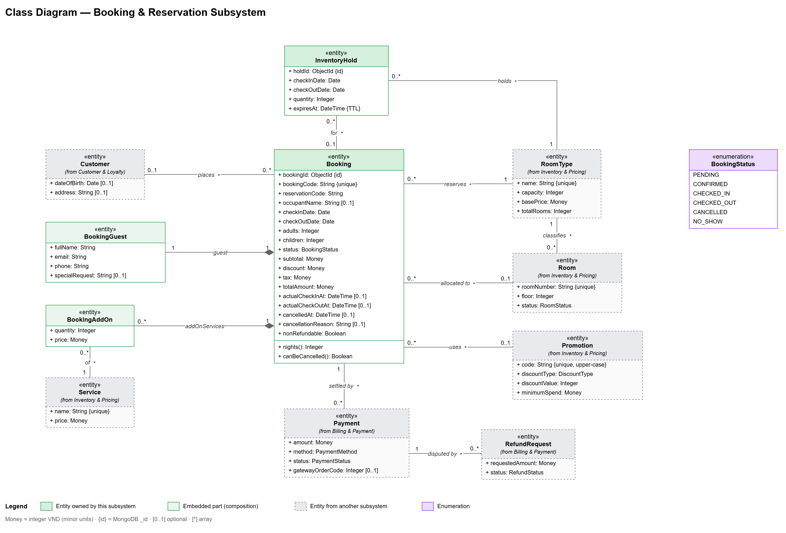
Figure 3.6 Class Diagram - Booking & Reservation
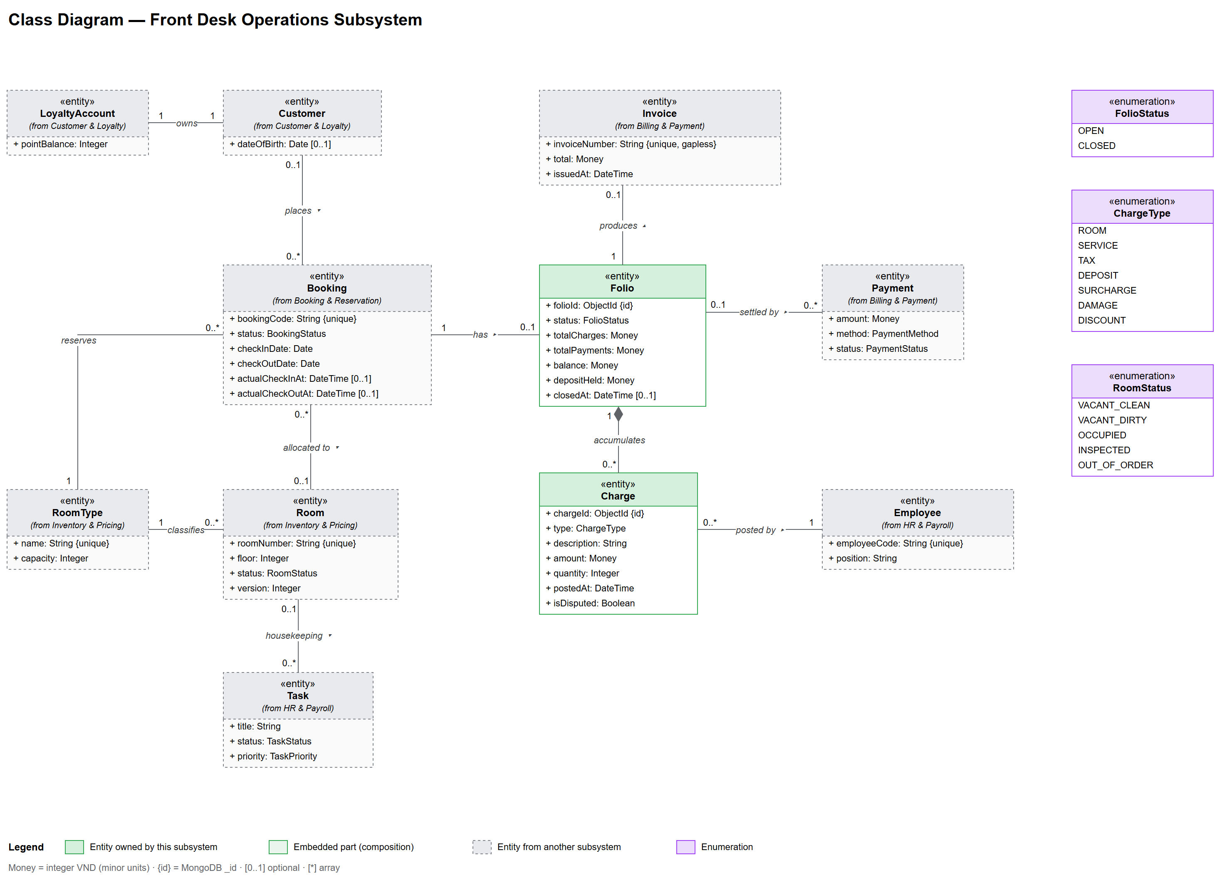
Figure 3.7 Class Diagram - Front Desk Operations
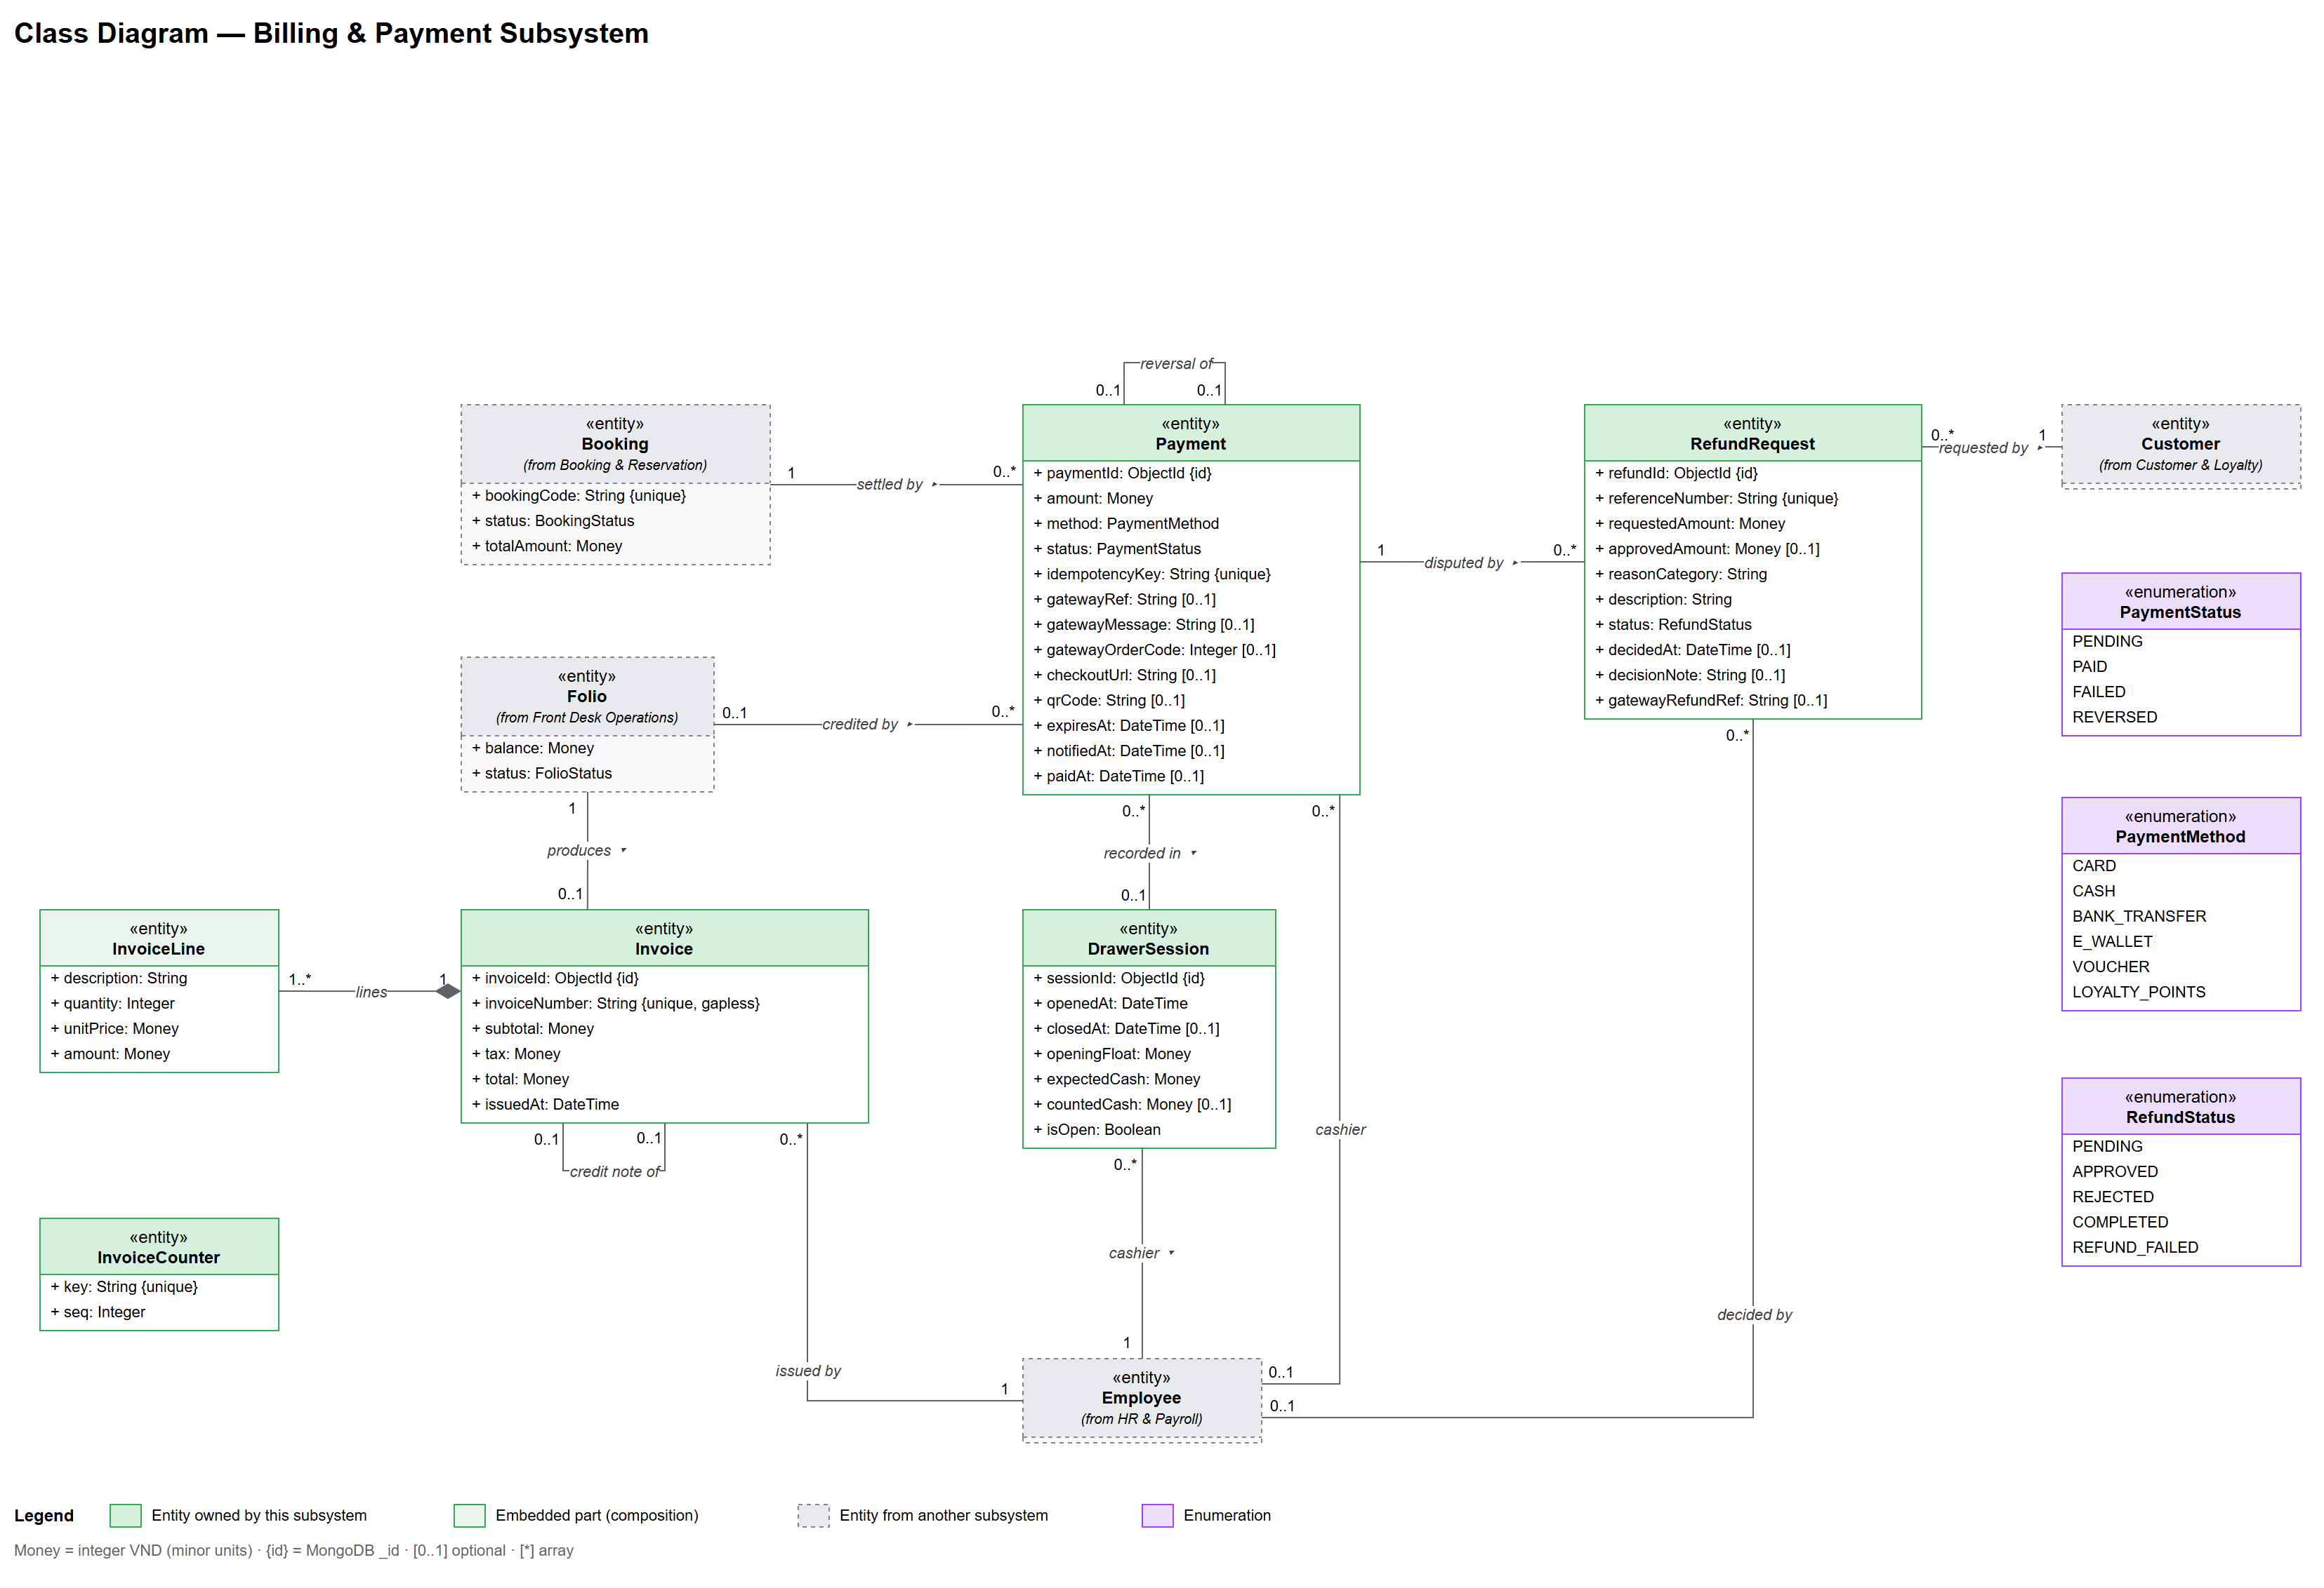
Figure 3.8 Class Diagram - Billing & Payment
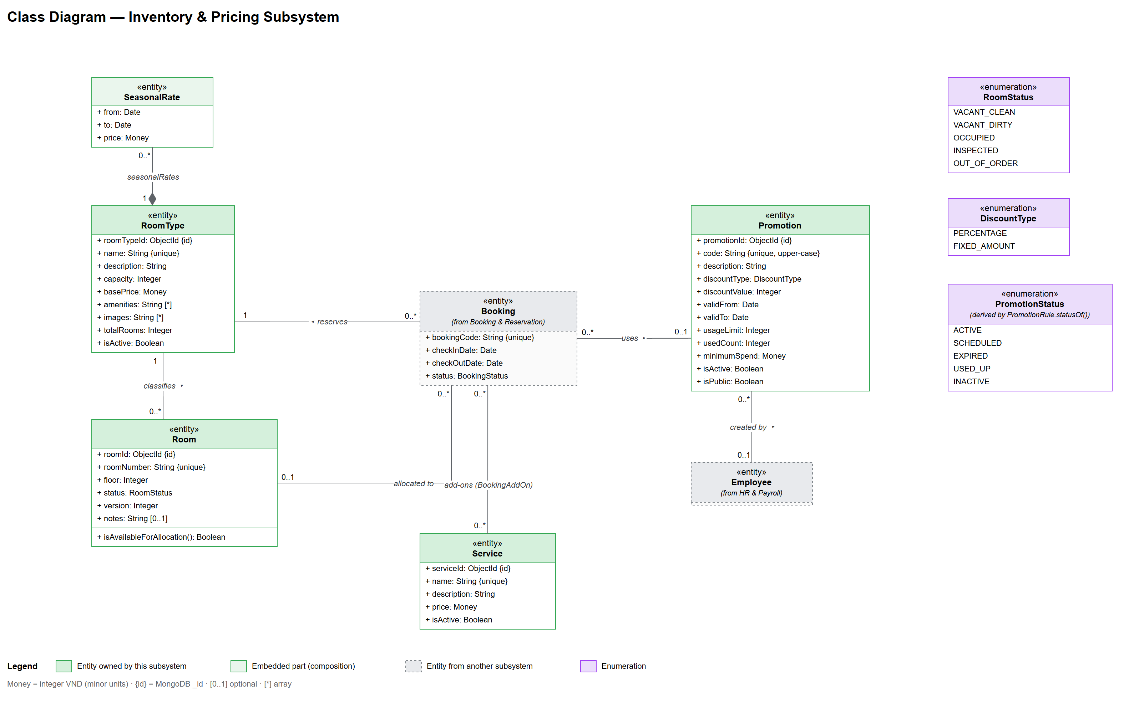
Figure 3.9 Class Diagram - Inventory & Pricing
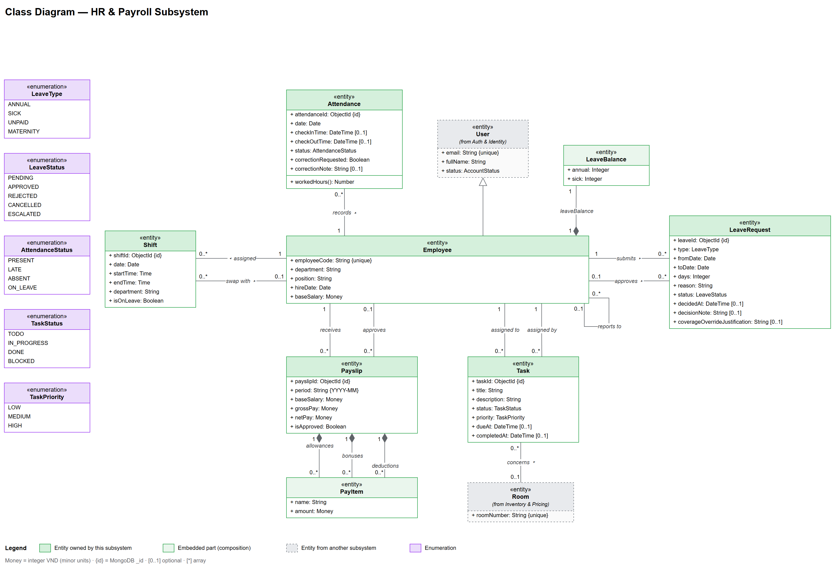
Figure 3.10 Class Diagram - HR & Payroll
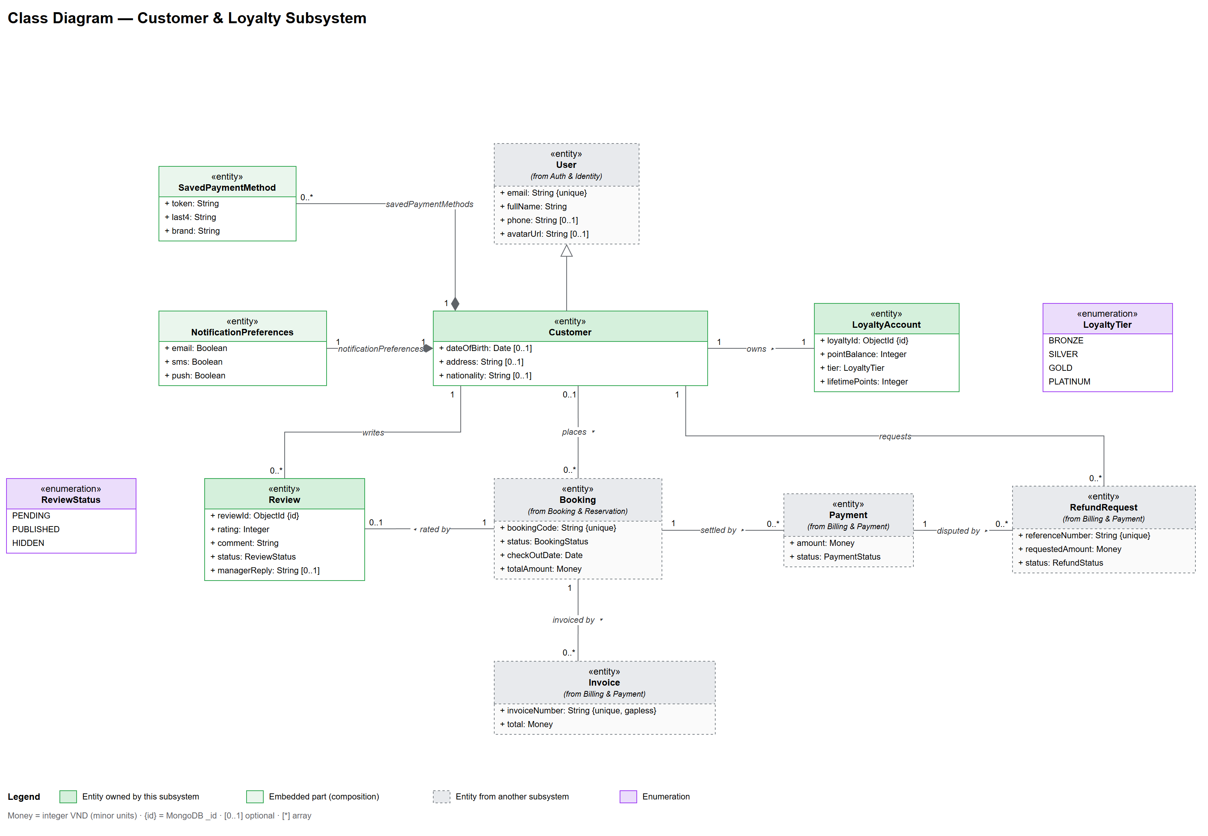
Figure 3.11 Class Diagram - Customer & Loyalty
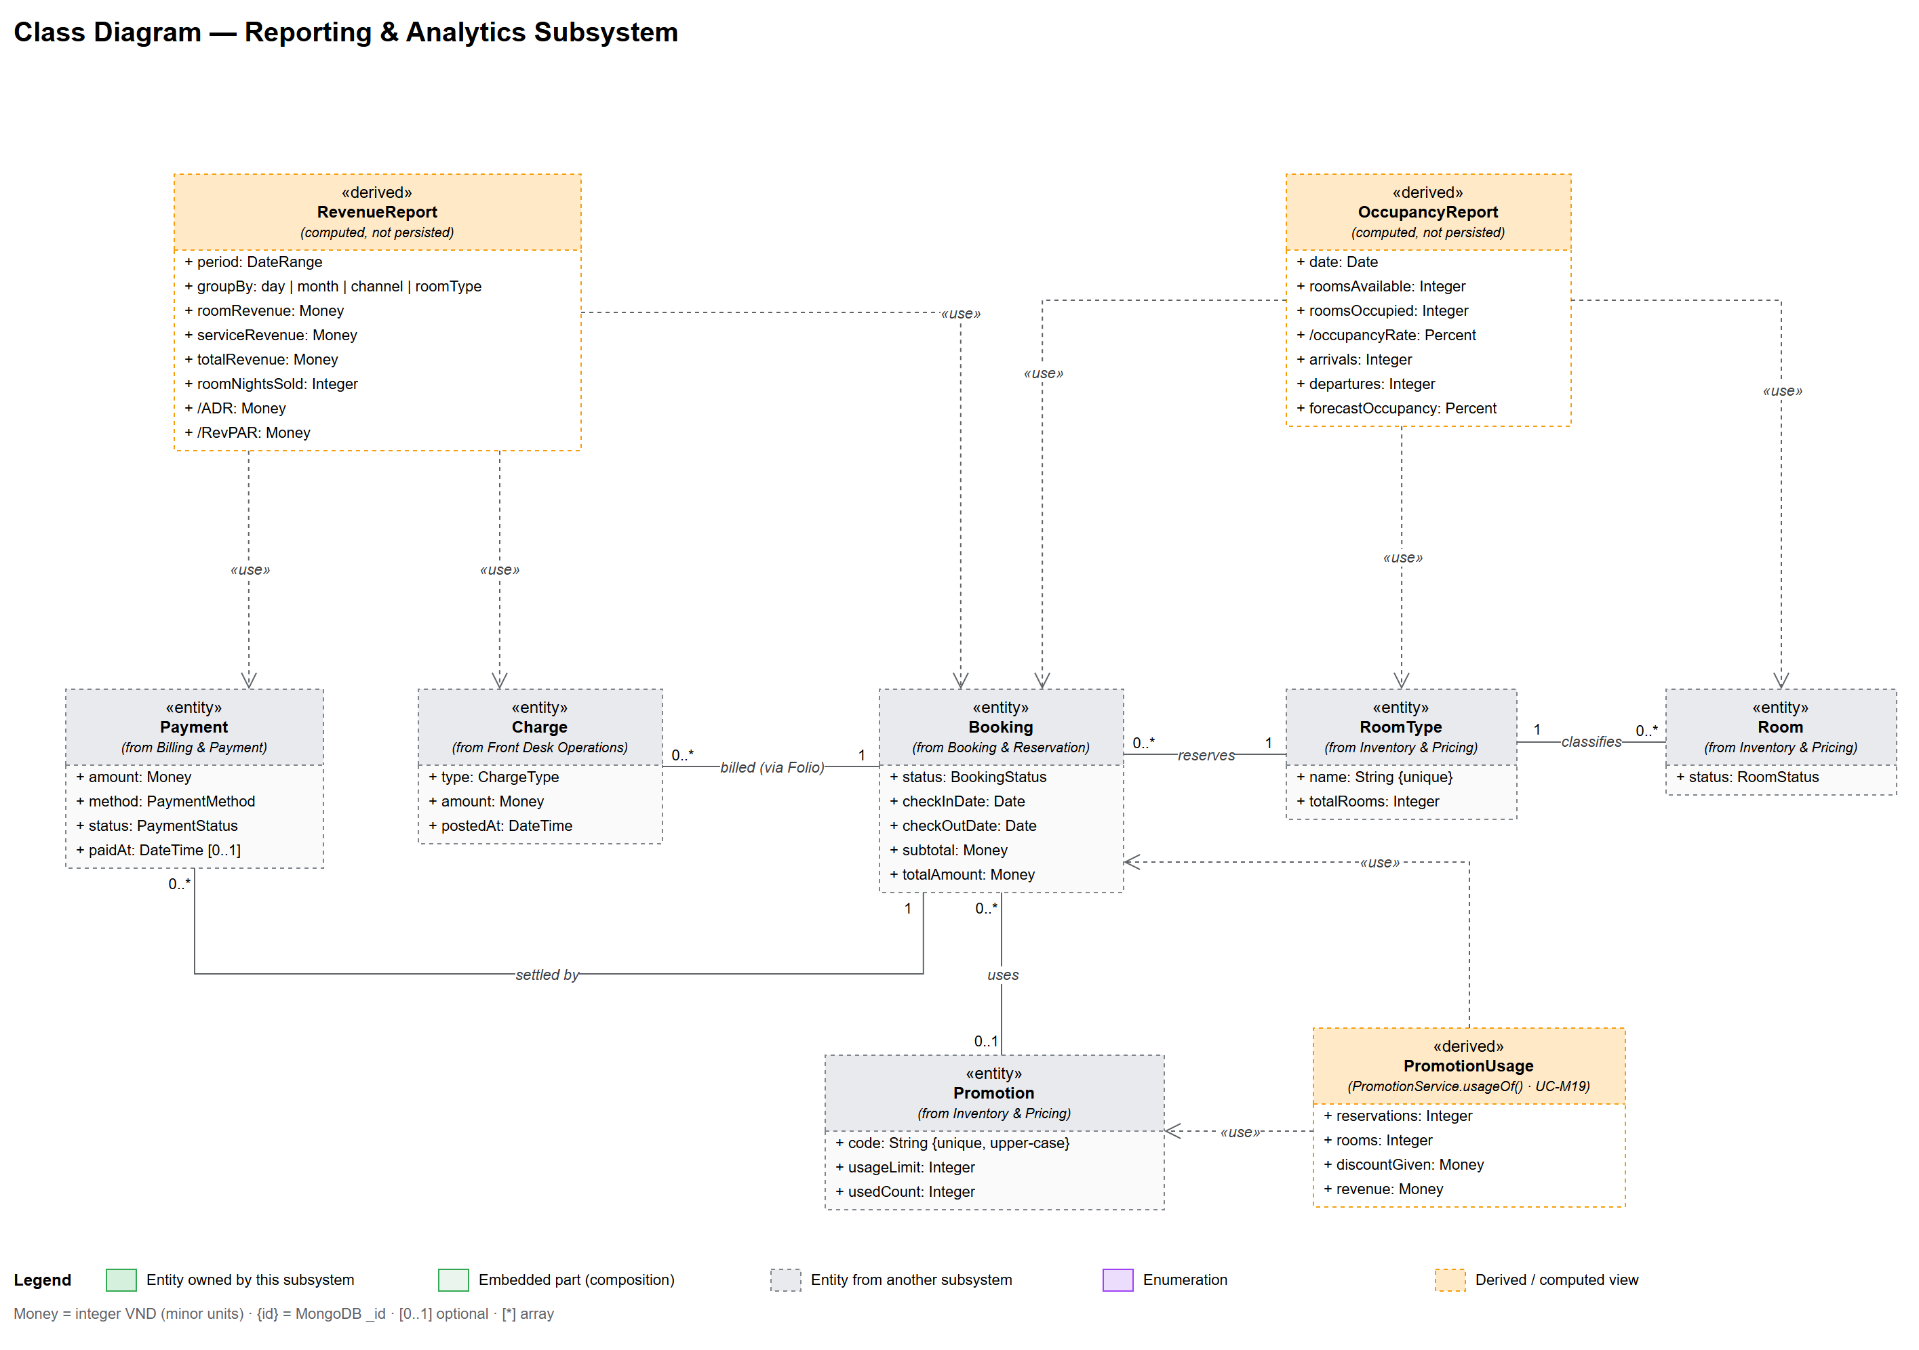
Figure 3.12 Class Diagram - Reporting & Analytics
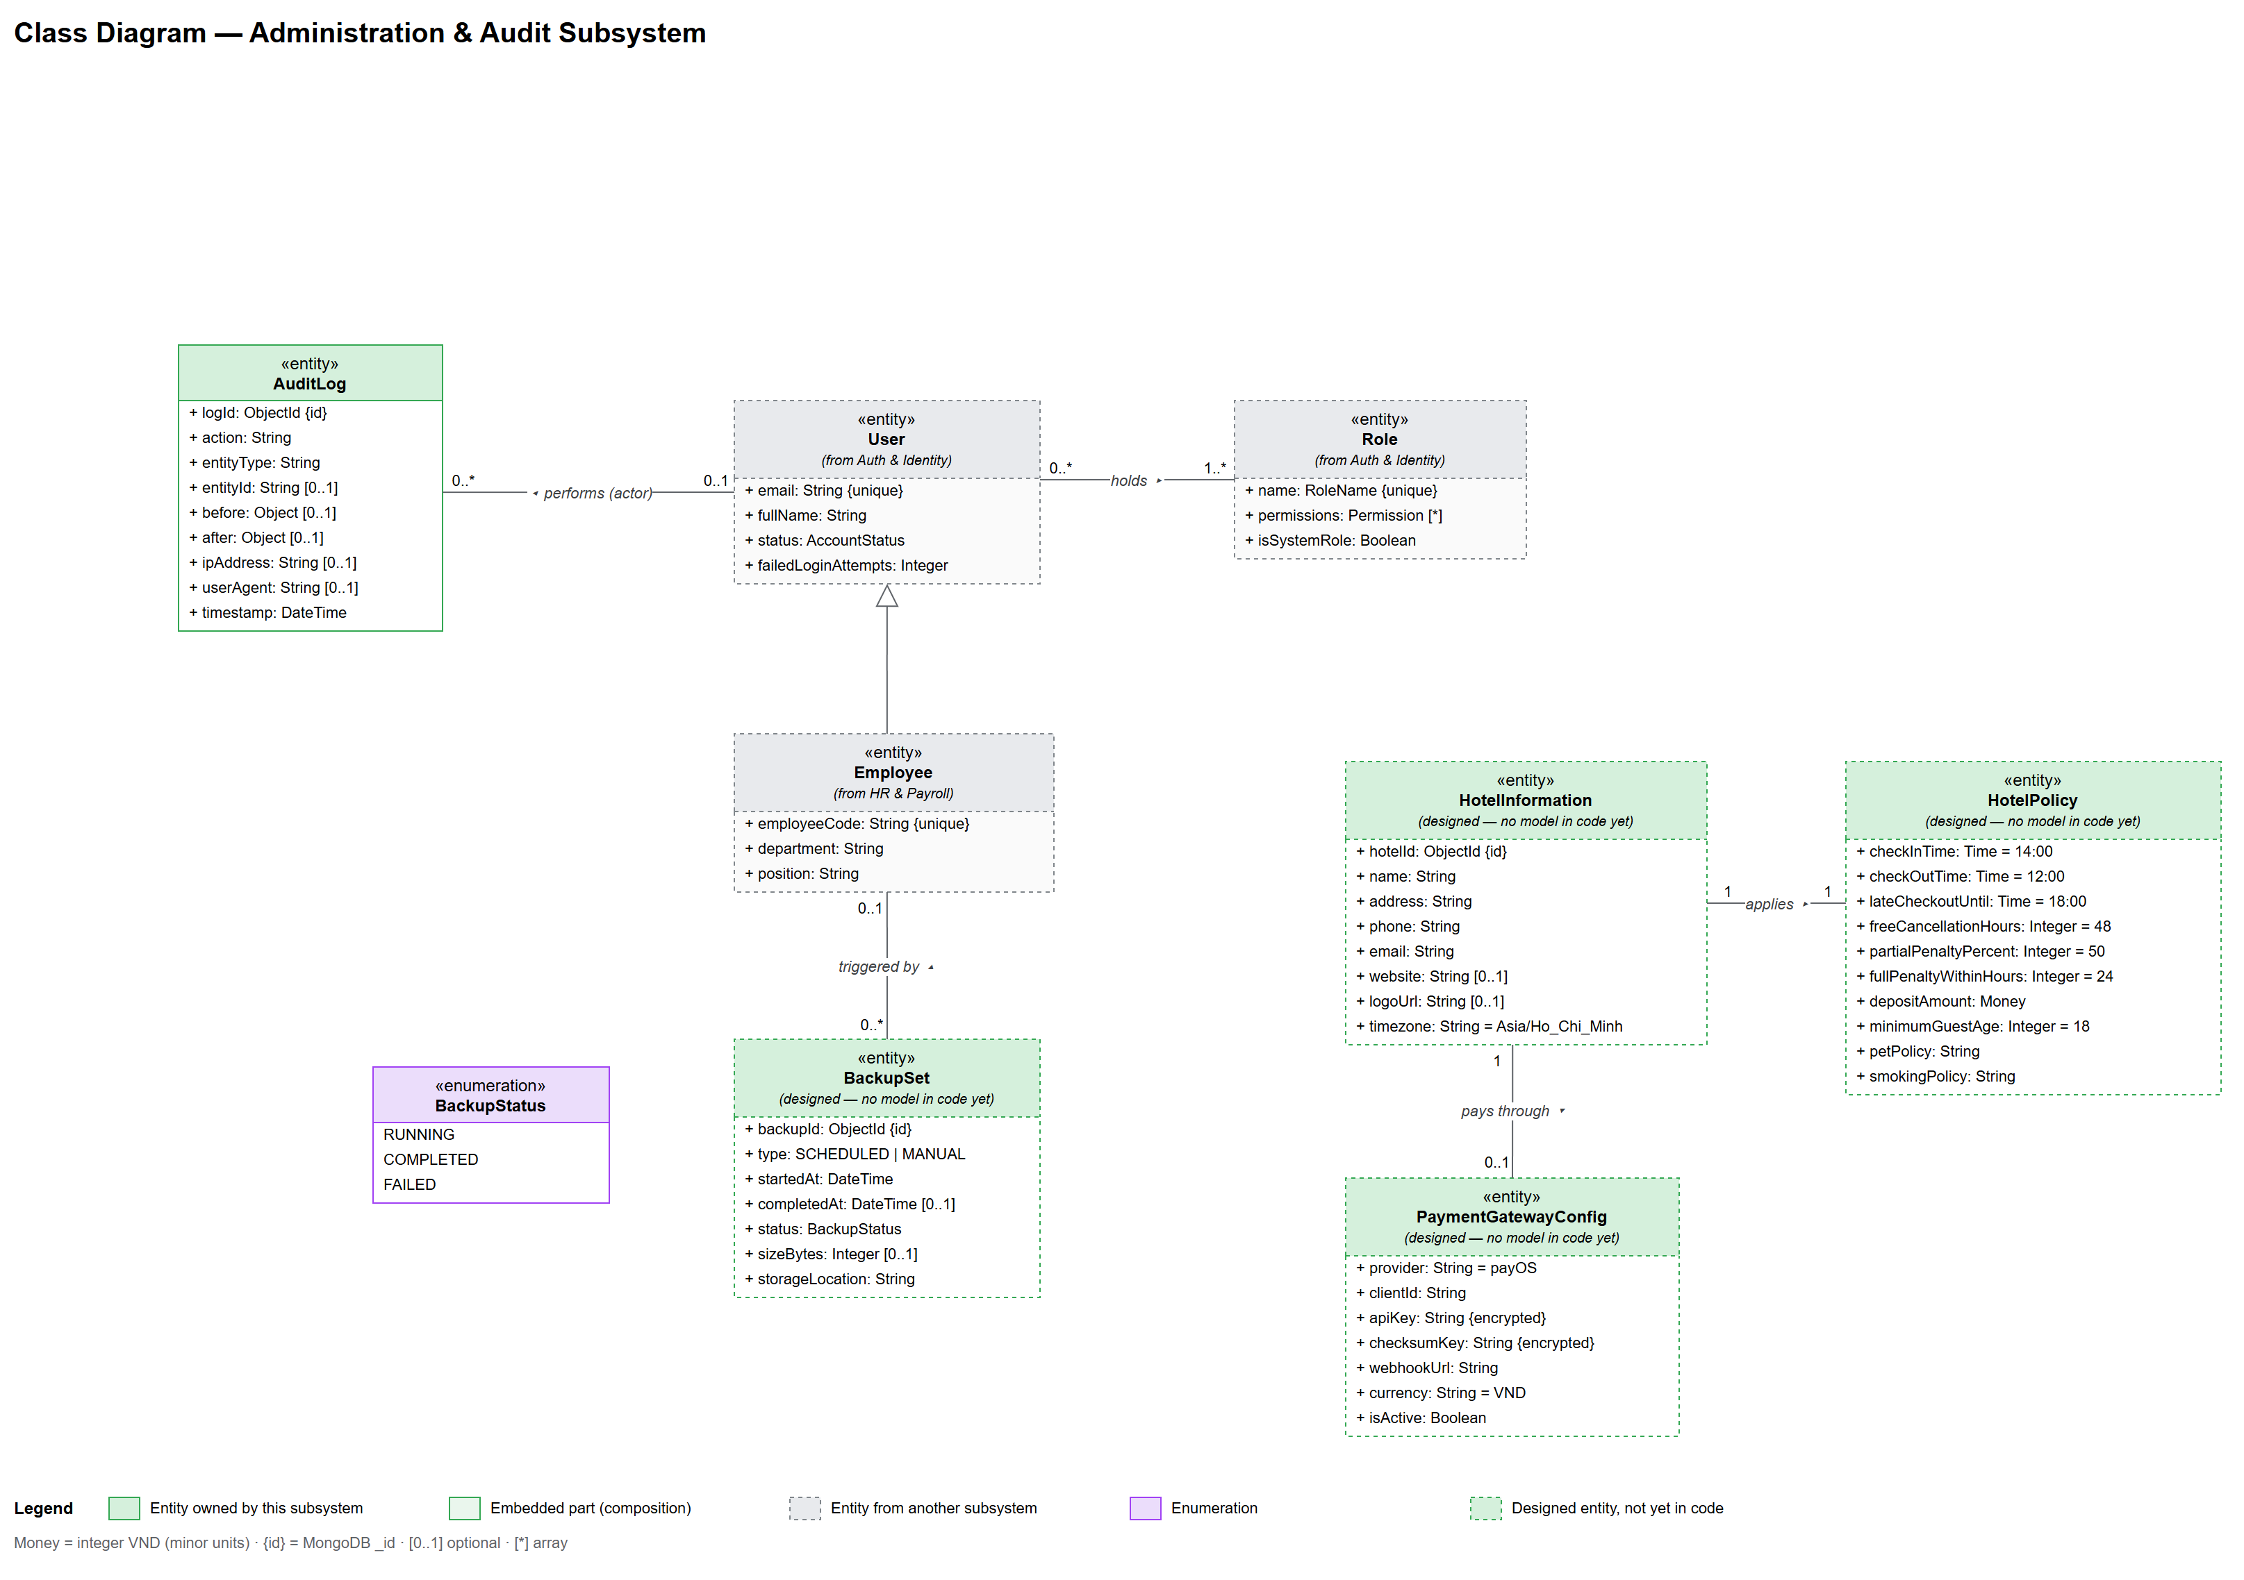
Figure 3.13 Class Diagram - Administration & Audit

2.2 Collection Descriptions
No | Collection | Description | Attributes
1 | User | System accounts; Customer and Employee are discriminators of User. | _id (PK), email, phone, passwordHash, fullName, status, roles (FK Role[]), failedLoginAttempts, lastLoginAt, emailVerifiedAt, avatarUrl
2 | User: Customer | Registered guest data. | dateOfBirth, address, nationality, savedPaymentMethods, notificationPreferences
3 | User: Employee | Hotel staff data. | employeeCode, department, position, hireDate, baseSalary, managerId (FK User), leaveBalance
4 | Role | Role catalogue for access control. | _id (PK), name, description, permissions[], isSystemRole
5 | RoomType | Room categories with rates. | _id (PK), name, description, capacity, basePrice, amenities, images, totalRooms, seasonalRates, isActive
6 | Room | Physical rooms of the hotel. | _id (PK), roomNumber (unique), roomTypeId (FK RoomType), floor, status, version, notes
7 | Booking | One room of a reservation; rooms of one reservation share reservationCode. | _id (PK), bookingCode, reservationCode, customerId (FK User), guest, occupantName, roomTypeId (FK), roomId (FK), checkInDate, checkOutDate, adults, children, status, addOnServices, promotionId (FK), subtotal, discount, tax, totalAmount
8 | InventoryHold | Temporary 15-minute hold of rooms during booking (TTL index). | _id (PK), roomTypeId (FK), checkInDate, checkOutDate, quantity, expiresAt, bookingId (FK)
9 | Service | Add-on services and prices. | _id (PK), name, description, price, isActive
10 | Promotion | Promotion / discount codes. | _id (PK), code (unique), description, discountType, discountValue, validFrom, validTo, usageLimit, usedCount, minimumSpend, isActive, isPublic, createdBy (FK User)
11 | Review | Customer reviews of completed stays. | _id (PK), bookingId (FK), customerId (FK), rating, comment, status, managerReply
12 | LoyaltyAccount | Loyalty points and tier of a customer. | _id (PK), customerId (FK), pointBalance, tier, lifetimePoints
13 | Folio | Running account of a stay. | _id (PK), bookingId (FK), status, totalCharges, totalPayments, balance, depositHeld, closedAt
14 | Charge | Line posted to a folio. | _id (PK), folioId (FK), type, description, amount, quantity, postedBy (FK User), postedAt, isDisputed
15 | Payment | Payment attempts (online or at the desk). | _id (PK), bookingId (FK), folioId (FK), amount, method, status, idempotencyKey, gatewayOrderCode, checkoutUrl, qrCode, cashierId (FK), drawerSessionId (FK), paidAt, reversalOfId (FK)
16 | Invoice | Final invoice with gapless number. | _id (PK), invoiceNumber, bookingId (FK), folioId (FK), lines, subtotal, tax, total, issuedAt, issuedBy (FK), creditNoteOfId (FK)
17 | RefundRequest | Customer refund requests and decisions. | _id (PK), referenceNumber, bookingId (FK), paymentId (FK), requestedBy (FK), requestedAmount, approvedAmount, reasonCategory, description, status, decidedBy (FK), decidedAt, decisionNote, gatewayRefundRef
18 | DrawerSession | Cash drawer session of a cashier. | _id (PK), cashierId (FK), openedAt, closedAt, openingFloat, expectedCash, countedCash, isOpen
19 | Shift | Work schedule entries. | _id (PK), employeeId (FK), date, startTime, endTime, department, isOnLeave, swapRequestedWith (FK)
20 | Attendance | Daily attendance records. | _id (PK), employeeId (FK), date, checkInTime, checkOutTime, status, correctionRequested, correctionNote
21 | LeaveRequest | Leave applications and decisions. | _id (PK), employeeId (FK), type, fromDate, toDate, days, reason, status, approverId (FK), decidedAt, decisionNote
22 | Payslip | Monthly payslips. | _id (PK), employeeId (FK), period, baseSalary, allowances, bonuses, deductions, grossPay, netPay, isApproved, approvedBy (FK)
23 | Task | Housekeeping / maintenance tasks. | _id (PK), title, description, assignedTo (FK), assignedBy (FK), roomId (FK), status, priority, dueAt, completedAt
24 | AuditLog | Append-only audit trail (BR-49). | _id (PK), actorId (FK), action, entityType, entityId, before, after, ipAddress, userAgent, timestamp

2.3 State Diagrams
The booking and the room are the two entities whose behaviour depends on their state; their transitions are enforced by BookingStateMachine and RoomStateMachine.
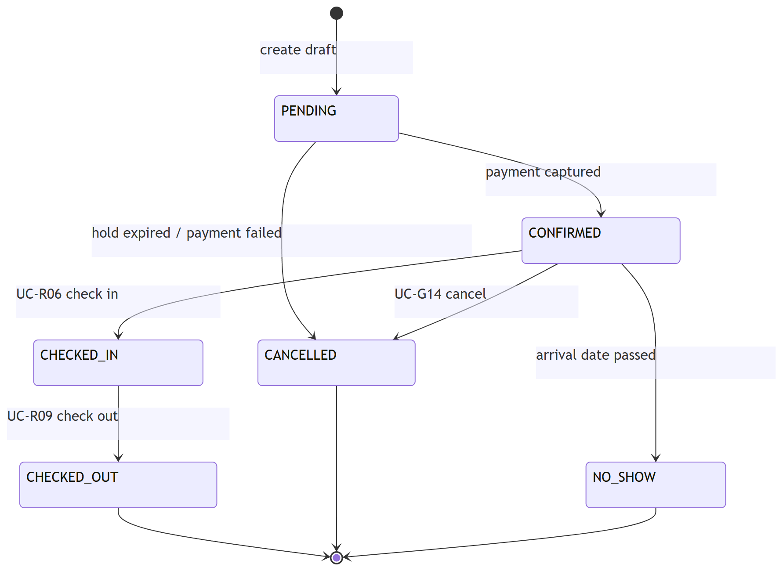
Figure 3.14 State Diagram - Booking
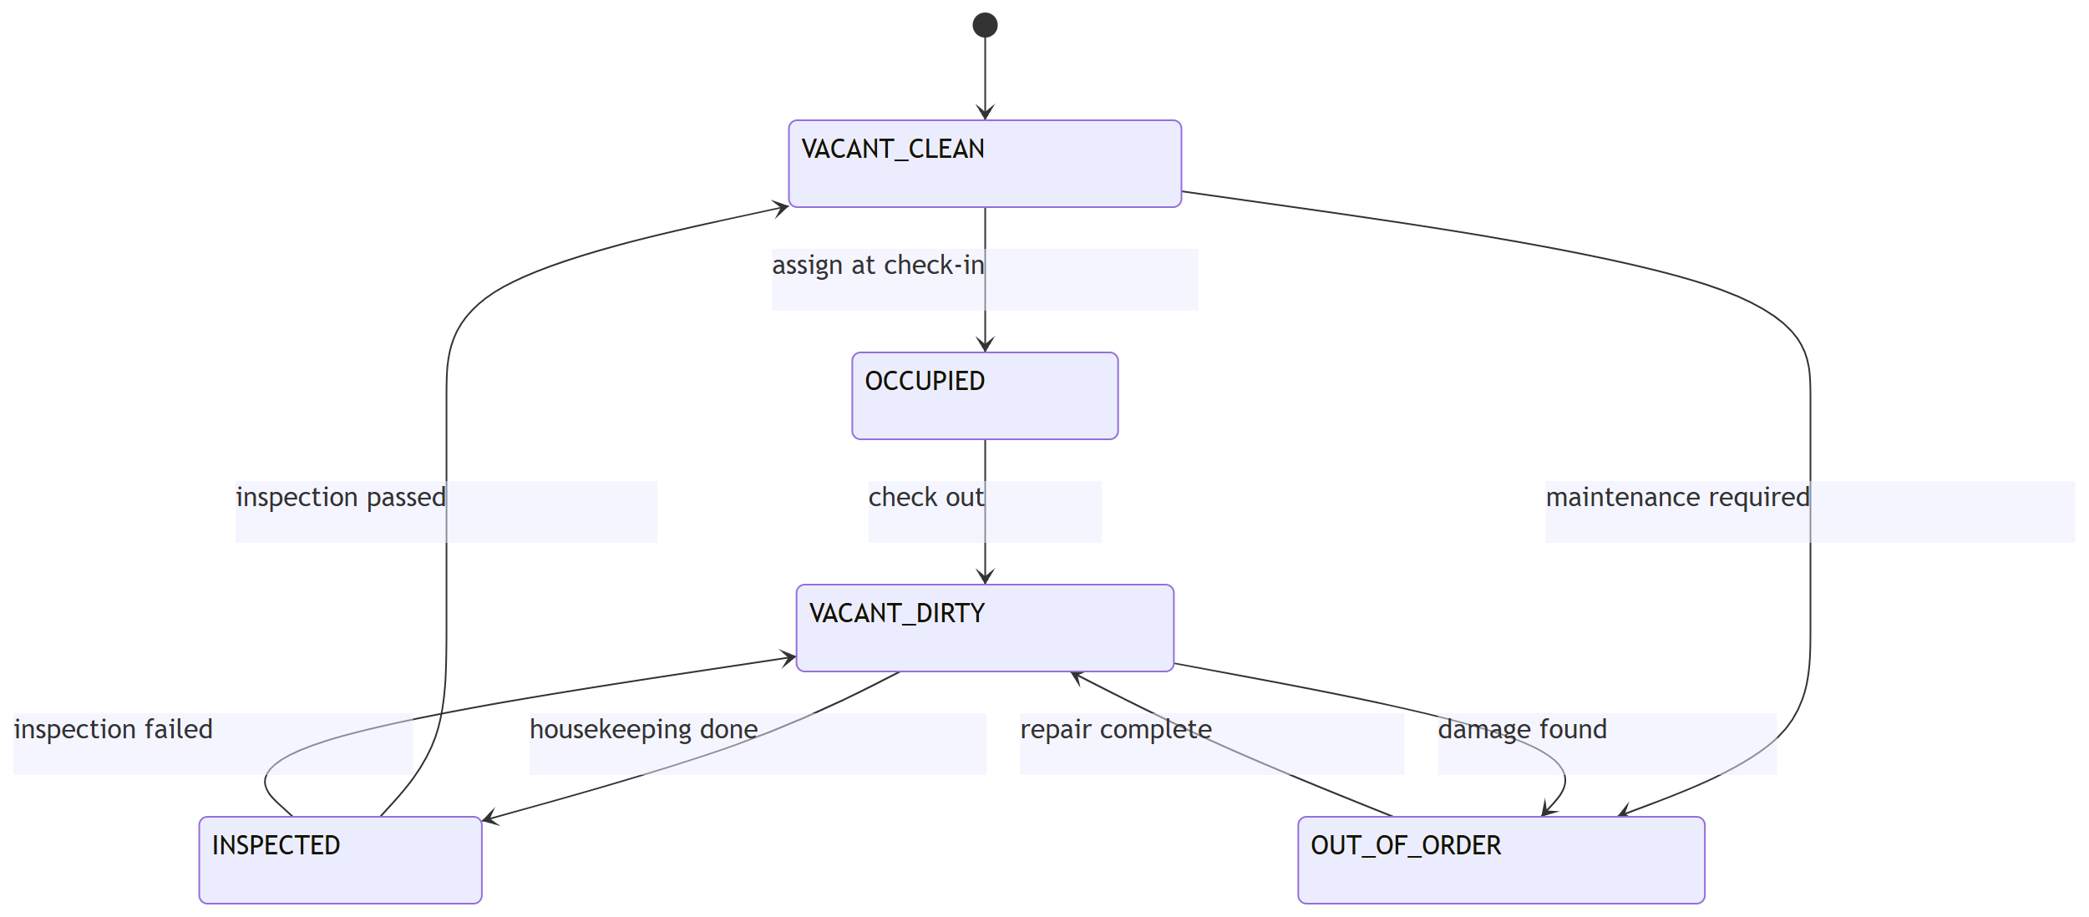
Figure 3.15 State Diagram - Room

