Archive Menu Manager

**Overview**

For those with archive manager permissions, an **Admin** menu will appear that features additional functions related to the Archive menu in MofficeSuite. In addition to a separate  **Admin** sub-menu, managers will also have a  **Manage Applicants** sub-menu.

[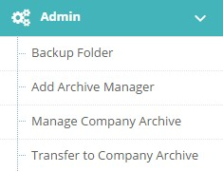](http://help.hanbiro.com/help/images/en/collaboration/admin-menu/menu-archive/aa-00.jpg)

**Backup Folder**

Take control of archive data backups with the **Backup Folder** sub-menu. View a list of scheduled and completed backups from the main list. Click the backup name to view more details.

[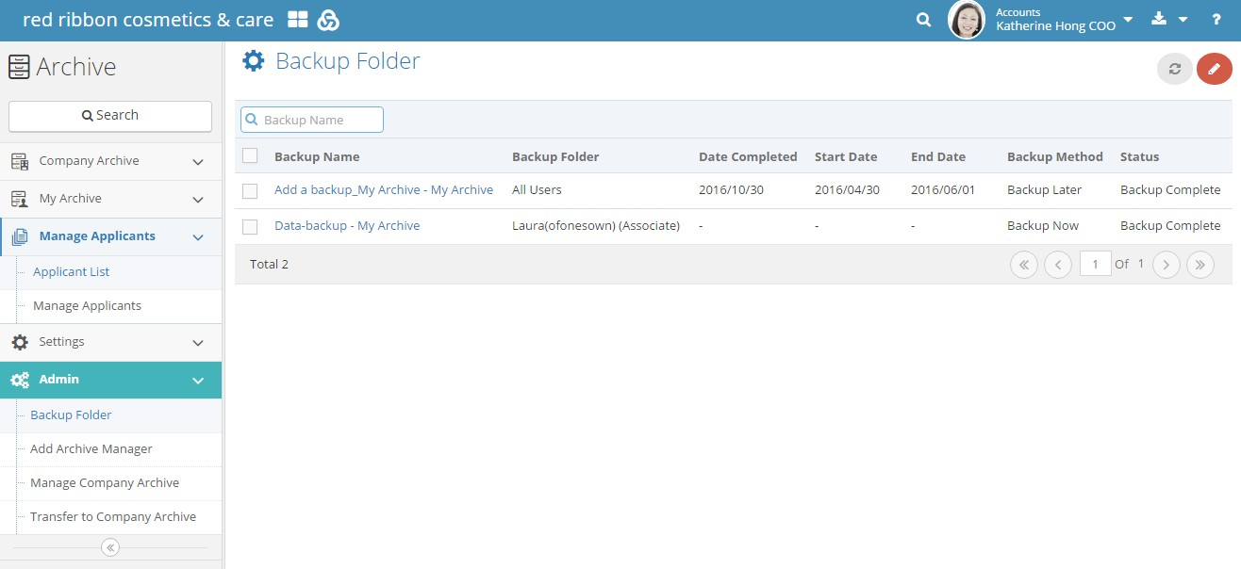](http://help.hanbiro.com/help/images/en/collaboration/admin-menu/menu-archive/aa-01a.jpg)

To create a new backup, click the pencil  icon in the top right corner and the creation page will open. Select one or more folders to backup and an estimate for volume and time will appear at the bottom.

[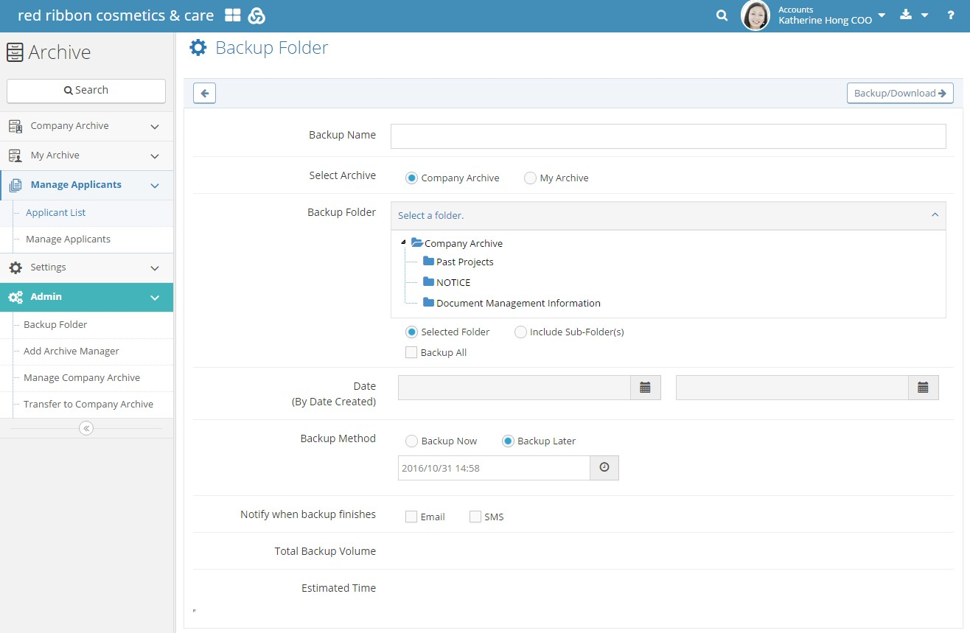](http://help.hanbiro.com/help/images/en/collaboration/admin-menu/menu-archive/aa-01b.jpg)

**Add Archive Manager**

There are two types of managers in the Archive menu; these can be managed through the **Add Archive Manager** sub-menu. Upon opening the menu, view a list of the current Archive managers, appointed by other managers or the postmaster administrator. Note managers added by the postmaster administrator cannot be edited. Other managers can be edited through the edit  button and checked  for bulk deletion.

[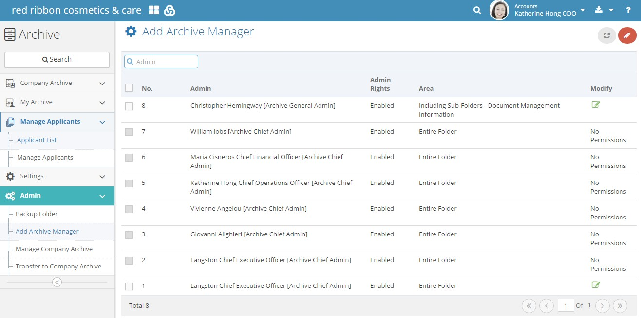](http://help.hanbiro.com/help/images/en/collaboration/admin-menu/menu-archive/aa-02a.jpg)

To add a new Archive manager, click the pencil  icon at the top right corner. A creation page will open wherein managers can make additional Chief or General Archive administrators. What's the difference between the two types? They are enumerated below.

|  |  |  |
| --- | --- | --- |
|  | **Archive Chief Admin** | **Archive General Admin** |
| **Permissions** | Delete / Move / Read / Download / Print | Read / Download / Print |
| **Permission Folders** | Applied based on permission settings (All folders / Selected folder only / Selected folder including sub-folders) | |
| **Approval Permissions for Review Requests** | Can approve for any file within a folder wherein the Admin has permissions | |

[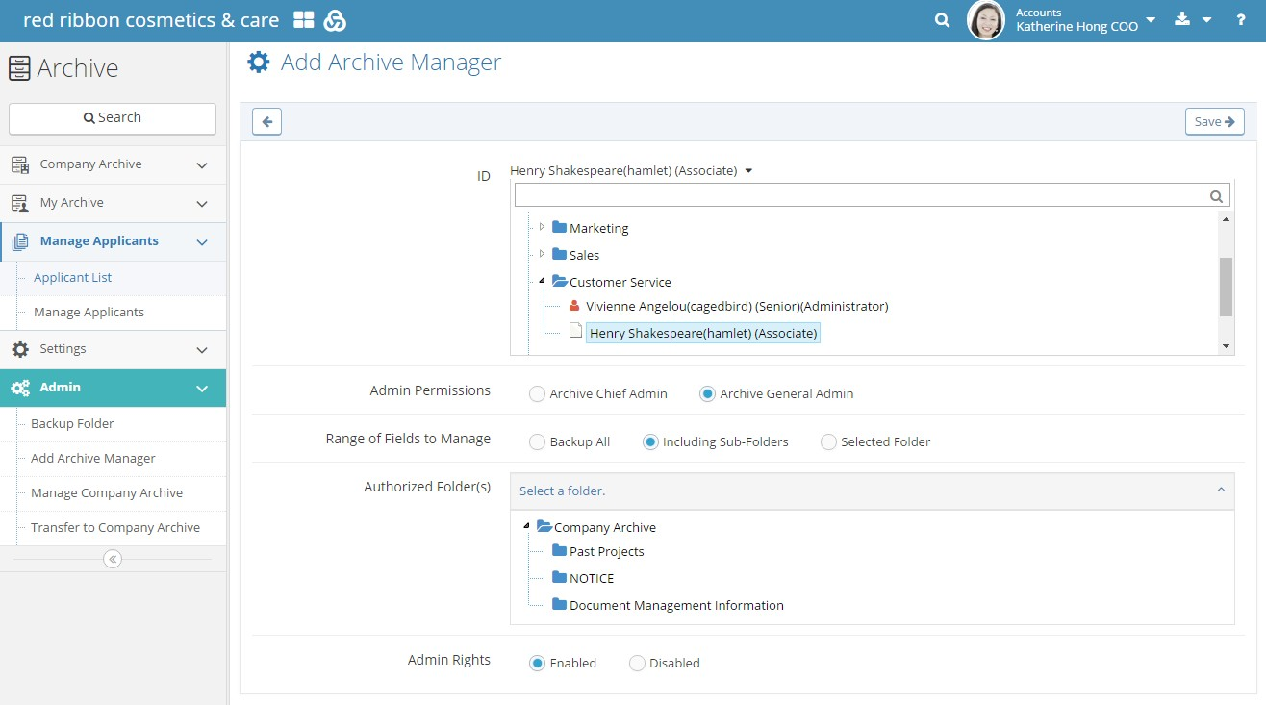](http://help.hanbiro.com/help/images/en/collaboration/admin-menu/menu-archive/aa-02b.jpg)

**Manage Company Archive**

Create, edit, and delete company folders through the **Manage Company Archive** sub-menu. Herein, click the Company Archive folder and the plus sign at the top right corner of the **Manage Company Archive** left-hand module. Decide whether to make the folder public or private, enable or disable approval permissions for the document, as well as the folder name. To edit the folder settings, click it from the Company Archive list.

[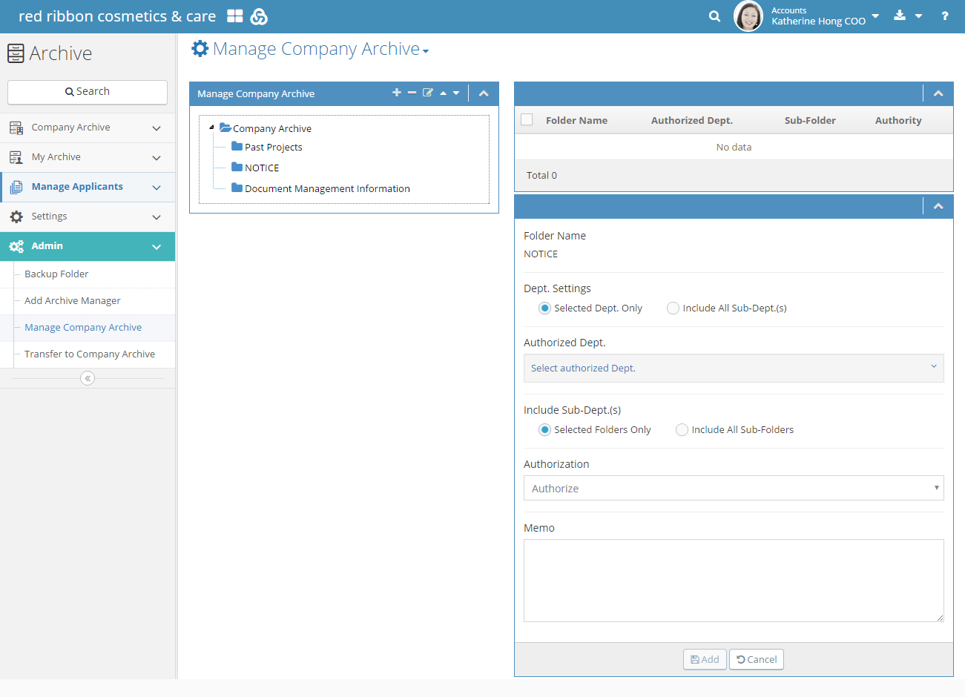](http://help.hanbiro.com/help/images/en/collaboration/admin-menu/menu-archive/aa-03.png)

**Transfer to Company Archive**

With the **Transfer to Company Archive** sub-menu, select data to be copied into the Company Archive. Click the sub-menu and enter the fields for document transfer.

[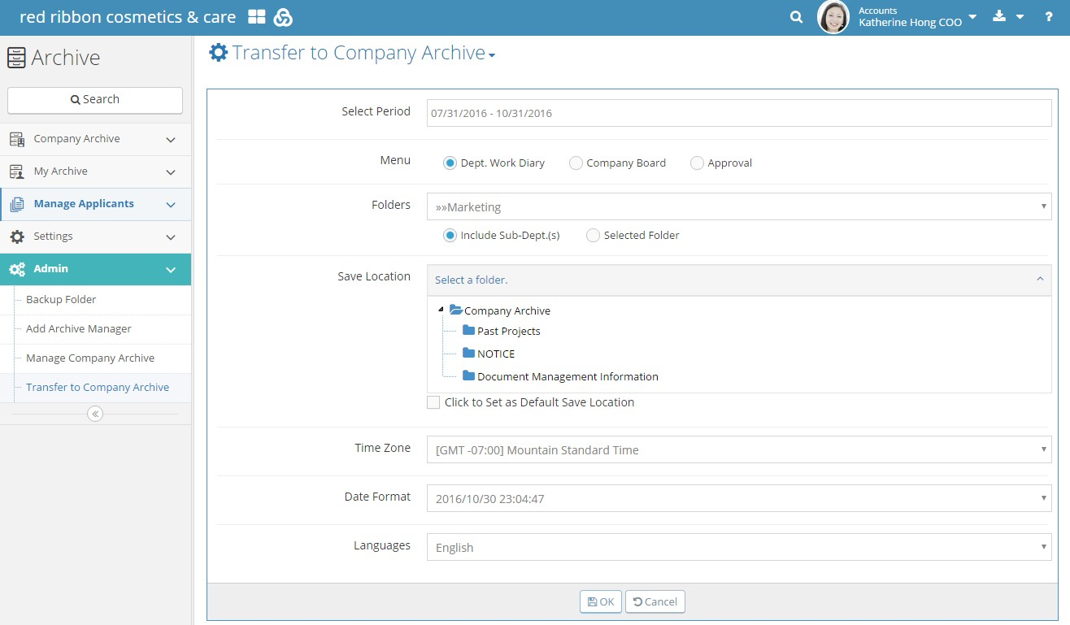](http://help.hanbiro.com/help/images/en/collaboration/admin-menu/menu-archive/aa-04.jpg)

**Manage Applicants**

For managers, use the **Manage Applicants** sub-menu to permit or reject review requests from users for various Archive folders. In the Manage Applicants sub-menu, view a list of applicants who requested perusal of normally restricted archive contents.

[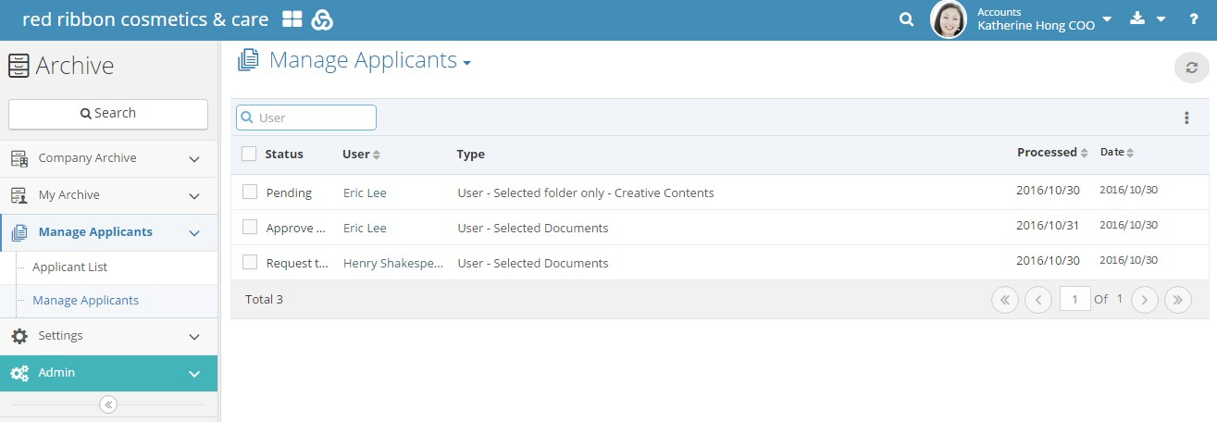](http://help.hanbiro.com/help/images/en/collaboration/admin-menu/menu-archive/aa-05a.jpg)

Click on the **Type** of an application to see details on the availability period, request, and more. Herein administrators can also choose to approve the review, engaged in various other options, or write a memo. Click  OK at the top-right corner to save any changes.

[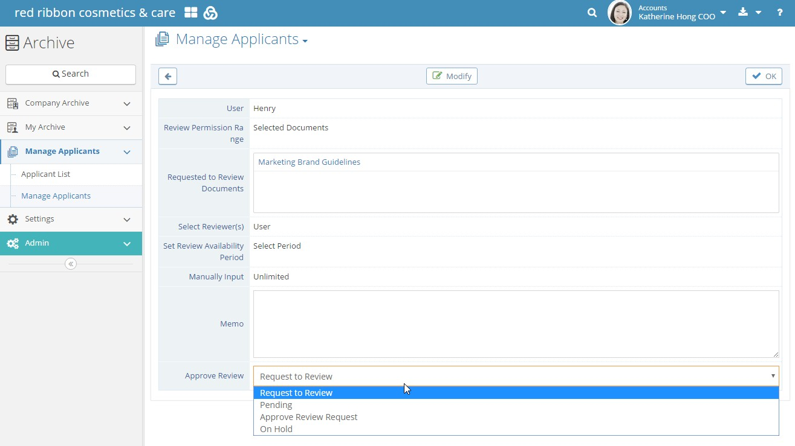](http://help.hanbiro.com/help/images/en/collaboration/admin-menu/menu-archive/aa-05b.jpg)