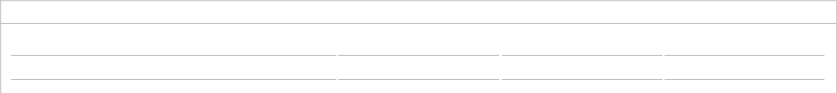
TRAVELER
{{ names | map('replace', ' ', '/', 1) | join('\n ') }}
420QJH

Passengers | Membership number | Ticket Number | Reservation code


FLIGHT - CHINA SOUTHERN AIRLINES (CZ) {{arrive_flight_number}} – {{arrive_day_name}}, {{arrive_month_MMM}} {{arrive_day}}, {{arrive_year_yyyy}}
 | Depart  SGN | →  02H 45M |  | Arrive  {{arrived_iata_code}} |  | Class of Service:  Economy (E)
China Southern Airlines (CZ)  Flight number: CZ - {{arrive_flight_number}}  Airline code: PX1DD4  Status: Confirmed  Duration: 02H 45M |  |  |  |  |  | Plane:  AIRBUS INDUSTRIE A321 NEO  Meal:  Dinner  Seat:
 | Airport: Tan Son Nhat International  Ho Chi Minh City, Vietnam Terminal 2  15:40 |  | Airport: Guangzhou Baiyun International  Guangzhou, China  Terminal 2  19:25 |  |  | Plane:  AIRBUS INDUSTRIE A321 NEO  Meal:  Dinner  Seat:
 | {{arrive_month_MMM|title}} {{arrive_day}}, {{arrive_year_yyyy}} |  | {{arrive_month_MMM|title}} {{arrive_day}}, {{arrive_year_yyyy}}

FLIGHT - CHINA SOUTHERN AIRLINES (CZ) {{departure_flight_number}} – {{departure_day_name}}, {{departure_month_MMM}} {{departure_day}}, {{departure_year_yyyy}}
 | Depart  {{departure_iata_code}} | →  02H 40M |  | Arrive  SGN |  | Class of Service:  Economy (U)
China Southern Airlines (CZ)  Flight number: CZ - {{departure_flight_number}}  Airline code: PX1DD4  Status: Confirmed  Duration: 02H 40M |  |  |  |  |  | Plane:  AIRBUS INDUSTRIE A320-100/200  Meal:  ComplimentaryRefreshments  Seat:
 | Airport: Guangzhou Baiyun International  Guangzhou, China Terminal 2  20:10  {{departure_month_MMM|title}} {{departure_day}}, {{departure_year_yyyy}} |  | Airport: Tan Son Nhat International  Ho Chi Minh City, Vietnam Terminal 2  21:50
 |  |  | {{departure_month_MMM|title}} {{departure_day}}, {{departure_year_yyyy}}

