
Booing Confirmation
CONFIRMATION NUMBER: 6521.961.589
PIN CODE: 7587
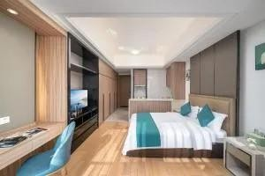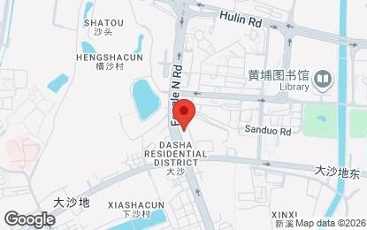
Hantao AI Select International Apartment CHECK-IN CHECK-OUT UNITS NIGHTS Address: Room 1018 Zhongdingminghui (Middle Tower), No 76 Feng Le {{first}} {{end}} {{names | length}} / 4 North Road, Huangpu District, Guangzhou, Guangdong, China, Huang Pu, {{f_month_text}} {{e_month_text}}
Guangzhou, 510799, China
Phone: +86 159 2018 7600 {{f_day_name}} {{e_day_name}}
GPS Coordinates: N 023° 6.467, E 113° 27.220 12:00 - 18:00 08:00 - 14:00

PRICE
{{names | length}} unit VND {{ ((names | length) * unit_of_hotel) | vnd_decimal}}
6 % VAT VND {{( (names | length) * unit_of_hotel * 0.06) | vnd_decimal }}
Price approx. VND {{(( names | length) * unit_of_hotel * 1.06) | vnd_decimal}}
(for {{ names | length }} guest) {{(( names | length) * unit_of_hotel * 1.06) | cny}}
The final price shown is the amount you'll pay to the property.
Booking.com doesn't charge guests any reservation, administration, or other fees. Your card issuer may charge you a foreign transaction fee.

Payment Info
Hantao AI Select International Apartment handles all payments.
This property accepts the following forms of payment: UnionPay debit card, UnionPay credit card

Currency & Exchange Rate Info
You'll pay Hantao AI Select International Apartment in CNY according to the exchange rate on the day of payment. The amount displayed in VND is just an estimate based on today's exchange rate for CNY.

Additional Info
Note that additional supplements (e.g. an extra bed) aren't added in this total. If you cancel, applicable taxes may still be charged by the property.
If you don’t show up for this booking, and you don’t cancel beforehand, the property is liable to charge you the full reservation amount. Remember to read the Important info below – it could contain important details not mentioned here.
Deluxe Double Room
Guest name: {{ names | join(', ') }}
Prepayment: No prepayment is needed.
Number of guests: {{ names | length }} adult
Cancellation cost:
Meal plan: No meal is included in this room rate.
Until {{ cancel_day_free_d }} {{ cancel_day_free_month_text }}, {{ cancel_day_free_y }} 11:59 PM: CNY 0
Private bathroom ? Landmark view ? Free toiletries ? Shower ? Air conditioning ? Kitchen ? Washing machine ? Toilet ?
from {{ cancel_day_lost_fee_d }} {{ cancel_day_lost_fee_month_text }}, {{ cancel_day_lost_fee_y }} 12:00 AM: CNY 1,648.80 ? Sofa ? Hardwood or parquet floors ? Towels ? Linens ? Socket near the bed ? Cleaning products ? Tile/Marble floor ?
Changing the dates of your stay isn't possible. Desk ? Soundproof ? TV ? Slippers ? Refrigerator ? Ironing facilities ? Tea/Coffee maker ? Iron ? Microwave ? Flat-screen
Cancellation deadlines are in the property's local time.
TV • Hairdryer • Towels/Sheets (extra fee) • Electric kettle • Wardrobe or closet • Dining table • Entire unit located on
Single-room AC for guest accommodation ? Hand sanitizer
Bed Size(s): 1 full bed (131-150 cm wide)
Single-room AC for guest accommodation • Hand sanitizer
Bed Size(s): 1 full bed (131-150 cm wide)

Important Information
This property does not accommodate bachelor(ette) or similar parties.

Hotel Policies

Guest parking
- Public parking is possible on site (reservation is not possible) and costs CNY 7,752,308,352 per day.
- WiFi is available in all areas and is free of charge.

Need Help?

You can always view, change or cancel your booking online at:
your.booking.com
For any questions related to the property, you can contact Hantao AI Select International Apartment directly at: +86 159 2018 7600

Or contact us by phone - we're available 24 hours a day:
Local number: 120 11639 For VinaPhone users Local number: 122 80200 For Viettel Mobile users
Support in English: 120 11637 For VinaPhone users
Local number: 122 80198 For Viettel Mobile users
When abroad or from China: +44 20 3320 2609
Travel with peace of mind
Looking for info about traveling safely? The safety resource center can help you prepare for your trip and enjoy a safe, relaxing stay.
See safety resource center
We’ve gathered the most important local phone numbers to help give you complete peace of mind during your stay in China.

See local emergency services

This print version of your confirmation contains the most important information about your booking. It can be used to check in when you arrive at Hantao AI Select International Apartment. For further details, please refer to your confirmation email sent to wmtravelvn@gmail.com.

