

Requirement & Design Specification
Book Store Management System (BSMS)
Version: 2.8

– Hanoi, March 2026–

Record of Changes
Version | Date | A*  M, D | In charge | Change Description
V1.0 | 05/02 | A | QuangLNHE194563 | Initialize project documentation, define scope and business requirements.
V1.1 | 08/02 | A | QuangLNHE194563 | Add UI/UX Wireframe design for Customer facing pages (Home, Product Detail, Cart).
V1.2 | 10/02 | A | DongTDHE171684 | Add UI/UX Wireframe design for Admin Dashboard (Manage books, orders, users).
V1.3 | 12/02 | A | QuangLNHE194563 | Initialize basic Database Schema (Users, Books, Categories, Review).
V1.4 | 15/02 | A | QuangLNHE194563 | Add API Specification for Authentication and User Management modules.
V1.5 | 18/02 | A | TrungNCHE172438 | Update Cart and Checkout processing flow in system design documentation.
V1.6 | 21/02 | M | TrungNCHE172438 | Modify Checkout UI/UX flow to support selecting multiple delivery addresses.
V1.7 | 23/02 | A | TrungNCHE172438 | Add VNPay payment gateway integration module and automated Email system.
V1.8 | 26/02 | M | TrungNCHE172438 | Update Database structure: Add Promotion module (Vouchers, User_Vouchers).
V1.9 | 01/03 | A | TrungNCHE172438 | Add Backend API specification for applying discount codes and calculating shipping fees.
V2.0 | 04/03 | A | QuangLNHE194563,  HoangNVHE191541 | Add Customer Support module design documentation (ReturnRequests, Support_Tickets).
V2.1 | 07/03 | A | QuangLNHE194563 | Add Community feature design: Save collections (Collections), Discussions.
V2.2 | 09/03 | D | QuangLNHE194563 | Remove legacy address field in User API, fully migrate to multi-branch Address system.
V2.3 | 12/03 | A | HoangNVHE191541 | Add e-Wallet and member reward point (F-Point) system design to Backend.
V2.4 | 15/03 | A | DongTDHE171684 | Add Warehouse Management flow documentation (Warehouse_Locations, Inventory_History).
V2.5 | 17/03 | M | TrungNCHE172438 | Update Admin interface to include import/export screens and shelf layout.
V2.6 | 19/03 | A | TrungNCHE172438 | Add Statistical Reporting module (Revenue, Best-selling books, Inventory) for Admin/Staff Roles.
V2.7 | 21/03 | A | QuangLNHE194563 | Add Test Cases for critical flows: Login, Checkout, Refund.
V2.8 | 23/03 | M | QuangLNHE194563 | Review all documentation, finalize design version in preparation for server deployment.
*A - Added M - Modified D - Deleted

Contents
Record of Changes 3
I. Overview 3
1. System Context 4
2. External Entities 4
3. Business Processes 6
3.1 Sale Process 6
3.2 Return Order 8
4. User Requirements 8
4.1 UCs for Admin 16
4.2 UCs for Warehouse 18
4.3 UCs for Guest… 19
4.4 UCs for Buyer 19
4.5 UCs for Staff……………………………………………………………………………………………………………………………..20
4.5 Users Story………………………………………………………………………………………………………………………………………………20
5. System Functionalities 69
5.1 Screens Flow 69
5.2 Screen Authorization 69
5.3 Non-UI Functions 72
II. Functional Requirements 74
- Feature: Storefront Supervision…………………………………………………………………………………………………76
1.1 SubFeature: Admin Toolbar & Overlay
1.2 SubFeature: Product Quick Inspection
1.3 SubFeature: Admin Search Scope
- Feature: Admin Dashboard & Management……………………………………………………………………………...79
2.1 SubFeature: Product Catalog Management
2.2 SubFeature: Order Processing
2.3 SubFeature: User Administration
- Feature: Sales & Performance Reporting…………………………………………………………………………………..93
3.1 SubFeature: Visual Sales Dashboard
- Feature: Warehouse Management…………………………………………………………………………………………..97
4.1 Inventory List
4.2 View Low Stock
4.3 Management Supplier
4.4 Management Location
4.5 Outbound Management
4.6 Inbound Management
4.7 View Invoice
4.8 Return Order & Inspect
4.9 View Invoice Detail
4.10 Inventory History
- Feature: Order Management………………………………………………………………………………………………..…119
5.1 SubFeature: Sale Dashboard
5.2 SubFeature: Order Status Update
5.3 SubFeature: Order Inspection
- Feature: User Authentication………………………………………………………………………………………………….125
6.1 SubFeature: User Login
6.2 SubFeature: User Register
- Feature: User Management…………………………………………………………………………………………………….128
7.1 SubFeature: View & Edit Profile
7.2 SubFeature: Manage Address
7.3 SubFeature: Change Password
7.4 SubFeature: Support Center
7.5 SubFeature: User Collections (My Collections)
7.6 SubFeature: My Orders
7.7 SubFeature: User Notifications
7.8 SubFeature: My Comments
7.9 SubFeature: Voucher Wallet (Ví Voucher)
- Feature: Product Browsing & Interaction………………………………………………………………………………150
8.1 SubFeature: Product Detail View & Actions
8.2 SubFeature: Q&A and Discussion
8.3 SubFeature: Product Search & Filtering
- Feature: Voucher Management………………………………………………………………………………………………159
9.1 SubFeature: Voucher Dashboard
9.2 SubFeature: Add voucher
- Feature: Cart Management……………………………………………………………………………………………………..165
10.1 SubFeature: View Cart Page
- Feature: Checkout Initiation…………………………………………………………………………………………………….168
11.1 SubFeature: Checkout
- Feature: Admin Processing & QC…………………………………………………………………………………………….173
12.1 SubFeature: Manage Returns
12.4 SubFeature: Real-time Admin Notifications
- Feature: F-point Management…………………………………………………………………………………………………176
13.1 SubFeature: F-point Dashboard
- Feature: Customer Management…………………………………………………………………………………………...179
14.1 SubFeature: Customer CRM Dashboard
14.2 SubFeature: Customer Inspection
- Feature: Review Management……………………………………………………………………………………………….180
15.1 SubFeature: Feedback Moderation
- Feature: Complaint & Return Management……………………………………………………………………………182
16.1 SubFeature: Feedback Moderation
III. System Design…………………………………………………………………………………………………………………………..184
- Software Architecture……………………………………………………………………………………………………………184
1.1 Overall Architectural Diagram
1.2 Component Descriptions
- Code Package Design……………………………………………………………………………………………………………..184
2.1 Package Diagram
2.2 Package Descriptions
- Database Design…………………………………………………………………………………………………………………..…185
3.1 Database Schema
3.2 Table Descriptions
- Sequence Diagram………………………………………………………………………………………………………………….200
4.1 For User Login

I. Overview

1. System Context
The BookStore Online System is a comprehensive e-commerce software system that modernizes and replaces the traditional manual processes for browsing, purchasing, and managing books. The context diagram below illustrates the external entities and system interfaces for release 1.0, including interactions between Customers, Sale Staff, Admins, and Warehouse personnel. The system is expected to evolve over several releases, ultimately integrating with advanced third-party logistics APIs (such as GHN), comprehensive online payment gateways (e-wallets and credit/debit card authorization services), and an AI-driven book recommendation engine.
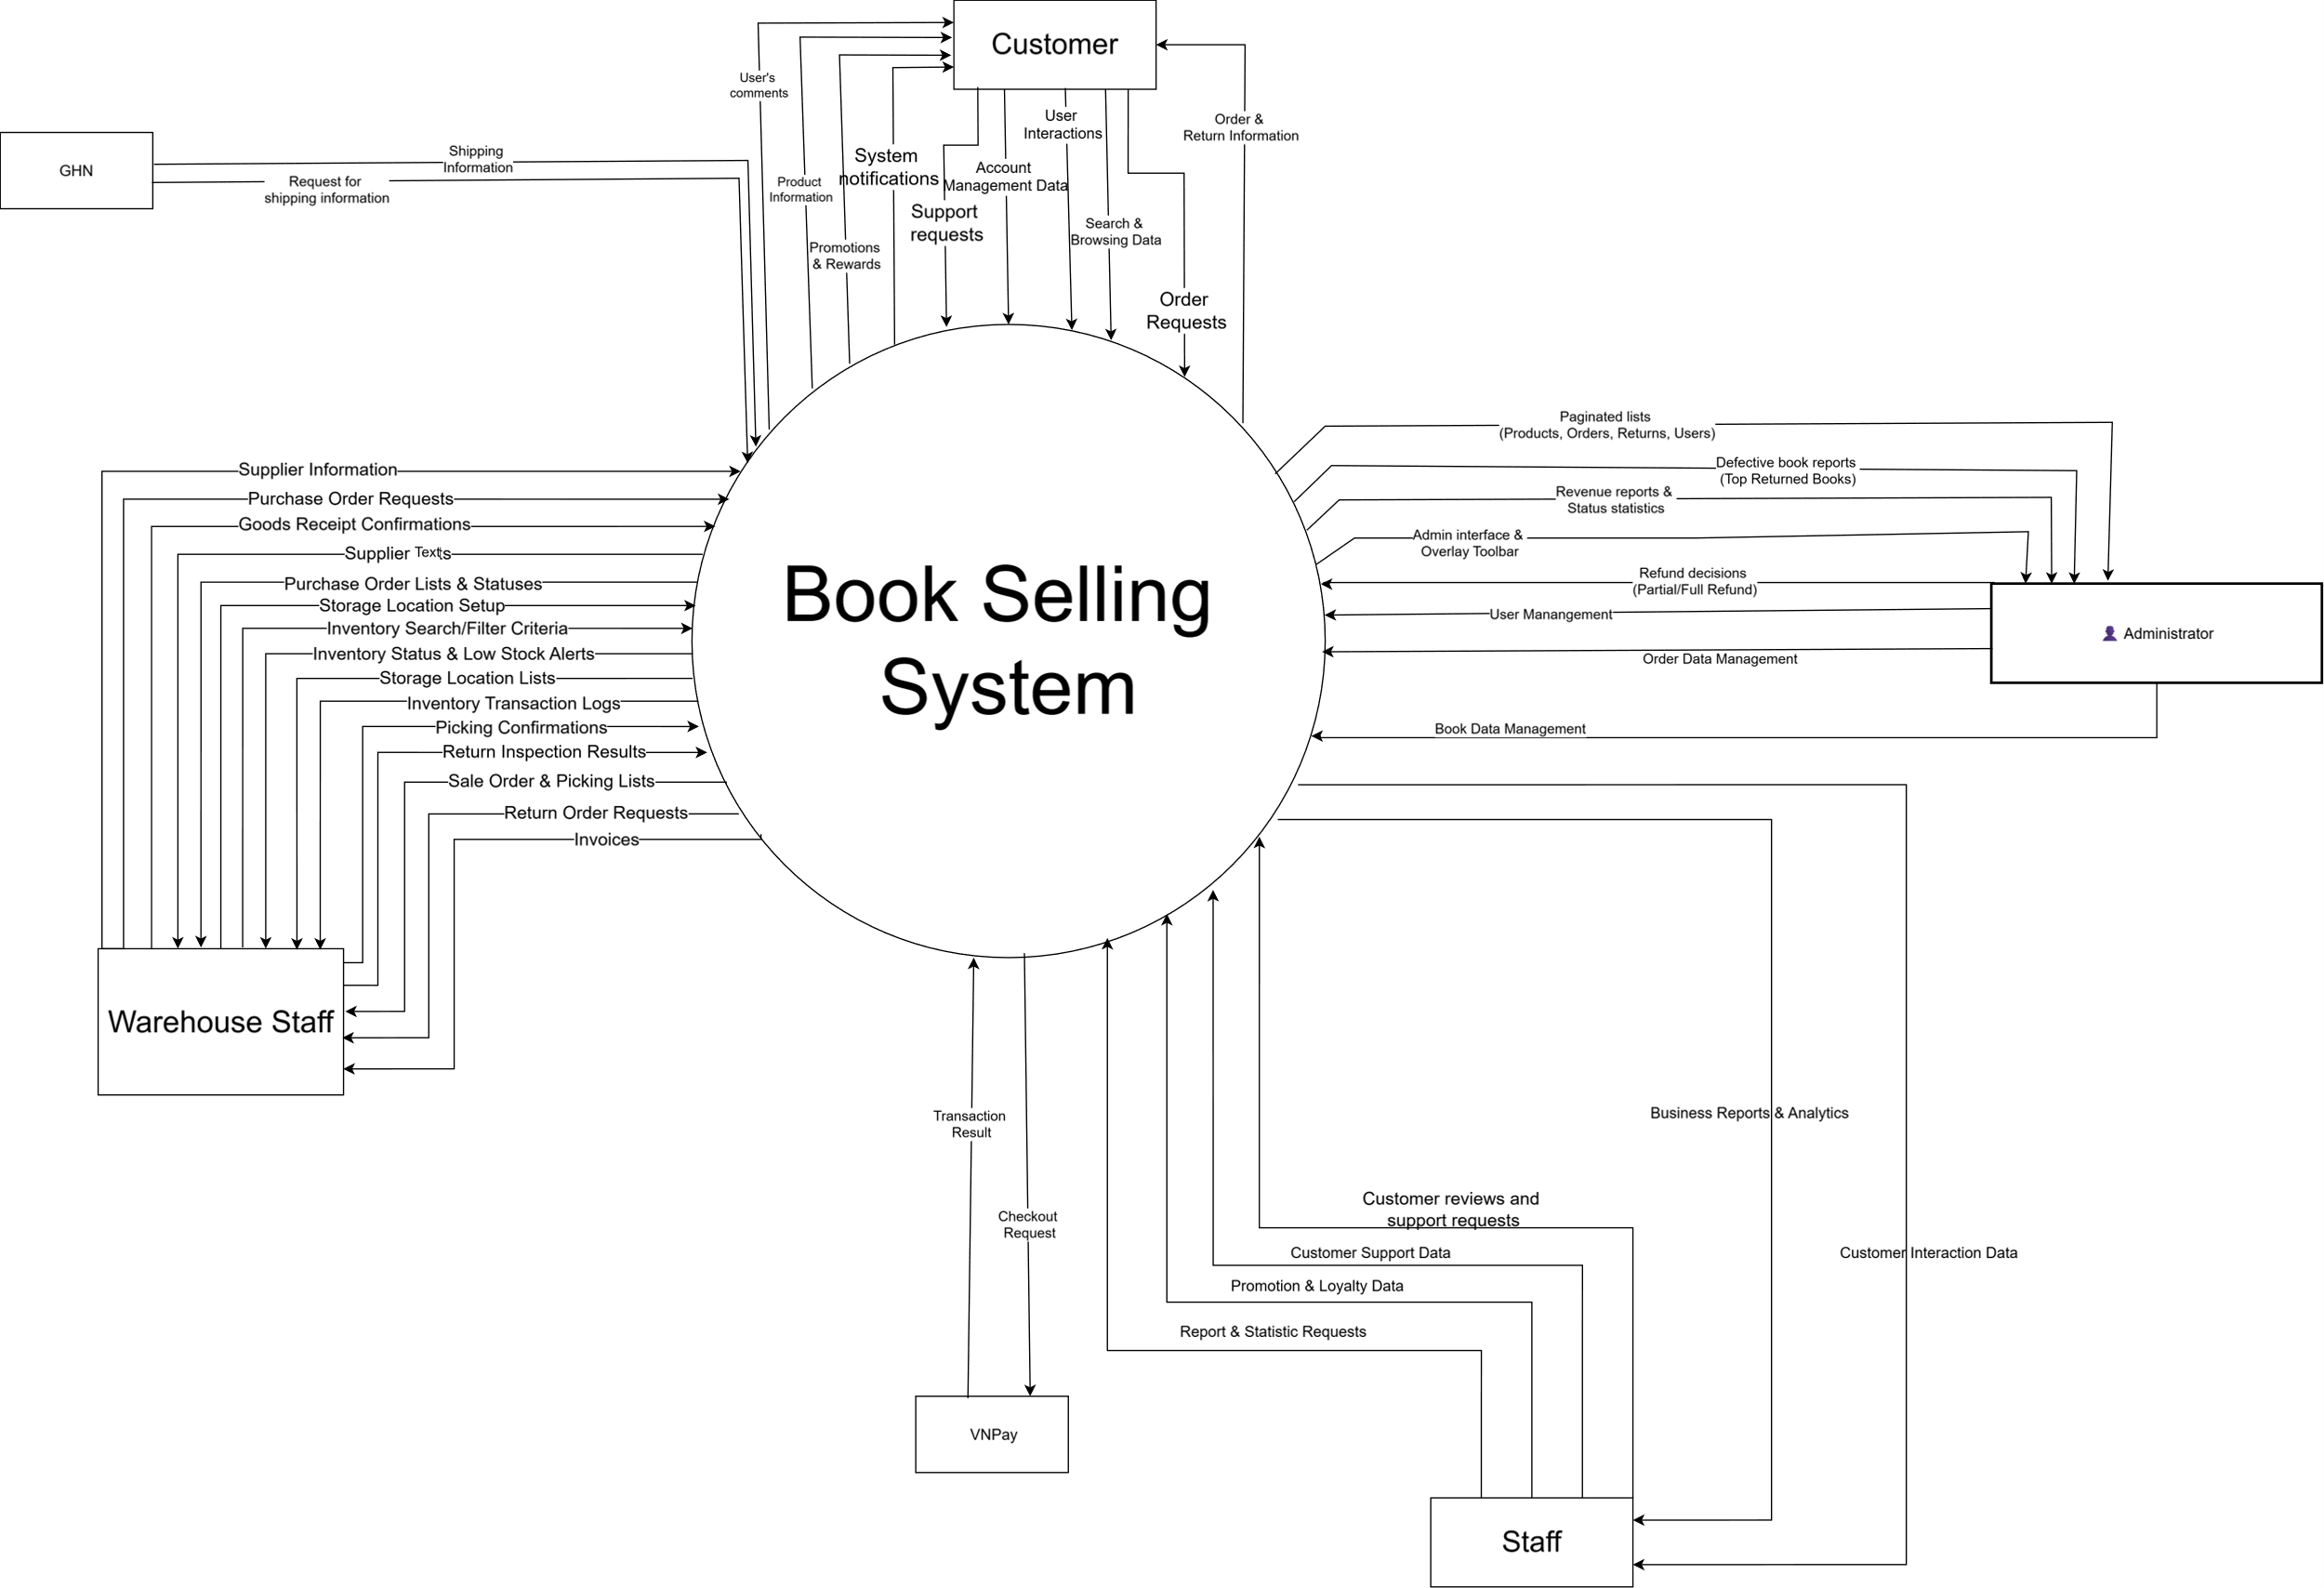

2. External Entities

# | Entity | Description
1 | Customer | The entity representing the end user (including visitors and registered members) interacts directly with the system. Customers provide input data such as account identification, search queries, shopping cart/ordering actions, and community interactions (reviews, comments). In return, they receive output data from the system such as book information, order processing status, notifications, and offers (vouchers).
2 | Sale Staff | The entity representing the bookstore's operational employees who handle day-to-day customer service and order management. Staff members interact with the system by updating order statuses, resolving customer complaints and return/refund requests, directly replying to product reviews, and managing user F-point transactions. In return, the system provides them with real-time data such as customer support tickets, detailed order lists, user feedback, and F-point audit histories to ensure smooth operations.
3 | Admin | The entity representing the system administrators and business managers who oversee the entire bookstore platform. Admins interact with the system by managing the product catalog (adding/editing books and categories), configuring system settings, managing user accounts and authorizations, and setting up marketing campaigns (vouchers, banners). In return, the system provides them with comprehensive analytical reports, sales dashboards, and system logs for strategic decision-making.
4 | Warehouse | The entity representing the inventory and fulfillment personnel responsible for physical goods. Warehouse interacts with the system by updating book stock levels, confirming goods receipts, and updating order statuses to "Packed" or "Handed over to carrier". In return, the system provides them with approved order details, packing slips, shipping labels, and low-inventory alerts to ensure timely fulfillment and restocking.
5 | GHN | The external entity representing the third-party logistics and delivery service provider. The system interacts with GHN by providing order-specific data such as customer delivery addresses (district and ward codes) and package details. In return, GHN supplies the system with real-time shipping calculations, including accurate delivery fees, estimated lead times, and updated administrative boundary data to dynamically render the frontend checkout UI.
6 | VNPay | The external entity representing the third-party payment gateway used to process secure online transactions. The system interacts with VNPay by sending outgoing data such as order information, payment amounts, and unique transaction IDs. In return, VNPay provides the system with incoming response data, including payment processing statuses, secure transaction codes (vnp_ResponseCode), and verification results to finalize or rollback the checkout process.

3. Business Processes

3.1 Sale Process
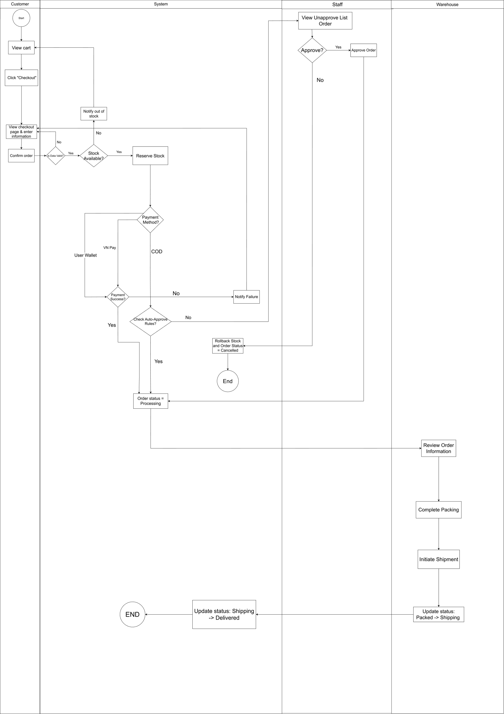

3.2 Return Order
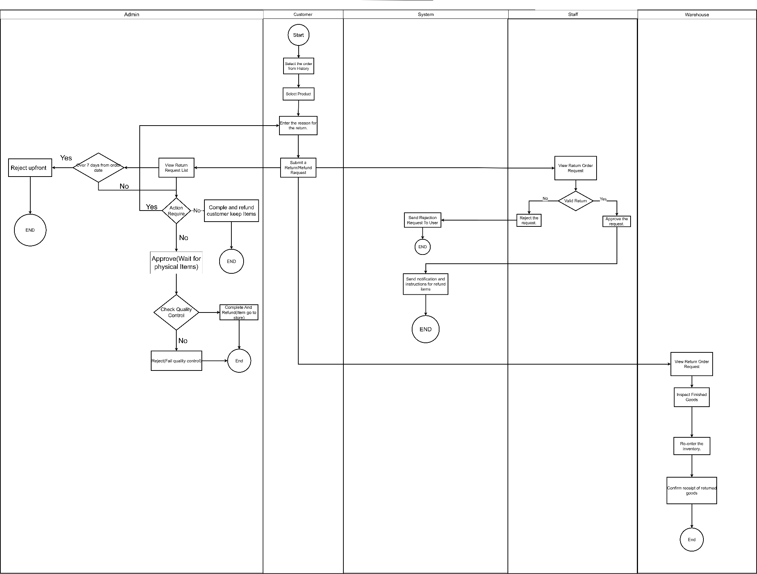

4. User Requirements

ID | Use Case | Feature | Main Actor | Use Case Description
01 | Browse Homepage | Menu Browsing | Guest, Customer, Admin, Sale Staff | Actor can view the homepage including dynamic banners, newest books, flash sale items, and book categories.
02 | Search & Filter Books | Menu Browsing | Guest, Customer, Admin, Sale Staff | Actor can search books by keyword and apply filters (price range, category, rating, title) with dynamic sorting.
03 | View Book Details | Menu Browsing | Guest, Customer, Admin, Sale Staff | Actor can view book details, images gallery, related books, reviews, discussion and calculate real-time shipping fees (via GHN API).
04 | Register Account | Account Management | Guest | Actor can create a new account using a 2-step verification process with an OTP sent to their email.
05 | Login & Logout | Account Management | Guest, Customer, Staff, Admin | Actor can log securely into the system. The system merges the guest's cart into their account upon successful login.
06 | Reset Password | Account Management | Guest | Actor can recover a forgotten password via an OTP email verification flow.
07 | Manage Profile | Account Management | Customer | Actor can view and update their personal information, including full name, email address, and phone number. Actor can save the modifications to keep their profile up to date.
08 | View Voucher Wallet | Voucher Management | Customer | Actor can view their collection of saved discount codes. Actor can check voucher terms, copy active codes for checkout, and distinguish between active and used/expired vouchers.
09 | View BookStore Wallet | Wallet Management | Customer | Actor can view their current available wallet balance. Actor can also monitor their detailed transaction history, including exact date, balance fluctuations (deductions for payments or additions for refunds), and transaction descriptions.
10 | Manage Address Book | Account Management | Customer, Admin, Sale Staff | Customer can add, edit, or delete shipping addresses using dynamic Vietnam location data and set a default address.
11 | Manage Cart | Shopping Cart | Guest, Customer | Actor can add books to the cart, update quantities, and view real-time subtotal calculations.
12 | Checkout | Order Management | Customer | Customer can fill choose addresses, payment method, apply a saved voucher, and checkout
13 | Manage My Orders | Order Management | Customer | Customer can view their order history, track status (Pending, Shipping, Completed), Cancel pending orders)
14 | Save & Use Vouchers | Promotion | Customer | Customer can save active vouchers to their personal wallet and apply them during the checkout process.
15 | Manage Collections | Personalization | Customer | Customer can create custom book collections, set privacy (Public/Private), and add/remove books from them.
16 | Post Review & Q&A | Social Interaction | Customer | Customer can rate books, write reviews, ask questions, and reply to existing threads with @username tagging.
17 | Submit Support Ticket | Customer Support | Customer | Customer can submit a new support request (issue type, details) and track the status/admin replies in their history.
18 | Manage My Comments | Social Interaction | Customer | Customer can view their entire history of reviews through a paginated list and navigate back to the product details.
19 | Manage Notifications | Account Management | Customer | Customer can view real-time alerts (e.g., being tagged), mark them as read via AJAX, and clear notification history.
20 | Change Password | Account Management | Customer | Actor can securely change their current account password from their profile dashboard.
21 | Manage Orders | Order Management | Staff | Staff can browse the list of all customer orders, and search or filter orders by customer name, phone number, or current status.
22 | Update Order Status | Order Management | Staff | Staff can update the processing progress of a specific orde
23 | View Order Details | Order Management | Staff | Staff can view the complete details of an order, including the purchased books, exact shipping address, and payment method.
24 | Manage Vouchers | Voucher Management | Staff | Staff can browse the list of all discount codes, view their limits, expiration dates, and current active/expired status.
25 | Create Voucher | Voucher Management | Staff | Staff can generate a new discount code by defining its discount type, value, minimum order requirement, usage limits, and valid dates.
26 | Update/Delete Voucher | Voucher Management | Staff | Staff can modify the details of an existing discount code or delete/deactivate it completely from the system.
27 | View Voucher Statistics | Voucher Management | Staff | Staff can view the performance analytics of a specific voucher, such as the number of users who saved it and how many times it was successfully applied.
28 | View Cart | Shopping Cart | Customer | Customer can view all books currently added to their cart, including product images, titles, unit prices, and subtotals.
29 | Update Item Quantity | Shopping Cart | Customer | Customer can increase or decrease the quantity of a specific book in the cart, and the system dynamically updates the total price.
30 | Remove Item from Cart | Shopping Cart | Customer | Customer can delete a specific book or multiple selected books from their shopping cart.
31 | Select Items for Checkout | Shopping Cart | Customer | Customer can check or uncheck specific items in the cart to choose which products they want to proceed to buy.
32 | Proceed to Checkout | Checkout | Customer | Customer can initiate the checkout process for the selected items, transferring the cart data to the order summary screen.
33 | View and Filter Customer List | Customer Management | Staff | Staff can view and filter the customer list by member tier, total spend, or keywords.
34 | View Customer Detail | Customer Management | Staff | Staff can view a specific customer's profile, contact info, and interaction history.
35 | Add Internal Note | Customer Management | Staff | Staff can log care notes (contact channel, content, follow-up date) for specific customers.
36 | Attach Customer Tags | Customer Management | Staff | Staff can attach or update classification labels (e.g., VIP, Spammer) for customers.
37 | Add/Subtract F-Point | F-Point Management | Staff | Staff can manually add or subtract reward points for a customer and specify the reason.
38 | View F-Point History | F-Point Management | Staff | Staff can view, filter, and export the F-Point transaction logs to a CSV file.
39 | Manage Reviews | Review Management | Staff | Staff can view and filter customer product reviews by rating score or keywords.
40 | Moderate Reviews | Review Management | Staff | Staff can reply to, delete, or mark inappropriate customer reviews as spam.
41 | Export Review Report | Review Management | Staff | Staff can export the current list of product reviews into an Excel file.
42 | Manage Support Tickets | Support Management | Staff | Staff can view, filter, update status, and reply to customer support tickets/complaints.
43 | View Inventory List | Inventory Management | Warehouse Staff | The user views a comprehensive list of books in stock, including details like shelf position, price, and stock quantity. The user can search by keywords or apply filters (Genre, Author, Publisher) to quickly locate specific items.
44 | Low Stock Books | Inventory Management | Warehouse Staff | The user monitors books that are running out, filters them by category, and uses the "Nhập hàng ngay" button to quickly navigate to the restocking process for items marked as "Cần nhập gấp."
45 | Supplier | Supplier Management | Warehouse Staff | The user performs full CRUD operations on supplier data, including adding, viewing, and updating provider details, as well as deleting or restoring archived suppliers from the "Kho lưu trữ" to maintain an accurate supplier database.
46 | Location Setup | Location Management | Warehouse Staff | The user manages warehouse storage layouts by performing CRUD operations on locations, including defining Zones, Shelves, and Levels, assigning them to specific book categories, and searching or filtering locations to optimize stock arrangement.
47 | Export & Order Management | Order Fulfillment | Warehouse Staff | The user manages the outbound fulfillment process by viewing the sales order list, reviewing detailed customer and item information in a modal, and executing the system-generated "Picking List" to locate items by Zone/Shelf and confirm quantities before packing.
48 | Return Order Management | Return Management | Warehouse Staff | The user manages customer return requests by viewing the return orders list, filtering by status, and executing the inspection process ("Kiểm hàng") to verify returned item quantities and conditions before confirming the restock ("Hoàn tất nhập kho").
49 | Create Purchase Order | Procurement Management | Warehouse Staff | The user creates a new import order from a specific supplier by selecting the provider, adding book items with their quantities and import prices, and saving the document to process incoming inventory.
50 | Purchase Order Management | Procurement Management | Warehouse Staff | The user manages inbound purchase orders by viewing the PO list, filtering by status or supplier, and executing the receiving process for "Approved" orders by clicking "Received" to verify expected quantities and confirm restock via the "Confirm Receive" button.
51 | View Invoice | Invoice Management | Warehouse Staff | The user views the list of invoices related to incoming purchase orders or outgoing sales, filters records by date or status, and reviews detailed invoice documents to verify billing and shipment information.
52 | Inventory History | Inventory Management | Warehouse Staff | The user views a comprehensive log of all stock movements, including imports, exports, and returns, filtering records by book title or date to track quantity changes and audit inventory accurately.
53 | Purchase Order Approval | Inventory Management | Admin | The user reviews pending purchase orders submitted by warehouse staff, examines the itemized book list, supplier details, and total costs, and approves the order to authorize the warehouse to receive the upcoming inventory.
54 | Purchase Order Detail View | Inventory Management | Admin | The user accesses a detailed breakdown of a specific purchase order to view the financial summary, requested quantities, and current workflow status (Pending, Approved, or Received) before making administrative decisions.
55 | Return Request & Wallet Refund Processing | Order Management | Admin | The user reviews customer return requests, makes approval or rejection decisions, processes financial refunds directly into the customer's website wallet, and determines if the returned item should be restocked into active inventory.
56 | Automated Return Notifications | Order Management | Admin / Staff | The user triggers automated, context-specific email notifications to customers based on return decisions (e.g., action required, rejection, or successful wallet refund), including administrative notes and instructions on keeping or returning the physical item.
57 | Add New Book | Product Management | Admin | The user creates a new book listing by entering details such as title, author, supplier, retail price, description, and uploading a cover image to expand the store's catalog.
58 | Edit Book Details | Product Management | Admin | The user modifies existing book information, including updating the retail price, adjusting category assignments, or correcting the description to ensure accurate storefront data.
59 | Manage Book Visibility | Product Management | Admin | The user toggles the active/inactive status of a book to hide it from the customer storefront without permanently deleting historical sales data or breaking past order records.
60 | View Customer Orders | Order Management | Admin / Staff | The user views a comprehensive list of all customer sales orders, filtering by current status (Pending, Shipping, Completed, Cancelled) and date to monitor daily fulfillment operations.
61 | Update Order Status | Order Management | Admin | The user manually advances the workflow status of a customer order (e.g., from Processing to Shipping) to keep the customer's dashboard, notifications, and tracking information up to date.
62 | View User Directory | User Administration | Admin | The user accesses a complete list of all registered accounts in the system, utilizing search and filter functions by email or username to monitor customer and staff profiles.
63 | Update User Roles & Access | User Administration | Admin | The user modifies the permission level of an account (e.g., promoting a Customer to Warehouse Staff or Admin) or restricts/bans an account to maintain system security and operational delegation.
64 | View Revenue Dashboard | Sales Report | Admin | The user views high-level financial metrics, including total revenue, total orders processed within a specified date range, to analyze overall business performance.
65 | Analyze Top Selling Books | Sales Report | Admin | The user reviews an aggregated list of the most frequently purchased books and highest revenue-generating titles to inform future inventory purchasing and marketing decisions.

4.1 UCs for Admin

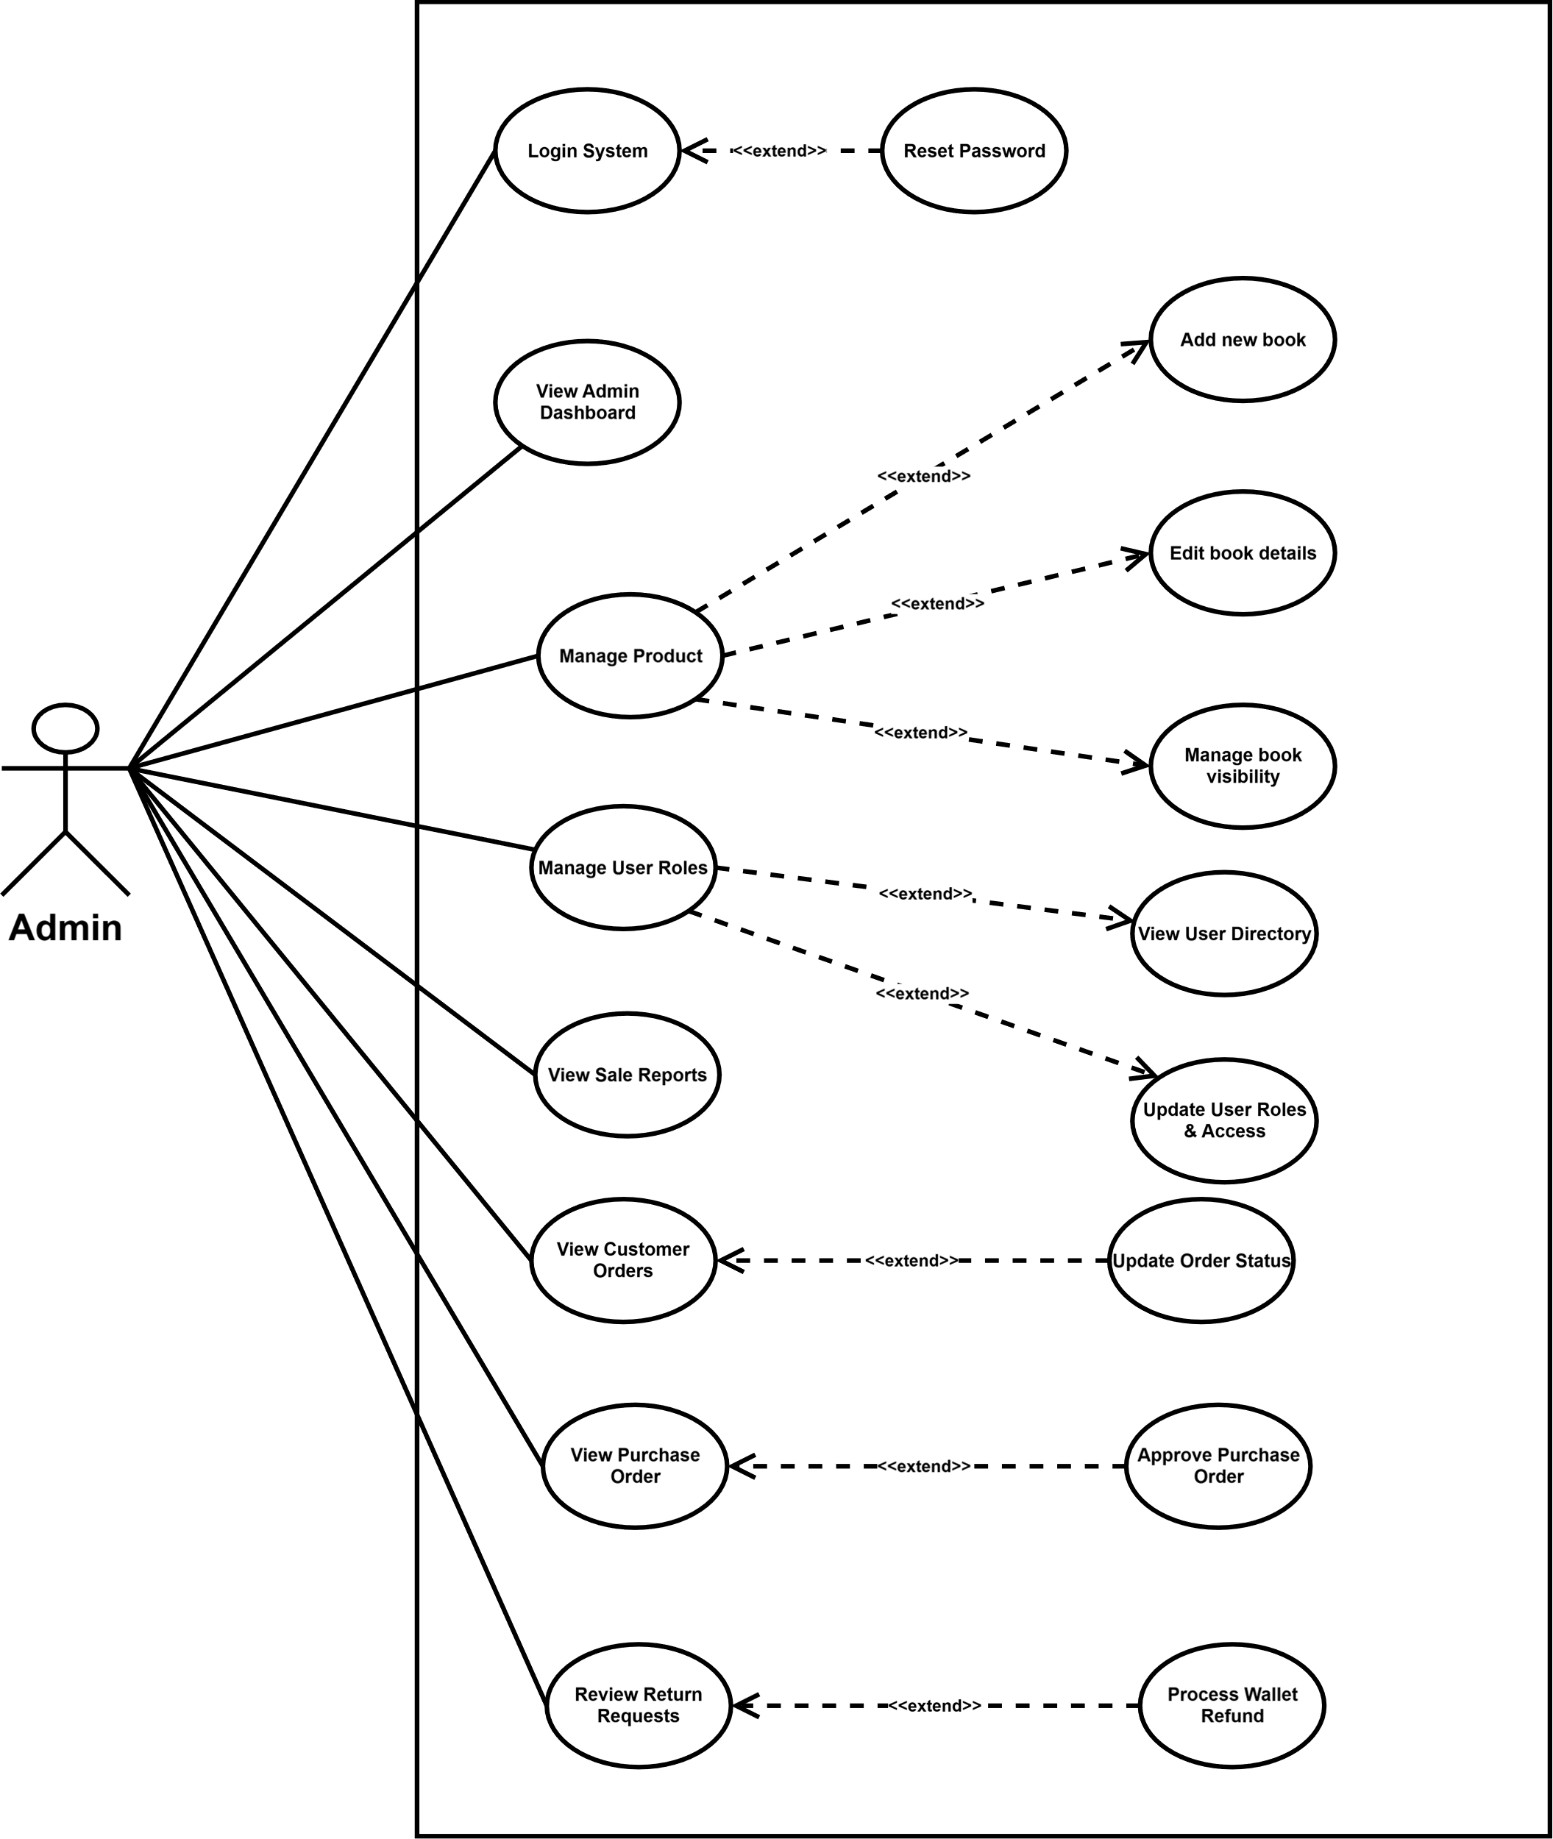

4.2 UCs for Warehouse
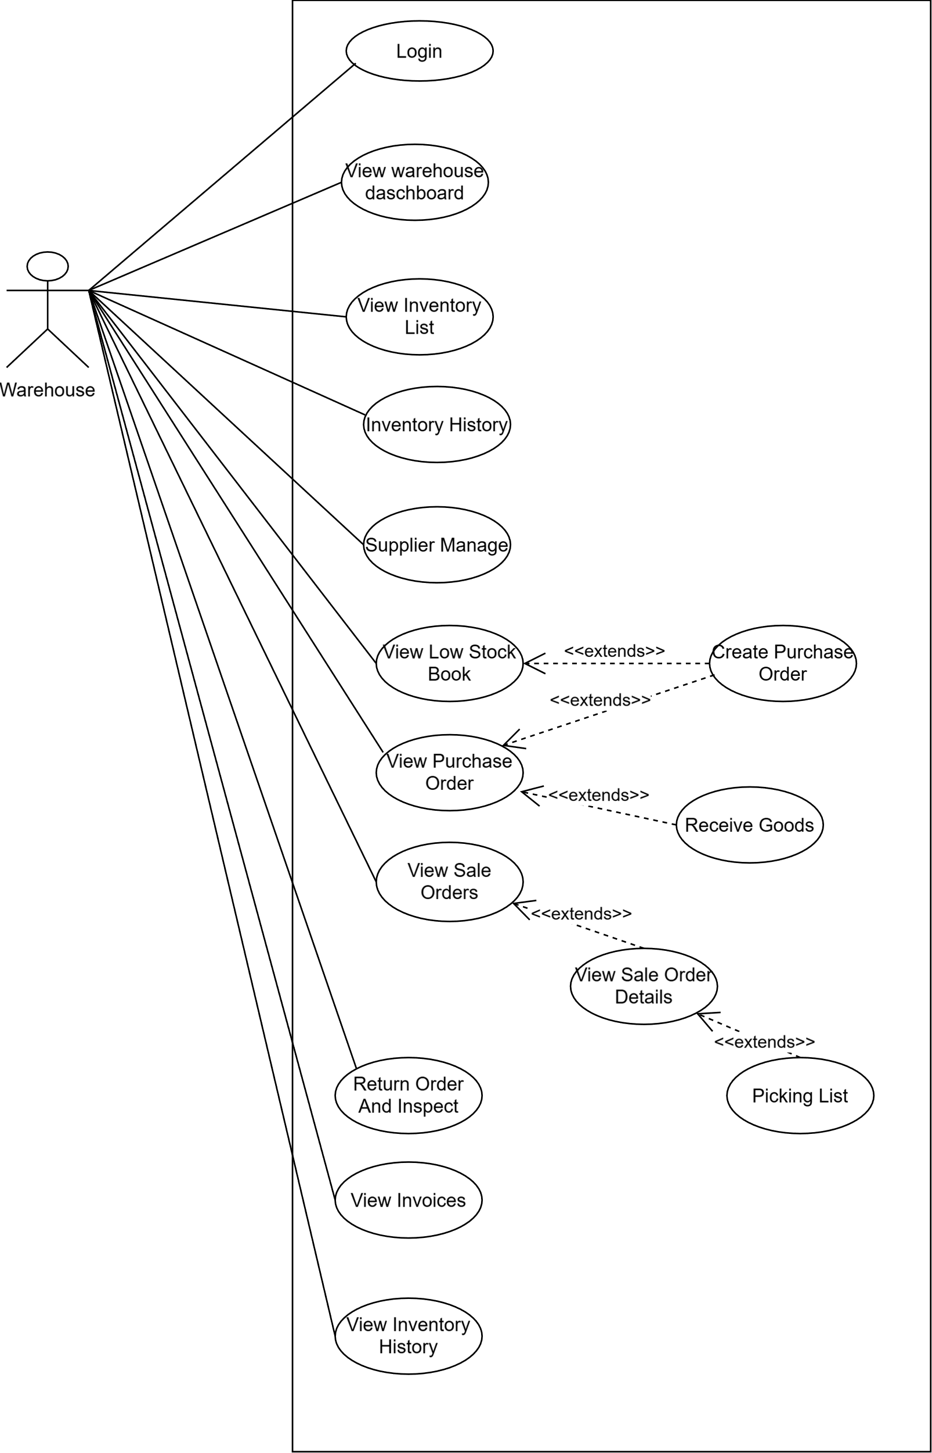

4.3 UCs for Guest

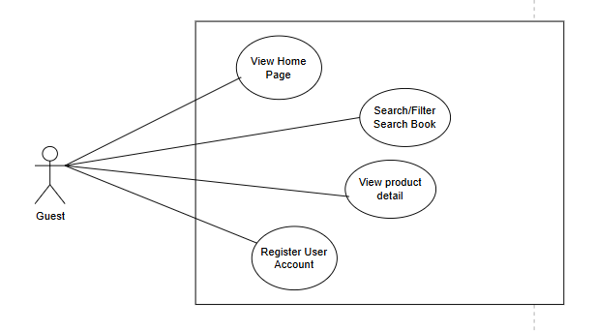

4.4 UCs for Buyer
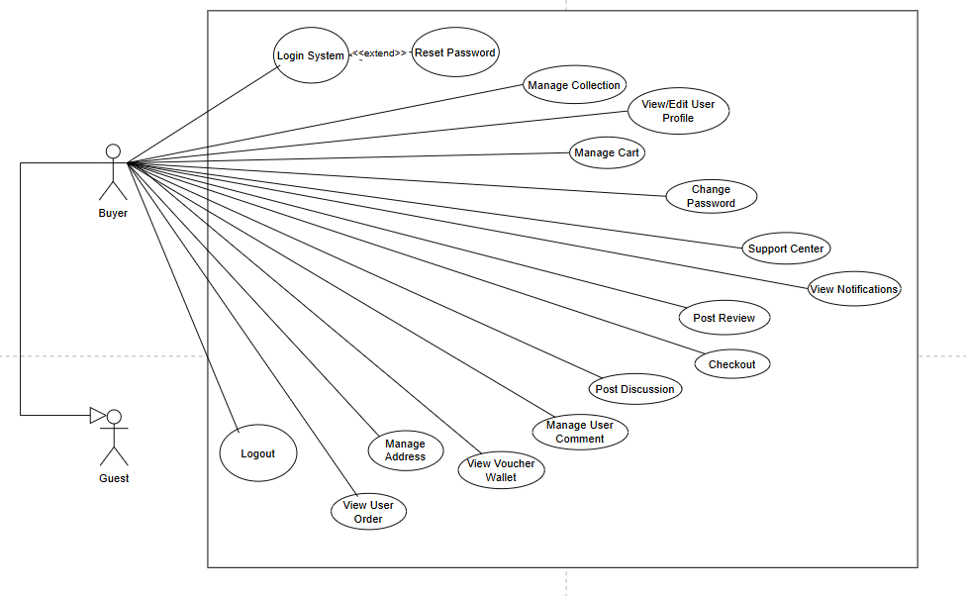

4.4 UCs for Staff
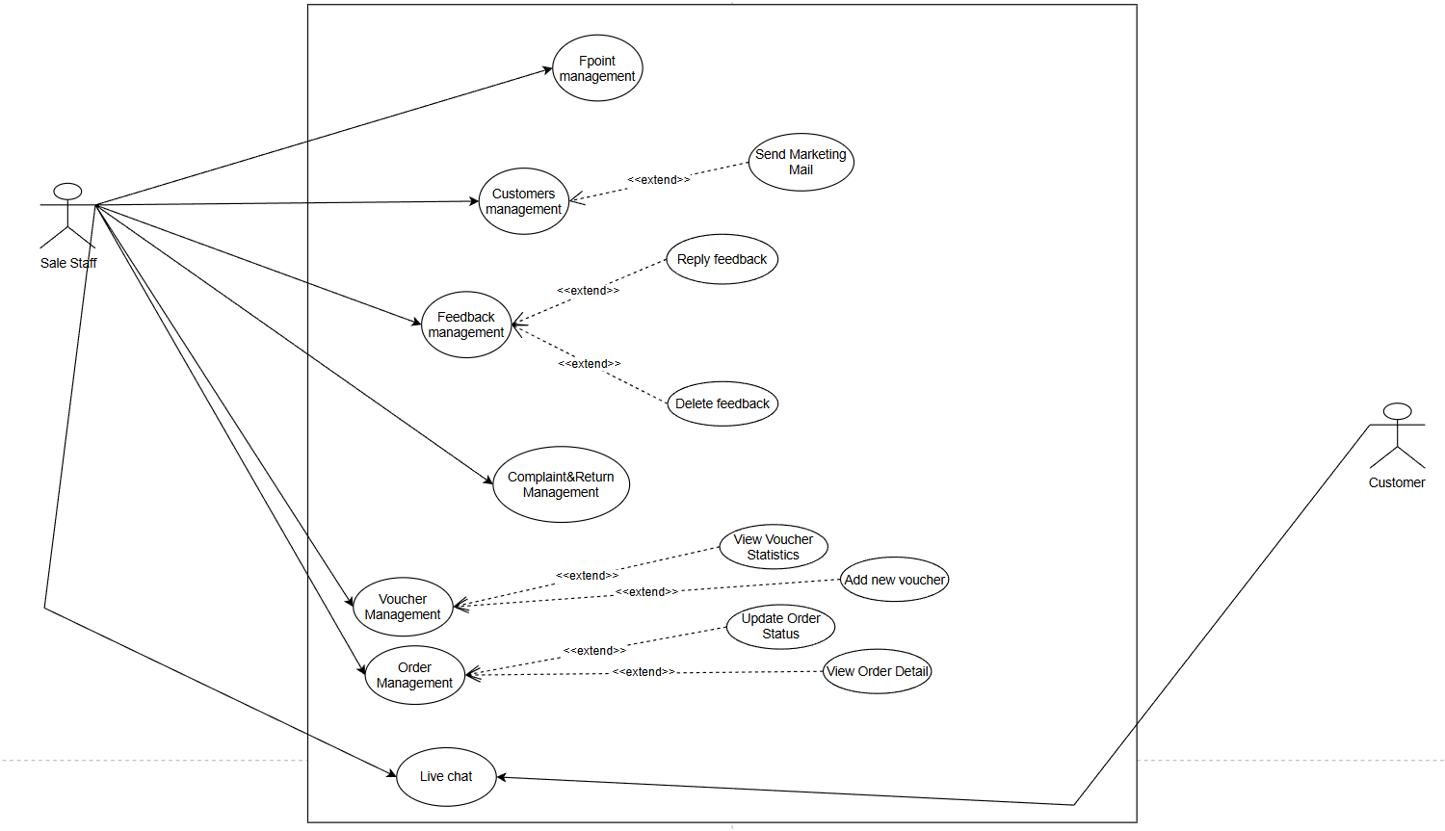

4.5 User Story

EPIC 1: Authentication

User Story 1: User Login
Description: As a Registered User, I want to log in to the system so that I can access the features and data authorized for my specific role.
- Normal Flow (Main Success Scenario):
  - User navigates to the Login Page.
  - The System displays the login form (Email/Username and Password fields).
  - User enters a valid Email and Password.
  - User clicks the "Login" button.
  - The System authenticates the credentials against the database and identifies the User Role.
  - The System creates a session and redirects the user based on their role:
    - Buyer: Redirected to the Homepage.
    - Admin: Redirected to the Admin Dashboard.
    - Warehouse Keeper: Redirected to the Inventory Management page.
- Alternative Flows:
  - AF 1: Remember Me: User selects the "Remember Me" checkbox before logging in. After successful authentication, the system saves a secure cookie to keep the user logged in for future visits.
- Exceptions:
  - EX 1: Invalid Credentials: User enters an incorrect email or password. The system remains on the Login page and displays: "Incorrect login information."
  - EX 2: Missing Required Fields: User leaves Email or Password blank. The system displays: "Please enter this information" directly under the empty field.
  - EX 3: Blocked Account: User enters correct credentials, but the account status is set to "Locked/Inactive". The system prevents login and displays: "Your account has been locked. Please contact support."
  - EX 4: SQL Injection/Malicious Input: User enters invalid characters in fields. The system sanitizes input and rejects the request.

User Story 2: User Logout
Description: As a Registered User, I want to log out of the website so that I can protect my personal data and maintain account security, especially when using a shared or public device.
- Normal Flow (Main Success Scenario):
  - A logged-in User clicks the "Logout" button (found in the Header or User Menu).
  - The System terminates the current server session.
  - The System clears local authentication data (cookies/tokens).
  - The System redirects the user to the Homepage (or Login Page).
  - The Header/Menu is updated to show "Login" and "Register" buttons instead of user-specific info.
- Alternative Flows:
  - AF 1: Logout from Profile: User logs out specifically from the account settings page. The flow remains the same as the Normal Flow.
- Exceptions:
  - EX 1: Back-button Browser Cache: User clicks the browser's "Back" button after logging out. The system checks for an active session; since none exists, it redirects the user back to the Login Page or displays an "Access Denied" message for restricted pages.
  - EX 2: Failed Session Termination: If the network fails during the logout request, the system prompts the user: "Unable to logout at this time. Please try again."

User Story 3: Register a New Account
Description: As an Unregistered User, I want to create a new account on the website so that I can manage my profile, track orders, and access member-exclusive features like vouchers and cart saving.
- Normal Flow (Main Success Scenario):
  - User navigates to the Registration Page.
  - User fills in all required fields: Full Name, Username, Email, Phone Number, Password, and Confirm Password.
  - User clicks the "Register" button.
  - The System validates the data formats and checks for existing accounts.
  - The System creates a new user record with the default 'Customer' role.
  - The System generates an OTP (One-Time Password) and sends it to the user's email.
  - The System redirects the user to the OTP Verification Page with a success notification.
- Exceptions:
  - EX 1: Duplicate Account Info: User enters a Username or Email that is already taken. The system remains on the page, retains non-sensitive data, and displays: "Username/Email already exists."
  - EX 2: Invalid Field Formats:
    - Email: User enters a string without "@" or ".com". Error: "Invalid email format."
    - Phone: User enters letters or special characters. Error: "Phone number must contain only digits."
    - Length: Phone number is too short or too long. Error: "Invalid phone number length."
  - EX 3: Password Mismatch: "Confirm Password" does not match "Password". The system displays: "Passwords do not match."
  - EX 4: Weak Password: User enters a password that is too simple (e.g., less than 6 characters). The system displays: "Password must be at least 6 characters long."
  - EX 5: Empty Mandatory Fields: User leaves required fields blank. The system displays: "This field is required" next to each empty field.
  - EX 6: Terms and Conditions Not Accepted: (Optional) If there is a checkbox for terms, the system prevents registration if it is unchecked.

EPIC 2: User Management

User Story 1: Edit User Profile (with OTP Verification)
Description: As a Registered User, I want to view and safely update my personal profile information (Full Name, Email, Phone Number) so that my contact details are up-to-date, with sensitive changes protected by OTP verification.
Normal Flow (Main Success Scenarios):
- Scenario A: Update Basic Info (Full Name)
  - The User navigates to the "My Profile" (Hồ sơ cá nhân) page.
  - The System retrieves and displays the current user data (Username is read-only).
  - The User modifies the "Full Name" (Họ và tên) directly in the input field.
  - The User clicks the "Save Changes" (Lưu thay đổi) button.
  - The System validates the name, updates the database, and displays a success notification.
- Scenario B: Update Email (Requires OTP)
  - The User clicks the "Change" (Thay đổi) button next to the Email field.
  - The System opens the "Change Email" (Thay đổi Email) modal.
  - The User enters a new email address and clicks "Send OTP" (Gửi mã OTP).
  - The System generates a 6-digit OTP and sends it to the newly entered email.
  - The User enters the 6-digit OTP into the verification field and clicks "Confirm" (Xác nhận).
  - The System verifies the OTP, updates the email in the database, closes the modal, and refreshes the UI with the new email.
- Scenario C: Update Phone Number (Requires OTP via Current Email)
  - The User clicks the "Change" (Thay đổi) button next to the Phone Number field.
  - The System opens the "Change Phone Number" (Thay đổi Số điện thoại) modal, displaying the user's current verified email.
  - The User clicks "Send OTP" (Gửi mã OTP).
  - The System sends a 6-digit OTP to the user's current email for security authorization.
  - The User retrieves the OTP, enters it into the modal, and inputs their New Phone Number.
  - The User clicks "Confirm" (Xác nhận).
  - The System verifies the OTP and the new phone format, updates the database, closes the modal, and refreshes the UI.
Alternative Flows:
- AF 1: Cancel Update: At any point inside the Email or Phone modals, the User clicks the "Back" (Trở về) button or the modal backdrop. The modal closes, and no changes are made to the database.
- AF 2: Resend OTP: If the User does not receive the OTP, they can wait for a cooldown timer (if implemented) and click "Resend OTP". The system invalidates the old OTP and sends a new one.
Exceptions:
- EX 1: Empty Full Name: The User clears the "Full Name" field and clicks "Save Changes". The system blocks the action and displays an error: "Full Name cannot be blank."
- EX 2: Invalid OTP: The User enters an incorrect 6-digit OTP and clicks "Confirm". The system prevents the update and displays an error directly inside the modal: "Invalid or expired OTP. Please try again."
- EX 3: Duplicate Email: In the Change Email modal, the User requests an OTP for an email that is already registered to another account. The system halts the action immediately and displays: "This email is already in use by another account."
- EX 4: Invalid Email Format: The User types an invalid email (e.g., missing '@') in the modal. The system disables the "Send OTP" button or throws a validation error: "Please enter a valid email address."
- EX 5: Invalid Phone Format: In the Change Phone modal, the User enters a valid OTP but an invalid new phone number (e.g., contains letters or wrong length). The system rejects the confirmation and displays: "Phone number must be 10 digits and start with 0."
- EX 6: OTP Timeout/Expiration: The User waits too long (e.g., over 5 minutes) to enter the OTP. Upon clicking "Confirm", the system rejects the input and prompts: "OTP has expired. Please request a new one."

User Story 2: Change Account Password
Description: As a Registered User, I want to change my current password from within my account settings so that I can maintain the security of my account and protect my personal data.
Normal Flow (Main Success Scenario):
- The User navigates to the "Change Password" section in Account Settings.
- The System displays three fields: Current Password, New Password, and Confirm New Password.
- The User enters the correct Current Password.
- The User enters a New Password that meets security requirements (e.g., minimum 6 characters).
- The User enters the same password in the Confirm New Password field.
- The User clicks the "Update Password" button.
- The System verifies the Current Password against the database and checks if the New Passwords match.
- The System encrypts the new password and updates the database.
- The System displays a success message and logs the user out for security purposes.
Alternative Flows:
- AF 1: Stay Logged In: Depending on system configuration, the system updates the password and allows the user to stay on the page with a success notification instead of forcing a logout.
Exceptions:
- EX 1: Incorrect Current Password: The User enters a current password that does not match the database record. The system displays: "Incorrect current password. Please try again."
- EX 2: Password Mismatch: The "New Password" and "Confirm New Password" fields do not match. The system displays: "Passwords do not match."
- EX 3: Weak Password: The User enters a new password that is too short (less than 6 characters). The system displays: "Password must be at least 6 characters long."
- EX 4: Same as Old Password: The User attempts to set a new password that is identical to the current password. The system displays: "New password cannot be the same as the old password."
- EX 5: Missing Fields: The User leaves any of the three fields empty and clicks "Update". The system displays: "All fields are mandatory."
- EX 6: Session Timeout: The User stays on the page too long before submitting. The system redirects to the Login page and displays: "Session expired. Please log in again."

User Story 3: Manage Address Book
Description: As a Registered User, I want to manage my shipping addresses (add, edit, delete, and set default) so that I can quickly and accurately select a delivery destination during checkout.
- Normal Flow (Main Success Scenario - Add New Address):
  - The User navigates to the "Address Book" (Sổ địa chỉ) page.
  - The User clicks the "Add New Address" (+ Thêm địa chỉ mới) button.
  - The System displays a modal with fields: Full Name, Phone Number, Province/City, District, Ward, and Specific Address.
  - The User enters valid data into all mandatory fields.
  - The User clicks the "Save Address" (Lưu địa chỉ) button.
  - The System validates the data, saves the new address to the database, closes the modal, and updates the Address Book list.
- Alternative Flows:
  - AF 1: Edit an Address: The User clicks "Edit" (Sửa) on an existing address. The system opens a form populated with current data. The user modifies the data, checks the "Use as default address" box, and saves. The system updates the record and moves it to the top with a "Default" badge.
  - AF 2: Delete an Address: The User clicks the Trash/Delete icon next to an address. The system prompts a confirmation. Upon confirming, the address is removed from the list and database.
  - AF 3: Cancel Action: While in the Add/Edit modal, the User clicks "Cancel" (Hủy). The modal closes without saving any changes.
- Exceptions:
  - EX 1: Invalid Name Format: The User enters numbers in the Full Name field. The system blocks submission and displays: "Name cannot contain numbers."
  - EX 2: Name Length Exceeded: The User enters a name longer than 50 characters. The system displays: "Length cannot exceed 50 characters."
  - EX 3: Invalid Phone Number: The User enters a phone number that contains letters, does not start with '0', or is not exactly 10 digits long. The system displays: "Phone number must contain only digits, be exactly 10 digits, and start with 0."
  - EX 4: Specific Address Length Exceeded: The User enters a specific address longer than 100 characters. The system displays: "Address cannot exceed 100 characters."
  - EX 5: Missing Dropdown Selection: The User forgets to select Province, District, or Ward. The system highlights the dropdowns and displays: "This field is required."

User Story 4: Manage My Collections (Bookshelves)
Description: As a Registered User, I want to create and manage custom book collections (bookshelves) so that I can organize my favorite books by topic (e.g., Wealth, Love Story, Comics) and control their privacy.
- Normal Flow (Main Success Scenario - Create Collection):
  - The User navigates to the "My Collections" (Giá Sách Của Tôi) page.
  - The User clicks the "Create New" (+ Tạo mới) button.
  - The System displays a modal for collection details.
  - The User enters a Collection Name, an optional Short Description, selects Privacy (Public/Private), and picks a representative Theme Color.
  - The User clicks "Create Now" (Tạo ngay).
  - The System saves the collection and displays it as a new color-coded card on the main page.
- Alternative Flows:
  - AF 1: Manage Books inside a Collection: The User clicks on a Collection card to view its details. The system displays all books inside. The user can search for a book by name, sort by "Recently added", or click the red "X" icon to remove a specific book from this collection.
  - AF 2: Edit Collection Metadata: The User clicks the Edit (Pencil) icon on a collection card. They change the name, description, privacy, or color, and click "Save changes".
  - AF 3: Delete Collection: The User clicks the Trash icon on a collection card. The system requests confirmation and then permanently deletes the collection and its associations.
- Exceptions:
  - EX 1: Empty Collection Name: The User leaves the "Collection Name" blank and clicks Create/Save. The system blocks the action and displays: "Collection name is required."
  - EX 2: Duplicate Collection Name: The User tries to create a collection with a name that already exists in their account. The system displays: "You already have a collection with this name."
  - EX 3: Remove Last Book Exception: The User removes the last book from a collection. The system displays an empty state message: "This collection has no books yet." rather than causing an error.

User Story 5: Manage Notifications
Description: As a Registered User, I want to view and manage my system notifications so that I can stay updated on activities related to me, such as being mentioned in a comment or order status updates.
- Normal Flow (Main Success Scenario):
  - The User clicks the Notification bell icon and navigates to the "All Notifications" (Tất cả thông báo) page.
  - The System displays a chronological list of alerts (e.g., "hi mentioned you in a comment") along with the timestamp.
  - The User clicks the Trash icon next to a specific notification.
  - The System instantly removes that single notification from the UI and updates the database via AJAX.
- Alternative Flows:
  - AF 1: Delete All Notifications: The User clicks the "Delete All" (Xóa tất cả) button at the top. The system clears the entire notification history and displays an empty state.
  - AF 2: Navigate via Notification: The User clicks on the text body of a notification. The system redirects the user to the relevant context page (e.g., the specific product detail page where the comment was made).
- Exceptions:
  - EX 1: Empty Notification List: The User accesses the page when there are no new or historical notifications. The system gracefully displays an empty state graphic and message: "You have no notifications at this time."
  - EX 2: Deletion Failure (Network Error): The User clicks the Trash icon, but the server connection is lost. The system keeps the notification on the screen and displays a message: "Failed to delete notification. Please try again."

User Story 6: View My Comments/Reviews
Description: As a Registered User, I want to view a centralized history of all the reviews and comments I have posted so that I can manage my interactions and revisit products I've rated.
- Normal Flow (Main Success Scenario):
  - The User navigates to the "My Comments" (Bình luận của tôi) page.
  - The System retrieves and displays a paginated list of the user's past reviews.
  - Each item displays: Product Name, Star Rating (if applicable), Date Posted, and the Comment Content.
  - The User clicks the "View" (Xem) button on a specific review.
  - The System redirects the user to that specific Product Detail page, anchoring down to the review section.
- Alternative Flows:
  - AF 1: Pagination/Scrolling: If the user has made many comments, they can use pagination controls at the bottom to navigate through older comments.
- Exceptions:
  - EX 1: No Comments History: The User has never posted a review or comment. The system displays an empty state: "You haven't posted any comments or reviews yet."
  - EX 2: Product Deleted/Unavailable: The User clicks "View" on a comment, but the product it belongs to has been removed from the store by the Admin. The system prevents redirection and displays an alert: "This product is no longer available."
  - EX 3: Long Comment Truncation: A user has written a massive review. To prevent breaking the UI, the system displays the first 3 lines of the comment and adds a "... Read more" toggle to expand the text.

User Story 7: Manage My Orders & Returns
Description: As a Registered User, I want to view and manage my order history so that I can track current deliveries, easily repurchase items, cancel pending orders, or submit return/refund requests for problematic products.
Normal Flow (Main Success Scenarios):
- Scenario A: View Order Status & Repurchase
  - The User navigates to the "My Orders" (Đơn hàng của tôi) page.
  - The System displays orders categorized by tabs: All, Processing, Shipping, Completed, and Cancelled.
  - The User views an order's details (Order ID, Date, Items, Total Price).
  - The User clicks the "Repurchase" (Mua lại) button on a completed order.
  - The System automatically adds those specific items back into the User's cart and redirects them to the Cart page.
- Scenario B: Request Return/Refund (Trả hàng / Hoàn tiền)
  - The User navigates to the "Completed" tab and locates a specific order.
  - The User clicks the "Return/Refund" button.
  - The System displays a modal asking for the Return Reason.
  - The User selects a radio button (e.g., Product defective, Wrong item delivered) and optionally inputs extra details in the text area.
  - The User clicks "Send Request" (Gửi Yêu Cầu).
  - The System saves the request, closes the modal, and notifies the user that the request is being processed.
Alternative Flows:
- AF 1: Cancel a Pending Order: The User navigates to the "Processing" (Đang xử lý) tab. They click the "Cancel Order" (Hủy đơn) button. The system asks for confirmation. Upon confirming, the order status changes to "Cancelled" and the warehouse is notified to halt packing.
Exceptions:
- EX 1: Cancellation Not Allowed: An order has moved to the "Shipping" (Đang giao) status. The system hides the "Cancel Order" button because the package has already left the warehouse.
- EX 2: Return Window Expired: An order was completed 30 days ago, exceeding the store's return policy. The system hides or disables the "Return/Refund" button.
- EX 3: Empty Return Reason: In the Return Modal, the User clicks "Send Request" without selecting a radio button reason. The system blocks submission and displays: "Please select a reason for the return."
- EX 4: Empty Order List: The User clicks on a tab (e.g., Cancelled) where they have no orders. The system displays an empty state: "You have no cancelled orders."

User Story 8: Manage Voucher Wallet
Description: As a Registered User, I want to view and manage my saved discount vouchers so that I can easily copy voucher codes and apply them during checkout to save money.
Normal Flow (Main Success Scenario):
- The User navigates to the "Voucher Wallet" (Ví voucher) page.
- The System retrieves and displays a grid of vouchers associated with the user.
- The System highlights active, usable vouchers in a bright color (e.g., Green) showing the discount amount, minimum spend, code, and expiry date.
- The User clicks the "Copy Code" (Copy mã) button on an active voucher.
- The System copies the code to the user's clipboard and displays a quick toast notification: "Code copied to clipboard!"
Alternative Flows:
- AF 1: View Voucher Details: The User clicks the "Details" (Chi tiết) link on a voucher. The system opens a popup explaining the specific terms, conditions, and applicable products for that voucher.
Exceptions:
- EX 1: Used/Expired Vouchers: The System detects that a voucher is past its expiry date or has already been used by the user. The system greys out the voucher card, changes the button text to "Used" (Đã dùng), and disables interactions.
- EX 2: Empty Wallet: The User has not saved any vouchers yet. The system displays an empty state: "Your voucher wallet is currently empty. Start shopping to collect vouchers!"

User Story 9 Support Center (Submit & Track Requests)
Description: As a Registered User, I want to submit support tickets and track their resolution status so that I can get official assistance with website issues or order problems directly from the store staff.
Normal Flow (Main Success Scenarios):
- Scenario A: Submit a New Request
  - The User navigates to the "Support Center" (Trung tâm Hỗ trợ) page and clicks the "Send New Request" (Gửi Yêu cầu Mới) tab.
  - The System displays a support form.
  - The User selects an Issue Type from the dropdown (e.g., Faulty product, Website error).
  - The User enters a Request Title and types the Issue Details.
  - The User clicks the "Send Request" (Gửi Yêu Cầu) button.
  - The System saves the ticket to the database, clears the form, and redirects the user to the "Request History" tab with a success message.
- Scenario B: Track Request History
  - The User navigates to the "Request History" (Lịch sử Yêu cầu) tab.
  - The System displays a chronological list of all submitted tickets.
  - Each ticket displays the Issue Category tag, Date, Title, and a visual Status Badge (e.g., Orange for "Pending" - Đang chờ xử lý).
Alternative Flows:
- AF 1: View Admin Reply: Once a Staff member replies to the ticket, the Status badge changes to "Resolved" (Đã xử lý). The user clicks on the ticket to open a modal or new page to read the admin's response.
Exceptions:
- EX 1: Missing Required Fields: The User clicks "Send Request" without selecting an Issue Type, or leaving the Title/Details blank. The system blocks the submission and highlights the missing fields in red: "This field is required."
- EX 2: Input Length Exceeded: The User types an excessively long title (e.g., over 100 characters). The system prevents typing further or throws a validation error upon submission to prevent database overflow.
EPIC 3: Product Discovery
User Story 1: View Product Details
Description: As a User (Guest or Registered), I want to view the comprehensive details of a specific book so that I can evaluate its content, check shipping costs, and decide whether to purchase it.
Normal Flow (Main Success Scenario):
- The User clicks on a book card from the Homepage, Search Results, or a Collection.
- The System navigates to the Product Detail page.
- The System retrieves and displays the book's information: Cover Image gallery, Title, Supplier, Publisher, Author, Format (e.g., Paperback), Average Star Rating, and number of items sold.
- The System calculates and displays the Current Price and the original crossed-out price with the discount percentage badge.
- The System displays the default shipping location and calculates the estimated standard shipping fee.
- The User can click "Add to Cart" (Thêm vào giỏ) or "Buy Now" (Mua ngay) to proceed with purchasing.
Alternative Flows:
- AF 1: Change Shipping Address: The User clicks "Change" (Thay đổi) in the shipping section. A modal appears allowing them to select a different Province/District/Ward. The system recalculates and updates the shipping fee dynamically.
- AF 2: Save to Wishlist/Collection: A Registered User clicks the Heart icon next to the action buttons to save the book to their personal collection.
Exceptions:
- EX 1: Out of Stock: If the book's inventory is 0, the System disables the "Add to Cart" and "Buy Now" buttons and displays an "Out of Stock" (Hết hàng) label.
- EX 2: Product Not Found: The User accesses a product URL with an invalid ID. The System displays a 404 Error page or a "Product no longer exists" message.

User Story 2: Product Reviews & Comments
Description: As a Registered User, I want to rate, review, and manage my feedback on a book so that I can share my reading experience and assist other customers in their purchasing decisions.
Normal Flow (Main Success Scenarios):
- Scenario A: Write a Review
  - The User scrolls down to the "Product Review" (Đánh giá sản phẩm) section.
  - The User clicks the "Write a Review" (Viết đánh giá) button.
  - The System expands the review form.
  - The User selects a Star Rating (1 to 5 stars) by clicking the interactive star icons.
  - The User types their feedback into the text area.
  - The User clicks "Submit Review" (Gửi đánh giá).
  - The System saves the review, updates the book's average rating, and displays the new review at the top of the list.
- Scenario B: Edit/Delete Review
  - The User locates their own published review in the list.
  - The User clicks the Three-dot menu (⋮) on the right side of their review.
  - To Edit: The User selects "Edit comment" (Sửa bình luận), modifies the text/stars, and saves.
  - To Delete: The User selects "Delete comment" (Xóa bình luận), confirms the prompt, and the system removes the review from the database.
Exceptions:
- EX 1: Missing Star Rating: The User writes text but forgets to click the star rating. Upon clicking Submit, the system blocks the action and displays: "Please select a star rating."
- EX 2: Guest Access: An unregistered User clicks "Write a Review". The System redirects them to the Login page with a message: "Please log in to review products."

User Story 3: Q&A and Discussion
Description: As a Registered User, I want to ask specific questions about the book, categorize my topic, and reply to others' questions so that I can build a community discussion and clarify doubts before buying.
Normal Flow (Main Success Scenarios):
- Scenario A: Ask a New Question
  - The User scrolls to the "Q&A & Discussion" (Hỏi đáp & Thảo luận) section.
  - The User clicks the "Ask a Question" (Đặt câu hỏi) button.
  - The System displays a discussion form.
  - The User enters the Question Title (Tiêu đề câu hỏi).
  - The User selects a Topic from the dropdown (e.g., Content inquiry / Hỏi nội dung).
  - The User types the Question Details (Chi tiết câu hỏi).
  - If the question reveals plot details, the User toggles on the "Contains Spoilers" (Có tiết lộ nội dung truyện) switch.
  - The User clicks "Submit Question" (Gửi câu hỏi).
  - The System saves and displays the thread with the appropriate Topic badge.
- Scenario B: Reply to a Thread
  - The User views an existing question and types a response into the input field at the bottom of that thread.
  - The User clicks "Send" (Gửi).
  - The System appends the reply chronologically under the parent question.
Alternative Flows:
- AF 1: Edit/Delete Discussion: Just like reviews, the User can click the three-dot menu (⋮) on their own question or reply to modify the text or permanently delete it.
Exceptions:
- EX 1: Missing Mandatory Fields: The User leaves the Title or Details field blank and clicks Submit. The system halts submission, focuses on the empty field, and displays a tooltip validation: "Please fill out this field" (Vui lòng điền vào trường này).
- EX 2: Content Moderation (Optional): The User includes banned words (profanity) in the discussion. The System detects it and displays: "Your comment contains inappropriate language and cannot be posted."
- EX 3: Spoiler Warning: If a User views a question marked with the "Spoiler" toggle, the system hides the detail text until the user explicitly clicks a "Show Spoiler" button (if implemented in your UI logic).

User Story 4: Search and Filter Books
Description: As a User (Guest or Registered), I want to search for books using keywords and apply multiple filters (such as price range, category, author, and rating) so that I can quickly and accurately find the specific products I want to purchase.
Normal Flow (Main Success Scenarios):
- Scenario A: Keyword Search
  - The User clicks on the Search Bar in the header.
  - The User types a keyword (e.g., "đắc nhân tâm").
  - The User clicks the red Search (Magnifying Glass) icon or presses "Enter".
  - The System queries the database and navigates to the Search Results page.
  - The System displays a header indicating the keyword and total items found: "Kết quả cho: 'đắc nhân tâm' (Tìm thấy 8 sản phẩm)".
  - The System displays the matching books in a grid layout.
- Scenario B: Apply Sidebar Advanced Filters
  - On the Search Results page, the User views the left sidebar ("Bộ lọc tìm kiếm").
  - The User inputs a Price Range (Từ - Đến), types an Author name, or selects a Publisher (Nhà xuất bản) from the dropdown.
  - The User selects a Sorting option (e.g., Mới nhất / Newest).
  - The User clicks the "Áp dụng bộ lọc" (Apply Filter) button.
  - The System instantly updates the product grid to show only the books that match both the search keyword and the selected filters.
- Scenario C: Pagination Navigation
  - If the results exceed the items per page limit, the System displays pagination controls at the bottom (e.g., 1, 2, 3 ... 37).
  - The User clicks on page "2" or the "Next" (>) arrow.
  - The System loads and displays the next set of products.
Alternative Flows:
- AF 1: Quick Header Filter: Before even typing a keyword, the User clicks the "Bộ lọc tìm kiếm" button next to the search bar. A dropdown menu appears allowing the User to select a Category (Thể loại), Price Range, Sorting, and Minimum Star Rating. Upon clicking "Apply", the system navigates directly to the filtered results.
- AF 2: Empty Search / Browse All: The User clicks the Search icon without typing any keyword. The System navigates to the results page and displays all available active books in the store (e.g., "Tìm thấy 721 sản phẩm").
- AF 3: Clear Filters: The User clicks the "Xóa bộ lọc" (Clear filter) text button on the sidebar. The System removes all applied filter parameters and refreshes the grid to show the original, unfiltered search results.
Exceptions:
- EX 1: No Results Found: The User searches for a non-existent book (e.g., "asdfghjkl") or applies filters that are too restrictive. The System returns 0 products and elegantly displays an empty state message: "No products match your search criteria. Please try different keywords or remove some filters."
- EX 2: Invalid Price Range Logic: The User enters a Minimum Price (Từ) that is greater than the Maximum Price (Đến) and clicks Apply. The System halts the action and displays a validation error tooltip/message: "Minimum price cannot be greater than maximum price."
- EX 3: Negative or Non-Numeric Price: The User types letters or negative numbers into the Price Range inputs. The System either prevents the input natively (HTML5 number input) or displays a validation error upon submission.
- EX 4: SQL Injection / Special Characters: The User enters malicious characters or script tags into the search bar. The System sanitizes the input, ignores the invalid characters, and safely returns 0 results or performs a standard safe search to protect the database.

EPIC 4: Sale Staff Management

User Story 1: Customer Relationship Management (CRM)
Description: As a Sale Staff, I want to view, filter, and manage customer profiles so that I can track their loyalty points (F-Point), classify them, and maintain internal care notes effectively.
Normal Flow (Main Success Scenario):
- The Sale Staff navigates to the "Quản lý khách hàng" (Customer Management) page.
- The System displays a comprehensive list of all registered customers, including their ID, Full Name, Contact Info, Member Tier (Diamond, Gold, Silver, Bronze), F-Point Balance, Status, and Actions.
- The Sale Staff selects a customer checkbox and clicks "Thêm ghi chú nội bộ" (Add Internal Note).
- A modal opens allowing the staff to input the contact channel, note content, and follow-up date.
- Upon saving, the system stores the data in the database and reloads the page with a success message.
Alternative Flows:
- AF 1 (Filter & Search): The Sale Staff enters a keyword (ID, Name, Email, Phone) and clicks "Lọc" (Filter). The system retrieves and displays the matching customers.
- AF 2 (Attach Classification Tags): The Sale Staff selects customer checkboxes and clicks "Gắn nhãn phân loại" (Attach Tag). The system updates their classification in the database (e.g., Khách mua sỉ, Hay Boom hàng, Tiềm năng, Khó tính) and visibly updates the UI badges.
- AF 3 (Send Marketing Mail): The Sale Staff selects customers and clicks the yellow "Gửi Mail Marketing" button. The system redirects the staff to the email module with the recipients.
Exceptions:
- EX 1 (No Data Found): The Sale Staff enters a search keyword or filter combination that does not match any existing customer records. The system displays an empty table state with a "Không tìm thấy khách hàng nào" message.

User Story 2: Review & Report Moderation
Description: As a Sale Staff, I want to view, filter, reply to, and moderate customer reviews (especially those reported by other users) so that I can maintain product quality and resolve community standard violations.
Normal Flow (Main Success Scenario - Reply to Review):
- The Sale Staff accesses the "Quản lý Đánh giá" (Review Management) page.
- The System displays product reviews showing: Review ID, Customer Name, Book Title, Star Rating, Comment Content, and Creation Date.
- The Sale Staff clicks the "Trả lời" (Reply) button next to a review. A modal opens displaying the customer's comment.
- The Staff types a response in the text area and submits.
- The System updates the staff_reply field in the Review table, instantly inserts a new record into the Notifications table tied to the customer's ID, and reloads the page with a success message.
Alternative Flows:
- AF 1 (Filter Reported Reviews): The Sale Staff toggles the "Bình luận bị tố cáo" (Reported Reviews) switch and clicks "Lọc". The system executes a subquery, displaying only reviews with active reports, prioritized by report count. A red badge (e.g., "Bị báo cáo (4)") appears next to the customer's name.
- AF 2 (Ignore Reports / Mark as Safe): The Sale Staff checks multiple flagged reviews and clicks "Bỏ qua báo cáo (An toàn)". After confirmation, the system updates the status in the Reported_Reviews table to 'Resolved', removes the red badges, and keeps the comment visible.
- AF 3 (Mass Delete Reviews): The Sale Staff checks multiple inappropriate reviews and clicks "Xóa các mục đã chọn". The system permanently deletes the records from both Reported_Reviews and Review tables.
- AF 4 (Export to Excel): The Sale Staff clicks the green "Xuất Báo Cáo Excel" button. The system executes JavaScript to clone the table, removes action columns, replaces star icons with text ("X Sao"), encodes the HTML to Base64, and downloads a .xls file.
Exceptions:
- EX 1 (Empty Bulk Action): The Sale Staff clicks "Xóa các mục đã chọn" or "Bỏ qua báo cáo" without selecting any review checkboxes. The system halts the action and displays a JavaScript alert: "Vui lòng tích chọn ít nhất 1 bình luận...".
- EX 2 (Empty Filter Result): The Sale Staff applies a filter (e.g., 1 Star) that has no matching reviews. The system displays an empty table state with an icon and the message: "Chưa có đánh giá nào phù hợp."

User Story 3: F-Point Management & Auditing
Description: As a Sale Staff, I want to manually add or subtract F-Points for customers and view transaction logs so that I can reward loyal users or resolve point-related disputes.
Normal Flow (Main Success Scenario - Execute Points):
- The Sale Staff navigates to the "Hệ thống F-Point" (F-Point System) page.
- The System displays an execution form on the left and a "Lịch sử biến động" (Transaction History) table on the right.
- The Sale Staff enters a valid Customer ID or Email, selects an action ("Cộng điểm (+)" or "Trừ điểm (-)"), enters an amount, and provides a system note/reason.
- The Sale Staff clicks "Xác nhận thực thi".
- The system verifies the user, updates their F-Point balance, inserts a new log record, and reloads the table showing the new fluctuation (colored green for '+' and red for '-').
Alternative Flows:
- AF 1 (Export CSV): The Sale Staff clicks the "Tải Log CSV" button. The system generates and downloads a UTF-8 BOM encoded .csv file containing the filtered transaction history.
Exceptions:
- EX 1 (Invalid Amount): The Sale Staff attempts to execute a transaction with an amount less than or equal to 0. The system blocks the submission and displays an error message.
- EX 2 (User Not Found): The inputted Customer ID/Email does not exist in the database. The system halts the transaction and displays a validation error.
- EX 3 (Missing Reason): The Sale Staff clicks execute without providing a reason in the textarea. The system prevents submission and highlights the required field.

User Story 4: Complaint & Return Management
Description: As a Sale Staff, I want to view and process customer support tickets and product return requests so that I can resolve their issues and automatically notify them of updates.
Normal Flow (Main Success Scenario):
- The Sale Staff accesses the "Quản lý Khiếu nại & Hỗ trợ" (Support Management) page.
- The System lists all tickets under tabs (Quản lý Khiếu nại / Duyệt Yêu cầu Trả hàng), sorted by status (e.g., "Chờ xử lý" first). The table displays Ticket Code (e.g., TK-00002), User ID, Issue Category, Title, Date, and Status Badge.
- The Sale Staff clicks the blue "Xử lý" (Process) button on a specific ticket. A modal opens displaying the customer's message.
- The Sale Staff changes the status to "Đã phản hồi" (Resolved), types a resolution message, and submits.
- The system updates the ticket status in the database, inserts a notification record for the customer, and reloads the page updating the Status Badge color (e.g., from Yellow to Green).
Exceptions:
- EX 1 (Missing Admin Reply): The Sale Staff attempts to submit a ticket update without filling in the mandatory reply field. The system prevents form submission and highlights the textarea, prompting the staff to enter a response.

User Story 5: Order Management Dashboard
Description: As a Sale Staff, I want to view, search, sort, and paginate through a comprehensive list of all customer orders so that I can efficiently monitor daily statistics, track pending shipments, and prioritize processing.
Normal Flow (Main Success Scenario):
- The Sale Staff navigates to the "Order Management" (Bảng Quản Lý Đơn Hàng) page via the Staff Dashboard.
- The System verifies the user's session and authorizes the access specifically for the Sale Staff role (Role = 3).
- The System calculates today's summary statistics (Total Orders, Pending Orders, and Revenue) in the background.
- The System retrieves and displays a paginated data table containing exactly 10 orders per page (pageSize = 10), defaulting to sort by "Order Date" (Ngày đặt) in Descending order.
- The table displays columns: No. (STT), Order Date, Customer, Phone, Address, Total Amount, Status, and Action.
- The System intelligently formats the "Status" column using specific colored badges based on the order's progress:
  - 1: Pending (Gray/Secondary).
  - 2: Processing (Purple / #8b5cf6).
  - 3: Packaged (Blue/Primary).
  - 4: Shipping (Blue/Primary).
  - 5: Completed (Green/Success).
  - 6: Canceled (Red/Danger).
Alternative Flows:
- AF 1: Search by Name or Phone: The Sale Staff enters a keyword into the search bar. The System queries the database using a LIKE operator matching either the receiver_name or phone_number and returns the filtered, paginated results. A red "Clear Search" (X) button dynamically appears to reset the filter.
- AF 2: Sort Order List: The Sale Staff clicks on the sortable column headers ("Order Date", "Customer", or "Total Amount"). The System dynamically toggles between Ascending (asc) and Descending (desc) order, updating the UI with corresponding sorting arrow icons (up/down/neutral) while preserving the current search queries.
- AF 3: Paginate Results: The Sale Staff clicks a page number (1, 2, 3...) at the bottom of the table. The System fetches the next offset of 10 records from the database while maintaining all active search and sorting parameters in the URL.
- AF 4: Process / View Order Details: The Sale Staff clicks the "Edit" (Pen icon) button to be redirected to the /edit-status page for updates, or clicks the "Detail" (Info icon) button to navigate to the order-detail page to view purchased items.
Exceptions:
- EX 1: Unauthorized Access: If an unauthenticated user or a user without the Sale Staff role (Role != 3) attempts to access the /orders-management URL, the System intercepts the request and automatically redirects them to the /login page.
- EX 2: Empty Order List / No Search Match: If the database contains no orders, or if a search query yields zero results, the System hides the standard table rows and safely displays the fallback message: "Không có đơn hàng nào phù hợp với tìm kiếm của bạn." (No orders match your search).
- EX 3: Missing or Invalid Parameters: If the URL lacks sorting or pagination parameters upon first load, the System's Controller automatically assigns default fallback values (sortBy = "date", sortOrder = "desc", page = 1, status = -1 for "all") to prevent crashes and ensure the page loads correctly.

User Story 6: Update Order Status
Description: As a Sale Staff, I want to update the processing status of an order so that the workflow can proceed to the next stage (e.g., from "Pending" to "Processing") and the system can accurately reflect the actual state of the transaction.
Normal Flow (Main Success Scenario):
- The Sale Staff navigates to the "Edit Status" page for a specific order by clicking the "Edit" (Sửa) button from the Order Management list.
- The System verifies the user's session and authorization (Role = 3).
- The System retrieves the order from the database and displays the brief order information in a table, including: ID, Order Date, Customer Name, Phone/Address, and Total Amount.
- The System displays a "Cập nhật trạng thái" (Update Status) dropdown list, automatically pre-selecting the current status of the order (e.g., "Chờ xử lý" or "Đang chuẩn bị hàng").
- The Sale Staff selects a new status from the dropdown options and clicks the "Lưu" (Save) button.
- The System intercepts the POST request and safely updates the status in the database (updateOrderStatus).
- Upon successful update, the System sets a success message ("Cập nhật trạng thái đơn hàng #[ID] thành công!") in the session and automatically redirects the user back to the Order Management list (/orders-management).
Alternative Flows:
- AF 1: Cancel Update: The Sale Staff decides not to make changes and clicks the "Back" button (arrow left icon). The System simply cancels the action and redirects the user back to the Order Management page without executing any database modifications.
Exceptions:
- EX 1: Unauthorized Access: If an unauthenticated user or a user without Sale Staff privileges attempts to access the edit page, the System immediately blocks the request and redirects them to the /login page.
- EX 2: Invalid Order ID / Order Not Found: If the System detects that the Order ID provided in the URL does not exist in the database, or if the ID format is invalid (e.g., text instead of numbers), it catches the exception and safely redirects the user back to /orders-management.
- EX 3: Update Blocked (Already Canceled): The Sale Staff attempts to update an order, but the System's database check reveals the order is already at status = 6 ("Đã hủy"). The System blocks the update to prevent data corruption, sets a specific error message ("Cập nhật thất bại! Đơn hàng này có thể đã ở trạng thái Đã Hủy từ trước."), and redirects the user back to the list.
- EX 4: Unexpected System Error: If a database connection error or invalid parameter submission occurs during the POST request, the System catches the exception, sets a fallback error message ("Lỗi hệ thống: Tham số không hợp lệ."), and safely redirects the user to /orders-management.

User Story 7:View Order Details
Description: As a Sale Staff, I want to view the full details of a specific order so that I can verify the customer's information, the ordered books, and the payment status before making a decision to confirm or cancel it.
Normal Flow (Main Success Scenario):
- The Sale Staff clicks the "Detail" button for a specific order on the Order Management page.
- The System retrieves the complete data for that order (including buyer information and the product list) and navigates to the Order Detail page.
- The System displays the Shipping Information section, which includes: Customer Name, Phone number, Delivery Address, Order Date, and the current Status badge.
- The System displays the Ordered Products section, listing all purchased books. Each row includes: a thumbnail image, book title, unit price (at the time of purchase), quantity, and the total amount per product line.
- The System calculates and prominently displays the Grand Total of the entire order at the bottom of the product list.
Alternative Flows:
- AF 1: Return to Dashboard: The Sale Staff finishes reviewing the order details and clicks the "Back to Dashboard" button. The System returns the user to the main Order Management list.
Exceptions:
- EX 1: Broken Image Fallback: The System cannot load a book's thumbnail image (e.g., the image path is incorrect or the file was deleted). The System displays a default fallback image (broken image icon) without crashing the page, ensuring the book title and other crucial data remain visible and properly aligned.
- EX 2: Missing Order Details: The System detects that the order exists in the database but has no associated product details (e.g., due to a past database transaction rollback error). The System successfully loads the page with the buyer's shipping information but leaves the ordered products table safely empty without throwing a 500 Internal Server Error.
- EX 3: Invalid Order ID: The System detects that the Order ID provided in the URL does not exist in the database or has an invalid parameter format. The System safely catches the error and automatically redirects the user back to the Order Management page.
EPIC 5: Cart
User Story: View & Manage Cart
Description: As a Customer or Guest, I want to review my shopping cart so that I can check the selected products, adjust quantities, choose specific items for purchase via checkboxes, or remove items before proceeding to checkout.
Normal Flow (Main Success Scenario):
- The Customer navigates to the Shopping Cart page.
- The System retrieves the cart data (from the database for logged-in users, or from the session for guests) and displays the list of added books.
- Each product row displays: a selection checkbox, a thumbnail image, book title, unit price, a quantity input with "+" and "-" buttons, the item's total price, and a delete (trash can) icon.
- The Customer selects the specific items they wish to purchase by checking the item checkboxes.
- The System's client-side script automatically calculates and displays the Grand Total ("Tổng thanh toán") based only on the currently checked items.
- The System enables the "THANH TOÁN" (Checkout) button, and the Customer clicks it to proceed to the payment step.
Alternative Flows:
- AF 1: Update Item Quantity: The Customer clicks the "+" or "-" button, or manually types a new number into the quantity input. The System triggers a request to the server, validates the new quantity against the database stock, updates the cart, and reloads the page with the updated subtotal.
- AF 2: Remove Item: The Customer clicks the Delete button (trash can icon) next to a product. The System prompts a JavaScript confirmation dialog stating "Bạn có chắc chắn muốn xóa sản phẩm này không?". Upon confirmation, the item is permanently removed from the cart, and the page reloads.
- AF 3: Select/Deselect All Items: The Customer clicks the "Chọn tất cả" (Select All) checkbox in the table header. The System instantly toggles all individual product checkboxes, recalculates the Grand Total, and updates the active/disabled state of the Checkout button.
Exceptions:
- EX 1: Empty Cart: The System detects that the cart size is 0. The System hides the standard cart table and displays an empty state containing an image, the message "Chưa có sản phẩm trong giỏ hàng của bạn.", and a "MUA SẮM NGAY" button that redirects to the home page.
- EX 2: Exceeding Stock Limit: The Customer attempts to increase or input a quantity that exceeds the available stock limit (stockQuantity). The System blocks the update, resets the quantity, and displays a red error alert banner at the top of the screen (e.g., "Kho chỉ còn [X] sản phẩm!" or "Sản phẩm đã vượt quá số lượng tồn kho!").
- EX 3: Minimum Quantity / Zero Quantity: If the Customer clicks the "-" button when the quantity is exactly 1, the System automatically flags the item for removal from the cart. If the Customer manually inputs a quantity less than 1, the System blocks it and displays an error alert ("Phải mua ít nhất 1 sản phẩm!" or "Số lượng tối thiểu là 1!").
- EX 4: No Items Selected for Checkout: If the Customer unchecks all product checkboxes in the cart, the System automatically disables the "THANH TOÁN" (Checkout) button, applying a grayed-out style (.btn-disabled) to prevent the user from proceeding with an empty order.

EPIC 6: Voucher Management

User Story 1: Manage Voucher List & Analytics
Description: As a Sale Staff, I want to view and manage all discount vouchers so that I can monitor their active status, track usage statistics, and remove obsolete campaigns.
Normal Flow (Main Success Scenario):
- The Sale Staff navigates to the "QUẢN LÝ MÃ GIẢM GIÁ (VOUCHER)" page via the Staff Dashboard.
- The System verifies the user's authorization to ensure they have the correct privileges (Role = 3). If the user is unauthenticated or unauthorized, they are immediately redirected to the /login page.
- The System retrieves the data via dao.getAllVouchersForStaff(), ordering the records from newest to oldest (ORDER BY voucher_id DESC), and displays a comprehensive table.
- The table includes columns for: ID, Mã CODE, Mức giảm (including max discount caps if applicable), Đơn tối thiểu, Lượt dùng, Thời hạn, Trạng thái, and Hành động.
- The System intelligently evaluates and displays the exact Status using colored badges based on a strict 3-tier priority hierarchy:
  - Sắp diễn ra (Upcoming - bg-warning Yellow) if startDate > now.
  - Đã hết hạn (Expired - bg-danger Red) if endDate < now.
  - Đang hoạt động (Active - bg-success Green) for all other healthy, applicable vouchers.
Alternative Flows:
- AF 1: View Real-time Analytics: The Sale Staff clicks the Chart icon (fa-chart-column) on a specific voucher. The System opens a Modal (#analyticsModal) and uses the Fetch API (AJAX) to send a background request to the server with ?action=analytics&id={id}. The Server queries the User_Vouchers table to count the total saved and successfully used instances, returning the data in JSON format. The System dynamically updates the numbers for "Lượt khách đã lưu vào ví" and "Lượt đã sử dụng thành công" on the Modal without reloading the page.
- AF 2: Delete Voucher: The Sale Staff clicks the Trash icon (fa-trash-can). The System displays a browser confirmation dialog stating: "Bạn có chắc chắn muốn xóa mã giảm giá [ CODE ] này không? Hành động này không thể hoàn tác!". Upon confirmation, the System calls the Server (action=delete), which safely deletes this voucher from all customers' wallets (User_Vouchers table) first, then deletes the core record from the main Vouchers table. The System refreshes the list with a success message: "Đã xóa Voucher thành công!".
- AF 3: Edit Voucher: The Sale Staff clicks the Pen icon (fa-pen), and the System redirects them to the update page via ?action=edit&id={id} to modify the voucher's details.
Exceptions:
- EX 1: Empty Voucher List: If there are no discount codes present in the system database, the data table safely hides empty rows and displays a fallback message spanning all columns: "Chưa có mã giảm giá nào trong hệ thống.".
- EX 2: Analytics Fetch Error: If the AJAX request fails to fetch statistics data from the server, the System catches the error and displays "Lỗi" (Error) instead of the numbers to prevent the modal from hanging indefinitely.

User Story 2: Add New Voucher
Description: As a Sale Staff, I want to create a new discount voucher with specific constraints (amount or percentage, date ranges, and usage limits) so that I can provide promotional incentives to customers and increase sales.
Normal Flow (Main Success Scenario):
- The Sale Staff clicks the "Thêm Voucher" (Add Voucher) button on the management page, triggering a request to ?action=add.
- The System navigates to the standalone Add Voucher page, displaying a centralized form card (add-voucher.jsp).
- The Sale Staff inputs the required information: Mã Code (which is forced to uppercase via CSS text-transform: uppercase), Loại giảm giá (defaults to "Giảm Số tiền (đ)"), Mức giảm, Áp dụng cho đơn tối thiểu từ, Số lượng phát hành, Từ ngày, and Đến ngày.
- The Sale Staff clicks the "Lưu Voucher" (Save Voucher) button.
- The System's backend processes the POST request, automatically trims and converts the code to uppercase, and appends precise time boundaries to the dates (00:00:00 for the start date and 23:59:59 for the end date).
- The System sets the voucher's default status to Active (1), saves the new record to the database via dao.addVoucherForStaff(v), stores a success message ("Thêm mới Voucher thành công!") in the session, and redirects the user back to the Voucher Management list.
Alternative Flows:
- AF 1: Percentage Discount Type: The Sale Staff changes the "Loại giảm giá" dropdown from "Giảm Số tiền" to "Giảm Phần trăm (%)". The System's frontend JavaScript dynamically unhides the maxDiscountBox ("Giảm tối đa (VNĐ)"). Upon submission, the backend strictly assigns the inputted value to discountPercent, captures the maxDiscount, and explicitly zeroes out the discountAmount to maintain database integrity.
- AF 2: Toggle Back to Amount: If the Sale Staff switches back to "Giảm Số tiền (đ)" after selecting percentage, the System dynamically hides the maxDiscountBox and immediately clears its value (maxDiscountInput.value = '') to prevent dirty data from being submitted.
- AF 3: Cancel Creation: The Sale Staff clicks the "Hủy" (Cancel) button or the "X" close icon at the top of the card. The System acts as a direct link, discarding all inputs and returning the user to the /vouchers-management page.
Exceptions:
- EX 1: Invalid Date Range: The Sale Staff mistakenly selects an endDate that occurs before the startDate and clicks Submit. The System's frontend JavaScript intercepts the form submission event, evaluates the dates, prevents the form from sending to the server (event.preventDefault()), and displays a browser alert: "LỖI: Ngày kết thúc không được phép nhỏ hơn Ngày bắt đầu!".
- EX 2: Backend Validation/System Error: If the submitted data format is fundamentally broken (e.g., parsing errors) or a database issue occurs during insertion, the System's catch block intercepts the exception, sets a danger message ("Dữ liệu không hợp lệ hoặc lỗi hệ thống!"), and gracefully redirects the user back to the management list without crashing the application.

EPIC 8: Business Intelligence & Analytics
Description: A data visualization suite that provides the Admin with real-time insights into store performance, financial health, and customer trends through interactive charts and summary cards.

User Story 1: Visual Sales Dashboard
Description: As an Admin, I want to view a graphical representation of revenue and order volume over time (e.g., last 7 days, this month), so that I can instantly spot sales trends without calculating them manually from the Order table.
Acceptance Criteria:
- Happy Case 1 (Revenue Chart Rendering):
  - Scenario: The Admin navigates to the "Reports" or "Dashboard" page.
  - Expected Result:
    - A Line Chart or Bar Chart loads immediately.
    - The X-axis represents the Timeline (e.g., Dates: Jan 20, Jan 21, Jan 22).
    - The Y-axis represents Currency (e.g., 0đ, 500.000đ, 1.000.000đ).
    - Tooltips appear on hover, showing the exact revenue for that specific day (e.g., "Jan 22: 1.250.000đ").
- Happy Case 2 (Data Consistency):
  - Scenario: The Admin calculates the total of all "Completed" orders from the Order Management page for today.
  - Expected Result:
    - The number displayed on the "Today's Revenue" card and the Chart's data point for "Today" matches the manual calculation exactly.
    - Note: Cancelled orders must be excluded from the Revenue calculation.
- Exception 1 (Zero Data State):
  - Scenario: The shop is new or has had no sales in the selected date range.
  - Expected Result:
    - The chart still renders but shows a flat line at 0.
    - The system displays a friendly message like "No sales data for this period" instead of a broken image or console error.

User Story 2: Order Status Distribution
Description: As an Admin, I want to see a breakdown of order statuses (Pending vs. Completed vs. Cancelled), so that I can assess the efficiency of my fulfillment process (e.g., "Are too many orders being cancelled?").
Acceptance Criteria:
- Happy Case (Pie/Doughnut Chart):
  - Scenario: The Admin views the "Order Summary" section of the report.
  - Expected Result:
    - A Pie Chart displays the proportion of orders.
    - Legend: Green for Completed, Yellow for Shipping, Red for Cancelled.
    - The chart displays percentages (e.g., "Completed: 80%", "Cancelled: 20%").
- Happy Case (Interactive Filtering):
  - Scenario: The Admin clicks on the "Cancelled" slice of the pie chart (if supported) or a "View Cancelled" link nearby.
  - Expected Result:
    - The system redirects the user to the Order Management page with the status=Cancelled filter automatically applied.

User Story 3: Date Range Filtering (The "JS" Part)
Description: As an Admin, I want to toggle the report view between "Last 7 Days", "Last 30 Days", or "All Time", so that I can analyze short-term spikes vs. long-term growth.
Acceptance Criteria:
- Happy Case (Dynamic Update):
  - Scenario: The chart currently shows "Last 7 Days". The Admin changes the dropdown filter to "Last 30 Days".
  - Expected Result:
    - The chart updates asynchronously (without reloading the entire page) using JavaScript/AJAX.
    - The X-axis expands to show 30 data points instead of 7.
    - The revenue totals summary updates to reflect the new 30-day period.
- Exception (Invalid Date Range):
  - Scenario: The Admin manually selects a "From Date" that is after the "To Date".
  - Expected Result:
    - The JavaScript validation prevents the request.
    - An alert or error message appears: "Start Date cannot be after End Date."

EPIC 9: Warehouse Inventory Management

1. User Story: View Inventory List
- Description: As a Warehouse Keeper, I want to view and search the inventory list so that I can monitor the stock levels and status of all books in the warehouse.
- Acceptance Criteria (AC):
- Happy Case 1: Display List & Status
  - Scenario: The Warehouse Keeper accesses the Inventory page.
  - Expected Result:
    - The system displays a table of books retrieved from the database.
    - Each row shows essential information: ISBN, Book Title, Category, Current Quantity, Bin Location, and Stock Status.
    - Stock Status Logic:
      - If Quantity = 0: Display "Out of Stock" (Red badge).
      - If Quantity <= 10: Display "Low Stock" (Yellow/Orange badge).
      - If Quantity > 10: Display "In Stock" (Green badge).
      - The inventory list is displayed in a structured table format and supports sorting by columns (e.g., Book Title, Price, Quantity).
- Happy Case 2: Search & Filter
  - Scenario: The Warehouse Keeper enters a keyword (e.g., a book title), selects a category or author, and clicks the Search button.
  - Expected Result:
    - The system refreshes the inventory list and displays only the books that match the entered keyword and/or selected filters.
    - The user can combine multiple search criteria (book title, category, author).
    - If sorting is applied (e.g., sort by quantity ascending or descending), the inventory list is reordered accordingly.
- Happy Case 3: Sorting Inventory Data
  - Scenario: The Warehouse Keeper clicks on a column header to sort the inventory list.
  - Expected Result:
    - The system allows sorting by the following columns:(Book Title, Category, Price, Current Quantity).
    - The first click sorts the column in ascending order.
    - The second click sorts the column in descending order.
    - The sorting result is immediately reflected in the inventory table.
- Exception 1: No Results Found
  - Scenario: The Warehouse Keeper enters a keyword or applies filters that do not match any inventory records.
  - Expected Result:
    - The system clears the current inventory list.
    - The inventory table displays no data rows.
    - The system displays an informational message to the user: "No inventory records found matching your criteria."
    - The system remains responsive and allows the user to modify search or filter criteria.

2. User Story: View Low Stock Book
- Description: As a warehouse staff, I want to view low-stock books so that I can restock them in time.
Acceptance Criteria (AC)
Happy Case 1: Display Low Stock Book List
Scenario:
- The warehouse staff accesses the View Low Stock Book page.
Expected Result:
- The system displays a table of low-stock books retrieved from the database.
- The table includes the following columns:
  - #
  - Image
  - Book Title
  - Category
  - Publisher
  - Current Stock Quantity
  - Level
- Only books with stock quantity less than or equal to the defined low-stock threshold (e.g., ≤ 10) are displayed.
- The "Level" column displays a yellow badge labeled “Urgent Restock” (or equivalent to “Cần nhập gấp”).
- Data is correctly loaded and displayed in structured table format.

Happy Case 2: Search Low Stock Books
Scenario:
- The warehouse staff enters a keyword in the Search field.
Expected Result:
- The system filters the low-stock list based on:
  - Book Title
  - Category
  - Publisher
- The table refreshes and displays only matching low-stock books.
- The filtering happens dynamically without affecting system performance.

Happy Case 3: Pagination / Show Entries
Scenario:
- The warehouse staff selects the number of entries to display (e.g., 10 entries).
Expected Result:
- The system displays the selected number of records per page.
- If the total number of low-stock books exceeds the selected limit, pagination is enabled.
- The user can navigate between pages.

Happy Case 4: Navigate to Import Stock
Scenario:
- The warehouse staff clicks the “Restock Now” (Nhập hàng ngay) button.
Expected Result:
- The system redirects to the Import/Stock-In page.
- The user can proceed with restocking the selected books.

Exception 1: No Low Stock Books Found
Scenario:
- There are no books that meet the low-stock condition.
Expected Result:
- The table displays no data rows.
- The system shows an informational message:
“No low stock books found.”
- The page remains functional and responsive.
Exception 2: No Search Results Found
Scenario:
- The warehouse staff enters a keyword that does not match any low-stock books.
Expected Result:
- The table becomes empty.
- The system displays the message:
“No matching low stock books found.”
- The user can modify the search keyword.

3. User Story: Supplier/Vendor Management
- Description : As a warehouse staff, I want to manage suppliers/vendors so that I can easily handle book purchasing and restocking.
Acceptance Criteria (AC)
Happy Case 1: View Supplier List
Scenario:
The warehouse staff accesses the Supplier Management page.
Expected Result:
- The system displays a table of suppliers retrieved from the database.
- The table includes the following columns:
  - STT (Index number)
  - Supplier Name
  - Contact Person
  - Phone Number
Email
  - Address
  - Actions
- The system supports:
  - Pagination
  - Selecting number of entries (e.g., Show 10 entries)
  - Search functionality
- Data is displayed in structured tabular format.
Happy Case 2: Search Supplier
Scenario:
- The warehouse staff enters a keyword in the Search field.
Expected Result:
- The system filters suppliers based on:
  - Supplier Name
  - Contact Person
  - Phone Number
  - Email
  - Address
- The table refreshes dynamically and displays matching results only.
Happy Case 3: Add New Supplier
Scenario:
The warehouse staff clicks the “+ Add New” button.
Expected Result:
- A modal form titled “Add Supplier” appears.
- The form includes the following fields:
  - Supplier Name (Required)
  - Contact Person
  - Phone Number (Required)
  - Email (Required)
  - Address (Required)
- Required fields are marked with "*".
- When clicking “Add Supplier”:
  - The system validates input fields.
  - If valid, the new supplier is saved to the database.
  - The modal closes.
  - The supplier list refreshes and displays the new record.
- Clicking “Cancel” closes the modal without saving data.

Happy Case 4: Update Supplier
Scenario:
The warehouse staff clicks the Edit (✏️) button in the Actions column.
Expected Result:
- A modal titled “Update Supplier” appears.
- All fields are pre-filled with existing supplier data.
- The staff can edit:
  - Supplier Name
  - Contact Person
  - Phone Number
  - Email
  - Address
- Clicking “Save Changes”:
  - Validates input fields.
  - Updates supplier information in the database.
  - Closes the modal.
  - Refreshes the table with updated data.
- Clicking “Cancel” closes modal without saving.
Happy Case 5: Delete Supplier
Scenario:
- The warehouse staff clicks the Delete (🗑️) button.
Expected Result:
- A confirmation dialog appears:
“Are you sure you want to delete this supplier?”
- If user clicks OK:
  - The supplier is permanently deleted from the database.
  - The table refreshes.
- If user clicks Cancel:
  - No data is deleted.
  - The dialog closes.
Exception 1: Validation Error When Adding or Updating
Scenario:
- The warehouse staff submits the form with missing required fields or invalid format.
Expected Result:
- The system prevents submission.
- Validation error messages are displayed under the invalid fields.
- The modal remains open.
- No data is saved to the database.
Exception 2: No Supplier Found
Scenario:
- The search keyword does not match any supplier.
Expected Result:
- The table displays no data rows.
- The system shows a message:
“No suppliers found.”
- The page remains functional.

4. User Story: Location Management
- Description: As a warehouse staff, I want to manage warehouse locations so that I can organize and control storage positions effectively.
Acceptance Criteria (AC)
Happy Case 1: View Location List
Scenario:
- The warehouse staff accesses the Location Setup page.
Expected Result:
- The system displays a table of locations retrieved from the database.
- The table includes the following columns:
- STT (Index number)
- Location Code
- Area
- Shelf
- Floor
- Category
- Note
- Actions
- The system supports:
- Pagination
- Selecting number of entries (e.g., Show 10 entries)
- Search functionality
- Data is displayed in structured tabular format.
Happy Case 2: Search Location
Scenario:
- The warehouse staff enters a keyword in the Search field.
Expected Result:
- The system filters locations based on:
- Location Code
- Area
- Shelf
- Floor
- Category
- Note
- The table refreshes dynamically and displays matching results only.
Happy Case 3: Add New Location
Scenario:
- The warehouse staff clicks the “+ Add Location” button.
Expected Result:
- A modal form titled “Add New Location” appears.
- The form includes the following fields:
- Area (Required)
- Shelf (Required)
- Floor (Required)
- Category (Required – Dropdown)
- Note
- Required fields are marked with "*".
- When clicking “Save”:
- The system validates input fields.
- The system automatically generates Location Code (Area-Shelf-Floor format, e.g., A-01-01).
- If valid, the new location is saved to the database.
- The modal closes.
- The location list refreshes and displays the new record.
- Clicking “Cancel” closes the modal without saving data.

Happy Case 4: Update Location
Scenario:
- The warehouse staff clicks the Edit (✏️) button in the Actions column.
Expected Result:
- A modal titled “Update Location” appears.
- All fields are pre-filled with existing location data.
- The staff can edit:
- Area
- Shelf
- Floor
- Category
- Note
- Clicking “Save”:
- Validates input fields.
- Regenerates Location Code if Area/Shelf/Floor changes.
- Updates location information in the database.
- Closes the modal.
- Refreshes the table with updated data.
- Clicking “Cancel” closes modal without saving.
Happy Case 5: Delete Location
Scenario:
The warehouse staff clicks the Delete (🗑️) button.
Expected Result:
- A confirmation dialog appears:
“Are you sure you want to delete this location?”
- If user clicks OK:
- The location is permanently deleted from the database.
- The table refreshes.
- If user clicks Cancel:
- No data is deleted.
- The dialog closes.
Exception 1: Validation Error When Adding or Updating
Scenario:
- The warehouse staff submits the form with missing required fields or invalid format.
- Expected Result:
- The system prevents submission.
- Validation error messages are displayed under the invalid fields.
- The modal remains open.
- No data is saved to the database.
Exception 2: Duplicate Location Code
Scenario:
- The generated Location Code already exists in the system.
Expected Result:
- The system prevents saving the data.
- An error message is displayed:
“Location Code already exists.”
- The modal remains open.
- No duplicate record is created.
Exception 3: Location In Use
Scenario:
- The warehouse staff attempts to delete a location that is currently assigned to inventory items.
Expected Result:
- The system prevents deletion.
- A message is displayed:
“This location is currently in use and cannot be deleted.”
- The location remains in the table.
User Story : Process Checkout
Description: As a Registered User, I want to provide my shipping address, apply discount vouchers, and choose a payment method so that I can securely complete my purchase and have the books delivered to me.
Normal Flow (Main Success Scenario):
- The User selects items in their cart and clicks "Checkout".
- The System verifies the user is logged in and checks if the requested quantity for all items is available in the current stock.
- The System loads the Checkout page, displaying the user's saved Delivery Addresses, Order Summary, Voucher options, and Payment Methods.
- The User selects a preferred Delivery Address from the list.
- The System automatically calls a third-party API (GHN) based on the selected address's District and Ward to dynamically calculate and display the Shipping Fee and Expected Delivery Date.
- The User selects the "COD" (Cash on Delivery) payment method and agrees to the Terms & Conditions.
- The User clicks the "Xác nhận thanh toán" (Confirm Payment) button.
- The System creates the order in the database, permanently deducts the book stock, removes the purchased items from the user's cart, and redirects the user to the Home page with a success message.
Alternative Flows:
- AF 1: Add or Edit Shipping Address: The User clicks "Thêm địa chỉ mới" (Add new) or "Sửa" (Edit) next to an address. The System opens a modal prompting for Name, Phone, and Region. The System performs frontend validation (e.g., no numbers in the name, exactly 10 digits for the phone) before saving the data and refreshing the address list.
- AF 2: Apply Voucher: The User clicks "Chọn mã khuyến mãi" to open their Voucher Wallet. The User selects an eligible voucher. The System dynamically calculates the discount (capping at the maximum allowed discount if it's a percentage) and updates the Grand Total in real-time on the interface.
- AF 3: Pay via VNPAY: The User selects the "VNPAY" payment method and clicks Confirm. The System temporarily reserves the stock, securely packages the session data (Order ID, Amount), and redirects the user to the external VNPAY secure payment gateway.
Exceptions:
- EX 1: Out of Stock Prevention: During Step 2, if the System detects that another customer has just bought the last copy of a book, it immediately aborts the checkout process, redirects the user back to the Cart, and displays an error: "Sản phẩm [Tên sách] chỉ còn [X] sản phẩm!".
- EX 2: Backend Voucher Security (Anti-Tampering): Upon submitting the order, the Backend recalculates the applied voucher to ensure it belongs to the user and meets the Minimum Order Value. If the User bypassed the frontend to inject an invalid voucher ID, the System silently nullifies the voucher and charges the original full price to prevent revenue loss.
- EX 3: Missing Shipping Address: If the User forcibly submits the form without selecting a shipping address, the Backend catches the missing parameter, blocks the database transaction, and redirects the user back to the checkout page with the error: "Vui lòng chọn địa chỉ giao hàng!".

5. User Story: Export & Order Management (View Sale Order & Picking)
Description: As a Warehouse Staff, I want to view sales orders and process picking lists so that I can accurately gather items in the warehouse and prepare customer orders for packing. Normal Flow (Main Success Scenario):
- User navigates to the "Quản Lý Xuất Kho & Đơn Hàng" (Export & Order Management) page.
- User filters or searches for orders with the "Processing" status.
- User clicks the "View" button on a specific order.
- The System opens the Order Detail Modal displaying customer info and the book list.
- User clicks the "Start Picking" button.
- The System redirects the user to the "Danh Sách Lấy Hàng" (Picking List) page.
- User physically locates the items using the suggested "Vị trí kho" (Zone/Shelf).
- User checks the box corresponding to each picked item (or uses "Check all").
- User clicks "Confirm & Pack".
- The System updates the order status, deducts the items from the available inventory, and returns the user to the order list. Exceptions:
- EX 1: Unchecked Items: User clicks "Confirm & Pack" without checking all the required items in the picking list. The system remains on the page and displays an error: "Vui lòng xác nhận lấy đủ số lượng sách trước khi đóng gói" (Please confirm all items are picked before packing).
- EX 2: Order Status Changed: While the user is in the modal, the customer cancels the order. When the user clicks "Start Picking", the system prevents navigation and shows: "Đơn hàng này đã bị hủy" (This order has been cancelled).
- EX 3: Missing Stock: The physical stock is less than the system indicates, meaning the user cannot pick the full quantity. (Assuming the UI allows it) User cannot check the box, and must report an inventory discrepancy.

6.User Story: Return Order Management
Description: As a Warehouse Staff, I want to manage return requests and inspect returned goods so that I can verify their condition and restock them into the inventory accurately. Normal Flow (Main Success Scenario):
- User navigates to the "Danh Sách Đơn Trả Hàng" (Return Orders) page.
- User identifies an order with the status "Received / Inspecting" and clicks "Kiểm hàng" (Inspect).
- The System navigates to the "Kiểm Hàng Hoàn Trả" (Return Inspection) page.
- User inspects the physical returned books and checks the box for each valid item.
- User clicks "Hoàn tất nhập kho" (Confirm Restock).
- The System updates the return order status to "Return Completed", increases the stock quantity for the checked items, and redirects the user back to the list. Exceptions:
- EX 1: Empty Selection: User clicks "Hoàn tất nhập kho" without selecting any items. The system displays an error: "Vui lòng chọn ít nhất một sản phẩm để nhập kho" (Please select at least one item to restock).

7. User Story: Create Purchase Order
Description: As a Warehouse Staff, I want to create a new purchase order so that I can request stock replenishment from suppliers for books that are running low. Normal Flow (Main Success Scenario):
- User navigates to the "Tạo Đơn Nhập Hàng" (Create Purchase Order) page.
- User selects a "Nhà cung cấp" (Supplier) from the dropdown list.
- User enters an optional note in the "Ghi chú đơn hàng" field.
- User clicks "+ Thêm dòng sách" to add items to the order.
- User selects a book from the dropdown, enters the "Số lượng" (Quantity), and "Giá nhập" (Import Price).
- The System automatically calculates and updates the "Tổng tiền" (Total Amount).
- User clicks the "Lưu Đơn" (Save Order) button.
- The System saves the purchase order with a "Pending" status and redirects the user to the Purchase Orders list with a success message. Exceptions:
- EX 1: Missing Supplier: User clicks "Lưu Đơn" without selecting a supplier. The system highlights the field and displays: "Vui lòng chọn nhà cung cấp" (Please select a supplier).
- EX 2: Invalid Quantity/Price: User enters letters, negative numbers, or zero in the quantity/price fields. The system displays: "Số lượng và giá nhập phải là số lớn hơn 0" (Quantity and price must be numbers greater than 0).
- EX 3: Empty Item List: User attempts to save the order without adding any book lines. The system displays: "Đơn hàng phải có ít nhất một sản phẩm" (The order must contain at least one item).

8. User Story: Purchase Order Management (Receive Goods)
Description: As a Warehouse Staff, I want to process approved purchase orders and confirm the receipt of goods so that I can update the warehouse inventory accurately when shipments arrive. Normal Flow (Main Success Scenario):
- User navigates to the "Quản lý Đơn Nhập Hàng" (Purchase Orders) page.
- User filters or finds a PO with the status "Approved".
- User clicks the green "Received" button in the Action column.
- The System navigates to the "Xác Nhận Hàng" (Receive Goods) page.
- User verifies the physical delivery against the "S.Lượng Dự Kiến" (Expected Quantity).
- User checks the boxes to confirm receipt of the items.
- User clicks the "Confirm Receive" button.
- The System updates the PO status to "Received", adds the quantities to the warehouse stock, and redirects the user back to the PO list. Exceptions:
- EX 1: Invalid Status Action: User attempts to click "Received" on a PO that is "Pending" or "Cancelled" (Button is disabled/grayed out). The system prevents the action.
- EX 2: Unchecked Confirmation: User clicks "Confirm Receive" without checking the item boxes. The system displays: "Vui lòng tick chọn xác nhận các sản phẩm đã nhận" (Please check the boxes to confirm received items).

9. User Story: View Invoice
Description: As a Warehouse Staff, I want to view a list of invoices and their details so that I can cross-reference physical shipments and stock movements with official billing documents. Normal Flow (Main Success Scenario):
- User navigates to the "View Invoice" page.
- User enters search keywords or applies filters (Date, Status, Supplier/Customer).
- The System displays a list of matching invoices.
- User clicks on a specific invoice record.
- The System opens a modal or new page displaying the detailed invoice information (items, total amounts, billing addresses). Exceptions:
- EX 1: No Invoices Found: User searches for an invoice ID that does not exist. The system displays an empty state with the message: "Không tìm thấy hóa đơn nào phù hợp" (No matching invoices found).

10. User Story: Inventory History
Description: As a Warehouse Staff, I want to view a comprehensive log of all inventory changes so that I can audit discrepancies, track when a book was restocked, or see when it was shipped out. Normal Flow (Main Success Scenario):
- User navigates to the "Inventory History" page.
- User applies filters such as "Tên sách" (Book Title), "Khoảng thời gian" (Date Range), or "Loại giao dịch" (Transaction Type: Import, Export, Return).
- The System displays a chronological log showing the date, reference ID (PO# or Order#), quantity change (+ or -), and the resulting total stock. Exceptions:
- EX 1: Invalid Date Range: User selects an End Date that is earlier than the Start Date. The system prevents the search and displays: "Ngày kết thúc không được nhỏ hơn ngày bắt đầu" (End date cannot be earlier than start date).
EPIC 10: Advanced Backend Management
Description: A suite of high-performance management tools that allow the Admin to efficiently search, sort, filter, and modify the store’s core entities (Products, Orders, and Users) without relying on direct database access.

User Story 1: Advanced Product Registry
Description: As an Admin, I want a paginated and sortable product table with status indicators, so that I can manage thousands of books efficiently and quickly identify items that are hidden or low in stock.
Acceptance Criteria:
- Happy Case 1 (Server-Side Sorting & Pagination):
  - Scenario: The Admin views the "Manage Products" page and clicks the "Price" column header.
  - Expected Result:
    - The table refreshes and displays the 5 cheapest/most expensive books (depending on toggle) from the entire database, not just the current page.
    - The URL updates to reflect the state (e.g., ?sortBy=price&sortOrder=ASC&index=1).
    - Pagination buttons at the bottom allow navigation to Page 2, 3, etc., while maintaining the "Price" sort order.
- Happy Case 2 (Status Visibility):
  - Scenario: The Admin views a list containing both active and soft-deleted books.
  - Expected Result:
    - Active books display a green "Active" badge.
    - Soft-deleted books display a grey "Hidden" badge and the entire row is dimmed (opacity 0.7) to visually distinguish it.
    - Hovering over a "Hidden" book shows a "Restore" or "Edit" option.
- Exception 1 (Invalid Page Request):
  - Scenario: The Admin manually types ?index=999 (a page that doesn't exist) into the URL.
  - Expected Result:
    - The system gracefully handles the error, defaulting to Page 1 or displaying a "No products found" message instead of crashing with a 500 error.

User Story 2: Smart Order Fulfillment
Description: As an Admin, I want a "Smart Search" bar and date filters for orders, so that I can instantly locate a transaction using only a partial ID, customer name, or phone number.
Acceptance Criteria:
- Happy Case 1 (Smart ID Search):
  - Scenario: A customer calls referencing "Order #5". The Admin types #5 into the search bar.
  - Expected Result:
    - The system detects the # symbol and performs an Exact Match search for Order ID 5 only.
    - The result table shows strictly Order #5, ignoring any other orders that might coincidentally contain the number "5" in their phone number or price.
- Happy Case 2 (Multi-Field Search):
  - Scenario: The Admin types "0901234567" (a phone number) or "John" (a name).
  - Expected Result:
    - The system performs a broad search across Order ID, Customer Username, and Shipping Phone Number.
    - The results display all orders associated with that phone number or customer name.
- Happy Case 3 (Date Range & Status Filter):
  - Scenario: The Admin selects "From: 01/01/2026", "To: 31/01/2026", and Status: "Pending".
  - Expected Result:
    - The table displays only orders created within January 2026 that are currently Pending.
    - The total page count (pagination) recalculates to reflect only this subset of data.

User Story 3: User Governance & Security
Description: As an Admin, I want to filter users by their specific Role (Admin/Customer/Warehouse) and Status, so that I can audit staff accounts or ban violative customers.
Acceptance Criteria:
- Happy Case 1 (Role Filtering):
  - Scenario: The Admin selects "Warehouse" from the Role dropdown and clicks Filter.
  - Expected Result:
    - The table displays only users with the RoleID = 3 (Warehouse).
    - Customer accounts are hidden from the view.
- Happy Case 2 (Ban Action):
  - Scenario: The Admin identifies a spam account and clicks the "Lock" (Ban) icon in the Actions column.
  - Expected Result:
    - A confirmation dialog appears asking "Are you sure you want to block this user?".
    - Upon confirmation, the page reloads, and the user's status badge changes from "Active" (Green) to "Banned" (Red).
    - The "Lock" icon changes to an "Unlock" icon.
- Exception 1 (Self-Ban Prevention):
  - Scenario: The Admin attempts to ban their own account.
  - Expected Result:
    - The system prevents the action (either by hiding the button for the current user or showing an error message: "You cannot ban yourself").

EPIC 11: Admin Processing & QC
Description: A suite of review and quality control tools allowing the Admin to rigorously assess customer return requests, request further evidence, and perform physical checks to prevent fraud.

User Story 1: Evidence Request & Explicit Rejection
Description: As an Admin, I want to change the return status to "Action Required" for better photos, or explicitly "Reject" it with a mandatory reason, so that the decision is transparent and justified to the customer.
Acceptance Criteria:
- Happy Case 1 (Action Required for Evidence):
  - Scenario: An Admin views a return request with blurry photos. They select "Action Required" from the status dropdown and type "Please provide a clear photo of the torn spine" in the Admin Note.
  - Expected Result: The system updates the status to 2 (Action Required), saves the note, and triggers an automated email to the customer asking for the new photos.
- Happy Case 2 (Explicit Rejection):
  - Scenario: A customer tries to return a book past the 30-day window. The Admin selects "Rejected Upfront", types "Return window expired", and clicks Save.
  - Expected Result: The system updates the status to 6 (Rejected), saves the note, and sends a rejection email containing the exact reason.
- Exception 1 (Missing Mandatory Note):
  - Scenario: The Admin selects "Rejected Upfront" but leaves the Admin Note text area blank and clicks Save.
  - Expected Result: The system prevents the form submission. The UI highlights the text area in red and requires the Admin to provide an explanation before saving.

User Story 2: Physical Quality Control (QC) Check
Description: As an Admin, I want to perform a Quality Control (QC) check when the physical book arrives at the warehouse and mark it as "Passed QC" or "Failed QC", so that I only issue refunds for valid returns.
Acceptance Criteria:
- Happy Case 1 (Passed QC & Refund):
  - Scenario: The warehouse receives the book in the stated condition. The Admin selects "Completed & Refunded (Item Returned to Store)", enters the refund amount, and saves.
  - Expected Result: The status updates to 5, the wallet refund is processed, and the inventory is restocked.
- Happy Case 2 (Failed QC):
  - Scenario: The warehouse receives the book, but it has coffee stains the customer caused. The Admin selects "Failed QC", adds a note explaining the damage, and saves.
  - Expected Result: The status updates to 4 (Failed QC), the refund section remains hidden/disabled, and no money is refunded.

EPIC 12: Advanced Refund & Restock
Description: Financial and inventory management features that handle the distribution of wallet refunds (including partial amounts) and conditionally restock inventory based on the item's physical condition.

User Story 3: Flexible Wallet Refunds
Description: As an Admin, I want to issue a full or "Partial Refund" directly to the customer's Website Wallet, so that the store retains the funds in its ecosystem while accounting for missing/damaged components.
Acceptance Criteria:
- Happy Case 1 (Full Wallet Refund):
  - Scenario: The Admin approves a flawless return, types the maximum allowed amount into the Refund input, and saves.
  - Expected Result: The exact amount is added to the user's wallet_balance, a record is inserted into Wallet_History with the tag "REFUND", and the order status is updated.
- Happy Case 2 (Partial Refund for Missing Items):
  - Scenario: A box set is returned missing a poster. The Admin enters an amount equal to 80% of the maximum allowed refund and notes "Deducted 20% for missing poster."
  - Expected Result: The system successfully processes the partial amount into the customer's wallet and logs the specific Admin Note.
- Exception 1 (Over-Refund Prevention):
  - Scenario: The Admin accidentally types "900000" instead of "90000" into the refund box (exceeding the original purchase price).
  - Expected Result: The HTML max attribute prevents form submission. If bypassed, the backend Servlet automatically caps the refund at maxRefundableAmount to prevent financial loss.

User Story 4: Conditional Inventory Restock
Description: As a System, I want to automatically skip adding the returned book back to the active stock if it "Failed QC" or the customer kept it, so that damaged goods aren't resold.
Acceptance Criteria:
- Happy Case 1 (Restock Sellable Item):
  - Scenario: The Admin updates a return to Status 5 (Completed & Refunded - Returned to Store).
  - Expected Result: The database executes an UPDATE Books SET stock_quantity = stock_quantity + quantity query.
- Happy Case 2 (Prevent Restock for Damaged/Kept Items):
  - Scenario: The Admin updates a return to Status 7 (Refunded - Customer Keeps Item) or Status 4 (Failed QC).
  - Expected Result: The system bypasses the inventory update query. The stock_quantity remains exactly as it was.

EPIC 13: Notifications & Exceptions
Description: Background system processes that keep customers informed via email, automatically clean up stale requests, and generate administrative reports on return trends.

User Story 5: Automated Lifecycle Notifications
Description: As a Customer, I want to receive automatic email updates at every major step of the return process (Action Required, Rejected, Refund Issued), so that I stay informed without constantly checking the website.
Acceptance Criteria:
- Happy Case 1 (Wallet Refund Email):
  - Scenario: The Admin completes a refund.
  - Expected Result: The system asynchronously sends an HTML email stating the exact VND amount added to the Website Wallet, including the Admin's note, without slowing down the Admin's web page load time.
- Happy Case 2 (Keep Item Instruction):
  - Scenario: The Admin refunds the customer but selects Status 7 (Customer Keeps Item).
  - Expected Result: The automated email dynamically includes a specific highlighted block telling the customer "You do not need to ship this item back."

User Story 6: Stale Request Auto-Cancellation
Description: As a System, I want to automatically cancel an approved return request if the customer does not hand over the book to the shipping carrier within 5 days, so that pending returns do not stay in the system forever.
Acceptance Criteria:
- Happy Case 1 (Auto-Cancel Stale Return):
  - Scenario: The daily database job runs and identifies a return request that has been at Status 3 (Approved) for 6 days.
  - Expected Result: The system automatically updates the status to 6 (Cancelled) and appends a system note: "System Auto-Cancel: Customer did not ship within 5 days."
- Exception 1 (Active Returns Ignored):
  - Scenario: The daily job runs and sees a return request approved 3 days ago.
  - Expected Result: The system ignores the record and takes no action.

User Story 7: Top Returned Books Report
Description: As an Admin, I want to view a monthly report of "Top Returned Books" and their return reasons, so that I can identify products with chronic quality issues from the publisher.
Acceptance Criteria:
- Happy Case 1 (Generate Report):
  - Scenario: The Admin navigates to the Returns Dashboard.
  - Expected Result: A table displays the Top N books with the highest return frequencies. It shows the Book Title, Author, Total Return Count, and Total Refunded Value (Financial Loss) calculated via SQL GROUP BY.

EPIC 14: Real-time Chat

User Story 1:Customer Chat Interface

Description: As a Customer or Guest, I want to send and receive direct messages with store staff so that my purchasing inquiries can be answered immediately.
Normal Flow (Main Success Scenario):
- The Customer navigates to any page on the bookstore website and opens the Live Chat widget.
- The System establishes a real-time WebSocket connection with the server.
- The Customer types a message into the input field and presses "Enter" or clicks the Send button.
- The System instantly renders the Customer's message in the chat UI with a specific styling (e.g., .msg-customer with a gray background).
- The System transmits the message to the server, which broadcasts it to the active Sale Staff.
- A Sale Staff member replies. The System instantly receives the message via WebSocket and renders it in the Customer's chat UI with staff styling
Alternative Flows:
- AF 1: Logged-in Customer: The System detects an active user session. It automatically retrieves the user's registered name (e.g., "NguyenA") and loads any previous chat history from the database into the chat window before the user sends a new message.
- AF 2: Guest User: The System detects no active session. It automatically generates a temporary guest identifier with a specific prefix (e.g., "Khách_1234") and initiates a fresh, blank chat session. Exceptions:
- EX 1: WebSocket Connection Failure: The System fails to connect to the WebSocket server (e.g., server down or network loss). The System disables the chat input field and displays a red error banner (e.g., "Mất kết nối với máy chủ, vui lòng thử lại sau.").
- EX 2: Empty Message Submission: The Customer attempts to send a blank message or only whitespaces. The System blocks the action on the client side, does not send a WebSocket payload, and keeps the chat state unchanged.

User Story 2:Staff Chat Management

Description: As a Sale Staff member, I want to manage the customer list and chat with multiple customers simultaneously on a single screen so that I can quickly provide consultation and close sales without missing anyone.
Normal Flow (Main Success Scenario):
- The Sale Staff navigates to the "Quản lý Live Chat" page.
- The System establishes a WebSocket connection and automatically sends a STAFF_JOIN signal to register the staff member.
- The System populates the left sidebar with a list of active customers, displaying their names and a preview snippet of their latest message.
- The Staff clicks on a specific customer's name (e.g., "NguyenA") in the sidebar.
- The System highlights the selected customer (.active), updates the Chat Header to show the customer's name, unlocks the chat input field, and loads the conversation into the main .chat-box.
- The Staff types a reply and clicks the "Send" button.
- The System instantly renders the message in the staff's main chat window, updates the preview snippet in the sidebar, and pushes the message to the customer's screen.
Alternative Flows:
- AF 1: Switching Conversations: While chatting with Customer A, the Staff clicks on Customer B in the sidebar. The System instantly clears the main .chat-box, loads Customer B's chat history, and auto-scrolls to the newest message at the bottom.
- AF 2: Receiving New Message from Unselected Customer: A new message arrives from Customer C while the Staff is viewing Customer A. The System updates Customer C's preview snippet in the sidebar and moves them to the top of the list to grab the Staff's attention, without interrupting the current chat with Customer A. Exceptions:
- EX 1: Attempting to Chat Without Selection: The Staff navigates to the page but has not clicked any customer in the sidebar. The System keeps the chat input field and "Send" button completely disabled (disabled attribute) and displays an empty state UI with the message "Vui lòng chọn một khách hàng bên trái để bắt đầu".

5. System Functionalities

5.1 Screens Flow
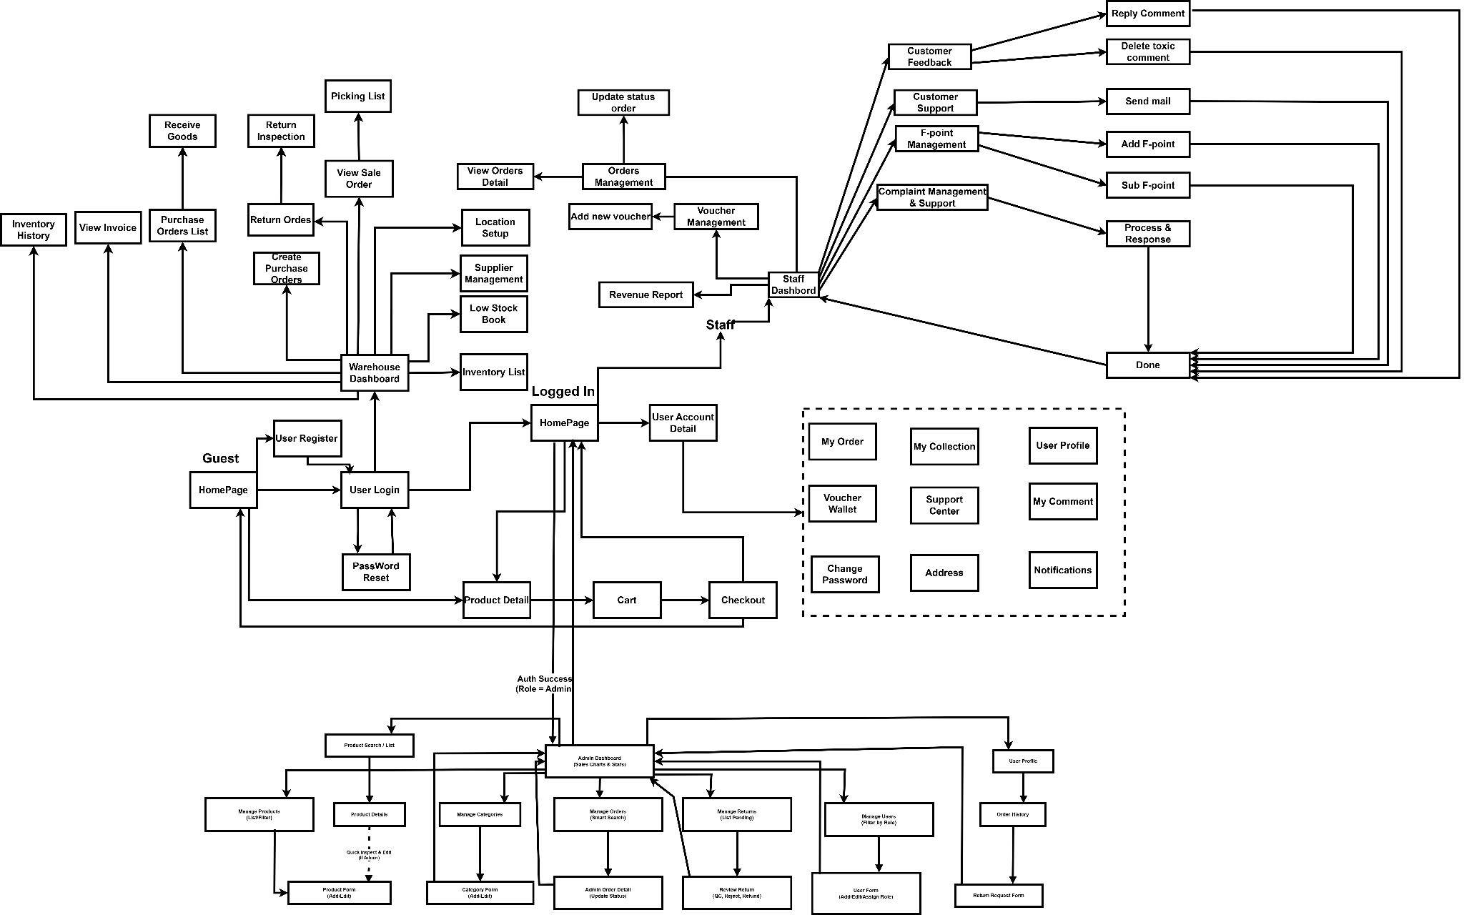

5.2 Screen Authorization

Screen | Customer | Staff | Admin | Warehouse | Guest
Global Header
Search Books | X | X | X |  | X
View Mini Cart | X |  |  |  | X
View Notifications | X | X |  |  | X
Login / Register | X | X |  |  | X
Logout | X | X | X | X | X
Access User Menu | X |  |  |  | X
Go to Admin Dashboard |  |  | X
Home Page | X |  | X | X
Query All Data | X |  |  |  | X
View Promotions /Banners | X |  |  |  | X
Filter by Category | X |  |  |  | X
View Book Collections | X |  |  |  | X
Product Detail | X |  |  |  | X
Add To Cart | X |  |  |  | X
Buy Book | X
Add To Collection | X
Review Book | X
Discussion | X
User Profile Page | X |  | X |  | X
Query Own Data | X
Update Basic Profile | X
Update Email / Request OTP | X
Update Phone / Request OTP | X
Voucher Hub Page | X |  |  |  | X
Query All Data | X |  |  |  | X
Save Voucher | X
Cart Page | X |  |  |  | X
Update Own Data | X |  |  |  | X
Order | X |  |  |  | X
Checkout | X
Query Own Data | X
Apply Voucher | X
Confirm Order | X
Update Own Data | X
Change Password Page | X
Query Own Data | X
Update Password | X
Query All Data | X
Address Page | X
Query Own Data | X
Add New Data | X
Update Own Data | X
Delete Data | X
My Order Page | X | X
Query All Data |  | X
Query Own Data | X
Update All Data (Change status) |  | X
Cancel Order | X
Request Return/Refund | X | X | X
Repurchase | X | X
Order management |  | X
My Collection Page | X
Query Own Data | X |  | X | X
Add New Data | X
Update Own Data | X
Delete Data | X
My Collection Detail Page | X
Search & Filter Books | X
Remove Book | X
Support Center Page | X
Query Own Data | X
Add New Data | X
Submit Support Request | X
My Comment Page | X
Query Own Data | X
View Product Detail | X
Notifications Page | X
Query Own Data | X
Delete Data | X
View Notification Detail | X
Voucher Wallet | X
Query Own Data | X
Copy Voucher Code | X
Voucher Management Page |  | X
Query All Data
Add New Data (Create new voucher) |  | X
Remove voucher |  | X
Revenue Details
Query All Data (View reports & charts) |  | X
Reply Customer |  | X
Mail Customer |  | X
Assist upgrade guests' rank. |  | X
Inventory List |  |  |  | X
Low Stock Book |  |  |  | X
Supplier Management |  |  |  | X
Location Setup |  |  |  | X
View Sale Order and Picking List |  |  |  | X
Return Orders and Inspect |  |  |  | X
Create Purchase Order |  |  |  | X
Purchase Order |  |  |  | X
View Invoice |  |  |  | X
Inventory History |  |  |  | X

5.3 Non-UI Functions

# | Feature | System Function | Description
1 | Voucher Management | Auto-update Voucher Status (Cron Job) | The system sets up a background process (batch job/cron job) that runs periodically every day (e.g., at 00:00). This process scans all discount code data and compares the endDate with the current date. If a voucher is past its expiration date, the system automatically changes its status to "Expired" without requiring manual staff intervention.
2 | Checkout | Calculate Shipping Fee (3rd Party API) | The system automatically calls the Giao Hang Nhanh (GHN) API, passing parameters such as to_district_id, to_ward_code, weight, and package dimensions to retrieve the real-time shipping fee.
3 | Checkout | VNPay Payment URL Generator (API/Service) | When a user selects VNPAY as the payment method, the backend (VNPayService) silently generates a secure encrypted string (hash) containing the order code (orderId), amount (amount), and transaction details, then communicates with the VNPAY server to generate a secure payment URL.
4 | Checkout | VNPay IPN Listener (Webhook/API) | The system provides a background API (Webhook) to listen for the Instant Payment Notification (IPN) returned from the VNPAY server. As soon as the customer successfully completes the transaction, VNPAY silently calls this API so the system can automatically update the order status to "Paid".
5 | Order Management | Auto-cancel Unpaid Orders (Cron Job) | The system runs a periodic background scan (e.g., every 30 minutes). If it detects VNPAY orders that have remained in the "Pending Payment" status beyond the allowed timeframe (e.g., 24 hours), the system will automatically change their status to "Canceled" and automatically restock the quantities for the associated products.
6 | Voucher Management | Auto-increment Usage Count (Service) | As soon as an order using a discount code is successfully placed, the system triggers a background function (e.g., markVoucherAsUsed) to increment the usage count of that specific voucher by 1. If the usage count reaches its maximum limit, the system automatically deactivates the code.
7 | Inventory Management | Auto-update Stock Quantity (Service) | As soon as a Goods Received Note (GRN) is successfully saved or approved, the system triggers a background function to increment the stock_quantity of the corresponding products in the database to ensure data consistency.
8 | Complaint&Return Management | External API & Webhook | A backend service that handles secure payment processing with the VNPAY gateway. It generates secure payment URLs and listens for the asynchronous callback (IPN/Return URL) from VNPAY. Upon a successful transaction code (vnp_ResponseCode == "00"), this service automatically triggers database updates: creating the order, deducting book stock, marking the applied voucher as used, and adding F-Points to the user's account.
9 | Logistics API | External API | A service that communicates with the external GHN API to calculate real-time shipping fees and estimated delivery times. It takes the customer's selected destination (Province, District, Ward) and the cart's total weight as inputs, and returns the exact shipping cost to be dynamically added to the checkout total.
10 | F-point Management | Internal Logic Service | A background computational logic that evaluates a customer's loyalty status. It dynamically calculates the total F-Points earned (rule: 1 book = 10 points for VNPAY orders) within the current month. Based on the aggregated points, it automatically classifies the user into the appropriate Membership Tier (Bronze, Silver, Gold, Diamond) without requiring manual cron jobs.
11 | Event-Driven Notification Trigger | Internal Service | An automated internal service that listens for specific state changes within the database. For instance, when a Sale Staff submits a reply to a customer's product review or updates the status of a support ticket to "Resolved", this trigger automatically inserts a new alert record into the Notifications table, pushing a real-time update to the customer's dashboard.

II. Functional Requirements

1. Feature: Storefront Supervision

1.1 SubFeature: Admin Toolbar & Overlay

1.1.1 Screen: Public Homepage (Admin Mode)

This function displays a management overlay at the top of public pages (Home, Search) exclusively for authenticated Administrators (Role = 1). It allows the Admin to verify they are logged in with elevated privileges and provides a one-click redirect to the Backend Dashboard.

Field Name | Description
Admin Overlay Container | Type: <div> (Fixed Position/Top)  Logic: Only rendered if sessionScope.user.role == 1. Hidden for Guests and Customers.
Admin Welcome Text | Type: Label  Data: String (User Fullname)  Format: "Xin chào, {fullname}"
Dashboard Button | Type: Button / Hyperlink (<a>)  Action: Redirects to /admin/dashboard  Style: Red background, prominent visibility.

1.2 SubFeature: Product Quick Inspection

1.2.1 Screen: Product Detail Page (Admin Mode)
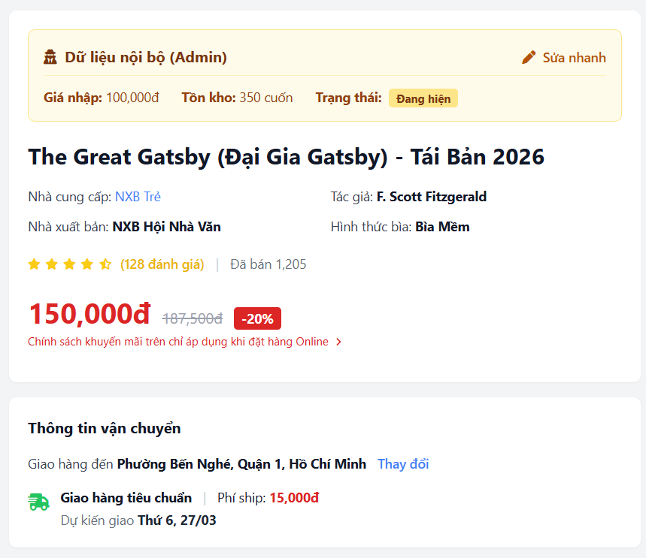
Allows Administrators to view sensitive internal data (Import Price, Stock Status) directly on the product detail page to spot pricing errors. It includes a "Quick Edit" button to jump to the editing form. Regular users do not see these components.

Field Name | Description
Internal Data Box | Type: Container (<div>)  Logic: Rendered only if session.role == 1. Styling: Yellow background (Warning color).
Import Price | Type: Decimal/Money  Source: Books.import_price  Format: Displayed with currency symbol (e.g., "$5.00").
Stock Quantity | Type: Integer  Source: Books.stock_quantity  Note: Displays exact count.
Visibility Status | Type: String/Boolean  Values: "Public" or "Hidden"  Source: Books.is_active
Quick Edit Button | Type: Hyperlink (<a>)  Action: Redirects to /admin/product/edit?id={book_id}.
Add to Cart Button (Test) | Type: Button  Logic: If Stock <= 0, Guest sees "Out of Stock" (Disabled). Admin sees "Test Add to Cart" (Active) to debug checkout flow.

1.3 SubFeature: Admin Search Scope

1.3.1 Screen: Search Results Page
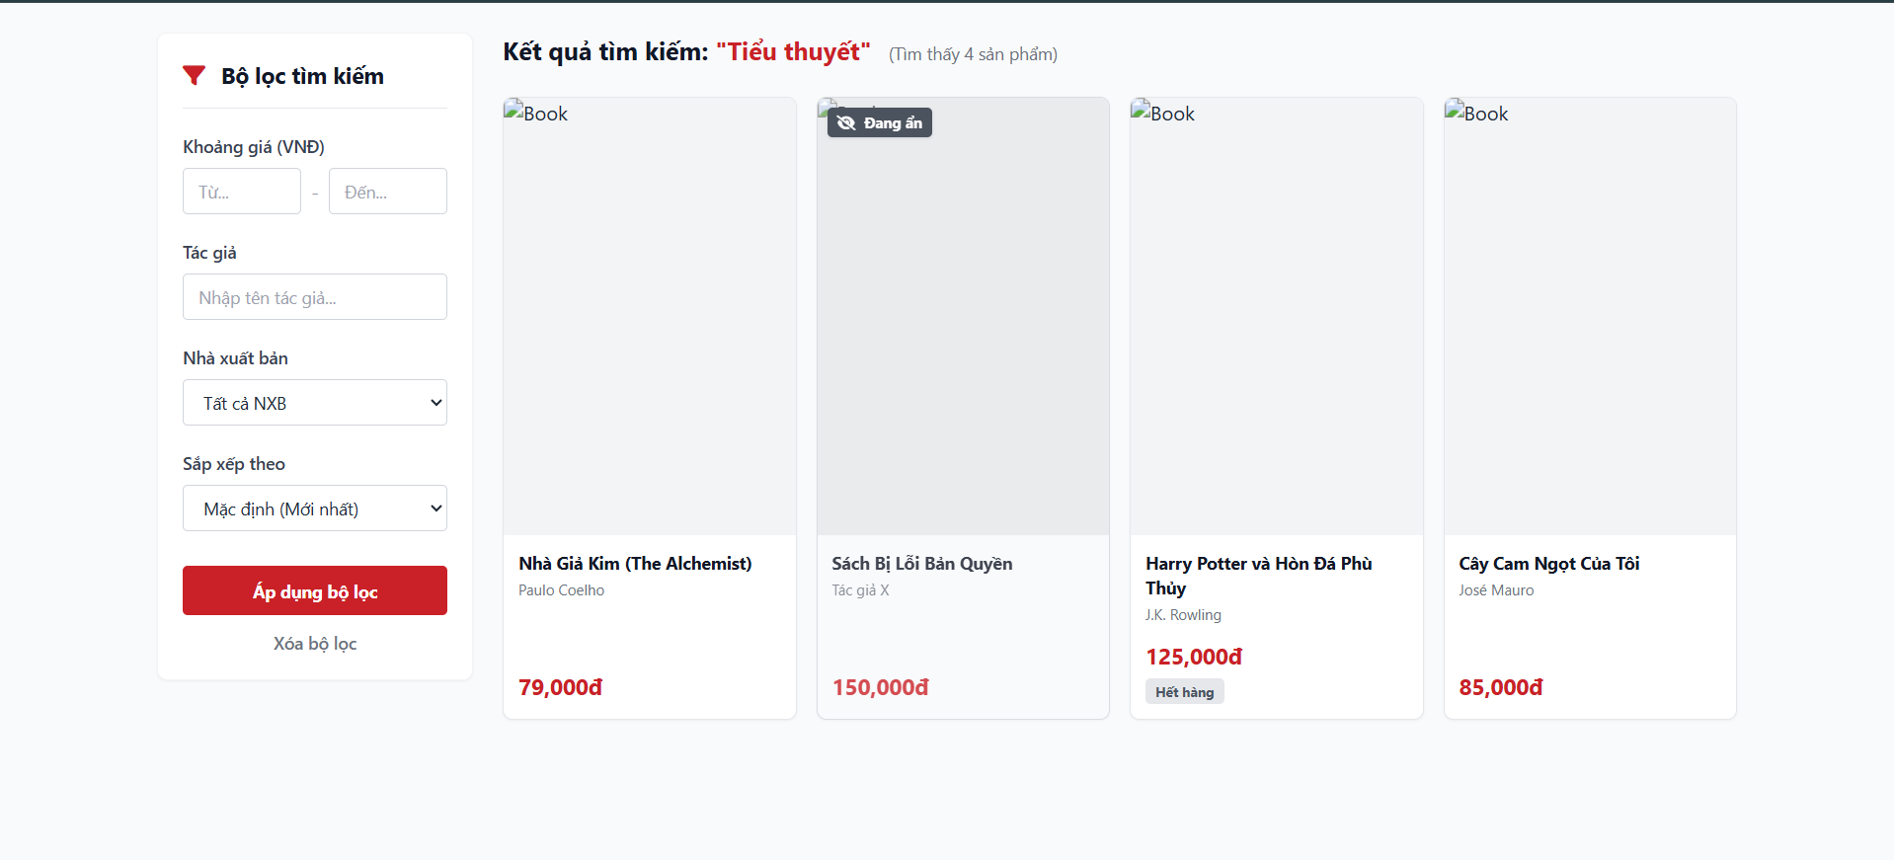
Extends the standard search function for Administrators to include "Hidden" (is_active=0) and "Out of Stock" products. These items are visually distinguished by badges so the Admin can verify their existence without altering the database.

Field Name | Description
Search Input | Type: Text Input  Max Length: 255 chars  Logic: Submits to HomeServlet (action="search").
Product Card | Type: Container  Content: Image, Title, Price.
Status Badge: [HIDDEN] | Type: Label (<span>)  Logic: Appears if is_active == false AND user.role == 1.  Style: Dark Grey, Opacity 0.9.
Status Badge: [OUT OF STOCK] | Type: Label (<span>)  Logic: Appears if stock_quantity <= 0 AND user.role == 1.  Style: Red.

2. Admin Dashboard & Management

2.1 SubFeature: Product Catalog Management

2.1.1 Screen: Manage Products Page (/admin/product/list)
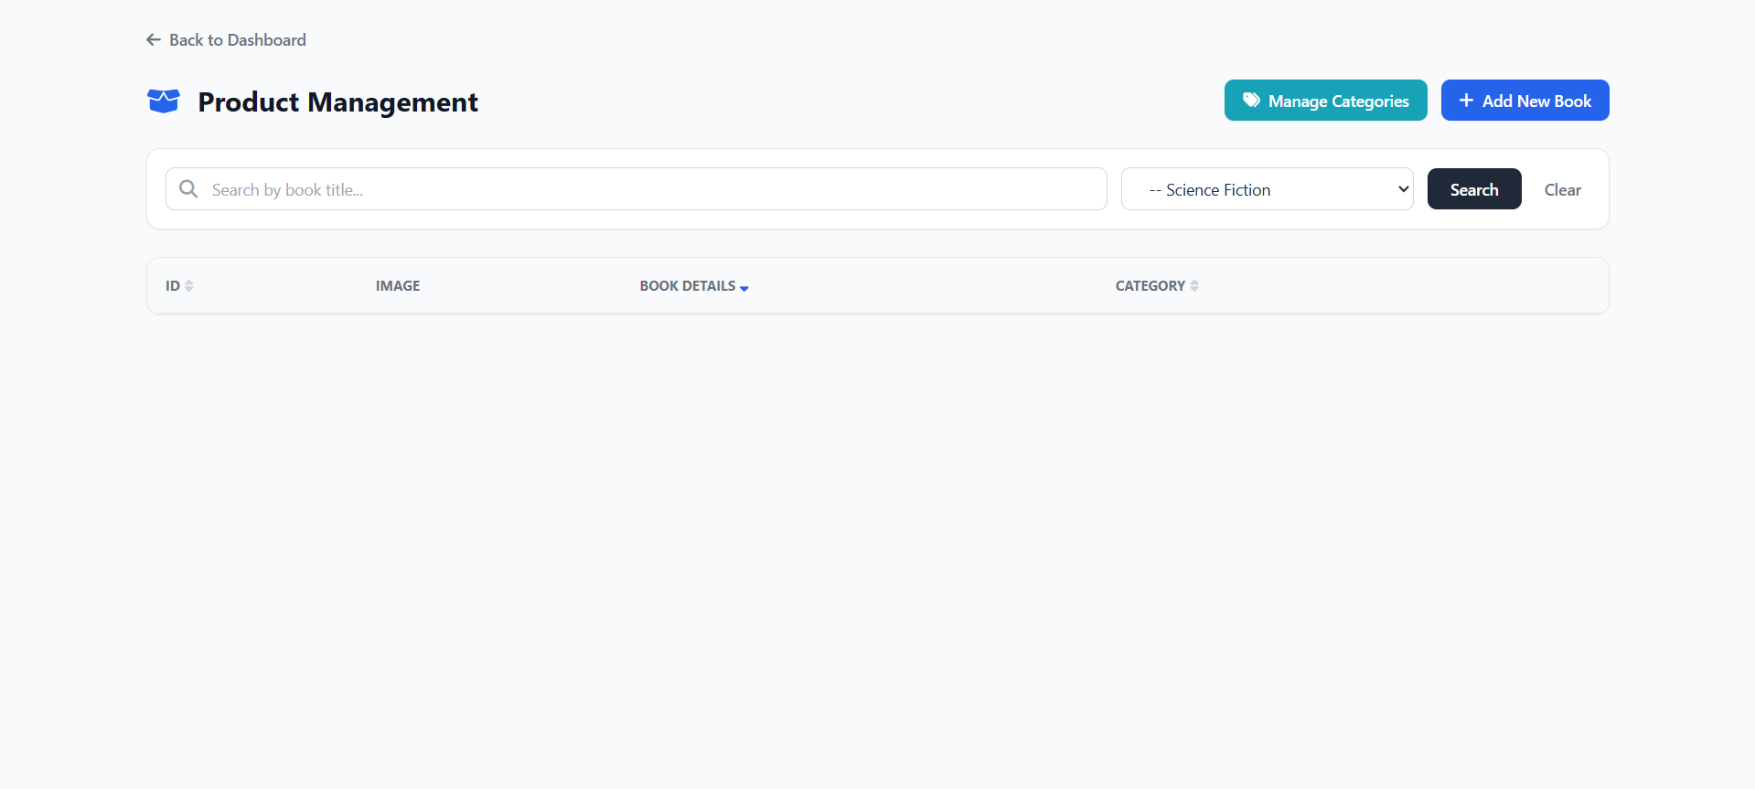
This function provides a comprehensive, paginated table of all inventory items. It allows the Admin to sort products server-side (by Price, Stock, Category) and visually distinguishes "Hidden" items without removing them from the view.

Field Name | Description
Filter Bar | Type: Container form (GET request)  Inputs:  1. Category Dropdown (Source: CategoryDAO.getAll())  2. Search Input (Matches Title or ID).
Sortable Headers | Type: Hyperlinks (<a>)  Logic: Clicking "Price", "Stock", or "Name" reloads the page with sortBy={field}&sortOrder={ASC/DESC}.  UI: Active sort displays a Gold Icon (fa-sort-up/down). Inactive displays Grey (fa-sort).
Product Row (Active) | Type: Table Row (<tr>)  Style: Standard white background.  Status: Badge "Active" (Green).
Product Row (Hidden) | Type: Table Row (<tr>)  Logic: Rendered if is_active == 0.  Style: Opacity 0.7 (Dimmed), Background #f8f9fa.  Status: Badge "Hidden" (Grey).
Pagination Controls | Type: Hyperlinks  Logic: page={index}. Keeps current filters and sort order active while switching pages.
Action Buttons | Type: Icon Links  Edit: Redirects to /admin/product/edit.  Delete: Triggers JS confirm(). If confirmed, sends ID to /admin/product/delete.

2.1.2 Screen: Add/Edit Product Page (/admin/product/add, /admin/product/edit)
This form allows administrators to insert or update product records with comprehensive metadata and client-side validation constraints.
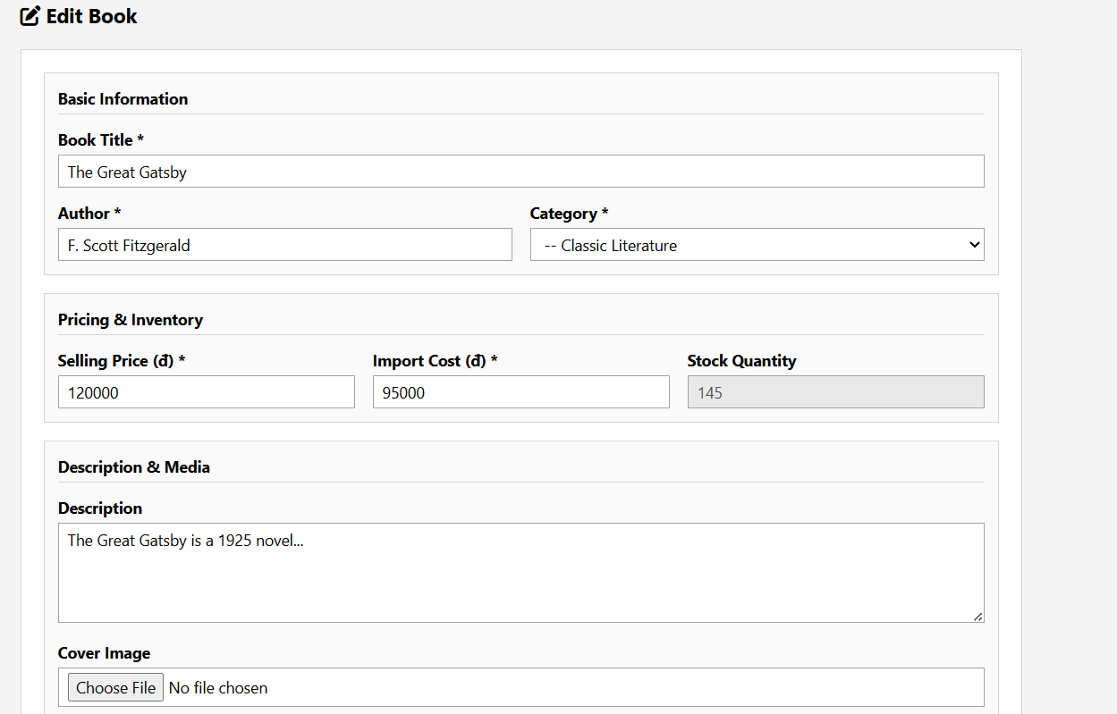

Field Name | Description
Core Details | Type: Text and Number Inputs (<input type="text">, <input type="number">)  Description: Fields for Title, Author, Price, Import Price, and Stock Quantity.
Extended Metadata | Type: Text and Number Inputs  Description: Inputs for Publisher, Year of Publish (min 1000, max 2099), Number of Pages, Supplier, and ISBN.
Description Field | Type: Textarea (<textarea>)  Description: Features a live JavaScript character counter detecting the maxlength attribute, changing color to warning/danger thresholds as the limit is approached.
Image Upload | Type: File Input (<input type="file">)  Description: Accommodates multipart/form-data for book cover uploads.

2.1.3 Screen: Manage Categories Page (/admin/categories)
Displays a hierarchical table mapping Parent categories and their associated nested sub-categories.
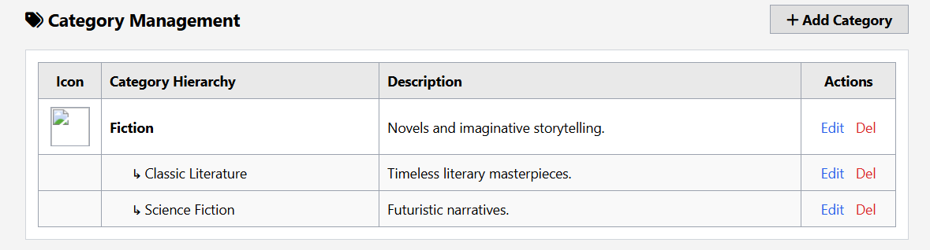

Field Name | Description
Hierarchical Table Rendering | Type: Nested Data Table (<table> with <c:forEach>)  Description: Logic executing an outer loop for Parent Categories and an inner nested loop displaying Child Categories directly beneath their respective parents.
Action Column | Type: Icon Buttons / Hyperlinks  Description: Edit and Delete buttons tied specifically to the individual category ID.

2.1.4 Screen: Add/Edit Categories Page (/admin/categories/add,admin/categories/edit)
Handles the creation and updating of categories with strict input validation to prevent database truncation errors.
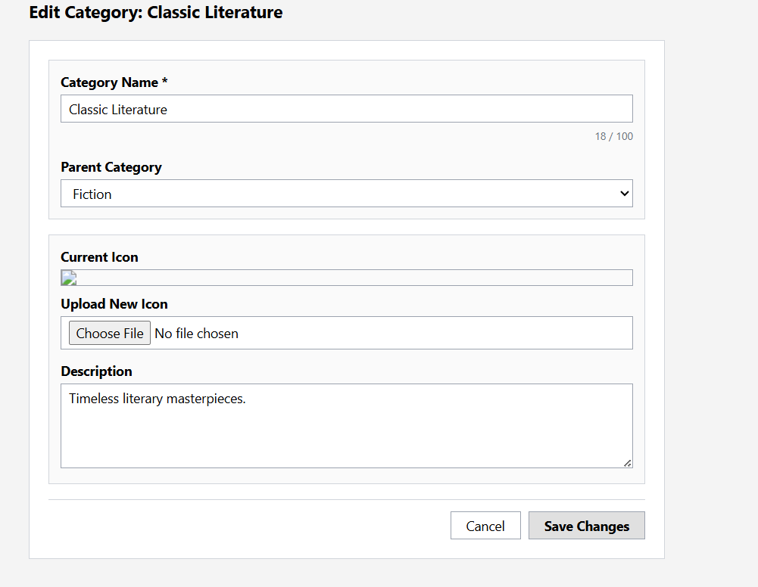

Field Name | Description
Category Name Input | Type: Text Input (<input type="text">)  Description: Strictly limited by maxlength="100" with a live JavaScript character counter.
Parent/Child Assignment | Type: Dropdown (<select>)  Description: Selects a Parent Category, or leaves blank to designate the current entry as a new Top-Level Parent.
Category Image Upload | Type: File Input (<input type="file">)  Description: Contextual JavaScript validation intercepts form submission to force an image upload if action === 'add' AND parentId === "" (Creating a new Parent Category).

2.2 SubFeature: Order Processing

2.2.1 Screen: Manage Orders Page (/admin/order)
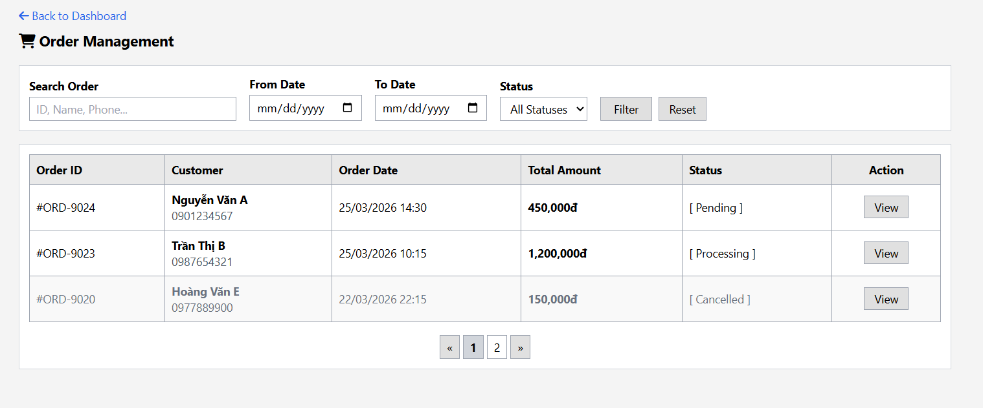
This screen allows Administrators to track and process customer orders. It features a "Smart Search" bar that automatically detects if the user is searching for a specific Order ID (using #) or a general keyword (Customer Name/Phone).

Field Name | Description
Smart Search Input | Type: Text Input  Logic:  1. If input starts with # (e.g., #5): Strips # and performs Exact Match on Order_ID.  2. If normal text: Performs LIKE search on Customer_Name OR Phone_Number.
Date Range Filter | Type: Date Pickers (<input type="date">)  Field 1: From Date  Field 2: To Date  Logic: Filters records where order_date falls between the selected range (inclusive).
Status Filter | Type: Dropdown (<select>)  Values: All, Pending, Shipping, Completed, Cancelled.  Action: Reloads table with status={value} parameter.
Order Date Cell | Type: Label  Format: Uses JSTL <fmt:formatDate> to display dd/MM/yyyy HH:mm:ss.
Total Amount Header | Type: Sortable Link  Action: Sorts orders by total_amount (High to Low / Low to High).
Status Badge | Type: Label (<span>)  Style Logic:  - Pending: Yellow (bg-warning)  - Shipping: Blue (bg-primary)  - Completed: Green (bg-success)  - Cancelled: Red (bg-danger)
View Detail Action | Type: Button (<a>)  Action: Redirects to /admin/order/detail?id={id} to see specific line items.

2.2.2 Screen: Order Detail Page (/admin/order/detail)
Displays the granular line items and customer information for a specific completed or pending order.
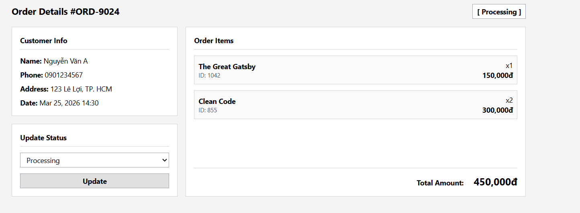
Field Name | Description
Customer Info Panel | Type: Read-Only Container / Labels  Description: Displays Name, Phone, and Shipping Address.
Order Info Panel | Type: Read-Only Container / Labels  Description: Displays Order Date, Payment Method, and Current Status.
Line Items List | Type: UI Repeater / Data List  Description: Displays Book Thumbnail, Title, Book ID, Quantity multiplier, and individual unit price for each item in the order.
Total Amount Summary | Type: Calculated Label  Description: Highlights the final calculated price formatting with currency symbols.

2.3 SubFeature: User Administration

2.3.1 Screen: Manage Users Page (/admin/users)
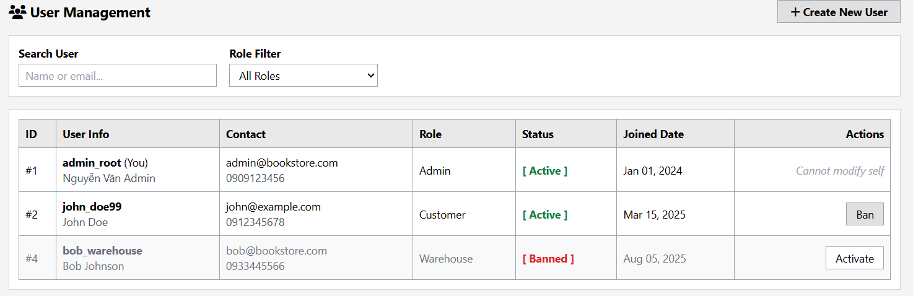
This function allows the Admin to audit user accounts. It includes specific logic to filter users by Role (to separate Customers from Staff) and provides security controls to "Ban" (Lock) suspicious accounts instantly.

Field Name | Description
Role Filter | Type: Dropdown  Values: Admin (1), Customer (2), Staff (3), Warehouse (4).  Logic: Filters the list to show only users with the selected role_id.
User Info Column | Type: Container  Content: Displays Username (Bold) and Full Name (Subtext) in a single cell for readability.
Contact Column | Type: Container  Content: Displays Email and Phone Number.
Role Badge | Type: Label  Style:  - Admin: Red  - Customer: Blue  - Warehouse: Yellow.
Ban/Lock Button | Type: Button (Visible only if User is Active)  Icon: fa-lock  Action: Prompts confirm('Block this user?'). Redirects to /admin/users/block?id={id}.  Result: Sets is_active = 0.
Unban/Unlock Button | Type: Button (Visible only if User is Banned)  Icon: fa-lock-open  Style: Green Background.  Action: Prompts confirm('Activate this user?'). Redirects to /admin/users/unblock.
Client-Side Sort Logic | Type: JavaScript Event Listener / DOM Manipulator  Description: Function triggered by header clicks to dynamically reorder table rows alphanumerically or numerically without a page reload

2.3.2 Screen: Admin User Creation Interface (/admin/users/add)
This covers the backend capability for an Admin to manually provision new accounts, bypassing the public registration page
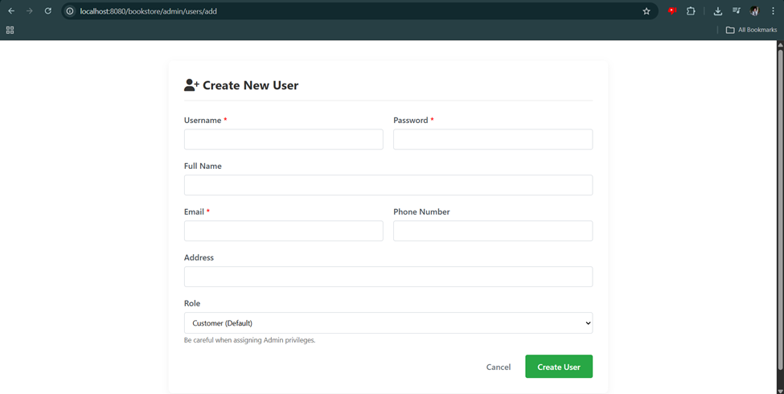

Field Name | Description
Mandatory Credential Provisioning | Type: Input Fields (<input>) & Client-Side Validation  Description: Enforces strict mandatory inputs for Username, Password, and Email using required attributes. This ensures that any Admin-created account has the minimum necessary credentials to successfully log into the system.
Optional Profile Hydration | Type: Input Fields (<input>)  Description: Provides optional fields for Phone Number and Address, allowing the Admin to fully populate a user's contact profile at the time of creation (useful for setting up internal staff or assisting customers).
System Role Assignment | Type: Dropdown Option (<select>)  Description: Allows the Admin to grant specific system access levels instantly upon account creation. The dropdown maps directly to the system's authorization roles: Customer (0 - default), Admin (1), Staff (2), and Warehouse Manager (3).
Creation Error Handling & Feedback | Type: Dynamic UI Alert (<c:if>)  Description: Automatically catches and displays a highlighted error message block if the backend Java servlet rejects the submission (e.g., if the Admin tries to use a Username or Email that already exists in the database), preventing silent failures.

3. Feature: Sales & Performance Reporting

3.1 SubFeature: Visual Sales Dashboard

3.1.1 Screen: Sales Report Page (/admin/reports)
This screen provides visual insights into store performance. Unlike the main dashboard, this page allows the Admin to filter data by time periods to analyze trends and export the results.
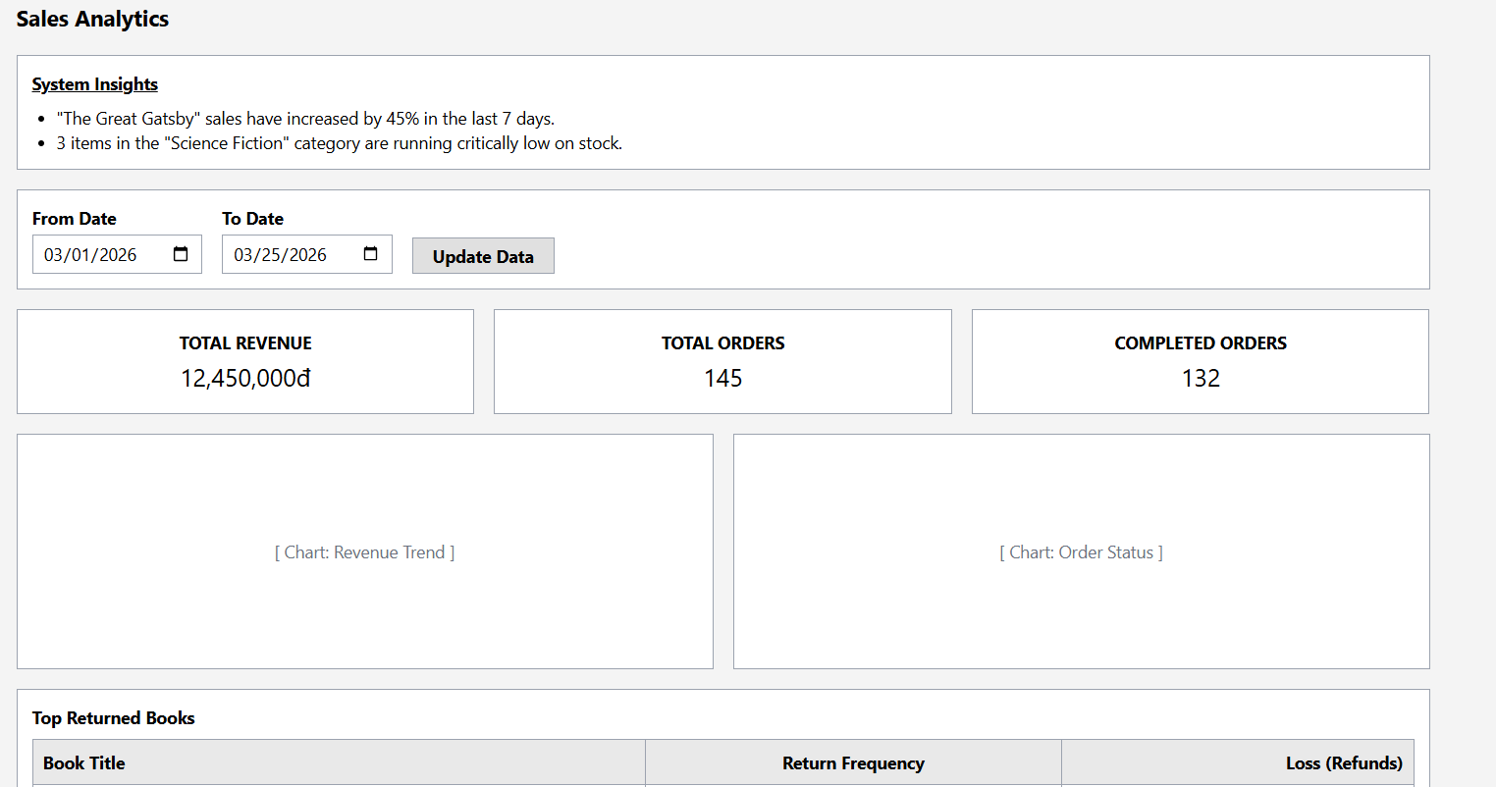

Field Name | Description
Date Range Filter | Type: Dropdown / Select  Values: "Last 7 Days" (Default), "Last 30 Days", "This Year".  Action: Triggers an AJAX request to fetch new JSON data and re-renders all charts without reloading the page.
Export Button | Type: Button  Label: "Export to PDF"  Action: Generates a downloadable PDF containing the currently visible charts and data tables.
KPI Cards (Dynamic) | Type: Summary Container  Content:  1. Period Revenue: Total total_amount for the selected date range.  2. Period Orders: Count of orders for the selected date range.  Style: Simple cards placed above the charts.
Revenue Trend Chart | Type: Line/Bar Chart (Canvas)  Library: Chart.js  X-Axis: Dates (formatted as dd/MM).  Y-Axis: Currency (VND).  Data Source: Aggregated sum of total_amount per day.  Logic: Excludes "Cancelled" orders.
Order Status Chart | Type: Doughnut Chart (Canvas)  Segments: Pending (Yellow), Shipping (Blue), Completed (Green), Cancelled (Red).  Tooltip: Shows Count and Percentage (e.g., "Cancelled: 2 orders (10%)").  Interaction: Clicking a slice redirects to /admin/order?status={clicked_status}.
Best Sellers Chart | Type: Horizontal Bar Chart (Canvas)  Data Source: Top 5 Book Titles by quantity sold.  Purpose: Identifies popular items to restock.

4. Warehouse Management

4.1. Inventory List

4.1.1 Screen Layout
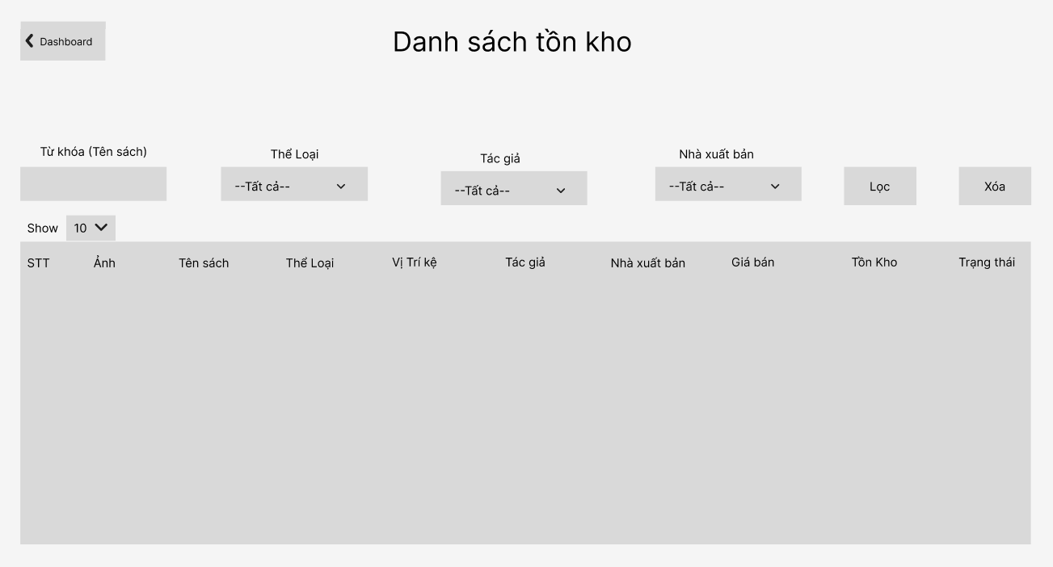
Purpose
This screen allows Warehouse Staff or Admin to view and monitor the current inventory of all books in the warehouse.
Users can search, filter, and browse inventory information such as book title, category, author, publisher, price, shelf location, and available stock quantity.
The page supports filtering options to quickly locate books in the warehouse and provides a paginated list of inventory items.

4.1.2 Field Description
Field Name | Description
Back to Dashboard Button | Type: Hyperlink Button  Action: Redirects the user to /dashboard.
Search Input (Book Name) | Type: Text Input  Placeholder: "Nhập tên sách..."  Action: Filters inventory list based on book title.
Category Filter | Type: Dropdown Select  Default: "-- Tất cả --"  Action: Filters books by category.
Author Filter | Type: Dropdown Select  Default: "-- Tất cả --"  Action: Filters books by author
Publisher Filter | Type: Dropdown Select  Default: "-- Tất cả --"  Action: Filters books by publisher.
Filter Button | Type: Button  Action: Applies all selected filter conditions and reloads the inventory list.
Clear Filter Button | Type: Button  Action: Clears all filter inputs and reloads the full inventory list.
Show Entries Dropdown | Type: Dropdown Select  Values: 10, 25, 50, 100  Action: Controls the number of records displayed per page
Inventory Table | Type: Container (Table)  Logic: Displays a paginated list of books retrieved from the database inventory.
Pagination | Type: Pagination Component  Action: Allows users to navigate between pages of inventory records.

4.2 View Low Stock

4.2.1 Screen Layout
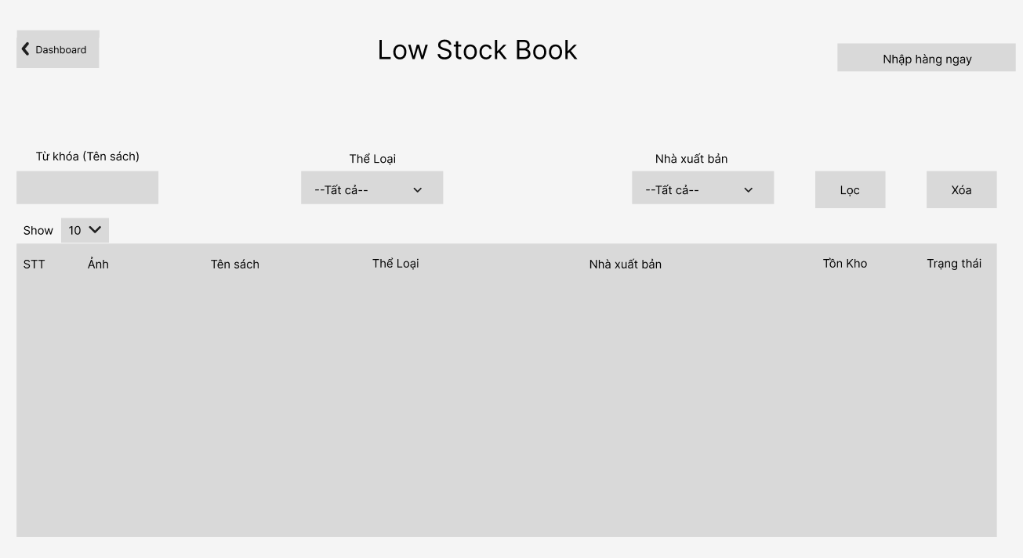Purpose
This screen allows Warehouse Staff or Admin to monitor books that are running low in stock and require replenishment.
The system highlights inventory items with low quantities to ensure timely restocking and prevent stockouts.
Users can quickly identify which books need to be reordered and initiate the restocking process.

4.2.2 Field Description

Field Name | Description
Back to Dashboard Button | Type: Hyperlink Button  Action: Redirects the user to /dashboard.
Add Stock Button (Nhập hàng ngay) | Type: Button  Action: Redirects the user to the Receive Goods / Add Inventory page to add new stock for books.
Show Entries Dropdown | Type: Dropdown Select  Values: 10, 25, 50, 100  Action: Controls the number of records displayed per page.
Search Input | Type: Text Input  Action: Filters the inventory list based on book title or related information.
Low Stock Table | Type: Container (Table)  Logic: Displays books with stock quantities below a predefined threshold.
Pagination | Type: Pagination Component  Action: Allows navigation between pages.

4.3 Management Supplier

4.3.1 Screen Layout
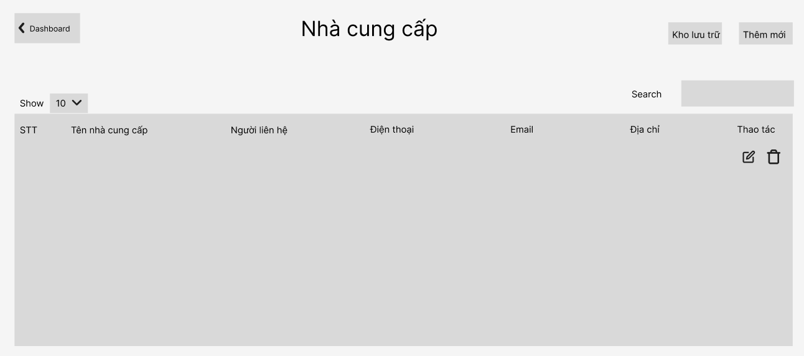
Purpose
This screen allows users to manage supplier information in the system. Users can view, search, add, update, delete, and restore supplier records. Supplier data is used for purchasing and inventory restocking.
Add Supplier Modal
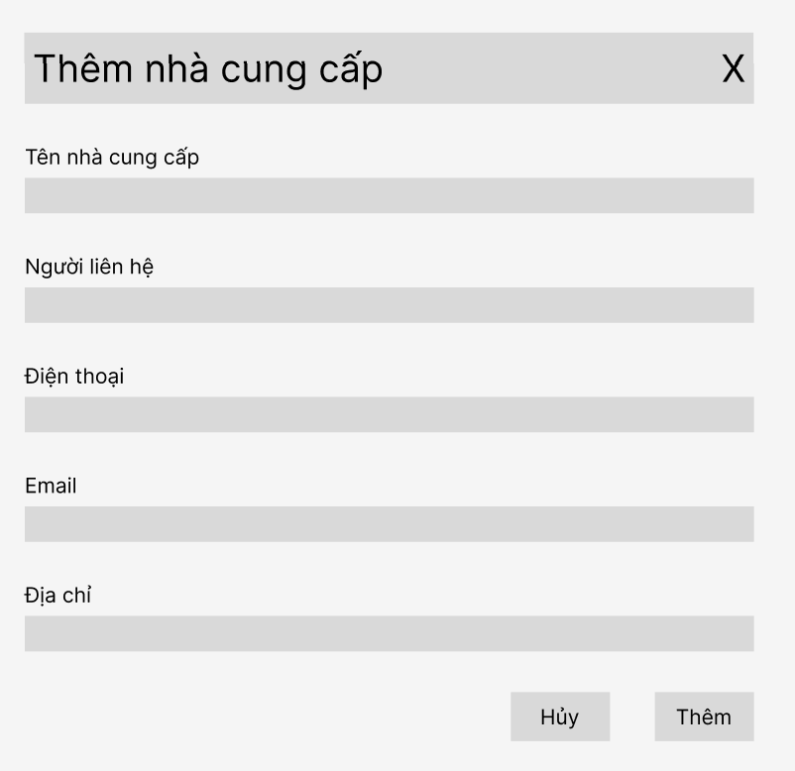
Purpose
This modal allows users to add a new supplier to the system by entering supplier details such as name, contact person, phone number, email, and address.
Update Supplier Modal
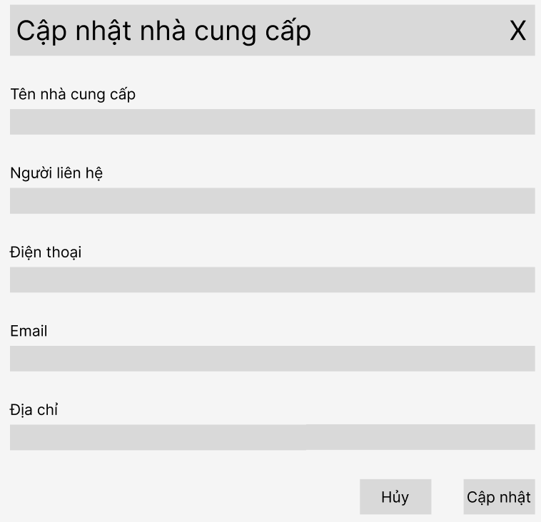
Purpose
This modal allows users to modify existing supplier information in the system.

Recycle Bin Modal
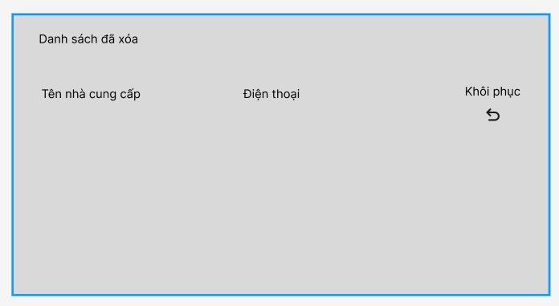
Purpose
This modal displays the list of deleted suppliers. Users can restore suppliers from this list back to the active supplier list.

4.3.2 Field Description
Field Name | Description
Back to Dashboard | Type: Hyperlink Button  Action: Redirects the user to /dashboard.
Recycle Bin (Kho lưu trữ) | Type: Button  Action: Opens the Recycle Bin modal displaying deleted suppliers.
Add New Supplier | Type: Button  Action: Opens the Add Supplier modal to create a new supplier.
Show Entries | Type: Dropdown Select  Values: 10, 25, 50, 100  Action: Controls the number of supplier records displayed per page.
Search | Type: Text Input  Action: Filters the supplier list based on supplier name, phone number, or email.
Supplier Table | Type: Container (Table)  Logic: Displays the list of suppliers stored in the system database.
Add Supplier Modal | Type: Modal Form  Logic: Allows users to enter supplier information including name, contact person, phone number, email, and address.
Update Supplier Modal | Type: Modal Form  Logic: Allows users to edit and update existing supplier information.
Restore Button | Type: Button  Action: Restores a deleted supplier back to the supplier list.
Pagination | Type: Pagination Component  Action: Allows users to navigate between different pages of suppliers.
Edit Button | Type: Icon Button  Action: Opens the Update Supplier modal with the selected supplier information.
Delete Button | Type: Icon Button  Action: Opens a confirmation dialog before moving the supplier to the recycle bin.

4.4 Management Location

4.4.1 Screen Layout
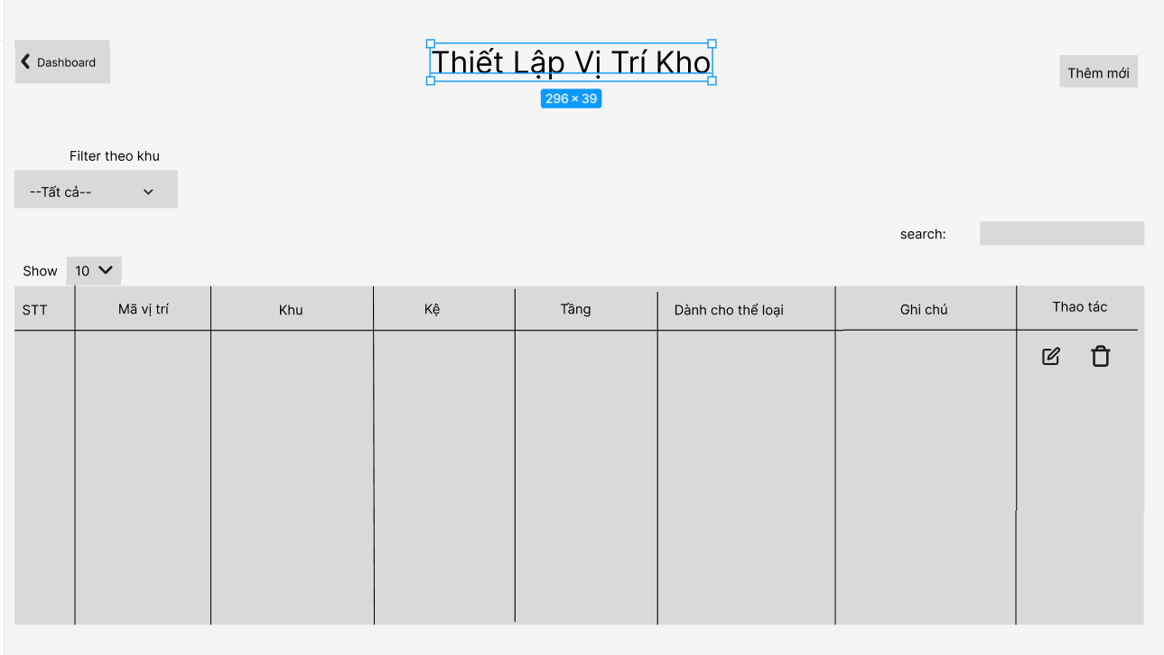
Purpose
Allow Admin or Warehouse Staff to manage warehouse storage locations, including creating, updating, viewing, and deleting location information.
This function helps organize books by area, shelf, and floor, and assign specific categories to each storage location.
Main Actions / Flow
A. View Location List
- User accesses the Warehouse Location Management page from Dashboard.
- The system displays a paginated list of warehouse locations (default: 10 entries per page).
- User can:
  - Search locations.
  - Change number of displayed entries.
  - Click Edit to update a location.
  - Click Delete to remove a location.
B. Add New Location
- User clicks "Add New Location".
- A popup form appears.
- User enters:
  - Area
  - Shelf
  - Floor
  - Assigned Category
  - Note (optional)
- System automatically generates the Location Code (Area-Shelf-Floor format).
- User clicks Save.
- System validates data and stores it in the database.
- The list refreshes automatically.
C. Update Location
- User clicks the Edit icon.
- The popup form appears with existing data.
- User modifies necessary fields.
- User clicks Save.
- System updates the database.
D. Delete Location
- User clicks the Delete icon.
- A confirmation dialog appears:
  - “Are you sure you want to delete this location?”
- If user selects OK, the system deletes the location.
- If user selects Cancel, no changes are made.

4.4.2 Field Description

Field Name | Description
STT | Sequential number of warehouse location
Location Code | Automatically generated code (e.g., A-01-01)
Area | Warehouse area identifier (A, B, C, etc.)
Shelf | Shelf number within the area
Floor | Floor level of the shelf
Category Assigned | Book category assigned to this location
Note | Additional description of the location
Search | Search warehouse locations
Show Entries | Select number of records displayed per page
Add New Location | Button to open Add Location form
Edit | Button to open Update Location form
Delete | Button to delete location
Save | Save new or updated location
Cancel | Close form without saving

4.5 Outbound Management

4.5.1 View Sale Order
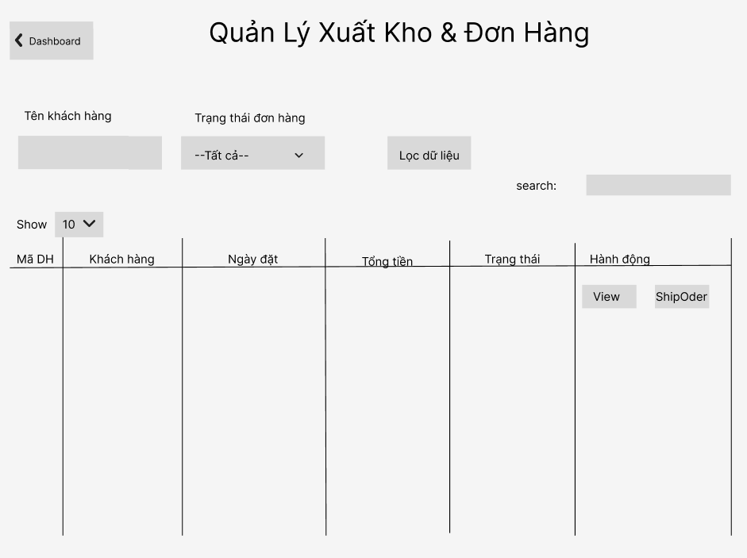
Purpose
This screen allows warehouse staff to view and manage sales orders that need to be processed for shipment. Users can filter orders by customer name or order status and view detailed information for each order. From the order details, staff can start the picking process to prepare items for shipment.

4.5.2 View Order Detail Modal
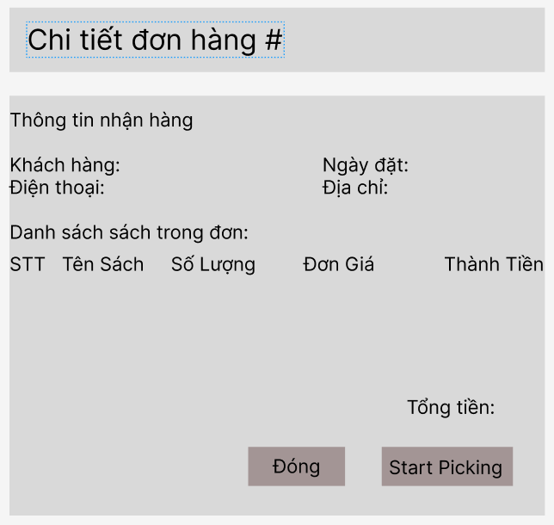
Purpose
This modal displays detailed information of a selected order including customer information and the list of ordered books. Warehouse staff can review the order and initiate the picking process.

4.5.3 Picking List
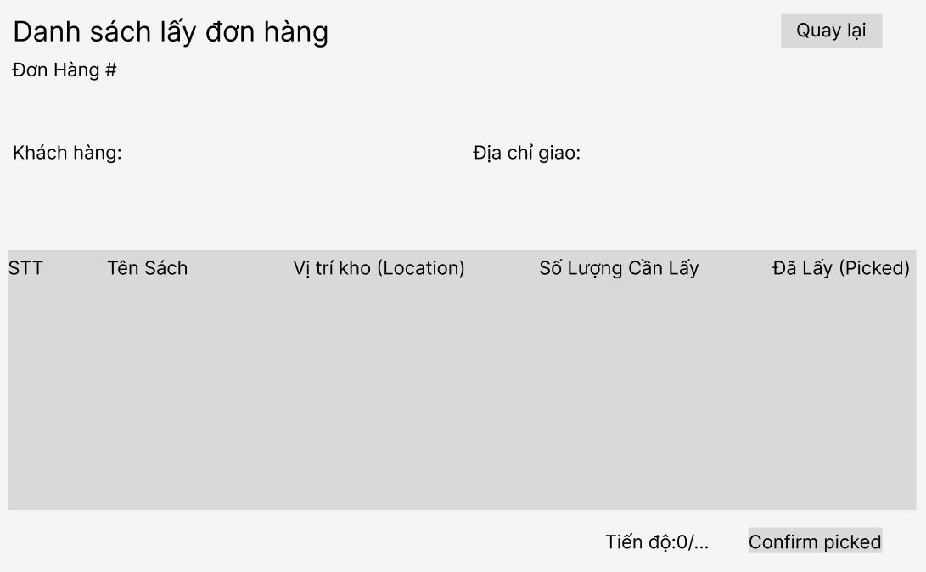
Purpose
This screen supports the warehouse picking process. It shows the list of books that must be collected from warehouse locations for the selected order. Staff can mark items as picked and confirm packing once all items are collected.

4.5.4 Field Description

Field Name | Description
Customer Name Filter | Type: Text Input  Action: Allows users to filter orders by customer name.
Order Status Filter | Type: Dropdown Select  Values: All, Pending, Packed, Shipping, Delivered, Cancelled  Action: Filters orders based on order status.
Filter Button | Type: Button  Action: Applies the selected filter conditions to the order list.
Show Entries Dropdown | Type: Dropdown Select  Values: 10, 25, 50, 100  Action: Controls the number of order records displayed per page.
Search Input | Type: Text Input  Action: Searches orders by order ID or customer name.
Order Table | Type: Container (Table)  Logic: Displays the list of sales orders retrieved from the database.
View Button | Type: Button  Action: Opens the Order Detail Modal to display detailed order information.
Ship Order Button | Type: Button  Action: Starts the shipping preparation process for the selected order.
Order Detail Modal | Type: Modal Window  Logic: Displays customer information and the list of books included in the selected order.
Customer Information | Type: Information Panel  Logic: Displays customer name, phone number, delivery address, and order date.
Order Items Table | Type: Container (Table)  Logic: Displays the list of books in the order including quantity and price.
Cancel Order Button | Type: Button  Action: Cancels the order if necessary.
Start Picking Button | Type: Button  Action: Redirects the user to the Picking List Screen.
Picking List Table | Type: Container (Table)  Logic: Displays books that must be collected from warehouse locations.
Warehouse Location | Type: Label  Logic: Displays the storage location code for the book in the warehouse.
Required Quantity | Type: Label  Logic: Displays the number of items that need to be picked.
Picked Checkbox | Type: Checkbox  Action: Allows staff to mark an item as picked from the warehouse.
Picking Progress | Type: Progress Indicator  Logic: Displays the number of items picked compared to total items.
Confirm & Pack Button | Type: Button  Action: Confirms that all items have been picked and updates the order status to Packed.
Back Button | Type: Button  Action: Returns the user to the order list screen.
Pagination | Type: Pagination Component  Action: Allows navigation between pages of order records.

4.6 Inbound Management

4.6.1 View Purchase Orders
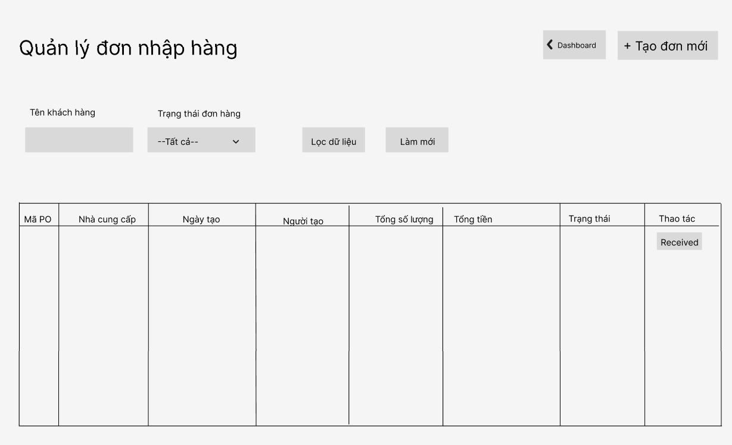
Purpose
Displays a list of purchase orders created in the system. Warehouse staff can search, filter, and review purchase orders before processing the receiving of goods from suppliers.

4.6.2 Receive Goods
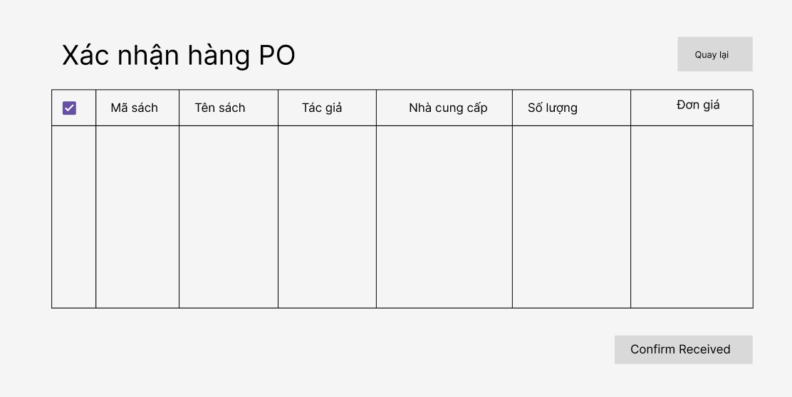
Purpose
Displays all approved purchase orders that are waiting for goods to be received. Warehouse staff can select a purchase order to start the receiving process.

4.6.3 Field Description

Field Name | Description
Back to Dashboard Button | Type: Hyperlink Button  Action: Redirects the user to /dashboard.
PO Code Input | Type: Text Input  Action: Allows users to search purchase orders by PO code.
Supplier Name Input | Type: Text Input  Action: Filters purchase orders by supplier name.
Status Dropdown | Type: Dropdown Select  Values: Pending Approval, Approved, Received, Cancelled  Action: Filters purchase orders based on status.
Search Button | Type: Button  Action: Executes the search using the selected filters.
Purchase Order Table | Type: Data Table  Logic: Displays purchase orders with PO ID, supplier, creation date, total quantity, total amount, and status.
Detail Button | Type: Button  Action: Opens the View Purchase Order Detail modal.
PO Information Section | Type: Information Display  Logic: Displays purchase order information such as PO ID, supplier, and creation date.
Book List Table (PO Detail) | Type: Data Table  Logic: Displays the list of books included in the purchase order.
Receive Goods Button | Type: Button  Action: Redirects the user to the Receive Goods screen.
Purchase Orders Waiting Table | Type: Data Table  Logic: Displays approved purchase orders waiting for goods receiving.
Receive Button | Type: Button  Action: Opens the Receive Goods Detail modal.
Receive Goods Detail Table | Type: Data Table  Logic: Displays detailed book information for receiving.
Expected Quantity | Type: Number  Logic: Displays the quantity expected from the supplier.
Location | Type: Text  Logic: Displays the warehouse storage location for the book.
Received Quantity Input | Type: Number Input  Action: Allows the warehouse staff to input the actual received quantity.
Confirm Receive Button | Type: Button  Action: Confirms the receiving process and updates the inventory.
Cancel Button | Type: Button  Action: Cancels the receiving operation and closes the modal.
Pagination | Type: Pagination Component  Action: Allows navigation between pages of records.

4.7 Create Purchase Order

4.7.1 Screen Layout
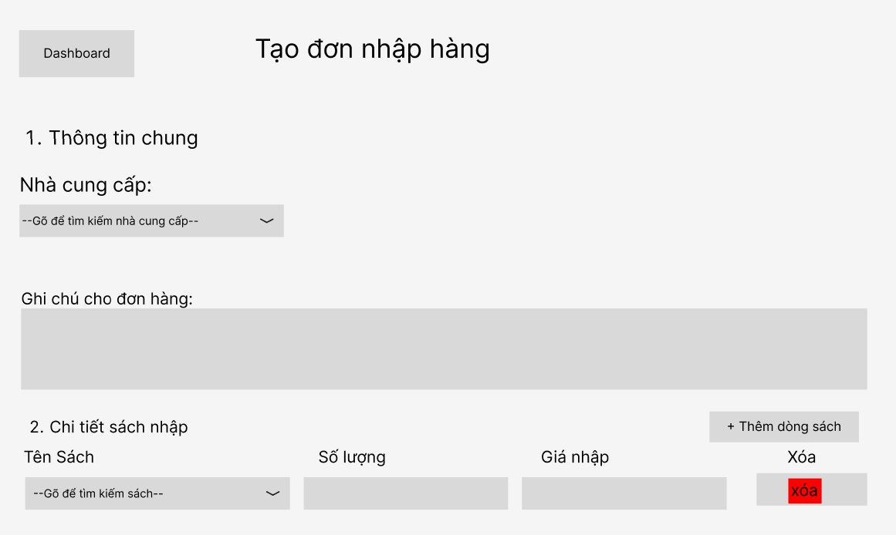

4.7.2 Field Description

Field Name | Description
Back Button | Type: Hyperlink Button Action: Redirects the user to /warehouse/dashboard.
Supplier Dropdown | Type: Dropdown Select Values: List of Suppliers (searchable) Action: Allows user to select a supplier for the purchase order. Required field.
Order Note Field | Type: Textarea Placeholder: Example: “Import books for year-end sale…” Action: Allows user to enter additional notes for the purchase order.
Add Book Button | Type: Button Action: Adds a new row to the book list table for entering book details.
Book List Table | Type: Data Table Logic: Displays list of books to import with the following columns: Book Title (Dropdown Select – searchable), Quantity (Number Input), Import Price (Number Input), Delete (Button).
Delete Row Button | Type: Button Action: Removes the selected book row from the table.
Total Amount Display | Type: Currency Text Logic: Automatically calculates and displays the total amount based on Quantity × Import Price of all rows (formatted in VND).
Save Button | Type: Button Action: Submits the form and sends purchase order data to the server for processing and saving.
Cancel Button | Type: Button Action: Cancels the current action and returns to the previous page or dashboard.

4.8 Return Order & Inspect

4.8.1 View Return Request
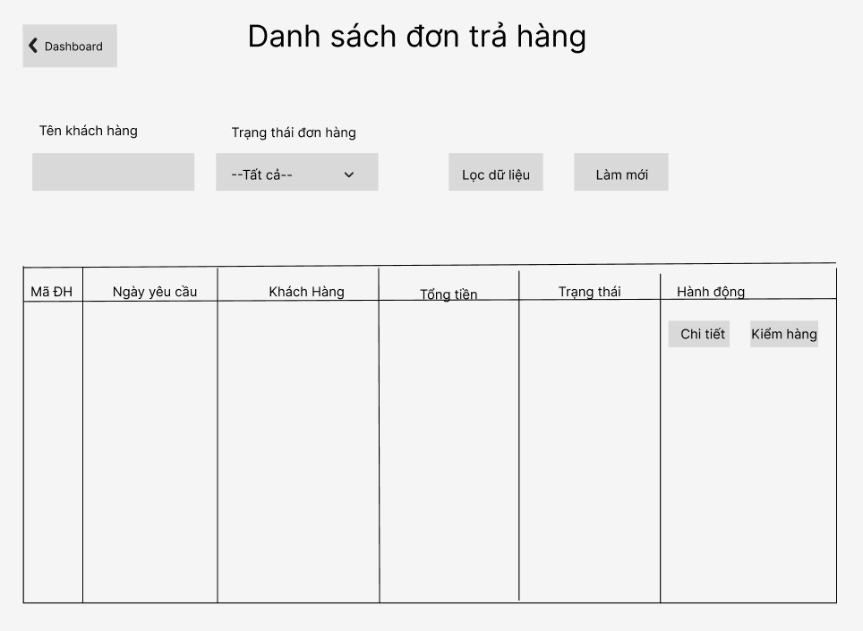
Purpose
Displays a list of return orders in the warehouse system.
Users can search and filter return orders by customer name and return status to quickly locate specific records.

4.8.2 Inspect Finished Good
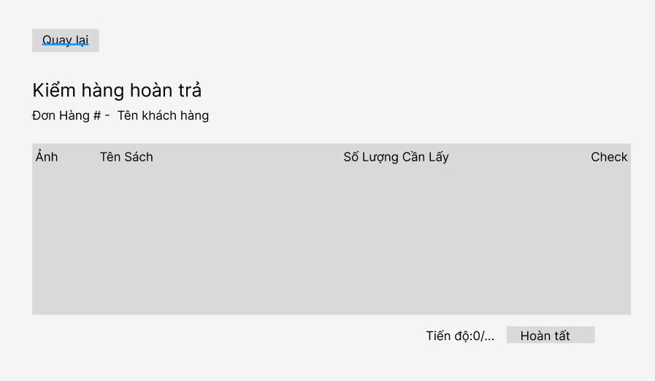
Purpose
Displays detailed information of a selected return order, including:
- Customer information
- Return status
- List of returned items and quantities
Users can also navigate to the inspection process if the return is approved.

4.8.3 Field Description

Field Name | Description
Back Button | Type: Hyperlink Button  Action: Redirects user to /dashboard (Return List) or /returns (Inspection).
Search Input | Type: Textbox  Logic: Allows users to search return orders by customer name.
Status Filter Dropdown | Type: Dropdown Select  Values: All, Requested, Approved, Inspecting, Completed.  Action: Filters return orders based on selected status.
Return List Table | Type: Data Table  Logic: Displays list of return orders with Order ID, Date, Customer, Total Refund, Status.
View Detail Button | Type: Button (Link)  Action: Opens Return Detail Modal for selected order.
Inspect Button | Type: Button (Link)  Condition: Visible when status is Approved or Inspecting.  Action: Redirects to inspection screen.
Return Detail Modal | Type: Modal  Logic: Displays order info and list of returned items.
Item List (Modal) | Type: Data Table  Logic: Displays returned items with Book Title and Quantity.
Inspection Item Table | Type: Data Table  Logic: Displays items to be inspected with checkbox selection.
Check All / Uncheck All | Type: Button  Action: Selects or deselects all items.
Progress Bar | Type: Progress Indicator  Logic: Shows inspection completion percentage.

4.9 View Invoice

4.9.1 View Invoice
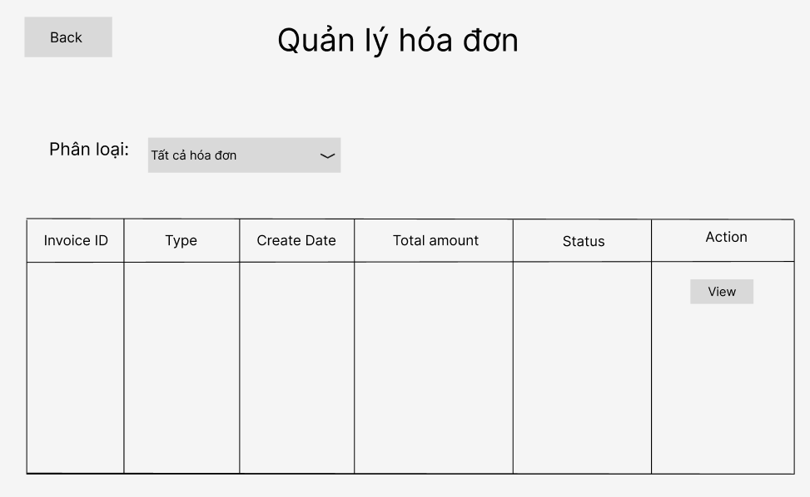
Purpose
Displays a list of invoices generated in the system.
Users can filter invoices by invoice type (Sale or Purchase) to quickly locate specific records.

4.9.2 View Invoice Detail
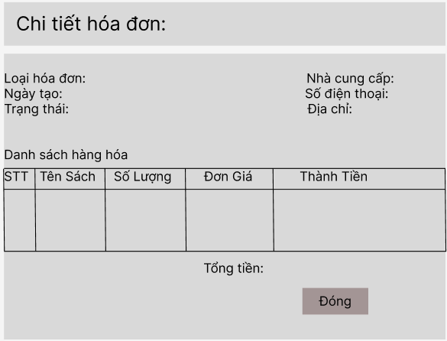
Purpose
Displays detailed information of a selected invoice, including:
- Invoice type and created date
- Customer or supplier information
- List of items (books)
- Quantity, unit price, and subtotal
- Total amount

4.9.3 Field Description

Field Name | Description
Back Button | Type: Hyperlink Button  Action: Redirects the user to /warehouse/dashboard.
Invoice Type Filter Dropdown | Type: Dropdown Select  Values: All Invoices, Sale Invoice, Purchase Invoice.  Action: Automatically submits form (onchange) and filters invoices.
Invoice List Table | Type: Data Table  Logic: Displays invoices with Invoice ID, Type, Created Date, Total Amount, Status.
View Detail Button | Type: Button (Link)  Action: Sends request with invoice ID and opens Invoice Detail Modal.
Invoice Detail Modal | Type: Modal  Logic: Displays general invoice information and related customer/supplier data.
Item List Table (Modal) | Type: Data Table  Logic: Displays list of items including Title, Quantity, Unit Price, Subtotal.
Total Amount Display | Type: Currency Text  Logic: Displays total invoice amount formatted in VND.
Close Button (Modal) | Type: Button  Action: Closes the modal and returns to invoice list.

4.10 Inventory History

4.10.1 Screen Layout
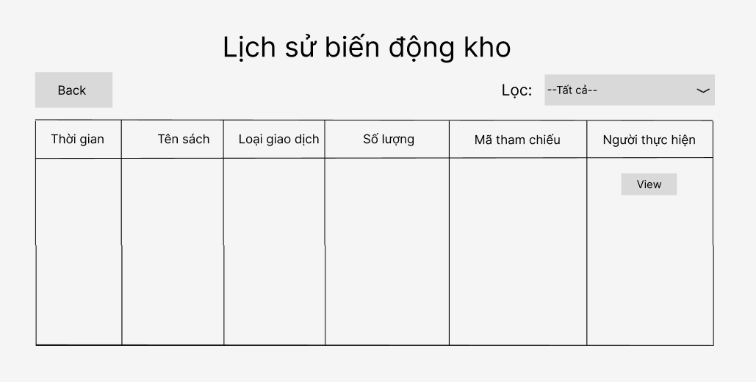
Purpose
Displays a history of inventory transactions in the warehouse system.
Users can filter and sort records to track stock movements such as imports, exports, and returns.

4.10.2 Field Description

Field Name | Description
Back Button | Type: Hyperlink Button  Action: Redirects user to /warehouse/dashboard.
Transaction Filter Dropdown | Type: Dropdown Select  Values: All, Import, Export, Return.  Action: Filters inventory history based on transaction type.
Inventory History Table | Type: Data Table  Logic: Displays transaction records with Date, Book Title, Transaction Type, Quantity, Reference ID, and User.
Sort Function (Columns) | Type: Clickable Column Header  Logic: Allows sorting by Date, Book Title, and Quantity (ASC/DESC).
Quantity Display | Type: Text (Styled)  Logic: Positive values (Import, Return) shown in green, negative values (Export) shown in red.
Reference ID | Type: Label  Logic: Displays related document ID (PO for import, ORD for export/return).
Pagination | Type: Navigation Control  Logic: Allows users to navigate between pages when data exceeds one page.
Close Button (Modal) | Type: Button  Action: Closes the modal and returns to invoice list.
Field Name | Description

5.Feature: Order Management

5.1 SubFeature: Sale Dashboard

5.1.1: Screen: Manage Orders Page (Sale Staff Mode)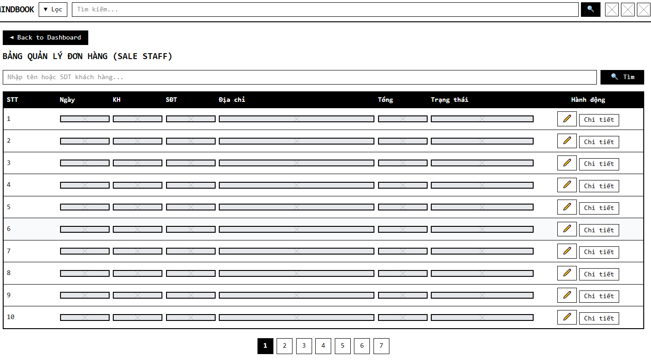
This function provides a comprehensive, paginated (or fully listed) table of all customer orders. It allows the Sale Staff (Role = 3) to monitor incoming orders, search for specific customers, sort the data, and navigate to detailed order views.

Field Name | Description
Back to Shop Button | Type: Hyperlink (<a>)  Action: Redirects to /home.
Search Input | Type: Text Input  Placeholder: "Nhập SĐT khách cần hỗ trợ..."  Action: Submits search query to filter orders by phone number.
Order Table | Type: Container (Table)  Logic: Iterates over the orders collection passed from the controller. Displays empty state message if no orders exist.
Order Date Header | Type: Sortable Link  Action: Reloads the page with sortBy=date and toggles sortOrder between asc and desc.  UI: Active sort displays a gold icon (text-warning sort-up/down). Inactive displays a grey sort icon.
Total Amount Header | Type: Sortable Link  Action: Reloads the page with sortBy=total and toggles sortOrder between asc and desc.
Total Amount Column | Type: Label  Format: Displayed with currency symbol (e.g., "100.000 đ") using <fmt:formatNumber>.  Style: Bold text, Danger (Red) color.
Status Badge | Type: Label (<span>)  Style Logic:  - 1 (Chờ xử lý): Gray( bg-secondary)  - 2 (Đang chuẩn bị hàng): Yellow(bg-warning)  - 3 (Đang giao): Blue (bg-primary)  - 4 (Đã giao): Green (bg-success)  - 5 (Đã hủy): Red (bg-danger)
Edit Action Button | Type: Icon Link  Action: Redirects to /edit-status?id={order.id}&status={order.status}.
Detail Action Button | Type: Icon Link  Action: Redirects to /order-detail?id={order.id}.

5.2 SubFeature: Order Status Update

5.2.1: Screen: Edit Status Form (Sale Staff Mode)
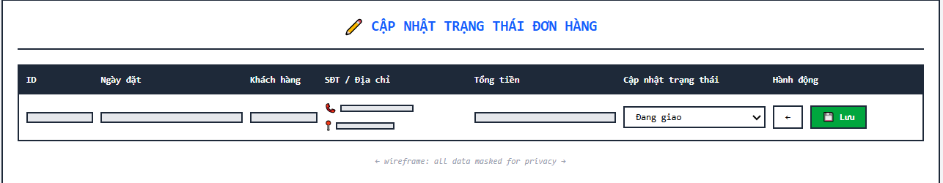

This screen allows the Sale Staff to manually intervene and update the processing status of a specific order

Field Name | Description
Order Info Section | Type: Container (Table Row)  Content: Displays static data including Order ID, Order Date, Customer Name, Phone, Address, and Total Amount.
Date Column | Type: Label  Format: dd/MM/yyyy HH:mm.
Status Dropdown | Type: Dropdown (<select>)  Values:  - 1: Chờ xử lý  - 2: Đang giao  - 3: Hoàn thành  - 4: Đã hủy  Logic: Pre-selects the option matching the current order.status from the database.
Back Button | Type: Hyperlink (<a>)  Action: Redirects back to dashboard without saving changes.
Save Button | Type: Submit Button (<button type="submit">)  Action: Submits the orderId and newStatus to the /edit-status POST controller to update the database via OrderDAO.updateOrderStatus, then redirects to dashboard.

5.3 SubFeature: Order Inspection

5.3.1: Screen: Order Detail Page (Sale Staff Mode)
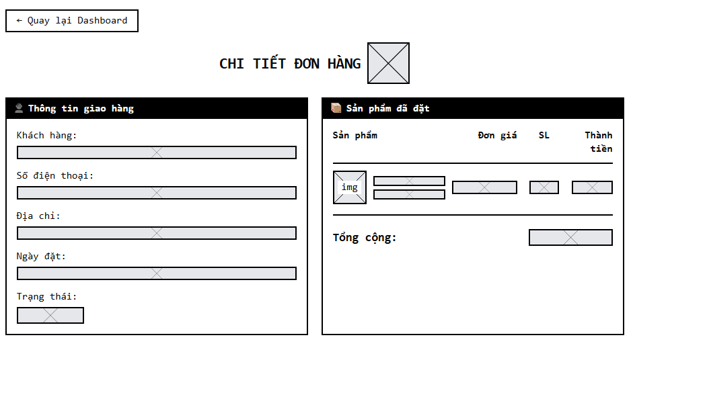
This function provides an in-depth view of a specific transaction, allowing the Sale Staff to verify customer credentials and the specific list of book items purchased before processing the order.

Field Name | Description
Back Button (Quay lại Dashboard) | Type: Hyperlink (<a>)  Action: Redirects to dashboard.  Style: Nút viền xám (Outline Secondary) kèm icon mũi tên trái.
Shipping Info Container (Thông tin giao hàng) | Type: Card Container  Content: Hiển thị các thông tin tĩnh được lấy từ object order bao gồm:  - Khách hàng: ${order.userName}  - Số điện thoại: ${order.phoneNumber}  - Địa chỉ: ${order.shippingAddress}  - Ngày đặt: Format theo định dạng dd/MM/yyyy HH:mm.
Status Badge (Trạng thái) | Type: Label (<span>)  Logic: Render màu sắc dựa trên giá trị của ${order.status}:  - 1: Chờ xử lý (Warning/Vàng)  - 2: Đang giao (Primary/Xanh dương)  - 3: Hoàn thành (Success/Xanh lá)  - 4: Đã hủy (Danger/Đỏ).
Ordered Products Container (Sản phẩm đã đặt) | Type: Card Container chứa Table  Logic: Duyệt vòng lặp forEach qua danh sách ${listDetails} do Controller trả về.
Product Detail Row | Type: Table Row (<tr>)  Content:  - Image & Title: Hiển thị ảnh bìa sách (${item.book.imageUrl}) và tên sách (${item.book.title}).  - Đơn giá: Giá tại thời điểm mua (${item.price}), format theo tiền tệ.  - Số lượng: ${item.quantity} (có tiền tố 'x').  - Thành tiền: Tính toán trực tiếp bằng phép nhân ${item.price * item.quantity}, hiển thị màu đỏ (Danger).
Print Invoice | Data type: Button.  Status: Triggers the browser's print function (window.print). Hidden on the printed paper document
Internal Note | Data type: NVARCHAR / TEXT.  Max length: 1000 characters.  Initial data: Previous note content from the staff (if any).  Status: Allows staff to input/edit text content.
Save Note | Data type: Button (Submit).  Initial data: [Save Note] button.  Purpose: Upon clicking, the data in the "Internal Note" area is sent via POST to OrderDetailController.java to be saved into the Database (updates staffNote).

6. Feature: User Authentication

6.1 SubFeature: User Login
6.1.1 Screen: Login Screen
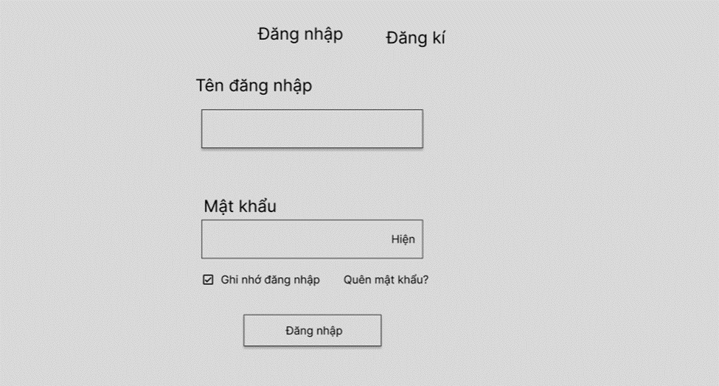
This screen allows the Guest (Unauthenticated User) to:
- Input Credentials: enter their registered Username or Email and Password to authenticate.
On the screen, s/he can also:
- Toggle Password Visibility: show or hide the entered password characters by clicking the "Hiện" text.
- Choose to go to the Forgot Password screen for recovering their account by clicking the "Quên mật khẩu?" link.
- Submit Login Request: send the authentication request to access the system by clicking the "Đăng nhập" button.

Field Name | Description
Field Group: Login Credentials
Tên đăng nhập / Email | - Data Type: Text  - Required: Yes.- Initial: Blank.  - Rule: Accept valid Username
Mật khẩu | - Data Type: Text (Password format).  - Required: Yes.  - Initial: Blank.
Buttons & Links
Text "Hiện" | - Action: Toggle to show/hide password characters.
Link "Quên mật khẩu?" | - Action: Navigate to the Reset Password screen.
Nút "Đăng nhập" | - Action: Validate inputs and submit login request.

6.2 SubFeature: User Register
6.2.1 Screen: Registration & OTP Verification Screen
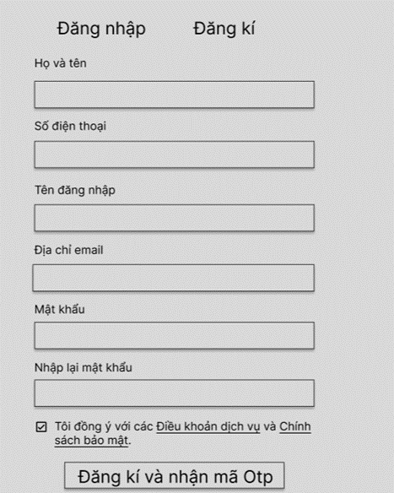 | 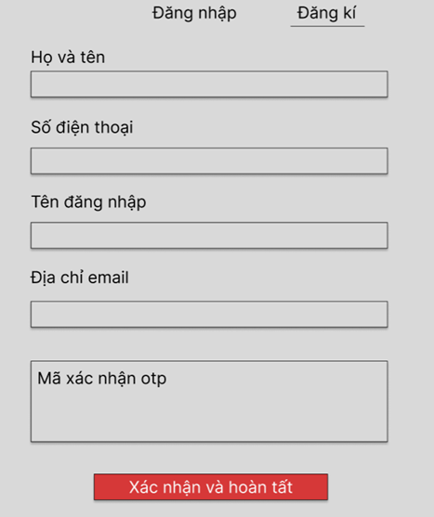
This screen allows the Guest (Unauthenticated User) to:
- Input Registration Details: enter their personal information (Full name, Phone number) and account information (Username, Email, Password).
On the screen, s/he can also:
- Request OTP: validate the inputted form and trigger the system to send a 6-digit verification code to the provided email by clicking the "Đăng Ký & Nhận Mã OTP" button.
- Verify OTP: input the received 6-digit code into the verification popup.
- Submit Registration: complete the account creation process by clicking the "Xác Nhận & Hoàn Tất" button.

Field Name | Description
Field Group: Personal Info
Họ và tên | - Data Type: Text.  - Length: Max 50 characters.  - Required: Yes.  - Rule: Alphabet characters only (No digits).
Số điện thoại | - Data Type: Text  - Length: Exactly 10 digits.  - Required: Yes.  - Rule: Must start with 0.
Field Group: Account Info
Tên đăng nhập | - Data Type: Text.  - Required: Yes  .- Rule: Must be unique. No spaces.
Địa chỉ Email | - Data Type: Text (Email format)  .- Required: Yes.  - Rule: Must be unique. Must follow @domain.com format.
Mật khẩu | - Data Type: Text (Password format).  - Length: Min 6 characters  .- Required: Yes.
Nhập lại mật khẩu | - Data Type: Text (Password format).- Required: Yes.- Rule: Must perfectly match the "Mật khẩu" field.
Field Group: Verification (OTP Form)
Mã xác nhận OTP | - Data Type: Text  - Length: Exactly 6 digits.  - Required: Yes.
Buttons
Nút "Đăng Ký & Nhận Mã OTP" | - Action: Validate form inputs. If valid, show OTP popup and call API to send email.
Nút "Xác Nhận & Hoàn Tất" | - Action: Submit OTP for verification. If successful, save new user to database and navigate to Login.

7. Feature: User Management

7.1 SubFeature: View & Edit Profile
7.1.1 Screen: User Profile & Contact Update Popups
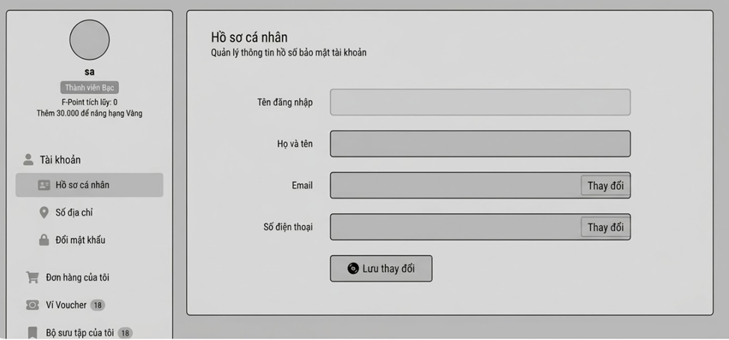
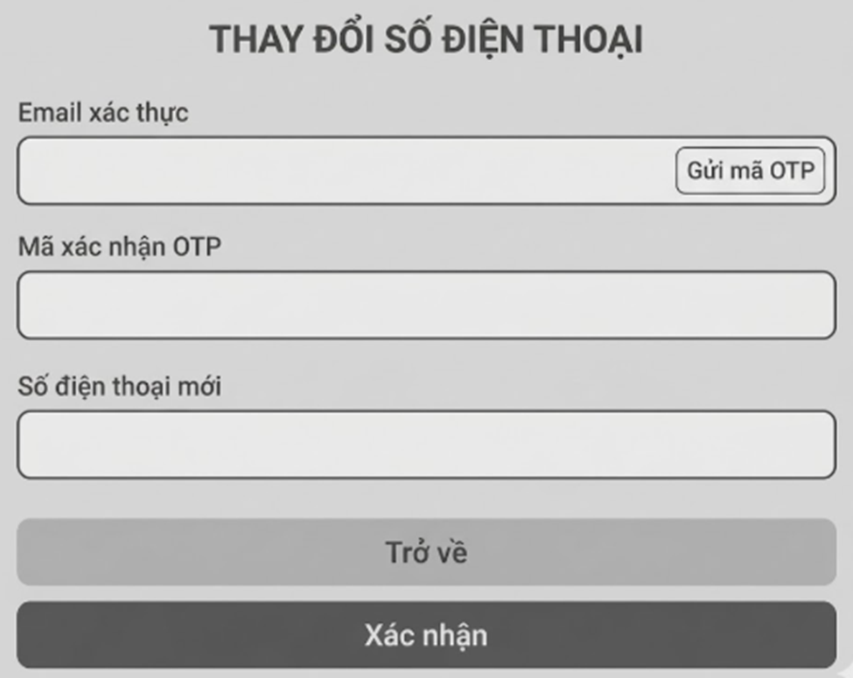

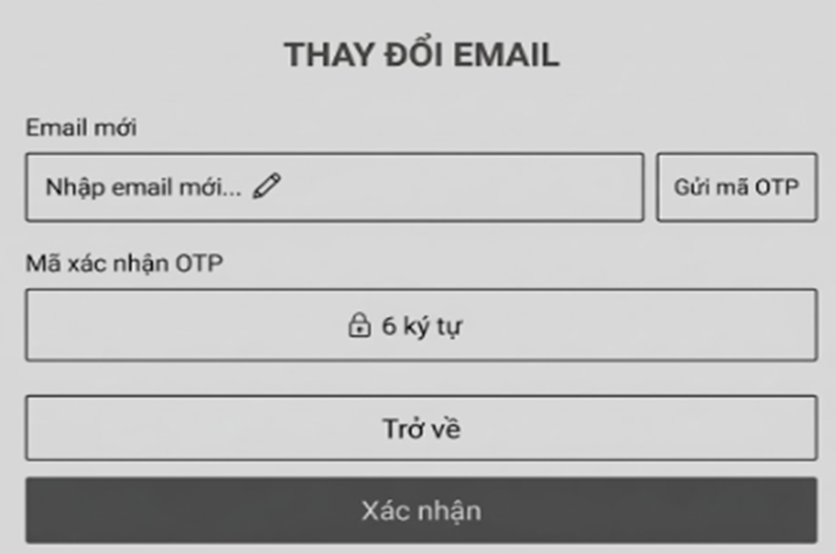
This screen allows the Registered User (Customer) to:
- View Account Details: view their current personal information including Username, Full name, Email, and Phone number.
- Update Basic Profile: modify their Full name and save the changes directly.
On the screen, s/he can also:
- Update Email Address: trigger a verification popup to input a new email, request an OTP to the new email, and verify the code to securely update their email address.
- Update Phone Number: trigger a verification popup to request an OTP to their current email, verify the code, and input a new phone number to update.

Field Name | Description
Field Group: Main Profile Form
Tên đăng nhập | - Data Type: Text.  - Required: Yes.  - Initial: Current username.  - Rule: Read-only (Disabled). Users cannot change their username.
Họ và tên | - Data Type: Text.  - Length: Max 50 characters.  - Required: Yes  - Initial: Current full name.
Email | - Data Type: Text.  - Initial: Current email address.  - Rule: Read-only on the main form. Must be updated via the "Thay đổi" popup.
Số điện thoại | - Data Type: Text  - Initial: Current phone number.  - Rule: Read-only on the main form. Must be updated via the "Thay đổi" popup.
Nút "Lưu thay đổi" | - Action: Save changes made to the "Họ và tên" field to the database.
Field Group: Change Email Popup | (Appears when clicking "Thay đổi" next to Email)
Email mới | - Data Type: Text (Email format).  - Required: Yes.  - Rule: Must be different from the current email and unique in the system.
Link "Gửi mã OTP" | - Action: Call API to send a 6-digit OTP to the newly entered email address.
Mã xác nhận OTP | - Data Type: Text  - Length: Exactly 6 digits.  - Required: Yes.
Nút "Xác nhận" | - Action: Verify the entered OTP. If valid, update the email in the database and close the popup.
Field Group: Change Phone Popup | (Appears when clicking "Thay đổi" next to Phone)
Email xác thực | - Data Type: Text.  - Initial: Current email address.  - Rule: Read-only.
Link "Gửi mã OTP" | - Action: Call API to send a 6-digit OTP to the current email address to verify identity.
Mã xác nhận OTP | - Data Type: Text  - Length: Exactly 6 digits.  - Required: Yes.
Số điện thoại mới | - Data Type: Numeric.  - Length: Exactly 10 digits.  - Required: Yes.  - Rule: Must start with 0 and be unique in the system.
Nút "Xác nhận" | - Action: Verify the entered OTP and format of the new phone number. If valid, update the database and close the popup.

7.2 SubFeature: Manage Address
7.2.1 Screen: Address Book List
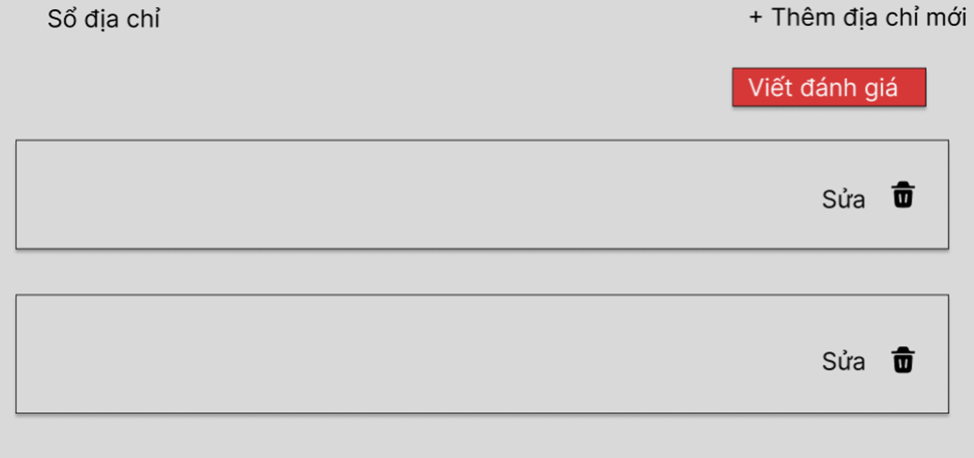
This screen allows the Registered User (Customer) to:
- View Address List: view all their saved delivery addresses, including receiver name, phone number, detailed address, and a badge indicating the "Default" address.
On the screen, s/he can also:
- Navigate to Add form: click the "+ Thêm địa chỉ mới" button to create a new address.
- Navigate to Edit form: click the "Sửa" link to modify an existing address.
- Delete Address: remove an address from the list by clicking the red Trash/Bin icon (triggers a confirmation popup).
Note: This is a data display grid. Data is mapped from the Addresses database table. Action buttons are described above
7.2.2 Screen: Add / Edit Address Form
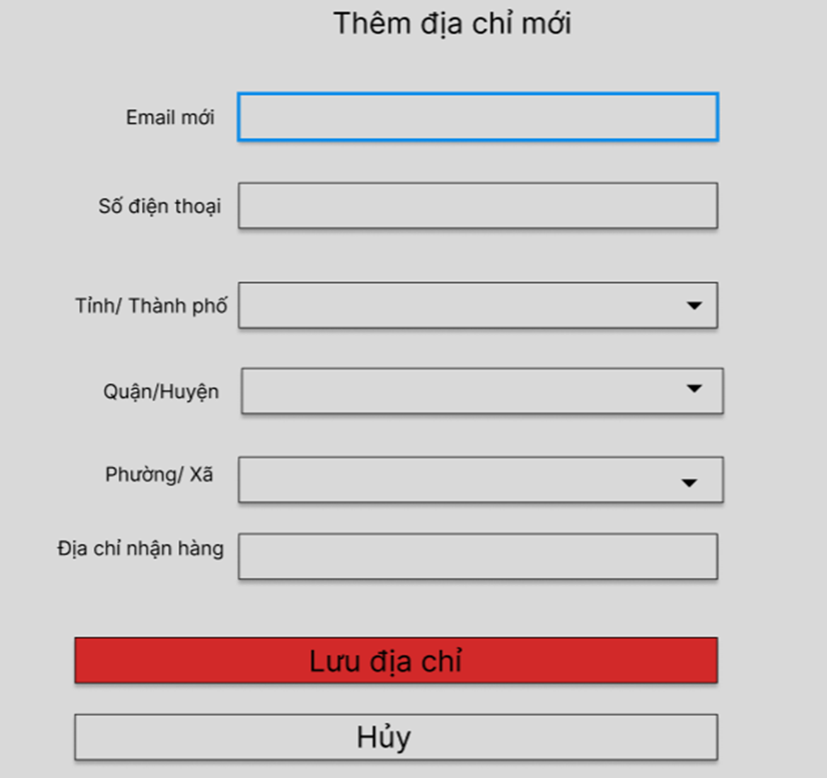
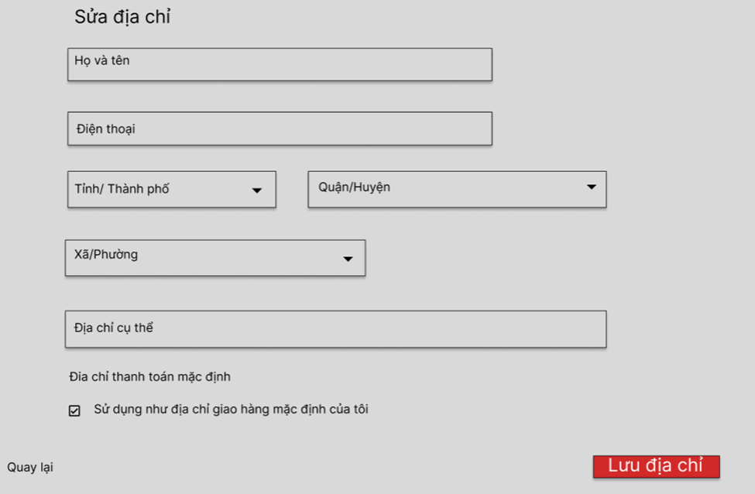
This screen/popup allows the Registered User (Customer) to:
- Input Address Details: enter or modify receiver information and geographical details for shipping purposes.
On the screen, s/he can also:
- Set Default Address: tick a checkbox to prioritize this address for future checkouts.
- Submit Form: validate and save the new/updated address to the database by clicking the "Lưu địa chỉ" button.
- Cancel Action: discard changes and close the form by clicking "Hủy" or "« Quay lại".

Field Name | Description
Field Group: Address Information Form | (Common input form for Add & Edit)
Full Name | - Data Type: Tex  t- Length: Max 50 characters  - Required: Yes  - Rule: Must not contain numbers (/\d/.test). Real-time validation shows an error if a number is entered.
Phone Number | - Data Type: Text (numeric format only)  - Length: Exactly 10 digits  - Required: Yes  - Rule: Must start with 0 and contain only digits (/^0\d{9}$/). Real-time validation included.
Province/City | - Data Type: Select (Dropdown List)  - Required: Yes  - Rule: Data is fetched automatically via API. Must select a valid option.
District | - Data Type: Select (Dropdown List)  - Required: Yes  - Rule: Options depend on the selected Province/City. Automatically resets when Province/City changes.
Ward/Commune | - Data Type: Select (Dropdown List)  - Required: Yes  - Rule: Options depend on the selected District. Automatically resets when District changes.
Specific Address | - Data Type: Text  - Length: Max 100 characters  - Required: Yes  - Rule: Used for house number, alley, street name, etc.
Set as Default Shipping Address | - Data Type: Checkbox  - Required: No  - Rule: Check this to prioritize this address for default delivery.
Field Group: Buttons & Actions | (Interactive buttons)
"Add New Address" Button | - Action: Opens the Add Modal. Clears (resets) all inputs/selects and removes the ID so the system recognizes it as a new entry.
"SAVE ADDRESS" Button | - Action: Triggers validation. If valid, submits data to the server (add-address or edit-address). If invalid, prevents submission and displays error messages.
"« Back" / "Cancel" Button | - Action: Closes the modal popup or returns to the Address Book list, discarding any unsaved inputs.
"Edit" Button | - Action: Navigates to the edit address page/form, passing the specific address ID via URL (action=edit&id=...). Loads the existing address data into the form fields.
"Delete" Button | - Action: Displays a JavaScript confirmation dialog ("Bạn có chắc chắn muốn xóa địa chỉ này?"). If confirmed, sends a request to the server to delete the selected address via URL (action=delete&id=...).

7.3 SubFeature: Change Password
7.3.1 Screen: Change Password Screen
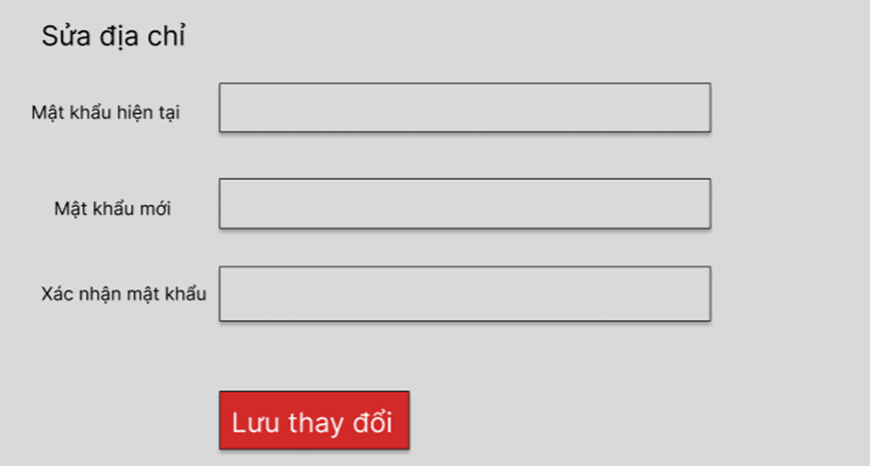
This screen allows the Registered User (Customer) to:
- Update Security Information: change their current account password to a new one to improve account security.
On the screen, s/he can also:
- Input Credentials: enter their current password for authorization, followed by the new password and its confirmation.
- Submit Changes: validate the inputs and update the password securely in the database by clicking the "Lưu thay đổi" button.

Field Name | Description
Field Group: Password Form
Mật khẩu hiện tại | - Data Type: Text (Password format).  - Required: Yes (Mandatory).  - Initial: Blank.  - Rule: Must exactly match the user's current password in the database.
Mật khẩu mới | - Data Type: Text (Password format).  - Length: Min 6 characters.  - Required: Yes (Mandatory).  - Rule: Should be different from the current password.
Xác nhận mật khẩu | - Data Type: Text (Password format).  - Required: Yes (Mandatory).  - Initial: Blank.  - Rule: Must perfectly match the value entered in the "Mật khẩu mới" field.
Buttons
Nút "Lưu thay đổi" | - Action: Validate all fields. If successful, update the password, clear the form, and display a success notification.

7.4 SubFeature: Support Center
7.4.1 Screen: Support Center Screen (History & New Request)

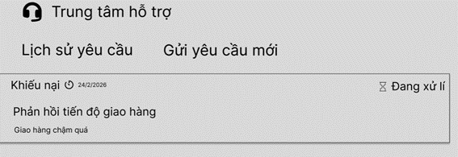 | 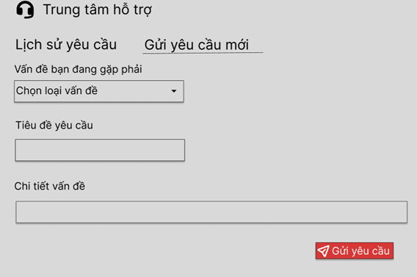
This screen allows the Registered User (Customer) to:
- View Request History: view the list of their previously submitted support tickets under the "Lịch sử Yêu cầu" tab, including ticket type, creation date, title, description, and current processing status.
On the screen, s/he can also:
- Navigate Tabs: switch between viewing history and creating a new request.
- Submit New Support Ticket: input issue details under the "Gửi Yêu cầu Mới" tab and send a message to the staff/admin by clicking the "Gửi Yêu Cầu" button.

Field Name | Description
Field Group: New Support Request Form
Vấn đề bạn đang gặp phải | - Data Type: Dropdown list.  - Required: Yes (Mandatory).  - Initial: "-- Chọn loại vấn đề --" (Blank selection).- Values: e.g., Sản phẩm lỗi / Thiếu hàng, Lỗi website / Ứng dụng, etc.
Tiêu đề yêu cầu | - Data Type: Text (String)  - Length: Max 100 characters.  - Required: Yes (Mandatory).  - Initial: Blank.
Chi tiết vấn đề | - Data Type: Text (Text area / Multi-line string).  - Length: Max 1000 characters.  - Required: Yes (Mandatory).  - Initial: Blank.
Buttons
Nút "Gửi Yêu Cầu" | - Action: Validate all required fields. If valid, insert a new support ticket record into the database with "Pending" (Đang chờ xử lý) status, and switch the view back to the History tab.

7.5 SubFeature: User Collections (My Collections)

7.5.1 Screen: Collections List View

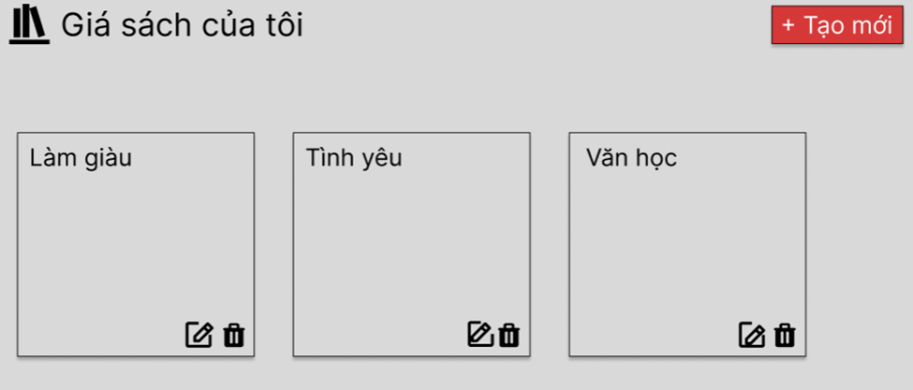
This screen allows the Registered User (Customer) to:
- View Custom Collections: view a grid list of all their created book collections. Each card displays the collection's theme color, title, privacy status, short description, and total book count.
On the screen, s/he can also:
- Navigate to Add Form: trigger the "Tạo Giá Sách Mới" popup by clicking the "+ Tạo mới" button.
- Navigate to Edit Form: trigger the "Sửa Giá Sách" popup by clicking the Pencil icon on a specific collection card.
- Delete Collection: permanently remove a collection by clicking the Trash/Bin icon (this action will prompt a confirmation dialog before executing).
7.5.2 Screen: Add / Edit Collection Form (Popup)

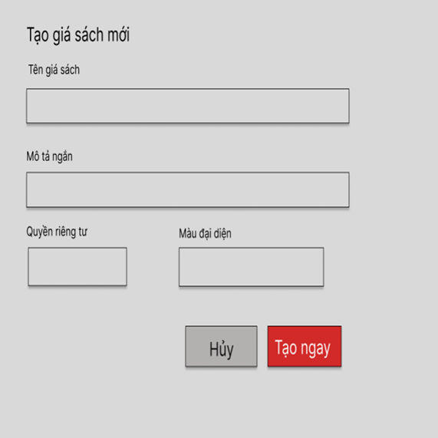 | 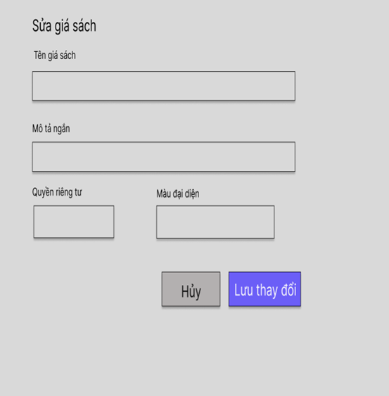
This popup screen allows the Registered User (Customer) to:
- Define Collection Details: input or update the metadata of a book collection, including its name and description.
- Customize Display & Privacy: select a specific theme color for the UI card and determine whether the collection is visible to the public or kept private.
On the screen, s/he can also:
- Submit Data: validate the inputs and save the collection to the database by clicking the "Tạo ngay" / "Lưu thay đổi" button.

Field Name | Description
Field Group: Collection Information
Tên giá sách | - Data Type: Text (String).- Length: Min 1, Max 50 characters.- Required: Yes (Mandatory).- Initial Value: Blank (for Add form) / Current Title (for Edit form).- Validation Rule: Cannot contain only blank spaces. Must be unique within the user's account.
Mô tả ngắn | - Data Type: Text Area (Multi-line string).- Length: Max 250 characters.- Required: No (Optional).- Initial Value: Blank (for Add form) / Current Description (for Edit form).
Field Group: Settings & Preferences
Quyền riêng tư | - Data Type: Dropdown List (Boolean/Enum mapping).- Required: Yes.- Values:1. Công khai (Mọi người có thể xem)2. Riêng tư (Chỉ mình tôi)- Default Value: "Công khai" (for Add form).
Màu đại diện | - Data Type: Color Picker / Visual Radio Group (Hex color code).- Required: Yes.- Default Value: System default color (e.g., Red #C92127) for Add form.- Action: Clicking on the color block opens a palette to select a new theme color for the collection card.
Buttons
Nút "Tạo ngay" / "Lưu thay đổi" | - Action: Validate the "Tên giá sách" field. If valid, insert/update the record in the database, close the popup, and refresh the Collection List View.
Nút "Hủy" / Icon "X" | - Action: Close the popup immediately without saving any changes.

7.5.3 Screen: Collection Detail View
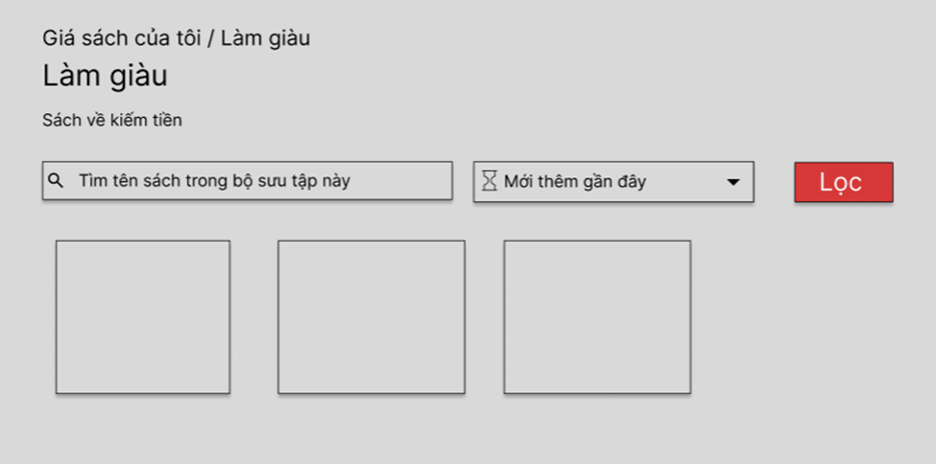

This screen allows the Registered User (Customer) to:
- View Collection Details: view the specific metadata of a selected collection (Title, Description, Book count, Privacy status) and the grid list of all books saved within it.
On the screen, s/he can also:
- Search within Collection: enter keywords to find specific books saved in this exact collection.
- Sort & Filter: use the dropdown menu to sort the books (e.g., by "Mới thêm gần đây" - Recently added) and apply filters.
- Remove Book: delete a specific book from the current collection by clicking the red "X" icon on the top right corner of the book card.

Field Name | Description
Field Group: Search & Filter Options
Tìm tên sách trong bộ sưu tập này... | - Data Type: Text input.- Length: Max 100 characters.- Required: No (Optional).- Initial Value: Blank.- Action: Typing keywords here will narrow down the book list below based on Book Title or Author, scoped only to this collection.
Sort Dropdown (Vd: Mới thêm gần đây) | - Data Type: Dropdown list.- Required: Yes (Always has a default state).- Values: e.g., Mới thêm gần đây (Newest), Giá thấp đến cao, Giá cao đến thấp
Nút "Lọc" | - Action: Apply the selected search keyword and sort criteria to reload the grid of books dynamically.
Field Group: Item Actions
Icon "X" màu đỏ (Remove from collection) | - Action: Trigger a confirmation popup (optional but recommended). If confirmed, remove the mapping between this Book ID and Collection ID in the database, and update the "Có [X] cuốn sách" counter at the top.

7.6 SubFeature: My Orders

7.6.1 Screen: Order History & Management
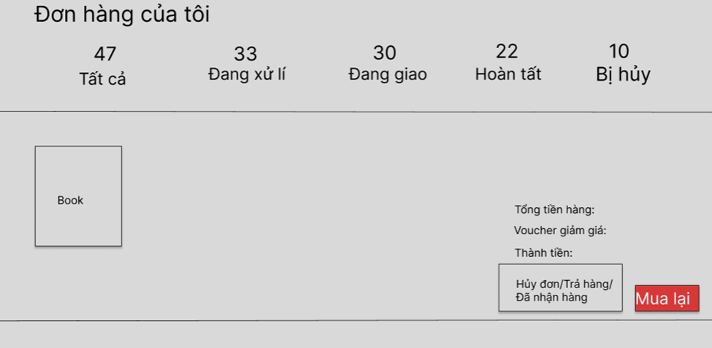This screen allows the Registered User (Customer) to:
- View Order History: view a comprehensive list of all their past and current orders, including order ID, date, product details, quantities, total amount, and applied vouchers.
- Filter Orders: navigate through different order statuses (Tất cả, Đang xử lý, Đang giao, Hoàn tất, Bị hủy) using the top navigation tabs.
On the screen, depending on the specific order's status, s/he can also:
- Cancel Order: abort an ongoing order by clicking "Hủy đơn" (available only for 'Pending/Đang xử lý' orders).
- Repurchase: quickly add all items from a previous order back into the shopping cart by clicking the "Mua lại" button.
- Initiate Return/Refund: trigger the Return Request popup for completed orders by clicking the "Trả hàng / Hoàn tiền" button.

7.6.2 Screen: Return / Refund Request Form (Popup)
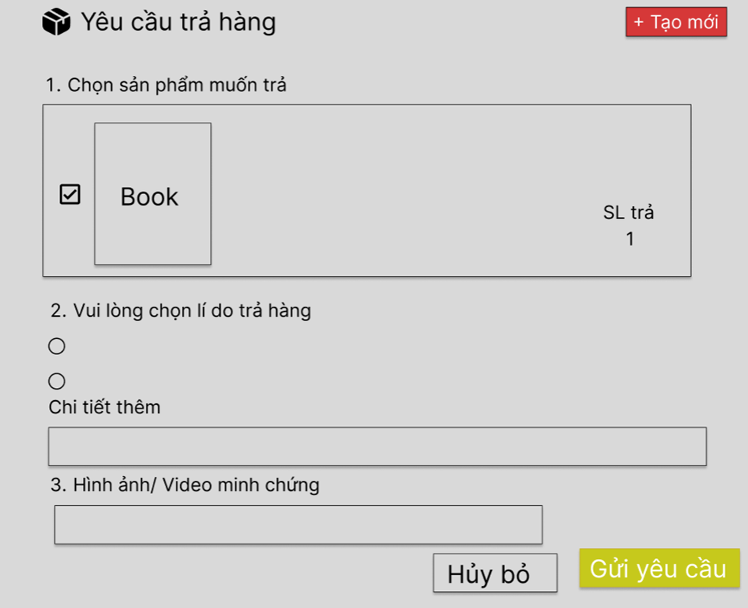
This popup screen allows the Registered User (Customer) to:
- Submit Return Request: provide reasons and specific details to request a product return or refund for a completed order.
On the screen, s/he can also:
- Submit Data: validate the inputs and send the request to the administrative system by clicking the "Gửi Yêu Cầu" button

Field Name | Description
Field Group: Request Details
Vui lòng chọn lý do trả hàng | - Data Type: Radio Button Group (Single selection).- Required: Yes (Mandatory - marked with *).- Initial Value: None selected.- Values:1. Sản phẩm bị lỗi, trầy xước...2. Giao sai sản phẩm...3. Sản phẩm không giống mô tả4. Thiếu phụ kiện...5. Lý do khác.
Chi tiết thêm | - Data Type: Text Area (Multi-line string).- Length: Max 500 characters.- Required: Conditional (Depends on specific system rules, usually required if "Lý do khác" is selected).- Initial Value: Blank.
Buttons
Nút "Gửi Yêu Cầu" | - Action: Validate that a reason is selected. If valid, insert a new Return Request record into the database, close the popup, and update the order's status tag.
Nút "Hủy bỏ" / Icon "X" | - Action: Discard the form and close the popup without submitting.
7.7 SubFeature: User Notifications
7.7.1 Screen: Notifications Page

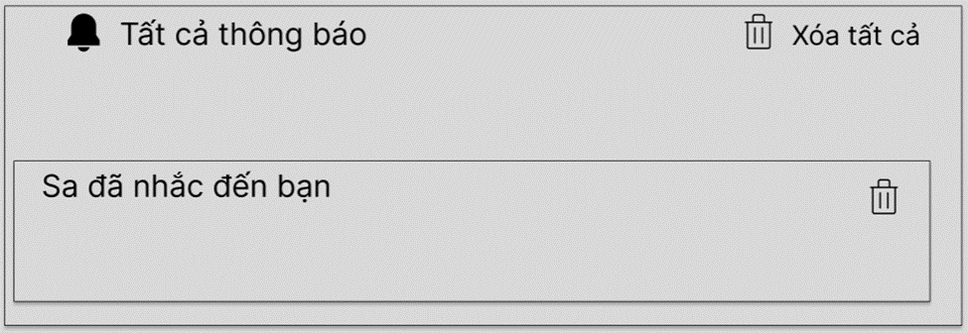

This screen allows the Registered User (Customer) to:
- View Notifications: view a chronological list of system alerts, such as being mentioned in a comment, order status updates, or promotional messages.
On the screen, s/he can also:
- Navigate to Context (Deep Linking): click on a specific notification record to be instantly redirected to the relevant page and section (e.g., auto-scroll to the exact comment/reply on the product detail page).
- Delete Single Notification: remove an individual notification from the list by clicking the Trash/Bin icon on the right side.
- Clear All Notifications: delete the entire notification history at once by clicking the red "Xóa tất cả" (Clear All) button at the top right corner.
Note: This screen does not contain data input forms. It is a read-only data view dynamically fetched from the Notification database table. Interactive elements are limited to navigation and deletion actions as explicitly described in above description

7.8 SubFeature: My Comments
7.8.1 Screen: User Comments History
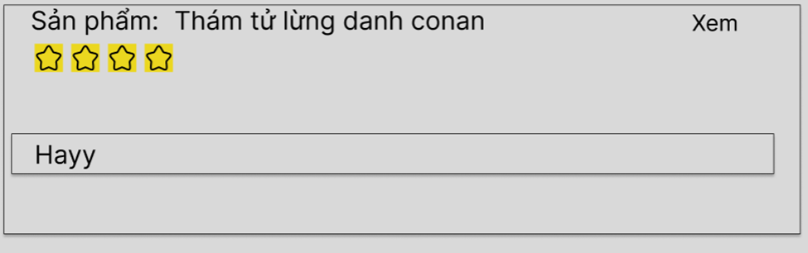
This screen allows the Registered User (Customer) to:
- View Review History: view a chronological list of all their submitted product reviews and ratings. Each record displays the associated product name, the star rating given, the exact submission date and time, and the text content of the comment.
On the screen, s/he can also:
- Navigate to Product Details: click the "Xem" (View) button next to a specific comment to be redirected to that exact product's detail page, allowing them to see their review in the public context.
(Note: This screen does not contain data input forms. It is a read-only data view dynamically fetched from the Review/Comment database table. Interactive elements are limited to the navigation action explicitly described in above description)

7.9 SubFeature: Voucher Wallet (Ví Voucher)
7.9.1 Screen: User Voucher List
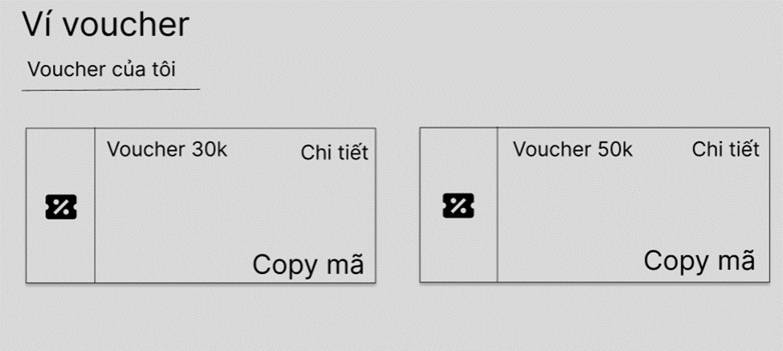
This screen allows the Registered User (Customer) to:
- View Saved Vouchers: view a grid list of all discount codes and promotional vouchers they have collected.
- Check Status: easily distinguish between available vouchers (highlighted in green) and inactive/used/expired ones (grayed out). Each card displays the discount value, minimum order requirement, specific code, and expiration date.
On the screen, s/he can also:
- Copy Code: automatically copy the promo code to the device's clipboard by clicking the blue "Copy mã" button (only available for active vouchers).
- View Details: click the "Chi tiết" link to read the specific terms, conditions, and applicable product categories for each voucher.
(Note: This screen does not contain data input forms. It is a read-only data view dynamically fetched from the User_Voucher database table. Interactive elements are limited to the copy and view detail actions explicitly described in above description)

8. Feature: Product Browsing & Interaction

8.1 SubFeature: Product Detail View & Actions
8.1.1 Screen: Main Product Detail Information
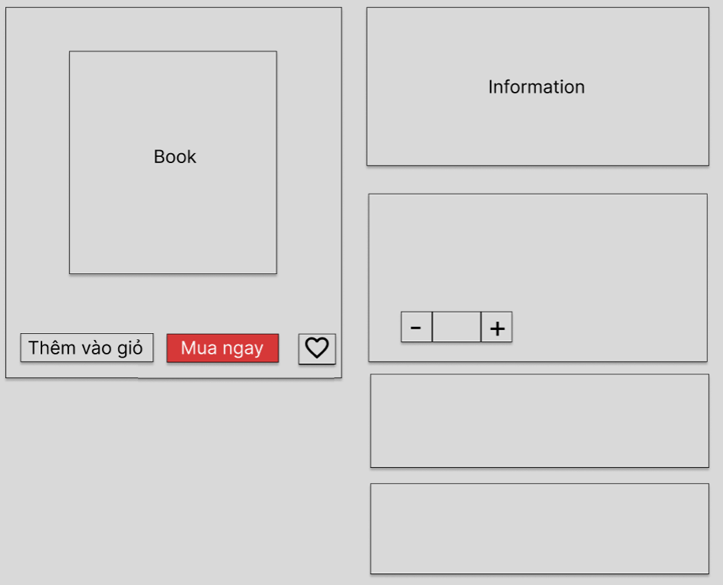

This screen allows the User (Guest/Customer) to:
- View Product Information: view comprehensive details of a specific book, including cover images, title, author, publisher, price, and current promotions.
- View Shipping Information: check the estimated delivery time and standard shipping fee based on the default location.
On the screen, s/he can also:
- Adjust Quantity: increase or decrease the number of items they wish to purchase.
- Add to Cart: place the selected quantity of the book into the shopping cart without leaving the page by clicking "Thêm vào giỏ".
- Buy Now: instantly add the item to the cart and navigate directly to the Checkout screen by clicking "Mua ngay".
- Trigger Modals: open the "Save to Collection" popup (Heart icon), "Change Shipping Address" popup, or "View Details" popup for vouchers.

Field Name | Description
Field Group: Purchase Actions
Số lượng (Quantity) | - Data Type: Text  - Length: Min value = 1, Max value = Current Stock level.  - Required: Yes.  - Initial Value: 1.  - Validation Rule: Users can type the number directly or use the + / - buttons. Cannot input negative numbers or text. If input exceeds stock, auto-revert to max stock and show a warning message.
Nút "Thêm vào giỏ" | - Action: Validate quantity. Add the item to the session/database cart. Show a success toast notification and update the cart counter on the Global Header.
Nút "Mua ngay" | - Action: Validate quantity. Add the item to the cart and immediately redirect the user to the Cart page.
Icon Trái tim (Wishlist) | - Action: Open the "Lưu sách vào Bộ sưu tập" modal (Requires user to be logged in).
Link "Thay đổi" (Shipping) | - Action: Open the "Chọn địa chỉ giao hàng" modal to recalculate shipping fees.
8.1.2 Screen: Save to Collection Modal
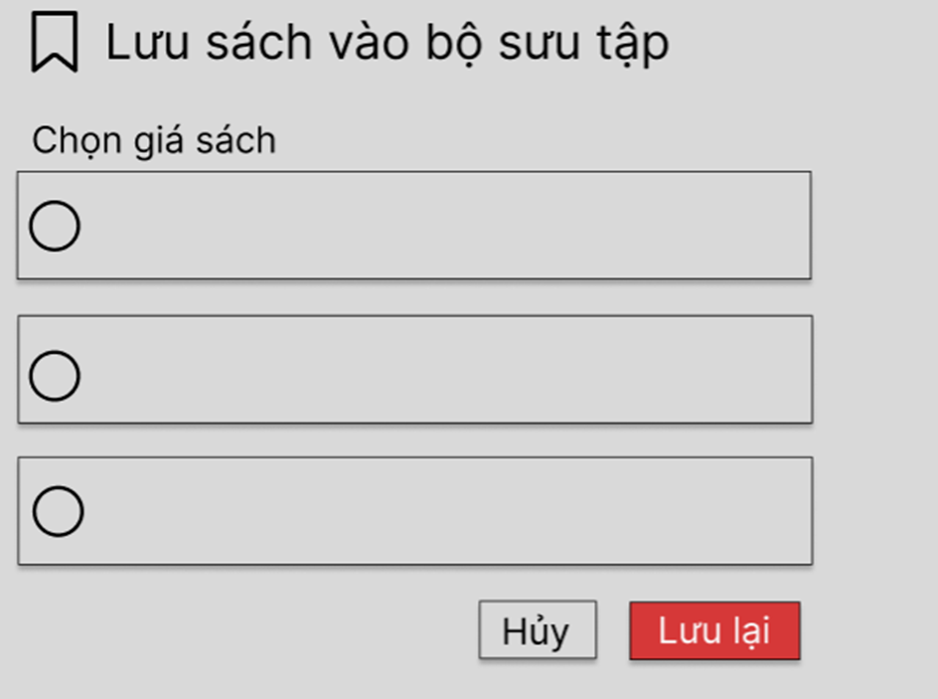
This modal allows the Registered User (Customer) to:
- Save Book to Collection: categorize the currently viewed book into one of their custom personal collections (e.g., "Làm giàu", "Tình yêu") for future reference.

Field Name | Description
Field Group: Collection Selection
Chọn giá sách | - Data Type: Radio Button Group (Single select).  - Required: Yes (Mandatory to proceed).  - Initial Value: None selected (or pre-select the collection if the book is already in one).  - Data Source: Dynamically loaded from the user's active collections in the database.
Nút "Lưu lại" | - Action: Validate selection. Insert a mapping record between the Book ID and the Collection ID in the database. Close modal and show success notification.
8.1.3 Screen: Change Shipping Address Modal
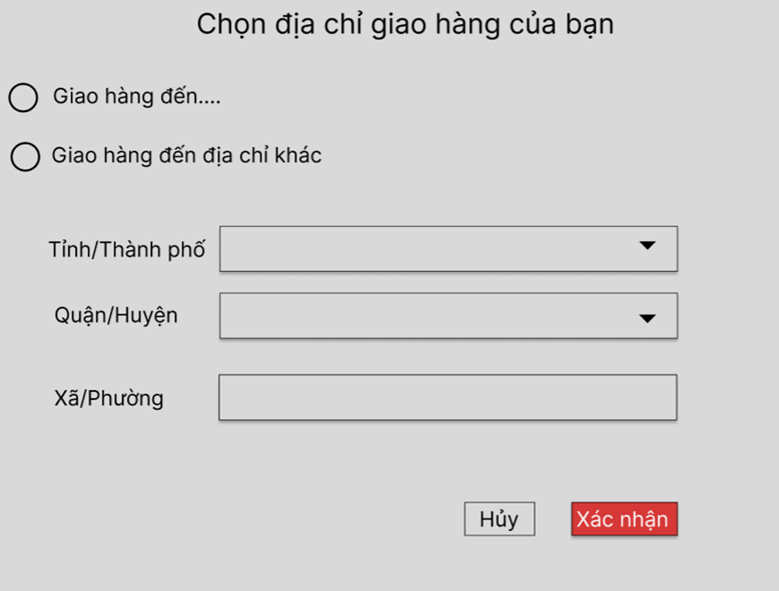
This modal allows the User to:
- Calculate Shipping Fee: temporarily change the destination address to preview the dynamic shipping cost before checking out.

Field Name | Description
Field Group: Location Inputs
Lựa chọn loại địa chỉ | - Data Type: Radio Button Group.  - Values:1. Giao hàng đến [Địa chỉ mặc định hiện tại]2. Giao hàng đến địa chỉ khác.  - Default: Option 1 selected.
Tỉnh/Thành Phố | - Data Type: Dropdown.  - Required: Conditional (Required only if "Địa chỉ khác" is selected).  - Rule: Disabled if Option 1 is selected.
Quận/Huyện | - Data Type: Dropdown.  - Required: Conditional.  - Rule: Cascading based on Tỉnh/Thành phố. Disabled if Option 1 is selected.
Phường/Xã | - Data Type: Dropdown.  - Required: Conditional.  - Rule: Cascading based on Quận/Huyện. Disabled if Option 1 is selected.
Nút "Xác nhận" | - Action: Send selected location data to the shipping API to recalculate the estimated shipping fee on the main Product Detail page. Close modal.
8.1.4 Screen: Product Review & Rating Section
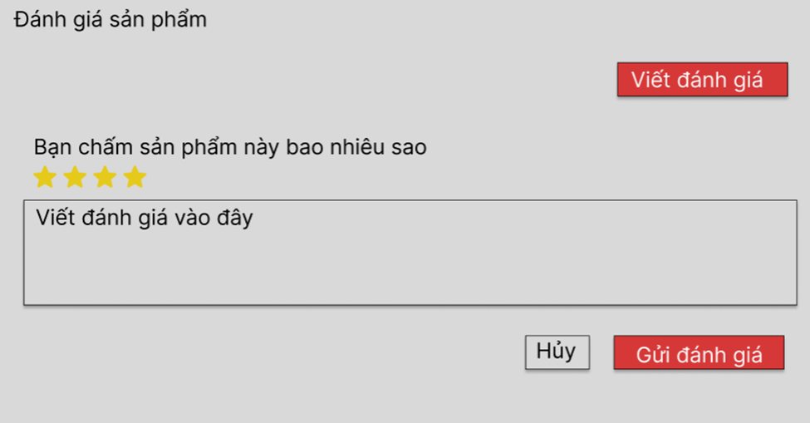
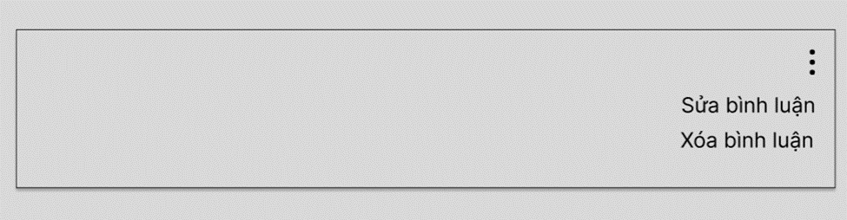
This section allows the User to:
- View Statistics: see the overall average star rating and the percentage distribution of reviews (5 stars down to 1 star).
- Write Review: submit a rating and text feedback for the product (typically restricted to users who have successfully purchased the item).
- Manage Own Review: edit or delete their previously submitted comment using the 3-dot action menu.

Field Name | Description
Field Group: Review Form
Chấm sao (Star Rating) | - Data Type: Interactive UI element (Numeric representation 1-5).  - Required: Yes (Mandatory to submit).  - Initial Value: 0 stars (Blank).  - Rule: Hovering illuminates stars; clicking sets the final integer value (1, 2, 3, 4, or 5).
Chia sẻ cảm nhận (Comment) | - Data Type: Text Area (Multi-line string).  - Length: Max 800 characters.  - Required: No (Optional - users can just leave a star rating without text).  - Initial Value: Blank.  - Rule: Automatically sanitizes HTML/scripts to prevent XSS attacks.
Nút "Gửi đánh giá" | - Action: Validate star rating. Save the review to the database, update the product's average rating asynchronously, and append the new comment to the top of the comment list.
Field Group: Comment Management | (Visible only on the user's own comments)
Nút "Sửa bình luận" | - Action: Transforms the static comment text back into the editable "Review Form" (Stars + Text Area) for modification.
Nút "Xóa bình luận" | - Action: Triggers a confirmation popup. If confirmed, soft-deletes the comment from the database and recalculates the product's average rating.
8.2 SubFeature: Q&A and Discussion
8.2.1 Screen: Ask a Question Form

This section allows the Registered User (Customer) to:
- Start a Discussion: create a new question or discussion thread related to the specific book.
On the screen, s/he can also:
- Categorize Question: select an appropriate topic (e.g., Content inquiry, Translation quality) for better filtering.
- Mark as Spoiler: toggle the "Spoiler" warning to hide sensitive plot details from other users who haven't read the book.
- Submit/Cancel: submit the question to the public board or cancel the action.

Field Name | Description
Field Group: Question Form
Tiêu đề câu hỏi | - Data Type: Text (String).  - Length: Max 150 characters.  - Required: Yes (Mandatory - marked with *).  - Initial Value: Blank.
Chủ đề | - Data Type: Dropdown list.  - Required: Yes (Mandatory - marked with *).  - Values: Dynamically loaded (e.g., Hỏi nội dung, Hỏi hình thức, Khác).
Chi tiết câu hỏi | - Data Type: Text Area (Multi-line string).  - Length: Max 800 characters.  - Required: Yes (Mandatory - marked with *).  - Initial Value: Blank.
Có tiết lộ nội dung truyện (Spoiler) | - Data Type: Toggle Switch (Boolean).  - Required: No (Optional).  - Default Value: Off (False).  - Action: If turned On, the system will apply a blur/hidden effect on the text when displaying it to other users until they click "Show anyway".
Buttons
Nút "Gửi câu hỏi" | - Action: Validate all required fields. Save the new thread to the database linked to the current Book ID and User ID. Refresh the discussion list.
Nút "Hủy" | - Action: Clear all inputs and collapse the form.
8.2.2 Screen: Discussion Thread & Interactions

This section allows the User to:
- Read Threads: view existing questions and their nested replies in a chronological, tree-structured format.
On the screen, s/he can also:
- Reply to Thread: input text into the reply box to participate in the conversation. Clicking "Trả lời" on a specific comment will auto-tag the user (e.g., @hi).
- Manage Own Content: click the 3-dot menu on their own posts to "Sửa câu hỏi" (Edit) or "Xóa câu hỏi" (Delete).
- Report Content: click the 3-dot menu on other users' posts to "Báo cáo" (Report) inappropriate content to the Administrator.

Field Name | Description
Field Group: Reply Form
Viết câu trả lời của bạn... | - Data Type: Text input.  - Length: Max 800 characters.  - Required: Yes (Mandatory to send).  - Initial Value: Blank, or contains @username if the user clicked a specific "Trả lời" link.
Nút "Gửi" (Icon Máy bay) | - Action: Submit the reply to the current thread. Append the new reply UI asynchronously without reloading the whole page.
Field Group: 3-Dot Action Menu (Contextual)
Nút "Sửa câu hỏi/bình luận" | - Visibility: Visible ONLY if Current_User_ID == Post_Owner_ID.  - Action: Transform the text block back into an editable form to update the content.
Nút "Xóa câu hỏi/bình luận" | - Visibility: Visible ONLY if Current_User_ID == Post_Owner_ID.  - Action: Trigger a confirmation popup. If confirmed, delete the post (and associated child replies, depending on DB logic).
Nút "Báo cáo" | - Visibility: Visible ONLY if Current_User_ID != Post_Owner_ID.  - Action: Open a "Report Reason" modal to flag the comment for Admin review.

8.3 SubFeature: Product Search & Filtering
8.3.1 Screen: Search Results & Filter Sidebar
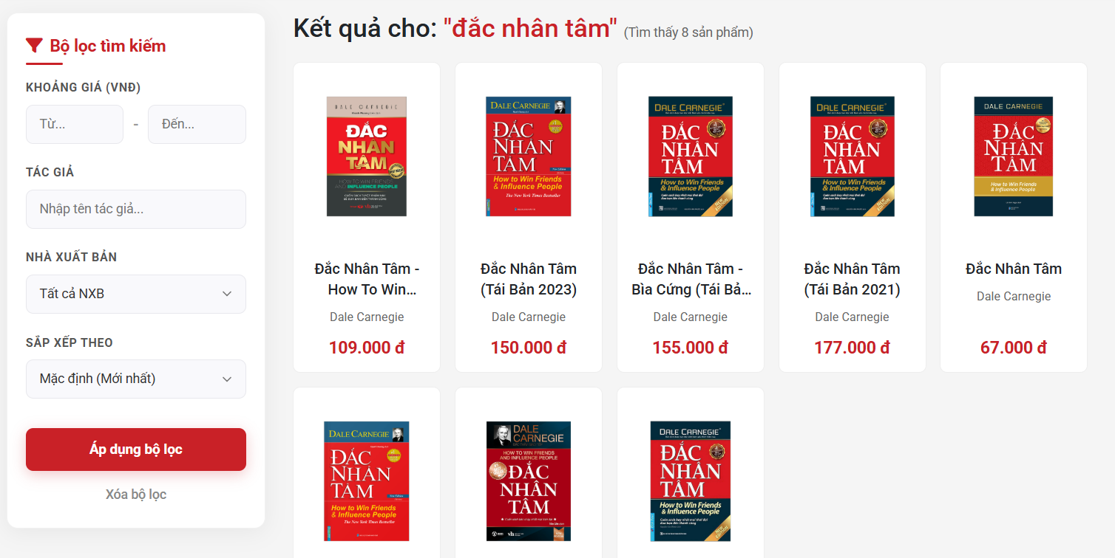
This screen allows the User (Guest/Customer) to:
- View Search Results: view the total count of products matching their search keyword and browse the results in a grid layout (displaying book cover, title, author, and price).
On the screen, s/he can also:
- Apply Advanced Filters: refine the search results by inputting a specific price range, author name, or selecting a publisher from the sidebar.
- Sort Results: change the display order of the books (e.g., Newest, Price Low to High) using the sorting dropdown.
- Clear Filters: quickly reset all filter conditions to their default state by clicking the "Xóa bộ lọc" text link.
- Navigate to Details: click on any book card to be redirected to its specific Product Detail page.

Field Name | Description
Field Group: Price Range Filter (Khoảng giá)
Từ... (Min Price) | - Data Type: Numeric (Integer).- Required: No (Optional).- Initial Value: Blank.- Validation Rule: Must be >= 0. Cannot contain text or special characters. If both fields are filled, "Từ..." must be less than or equal to "Đến...".
Đến... (Max Price) | - Data Type: Numeric (Integer).- Required: No (Optional).- Initial Value: Blank.- Validation Rule: Must be >= 0. Must be greater than or equal to the "Từ..." value.
Field Group: Attribute Filters
Nhập tên tác giả (Author) | - Data Type: Text (String).- Length: Max 100 characters.- Required: No (Optional).- Initial Value: Blank.
Chọn Nhà xuất bản (Publisher) | - Data Type: Dropdown list.- Required: No (Always has a default state).- Values: Dynamically loaded from the Publisher database table.- Default Value: "Tất cả NXB" (All Publishers).
Field Group: Sorting
Sắp xếp theo (Sort by) | - Data Type: Dropdown list.- Required: Yes (Always active).- Values: e.g., Mặc định (Mới nhất), Bán chạy nhất, Giá thấp đến cao, Giá cao đến thấp.- Default Value: "Mặc định (Mới nhất)".
Buttons & Actions
Nút "Áp dụng bộ lọc" | - Action: Validate the Price Range logic (check for min > max errors). If valid, append all selected filter parameters to the API request, reload the book grid, and update the "Tìm thấy [X] sản phẩm" counter.
Link "Xóa bộ lọc" | - Action: Clear all inputs in the Price Range and Author fields, reset the Publisher and Sorting dropdowns to their default values, and reload the original unfiltered search results.

9. Feature: Voucher Management

9.1 SubFeature: Voucher Dashboard
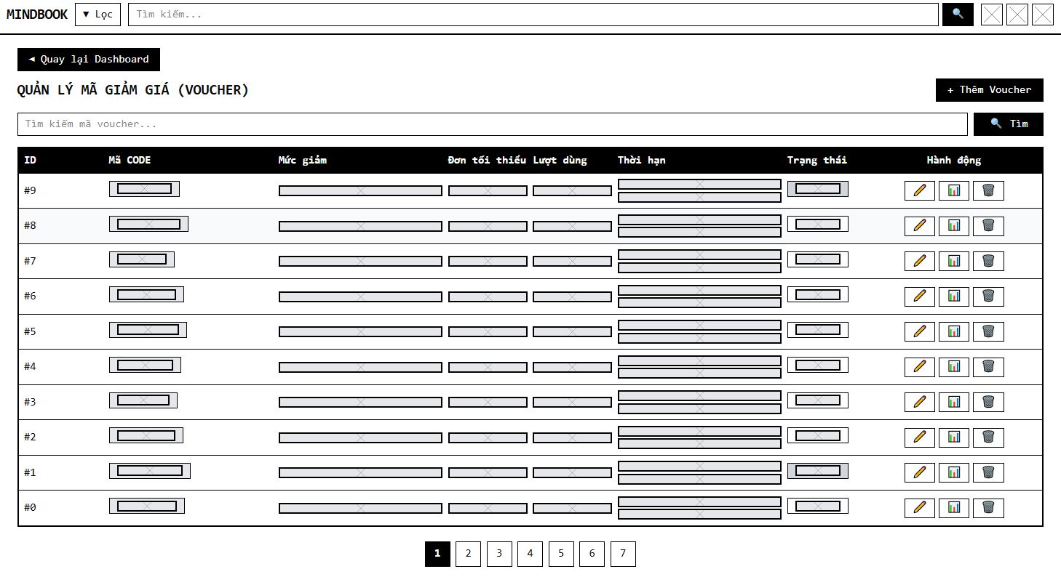

Field Name | Description
Back to Dashboard | Data type: Button/Link.  Action: Redirects the user back to the main staff dashboard.
Add Voucher Button | Data type: Button.  Initial data: + Thêm Voucher button located at the top right.  Action: Opens the "Add New Voucher" modal to create a new discount code.
Expiration Date | Data type: DATETIME / DATE.  Format: dd/MM/yyyy $\rightarrow$ dd/MM/yyyy.  Initial data: Displays the start date and end date of the voucher.  Status: Read-only.
Status | Data type: INT / BIT (Displayed via UI as a Text Badge).  Initial data: Dynamically rendered based on expiration date and usage limits. Displays "Đang hoạt động" (Active - Green) or "Đã hết hạn" (Expired - Red).  Status: Read-only.
Edit Button | Data type: Button (Icon pen).  Action: Opens a modal to modify the details of the selected voucher.
Statistics Button | Data type: Button (Icon chart).  Action: Opens a modal displaying detailed statistics for the specific code (Number of users who saved it & Number of successful usages).
Delete Button | Data type: Button (Icon trash bin).  Action: Triggers a browser confirmation alert ("Are you sure you want to delete...?"). If confirmed, sends a request to delete or deactivate the voucher from the database.
Saved Count | Data type: INT.  Min value: 0.  Initial data: The number of users who have saved this code to their wallet.  Status: Read-only.
Used Count | Data type: INT.  Min value: 0.  Initial data: The number of times this code has been successfully applied to completed orders.  Status: Read-only.

9.1 SubFeature: Add voucher
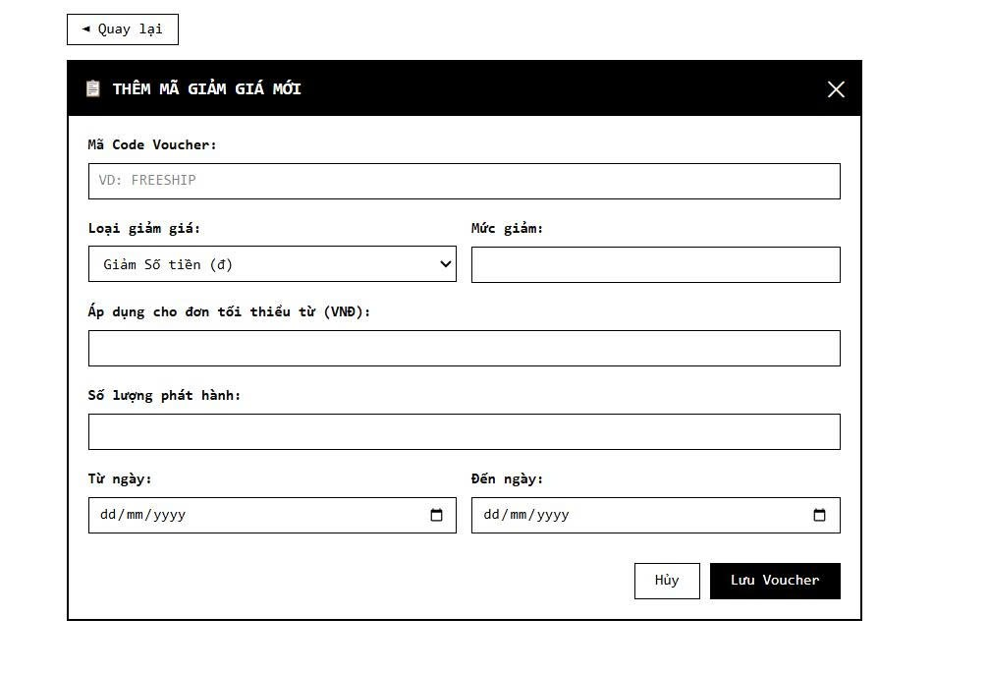

Field Name | Description
Code Name | Data type: Text Input.  Format: Text input. Must be entered in uppercase letters (text-transform: uppercase).  Status: Required field (required).
Discount Type | Data type: Dropdown List (Select).  Initial data: Contains two options: "Giảm Số tiền (đ)" and "Giảm Phần trăm (%)".  Status: Required field (required). Triggers UI changes when the selection is modified.
Discount Value | Data type: Number Input.  Min value: 1.  Status: Required field (required).
Maximum Discount | Data type: Number Input.  Placeholder: "Bỏ trống nếu không giới hạn".  Status: Optional. Hidden by default. This input field dynamically appears only when the user selects "Giảm Phần trăm (%)" from the Discount Type dropdown.
Minimum Order Value | Data type: Number Input.  Min value: 0.  Status: Required field (required).
Total Quantity | Data type: Number Input.  Min value: 1.  Status: Required field (required). Defines the total usage limit of the voucher.
Start Date &End Date | Data type: Date Input (Date Picker).  Format: dd/MM/yyyy.  Status: Required field (required).
Cancel Button | Data type: Button.  Action: Discards the inputted data and closes the form without saving.
Save Voucher | Data type: Button (Submit).  Action: Validates the input fields. If valid, sends a POST request to save the new discount code and refreshes the list.

10. Feature: Cart Management

10.1 SubFeature: View Cart Page

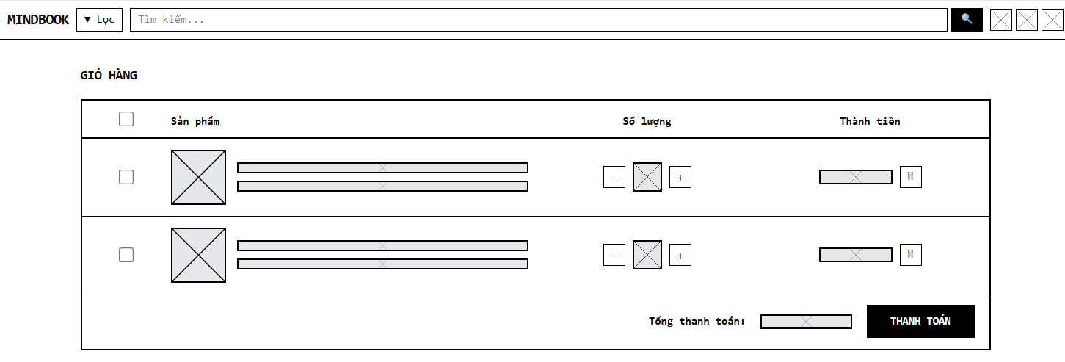

Field Name | Description
Select All Checkbox | Data type: Checkbox.  Action: Toggles the selection of all items currently in the shopping cart. When checked, the total amount updates to include all items.
Item Selection Checkbox | Data type: Checkbox (Per item).  Action: Selects or deselects an individual book for purchase. Only selected items are calculated into the final total and passed to the checkout stage.
Quantity Input | Data type: Number Input.  Initial data: The quantity previously added to the cart by the user.  Action: Users can manually type a number to change the desired quantity. Minimum value is 1.
Decrease Quantity (-) | Data type: Button.  Action: Decreases the item's quantity by 1. If the quantity is 1, the button may be disabled or trigger a removal confirmation.
Increase Quantity (+) | Data type: Button.  Action: Increases the item's quantity by 1. The subtotal and total amounts update dynamically.
Delete Item | Data type: Button (Trash bin icon).  Action: Prompts a browser confirmation alert ("Are you sure you want to delete this product?"). If confirmed, the item is removed from the cart and the total is recalculated.
Subtotal (Thành tiền) | Data type: Number (Currency format).  Status: Read-only. Automatically calculated as : Unit Price * Quantity for that specific item.
Thanh Toán (Checkout Button) | Data type: Button.  Status: Active only when at least one item is selected. Disabled if total is 0.  Action: Proceeds to the Checkout screen with the selected items.

11. Feature: Checkout Initiation

11.1 SubFeature:Checkout

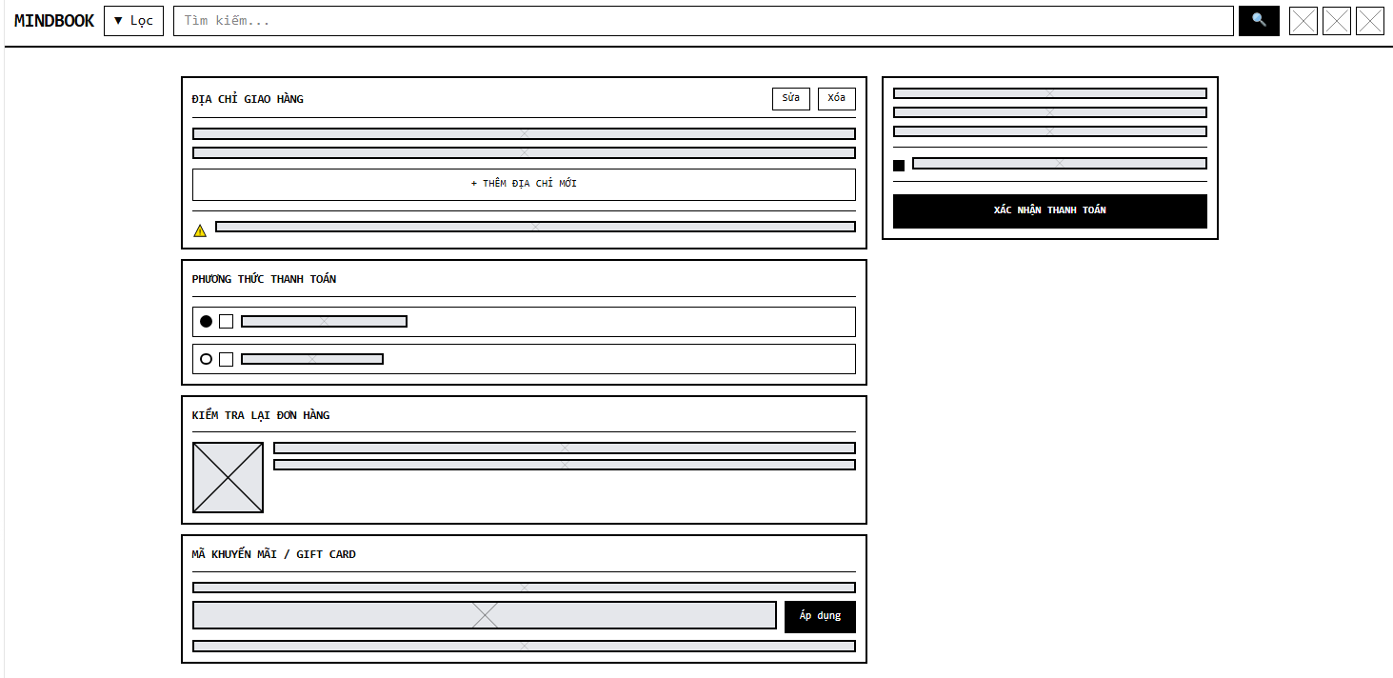

Field Name | Description
Select Address | Data type: Radio Button.  Action: Selects the delivery address from the user's saved list. Triggers the GHN API to calculate the shipping fee based on the selected address's district and ward.
Add New Address | Data type: Link / Button.  Action: Opens the Address Modal to input a new delivery address.
Full Name | Data type: Text Input.  Status: Required field. Contains validation to prevent numbers.
Phone Number | Data type: Text Input.  Status: Required field. Must be exactly 10 digits and start with '0'.
City / District / Ward | Data type: Dropdown List (Select).  Status: Required fields. The options are dynamically fetched and cascaded using the GHN API.
Address Detail | Data type: Text Input.  Status: Required field. Used for specific house numbers or street names.
Save Address | Data type: Button (Submit).  Action: Saves the new or modified address to the database and refreshes the checkout page.
Payment Options | Data type: Radio Button.  Initial data: Provides options for "COD" (Cash on Delivery) and "VNPAY". COD is selected by default.
Voucher Code Input | Data type: Text Input.  Status: Optional. Allows the user to manually type a discount code.
Apply | Data type: Button.  Action: Validates the entered code against the user's wallet and minimum order conditions. If valid, calculates the discount and updates the grand total.
Choose Voucher | Data type: Link.  Action: Opens a modal displaying all saved, eligible vouchers in the user's wallet for quick selection.
Subtotal (Thành tiền) | Data type: Number (Currency format).  Status: Read-only. The total price of the items.
Shipping Fee | Data type: Number (Currency format).  Status: Read-only. Dynamically calculated via GHN API based on the selected address.
Confirm Payment | Data type: Button (Submit).  Action: Submits the form. If COD is chosen, creates the order and redirects to the success page. If VNPAY is chosen, generates a payment URL and redirects the user to the VNPAY gateway.

12. Feature: Admin Processing & QC

12.1.1 Screen: Manage Returns Page (/admin/returns)
Provides a dashboard of customer return requests requiring administrative review.
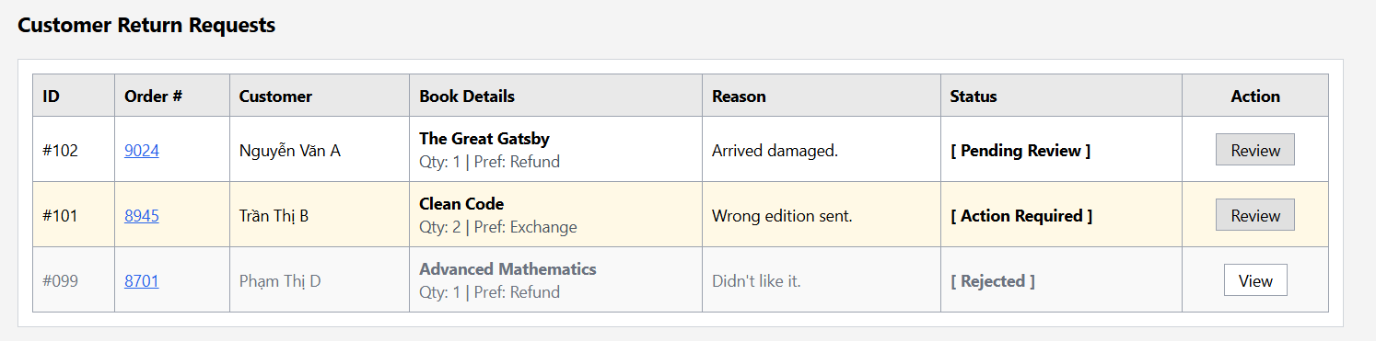

Field Name | Description
Request Grid | Type: Data Table  Description: Displays Return ID, associated Order # (hyperlinked), Customer Name, Book Details (Title, Qty, Refund Preference), and Customer's stated reason.
Status Badges | Type: UI Badges / Labels (<span>)  Description: Visual indicators mapping to processing stages (Pending Review, Action Required, Approved, Failed QC, Completed & Refunded).
Review Action | Type: UI Badges / Labels (<span>)  Description: Visual indicators mapping to processing stages (Pending Review, Action Required, Approved, Failed QC, Completed & Refunded).

12.1.2 Screen: Review Returns Processing Page (/admin/returns/review)
A dynamic decision-making form allowing Admins to approve, reject, ask for more info, or process financial refunds, coupled with automated asynchronous communications.
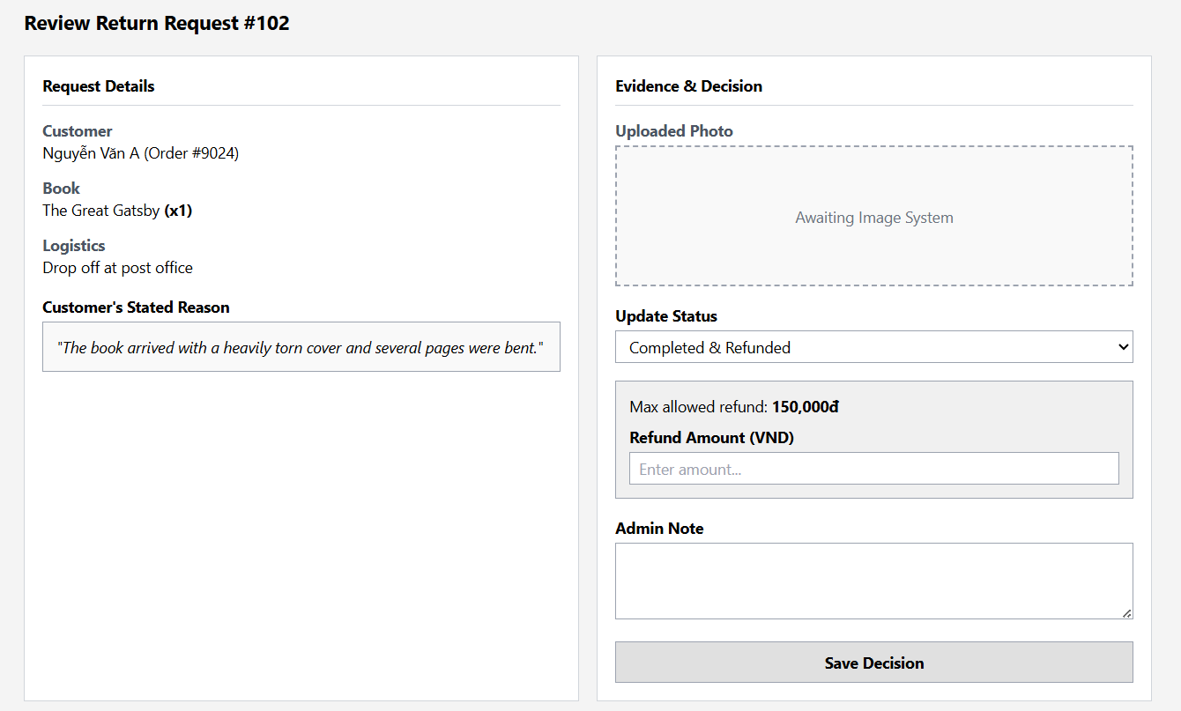

Field Name | Description
Read-Only Request Context | Type: Display Container (<div>)  Description: Displays requested logistics method, user banking details, and the customer's stated reason styled as a quote block.
Status Updater | Type: Dropdown (<select>)  Description: Captures the Admin's decision state (1 through 7).
Explicit Rejection Action | Type: Dropdown Option (<select>) & JavaScript Event  Description: Allows the Admin to outright deny a return request (e.g., "Rejected Upfront"). Selecting this status instantly enforces client-side and server-side validation on the Admin Note field.
Mandatory Reason Input (For Rejections & Action Required) | Type: Textarea (<textarea>)  Description: A text input box that becomes strictly required via JavaScript when "Rejected" or "Action Required" is selected. It captures the exact explanation (e.g., "Past return window", "Book damaged by user") to maintain transparency.
Dynamic Financial Controls | Type: Number Input & Text Input  Description: Unhidden via JS if a "Refunded" status is selected. Requires a "Refund Amount" (capped by server-calculated maxRefundableAmount) and a "Bank Transfer Reference Code".
Warehouse Quality Control (QC) Check | Type: Dropdown Options (<select>)  Description: Status toggles used after the physical book arrives at the warehouse. The Admin can select "Passed QC" (to proceed to the refund phase) or "Failed QC" (if the physical inspection reveals fraud or severe unapproved damage).
Asynchronous Email Triggers | Type: Background Java Thread (CompletableFuture.runAsync)  Description: Executes upon form submission. Dynamically selects HTML email templates and routes them to the customer's email without blocking the Admin's UI thread.

12.1.3 Component: Automated System Communications
This operates invisibly in the background to handle the automated email user story

Field Name | Description
Automated Rejection Mailer | Type: Background Java Thread (CompletableFuture.runAsync / JavaMail API)  Description: A system-level listener triggered specifically when a return request is saved with a "Rejected" or "Failed QC" status. It automatically injects the text from the Mandatory Reason Input into a formatted HTML email template and sends it to the customer's registered email address, closing the communication loop without manual support staff intervention.

12.4 SubFeature: Real-time Admin Notifications

12.4.1 Component: Notification System UI (admin-notification.jsp)
A global utility providing immediate, non-intrusive alerts to administrators regarding new platform events.
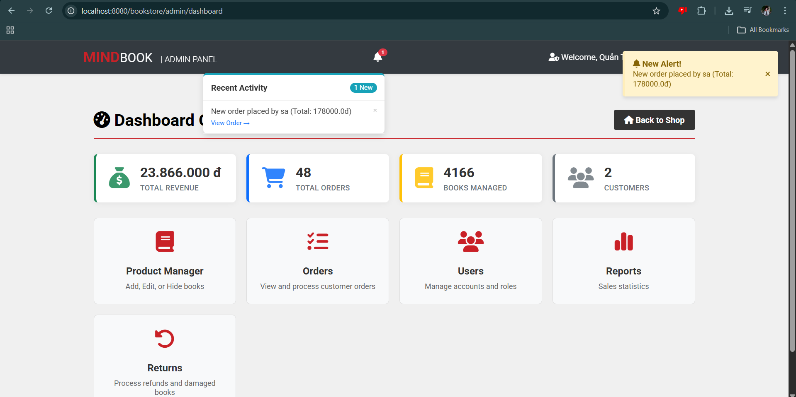

Field Name | Description
Polling Engine | Type: JavaScript Timer (setInterval / fetch())  Description: Executes a background HTTP request to /admin/api/notifications every 15 seconds.
Toast UI Renderer | Type: Dynamic DOM Element (Toast Notification)  Description: Constructs absolutely-positioned alert boxes overlaid on the DOM containing the alert message and an actionable link.
Dismissal Logic | Type: Button (<button>)  Description: Close button (&times;) triggering a POST request to mark the notification as read in the database, subsequently refreshing the local display.

13 Feature: F-point Management

13.1 SubFeature: F-point Dashboard
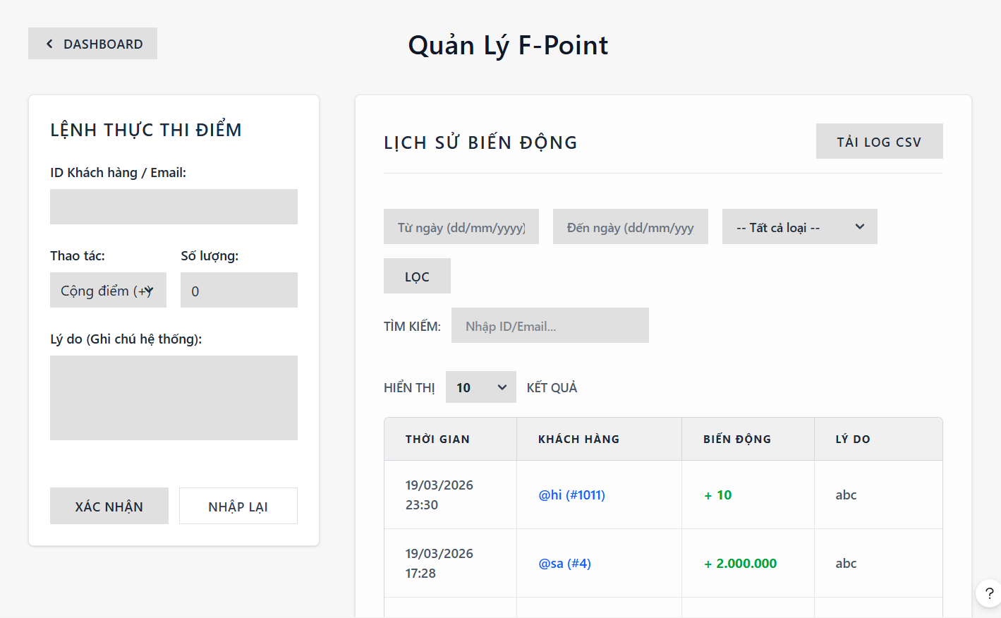
This function allows the Sale Staff to manually intervene and update the F-Point balance of a specific customer, as well as monitor the automated and manual transaction history.
Field Name | Description
Customer ID/Email Input | Type: Text Input  Placeholder: "Nhập ID hoặc Email..."  Action: Captures the customer identifier to perform the point transaction.
Action Type Dropdown | Type: Dropdown (<select>)  Values:  - add: Cộng điểm (+)  - sub: Trừ điểm (-)  Logic: Determines whether to increase or decrease the user's F-Point balance.
Amount Input | Type: Number Input  Placeholder: "0"  Logic: Must be greater than 0. Validates the point quantity to be executed.
Reason Textarea | Type: Textarea  Placeholder: "For example: Giving birthday points, compensating for mistakes..."  Action: Captures the mandatory reason for the transaction to be saved in the system log.
Execute Button | Type: Submit Button (<button type="submit">)  Action: Submits the form data to the StaffFPointServlet to update the database via FPointHistoryDAO.insertLog, then redirects to the dashboard with a success/error message.
Transaction History Table | Type: Container (Table)  Logic: Iterates over the historyLogs collection. Displays an empty state message if no history exists.
Fluctuation Column | Type: Label  Format: Displayed with currency/number formatting using <fmt:formatNumber>.  Style Logic:  - If action is "add": Displays "+" and uses Green color (text-success).  - If action is "sub": Displays "-" and uses Red color (text-danger).
Export CSV Button | Type: Hyperlink / Button  Action: Triggers a download of the filtered F-Point history as a CSV file (Lich_Su_FPoint.csv) with UTF-8 encoding.

14 Feature: Customer Management

14.1 SubFeature: Customer CRM Dashboard
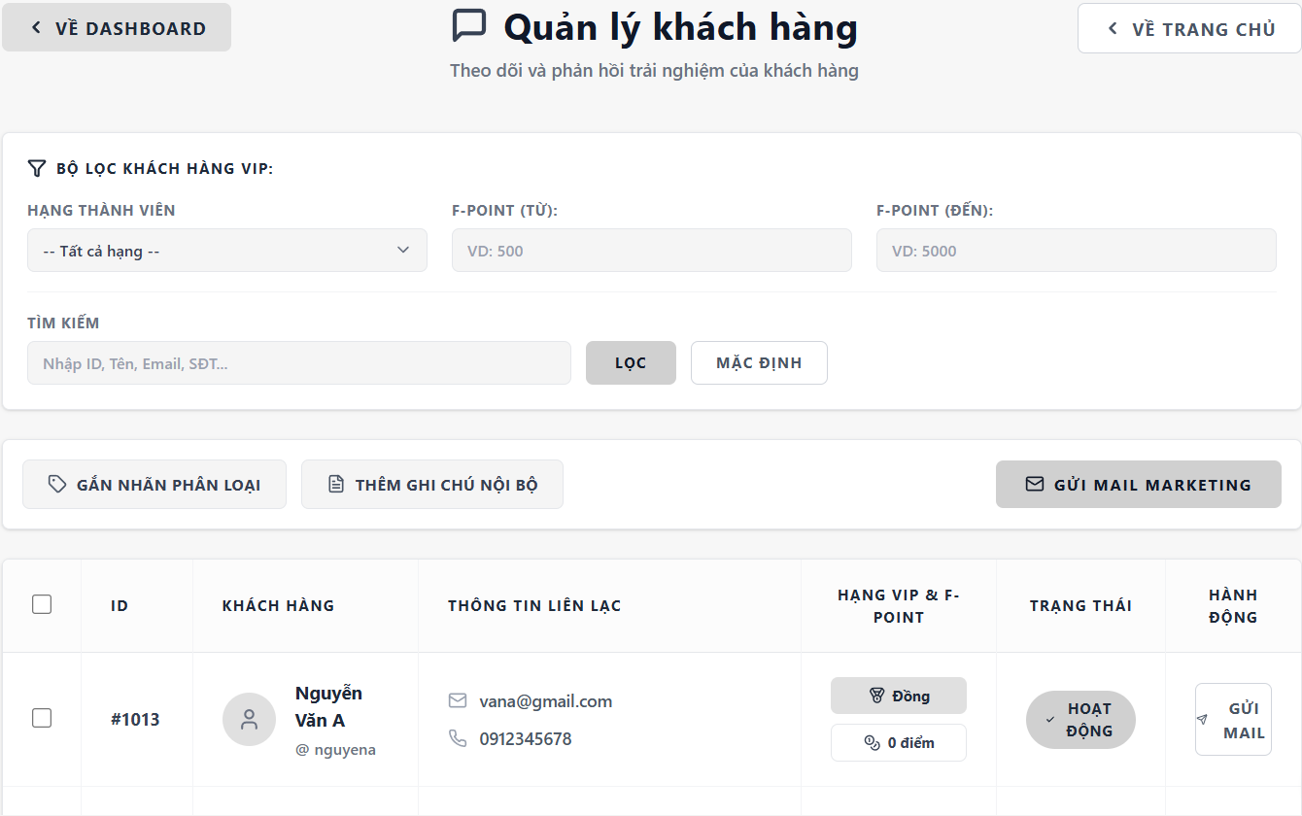

This screen provides a comprehensive list of all registered customers. It allows the Staff to filter users by VIP tiers, track spending, attach classification tags, and add internal notes.

Field Name | Description
Member Tier Dropdown | Type: Dropdown (<select>)  Values: Tất cả hạng, Diamond, Gold, Silver, Bronze.  Action:Filters the customer list based on their dynamically calculated total order spend.
Search Input | Type: Text Input  Placeholder: "Nhập ID, Tên, Email, SĐT..."  Action: Submits search query to filter customers by keyword.
Filter Button | Type: Submit Button  Action: Reloads the page with the applied filters (member tier, spend range, keyword).
Add Internal Note Button | Type: Button  Action: Opens a modal allowing staff to input internal care notes (Channel, Content, Follow-up date) for the selected customers, submitting to StaffCustomerNoteServlet.
Attach Tag Button | Type: Button  Action: Opens a modal to attach classification labels (e.g., VIP, Spammer) to selected customers, submitting to StaffCustomerTagServlet.
Send Marketing Mail Button | Type: Button  Action: Redirects to the email marketing module with the currently customer list.

14.2 SubFeature: Customer Inspection
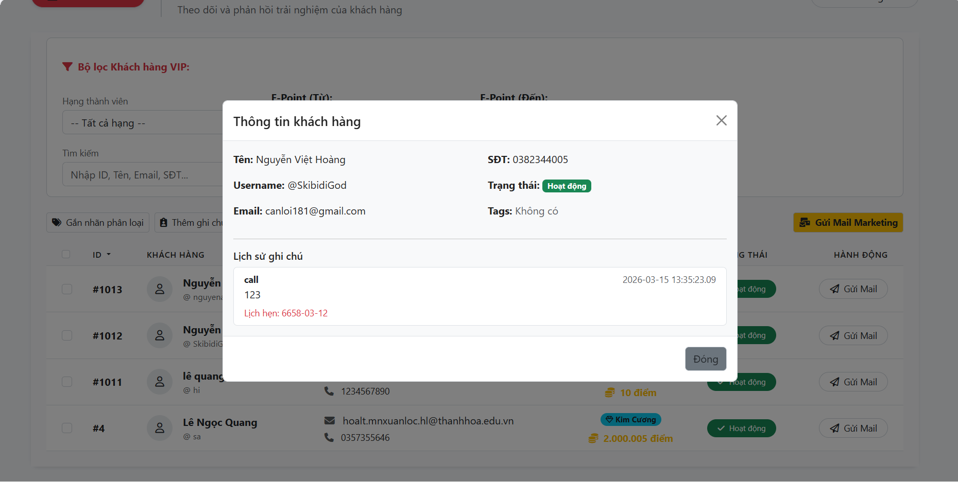
This function provides an in-depth view of a specific customer's profile, contact information, and their entire interaction history with the staff.

Field Name | Description
Back Button (Quay lại Dashboard) | Type: Hyperlink (<a>)  Action: Redirects back to the previous page (staff-dashboard.jsp).
Customer Info Container | Type: Card Container  Content: Displays static data including Full Name, Username, Phone, Email, and current Status.
Internal Notes Timeline | Type: Container (List)  Logic: Iterates over the notes collection passed from the controller.
Note Item Content | Type: Text Label  Content: The note content, the creation date, and the follow-up date.
15 Feature: Review Management
15.1 SubFeature: Feedback Moderation
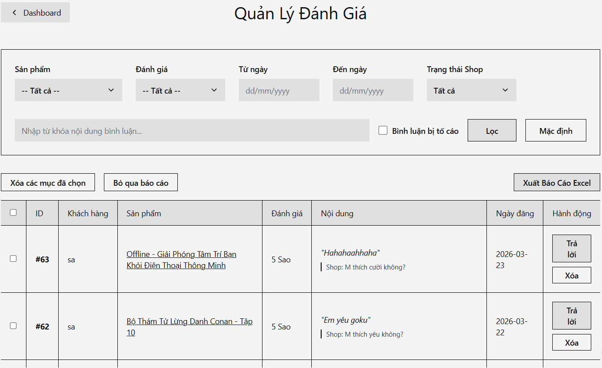

Field Name | Description
Rating Filter | Type: Dropdown (<select>)  Values: All stars, 1 Star to 5 Stars.  Action: Filters the reviews displayed in the table by the rating score.
Keyword Search | Type: Text Input  Placeholder: "Nhập từ khóa nội dung bình luận cần tìm..."  Action: Filters the reviews based on the text content.
Reported Reviews Switch | Type: Switch Checkbox (<input type="checkbox">).  Action: Triggers an onchange form submission to filter the table, displaying only reviews that have pending user reports, sorted by report count.
Review Table | Type: Container (Table)  Content: Displays the Review ID, Customer Name, Book Title, Rating (displayed as gold star icons), Comment Content, and Date. Reviews with active reports will prominently display a Red Badge showing the total report count.
Reply Button | Type: Button  Action: Opens the replyModal to submit a staff response. Upon successful submission via StaffReviewServlet, it updates the database and triggers a system notification to the customer.
Delete Button | Type: Button  Action: Collects selected review checkboxes and permanently deletes the inappropriate reviews from the database (including their associated reports).
Ignore Reports Button | Type: Button  Action: Collects selected review checkboxes and updates their report status to 'Resolved', effectively dismissing the reports and removing the red warning badges from the UI.
Export Excel Button | Type: Button  Action: Executes a JavaScript function (exportToExcel()) that clones the current HTML table, removes action/checkbox columns, replaces star icons with text, wraps the content in Microsoft Excel XML tags, encodes it to Base64, and forces an automatic .xls file download.

16 Feature: Complaint&Return Management
16.1 SubFeature: Feedback Moderation
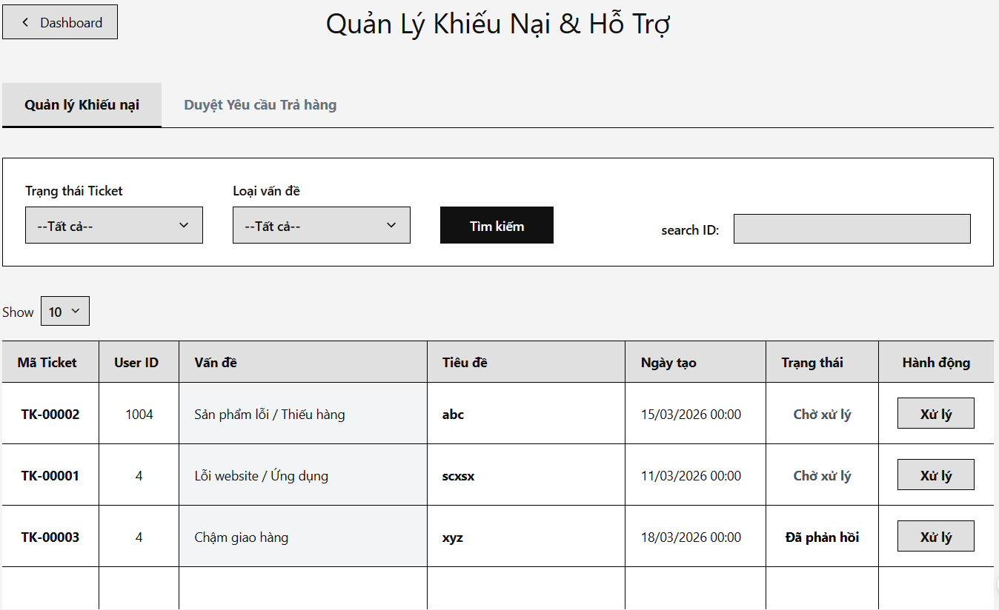

Field Name | Description
Back Button (Về Dashboard) | Type: Hyperlink (<a>)  Action: Redirects back to the staff dashboard /staff/dashboard.
Ticket Table | Type: Container (Table)  Logic: Iterates over the listTickets collection passed from the StaffTicketServlet. Displays an empty state message if no tickets exist in the system.
Ticket ID Column | Type: Label  Format: Displayed with a "TK-" prefix and zero-padded format using <fmt:formatNumber> (e.g., "TK-00007").
Status Badge | Type: Label (<span>)  Logic: Renders background color based on the value of ${ticket.status}:  - Pending: Yellow (bg-warning)  - Processing: Blue (bg-primary)  - Resolved: Green (bg-success)
Process Action Button (Xử lý / Trả lời) | Type: Button  Action: Opens a specific Modal popup (#replyModal${ticket.ticketId}) containing the customer's original message and uploaded images to handle the selected ticket.
Ticket Modal Form | Type: Form (<form>)  Logic: Contains hidden inputs for ticketId and userId. Sends data via POST method to /staff/tickets.
Status Update Dropdown | Type: Dropdown (<select>)  Values: Pending, Processing, Resolved.  Logic: Pre-selects the option matching the current ticket status from the database.
Staff Reply Textarea | Type: Textarea  Action: Captures the mandatory resolution instructions or response from the staff. Submitting this form updates the ticket and triggers an automated system notification to the customer's dashboard.

17. Feature: Promotion management
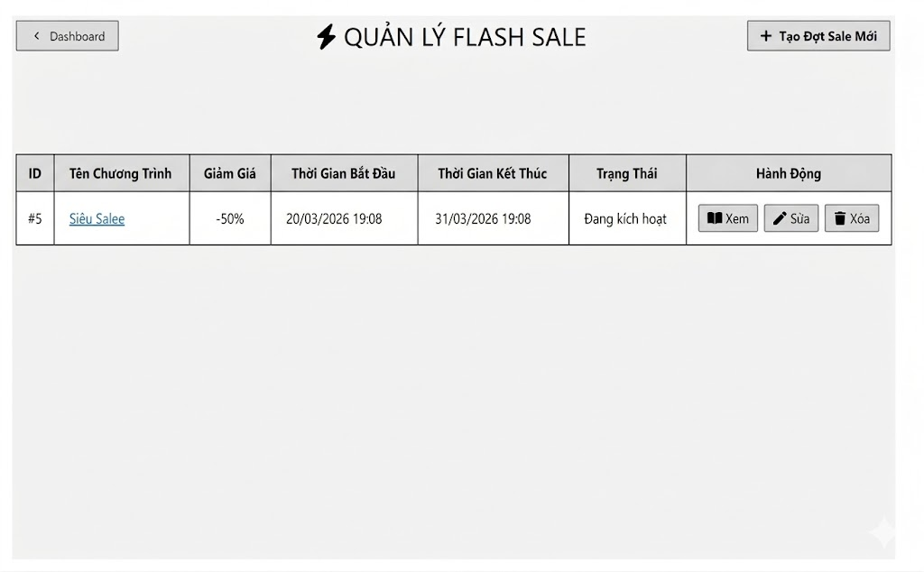
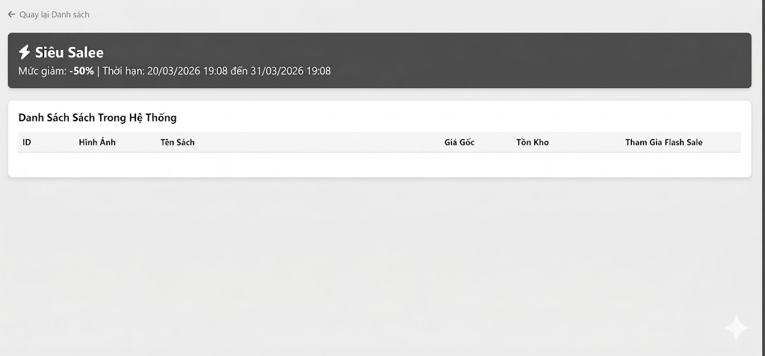
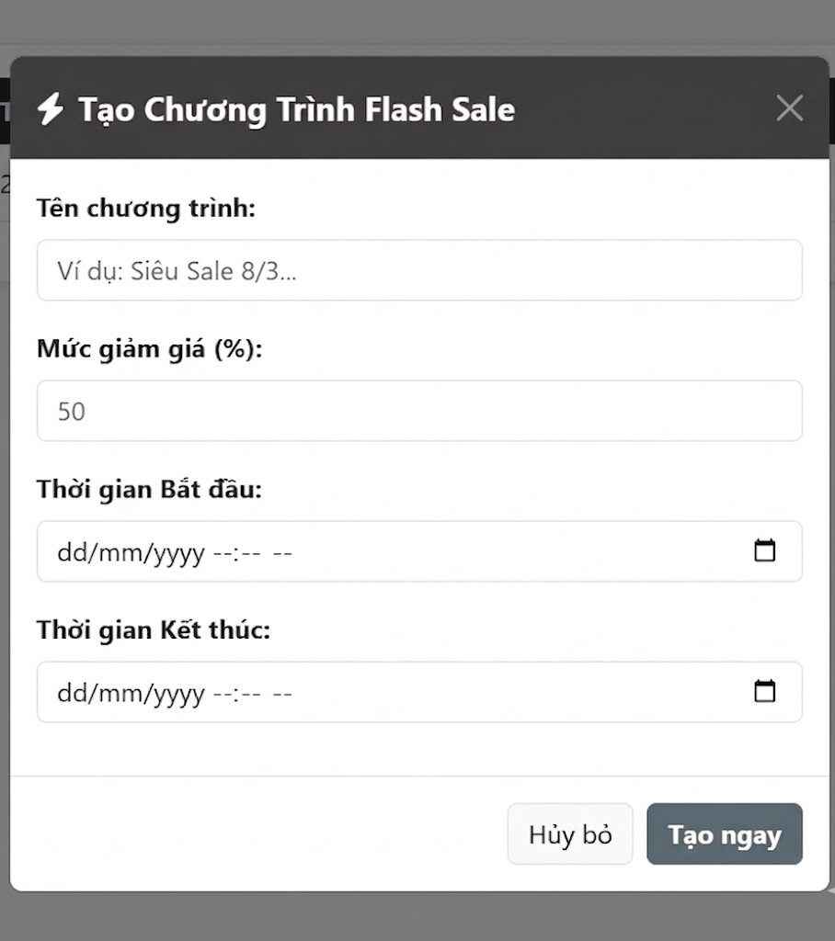
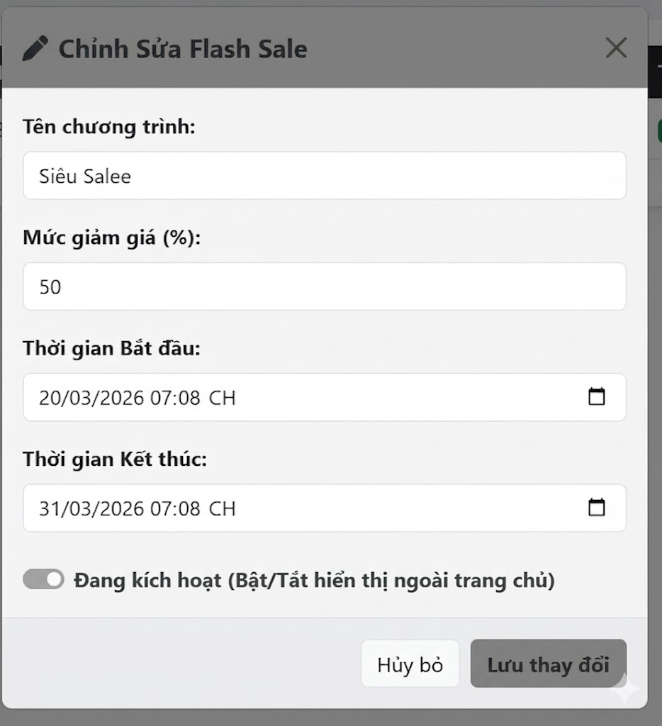

Field Name | Description
Program Name(Tên chương trình) | Type: Text InputAction: Allows the user to enter the name of the Flash Sale event (e.g., Siêu Sale 8/3, Siêu Salee...).
Discount Rate (%)(Mức giảm giá) | Type: Number InputLogic: Accepts numerical values. Represents the default discount percentage applied to the items in this Flash Sale.
Start / End Time(Thời gian Bắt đầu / Kết thúc) | Type: Date/Time PickerFormat: Displayed in dd/mm/yyyy --:-- -- format.Action: Opens a calendar popover for the user to select the starting and ending date/time of the program.
Active Status(Trạng thái kích hoạt) | - Type: Toggle SwitchLogic: A boolean toggle (True/False) that determines whether this Flash Sale is publicly visible on the homepage. (Note: Only available in the Edit Modal).
Cancel Button(Hủy bỏ) | Type: ButtonAction: Closes the current modal popup and discards any unsaved changes.
Submit Button(Tạo ngay / Lưu thay đổi) | Type: Submit ButtonAction: Submits the form data to the system to either create a new Sale event (Red button) or save updates to an existing one (Yellow button).
Sale Info Banner | Type: Container / LabelFormat: A prominent red banner displaying the Program Name, Discount Rate, and Time Limit.
Book List Table(Danh Sách Sách Trong Hệ Thống) | Type: Container (Table)Logic: Iterates over the list of books in the system. Displays columns for: ID, Image, Book Name, Original Price, and Stock.

III. System Design

1. Software Architecture

1.1 Overall Architectural Diagram
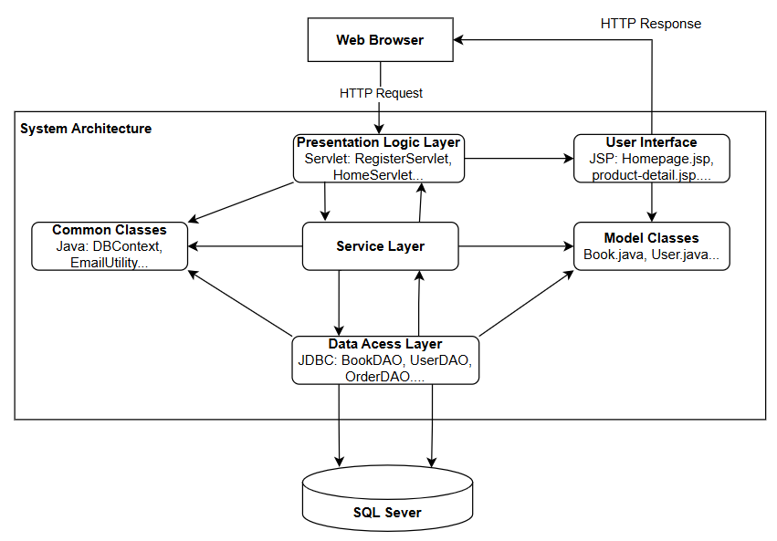

1.2 Component Descriptions
No | Component | Description
01 | Presentation Logic Layer | The Controller layer (represented by Servlets such as HomeServlet, RegisterServlet, etc.) is responsible for receiving requests from the browser, validating input data, calling the underlying processing layers, and directing the results to the appropriate display page.
02 | User Interface | The View class (represented by JSP files in the view directory) is responsible for receiving processed data from the Controller and rendering it into a complete web interface to send back to the Web Browser.
03 | Service Layer | This layer contains the system's complex business logic and rules. It handles calculations, condition checks, or calls to external services (such as sending OTP emails) before interacting with the database.
04 | Data Access Layer | The data retrieval layer (represented by DAO files such as BookDAO, UserDAO...) contains SQL statements and uses JDBC to interact directly with the database (add, edit, delete, retrieve data).
05 | Model Classes | Entity classes (represented by classes like Book, User, etc.) are Java objects (POJOs) that mimic the structure of tables in a database, acting as "containers" for transferring data between layers.
06 | Common Classes | Shared utility and configuration layers (represented by DBContext, EmailUtility, etc.) contain support code that is used repeatedly in many places in the system, making it easy to maintain and manage core configurations.
07 | Database | Database management system (SQL Server). A physical storage location for all system information (books, users, orders, etc.) in a secure and organized manner.
-

2. Code Package Design

2.1 Package Diagram
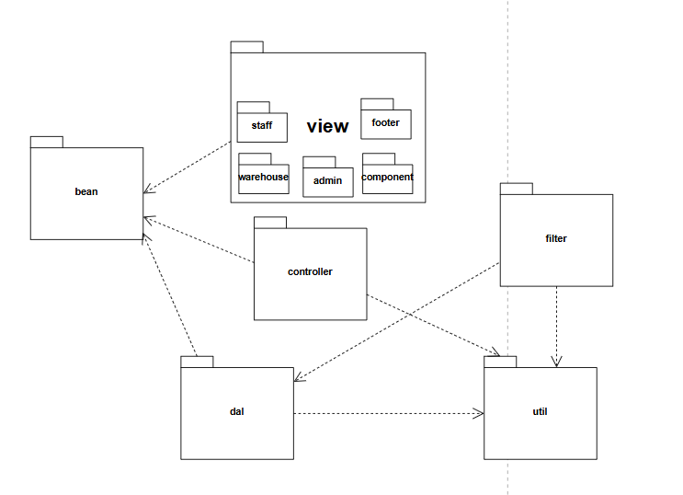

2.2 Package Descriptions
No | Package | Description
01 | View | Contains frontend files such as JSP, HTML, CSS, and JavaScript. It is responsible for rendering the user interface and displaying the data provided by the Model to the end-user.
02 | model | Contains entity classes (POJOs) that represent database tables (e.g., Book, User). These classes act as data containers to transfer information between the View, Controller, and DAL packages.
03 | controller | Contains Java Servlets that act as the middleman. It receives HTTP requests from the client, validates user input, invokes the DAL for data processing, and forwards the results to the appropriate View.
04 | util | Stands for Data Access Layer (replaces dao). Contains classes responsible for executing SQL queries (CRUD operations) and interacting directly with the database using JDBC.
05 | util | Contains common utility classes and configurations shared across the entire system, such as database connection management (DBContext) and email sending services (EmailUtility).
06 | filter | Contains Servlet Filters that intercept incoming requests before they reach the controller. It is typically used for pre-processing tasks such as user authentication (checking login sessions) or setting UTF-8 character encoding.

3. Database Design
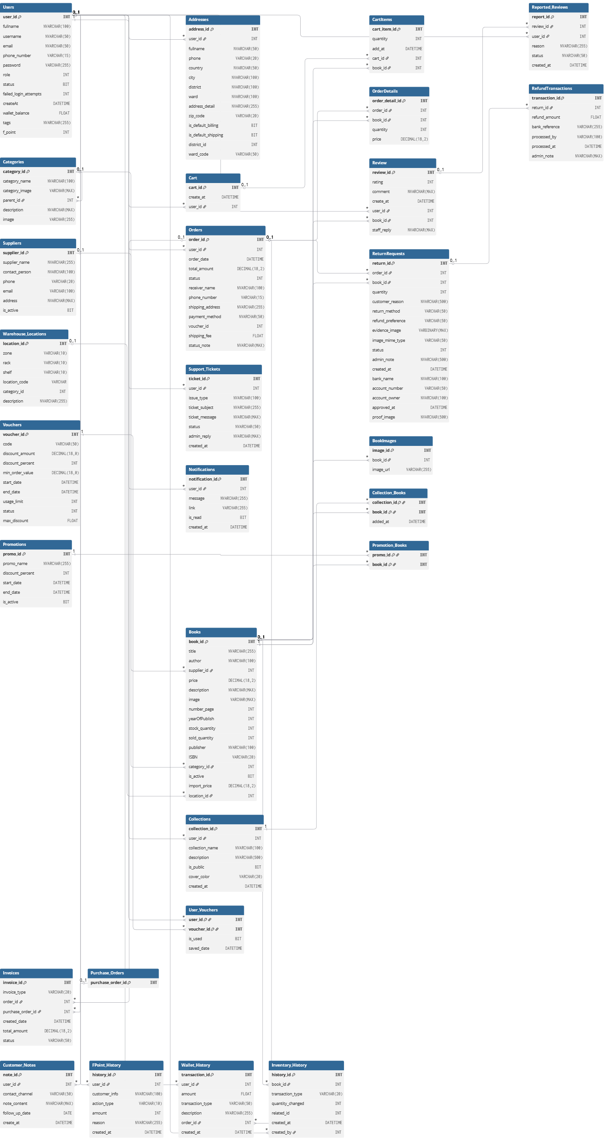

3.2 Table Descriptions

3.2.1 Users
* PK~Primary Key; FK~Foreign Key; UN~Unique; NN ~ not null
No | Field | PK | FK | UN | NN | Description
1 | user_id | X |  |  | IDENTITY(1,1) | Unique system ID for the user.
2 | fullname |  |  |  |  | User's full name (Vietnamese support).
3 | username |  |  |  |  | Login username.
4 | email |  |  |  |  | User's email (Unique constraint).
5 | phone_number |  |  |  |  | Contact phone number.
6 | password |  |  |  |  | Encrypted password string.
7 | role |  |  | X | 2 | 1=Admin, 2=Customer, 3=Sale, 4=Warehouse.
8 | status |  |  | X | 1 | 1=Active, 0=Locked/Inactive.
9 | failed_login_attempts |  |  | X | 0 | Security tracker for failed logins.
10 | wallet_balance |  |  | X | 0 | Current balance in the digital wallet.
11 | f_point |  |  | X | 0 | Loyalty/Reward points balance.
12 | tags |  |  | X |  | Metadata tags for customer segmentation.
13 | createAt |  |  | X | GETDATE() | Account registration timestamp.

3.2.2 Categories

No | Field | PK | FK | UN | NN | Description
1 | category_id | X |  |  | IDENTITY(1,1) | Unique identifier for the category.
2 | category_name |  |  |  |  | The display name (e.g., 'VĂN HỌC', 'Tiểu Thuyết').
3 | parent_id |  | X | X | NULL | Self-reference to category_id. NULL = Root category.
4 | category_image |  |  | X |  | The primary path for the category icon/banner.
5 | image |  |  | X |  | Added via ALTER: Secondary image path or specific thumbnail.
6 | description |  |  | X |  | Detailed explanation of the category's scope.

3.2.3 Books

No | Field | PK | FK | UN | NN | Description
1 | book_id | X |  |  | IDENTITY(1,1) | Unique identifier for the book.
2 | title |  |  |  |  | The title of the book.
3 | author |  |  | X |  | Author of the book.
4 | price |  |  |  |  | Selling price to customers.
5 | import_price |  |  | X | 0 | Internal cost price for profit analysis.
6 | stock_quantity |  |  | X | 0 | Current units available in the warehouse.
7 | sold_quantity |  |  | X | 0 | Total units sold across all orders.
8 | category_id |  | X | X |  | Links to Categories(category_id).
9 | supplier_id |  | X |  |  | Links to Suppliers(supplier_id).
10 | location_id |  | X | X |  | Links to Warehouse_Locations(location_id).
11 | is_active |  |  | X | 1 | 1=Available for sale, 0=Hidden/Inactive.
12 | ISBN |  |  | X |  | Unique International Standard Book Number.
13 | image |  |  | X |  | Primary cover image URL.
14 | description |  |  | X |  | Detailed summary or blurb.
15 | number_page |  |  | X |  | Total page count.
16 | yearOfPublish |  |  | X |  | Year the book was released.
17 | publisher |  |  | X |  | Publishing house name.

3.2.4 Addresses

No | Field | PK | FK | UN | NN | Description
1 | address_id | X |  |  | X | Unique identifier for the address (Auto-increment).
2 | user_id |  | X |  | X | Foreign Key linking to Users(user_id).
3 | fullname |  |  |  | X | Recipient's name (supports gifting to others).
4 | phone |  |  |  | X | Recipient's contact phone number.
5 | country |  |  |  |  | Country of the recipient.
6 | city |  |  |  | X | Province or City.
7 | district |  |  |  | X | District or Town.
8 | ward |  |  |  | X | Ward or Commune.
9 | address_detail |  |  |  | X | Specific address (House number, street name, etc.).
10 | zip_code |  |  |  |  | Postal/Zip code.
11 | is_default_billing |  |  |  |  | Flag for the default billing address (1 = True).
12 | is_default_shipping |  |  |  |  | Flag for the default shipping address (1 = True).

3.2.5. BookImages

No | Field | PK | FK | UN | NN | Description
1 | image_id | X |  |  | X | Sub-image code (Auto-increment Identity 1,1)
2 | book_id |  | X |  | X | Book code (ON DELETE CASCADE - Automatically delete images if the book is deleted)
3 | image_url |  |  |  | X | Path to store the book's sub-image

3.2.6. Cart

No | Field | PK | FK | UN | NN | Description
1 | cart_id | X |  |  | X | Cart code (Auto-increment Identity 1,1)
2 | create_at |  |  |  |  | Cart creation time (Default: GETDATE())
3 | user_id |  | X |  |  | User ID

3.2.7. CartItems

No | Field | PK | FK | UN | NN | Description
1 | cart_item_id | X |  |  | X | Unique identifier for the cart item (Auto-increment).
2 | quantity |  |  |  |  | The number of copies added to the cart.
3 | add_at |  |  |  |  | Timestamp of when the item was added to the cart.
4 | cart_id |  | X |  |  | Links to Cart(cart_id). Includes ON DELETE CASCADE.
5 | book_id |  | X |  |  | Links to Books(book_id).

3.2.8 Review

No | Field | PK | FK | UN | NN | Description
1 | review_id | X |  |  | X | Unique identifier for the review (Auto-increment).
2 | rating |  |  |  |  | Rating score (CHECK constraint: 1 to 5).
3 | comment |  |  |  |  | Review content or customer feedback.
4 | create_at |  |  |  |  | Timestamp of when the review was created.
5 | user_id |  | X |  |  | ID of the user who wrote the review.
6 | book_id |  | X |  |  | ID of the book being reviewed.
7 | staff_reply |  |  |  |  | Response/Feedback from the Staff or Admin.

3.2.9 Orders

No | Field | PK | FK | UN | NN | Description
1 | order_id | X |  |  | X | Unique Order ID (Auto-incrementing).
2 | user_id |  | X |  | X | ID of the user who placed the order.
3 | order_date |  |  |  |  | Timestamp of when the order was placed.
4 | total_amount |  |  |  | X | Total value of the order.
5 | status |  |  |  |  | Status (1: Pending, 2: Shipping, 3: Completed, 0: Cancelled).
6 | receiver_name |  |  |  |  | Full name of the recipient.
7 | phone_number |  |  |  |  | Recipient's contact phone number.
8 | shipping_address |  |  |  |  | Detailed delivery address.
9 | payment_method |  |  |  |  | Payment method (e.g., COD, VNPay, Wallet).
10 | voucher_id |  | X |  |  | Applied discount code (if any).
11 | status_note |  |  |  |  | Internal notes or reason for status change (e.g., Cancellation reason).
12 | shipping_fee |  |  |  |  | The cost of delivery for this order.

3.2.10. OrderDetails

No | Field | PK | FK | UN | NN | Description
1 | order_detail_id | X |  |  | IDENTITY(1,1) | Unique identifier for the order detail line.
2 | order_id |  | X |  |  | Links to Orders(order_id).
3 | book_id |  | X |  |  | Links to Books(book_id).
4 | quantity |  |  |  |  | Number of units purchased for this specific book.
5 | price |  |  |  |  | The unit price of the book at the exact time of purchase.

3.2.11 Vouchers

No | Field | PK | FK | UN | NN | Description
1 | voucher_id | X |  |  | X | Voucher ID (Auto-increment Identity 1,1)
2 | code |  |  | X | X | Voucher code (e.g., FREESHIP, SALE20). Must be unique
3 | discount_amount |  |  |  |  | Fixed discount amount
4 | discount_percent |  |  |  |  | Discount percentage (e.g., 10 for 10%)
5 | min_order_value |  |  |  |  | Minimum order value required to apply the voucher (Default: 0)
6 | start_date |  |  |  | X | Start date of voucher validity
7 | end_date |  |  |  | X | Expiration date of the voucher
8 | usage_limit |  |  |  |  | Maximum total usages allowed across the system (Default: 100)
9 | status |  |  |  |  | Voucher status (Default 1: 1 for Active, 0 for Inactive)
10 | max_discount |  |  |  |  | Maximum discount amount allowed (used when applying discount_percent)

3.2.12 User_Vouchers
No | Field | PK | FK | UN | NN | Description
1 | user_id | X | X |  | X | User ID (ON DELETE CASCADE)
2 | voucher_id | X | X |  | X | Voucher ID (ON DELETE CASCADE)
3 | is_used |  |  |  |  | Status showing if the voucher has been used (0: Not used, 1: Used) - Default: 0
4 | saved_date |  |  |  |  | The exact time the user saved the voucher to their wallet - Default: GETDATE()

3.2.13. Warehouse_Locations

No | Field | PK | FK | UN | NN | Description
1 | location_id | X |  |  | X | Warehouse location ID (Auto-increment Identity 1,1)
2 | zone |  |  |  | X | Warehouse zone (e.g., A, B, C)
3 | rack |  |  |  | X | Rack number within the zone
4 | shelf |  |  |  | X | Shelf number on the rack
5 | location_code |  |  | X |  | Computed column (zone-rack-shelf). Persisted and Unique
6 | category_id |  | X |  |  | ID of the book category placed in this location
7 | description |  |  |  |  | Detailed description of the storage location

3.2.14. Suppliers

No | Field | PK | FK | UN | NN | Description
1 | supplier_id | X |  |  | X | Supplier ID (Auto-increment Identity 1,1)
2 | supplier_name |  |  |  | X | Name of the supplier, publisher, or distributor
3 | contact_person |  |  |  |  | Full name of the main contact person
4 | phone |  |  |  |  | Contact phone number of the supplier
5 | email |  |  |  |  | Contact email address
6 | address |  |  |  |  | Physical address of the supplier's office or warehouse
7 | is_active |  |  |  |  | Status indicating if the supplier is currently active or cooperating (Default: 1)

3.2.15. ReturnRequests

No | Field | PK | FK | UN | NN | Description
1 | return_id | X |  |  | X | Return request ID (Auto-increment Identity 1,1)
2 | order_id |  | X |  | X | ID of the order containing the returned book
3 | book_id |  | X |  | X | ID of the specific book being returned
4 | quantity |  |  |  | X | Quantity of the book being returned
5 | customer_reason |  |  |  | X | Reason for return provided by the customer
6 | return_method |  |  |  | X | Chosen method to return the item (e.g., pickup, drop_off)
7 | refund_preference |  |  |  | X | Chosen refund method (e.g., bank_transfer, refund_wallet)
8 | evidence_image |  |  |  |  | Image evidence of the issue uploaded by the customer (stored as binary data)
9 | image_mime_type |  |  |  |  | The MIME type of the uploaded evidence image (e.g., image/jpeg, image/png)
10 | status |  |  |  |  | Status of the return request (Default: 1)
11 | admin_note |  |  |  |  | Additional notes left by the Admin processing the request
12 | created_at |  |  |  |  | The exact date and time the request was created (Default: GETDATE())
13 | bank_name |  |  |  |  | Customer's bank name (if bank transfer is selected)
14 | account_number |  |  |  |  | Customer's bank account number
15 | account_owner |  |  |  |  | Full name of the bank account owner
16 | approved_at |  |  |  |  | Date and time when the Admin approved the return request
17 | proof_image |  |  |  |  | URL/Path to store the proof image (Likely added to replace or supplement evidence_image)

3.2.16. Collections

No | Field | PK | FK | UN | NN | Description
1 | collection_id | X |  |  | X | Collection ID (Auto-increment Identity 1,1)
2 | user_id |  | X |  | X | ID of the user who owns this collection (ON DELETE CASCADE)
3 | collection_name |  |  |  | X | Name of the collection
4 | description |  |  |  |  | Detailed description of the collection
5 | is_public |  |  |  |  | Visibility status (1: Public, 0: Private) - Default: 1
6 | cover_color |  |  |  |  | Representative cover color stored as a Hex code - Default: '#C92127'
7 | created_at |  |  |  |  | Date and time the collection was created - Default: GETDATE()

3.2.17. Collection_Books

No | Field | PK | FK | UN | NN | Description
1 | collection_id | X | X |  | X | ID of the collection (ON DELETE CASCADE)
2 | book_id | X | X |  | X | ID of the book added to the collection (ON DELETE CASCADE)
3 | added_at |  |  |  |  | Date and time when the book was added to the collection (Default: GETDATE())

3.2.18. Reported_Reviews

No | Field | PK | FK | UN | NN | Description
1 | report_id | X |  |  | X | Report ID (Auto-increment Identity 1,1)
2 | review_id |  | X |  |  | ID of the review being reported
3 | user_id |  | X |  |  | ID of the user who submitted the report
4 | reason |  |  |  |  | Reason for reporting (e.g., spam, inappropriate language)
5 | status |  |  |  |  | Status of the report (Default: 'Pending')
6 | created_at |  |  |  |  | Date and time the report was created (Default: GETDATE())

3.2.19. Support_Tickets

No | Field | PK | FK | UN | NN | Description
1 | ticket_id | X |  |  | IDENTITY(1,1) | Unique identifier for each support ticket.
2 | user_id |  | X | X |  | Reference to the user who created the ticket (Users table).
3 | issue_type |  |  |  |  | Category of the issue (e.g., Web Error, Damaged Item, Q&A).
4 | ticket_subject |  |  |  |  | Brief summary or title of the user's problem.
5 | ticket_message |  |  |  |  | Detailed description of the issue provided by the user.
6 | status |  |  | X | Pending' | Current state: 'Pending', 'Replied', or 'Closed'.
7 | admin_reply |  |  | X |  | Response or solution provided by the administrator.
8 | created_at |  |  | X | GETDATE() | Timestamp when the ticket was first submitted.

3.2.23. Notifications

No | Field | PK | FK | UN | NN | Description
1 | notification_id | X |  |  | IDENTITY(1,1) | Unique identifier for the notification.
2 | user_id |  | X | X |  | Foreign Key linking to Users(user_id). The recipient of the alert.
3 | message |  |  |  |  | The alert text (e.g., "User A mentioned you..."). Supports Vietnamese.
4 | link |  |  |  |  | The URL or internal path leading directly to the interaction.
5 | is_read |  |  | X | 0 | Flag to track status (0: Unread, 1: Read).
6 | created_at |  |  | X | GETDATE() | Timestamp of when the notification was triggered.

3.2.24. RefundTransactions

No | Field | PK | FK | UN | NN | Description
1 | transaction_id | X |  |  | IDENTITY(1,1) | Unique ID for the refund transaction.
2 | return_id |  | X |  |  | Links to ReturnRequests(return_id).
3 | refund_amount |  |  |  |  | The specific amount of money refunded.
4 | bank_reference |  |  | X |  | Bank transfer code or external reference ID.
5 | processed_by |  |  | X |  | Username of the Admin who authorized the refund.
6 | processed_at |  |  | X | GETDATE() | Timestamp of when the refund was executed.
7 | admin_note |  |  | X |  | Internal comments or justification for the refund.

3.2.25. Customer_Notes

No | Field | PK | FK | UN | NN | Description
1 | note_id | X |  |  | IDENTITY(1,1) | Unique identifier for the specific note.
2 | user_id |  | X |  |  | Links to Users(user_id). Includes ON DELETE CASCADE.
3 | contact_channel |  |  | X |  | Method of contact (e.g., 'call', 'email', 'zalo').
4 | note_content |  |  |  |  | Detailed content of the interaction/note.
5 | follow_up_date |  |  | X |  | Scheduled date for the next contact attempt.
6 | create_at |  |  | X | GETDATE() | Timestamp of when the note was created.

3.2.26. FPoint_History

No | Field | PK | FK | UN | NN | Description
1 | history_id | X |  | No | IDENTITY(1,1) | Unique identifier for each point transaction.
2 | user_id |  | X | X |  | Foreign Key linking to Users(user_id).
3 | customer_info |  |  | X |  | Supplementary field for customer details/name.
4 | action_type |  |  | X |  | Type of point movement (e.g., 'EARN', 'SPEND').
5 | amount |  |  | X |  | The number of points added or subtracted.
6 | reason |  |  | X |  | Description of why points were adjusted (e.g., 'Order #101').
7 | created_at |  |  | X | GETDATE() | Timestamp when the point transaction occurred.

3.2.27. Wallet_History

No | Field | PK | FK | UN | NN | Description
1 | transaction_id | X |  |  | IDENTITY(1,1) | Unique ID for each wallet transaction.
2 | user_id |  | X |  |  | Links to Users(user_id). The owner of the wallet.
3 | amount |  |  |  |  | The change in balance (Positive for deposits/refunds, Negative for payments).
4 | transaction_type |  |  |  |  | Category of transaction (e.g., 'REFUND', 'PAYMENT').
5 | description |  |  |  |  | Detailed explanation (e.g., 'Refund for order #123'). Supports Vietnamese.
6 | order_id |  | X | X |  | Links to Orders(order_id) to track the source of the transaction.
7 | created_at |  |  | X | GETDATE() | The exact date and time the transaction was recorded.

3.2.28. Invoices

No | Field | PK | FK | UN | NN | Description
1 | invoice_id | X |  |  | IDENTITY(1,1) | Unique serial number for the invoice.
2 | invoice_type |  |  |  |  | Type of invoice: 'SALE' or 'PURCHASE'.
3 | order_id |  | X | X |  | Links to Orders(order_id). Required if type is 'SALE'.
4 | purchase_order_id |  | X | X |  | Links to Purchase_Orders. Required if type is 'PURCHASE'.
5 | created_date |  |  |  | GETDATE() | The date the invoice was generated.
6 | total_amount |  |  |  |  | Total monetary value of the transaction.
7 | status |  |  |  | COMPLETED' | Current state (e.g., COMPLETED, CANCELLED).

3.2.29. Inventory_History

No | Field | PK | FK | UN | NN | Description
1 | history_id | X |  |  | IDENTITY(1,1) | Unique tracking ID for each stock movement.
2 | book_id |  | X |  |  | Links to Books(book_id).
3 | transaction_type |  |  |  |  | Movement type: 'IMPORT', 'EXPORT', or 'RETURN'.
4 | quantity_changed |  |  |  |  | The delta value (+ for increase, - for decrease).
5 | related_id |  |  | X |  | ID of the source document (Purchase_Order or Order).
6 | created_at |  |  |  | GETDATE() | The timestamp of the warehouse operation.
7 | created_by |  | X | X |  | Links to Users(user_id). Identifies the warehouse staff.

3.2.29. Promotions

No | Field | PK | FK | UN | NN | Description
1 | promo_id | X |  |  | IDENTITY(1,1) | ID duy nhất cho mỗi chương trình khuyến mãi.
2 | promo_name |  |  |  | X | Tên chương trình (VD: Flash Sale Nửa Đêm).
3 | discount_percent |  |  |  | X | Phần trăm giảm giá (VD: 50).
4 | start_date |  |  |  | X | Thời gian ngày bắt đầu chương trình.
5 | end_date |  |  |  | X | Thời gian ngày kết thúc chương trình.
6 | is_active |  |  |  | DEFAULT 1 | Trạng thái: Kích hoạt / Tắt ngang.

3.2.30. Promotion_Books

No | Field | PK | FK | UN | NN | Description
1 | promo_id | X | X |  |  | Liên kết đến bảng Promotions(promo_id).
2 | book_id | X | X |  |  | Liên kết đến bảng Books(book_id).

4.Sequence Diagram

4.1 For User Login
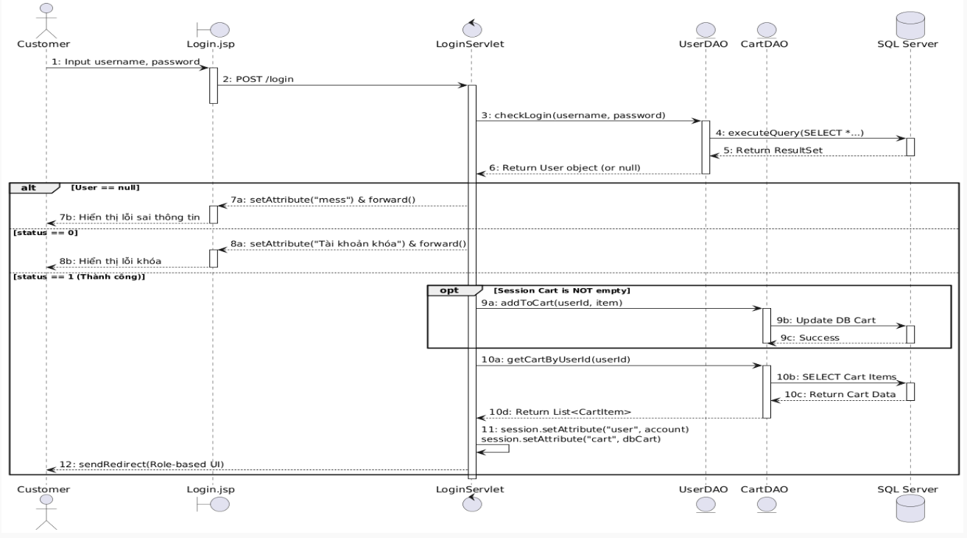

Link github: https://github.com/ngocquang339/BookStore

