Agentic RCA Solution for Databricks Pipelines
Intelligent Root Cause Analysis for Data Pipeline Anomalies
―――――――――――――――――――――――――

🎯 Summary
The Challenge: When Databricks ETL pipelines drop rows unexpectedly, finding the root cause is time-consuming and requires deep technical expertise. Data teams spend hours manually investigating SQL logs, Delta history, and code changes.
Our Solution: An AI-powered system that automatically detects data anomalies and provides intelligent root cause analysis with actionable recommendations — reducing investigation time from hours to minutes.
Business Impact:
- 90% faster anomaly resolution
- Proactive detection before business impact
- Automated explanations in plain English
- Zero pipeline modifications required
―――――――――――――――――――――――――

🏗️ Solution Architecture

Two-Phase Intelligent Design
Phase 1: Continuous Monitoring
- Pipeline Runs
- Smart Collector
- Unity Catalog Lineage
- Delta Transaction Logs
- Execution Metrics
- Historical Database
Phase 2: AI Investigation
- Anomaly Detected
- Context Builder
- AI Detective Agent
- Root Cause Report

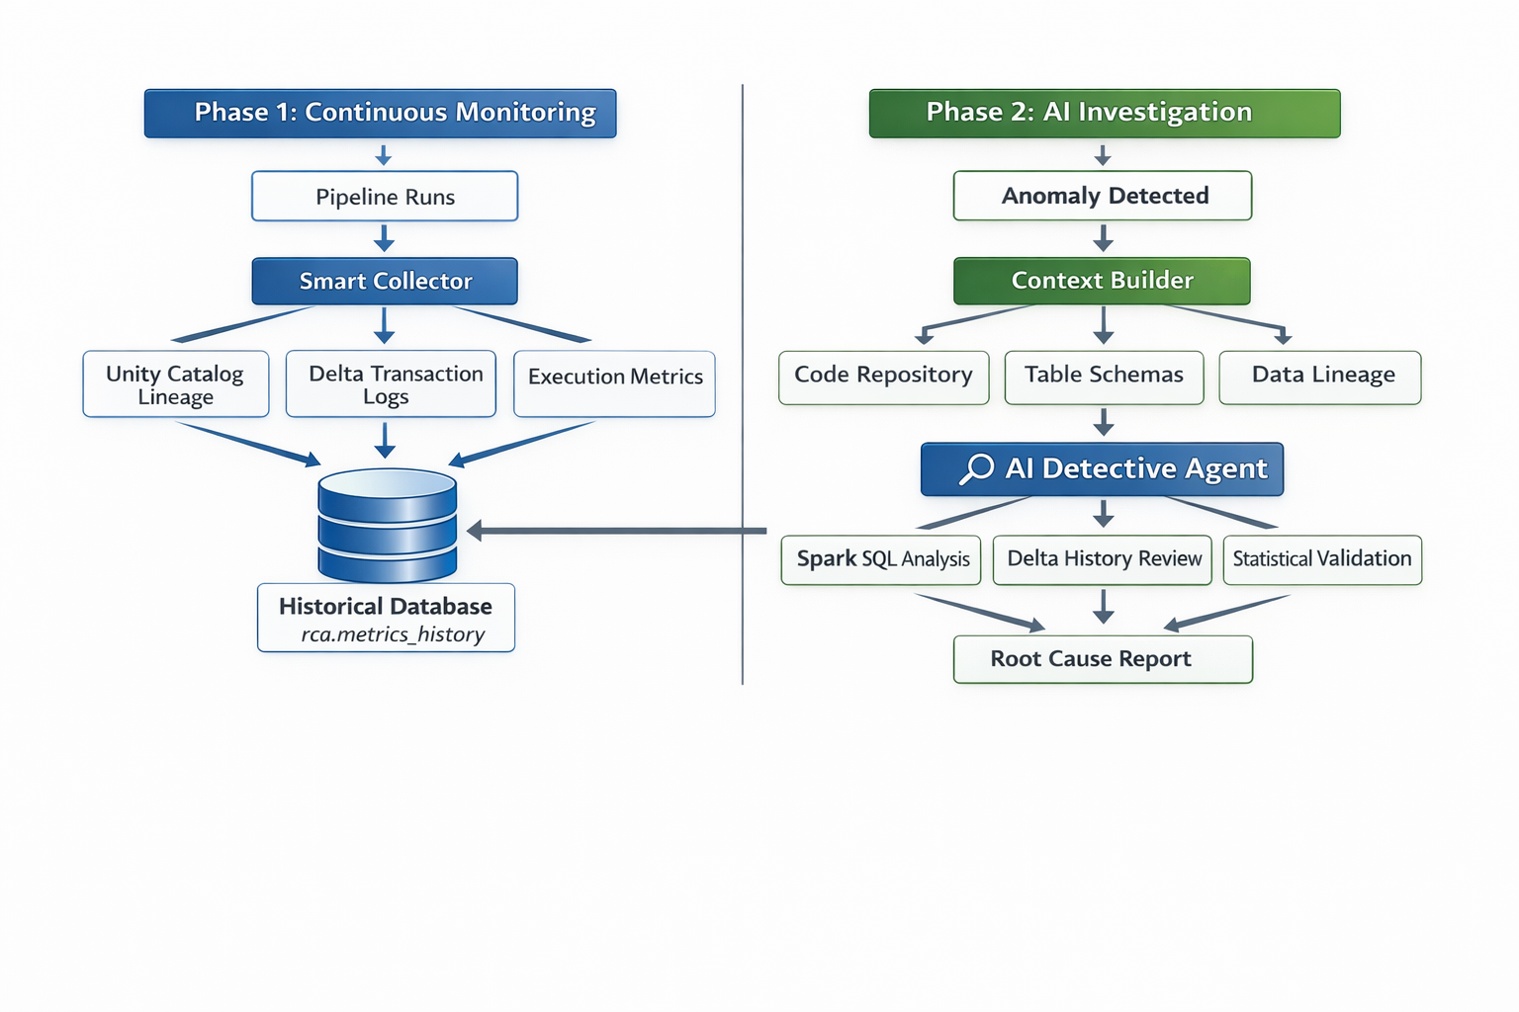

Key Components
Component | Purpose | Technology
Smart Collector | Captures pipeline execution data automatically | Databricks APIs, Delta Logs
Anomaly Engine | Detects unusual patterns using statistical analysis | Z-Score, Historical Baselines
AI Detective | Investigates root causes using evidence-based reasoning | LLM, Spark SQL
Context Builder | Assembles complete execution picture | Unity Catalog, Git Integration
―――――――――――――――――――――――――

🔍 How It Works

1. Automatic Detection
- Continuous monitoring of all pipeline runs
- Statistical analysis comparing current vs historical patterns
- Smart alerts only for genuine anomalies

2. Intelligent Investigation
When an anomaly is detected, our AI agent:
- Analyzes the code that caused the issue
- Queries the data to validate hypotheses
- Checks table schemas for structural changes
- Reviews Delta history for unexpected operations

3. Actionable Results
- Root cause summary in business terms
- Technical evidence with data points
- Specific recommendations for fixes
- Impact assessment and urgency level
―――――――――――――――――――――――――

🛠️ Technical Specifications

Databricks-Native Integration
- Unity Catalog for automatic lineage discovery
- Delta Lake transaction logs for precise metrics
- Jobs API for execution context
- Spark SQL for data validation

AI-Powered Analysis
- LLM model for intelligent reasoning
- Statistical models for anomaly detection
- Evidence-based hypothesis validation
- Natural language explanations

Enterprise-Ready
- Zero pipeline changes required
- Secure by design using existing permissions
- Scalable architecture for large environments
- Audit trail for all investigations
―――――――――――――――――――――――――

🎯 Implementation Roadmap

Phase 1: Foundation
- Deploy monitoring infrastructure
- Configure Unity Catalog integration
- Set up historical data collection
- Basic anomaly detection

Phase 2: Intelligence
- AI agent deployment
- Advanced investigation capabilities
- Custom alerting rules
- Dashboard integration

Phase 3: Optimization
- Performance tuning
- Custom business rules
- Advanced reporting

