***Systems Programming***

***Final Project – SIC/XE Assembler***

***Phase 1***

**Prepared by:**

1. Eman Rafik ID:11
2. Toka Alaa ID:14
3. Nada Salama ID:55
4. Yomna Gamal ID:60

* **Requirements Specifications:**

Implementing pass 1 of two pass SIC/XE assembler with the following specifications:

1. Building a parser to parse each of source code lines and capable of:

* Decoding 2, 3 and 4-byte instructions as follows:

a) 2-byte with 1 or 2 symbolic register reference (e.g., TIXR A, ADDR S,A)

b) RSUB (ignoring any operand or perhaps issuing a warning)

c) 3-byte PC-relative with symbolic operand to include immediate, indirect, and indexed addressing.

d) 3-byte absolute with non-symbolic operand to include immediate, indirect, and indexed addressing.

e) 4-byte absolute with symbolic or non-symbolic operand to include immediate, indirect, and indexed addressing.

* Handling all storage directives (BYTE, WORD, RESW, and RESB).
* Handling comment lines.
* Ignoring unimplemented directives and operations with a warning.

2. The output of this phase is:

* The symbol table.
* The source program code with location counter before each line.
* A meaningful error message printed below the line in which the error occurred.
* **Extra Features:**

1. The parser is capable of parsing free format lines.
2. The program deals with literals and print them in the output source code.
3. Expressions are allowed as operands for EQU directive.

* **Design:**

**The assembler source code is mainly composed of six main classes:**

* **Class Program:**

It is a singleton and the main class in the program having reference to all other main classes.

It saves the program attributes (ex: name, starting address, …).

It has pass1 method which from which pass 1 launches and it controls the program till the end of pass 1.

* **Class Address:**

It deals with location counter and update it throughout the program.

It has three methods:

1. startCounter: to initialize the location counter to certain position.
2. updateCounter: to update counter after each line according to its format.
3. getAddress: to get the current location counter.

* **Class SymbolTable:**

It deals with symbol table and add labels to the table whenever found throughout the program.

It has one parameter: map symbtable to save the symbol table.

Its main methods are:

1. addlabel: to add label to the map and return a string of error if occurred (empty string in case no error).
2. getSymTab: to get a reference to the symbol table map.

* **Class LiteralTable:**

It deals with literals throughout the program.

It has a main parameter: litTab map to save the literal table.

It has two methods:

1. addLiterals: to add literals to the map.
2. setLiterals: to be called at LTORG or END to set address to previous literals.

* **Class Parser:**

It is responsible to parse each line of the input code.

It has three main functions:

1. parseStart: to parse line with start directive if found at the beginning of the input program.
2. parseLine: to parse each input line of the input file.
3. parseEnd: to parse the end line of the program.

* **Class Line:**

Saves the parameters of each line after parsing.

It has parameters with all fields of the line, in addition to string to for the error if occurred, and two boolean parameters to determine if there is an error and if the line is a comment line.

It has two main methods:

1. executer: to perform line updates (ex: update counter, …).
2. write: to write the line to output file.

In addition to some helping functions (ex: method to handle special cases of operation codes, …)

**In addition, there are three other helping classes:**

* **Class Output:**

Responsible for writing the output file.

It has two main methods:

1. makeLine: to re-format the fields of the line and print it to the output file.
2. printSymbolTable: to print the symbol table at the end of output file.

In addition to a helping function (writeLine) to print a line immediately to the output file.

* **Class FormatChecker:**

Responsible to check and validate format of operands according to the operation code.

It has four main methods:

1. formatThree:
2. formatTwo: to check operands of format two and return a boolean accordingly.
3. storageDirectives: to check format of storage directives and return a Boolean accordingally.

* **Class OperationCodes:**

Save all operation codes with the expected format of operands and also save directives to validate the operation code of each line.

* **Main Data Structures:**

1. Three maps for symbol table, literal table and operation codes.
2. Two arrays for storage directives and assembler directives.

* **Algorithms Description:**

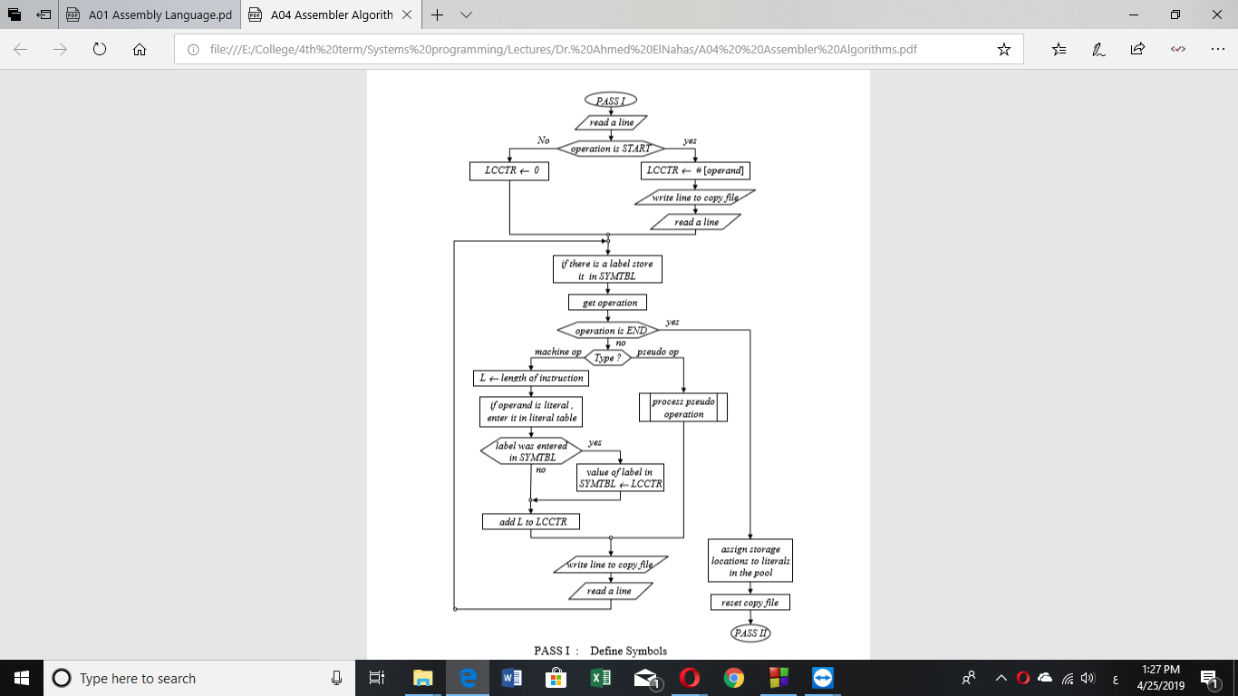

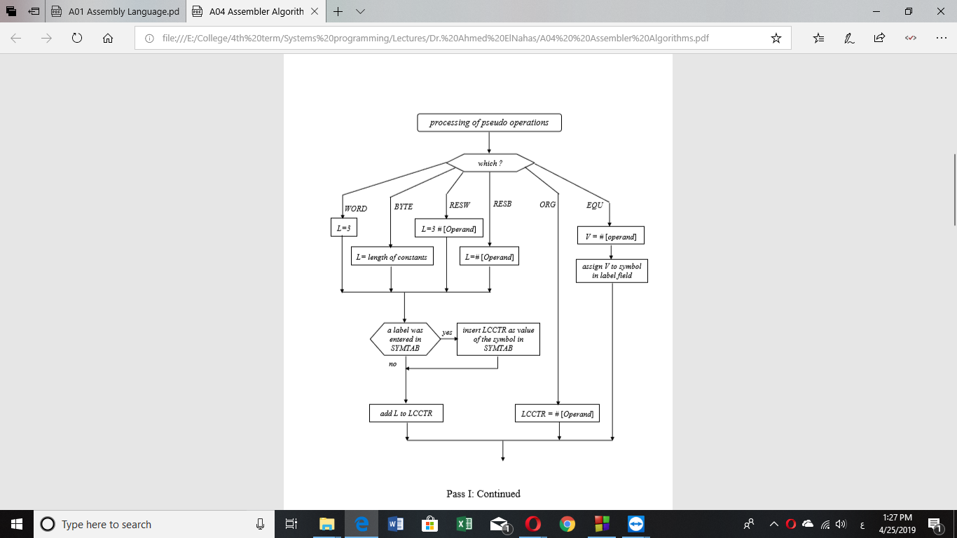

* **Assumptions:**

1. Each code line must all be entered in an individual line.
2. The program supports free format. i.e. Fields are not restricted to specific position in the line.
3. Comment of a line must be preceded by (.).
4. Any comment line must be preceded by(.) at the very beginning of the line.
5. Labels and operands must much the naming conventions (begins with a letter and contains only letters, numbers and (_).
6. Operands length are not limited, however if they exceed the memory allowed an error will occur during running the program.
7. Output is printed in a text file named “Output.txt” in a path relative to the executable file of the program.
8. Labels and operands are illegal to be one of the assembly keywords.

* **Sample Runs:**

Sample 1:

* Input:

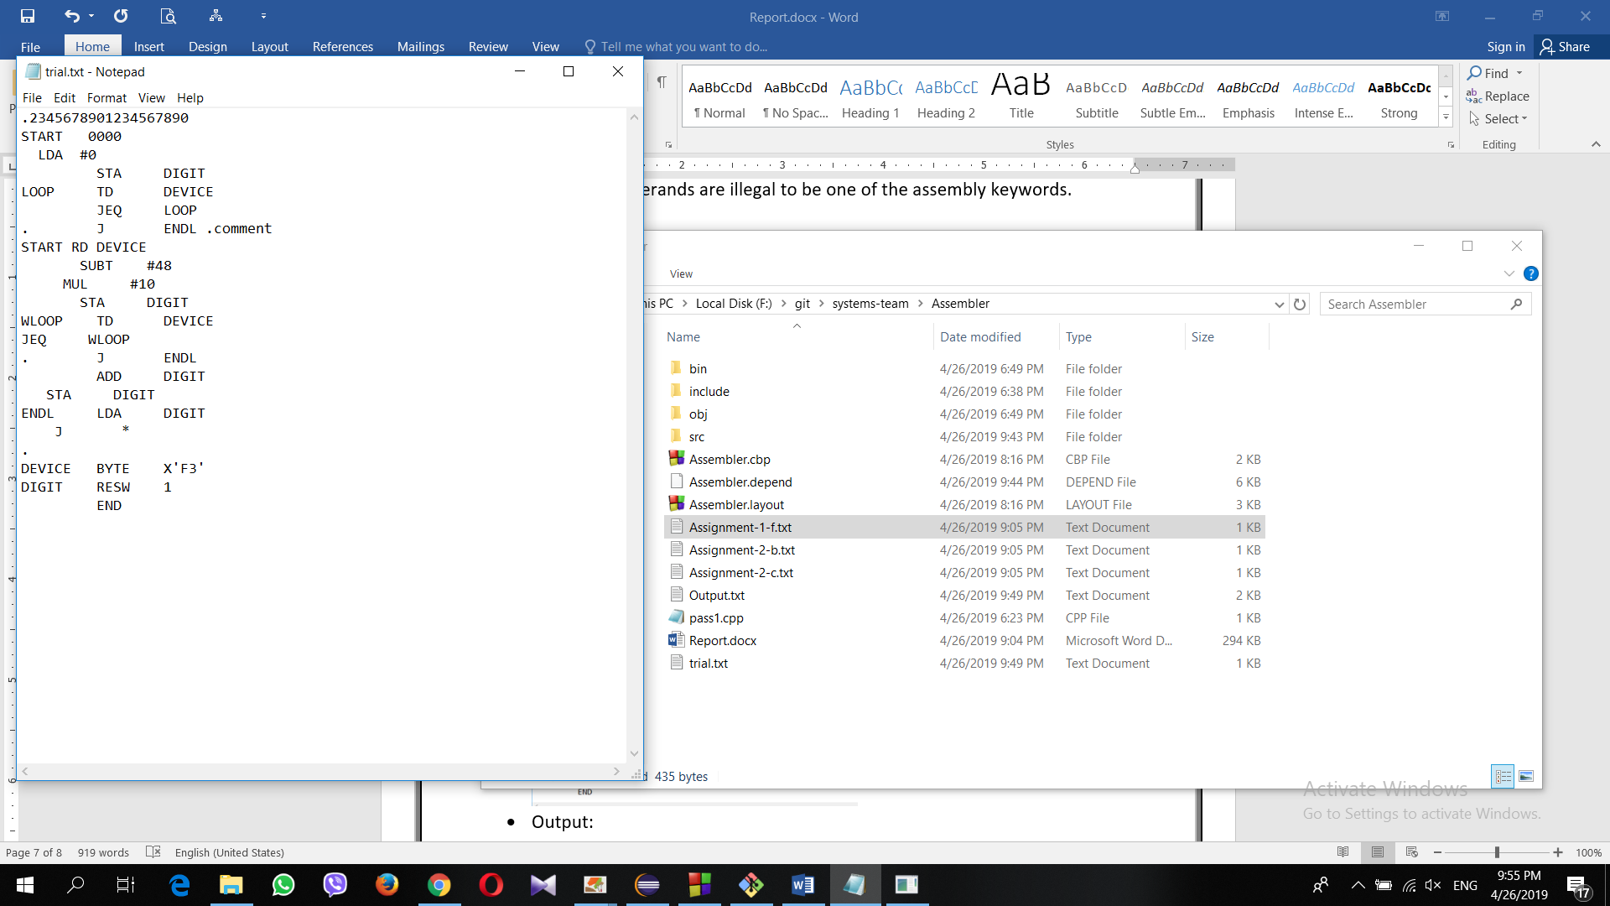

* Output:

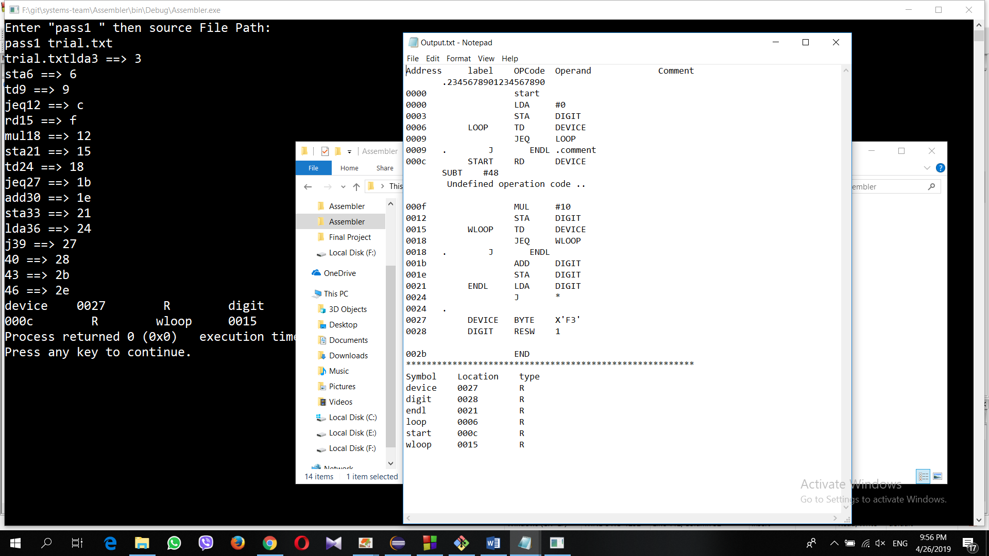

Sample 2:

* Input:

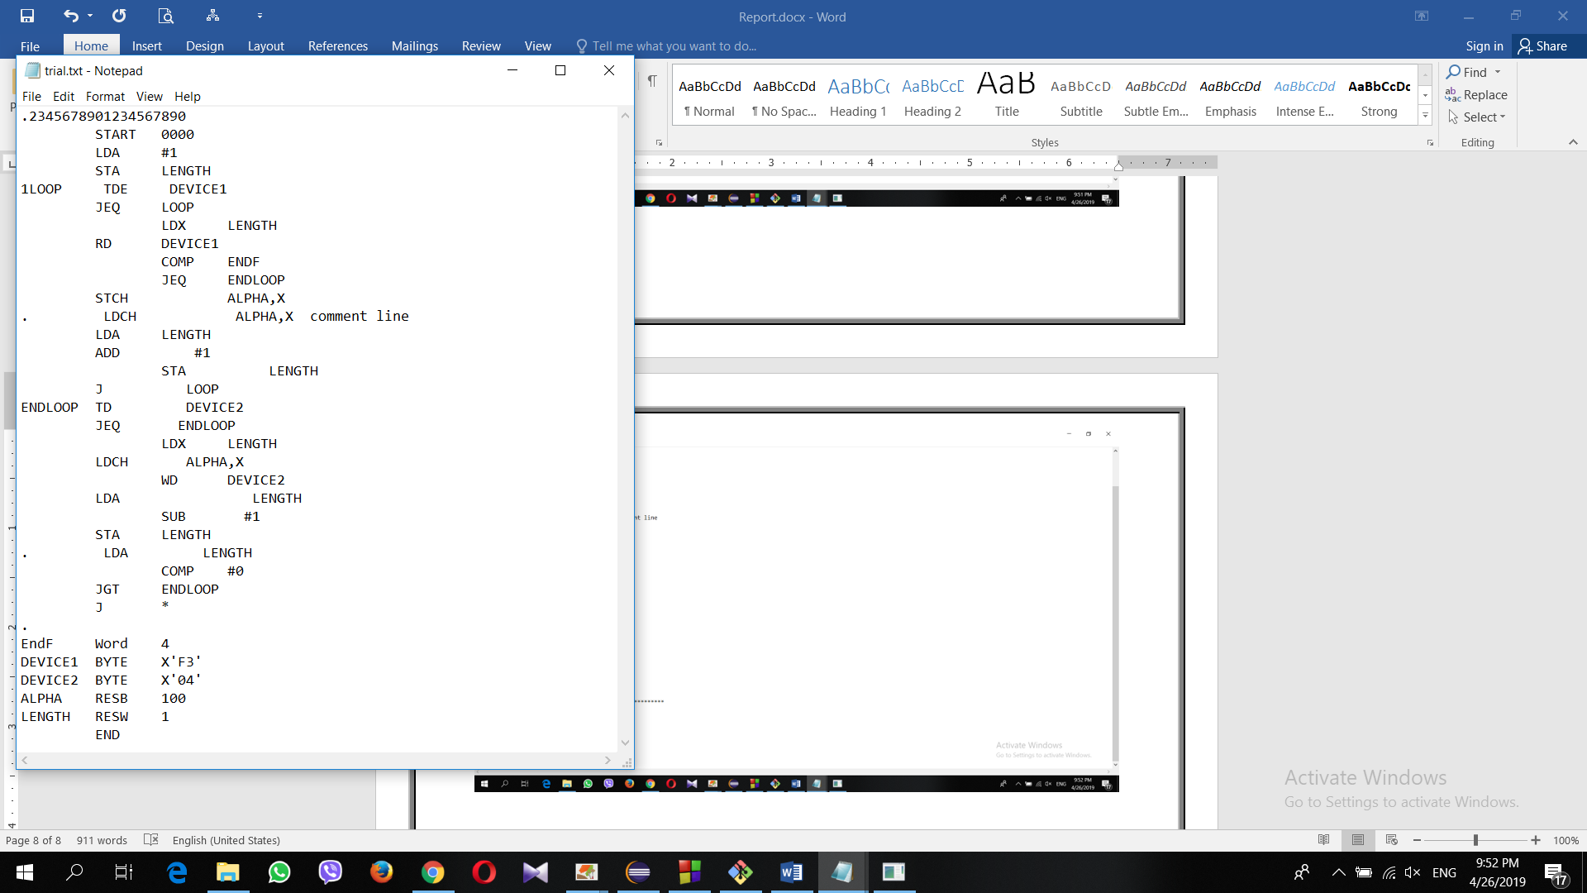

* Output:

