Sourcetree is used to manage the different versions of code/files of different users, create code branches from the master branch and review the commitments of the branch code to the master code.

!Always work in branches

!Firstly create a branch and then start changing the code

To start

1. Open the task in Jira and create a branch

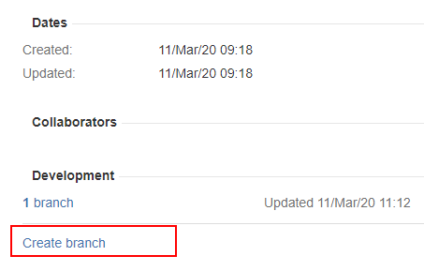

(Or you can go directly to bitbucket and create the branch)

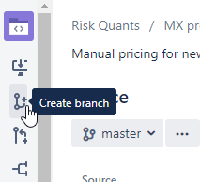

1. Choose Bitbucket
2. Choose “Branch type” = Feature.

Change “Branch name” adding the details to the task name

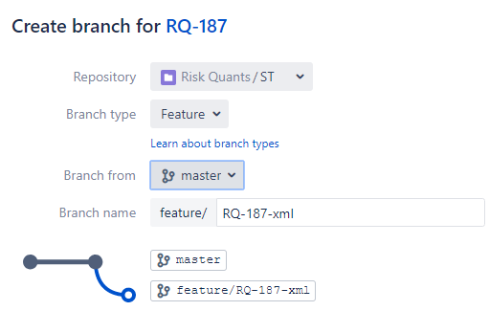

1. Open sourcetree. Create a branch if there is no opened repository on the computer:

Clone

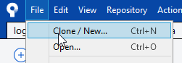

Put the link from Bitbucket to the Source Path in SourceTree

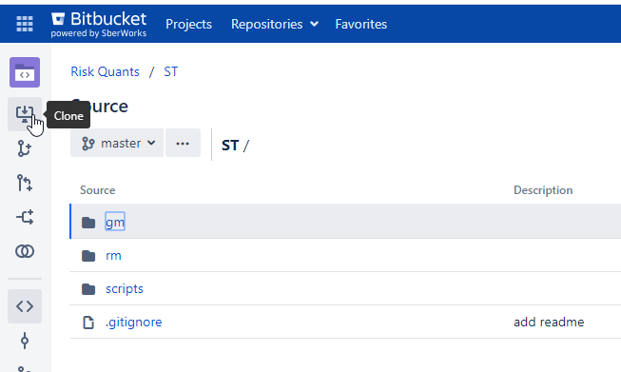

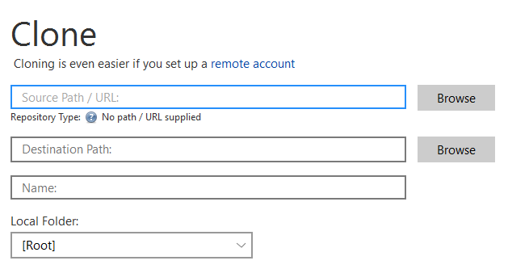

Put the folder on PC to the *Destination Path* in SourceTree

1. If there was Repository on computer than *Fetch* and fetch all tags

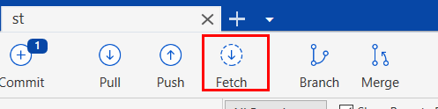

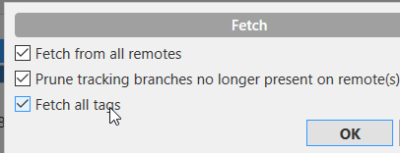

After that go to REMOTES and double-click on your branch

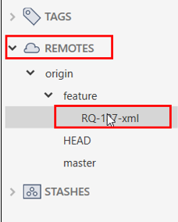

Select *CheckOut New Branch*

Now you can see your branch in *BRANCHES*

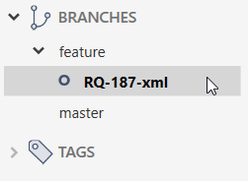

And you can see that your PC files became the same as the files of this branch in Bitbucket server.

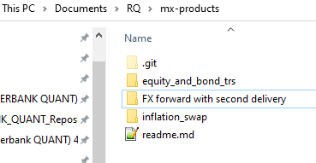

**WHEN MADE THE CHANGE IN A BRANCH AND WANT TO MAKE A CHANGE ON THE SERVER IN THIS BRANCH**

1. When adding the files and commit:

* go to Log/History tab (in the bottom or on the left top)

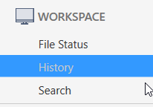

* choose files that have some amendments
* stage files
* go to Files Status tab (in the bottom or on the left top)
* add the comment in style “add the change in…”
* commit

1. Push (put from local branch to the server branch in the git)

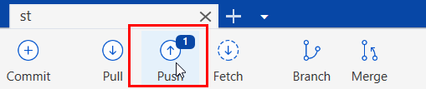

To commit in Master

1. Open bitbucket and make a pull request. Push *Create a pull request* button in the right-top corner.

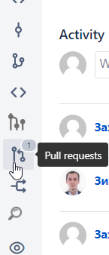

Choose the branch that needs to be merged in master

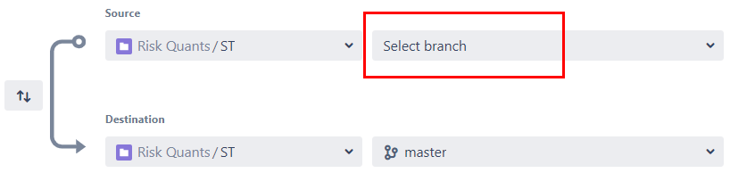

Add the reviewer



1. If the change has been approved by Reviewer please *Merge* (in the right top corner)



1. Choose master to commit (with the flag *deleting the branch*)

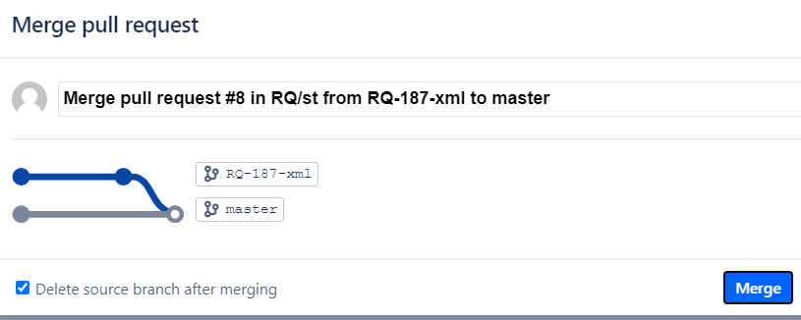

Now the branch merged to the master

1. The next steps are about synchronizing your local repository with server’s one. In SourceTree checkout Master (double-click)

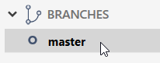

1. In SourceTree choose Fetch (in the top). Now you can see the changes before pressing Pull.

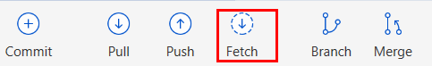

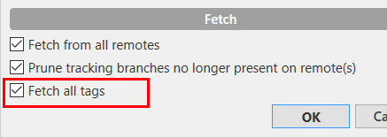

1. Pull

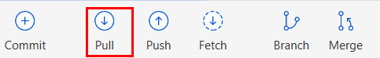

1. Choose the branch and delete the local branch

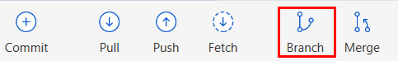

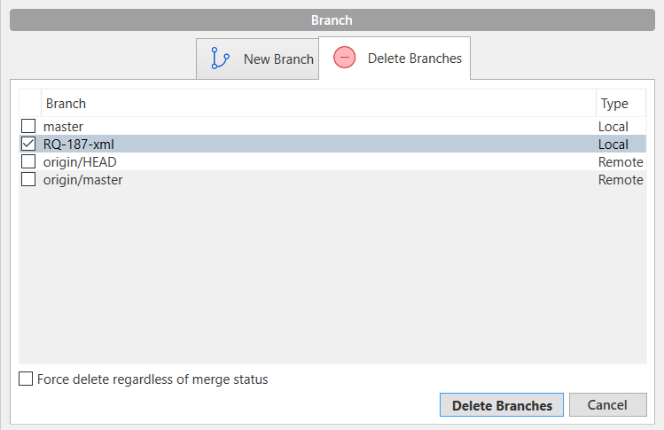

If you need please check force delete

*P.S. Можно перейти через cmd в папку с развернутым репозиторием:*

* *cd «имя папки» чтобы внутрь перейти*
* *cd .. чтобы выше перейти*
* *dir чтобы посмотреть все файлы)*

*git status*

*git diff*