Smart City Incident Management System
Database Systems Course — Mini-Project
Combined Project Document: R#1, R#2, R#3, R#4, Bonus
Team
Role | Name
Team Leader
Team Member 2
Team Member 3
Team Member 4
Team Member 5
Team Member 6

Course: _______________________ Instructor: _______________________
Submission / Discussion Date: _______________________

R#1 — Business & System Requirements Specification

1. Project Overview
The Smart City Incident Management System is a centralized platform that enables citizens to report city incidents and allows government agencies to assign, monitor, and resolve them efficiently. It manages incidents such as traffic accidents, water leaks, power outages, road damage, broken streetlights, garbage collection issues, fire emergencies, flooding, and public safety complaints — providing real-time tracking, automatic task assignment, response monitoring, and performance analytics.
This document defines each stakeholder's business requirements and the corresponding system (functional) requirements, traced to the entities and relationships of the final ERD, so requirements, ERD, and schema stay fully consistent.

2. Stakeholders and Their Requirements

2.1 Citizen
ID | Requirement | Type | Related ERD Entities / Relationships
BR1 | Citizens shall be able to report a city incident, specifying its location and type. | Functional | CITIZEN (reports) → INCIDENT; INCIDENT_LOCATION; INCIDENT_TYPE
BR2 | Citizens shall be able to attach one or more photos as supporting evidence when reporting an incident. | Functional | INCIDENT (contains) → INCIDENT_EVIDENCE [weak entity]
BR3 | Citizens shall be able to track the current status of any incident they reported. | Functional | INCIDENT_STATUS → INCIDENT; INCIDENT_STATUS_HISTORY [weak entity]
BR4 | Citizens shall automatically receive a notification whenever the status of their reported incident changes. | Functional | INCIDENT (triggers) → NOTIFICATION; CITIZEN (receives) → NOTIFICATION
BR5 | Citizens shall be able to rate the resolution of an incident and leave a comment once it is closed. | Functional | INCIDENT → CITIZEN_FEEDBACK; CITIZEN (submits) → CITIZEN_FEEDBACK

2.2 Operator
ID | Requirement | Type | Related ERD Entities / Relationships
BR6 | Operators shall review newly submitted incidents and mark them as validated or rejected. | Functional | OPERATOR (validates) → INCIDENT; VALIDATION
BR7 | Operators shall classify a validated incident's severity and priority level. | Functional | SEVERITY → INCIDENT; PRIORITY → INCIDENT
BR8 | Operators shall assign a validated incident to the appropriate response team. | Functional | OPERATOR (creates), INCIDENT, RESPONSE_TEAM → INCIDENT_ASSIGNMENT
BR9 | The system shall automatically suggest a department based on the incident's category to speed up assignment. | Functional | INCIDENT_CATEGORY ↔ DEPARTMENT, resolved via CATEGORY_DEPARTMENT

2.3 Response Team & Team Members
ID | Requirement | Type | Related ERD Entities / Relationships
BR10 | Response teams shall be notified immediately when an incident is assigned to them. | Functional | RESPONSE_TEAM (receives) → INCIDENT_ASSIGNMENT
BR11 | Response teams shall be able to update the progress and status of an assigned incident. | Functional | INCIDENT_ASSIGNMENT (AssignmentStatus, dates)
BR12 | Response teams shall be able to upload evidence (photos/documents) proving that work has been completed. | Functional | INCIDENT (contains) → INCIDENT_EVIDENCE [weak entity]
BR13 | Each response team shall maintain a roster of its members. | Functional | RESPONSE_TEAM ↔ EMPLOYEE, resolved via TEAM_MEMBER [weak entity]
BR13a | Response teams shall be able to record their capabilities/skills. | Functional | RESPONSE_TEAM ↔ TEAM_SKILL, resolved via TEAM_HAS_SKILL

2.4 Department Manager
(Modeled as an EMPLOYEE linked to a DEPARTMENT via a RESPONSE_TEAM leadership role, through ROLE/ROLE_ASSIGNMENT — no separate DEPARTMENT_MANAGER entity is needed since USER_ACCOUNT + ROLE already generalizes staff roles.)
ID | Requirement | Type | Related ERD Entities / Relationships
BR14 | Department managers shall be able to monitor the current workload (open/assigned/in-progress incidents) of their department. | Functional | DEPARTMENT → RESPONSE_TEAM → INCIDENT_ASSIGNMENT
BR15 | Department managers shall be able to review average response and resolution times for their department's incidents. | Reporting | PERFORMANCE_RECORD; derived from INCIDENT dates
BR16 | Department managers shall be able to generate performance reports for their department. | Reporting | DEPARTMENT (generates) → PERFORMANCE_REPORT; EMPLOYEE (prepares) → PERFORMANCE_REPORT

2.5 City Administrator
ID | Requirement | Type | Related ERD Entities / Relationships
BR17 | City administrators shall be able to create, update, and deactivate departments. | Functional | CITY_ADMINISTRATOR (manages) → DEPARTMENT
BR18 | City administrators shall be able to manage user accounts for citizens, operators, response team members, and staff. | Functional | USER_ACCOUNT; ROLE; ROLE_ASSIGNMENT
BR19 | City administrators shall be able to configure system reference data: categories/types, severity, priority, status. | Functional | INCIDENT_CATEGORY; INCIDENT_TYPE; SEVERITY; PRIORITY; INCIDENT_STATUS
BR20 | City administrators shall be able to view system-wide dashboards summarizing incidents, teams, and departments. | Reporting | Aggregate queries across INCIDENT, DEPARTMENT, RESPONSE_TEAM, PERFORMANCE_RECORD
BR21 | City administrators shall be able to manage employees and their department assignments. | Functional | CITY_ADMINISTRATOR (manages) → EMPLOYEE

3. Cross-Cutting System Requirements
ID | Requirement | Type | Related ERD Entities / Relationships
SR1 | The system shall associate every reported incident with a specific geographic location. | Functional | INCIDENT_LOCATION (occurs at) → INCIDENT
SR2 | The system shall be able to link an incident to a specific service area for routing and reporting. | Functional | SERVICE_AREA ↔ INCIDENT, resolved via INCIDENT_AREA
SR3 | The system shall preserve a full record of who created, validated, and assigned each incident. | Non-Functional | INCIDENT.CitizenID; VALIDATION.OperatorID; INCIDENT_ASSIGNMENT.OperatorID
SR4 | The system shall enforce that every incident always has a status, defaulting to "Reported". | Data Integrity | INCIDENT_STATUS (has status) → INCIDENT
SR5 | The system shall allow a response team to belong to exactly one department. | Data Integrity | DEPARTMENT (has) → RESPONSE_TEAM — 1:N, total participation

4. Non-Functional Requirements
- The system shall be accessible to citizens through a mobile-friendly interface.
- The system shall notify citizens of status changes within a reasonable time (near real-time).
- The system shall restrict access to administrative and operator functions using role-based user accounts, via USER_ACCOUNT + ROLE + ROLE_ASSIGNMENT.
- The system shall keep historical records of resolved incidents for reporting and analytics (INCIDENT_STATUS_HISTORY, PERFORMANCE_RECORD).
- The database shall enforce referential integrity between all related entities shown in the ERD (foreign key constraints).

5. Requirements Traceability Summary
Every functional requirement above maps directly onto one or more entities/relationships of the final ERD, and every entity/relationship in that ERD is used to satisfy at least one requirement. This traceability should be demonstrated to the TA during discussion: pick any stakeholder requirement, point to the corresponding entity or relationship on the printed A3 ERD, and explain the cardinality/participation choice.

R#2 — Entity-Relationship Diagram
The ERD below was designed according to the functional requirements defined in R#1, and matches the relational schema in R#3 exactly (37 tables, grouped by subsystem).
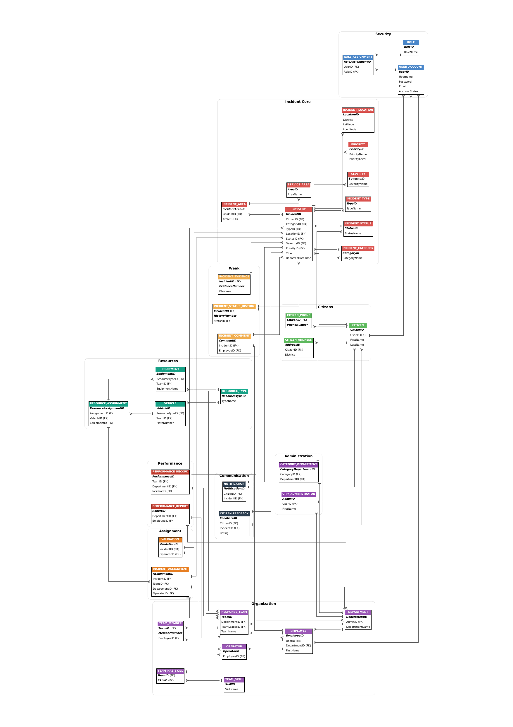
.

R#3 — Relational Schema & Data Dictionary
Data types below are generic (INT, VARCHAR, DATE, DATETIME, DECIMAL, TEXT) — matches the SQL Server build exactly (see SmartCity_Schema_SQLServer.sql).
Legend: PK = Primary Key, FK = Foreign Key, NN = Not Null, U = Unique

1. Security & Access

USER_ACCOUNT
Column | Type | Notes
UserID | INT | PK
Username | VARCHAR(50) | NN, U
Password | VARCHAR(255) | NN (store hashed)
Email | VARCHAR(100) | NN, U
AccountStatus | VARCHAR(20) | e.g. Active/Suspended
CreatedDate | DATETIME | NN
LastLoginDate | DATETIME

ROLE
Column | Type | Notes
RoleID | INT | PK
RoleName | VARCHAR(50) | NN, U
Description | VARCHAR(255)

ROLE_ASSIGNMENT (resolves M:N USER_ACCOUNT ↔ ROLE)
Column | Type | Notes
RoleAssignmentID | INT | PK
UserID | INT | FK → USER_ACCOUNT, NN
RoleID | INT | FK → ROLE, NN
AssignedDate | DATE | NN
EndDate | DATE | nullable
AssignmentStatus | VARCHAR(20)

2. Citizens

CITIZEN
Column | Type | Notes
CitizenID | INT | PK
UserID | INT | FK → USER_ACCOUNT, nullable, U
FirstName | VARCHAR(50) | NN
MiddleName | VARCHAR(50)
LastName | VARCHAR(50) | NN
DateOfBirth | DATE
Nationality | VARCHAR(50)
RegistrationDate | DATE | NN

CITIZEN_PHONE (resolves multivalued PhoneNumber)
Column | Type | Notes
CitizenID | INT | PK (composite), FK → CITIZEN
PhoneNumber | VARCHAR(20) | PK (composite)

CITIZEN_ADDRESS
Column | Type | Notes
AddressID | INT | PK
CitizenID | INT | FK → CITIZEN, NN
BuildingNumber | VARCHAR(10)
Street | VARCHAR(100)
District | VARCHAR(50)
City | VARCHAR(50)
PostalCode | VARCHAR(15)
AddressType | VARCHAR(20) | e.g. Home/Work

3. Incident Core

INCIDENT
Column | Type | Notes
IncidentID | INT | PK
CitizenID | INT | FK → CITIZEN, NN
CategoryID | INT | FK → INCIDENT_CATEGORY, NN
TypeID | INT | FK → INCIDENT_TYPE, NN
LocationID | INT | FK → INCIDENT_LOCATION, NN
StatusID | INT | FK → INCIDENT_STATUS, NN
SeverityID | INT | FK → SEVERITY, NN
PriorityID | INT | FK → PRIORITY, NN
Title | VARCHAR(150) | NN
Description | TEXT
ReportedDateTime | DATETIME | NN
ResolvedDateTime | DATETIME | nullable
Derived attributes ResponseTime and ResolutionTime are not stored — computed in queries/views.

INCIDENT_CATEGORY / INCIDENT_TYPE / INCIDENT_STATUS / SEVERITY / PRIORITY
All five follow the same lookup pattern: an identity PK, a NOT NULL name column, and an optional description.
Column | Type | Notes
CategoryID / TypeID / StatusID / SeverityID / PriorityID | INT | PK
CategoryName / TypeName / StatusName / SeverityName / PriorityName | VARCHAR(20–50) | NN
PriorityLevel (PRIORITY only) | INT | NN
Description | VARCHAR(255)

INCIDENT_LOCATION
Column | Type | Notes
LocationID | INT | PK
BuildingNumber | VARCHAR(10)
Street | VARCHAR(100)
District | VARCHAR(50)
City | VARCHAR(50)
PostalCode | VARCHAR(15)
Latitude | DECIMAL(9,6)
Longitude | DECIMAL(9,6)

SERVICE_AREA / INCIDENT_AREA
Column | Type | Notes
AreaID | INT | PK (SERVICE_AREA)
AreaName | VARCHAR(50) | NN
IncidentAreaID | INT | PK (INCIDENT_AREA)
IncidentID | INT | FK → INCIDENT, NN
AreaID (in INCIDENT_AREA) | INT | FK → SERVICE_AREA, NN
AssignedDate | DATE

4. Weak Entities

INCIDENT_EVIDENCE
Column | Type | Notes
IncidentID | INT | PK (composite), FK → INCIDENT
EvidenceNumber | INT | PK (composite) — partial key
FileName | VARCHAR(150) | NN
FileType | VARCHAR(20)
FilePath | VARCHAR(255) | NN
UploadDateTime | DATETIME | NN
EvidenceType | VARCHAR(30)
Notes | VARCHAR(255)

INCIDENT_STATUS_HISTORY
Column | Type | Notes
IncidentID | INT | PK (composite), FK → INCIDENT
HistoryNumber | INT | PK (composite) — partial key
StatusID | INT | FK → INCIDENT_STATUS, NN
ChangeDateTime | DATETIME | NN
Notes | VARCHAR(255)

INCIDENT_COMMENT
Column | Type | Notes
CommentID | INT | PK
IncidentID | INT | FK → INCIDENT, NN
EmployeeID | INT | FK → EMPLOYEE, NN (author)
CommentText | TEXT | NN
CommentDateTime | DATETIME | NN
CommentType | VARCHAR(20)

5. Organization

DEPARTMENT
Column | Type | Notes
DepartmentID | INT | PK
AdminID | INT | FK → CITY_ADMINISTRATOR, NN
DepartmentName | VARCHAR(50) | NN
Description | VARCHAR(255)
Phone | VARCHAR(20)
Email | VARCHAR(100)
Location | VARCHAR(100)

EMPLOYEE
Column | Type | Notes
EmployeeID | INT | PK
UserID | INT | FK → USER_ACCOUNT, nullable, U
DepartmentID | INT | FK → DEPARTMENT, NN
FirstName | VARCHAR(50) | NN
MiddleName | VARCHAR(50)
LastName | VARCHAR(50) | NN
Phone | VARCHAR(20)
HireDate | DATE

OPERATOR / RESPONSE_TEAM / TEAM_MEMBER / TEAM_SKILL / TEAM_HAS_SKILL
Column | Type | Notes
OperatorID | INT | PK; EmployeeID FK → EMPLOYEE, NN, U
TeamID | INT | PK (RESPONSE_TEAM); DepartmentID FK NN; TeamLeaderID FK → EMPLOYEE, nullable
TeamID + MemberNumber | INT + INT | PK composite (TEAM_MEMBER); EmployeeID FK NN
SkillID | INT | PK (TEAM_SKILL); SkillName NN
TeamID + SkillID | INT + INT | PK composite (TEAM_HAS_SKILL), both FK

6. Assignment & Response

INCIDENT_ASSIGNMENT
Column | Type | Notes
AssignmentID | INT | PK
IncidentID | INT | FK → INCIDENT, NN
TeamID | INT | FK → RESPONSE_TEAM, NN
DepartmentID | INT | FK → DEPARTMENT, NN
OperatorID | INT | FK → OPERATOR, NN
AssignmentDateTime | DATETIME | NN
AcceptedDateTime / CompletionDateTime | DATETIME | nullable
AssignmentStatus / AssignmentMethod / AssignmentNotes | VARCHAR

VALIDATION
Column | Type | Notes
ValidationID | INT | PK
IncidentID | INT | FK → INCIDENT, NN, U
OperatorID | INT | FK → OPERATOR, NN
ValidationDateTime | DATETIME | NN
ValidationResult / ValidationNotes | VARCHAR

7. Resources
Column | Type | Notes
ResourceTypeID | INT | PK (RESOURCE_TYPE); TypeName NN
VehicleID | INT | PK (VEHICLE); ResourceTypeID FK NN; TeamID FK nullable; PlateNumber U
EquipmentID | INT | PK (EQUIPMENT); ResourceTypeID FK NN; TeamID FK nullable
ResourceAssignmentID | INT | PK (RESOURCE_ASSIGNMENT); AssignmentID FK NN; exactly one of VehicleID/EquipmentID set (CHECK constraint)

8. Communication
Column | Type | Notes
NotificationID | INT | PK (NOTIFICATION); CitizenID FK NN; IncidentID FK NN
FeedbackID | INT | PK (CITIZEN_FEEDBACK); CitizenID FK NN; IncidentID FK NN, U
Rating | INT | NN, CHECK (1–5)

9. Performance & Reporting
Column | Type | Notes
PerformanceID | INT | PK (PERFORMANCE_RECORD); TeamID/DepartmentID FK nullable; IncidentID FK NN
ResponseTime / ResolutionTime | DECIMAL(10,2)
ReportID | INT | PK (PERFORMANCE_REPORT); DepartmentID FK NN; EmployeeID FK NN

10. Administration
Column | Type | Notes
AdminID | INT | PK (CITY_ADMINISTRATOR); UserID FK nullable, U
CategoryDepartmentID | INT | PK (CATEGORY_DEPARTMENT); CategoryID FK NN; DepartmentID FK NN
IsPrimaryDepartment | BOOLEAN/BIT

Summary
- Total tables: 37
- Weak entities: INCIDENT_EVIDENCE, INCIDENT_STATUS_HISTORY, TEAM_MEMBER
- M:N junction tables: ROLE_ASSIGNMENT, TEAM_MEMBER, TEAM_HAS_SKILL, CATEGORY_DEPARTMENT
- Multivalued attribute resolved: CITIZEN_PHONE
- Composite attributes flattened: Name → FirstName/MiddleName/LastName (CITIZEN, EMPLOYEE)
- Derived attributes (computed, not stored): ResponseTime, ResolutionTime on INCIDENT
Matching runnable script: SmartCity_Schema_SQLServer.sql

R#4 — DQL Reports (SELECT Queries)
Each report below includes: the SELECT query (DQL), a screenshot of it running against the live database, and its corresponding relational algebra expression.

Report 1 — Full Incident Report
Concept: Multi-table JOIN
SQL Query:
SELECT
I.IncidentID,
I.Title,
C.FirstName + ' ' + C.LastName AS ReportedBy,
IC.CategoryName,
IS2.StatusName,
SV.SeverityName,
PR.PriorityName,
I.ReportedDateTime
FROM INCIDENT I
JOIN CITIZEN C ON I.CitizenID = C.CitizenID
JOIN INCIDENT_CATEGORY IC ON I.CategoryID = IC.CategoryID
JOIN INCIDENT_STATUS IS2 ON I.StatusID = IS2.StatusID
JOIN SEVERITY SV ON I.SeverityID = SV.SeverityID
JOIN PRIORITY PR ON I.PriorityID = PR.PriorityID
ORDER BY I.ReportedDateTime DESC;
Output:
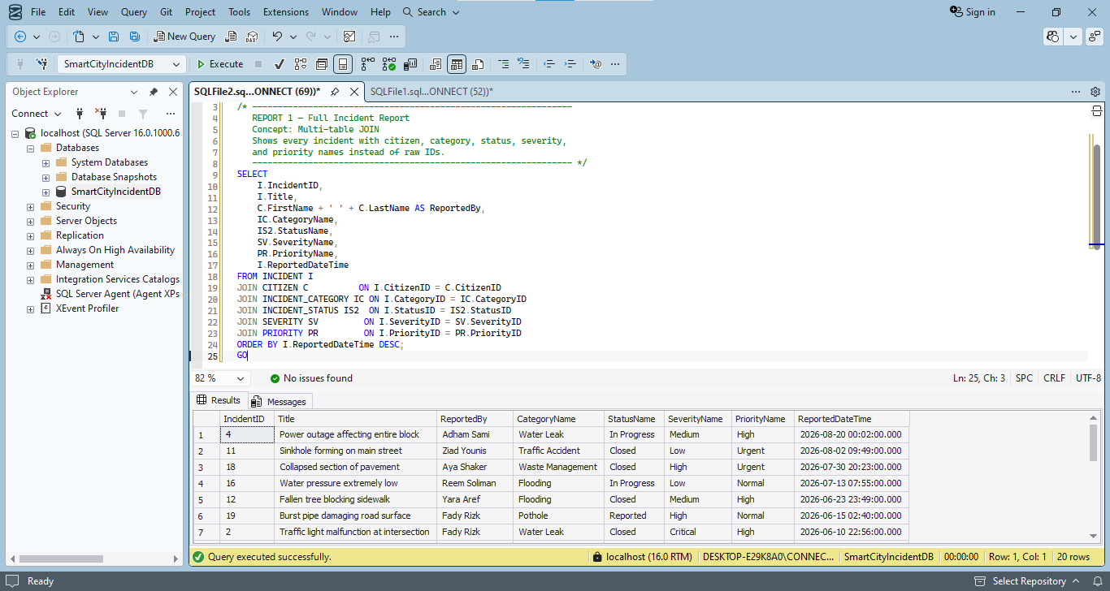
Relational Algebra:
π IncidentID, Title, ReportedBy, CategoryName, StatusName, SeverityName, PriorityName, ReportedDateTime (
INCIDENT ⋈ CITIZEN ⋈ INCIDENT_CATEGORY ⋈ INCIDENT_STATUS ⋈ SEVERITY ⋈ PRIORITY
)

Report 2 — Incident Count per Category
Concept: Aggregate (COUNT) + GROUP BY
SQL Query:
SELECT
IC.CategoryName,
COUNT(I.IncidentID) AS TotalIncidents
FROM INCIDENT_CATEGORY IC
LEFT JOIN INCIDENT I ON IC.CategoryID = I.CategoryID
GROUP BY IC.CategoryName
ORDER BY TotalIncidents DESC;
Output:
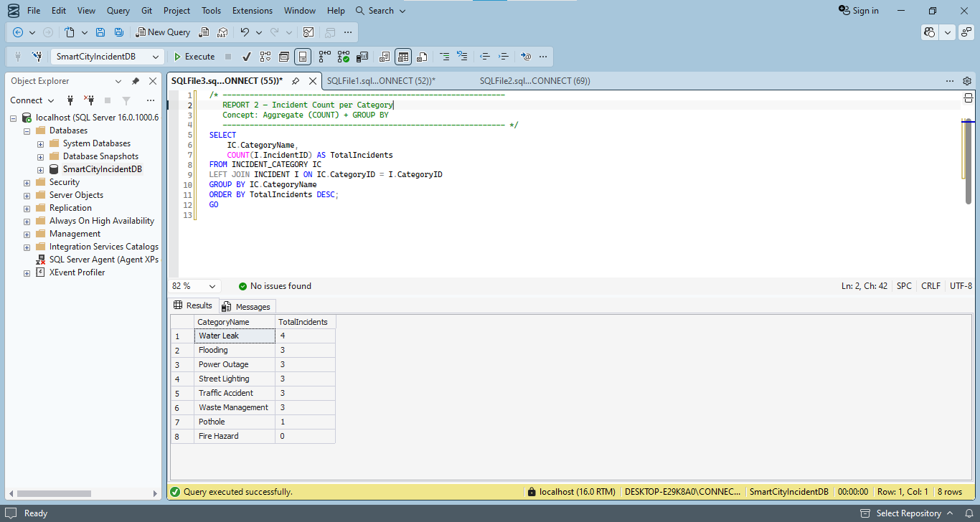
Relational Algebra:
CategoryName 𝒢 COUNT(IncidentID) (
INCIDENT_CATEGORY ⋈L INCIDENT
)

Report 3 — Average Resolution Time per Department
Concept: Aggregate (AVG) + JOIN + GROUP BY
SQL Query:
SELECT
D.DepartmentName,
AVG(PRc.ResolutionTime) AS AvgResolutionTime
FROM PERFORMANCE_RECORD PRc
JOIN DEPARTMENT D ON PRc.DepartmentID = D.DepartmentID
GROUP BY D.DepartmentName
ORDER BY AvgResolutionTime;
Output:
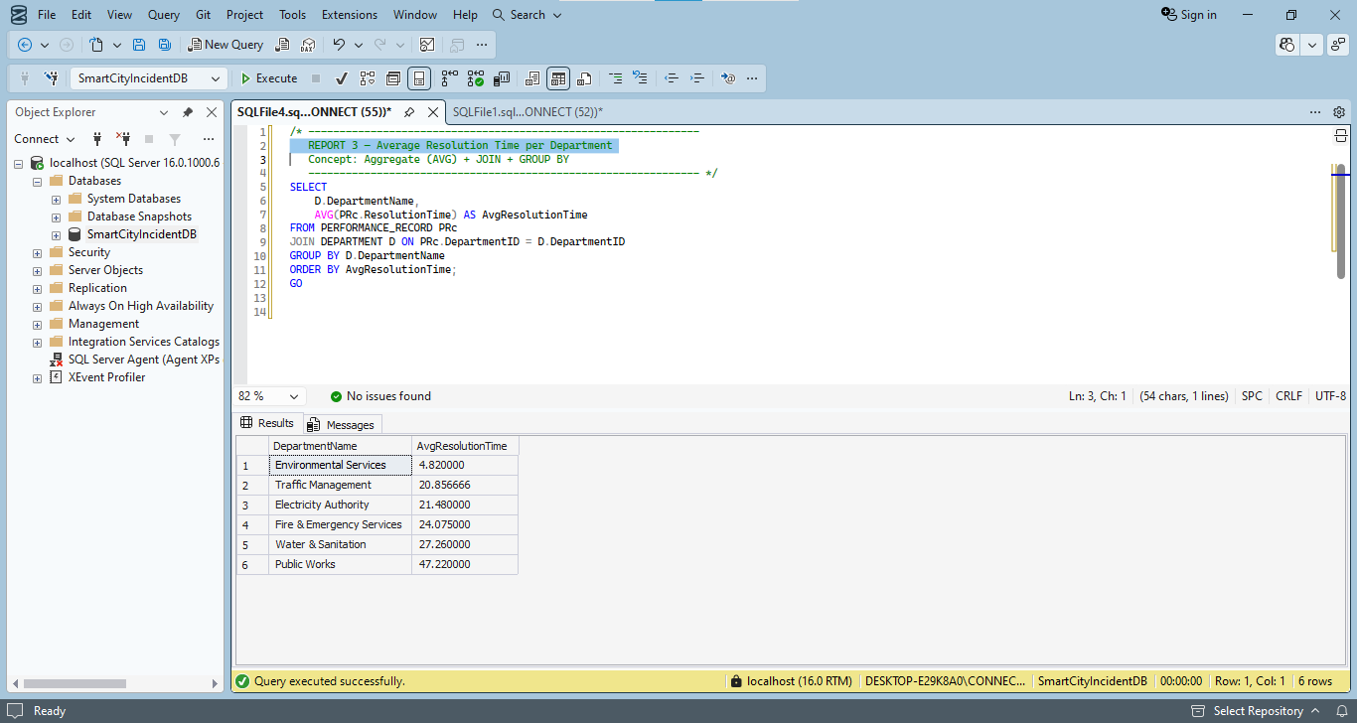
Relational Algebra:
DepartmentName 𝒢 AVG(ResolutionTime) (
PERFORMANCE_RECORD ⋈ DEPARTMENT
)

Report 4 — Departments Handling More Than 2 Incidents
Concept: Aggregate + GROUP BY + HAVING
SQL Query:
SELECT
D.DepartmentName,
COUNT(IA.AssignmentID) AS IncidentsHandled
FROM DEPARTMENT D
JOIN INCIDENT_ASSIGNMENT IA ON D.DepartmentID = IA.DepartmentID
GROUP BY D.DepartmentName
HAVING COUNT(IA.AssignmentID) > 2
ORDER BY IncidentsHandled DESC;
Output:
Screenshot shared with Report 5 (top grid = Report 4 result).
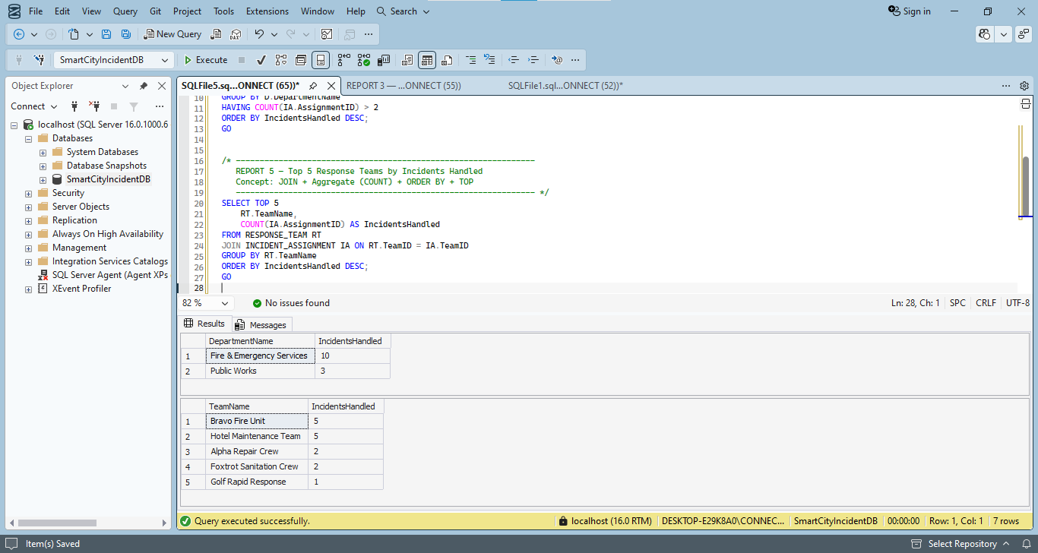
Relational Algebra:
σ COUNT(AssignmentID) > 2 (
DepartmentName 𝒢 COUNT(AssignmentID) (DEPARTMENT ⋈ INCIDENT_ASSIGNMENT)
)

Report 5 — Top 5 Response Teams by Incidents Handled
Concept: JOIN + Aggregate (COUNT) + ORDER BY + TOP
SQL Query:
SELECT TOP 5
RT.TeamName,
COUNT(IA.AssignmentID) AS IncidentsHandled
FROM RESPONSE_TEAM RT
JOIN INCIDENT_ASSIGNMENT IA ON RT.TeamID = IA.TeamID
GROUP BY RT.TeamName
ORDER BY IncidentsHandled DESC;
Output:
Screenshot shared with Report 4 (bottom grid = Report 5 result).
Relational Algebra:
TeamName 𝒢 COUNT(AssignmentID) (
RESPONSE_TEAM ⋈ INCIDENT_ASSIGNMENT
)

Report 6 — Citizens Who Submitted More Than 1 Incident
Concept: Aggregate + GROUP BY + HAVING
SQL Query:
SELECT
C.CitizenID,
C.FirstName + ' ' + C.LastName AS CitizenName,
COUNT(I.IncidentID) AS IncidentsReported
FROM CITIZEN C
JOIN INCIDENT I ON C.CitizenID = I.CitizenID
GROUP BY C.CitizenID, C.FirstName, C.LastName
HAVING COUNT(I.IncidentID) > 1
ORDER BY IncidentsReported DESC;
Output:
Screenshot shared with Report 7 (top grid = Report 6 result).
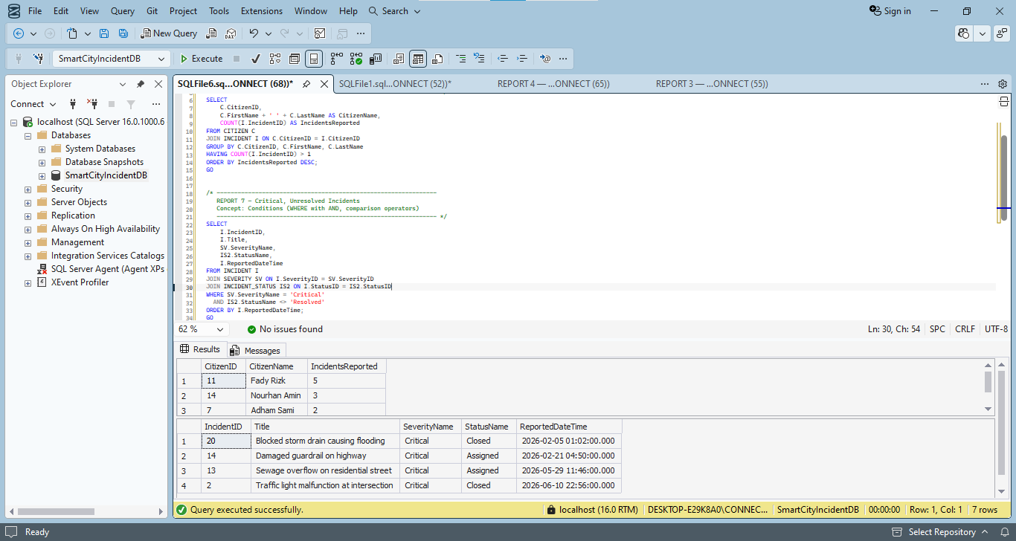
Relational Algebra:
σ COUNT(IncidentID) > 1 (
(CitizenID, CitizenName) 𝒢 COUNT(IncidentID) (CITIZEN ⋈ INCIDENT)
)

Report 7 — Critical, Unresolved Incidents
Concept: Conditions (WHERE with AND, comparison operators)
SQL Query:
SELECT
I.IncidentID,
I.Title,
SV.SeverityName,
IS2.StatusName,
I.ReportedDateTime
FROM INCIDENT I
JOIN SEVERITY SV ON I.SeverityID = SV.SeverityID
JOIN INCIDENT_STATUS IS2 ON I.StatusID = IS2.StatusID
WHERE SV.SeverityName = 'Critical'
AND IS2.StatusName <> 'Resolved'
ORDER BY I.ReportedDateTime;
Output:
Screenshot shared with Report 6 (bottom grid = Report 7 result).
Relational Algebra:
π IncidentID, Title, SeverityName, StatusName, ReportedDateTime (
σ SeverityName = 'Critical' AND StatusName ≠ 'Resolved' (
INCIDENT ⋈ SEVERITY ⋈ INCIDENT_STATUS
)
)

Report 8 — Employees Who Are NOT Operators
Concept: LEFT JOIN + condition (IS NULL)
SQL Query:
SELECT
E.EmployeeID,
E.FirstName + ' ' + E.LastName AS EmployeeName,
D.DepartmentName
FROM EMPLOYEE E
JOIN DEPARTMENT D ON E.DepartmentID = D.DepartmentID
LEFT JOIN OPERATOR O ON E.EmployeeID = O.EmployeeID
WHERE O.OperatorID IS NULL;
Output:
Screenshot shared with Report 9 (top grid = Report 8 result).
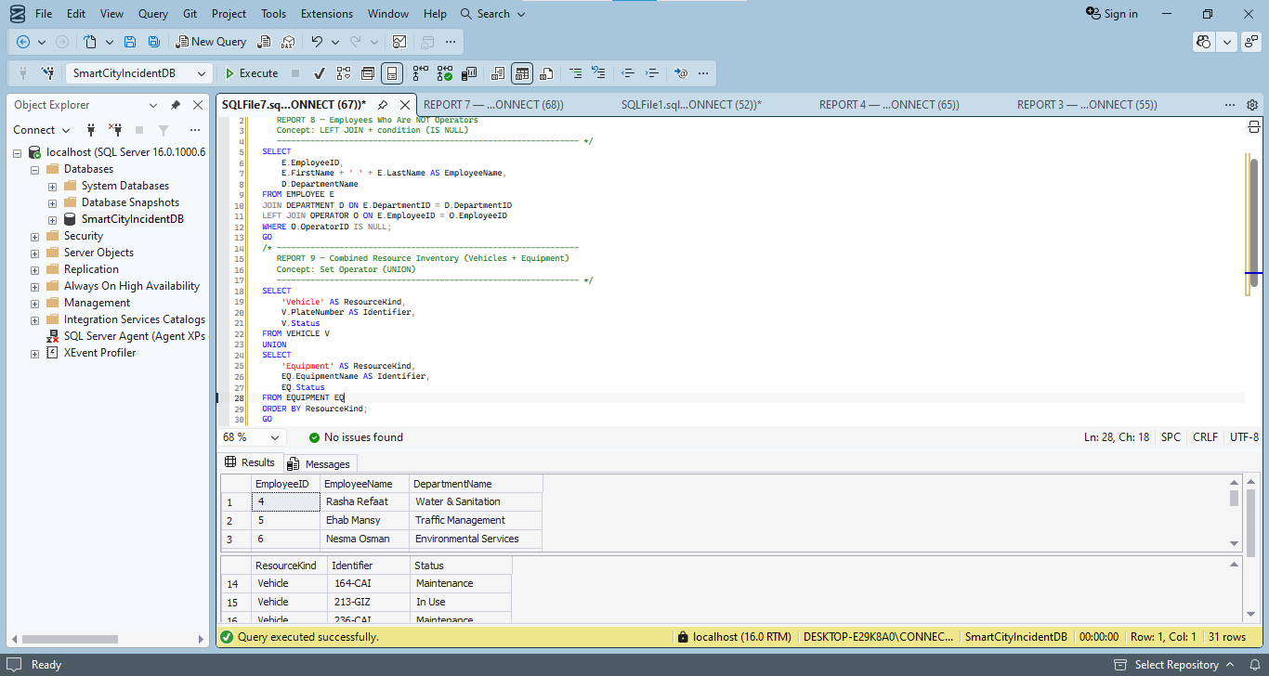
Relational Algebra:
π EmployeeID, EmployeeName, DepartmentName (
(EMPLOYEE ⋈ DEPARTMENT) − (EMPLOYEE ⋈ OPERATOR)
)

Report 9 — Combined Resource Inventory (Vehicles + Equipment)
Concept: Set Operator (UNION)
SQL Query:
SELECT
'Vehicle' AS ResourceKind,
V.PlateNumber AS Identifier,
V.Status
FROM VEHICLE V
UNION
SELECT
'Equipment' AS ResourceKind,
EQ.EquipmentName AS Identifier,
EQ.Status
FROM EQUIPMENT EQ
ORDER BY ResourceKind;
Output:
Screenshot shared with Report 8 (bottom grid = Report 9 result).
Relational Algebra:
ρ (ResourceKind ← 'Vehicle', Identifier ← PlateNumber) ( π PlateNumber, Status (VEHICLE) )
∪
ρ (ResourceKind ← 'Equipment', Identifier ← EquipmentName) ( π EquipmentName, Status (EQUIPMENT) )

Report 10 — Departments With BOTH Assigned Incidents AND Registered Vehicles
Concept: Set Operator (INTERSECT)
SQL Query:
SELECT D.DepartmentID, D.DepartmentName
FROM DEPARTMENT D
JOIN INCIDENT_ASSIGNMENT IA ON D.DepartmentID = IA.DepartmentID
INTERSECT
SELECT D.DepartmentID, D.DepartmentName
FROM DEPARTMENT D
JOIN RESPONSE_TEAM RT ON D.DepartmentID = RT.DepartmentID
JOIN VEHICLE V ON RT.TeamID = V.TeamID;
Output:
Screenshot shared with Report 11 (top grid = Report 10 result).
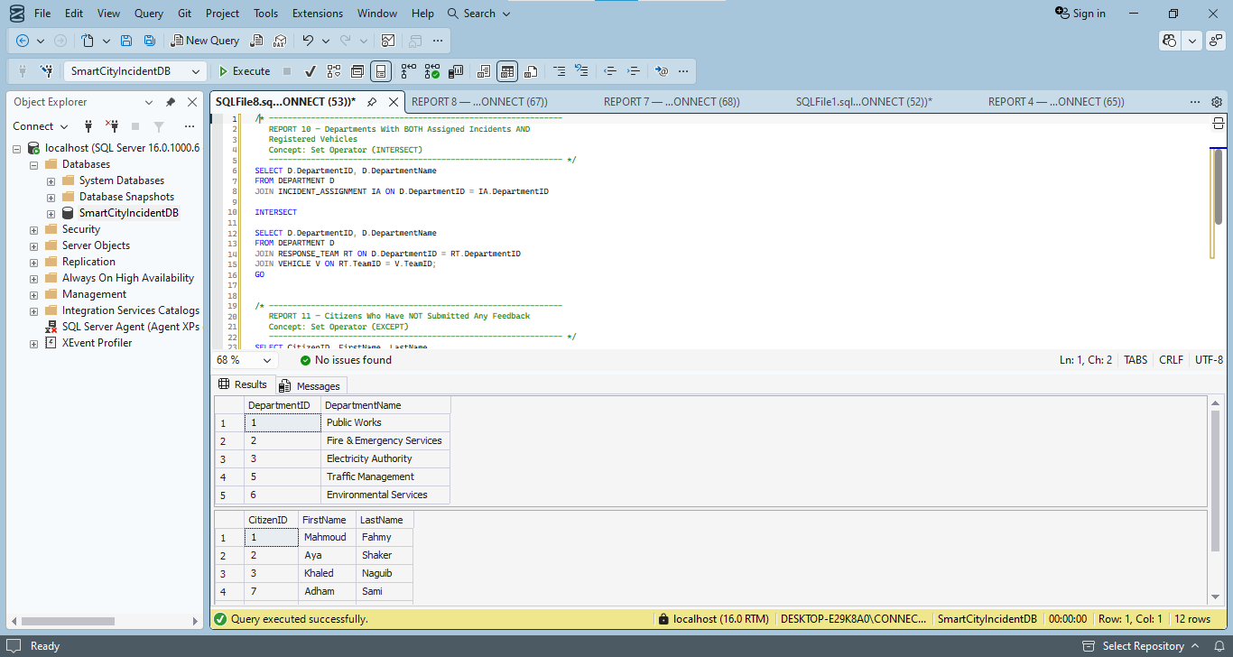
Relational Algebra:
π DepartmentID, DepartmentName ( DEPARTMENT ⋈ INCIDENT_ASSIGNMENT )
∩
π DepartmentID, DepartmentName ( DEPARTMENT ⋈ RESPONSE_TEAM ⋈ VEHICLE )

Report 11 — Citizens Who Have NOT Submitted Any Feedback
Concept: Set Operator (EXCEPT)
SQL Query:
SELECT CitizenID, FirstName, LastName
FROM CITIZEN
EXCEPT
SELECT C.CitizenID, C.FirstName, C.LastName
FROM CITIZEN C
JOIN CITIZEN_FEEDBACK CF ON C.CitizenID = CF.CitizenID;
Output:
Screenshot shared with Report 10 (bottom grid = Report 11 result).
Relational Algebra:
π CitizenID, FirstName, LastName ( CITIZEN )
−
π CitizenID, FirstName, LastName ( CITIZEN ⋈ CITIZEN_FEEDBACK )

Bonus — Views
Six of the R#4 report queries were saved as permanent views, so any of them can be re-run at any time with a single SELECT instead of the full query.
/* ================================================================
SmartCity Incident Management System — BONUS
Views

These wrap several of the R#4 report queries as permanent,
reusable views. Anyone can now just run:
SELECT * FROM vw_ViewName;
instead of retyping the full query.
================================================================ */

USE SmartCityIncidentDB;
GO

/* ---------------------------------------------------------------
vw_FullIncidentReport
Every incident with human-readable category/status/severity/priority
--------------------------------------------------------------- */
CREATE VIEW vw_FullIncidentReport AS
SELECT
I.IncidentID,
I.Title,
C.FirstName + ' ' + C.LastName AS ReportedBy,
IC.CategoryName,
IS2.StatusName,
SV.SeverityName,
PR.PriorityName,
I.ReportedDateTime
FROM INCIDENT I
JOIN CITIZEN C ON I.CitizenID = C.CitizenID
JOIN INCIDENT_CATEGORY IC ON I.CategoryID = IC.CategoryID
JOIN INCIDENT_STATUS IS2 ON I.StatusID = IS2.StatusID
JOIN SEVERITY SV ON I.SeverityID = SV.SeverityID
JOIN PRIORITY PR ON I.PriorityID = PR.PriorityID;
GO

/* ---------------------------------------------------------------
vw_IncidentCountByCategory
Aggregate report: incidents per category
--------------------------------------------------------------- */
CREATE VIEW vw_IncidentCountByCategory AS
SELECT
IC.CategoryName,
COUNT(I.IncidentID) AS TotalIncidents
FROM INCIDENT_CATEGORY IC
LEFT JOIN INCIDENT I ON IC.CategoryID = I.CategoryID
GROUP BY IC.CategoryName;
GO

/* ---------------------------------------------------------------
vw_AvgResolutionTimeByDepartment
Performance report: average resolution time per department
--------------------------------------------------------------- */
CREATE VIEW vw_AvgResolutionTimeByDepartment AS
SELECT
D.DepartmentName,
AVG(PRc.ResolutionTime) AS AvgResolutionTime
FROM PERFORMANCE_RECORD PRc
JOIN DEPARTMENT D ON PRc.DepartmentID = D.DepartmentID
GROUP BY D.DepartmentName;
GO

/* ---------------------------------------------------------------
vw_CriticalUnresolvedIncidents
Operational view: incidents needing urgent attention
--------------------------------------------------------------- */
CREATE VIEW vw_CriticalUnresolvedIncidents AS
SELECT
I.IncidentID,
I.Title,
SV.SeverityName,
IS2.StatusName,
I.ReportedDateTime
FROM INCIDENT I
JOIN SEVERITY SV ON I.SeverityID = SV.SeverityID
JOIN INCIDENT_STATUS IS2 ON I.StatusID = IS2.StatusID
WHERE SV.SeverityName = 'Critical'
AND IS2.StatusName <> 'Resolved';
GO

/* ---------------------------------------------------------------
vw_TopResponseTeams
Ranking view: incidents handled per team
--------------------------------------------------------------- */
CREATE VIEW vw_TopResponseTeams AS
SELECT
RT.TeamName,
COUNT(IA.AssignmentID) AS IncidentsHandled
FROM RESPONSE_TEAM RT
JOIN INCIDENT_ASSIGNMENT IA ON RT.TeamID = IA.TeamID
GROUP BY RT.TeamName;
GO

/* ---------------------------------------------------------------
vw_CombinedResourceInventory
Set-operator view: vehicles + equipment as one resource list
--------------------------------------------------------------- */
CREATE VIEW vw_CombinedResourceInventory AS
SELECT
'Vehicle' AS ResourceKind,
V.PlateNumber AS Identifier,
V.Status
FROM VEHICLE V

UNION

SELECT
'Equipment' AS ResourceKind,
EQ.EquipmentName AS Identifier,
EQ.Status
FROM EQUIPMENT EQ;
GO

/* ---------------------------------------------------------------
Quick test — run these to confirm all 6 views work
--------------------------------------------------------------- */
SELECT * FROM vw_FullIncidentReport;
SELECT * FROM vw_IncidentCountByCategory;
SELECT * FROM vw_AvgResolutionTimeByD
-- (truncated for length — full script: SmartCity_Views.sql)

Proof of Working Views
Screenshot below shows vw_FullIncidentReport, vw_CriticalUnresolvedIncidents, vw_IncidentCountByCategory, and vw_TopResponseTeams all being called successfully.
