AdministrativeBudget User Guide

The Sectional Title Schemes Management Act
Under the Sectional Title Act, the Trustees of a Body Corporate had to prepare a budget in which they estimated the expenses that would be incurred in the next financial year. Those expenses could include day-to-day expenses such as utility costs (water, electricity and refuse collection), managing agent fees, insurance, premiums, etc. and infrequent, large cost items such as repainting or replacing fences or security systems.
In 2016, the Sectional Title Schemes Management Act (STSMA) and Sectional Title Schemes Management Regulations (STSMR) came into effect. Under the STSMR, the Trustees need to present two budgets: An administrative budget and a reserve fund budget. The administrative budget describes the anticipated expenses for day-to-day expenses.
This user guide describes a simple spreadsheet for preparing the administrative budget. There is a separate spreadsheet for preparing a reserve fund budget that can be downloaded or cloned from https://github.com/tokaivillas/ReserveFundBudget

Copyright, Disclaimers and Other Legal Stuff
This spreadsheet is “free sofware” meaning that you are free to use it as you see fit at no cost. However the spreadsheet is licensed under the GNU Public License (GPL) version 3 meaning that if you extend the software in any way, you are obliged to release your changes under the same license conditions.
Software inevitably has bugs and the GPL acknowledges this fact
This program is distributed in the hope that it will be useful,
but WITHOUT ANY WARRANTY; without even the implied warranty of
MERCHANTABILITY or FITNESS FOR A PARTICULAR PURPOSE. See the
GNU General Public License for more details.

Finally, the STSMR is a legal document and the creators of the spreadsheet are not lawyers but we've tried to interpret the requirements for drawing up an administrative budget in a reasonable way.

Preparing an Administrative Budget
Preparing an administrative budget using this spreadsheet has two steps:
- Capturing the previous year's administrative expenses under various categories and sub-categories
- Using the previous year's expenses to project the current year's expenses

Step 1: Recording the Previous Year's Expenses
If you open the AdministrativeBudget.ods spreadsheet, you will see that it has four worksheets:
- An “About” worksheet
- A “Previous Year's Financials” spreadsheet
- A “Budget Planner” spreadsheet
- A “Budget Summary” spreadsheet

The “About” spreadsheet contains the legal stuff governing the use of the spreadsheet. More useful is the “Previous Year Financials.”
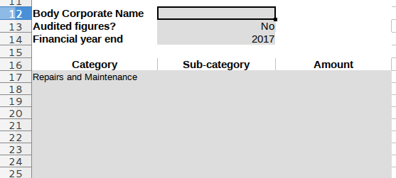
The first three values to enter are:
- The name of the Body Corporate
- A Yes/No answer to whether the figures are audited. You might present a budget where the figures used for planning are different (hopefully, not dramatically different) from the figures presented in your Audited Financial Statements (AFS) and answering “No” to this helos to explain at the AGM why the figures aren't in agreement
- The year under review

You next need to capture the amounts under category and sub-category headings. The spreadsheet is opinionated. It regards putting a category and sub-category on the same line as a mistake
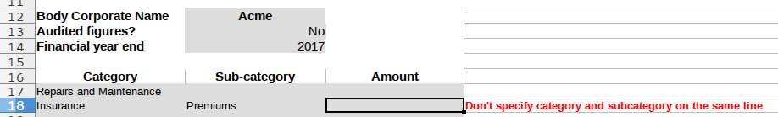
The spreadsheet also doesn't like it if you assign an amount directly to a category
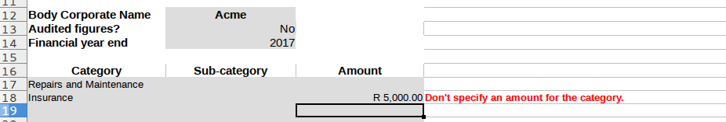
Amounts must be assigned only to sub-categories. If you open the Example1.ods spreadsheet in the Examples folder and select the “Previous Year Financials” worksheet you can see a worksheet that has been correctly populated.
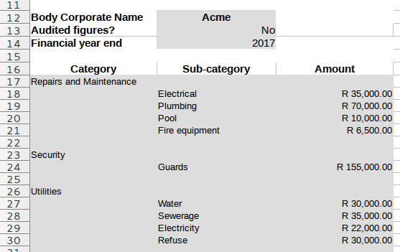
You can choose whatever category and sub-category names you like with one exception; your spreadsheet must contain a “Repairs and Maintenance” category. The “Repairs and Maintenance” line item has special significance since the STSMA requires that the minimum amount contributed each year to the Reserve Fund is partially determined by the amount that a BC anticipates will be spent on Repairs and Maintenance.
Once you've populated the “Previous Year Financials” worksheet, you can start budgeting for the current year.

Step 2: Preparing the Budget
If you open the “Budget Planner” worksheet of Example1.ods you can specify a default percentage change, i.e. some assumed rate of inflation. In this example, we assume 7%
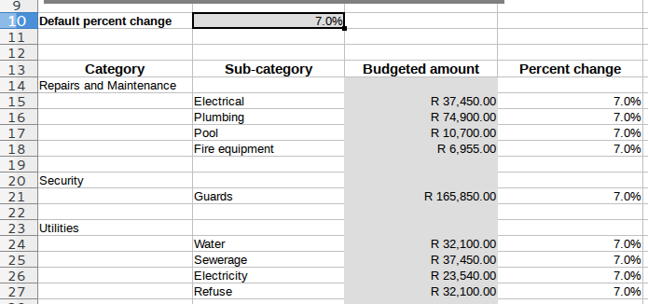
You should now go through each line item and revise it based on additional information or, if you want, round the amount to a sensible approximation. The Example1_revised.ods spreadsheet contains the results of such an exercise. For example, the amount assigned to the “Electrical” sub-category in the “Repairs and Maintenance” category has been rounded to R37,000 from R37,450. The estimate for “Water” (under “Utilities”) has been increased from R32,100 to R36,000 based on additional information (a 20% increase instead of the default value of 7%)
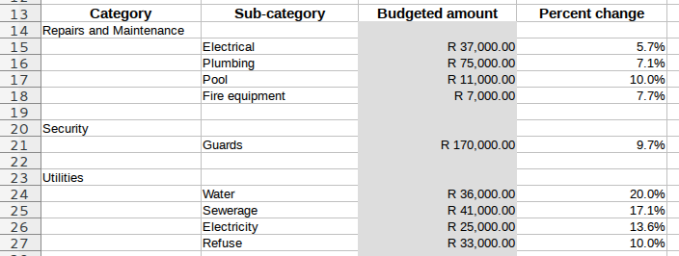
And that's pretty much all that's involved in preparing an Administrative Budget.

Viewing the Budget Summary

Revision History
Version | Date | Changes
1.0.0 | May 2017

