ReserveFundBudget User Guide

The Sectional Titles Schemes Management Act (STSMA), the Regulations of the STSMA and Prescribed Management Rules
Certain items on a Sectional Title scheme's budget are pretty predictable from year to year. For example, if you know how much was spent on gardening, electricity, managing agent's fees or insurance in one year, it is pretty easy make an educated guess as to the amount that will be spent on the same item in the following year. A first approximation would be to take the amount spent in the most recent financial year and assume that you will spend the same amount increased by the rate of inflation.
However, a Body Corporate's (BC's) expenses can vary wildly from year to year when certain expensive maintenance needs to be undertaken such as repainting, repaving a driveway or replacing a wall or fence. Unless a BC maintains a healthy reserve fund, these large capital items can result in levies changing dramatically from year to year. In particular, BC's may need to issue special levies which are frequently unpopular with owners and frowned upon in the STSMA.
The Sectional Titles Schemes Management Regulations (“The Regulations”) require that the trustees of a BC prepare:
- An administrative budget to cover day-to-day expenses (such as gardening, managing agent fees, electricity and regular repairs and maintenance like fixing minor plumbing problems or replacing light bulbs) for the following financial year
- A maintenance plan and reserve fund budget that identifies large maintenance work that needs to be undertaken over the next ten years that shows how these large-scale works will be funded from a reserve fund.
The Regulations specify that the reserve fund must be maintained separately from the administrative fund and stipulates amounts that must be contributed to the reserve fund each year. The minimum amounts that must be put into the reserve fund annually are significant. The following three slightly messy requirements apply (if, on a first reading, you don't understand them, don't worry):
- If the amount in the reserve fund is insufficient to cover a full year's administrative costs but more than one quarter of the amount spent on administration, then the BC must ensure that an amount greater than or equal to the Repairs & Maintenance line item on the administrative budget must be contributed to the reserve fund.
- If the amount in the reserve fund is less than one quarter of the amount spent on administration, a BC is required to put an amount greater than or equal to 15% of the total administrative budget into the reserve fund in the next financial year.
- If the reserve funds are sufficient to cover a full year's administrative costs, a BC does not need to put any money into the reserve fund in the next financial year.
The regulations also specify Management Rules that govern the running of a BC. Most importantly for this document is Prescribed Management Rule 22 (“PMR22”) that provides a formula to calculate a minimum amount that a BC should put into the Reserve Fund based on expected maintenance costs.
The reserve fund would be pointless if a BC was obliged to put money into the fund but could never take the money out again. Fortunately, money can be spent from the reserve fund but only on items in the ten year maintenance plan. For example, a BC may not pay its electricity bill out of the reserve fund. If a BC finds that it cannot pay administrative costs (such as its electricity account or its auditing fees), it is obliged to raise a special levy.
There are a large number of items that can be included on a ten year plan and trying to make an educated guess as to whether the reserve fund will be sufficiently well funded at some distant time is not realistic. Happily, spreadsheets are a great tool for budgeting and checking compliance with, e.g., the minimum amount to be contributed to the reserve fund in a year.

The ReserveFundBudget Spreadsheet
The Brittany, Tokai Villas trustees created a spreadsheet to help them:
- Identify items that need to be maintained over a ten year period (such as paint jobs, replacing electric fencing, resurfacing the pool, etc.)
- Determine what the impact of these big-ticket items is on the budget and how to prepare budgets that do not see significant fluctuations in levies from year to year.
This user guide describes how to use the spreadsheet.

Real world budgeting
It's important to be realistic; ten years is a long time period. A spreadsheet is not going to be precisely accurate even over one year and the inaccuracies get worse over time. Some of the problems with long range budgeting are:
- Inflation can vary and the spread between the interest earned on the reserve fund can be significantly different from year to year over ten years
- Assumptions about when maintenance work is needed can be wrong; a paint job that was expected to last seven years may be looking shoddy after six
- Events that were assumed to have no realistic chance of happening may come to pass
The intellectually lazy might, then, assume that preparing a ten year plan is a waste of time. If that's your point of view, you should stop reading now. Budgeting can highlight potential problems without being 100% accurate.

The Structure of the Spreadsheet
The spreadsheet consists of six worksheets:
- An “About” worksheet that includes a copyright notice and a disclaimer
- A “Current Financials” worksheet that captures details from the previous year's (hopefully audited) financial statements and important details from the administrative budget
- A worksheet that captures items that need to be maintained over the next ten years (e.g. painting) or large value capital purchases (e.g. a new irrigation system)
- A worksheet that gives an assessment of the current health of the reserves and a recommendation of the minimum amount by which the levies should be increased (or decreased) over the previous year. This recommendation can serve as a starting point for your planning. This recommendation uses the formula of PMR22(2).
- A “Planning and Projections” worksheet to determine year on year changes over the ten year period to help ensure that the reserves of the BC are sufficient to cover the expenses for each year and to ensure that the amount in the reserve fund is always compliant with the Regulations.
- A “Summary” sheet that describes the impact of the ten year plan for the immediate financial year.

The next sections work through two example spreadsheets for planning. The examples make the same assumptions about the initial state of a BC but differ in the formality of the ten year plan. The first example uses somewhat informal planning while the second uses a checklist of items to budget for.

There is a third example spreadsheet that is only relevant to Appendix 2 of this user guide. Appendix 2 is intended for readers who want an in-depth understanding of how this spreadsheet calculates values.

Disclaimers and Other Legal Stuff
The STSMA and the Regulations are legal documents and the creators of this spreadsheet are not lawyers. We have, however, tried to interpret the regulations correctly and reasonably.
It should be noted that Section 2 of the Regulations specifies minimum amounts that must be contributed annually to the reserve fund. Additionally, PMR22(2) has a formula that stipulates how to calculate an annual amount that must be contributed to the reserve fund. The amount that you contribute to the reserve fund must be greater than or equal to the LARGER of the amounts determined by applying Regulation 2 and PMR22(2).
A maintenance plan involves more than just calculations. You should prepare a text document that justifies the assumptions that you make in your budgeting and spreadsheet.
This spreadsheet is software and software inevitably has bugs. Note that the GNU Public License under which this software is made freely available includes this disclaimer:
This program is distributed in the hope that it will be useful,
but WITHOUT ANY WARRANTY; without even the implied warranty of
MERCHANTABILITY or FITNESS FOR A PARTICULAR PURPOSE. See the
GNU General Public License for more details.

This software is copyrighted. You may distribute budgets using this spreadsheet but do not remove any worksheet that contains the copyright notice.

Example Spreadsheets
This section considers two fictitious Sectional Title Schemes: The Acme Body Corporate (ABC) and the Zenith Body Corporate (ZBC).
The first example is some what simpler and the second takes a more formal approach. The spreadsheets are found in the examples folder.
The Regulations require that a Body Corporate approve both an administrative budget and a reserve fund budget. The administrative budget must be prepared before the reserve fund budget since the reserve fund budget relies on values contained in the administrative budget. Appendix 1 gives an example of preparing an administrative budget. You can read Appendix 1 first if you want to see what is typically included in that budget.

Important note: The example spreadsheets are based on v1.4.6 of the software. The current version (v1.5) interprets PMR22(2) in a less literal (but considerably more reasonable way) and will generally provide more sensible estimates of how much money a BC should contribute to the reserve fund. Appendix 2 describes the differences between versions v1.4.x (and earlier) and v1.5.0/

Example 1: The Acme Body Corporate
The ABC have prepared their 2017/2018 administrative budget in which they've identified how much money they need to cover the day-to-day running costs of their scheme. The table below shows the results
 | Amount
Repairs & Maintenance | R130 000
Managing agent fees | R73 000
Gardening contract | R170 000
Utilities | R135 000
Legal fees | R6 000
Security | R170 000
Auditors' fees | R16 000
Insurance | R70 000
Gardener and Caretaker salaries | R190 000
Total | R960 000

The ABC have also sent off their financial statements for the previous financial year (2016/17) to their auditors. The previous year, ABC's total budget was R1,000,000 and their administration costs came to R900,000. So the difference between the R1,000,000 gathered on levies and the R900,000 paid for various services was put into their reserve/contingency/management fund. We'll assume that ABC's reserve fund has R550,000 in it at the start of the year.
ABC's trustees now want to prepare a reserve fund budget. The data that they need are:
- The current year's total administrative budget (R960,000)
- The amount budgeted for Repairs & Maintenance (R130,000)
- The amount in the reserve fund at the start of the year (R550,000)
- An educated guess as to inflation (7%)
- The interest rate applicable to the account in which they keep their reserve funds (5%)
If you open the example1.ods spreadsheet and click on the “Current Financials” worksheet, you'll see the above data captured.
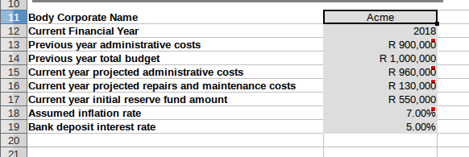
The actual planning now needs to start. The trustees have identified five expensive maintenance items that need to be repaired, maintained or replaced over the next ten years (2018-2027):
- The electric fence is beginning to look tatty and will need to be replaced. They've obtained a quote of R70,000 if it were done immediately. The trustees figure that the work can wait until 2019 (although, with inflation, it will cost more than R70,000 in nominal terms then)
- The walls of the complex are repainted every seven years and the next job will be in 2020 (and another in 2027). They estimate that currently (in 2018 Rand terms), it will cost R750,000.
- The irrigation system will be 20 years old in 2025 and they believe it will need to be replaced then. An estimate of R80,000 in 2018 Rand term seems reasonable to them.
- ABC's caretaker tells them that the gutters and downpipes need replacing at a cost of about R250,000. The trustees decide that maintenance work can be held over until 2021.
- Finally, woodwork and metalwork needs to be repainted every four years with the next round of repainting in the current financial year at a cost of R280,000. The exercise will be repeated in 2022 and 2026.
ABC's trustees capture their reserve fund budget items in the “Ten Year Plan' worksheet.
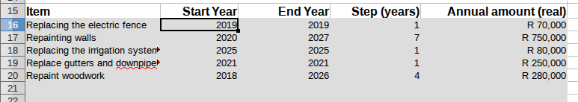
Note the step values of 7 and 4 for the repainting items above.
If you scroll over further right on the same spreadsheet, you'll see the same data captured on a year-by-year basis after applying the assumed rate of inflation.
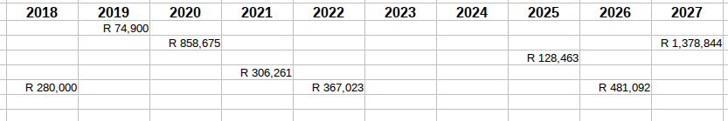
So, for example, it's estimated that repainting the woodwork in 2026 will cost R481,000 and the 2020 paint job will cost R859,000 when we take inflation into account.
Initially that R550,000 in the reserve fund may have looked healthy but with the expenses in 2018, 2019 and the very expensive maintenance work in 2020, it no longer looks so good.
Clicking on the “Current Year Planner” worksheet is depressing.
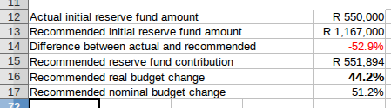

What the above is saying is that the ABC should have had R1,167,000 in reserves rather than R550,000. Using a formula from Section 22(2) of the Management Rules, the spreadsheet suggests that the 2017/18 budget should be increased by 44.2% in real terms over the 2016/17 budget. Since inflation is running at 7%, this translates to a 51.2% increase in the budget. The result is that the trustees will be crucified at ABC's AGM when they announce that the levies for 2017/2018 are going up by more than 50%. Fortunately, we can probably ignore that recommendation except to use it as a starting point in determining how to get ABC's finances into a healthier state. If you're interested in seeing how the spreadsheet calculated the “recommended” values, read Appendix 2.
If a scheme has been managing its finances prudently, the budget (and levies) should increase approximately in line with the general rate of inflation. The “Planning and Projections” worksheet makes the initial assumption that over the next ten years, the budget should not increase in real terms (i.e. the annual real increase should be 0%). That assumption doesn't work out well here and there's a sea of red for ABC's projected financial state in the next image.
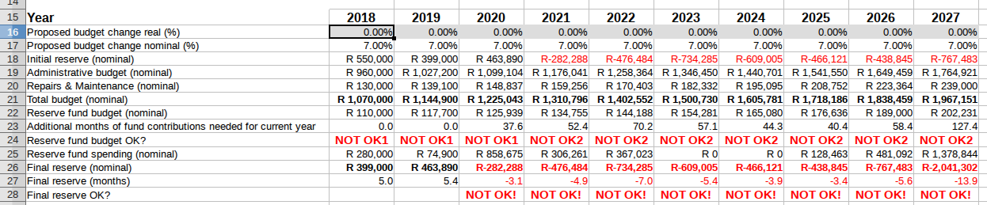
From 2020 to 2027, ABC's reserve fund is “NOT OK” since the balance is negative and the scheme is bankrupt.
The spreadsheet is also complaining from 2018 to 2027 about the amount being contributed to the reserve fund. Initially, from 2018 to 2020, we see a “NOT OK1” warning. This warning means that the amount being contributed to the reserve fund is less than the amount being spent on Repairs & Maintenance. As the financial situation deteriorates the warning changes to “NOT OK2”. The Regulations require that scheme's with inadequately funded reserves must put an amount greater than or equal to 15% of their overall administrative budget into the reserve fund. This budget would, from 2021, be failing to meet that legal requirement.
The previous worksheet recommended that the ABC increase their budget by 44.2% (in real terms). Let's see what happens if we do what the computer tells us to do.
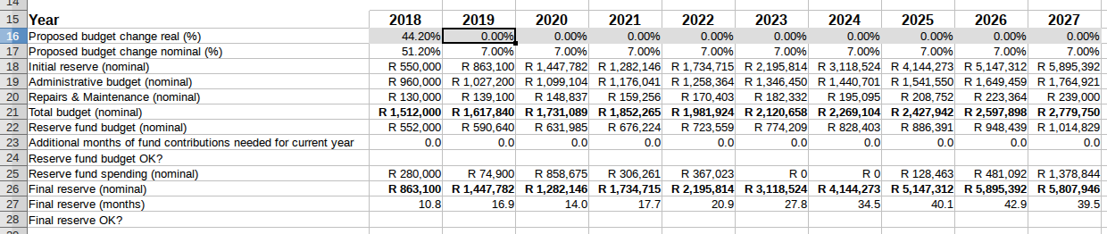
All the red disappears, so things are looking better in most respects. One problem, though, is going to be the angry hordes at the AGM. A second problem is that we have increased the budget (and levies) to solve an immediate problem. If we maintain the budget at this rate, we are going to be continuing to be throwing more and more money into the reserve fund. Looking at the column for 2027, we see that the spreadsheet (with absurd precision) predicts that by 2027 the amount in the reserve fund will be sufficient to cover 39.5 months (more than three years) of operating costs.
Since the interest earned is less than the rate of inflation, very large reserves will have their value eroded by inflation. It is actually possible to have too much money in a reserve fund. Let's try fixing that problem by reducing the budget in 2019. If we reduce the budget in 2019 by 25% in real terms (18% in nominal terms excluding inflation), we get a plan that looks pretty good.

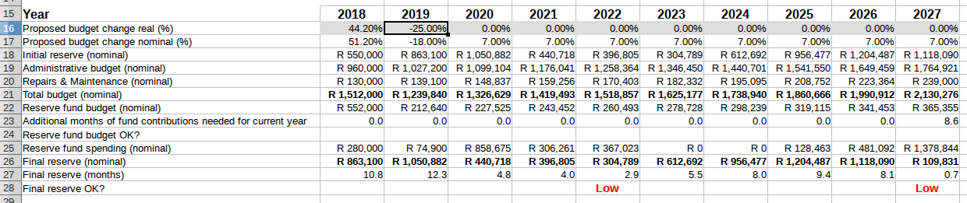
There are warnings that in 2022 and 2027 the amount in the reserve fund will be “low”. That warning means that the reserves are insufficient to cover three months' administrative costs but the projections don't look too bad on the whole. Unfortunately, the current trustees will probably be criticized for hiking the levies dramatically while the next group of trustees will be praised for the financial acuity when they lower levies by 18% but still manage to present a balanced budget.
Rather than dramatically hiking levies and then slashing them, we should try to find a position with moderate increases over one or more years. If we increase the budget by 16% in real terms, the projection is that over the next ten years, things should be OK.

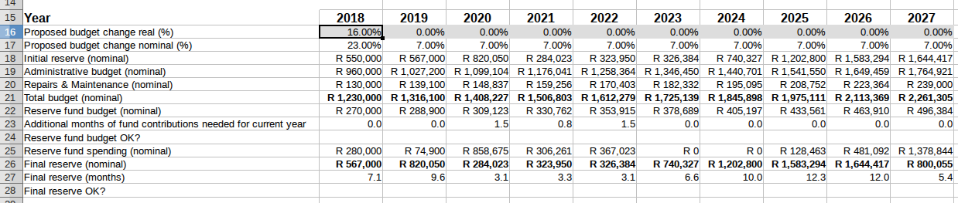
That 16% increase translates into a 23% levy increase in nominal terms. If the trustees aren't comfortable with such an increase in one go, they could investigate whether staggered increases over two or three years might work to get ABC into a sustainable position.
For example, a 10% (17% nominal) increase in 2018 followed by 6% (13% nominal) and 4% (11% nominal) increases in 2019 and 2020 would see the scheme able to meet the expense of the major repainting exercise in 2020.
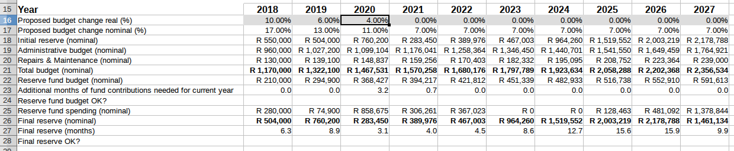

That seems like a more sensible bit of budgeting than the computer's suggestion that ABC hike levies by 51.2% in 2017/18. Why did the spreadsheet recommend that? The answer is in the final worksheet which summarizes the most important points of the 2017/18 budget.

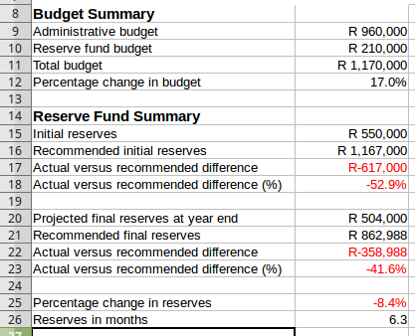

Note that at the start of the financial year, ABC's reserve fund was 52.9% less than an ideal value. By increasing levies by only a nominal 17%, the amount in the reserve fund at the end of the year will still be less than an ideal value by 41.6%. If the trustees had hiked levies by 51.2% the BC would have had the recommended amount in the reserve fund by the close of the financial year.
Section 22(2) of Management Rules has a simple formula for calculating how much should be contributed to the reserve fund (see Appendix 2 if you want the details.) Evaluating the formula as used in the spreadsheet would have got the reserves to the recommended value in a single year. However, it's not clear that it’s reasonable for BC to get to a fully funded reserve in one year since the Regulations also specify the minimum amount to be contributed to the reserve fund. The ABC trustees can probably get their scheme healthy by staggered increases as long as:
- They contribute at least the minimum amounts to the reserve fund required by Section 2 of the Regulations and
- They inform the BC when presenting the budget that there will be future levy increases above the inflation rate and have a plausible plan to get into compliance in a reasonable number of years
Management Rule 22(4) of the Regulations requires that
“The trustees must report the extent to which the approved maintenance, repair and replacement plan has been implemented to each annual general meeting.”

It would seem that the trustees could legitimately explain that a BC will need to have future levy (and budget) increases above inflation to implement the “approved maintenance, repair and replacement plan.” In the example here, the difference between the actual and ideal amounts in the reserve fund was reduced significantly from a 52.9% shortfall at the start of the year to a 41.6% shortfall by the end of the year. In particular, the trustees could indicate that levy increases of 6% and 4% above inflation in the next two years might be sufficient to ensure the financial sustainability of the scheme.
That concludes Example 1 which had a somewhat simplistic maintenance plan with only five items. The second example is more detailed (it contains six items).

Example 2: The Zenith Body Corporate
The financial state of the Zenith Body Corporate is identical to that of the Acme Body Corporate and is captured in the example2.ods spreadsheet.

Drawing up a Ten Year Plan
The trustees of ZBC look at the Regulations and see that the regulations breaks down “major capital items” into eleven categories:
- Wiring, lighting and electrical systems
- Plumbing, drainage and storm-water systems
- Interior and exterior painting and waterproofing
- Parking facilities, roadways and paved areas
- Security systems and facilities
- Community and recreational facilities
- Communication and service supply systems
- Lifts
- Carpeting and furnishings
- Roofing
- Heating and cooling facilities

Like the trustees of the Acme Body Corporate, ZBC's trustees identify that the complex needs to be repainted every few years and that the gutters, electric fence and irrigation system need to be replaced. As they go down the Regulations checklist, they get to the “Community and recreational facilities” heading and realize that they have a swimming pool that periodically needs to be resurfaced.
The ZBC trustees check their records and see that the swimming pool was last resurfaced in 2009 at a cost of R26,000. Pool resurfacing typically lasts about ten years and the trustees decide that they should assume that the pool may need to be resurfaced in 2019. Since nine years have elapsed since the last resurfacing, they calculate that the cost of resurfacing it now (in 2018) would come to R26000 x (1.07)⁹ = R49,000. The multiplying factor of 1.07 comes from their assumption that inflation has averaged 7% over the last nine years.
The resultant plan and estimated costs are shown.
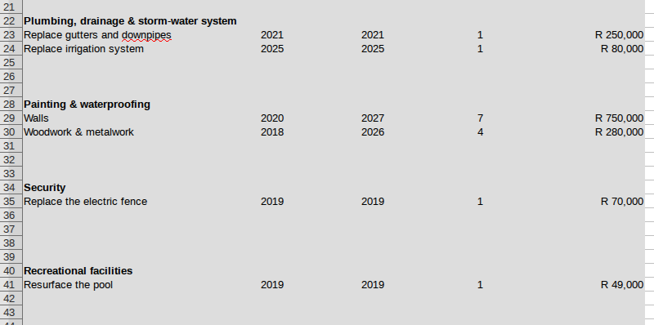
Opening the “Current Year Planner” of the example2.ods spreadsheet shows that ZBC should have had R1,206,200 in its reserve fund and the actual reserves of R550,000 represent a shortfall of 54.6%. To get its reserves up to the recommended level in one year requires a real 46.6% (nominal 53.6%) increase in the budget over the previous year.
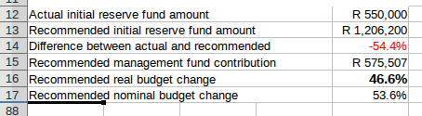

If the ZBC were hoping to get away with budget increases that are limited to the rate of inflation, they're going to be disappointed as the next projection shows. Warnings about the contributions to the reserve fund are generated right from the start and by 2020 the scheme is bankrupt.
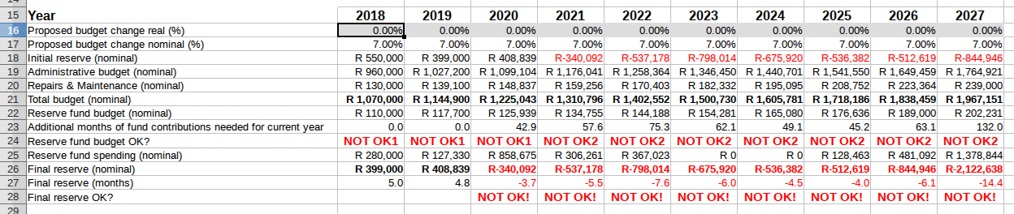
The nominal 53.6% increase recommended on the “Current Year Planner” doesn't seem like something that the trustees will be able to sell to the other members of the Body Corporate. The trustees note that the immediate problem is the paint job in the 2020 financial year and decide to try to stagger the increases evenly over the next three financial years. The projection is that real increases of 9%, 8% and 8% from 2018 to 2020 should be a financially acceptable solution.
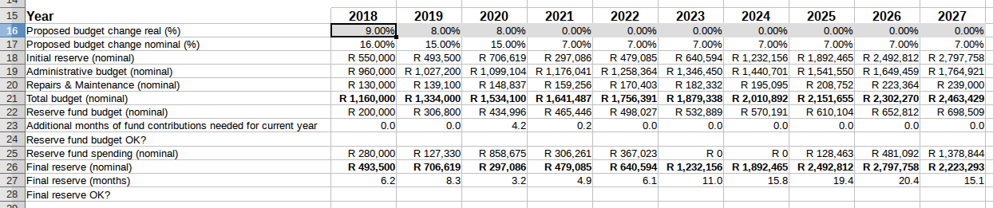
On closer examination, the trustees notice that, even though are no warnings, the proposed budgeting won't work for them. They want to repaint in the first few months of the 2020 financial year. At the start of the financial year they will have reserves of only R706,619 (or thereabouts since projections are imperfect) while the paint job will cost a projected R858,675. Looking at the “Additional months of fund contributions needed for current year”, they see that it will take 4 months (or 4.2 according to the excessively precise predictions of the spreadsheet) before their reserves will be adequate to cover the full year's expenses. The trustees decide that they should aim for two equal levy increases in 2018 and 2019 so that the value of the “ Additional months of fund contributions needed for current year” comes to zero. Two real increases of 13% (i.e. nominal increases of 20%) should satisfy their requirements.
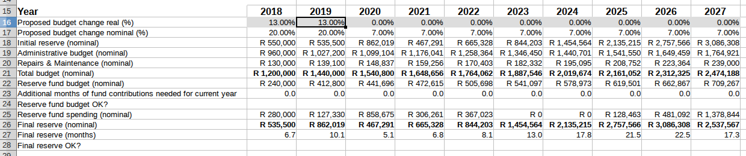
That's probably the least unpalatable solution that the trustees can impose on the owners.
Finally, the important points of the budget for the immediate year are summarized with levies going by 20% and the shortfall in the reserves dropping from R656,200 at the start of the year to R352,282 by the end of the year. Despite undertaking some expensive maintenance work during the year, the reserves should only drop by about 2.6% by the end of the year.
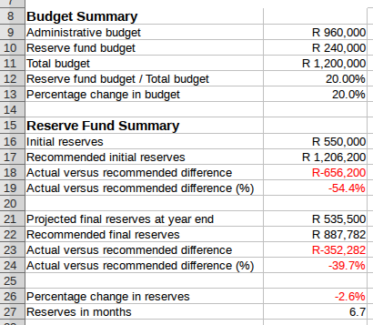

There are other experiments that the trustees could play around with:
- What happens if the pool resurfacing needs to take place in 2018 instead of 2019?
- How much can they reduce the levies by if the pool resurfacing is never needed?
- What happens if the paint job in 2020 costs R1 million instead of R860,000?
- What happens if the paint job carried out in 2020 lasts only for six years instead of seven and the next wall repainting needs to move forward from 2027 to 2026?

The spreadsheet can give answers to all those questions and others. Obviously the answers are absurdly precise but they hopefully resemble reality and can give the trustees some confidence that the BC is budgeting prudently.

Real World Examples
The real_world directory contains examples of budgets prepared by real sectional title schemes. If your complex prepares a budget using this spreadsheet, you're welcome to submit it for inclusion so that other schemes can learn from your worksheets. You can submit your spreadsheet by emailing it trustees@brittanytokaivillas.com.

Preparing your own Reserve Fund Spreadsheet
Hopefully this spreadsheet will take some of the pain out of complying with the Reserve Fund requirements of the Regulations. The ReserveFundBudget.ods spreadsheet is blank but with the eleven categories of major repair items that a BC may need to spend money on. Unfortunately, the spreadsheet doesn't provide any assistance in preparing a budget for the day-to-day running of the complex. Section 17 of the Regulations Management Rules (in Annexure 1 of the Regulations) requires the trustees of a BC present both an administrative and a reserve fund budget at the AGM. This spreadsheet can help with the preparation of the reserve fund budget but it doesn't help with the preparation of the administrative budget. In fact, you need to prepare your administrative budget before preparing your reserve fund budget since the minimum amounts that must be contributed to the reserve fund budget are a function of the amounts of:
- The total administrative budget
- The Repairs & Maintenance line item on the administrative budget.
Preparing an administrative budget should have been something that your BC has been doing annually for years. However, Appendix 1 describes a spreadsheet for creating an administrative budget if you'd like to see one approach to creating such a budget.

The “Ten Year Plan” worksheet also includes an “Other” category since there are items that a BC may want to spend money on that do not fit easily into any of the eleven prescribed categories. For example, a BC must maintain fire extinguishers annually and should budget for replacing them from time to time but that expense doesn't seem to fit naturally into any of the existing categories. Gates, doors and windows are other capital items that aren't naturally categorized in the Regulations checklist.

Finally, it's important to prepare a new reserve fund budget every year even though the budget plans for ten years. At the start of a new financial year, the trustees should revisit the items that need to be maintained and revise the estimates of the costs associated with the items on their maintenance plan.

If you find this spreadsheet useful, please let us know by emailing hammingweight@gmail.com

Appendix 1: Creating an Administrative Budget
This Appendix uses the administrative budget spreadsheet that can be downloaded from https://github.com/tokaivillas/AdministrativeBudget There are two steps involved in preparing an administrative budget using the example spreadsheet.

Step 1: Capture the Previous Year's (Administrative) Expenses
The trustees of a body corporate have to present (Audited) Financial Statements at every AGM. These financial statements serve as a useful starting point when preparing the following year's administrative budget. The figure below captures some of the detail. Note that the preparation of the budget may start before the financial statements have been audited, so there may be discrepancies between the figures in the budget and the Audited Financial Statements, so the spreadsheet states these are unaudited figures.
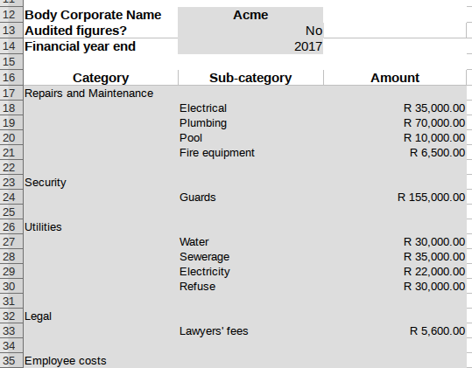

Step 2: Do the Budgeting
The next thing is to make an assumption as to what the rate of inflation for the expenses of the body corporate. In this example, we've assumed that it's 7% and the “Budget Planner” worksheet simply takes the previous year's figures and applies the default rate of inflation.
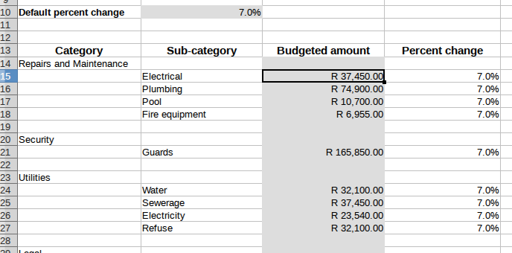
The Trustees then go through these items one-by-one and adjust them based on what other factors they feel should be taken into account. For example:
- For repairs and maintenance items, they round the figures to the nearest R500
- In the case of security, they know that there have been above inflation increases in the minimum wage applicable to the security industry so they adopt a figure larger than a naive increase based on inflation
- They assume that the price of water will go up dramatically based on a recent drought

Some of the detail from the final administrative budget is
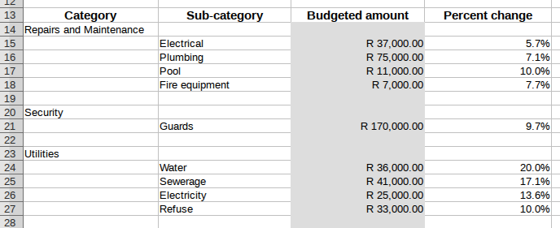
For preparing the Reserve Fund budget, they need to know:
- The total Administrative Budget
- The budgeted amount for Repairs and Maintenance
Those items can be seen in the “Budget Summary” worksheet
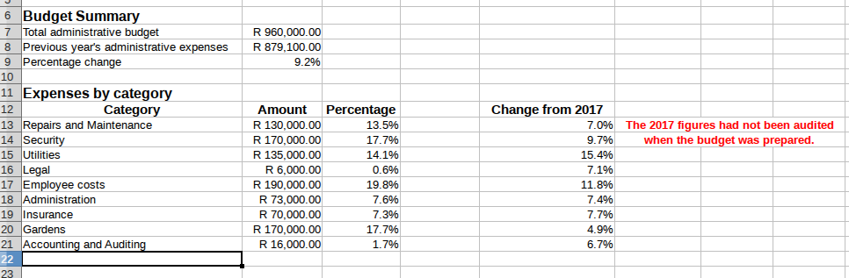
The Trustees can now prepare a reserve fund budget based on the following amounts
- Total administrative budget = R960,000
- Budgeted amount for Repairs & Maintenance = R130,000

Appendix 2: Assumptions of the Spreadsheet Modelling
This appendix is for informational purposes - read it only if you want know how the spreadsheet calculates things or are sceptical that the calculations are even sane let alone useful.
The Regulations requires that trustees of a BC prepare a ten year plan. Trying to predict financial health over a ten year period with precision is challenging if not impossible. This appendix details how the spreadsheet calculates the expected reserves and the amounts needed for maintenance work in each of the ten years. There are several factors that that affect the accuracy of these projections:
- High interest rates and inflation rates adversely affect the accuracy of projections
- Legislative changes may make projections difficult. For example, if some maintenance work is labour-intensive and wages in the sector are increased significantly, the initial projections will be inaccurate
- Commodity price variations can make prediction difficult. E.g. If demand for aluminium goes up, then maintenance work that requires aluminium is going to cost more than initially assumed.

This appendix details how the spreadsheet determines the projected administrative costs, the projected cost of maintenance work, the final reserves at the end of a financial year and how much should be in the reserve fund at the start of a year.

Projecting Administrative Costs
The simplest calculation is the projection of administration costs over a ten year period. Looking at the costs from 2018 to 2027 below, we see that the administrative budget goes up from R960,000 in 2018 to R1,027,200 in 2019. The value of R1,027,200 = R960,000 x 1.07 or the value from 2018 plus a simple increase based on the assumed rate of inflation. Similarly the value for 2020, again assumes a 7% increase over the 2019 amount (R1,099,104 = 1.07 x R1,027,200).
The accuracy of this prediction is dependent on a number of factors:
- How applicable is the assumed rate of inflation to all the items in the administrative budget. For example, if the price of water goes up by 25% and the cost of water makes up only 5% of the administrative budget, the calculation may be reasonably accurate. If the water budget makes up 30% of the overall administrative budget, the calculation may be off by a significant amount.
- The size of the scheme for which the budget is being prepared. Schemes with more units (and bigger budgets) are likely to find this calculation relatively more accurate than smaller complexes. Suppose that 15% of units typically experience plumbing-related problems in a year. Now in a complex with 60 units we would expect 9 units to need repairs in a year. If it happens that one more unit than expected needs repairs, a reasonable estimate is that the plumbing line item will be out by about (10 / 9) or about 11%. For a complex with 20 units, we would expect repairs to be needed at 3 units. If 4 units experience problems in one year at the complex, the plumbing budget might be out by 33%.
The calculation of the Repairs & Maintenance projections is done in the same way as for the total administrative budget.

Projecting Maintenance Costs
When preparing the ten year plan, the costs should be expressed in current Rand terms and the spreadsheet will then apply the assumed inflation rate to estimate the nominal cost in the year of interest. For example, if repainting a complex at the start of the 2018 financial year would cost R750,000 but the work is only scheduled to happen in 2020 (2 years later) and, again, in 2027 (9 years later) and inflation is running at 7%, then the projected (nominal) costs are
R750,000 x (1.07)² = R858,675
R750,000 x (1.07)⁹ = R1,378,844
If you look at the example1 and example2 spreadsheets, you'll see that those are the estimates in the spreadsheet. There are a couple of minor problems with this:
- The estimate of inflation is imprecise and the general rate of inflation might not be applicable to the activity
- The assumption is that the activity will happen at the same time of year as the estimate is based. For example, if an estimate is calculated at the start of a financial year but the activity takes place at the end of the corresponding financial year, the estimate will be off by about the rate of inflation (i.e. about 7% in the above example). You can compensate for this by modifying the original estimate. For example, if you anticipate that the activity will take place 6 months (0.5 years) into the financial year, multiply the current estimate by (1.07)^{0.5} and replace the R750,000 with an estimate of R776,000.
The (nominal) estimate of reserve fund expenses for a year is, unsurprisingly, simply the sum of the individual maintenance costs for the year. For example, if we estimate that in 2019 we will spend R74,900 on replacing the electric fence and R52,430 on resurfacing the pool (as captured in the “Ten Year Plan” worksheet) then the “Reserve Fund Spending” value for 2018 on the “Planning and Projections” worksheet is R74,900 + R52,430 = R127,330.

Projecting Final Reserves
The spreadsheet estimates the amount in the reserve fund at the end of each financial year (which is the same as the estimate for the initial reserves at the start of the next financial year). The way that the calculation is performed depends on the version of the spreadsheet that you're using: version 1.3 (or earlier) or version 1.4 (or later). The examples in the body of this user guide and in the example spreadsheets used the earlier formula.

Version 1.3 Calculation
The calculation is quite naive, it is evaluated as
(initial reserves – reserve fund spending + reserve fund budget) x (1 + interest rate)
For example, if in 2018, we have initial reserves of R550,000, we spend R280,000 from the reserves, have a reserve fund budget for the year of R240,000 and our interest rate is 5% then the final reserve fund amount is estimated to be
(R550,000 – R280,000 + R240,000) x 1.05 = R535,500

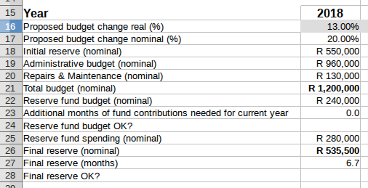

The calculation is naive because:
- The calculation is valid only if interest is calculated and compounded annually. If interest is calculated monthly, the actual interest earned on a positive balance would be greater
- Interest rates may vary depending on the amount in the reserve fund.
- The interest earned should be a function of when in the year spending happens (and when in the year money is moved into the reserve fund).
None of the above limitations is necessarily serious if interest rates are low. For example, a nominal interest rate of 5% if compounded monthly is equivalent to an effective interest rate of 5.1% compounded annually. That's not a big difference.

Version 1.4 Calculation
One of the limitations of the Version 1.3 calculation is that it ignores when money is moved into or out of the reserve fund. The inaccuracy of this is most extreme under these conditions:
- Most spending happens towards the end of the financial year (in which case the formula underestimates the amount of interest earned)
- Reserve fund contributions are made towards the end of the financial year or in equal contributions over the course of the year and there is little or no spending from the reserve fund (in which case the spreadsheet overestimates the amount of interest earned).
To avoid the inaccuracies associated with the extreme scenarios above, the new formula works out the amount of interest earned on the mean of the initial amount in the reserve fund and the final amount in the reserve fund (if no interest was earned). The formula for the interest earned is then
(2 x initial reserves – reserve fund spending + reserve fund budget) / 2 x interest rate
So, if we have initial reserves of R550,000, a budget of R240,000, will spend R280,000 and the interest rate is 5%, then we calculate the interest earned to be
(2 x R550,000 – R280,000 + R240,000) / 2 x 0.05 = R26,500
The final reserve amount is then calculated as
initial reserves – reserve fund spending + reserve fund budget + interest earned
which, for our example, is
R550,000 – R280,000 + R240,000 + R26,500 = R536,500
which is only R1,000 different (or less than 0.2%) from the value used in version 1.3 of the spreadsheet.

Calculating The Recommended Reserve Fund Contribution

Version 1.4 Calculation
Section 22 of the Management Rules (Annexure 1) of the Regulations has a formula for calculating how much must be paid into the Reserve Fund for each item on the ten year maintenance planning:
The annual contribution to the reserve fund for the maintenance, repair or replacement of each of the major capital items must be determined according to the following formula: [(estimated cost minus past contribution) divided by expected life]
There are three (hopefully minor) problems with this:
- “Expected life” has the unusual definition of “the estimated number of years before it is expected that the cost of maintenance, repair or replacement of a major capital item will be incurred” So, if it is expected that in nine years time a paint job will be required. “expected life” means 9 years even if the paint job is expected to only be good for 4 years.
- It is not explained whether “estimated cost” is in “real” or “nominal” terms. The spreadsheet uses the real (i.e. current cost) of the work and neglects inflation. Since the reserve fund should be in an interest-bearing account, this seems to be a more sensible interpretation than assuming that the cost should use the nominal value of the work using an estimate of inflation.
- “Past contribution” is a particularly difficult term to understand unless a BC has kept a meticulous record of the amount contributed in each preceding year towards a particular capital item. We assume that a BC knows only the total amount in the reserve fund without knowing the constituent contributions that made up the reserve fund. We explain next how we calculate an estimate of the “past contribution” to determine what this year's contribution should be.
Note: There is a fourth problem with the interpretation of the formula that is addrtessed in v1.5 of the spreadsheet.

To explain how we calculate the “past contribution”, consider the simple ten year plan in example3.ods where there are only two capital items for the next ten years:
- An expense of R70,000 in the current financial year
- An expense of R300,000 in the next financial year
Both of these items should have appeared in ten year plans in the past:
- The first item should have been in the previous 9 plans, so we should have collected money to cover 90% of the cost already
- The second item should have appeared in 8 previous plans, so the reserve should already contain 80% of the money needed for this capital item.

So, ideally, the amount in the reserve fund should be at least
90% x R70,000 + 80% x R300,000
= R63,000 + R240,000 = R303,000
Now suppose that we have only R100,000 in the reserve fund, i.e. we have only 0.33 of the required amount.

Using the factor 0.33, we calculate that instead of having contributed R63,000 towards the electric fence, only
0.33 x R63,000 = R20,792
has been contributed.

Similarly instead of having contributed R240,000 towards the paint job, we have only contributed
0.33 x R240,000 = R79,208
for this capital item in the reserve fund.

Now, using the formula from the Regulations, we need to calculate how much should ideally be contributed in this financial year for each of these two items. For the first item we must contribute
= R49,208
where the '1' in the denominator above reflects the fact that we have only 1 year in which to collect the money for the cost to be incurred (in the unusual wording of the Regulations, the “expected life” is 1 year.)

Similarly we calculate that we should collect
= R110,396
in the current financial year towards the painting. The factor '2' in the denominator arises from the fact that we can contribute towards the reserve fund over two years to pay for this painting.
So the total contributions that we must ideally collect in the current financial year is R110,396 + R49,208 = R159,604.

If we look at the “Current Year Planner” for example3.ods we see that R159,604 is indeed the amount that we should contribute. The figure of R303,000 that the complex should ideally have had in reserve at the start of the year is also shown.

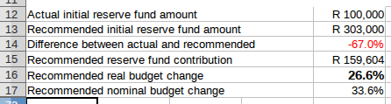

If you look at the “Current Year Planner”, you might notice that rows 18 onwards are hidden. The intermediate results used to calculate the “Recommended initial reserve fund amount” and “Recommended reserve fund contribution” are calculated in those rows. If you want to see them, unprotect the worksheet and select “Show” for the relevant rows.

Version 1.5 Interpretation of PMR22(2)
Suppose that a BC prepares a maintenance plan that has only repainting as an item on the plan and
- That repainting is required every 7 years.
- The paint job is estimated to cost R600,000
- The next paint job is required in 3 years time and the subsequent job is in 10 years
- There is no money in the reserve fund

A literal interpretation of PMR22(2) would suggest that the BC must budget for both the work to be undertaken in 3 years and in 10 years, i.e. they must set budget R600.000/3 (=R200,000) for the work to be undertaken in 3 years + R600,000/10 = R60,000 for the work in 10 years’ time, i.e. they must set aside R260,000 to undertake the work. That is the interpretation used in this spreadsheet prior to version 1.5.
In version 1.5, PMR 22(2) is taken to mean that one only needs to budget for the first occurrence of maintenance work, i.e. that only R200,000 per year needs to be added to the reserve fund. That is a more reasonable requirement and leads to much less aggressive recommendations.

Carl Meijer
January 2023

Revision History
Version | Date | Changes
1.0.0 | April 2017
1.1.0 | 1 May 2017 | Budget summary displays percentage of the total budget that goes into the reserve fund.
1.2.0 | 8 May 2017 | Added an appendix on preparing an Administrative budget.
1.3.0 | 8 June 2017 | Various typographical changes to the documentation and the spreadsheet.
1.4.0 | 14 June 2017 | Added material on how to calculate the final reserve amount in version 1.4 of the spreadsheet.
1.4.1 | 9 July 2017 | Small changes to the descriptive text in the spreadsheet template.
1.4.2 | 14 July 2017 | Document corrects references to “Sectional Title” to “Sectional Titles”.
1.4.3 | 19 July 2017 | Added material about real world schemes.
1.4.4 | 20 July 2017 | Can use an ODS or XLSX spreadsheet.
1.4.6 | 30 March 2018 | Corrected example 1 budget spreadsheet summary.
1.5.0 | 3 January 2023 | Changed the interpretation of PMR22(2) to be less aggressive.  Added 10 year planning to the budget summary.  Cleaned up spreadsheets to display fewer intermediate results.

