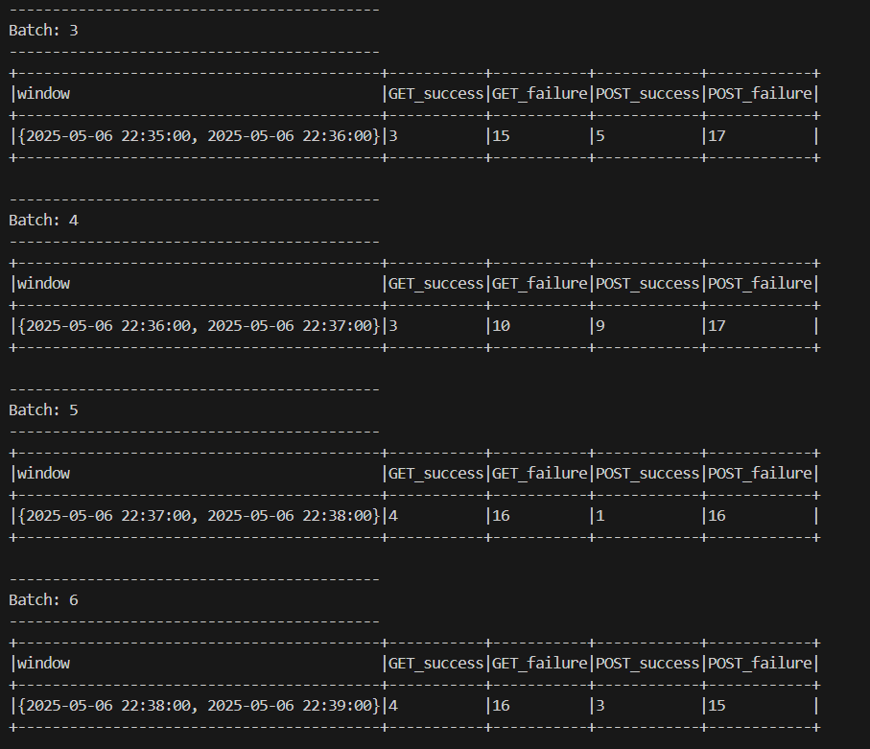

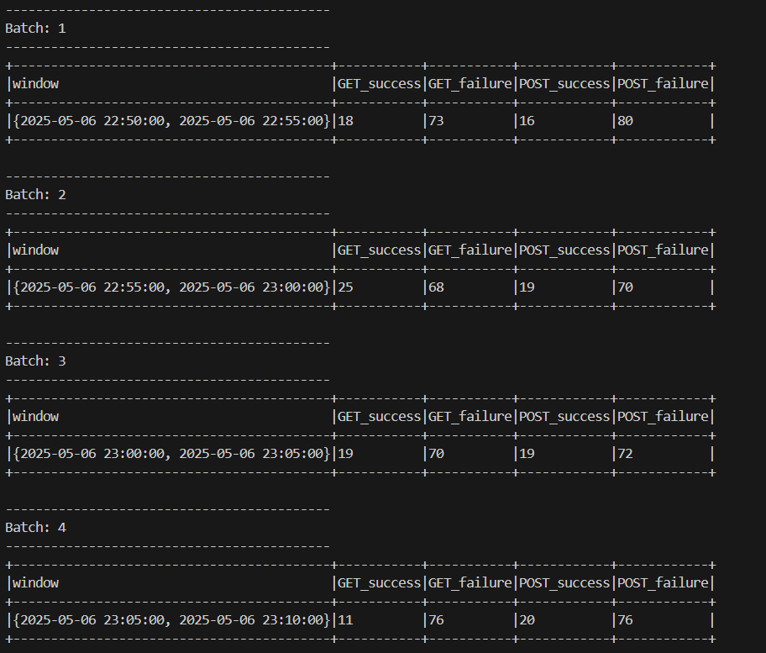

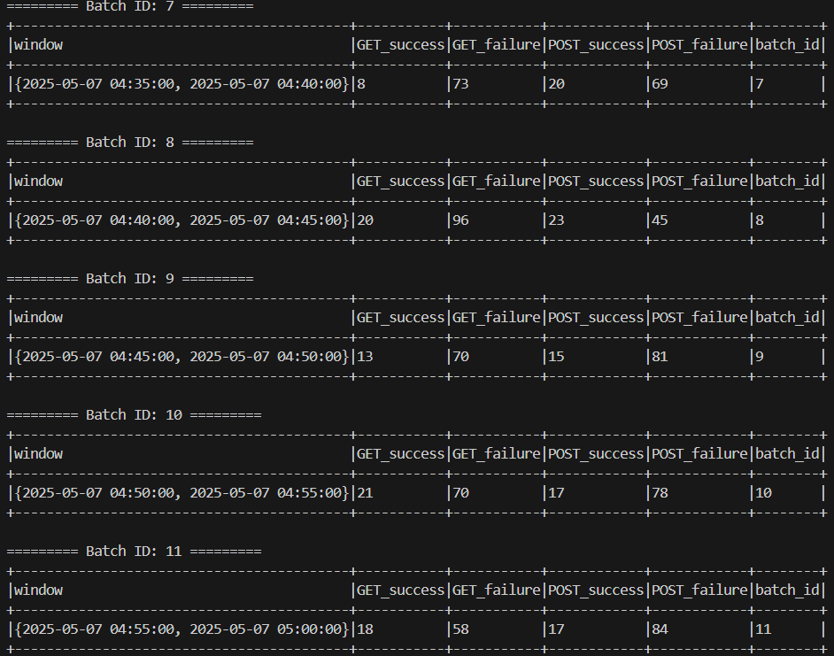

PS C:\Users\PCCV> docker run -it -p 8042:8042 -p 9870:9870 -p 9864:9864 -p 8020:8020 -p 9000:9000 --name "hadoopc" -h hadoopc asami76/hadoop-pseudo:v1.0 bash -c "/usr/local/bootstrap.sh; bash"

