MEMO for WPMAG-MCD-3.1
Task Area: | MCD-3.1-T03
Deliverable: | RS03
Title: | TF Magnet system configuration extracted from IDM central database CAD model
IDM Reference: | EFDA_D_2LMDTE
Authors: | F. Nunio
Date: | 04/09/2015
Abstract: | The TF Magnet system configuration is extracted from IDM central database CAD model in order to produce the drawings of the radial built of the TF coil and of the D shape parameters.  The main evolution between the 2014 and 2015 configurations applied by PMI are commented.  A set of 3D converted files to be used for mechanical model building are given in STEP and IGES format.  -----------------  The reference Task Specification can be found at https://idm.euro-fusion.org/?uid=2MC938

Table of Contents
1 Introduction 3
2 Reference document 3
3 Synthesis of the main evolutions of the Reference CAD model between 2014 and 2015 3
4 Drawings of the radial built and D-shape of the TFC 4
4.1 Updated baseline for WPMAG (de-coupled CAD) 4
4.2 Definition of the shape of the TF coil 7
4.3 CS coils 9
4.4 PF coils 10
4.5 Plasma 11
5 CAD models in neutral format 12
References 12

Introduction
This document describes the methodology that has been applied in order to extract the drawings of the radial built of the Toroidal Field Coil (TFC) and of the overall shape of the coil. An illustration of the main evolutions of the reference CAD model between the 2014 version and the 2015 version is also stated, with an emphasis on the TFC structures.
Finally, a description of the set of 3D converted files to be used for mechanics model building is given.

Reference document
The reference CAD model has been issued the 8 may 2015:
EU DEMO1 2015 - DEMO_TOKAMAK_COMPLEX (https://idm.euro-fusion.org/?uid=2M9AJJ)

Synthesis of the main evolutions of the Reference CAD model between 2014 and 2015
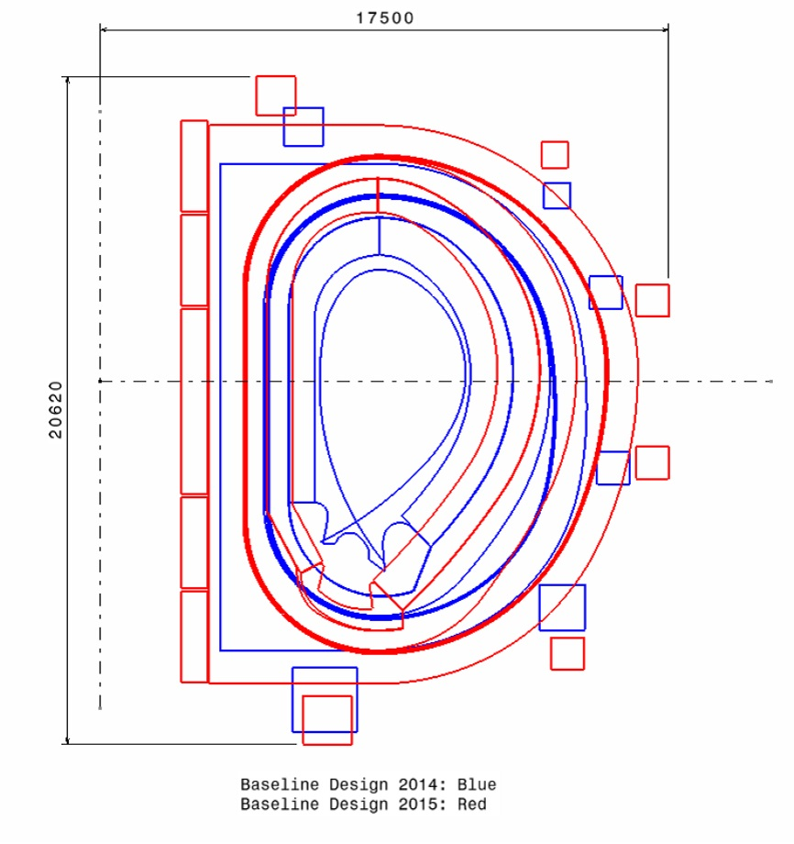
Figure 1 : see []
The main evolutions of the reference CAD 2015 [Error: Reference source not found] are:
- the number of TF coil has been increased from 16 up to 18
- a major change in dimension (increase in height and of the overall diameter …)
- a variation between inner "straight" leg and outer "curved" leg : the thickness of plasma side plate is different (40mm for inner leg and 190 mm for outer leg – see Figure 2). Consequently, the D-shape of the TFC cannot be directly deduced from the external shape of the casing of the TFC (see 4.2). This feature has been implemented following the structural analyses performed in [].
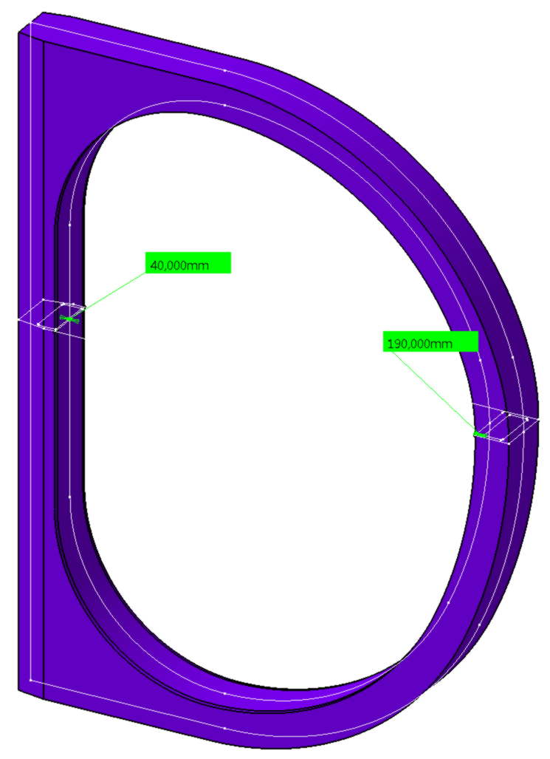
Figure 2

Drawings of the radial built and D-shape of the TFC

Updated baseline for WPMAG (de-coupled CAD)
Following the WPMAG preliminary mechanical analyses (lack of cross section for the Winding Pack), a new baseline of the TFC radial built has been implemented, increasing the TF empty space allocated to the WP by 125 mm in radial direction toward plasma (see Figure 3 below).

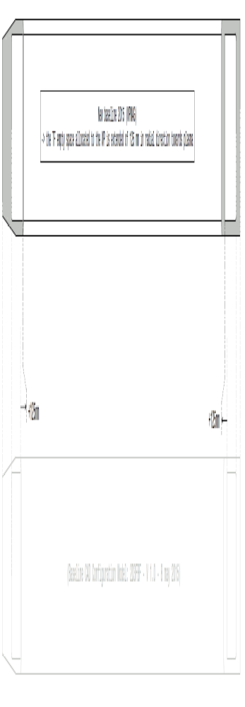
Figure 3 : new baseline WPMAG 2015
The radial built of the TFC has been modified accordingly (see Figure 4)
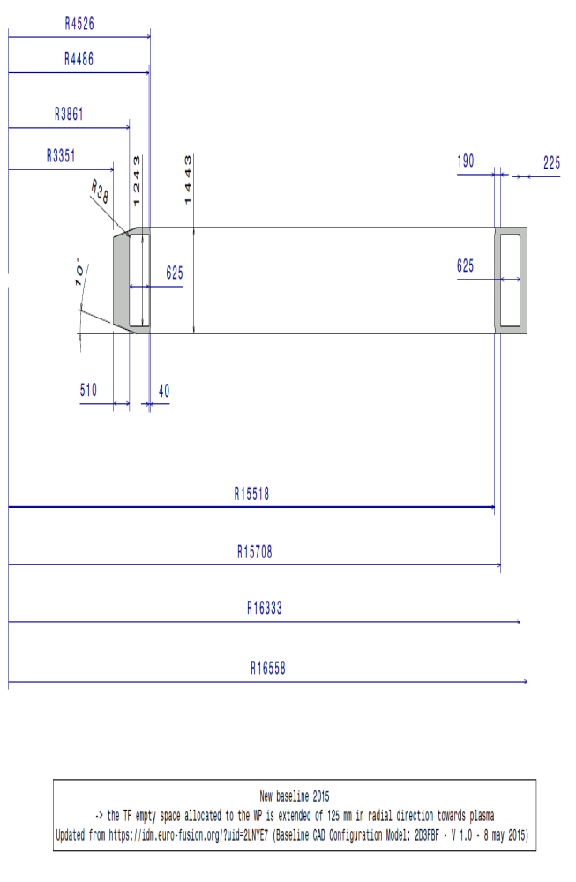

Figure 4 : TFC section (mm)

Definition of the shape of the TF coil
Due to the difference between the thickness of the plasma side plate of inner and outer legs (see Figure 2 – paragraph 3), the D-shape of the TFC winding pack cannot be directly deduced by a shift of the external shape of the casing. In order to build the shape of the "empty space" allocated for the WP, the path of the centreline is constructed considering that the shift between the 40mm and 190mm thicknesses is given at the level of the arc_1 and arc_6 (see Figure 5). In this way, the TFC casing is consistent with the requirements of [Error: Reference source not found].

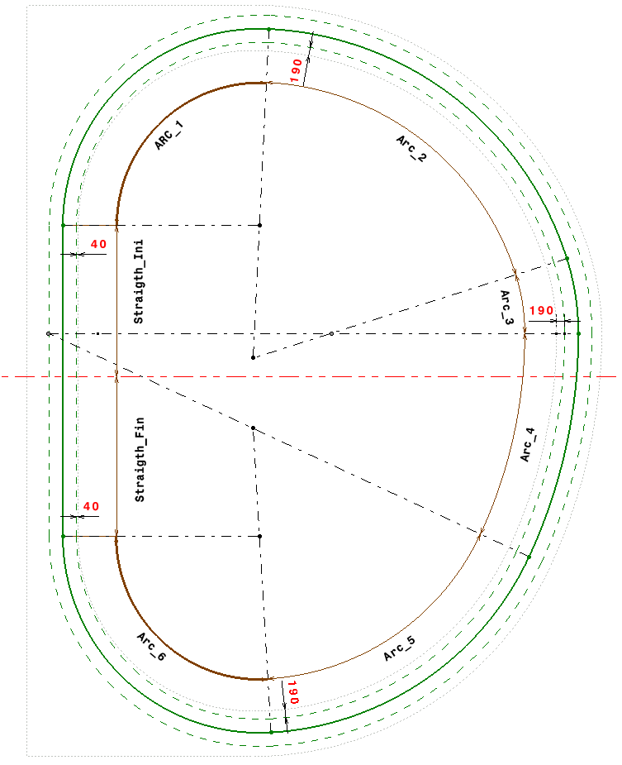
Transition here
Transition here
Figure 5
According to this, the shape of the centerline of the "empty space" of the TFC casing is given by Figure 6. The corresponding description of the path is given in Table 1.
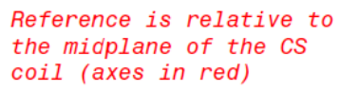
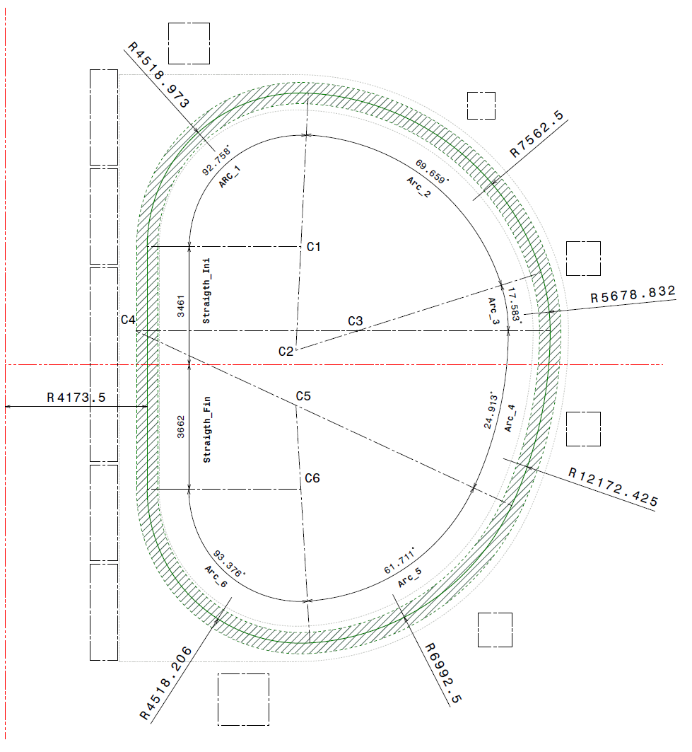
Figure 6 : centerline of the "empty space" of the TFC casing (mm)
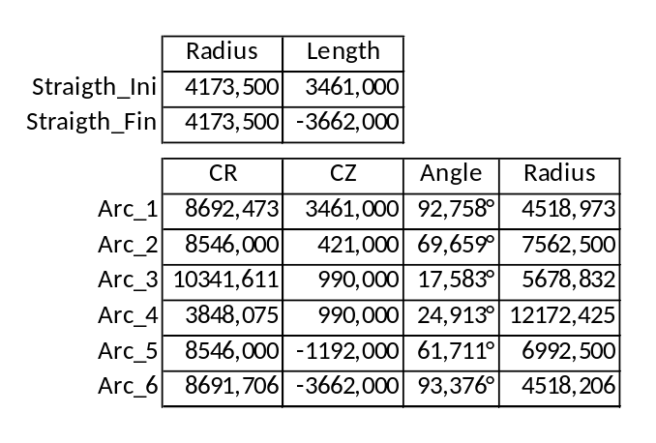
Table 1

CS coils
The section of the Central solenoid Coils is given in Figure 7.

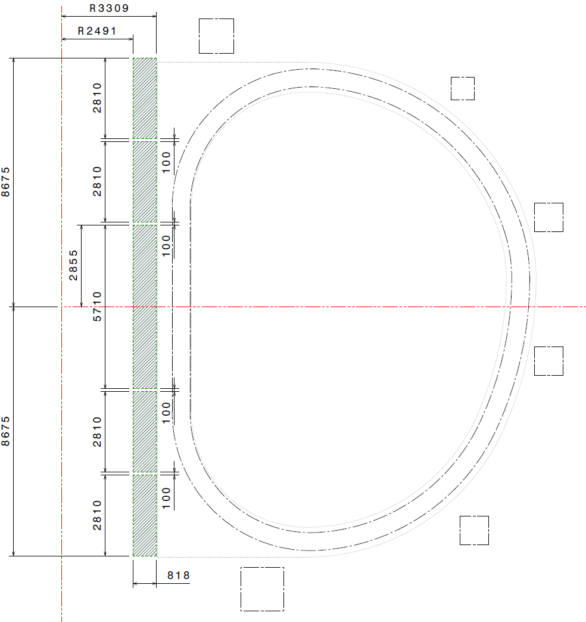
Figure 7 : CS section (mm)

PF coils
The section of the Poloidal Field Coils is given in Figure 8.

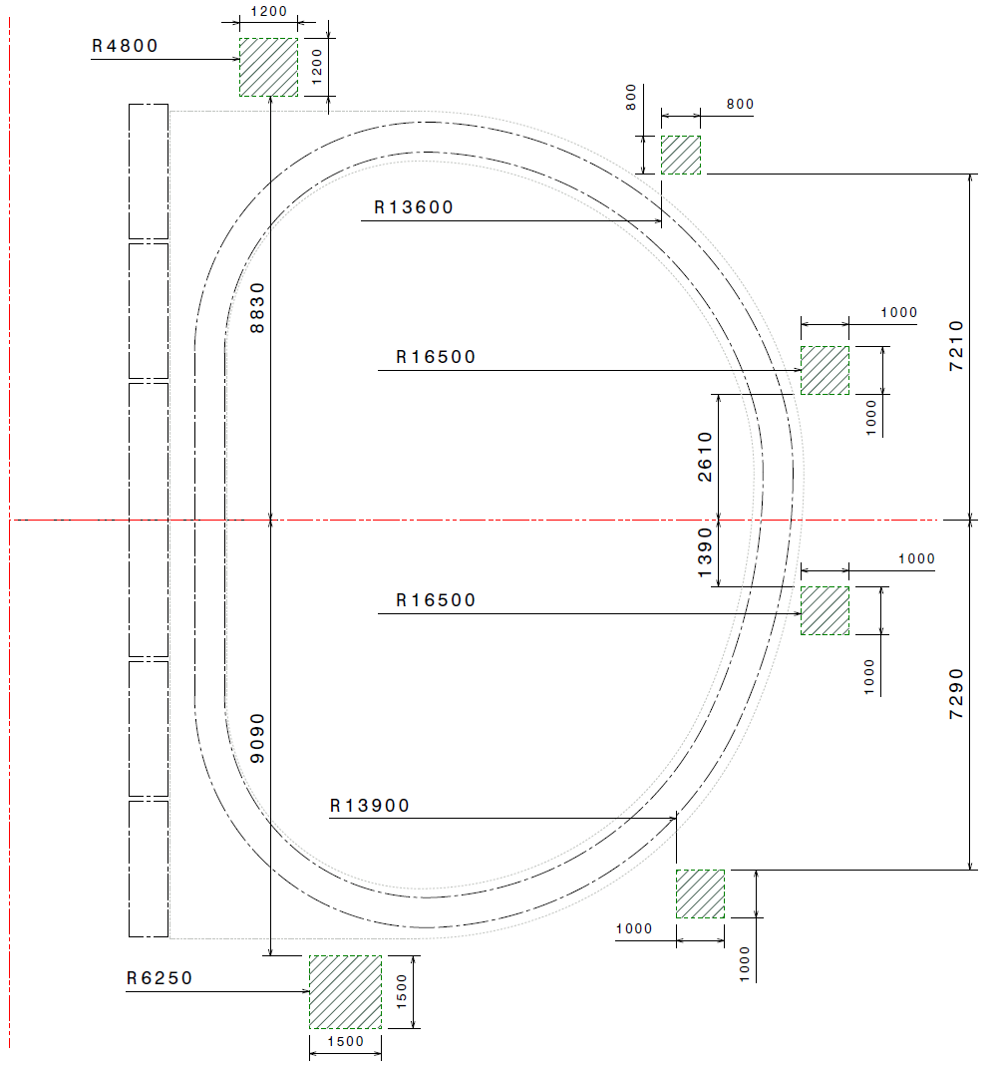
Figure 8 : PF section (mm)

Plasma
The location of the center of the plasma is given in Figure 9.

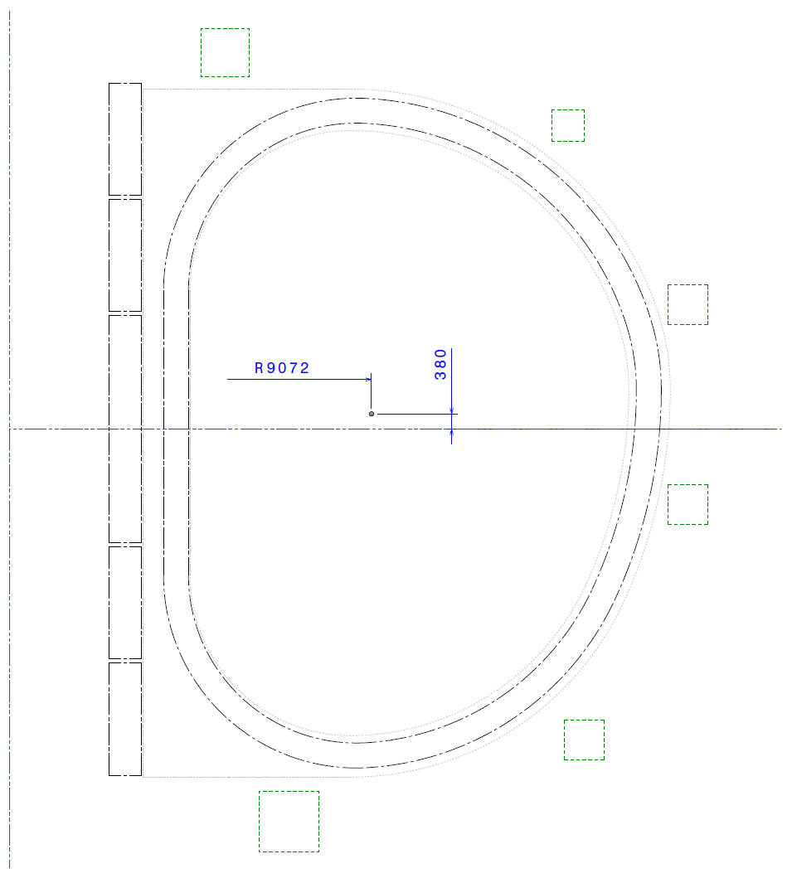
Figure 9 : Plasma center location (mm)

CAD models in neutral format
A set of 3D neutral files to be used for mechanics model building are given in STEP and IGES format. These files are derived from the previously described de-coupled CAD. Their composition is given in the following Table 2. The dimension of the 3D models are mm.

Model # | Filenames | Description
1 | newBaselineWPMAG2015_TFC.stp  newBaselineWPMAG2015_TFC.igs | One toroidal field coil, with "empty space".  Two components: the TFC casing and the enclosed "empty space" as a volume | 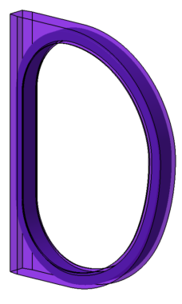
2 | newBaselineWPMAG2015_MAG.stp  newBaselineWPMAG2015_MAG.igs | One sector (1/18th) of the magnetic system, without plasma.  Three components: Model #1 plus the CS geometry and the PF system geometry. | 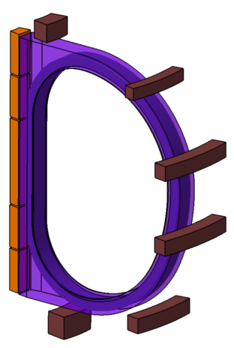
3 | newBaselineWPMAG2015_ALL.stp  newBaselineWPMAG2015_ALL.igs | One sector (1/18th) of the tokamak, without thermal shield.  Two components: Model #2 and the vacuum vessel geometry, here given to check the allocated space for the OIS.  NOTICE: as the TFC model has been modified (de-coupled version), there is a clash between TFC casing and vacuum vessel. | 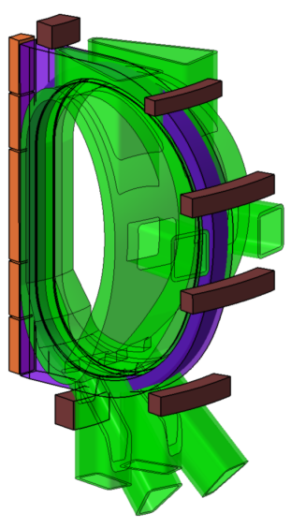
Table 2

References

[?]B. Meszaros, H. Hurzlmeier - EU DEMO1 2015 - DEMO_TOKAMAK_COMPLEX - https://idm.euro-fusion.org/?uid=2M9AJJ
[?]Y. Krivchenkov, V. Riccardo - Outer TF Coil casings for different aspect ratio cases - https://idm.euro-fusion.org/?uid=2KW6GP

